Walton-On-Thames UXB October 1993.
After Action Report.
Walton-On-Thames
Task number: 33107.
BDO: Captain T Lardner RE.
BD Engineer: Lance Corporal C Panton.
- Initial Call and Tasking. At 1235 on Thursday 15 October 1993, I, as duty Bomb Disposal Officer (BDO) for 33 Engineer Regiment (EOD) was paged and informed of an incident in Walton-On-Thames. My BD Engineer was with me and we proceeded directly to the incident arriving at 1345.

- Location. On investigating, the bomb was clearly visible in the bucket of a large excavator. The bucket was at ground level relative to the excavator which was, in turn, on a shelf some 10’ below normal ground level with another shelf some 10’ below that. The surrounding area had already been evacuated to 200m by the police and, on my request, this was extended to 300m. There were several aviation fuel tanks 250-300m away and their owners were of the problem. Additionally the police had closed the Tames 500M away and had pre-emptied my request for a notam. The main pumping station for London Water was approx. 250, from the bomb and the staff who were advised to move declared that they were ‘essential services’ and they were then advised to stay at the rear of the building.

- Access. There were no access problems with the bomb.

- Diagnosis. The bomb was in an excellent condition and although it has some gravel heavily caked onto the body, it was easily identifiable as a 1000 kg SC ‘HERMAN’. Although the fuze appeared to be in excellent condition, it proved impossible to positively identify it. Although the SOP RSP for the HERMAN states that I should have assumed a fuze to be a 17 Series, the fact that there were not three screws around the outside of the fuze head led me to believe it was a 55 Series.

- Protection. Due to the positioning of the bomb on a shelf about 10’ below ground level, protection was not necessary.

- Render Safe Procedure (RSP). The first stage of the RSP was to immunise the fuzes. This was done using the ‘S; set with method C (salt solution). This was done by introducing salt solution into the fuze pocket. One the solution had been introduced; a soak period was waited before it was assumed that immunisation had taken place. Following this, the plan was to trepan a hole towards the rear of the bomb (the area where the powder fill (AMOTOL) was expected. On closer inspection following immunisation, I found impact damage at the rear of the bomb, in the for of a tear between the base plate and the body. The tear was approx. 8”long and 2” wide. Some filling had been released and I could feel that crystals had formed in this area. I was concerned that the bomb was still in a dangerous state and thus attempted to keep manpower to a minimum on the bomb site. LCpl Panton and I, together with several of the crash crew then spent several hours tunnelling under the bomb, removing the spoil by hand , to allow the trepanner chains to be fastened around the bomb. We eventually set up and began trepanning around 2000. On the first 3 attempts the trepanner slipped rearwards, as it had been positioned due to the constraints of the bucket, on the rear slope of the body. We then went through the same procedure of re-tunnelling and repositioning, again for several hours before we achieved a good position. Eventually we achieved two holes in the rear, exposing the powder fill.
The UXB operations section of 33 Engr Regt (EOD) SOPs, helpfully told me to “wash out the powder filling”. With the loan of some of Surrey Fire Brigade’s pumping equipment, I began to wash the fill out on my own. The powder has solidified and crystallised considerably and proved very difficult to shift, especially as I was loathed to us much pressure because of the crystals at the rear of the powder fill. Over the next few hours I washed and manually broke up the AMATO. The slurry which was washed out was AMATOL (essentially ammonium nitrate) solution, fairly caustic and giving off ammonia vapour. LCpl Panton and I had to remove the slurry from the bucket of the excavator on two occasions, by plastic buckets, to several “wheely bins” requisitioned from the local council (this transferral was done in chemical protective suits). At around 0330 I saw inside the excavated space (probably 50 % by volume of the amatol) a black wire hanging from the centre of the fuze pocket. I immediately retired to a safe distance and referred to the fuze book which did not refer to a type 55 fuze with a wire which the manual informed us that on no account should it be interfered with. There was much scratching of heads whilst the CO. who was at the ICP, and I discussed the options. Eventually a phone call to Major Hogben from the EOD Technical Information Centre (EODTIC) confirmed my belief that the wire did not pose a treat. I then proceeded with the washing operation. After several more hours, it was clear that the remaining 40% of the fill would not wash out and, although I had freed about 65% of the fuze pocket, the remaining 35% was stuck fast. I then decided, based on the fact that we would be unable to safely move the bomb even with the fuze pocket out, and that it was likely to be destroyed in situ anyway, that I would attempt to trepan the fuze pocket. I hoped that the force would tear out the remaining 35% held in the solidified powder, with there being a small risk of detonating the bomb. LCpl Panton assisted me setting up the trepanner and then cut into the over the fuze pocket. The fuze pocket was free from the top body but still held in by the bottom 20% of the solidified fill. The next 2-3 hours were spent attempting to carefully remove the solidified explosive. This involved laying on top of the bomb with my arm in as far as it could go, (I could just touch the far side of the bomb.) trying to free the fuze pocket. LCpl Panton shone a torch through the trepanned hole and I squinted through the circular cut around the fuze. At around 1400 it was clear that although I would eventually be able to achieve the removal of the fuze pocket, it would take a considerable amount of time (possibly days). This would have inconvenienced the local population for several more days. Because the bomb was in a very unstable condition, it was clear that we would be unable to move it to a sfe disposal site and it would have to be destroyed in situ., with all the corresponding problems. The situation now appeared to be one of damage limitation and I decided to attempt a deflagration of the bomb using Charge Linear Cutting (CLC) of 180 g/m weight, the heaviest carried by the BDO wagon. The bomb at this stage was still in the bucket of the excavator and to reduce damage to more property, following a two minute ‘learn to drive an excavator course’, I moved the bomb into the trench below the ledge and eased it out of the bucket. I drove the excavator away to a safe distance and the returned to place the CLC on the case of the bomb. This was then set up and fired at 1650. Upon inspection I discovered that deflagration had not taken place and, although the case had been split over the area of the removed powder filling the case covering the cast filling was cut but not through to the filling. Because the police had cordoned out to 100m with householders indoors within this are, I was under a certain amount of pressure to complete the operation and so resorted to initiating a high order detonation, with the time of detonation at 1717.
There was some damage done to property in the area, with windows being reported to have been broken out to 600m. There were no reports of any casualties, although there is a possibility of damage by flying objects throughout the area.

The above report was shared with us by Tim Lardner
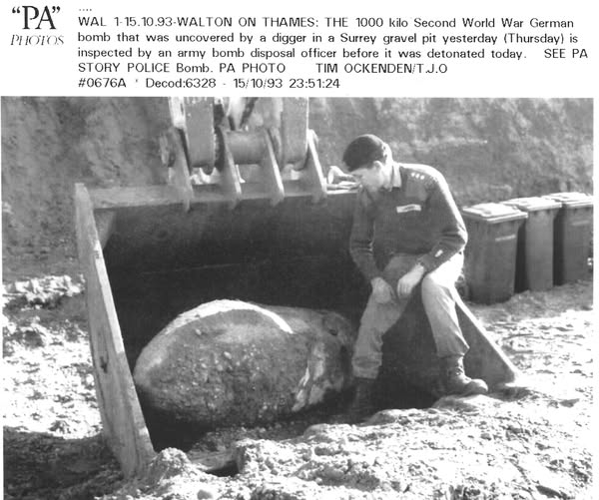
Team members recollections.
Col Dawson.
When the digger driver realised what t was, he was oof like a shot. There was about a 10 feet gap between each of his footprints in the mud where he’d legged it. And the cab door was lying open.
Robert Douglas Jones.
I was crash crew commander on this job, have a trepanner cut of the bomb case, a great job and with an Officer of great calibre.
I also remember this task with fond memories. A helicopter landed followed by a Brigadier tugging on my leg whilst I was standing on the tailgate of the crash wagon.
Col Dawson.
The Brigadier was Brigadier McGill (think he was South African) he took the time to speak to each of us and wish us well.
Tim Lardner that’s him met him a couple of times and always genuinely nice and friendly officer. The national news showed footage of his helicopter landing at the scene but announced it’s a Bomb Disposal Team being airlifted in.
David Harrison.
With an elite crash crew, Andrew Flavell, Col Dawson, David Harrison.
Ashley Collins.
Didn’t it high order on us? I am sure we blew half a dozen police bikes over. Put on half a stone living of free MacDonalds.
Newspaper Article. Surrey Herald 21October 1993.
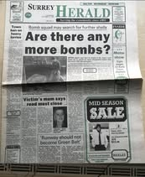
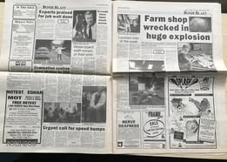
Photo of incident.
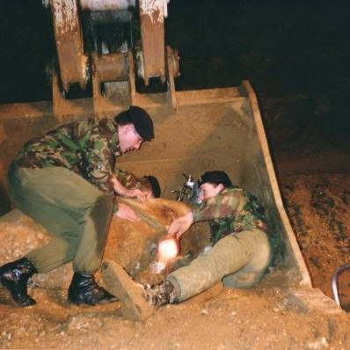
Left Col Dawson, centre Robert Jones right Tim Lardner.

