Rainham, Essex UXB October 1997.
Dover’s Corner, Rainham, Essex
29 October – 01 November 1997
WO2 (SSM) K Grantham RE.
Taken from The Redwing Magazine, shown below.
The rest of the Regiment deployed on the annual Regimental exercise Grand Slam (called a number of other things not printable) we as part of 21 Field Squadron (EOD) set up home at Whitburn Camp near Sunderland to act as umpires and as the neutral organisation. We were also the duty crash crew for the duration of the exercise always hoping for that big call out but never believing it could really happen in the middle of Exercise Grand Slam (no one could be that lucky). But the call did come on 28 October at around 1100 in the shape of a 250 kg (500 lb) German bomb in Rainham, Essex.
The first reports given to us suggested a 500 kg (1,000 lb) but these proved to be unfounded unfortunately. But a 250 kg still proved a grave threat to the inhabitants of Rainham and a great challenge to ourselves.
We deployed to Rainham, a good seven hours drive even for our quick reaction Daf! The duty BDO WO2 (SSM) Kev Grantham and is number two LCpl Jim Moynan had already deployed to site and we followed.
A quick discussion was required to decide where we were to stop for our only pit stop. The location quickly choses, McDonalds at Retford obviously! After our very brief stop we arrived at Rainham police station at around 1900 to the great relief of Spr Watkins who endured the blue light escapades of Sprs Short and McDowell in the Daf. A blue light is a very useful aid around towns and traffic problems but rather embarrassing on the A1, especially being overtaken by everything that had previously moved aside for you. Some choice words and the offending sappers soon learnt the error of their ways.
Following our arrival at Rainham we were briefed by the BDO and soon realised the extent of the problem. At least 5,000 residents were to evacuated and the A13 was to be closed for at least 8 hours. So, taking all this into account it was decided that the operation was to be carried out on Friday 13 October (Halloween). Thus giving us a day’s grace to prepare everything we possibly could, and of course to do all our press interviews and photo shoots.
Thursday 30 October and the crash crew’s first sight of the bomb. The BDO and his number two went to DEODS to brush up their fuze immunisation skills and to gain any extra intelligence on the fuzes in question with the invaluable help of Sandy Sanderson of course. We the crash crew ensured all our equipment was serviceable and prepared the protective works required with just a little help from the civilian JCB operator who found the bomb in the first place.
Starring Role.
Once work had started a listening watch using a micsteth was placed on the bomb to ensure any vibrations caused did not start the fuze functioning again. Spr (Beavis) McDowell who managed to star in every TV clip shown of the event, much to the annoyance of everyone else. The Army had sent its own press team to do all the coverage and were to release the material to local television, radio and newspapers. ‘ Great’ we thought, ‘they’ll be so much quicker than their civilian counterparts’. How wrong we were ! We completely forgot the infamous local boy stories and that it is definitely more important to take pictures of the bomb than to be able to prepare to actually get rid of it!
After what seemed like an age the press team finally left, our five minutes of fame were over and we were able to get on with the work required and the sergeant major and LCpl Jim Moynan could leave for DEODS. Work then carried on for the rest of the day with few major problems except one, the steamer was refusing to work to order. This coupled with the fact that the fitter had only learnt about the steamer the day before could have turned into a minor headache but he battled on and eventually won. This was with a little help from his fitter’s precision tool kit, mainly his hammer we think. It was decided to call for the Regiments remaining two steamers, better to be safe than extremely sorry.
The world was our oyster.
Once work had been completed and after a final check by the BDO and myself retired back to Rainham police station. Well, we were just outside London on a Thursday night – the world was our oyster. However, we didn’t think combats caked in mud and London clay had quite caught on yet so we opted for a local Chinese restaurant instead. We banked on some strange looks and a few questions, which we answered as best we could. Most of them coming from local business owners asking us to be as quick as we could. Thinking we were the new local heroes, we were completely oblivious to some people’s annoyance that they were to be evacuated and businesses were going to lose a day’s work.
The day finally arrived and we were up with the sparrows. We were going down to the site first thing to double check everything and to do any fine tuning required to ensure the operation went as smoothly as possible. The BDOs stage was set for 0900 when the evacuation was to be complete and the A13 closed. That deadline came and went and we thought it would be near dinnertime when the fuze immunisation would begin. Well, we were wrong and at around 0930 the news came that the evacuation was complete and the BDO could begin. The crash crew retired back to Rainham police station awaiting a call to say the fuze immunisation was successful or alternatively a large bang to say it was not successful. Thankfully we received the phone call to say the BDO was on his way back to wait the soak period required. Two cups of coffee were quickly rustled up for the conquering heroes on their return.
After a quick live radio interview by the BDO and a ten-minute breather it was time to return to the bomb to begin trepanning (cutting into the case to expose the explosive fill). The trepanner was already prepared to go and just needed attaching to the bomb itself which took no time at all. We then began to cut our first hole into the bomb case. Sensing a problem with the cutter the BDO went to investigate and found all the gravel stuck to the bomb had blunted the blare. After a quick change of blade we were off again this time with much more success and after 15 minutes we were through to the explosives. Time for the next cut which caused not problems whatsoever and we were through again in 15 minutes. Two cuts are required to allow one hole for the steaming nozzle to go into and the other for the explosives to run out! The fitter (LCpl Standish) had been busy ensuring the steamer was 100 per cent while we were trepanning, and gave us a very confident thumbs up. So steaming could begin.
The pressure was on.
After the initial breaking into the explosives with the steamer we could not stop steaming at any cost due to the effect the heat has on the explosive’s stability. So the pressure was on the fitter to keep it running. A challenge he matched head on. Steaming is the longest part of any job and it took us around 4 hours, which is classed as a quick operation, so you can imagine how long it could take. The only problems we encountered during steaming were firstly the explosives would not play and would not flow through the hole that had been cut for that express purpose. All it wanted to do was bubble out of the steaming nozzles hole but with a little bit of careful guidance the problem was soon solved. The other problem was that the explosives would not break up from the hard-to-reach places such as the nose and tail behind the fuze wells, but again this problem was soon overcome.
We were still on schedule to meet our deadline which had been given to the police. All that was left to do was remove the fuze pockets out of the bomb case, easy! Or so we thought! The idea was to place a few lengths of detonating cord into the bomb case this giving it just enough of a jolt to pop the fuzes out, not quite. When this failed it was time to resort to some old-fashioned methods. Two sticks of PE4 should do the trick. Oh and they did, the problem now was finding all the bits of the bomb. So a days work was successfully complete and the police could move people back into their homes and reopen the road.
The main part of the task was completed in just over eight hours, 15 minutes over out timeline. All that was left to do was get some food and a good night sleep. Well we got two out of three. I’ll leave which two to your imagination. I hasten to add; there are some disadvantages to having you sergeant major as BDO.

Loose ends.
Almost time for us to leave after tying up a few loose ends. One minor one being to find all the pieces of the bomb and the other to burn the steamed-out explosives. When the explosives are steamed out, they are caught by hessian strips laid into a specially designed pit, strangely enough called a steaming pit. The bomb pieces were quickly found though they were well spread out. The hessian strips were doused in kerosene and lit using puffs powder and was left to burn quite merrily. We had all packed up and were raring to go. We had the promise of a night in Wimbish rather than having to go straight back on exercise. Once the explosives had finished burning we were on our way back up the M11. On return a quick clean of kit then the night was our own, but w always knew in the back of our minds we were returning to Grand Sham the following day-lucky us.
The Rainham Team.
BDO | WO2 (SSM) Kev Grantham
BDO Engineer | LCpl Jim Moyan
Crash Crew Commander | LCpl Wayne Bye
Crash one | Spr Ross Watkins
Crash two | Spr Si Chivers
Crash three | Spr Jamie (Beavis McDowell
Crash driver | Spr Darrell Short
Crash fitter | LCpl Tony Standish (22 HQ Squadron (EOD)

WO II (SSM) Kevin Grantham was awarded the Queens Gallantry Medal for this incident.
It is hoped that some time in the future we will be able to share with you the after action report.
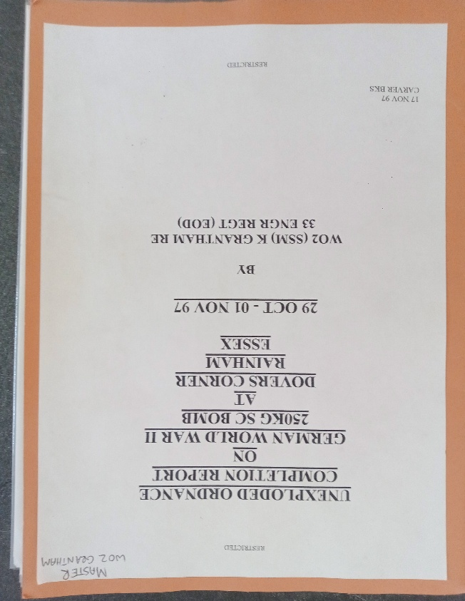
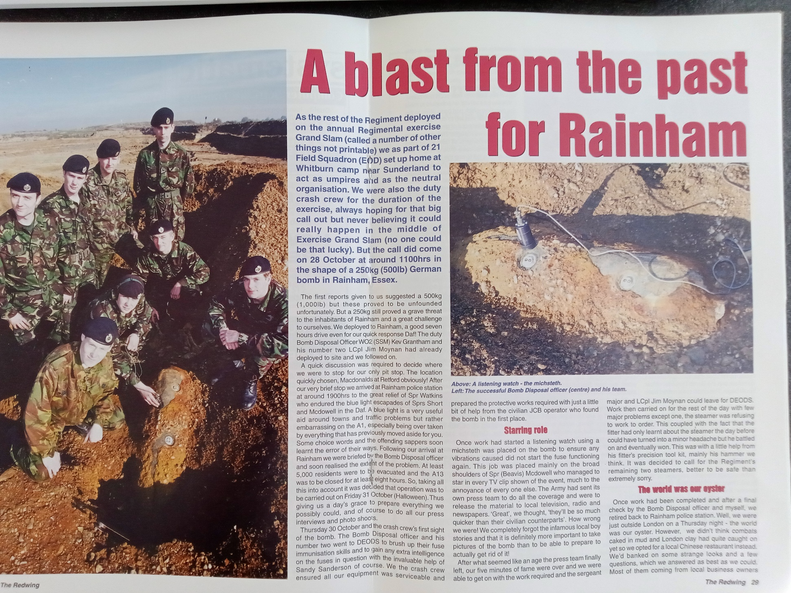
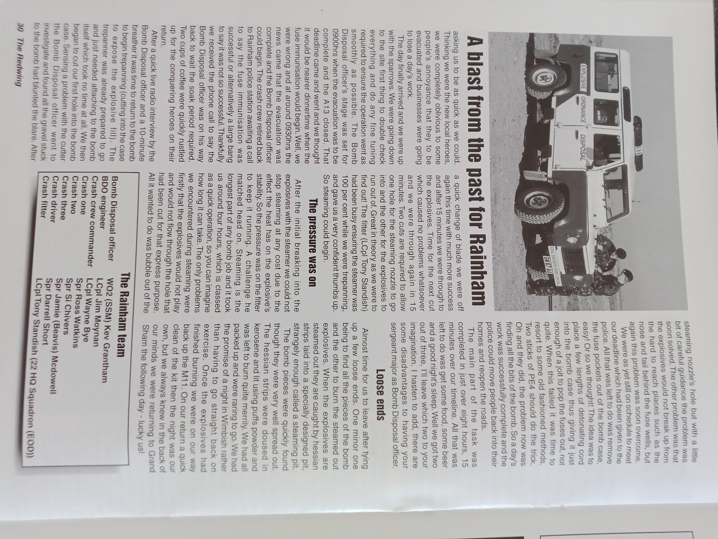
Citation for WO II SSM K Grantham QGM.
