Russian RHG-3EM Hand Grenade.
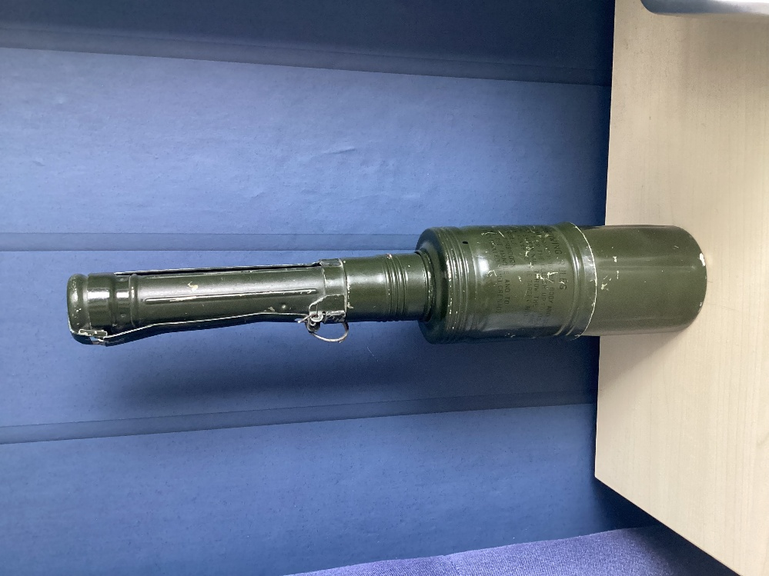 | Russian in origin.  High explosive anti-tank (HEAT), hand thrown, stabilised by a parachute. It is inertia fired on impact. It has a larger warhead and boasts of a penetration of 220mm. This version uses a copper shaped charge were as the RKG 3E has a steel shaped charge.  The hand grenade is activated by the fuze in the handle, where a strap like lever covers the base and runs up each side.  When the pin is pulled the lever falls away and when thrown a four panelled drogue chute is deployed by a spring.  This parachute stabilises the grenade in flight and ensures that it strikes the target at a 90-degree angle.

Maximising the shape charge effect.
When the parachute deploys, its ejection throws a weight to the rear of the handle and disables the safety. When it stops, inertia causes the weight to fly forward and hit the spring-loaded firing pin, this activates the primer detonator in the base.
The booster charge is then activated in the base of the shaped charge, detonating and enhancing the main charge.
The shape charge becomes inverted hitting and penetrating the armour. Lethal radius is 2 metres.
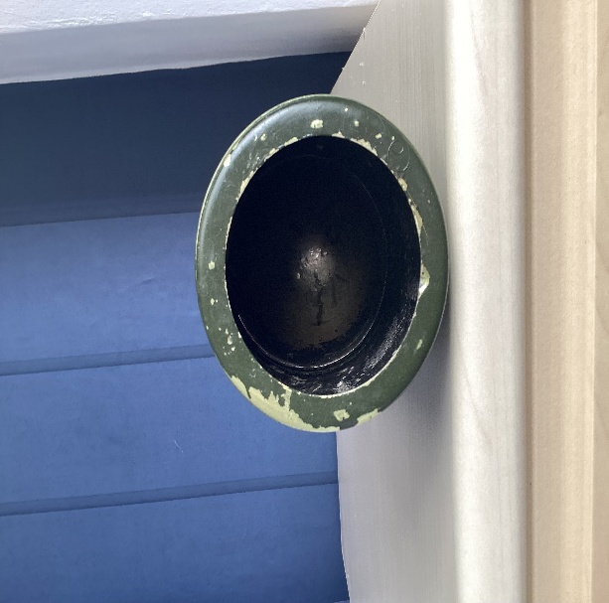 | The bottom of the shaped charge can be seen in this photo.
Left is the pin that holds the bottom of the covering cap for the handle and the two sleeves that hold it in place can be seen.  The component on the right is the handle the rod that can be seen to the front of the wrapped parachute, is the weight that fly’s forward on landing. | 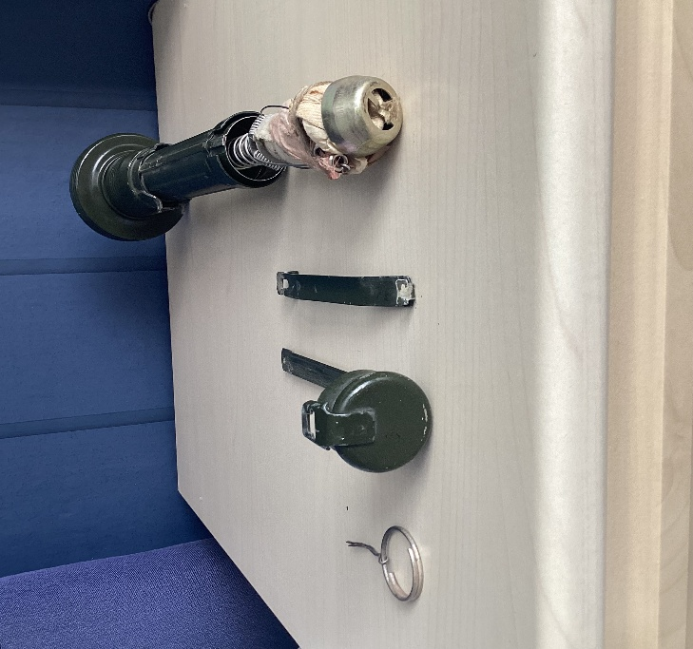
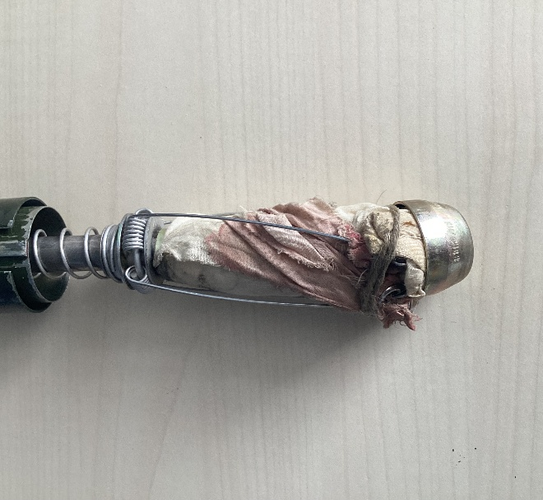 | The wrapped parachute can be seen, with two of the four wires which spring out giving it the drogue effect.

