Awards
to
Royal Engineers Bomb Disposal
and
Explosive Ordnance Disposal

-1940 to 2025 -

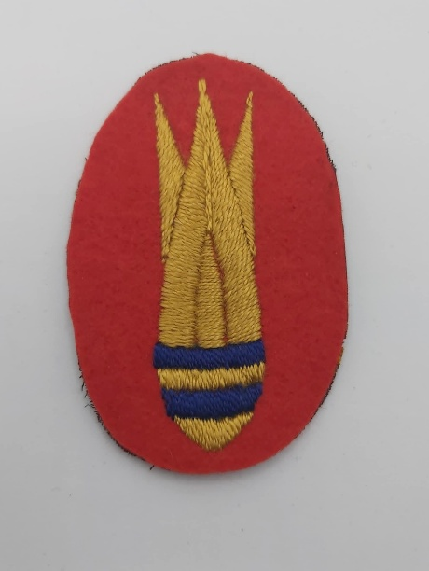

Compiled by Peter Markham

Table of Contents
Foreword – A S M Hudson-------------------------------------------------------------------------------- 4

Foreword - C Ranstead --------------------------------------------------------------------------------- 5

Introduction ---------------------------------------------------------------------------------------------- 6

Acknowledgements ------------------------------------------------------------------------------------- 9

The Royal Engineers’ Bomb Disposal Badge - the Battle Honour ------------------------------- 10

Part 1 Awards during World War II: 1940 to VJ Day ---------------------------------------------- 12

Medals for BD ----------------------------------------------------------------------------------------- --13

Empire Gallantry Medal ------------------------------------------------------------------------------ 14

George Cross ------------------------------------------------------------------------------------------- 16

Military Medal ------------------------------------------------------------------------------------------ 32

George Medal ------------------------------------------------------------------------------------------ 34

Knight Commander of the Most Excellent Order of the British Empire ---------------------- 107

Commander of the Most Excellent Order of the British Empire -------------------------------108

Officer of the Order of the Most Excellent Order of the British Empire -------------------- 110

Member of the Most Excellent Order of the British Empire ----------------------------------- 115

British Empire Medal ------------------------------------------------------------------------------- 136

Croix de Guerre ---------------------------------------------------------------------------------------171

Kings Commendation ------------------------------------------------------------------------------- -174

Part 2 Post War: V J Day to 2025 ---------------------------------------------------------------------- 181

Military Cross ---------------------------------------------------------------------------------------- 182

Distinguished Service Cross ----------------------------------------------------------------------- 186

Conspicuous Gallantry Medal ---------------------------------------------------------------------- 189

George Medal ---------------------------------------------------------------------------------------- 192

Officer of the Most Excellent Order of the British Empire ------------------------------------ 211

Member of the Most Excellent Order of the British Empire ---------------------------------- 218

Queens Gallantry Medal ---------------------------------------------------------------------------- 266

British Empire Medal ------------------------------------------------------------------------------- 293

British Empire Civilian Searchers -------------------------------------------------------------------339

King George VI Commendation for Bravery ------------------------------------------------------ 341

Queen Elizabeth II Commendation for Bravery ---------------------------------------------------- 347

King Charles VIII Commendation for Bravery ------------------------------------------------------ 348

Bomb and Mine Clearance Medal ------------------------------------------------------------------- 349

Meritorious Service Medal ---------------------------------------------------------------------------- 352

Legion of Merit Officer Class ------------------------------------------------------------------------ 353

Annex A. Other Awards and Commendations ------------------------------------------------------ 354

Annex B. Awards to BD/EOD personnel not directly serving as RE BD/EOD ----------------- 357

Annex C. Possibly Bomb Disposal/EOD - Related Awards --------------------------------------- 359

Annex D. Was BD/EOD Awarded while serving outside BD/EOD ----------------------------- 364

Index -------------------------------------------------------------------------------------------------- 366

Abbreviations --------------------------------------------------------------------------------------- 375

Sources Referenced -------------------------------------------------------------------------------- 377

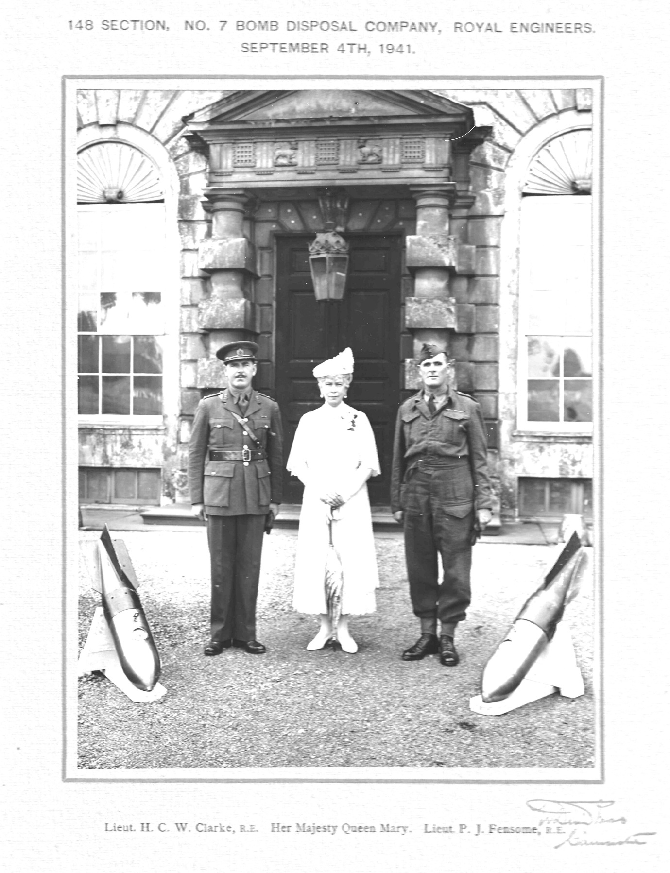
Her Majesty Queen Mary designed the Bomb Disposal Badge
Photo credit: Peter Markham’s Collection

Forward
S A M Hudson

For the first time, thanks to the tireless work of Peter Markham and the small dedicated team, information is now available in easily accessible format detailing outstanding achievements of those who served in Royal Engineers Bomb Disposal and Explosive Ordnance Disposal from their outset in 1940 to the present day.
First-hand knowledge of many of these events is fast fading into history. Often the individual who has been honoured never recounts the story of their award in later life, leaving following generations with a medal and a name, but little more. As someone who knew almost nothing of my father’s bomb disposal service in World War 2, the need to discover more required years of navigating archives and records. Now, with this comprehensive collection, that type of quest will be so much easier.
Each of the awards listed here is representative of many more similar acts of courage and dedication which went unremarked. In the earliest months of Royal Engineers Bomb Disposal in 1940-41, when knowledge was still limited and enemy fuzes were constantly evolving to be fatal to those who tried to make them safe, many actions were rightly recognised as exceptional, and awards were justly made. However, as blitzkrieg and carpet bombing reached massive proportions, similar acts, though requiring no less courage and devotion to duty, became the norm. Yet those bomb disposal pioneers would regard the IED (improvised explosive device) of more recent conflicts as a much greater challenge: entirely unpredictable; its operation is specifically designed to kill anyone who tries to make it safe, rendering every action to do so worthy of recognition.
Yet it is common for the recipients of awards to respond that they were ‘just doing a job’. I believe all those listed here would willingly view their recognition as representative of the work of all who undertook this dangerous service. This document can therefore stand as a monument to all those who served in bomb and explosive ordnance disposal, whether they received an award or not.
S A M Hudson
Author UXB Malta.

Chris Ranstead
From an archival perspective, this document ticks all the boxes. The information within has been collated from numerous sources, (that are helpfully quoted throughout), thereby bringing together pieces of the historical jigsaw and providing the reader with a broad and accurate overview of bomb disposal operations over a period of some 85 years. This covers both times of conflict, when unexploded bombs had to be urgently dealt with whatever the risk, to peacetime conditions where the priorities focused more on clearing up of the detritus of war, whilst protecting lives and property. The risk to those involved, in many cases, was indistinguishable between war and peace, as the technical mechanisms being dealt with were oblivious to a war’s end. In fact, the passage of time might create even more risks as the condition of the ordnance deteriorates and the threat changes to terrorism and Improvised Explosive Devices.
The fine level of detail and the fact that this document is in a digital format means that word searches can be performed, enabling one to find a particular incident or individual, by name, location, unit or date. The document also contains some personal details relating to some of the individuals themselves, providing some contextual background information, helping to paint a better picture in one’s mind’s eye. It also provides enough facts to act as a springboard to further avenues of research.
Altogether this is a superb research tool, useful to all manner of people, from those interested in Bomb Disposal/EOD history, to genealogist, medal collectors, to those interested in the broader processes of the British awards and honours system. In addition, to the casual reader with no previous knowledge or interest in Bomb Disposal/EOD, this document presents a multitude of gripping accounts of daring deeds of courage, duty and sacrifice that cannot fail to inspire and indeed instil a deep respect for all those involved. In fact, this document is more than just a research aid, or a collection of gripping yarns, it is a memorial that keeps the memory alive of hundreds of individuals, recognised for the courageous work performed while serving in Bomb Disposal/EOD. It perhaps also encourages the reader to consider those whose bravery may have gone unseen and unrewarded but also demand just as much respect.

Chris Ranstead.
Author and Researcher of Bomb Disposal.

Introduction

The aim of this download is to give as much detail as possible about the various awards presented to those serving in Bomb Disposal (BD) and Explosive Ordnance Disposal (EOD), be they Regulars, Territorial Army/Reserves or those Civilians employed as Searchers or Support Staff.

The research commences in the early days of 1940 and moves forward in time. It considers awards from the George Cross to the Monarchs Commendations for Brave Conduct. As Churchill noted in 1944:

The object of giving medals, stars and ribbons is to give pride and pleasure
To those who have deserved them. At the same time a distinction is
Something which everybody does not possess. If all have it is of less value.
There must, therefore, be heartburning’s and disappointment on the border
Line. A medal glitters, but it also casts a shadow.

Knowing simply that a medal was awarded to a deserving recipient represents only a tantalising glimpse into events of the past: but it hints at a tale worth telling. The shadow the award casts represents the often-gripping historical significance of those events that were judged to have fallen on the right side of ‘the border line’.

What’s included and what’s excluded
The focus of the following list is Royal Engineers Bomb Disposal and for inclusion a very specific set of criteria has been set.
- Recipients must have been serving Royal Engineers, and direct members of a BD/EOD Unit and their citations must have been written by those units. The only exception relates to BEM’s awarded to civilian workers (such as Explosive Ordnance Clearance (EOC) Searchers, working under direct RE command.)
- The award needs to be validated by reference to a citation and an entry in the London Gazette - or through other credible and reliable sources.
- Those who earned their awards whilst serving in other units, before or after their time in BD/EOD, are not included.
- Awards that cannot be substantiated by research are not included.

However, and to aid general understanding, there is an annex listing those who were awarded whilst engaged closely with BD/EOD during serving with other units or arms of the services.

How the list was compiled
The list is a living document, compiled through research over many years. Numerous sources have been used to identify and triangulate the names, awards and stories of those listed. These include works published in open sources, official RE Corps publications and mentions in the Royal Engineer Association Bomb Disposal Branches’ newsletters (some dating back to 1946). Also consulted were the EOD and Search Association and 101 EOD and Search Regimental Association, as well as thousands of Royal Engineer Service Cards and Citations held, for example, at the National Archives.

Each entry, wherever possible, includes the service number, rank and full-name. (For the more recent awards some of this detail has been redacted). Also included is the citation file number/date from the National Archives and the supplement/page number of the London Gazette entry. Other sources are listed where appropriate. If available, the citation or a description of exactly what the award was for is also included: in some cases, this level of detail was found to be disappointingly sparse. If a recipient died whilst serving, the list includes a description of how and where they died, are buried/commemorated. Where possible, a photo of their grave or memorial is also included.

What follows is not a history of BD/EOD, nor was it ever intended as such. However, as the tales of heroism, valour, sacrifice and loss unfold, and the shadow reduces, it certainly adds to our overall understanding of our history in context. Within a work of this magnitude there may well be errors: if so, they can be rectified as soon as notified.

This document only covers RE BD /EOD Awards; however, it must be remembered that the many other Units in the Corps of Royal Engineers in particularly, were heavily involved in mine clearance and received awards, here is one such example;

SOUTHALL, Robert, (8783335) Sapper, 221 Field Company, Royal Engineers,

Citation taken from file WO373/ held at the National Archives.
Placed in the London Gazette on the 28 September 1943, Supplement

On the 15 May 1943, Sapper Southall was searching with a party of sappers for mines around telegraph poles along the railway north of Enfidaville, Tunisia: A Royal Airforce other rank entered the minefield and Sapper Southall shouted at him to keep out of the field. His attention was taken off his work and he stepped onto a mine. In order to keep the mine from rising in the air and exploding he kept his foot on it. Six seconds later the mine exploded and blew his foot off. By this very gallant and self-sacrificing act he undoubtably saved the remaining sappers from becoming casualties, possibly saving their lives.

Further Information.
Sapper Southall had previously served in the Long-Range Desert Group. Despite his injuries he was able to continue to serve and obtained the rank of Captain.

Doctor Adrian Dywer MBE served with 58 EOD Squadron, Royal Engineers and Peter Markham served with 49 and 58 EOD Squadron, Royal Engineers.

Acknowledgements

This project has been ongoing for some years and much input and contributions have come from various sources and individuals, therefore apologies for any individual or Association that has been missed off, never intentional, just my bad note taking at times.

A massive thank you must go to Susan, my wife. She has put up with the many hours that I have shut myself away whilst working on this. For the encouragement and assistance, not just for this project, but through the years, Ollie Allerhead (my go-to medals man) Col Dawson, Adrian Dwyer (for having the patience to sort the formatting), Robin Bennett, Rey Fadil (been behind me all the way), Ben Hawkins, Graham Plumridge, Chris Ranstead (who’s book BD Casualties in World War II and further books, got me underway), David Southall (our Patron), Gonz Wright, many thanks to everyone for keeping me on the straight and narrow, giving advice and constructive feedback as work progressed. Couldn’t have done it without you.

There three main Royal Engineer Bomb Disposal/EOD and Search Associations that have been involved in this project and numerous topics I have delved into over the years. These are:

- The Royal Engineers Association, Bomb Disposal Branch.

- The 101 Engineer Regiment Regimental Association.

- The EOD and Search Association.

Throughout, another great source of information has been the RE Bomb Disposal EOD History Group. This group has also been used to obtain feedback as the project has moved forward.

I hope that this project is of interest to many and covers an area of research that has only been partially addressed in other publications.

Pete Markham

The Royal Engineers’ Bomb Disposal Badge - the Battle Honour

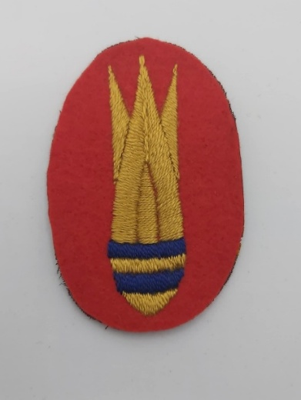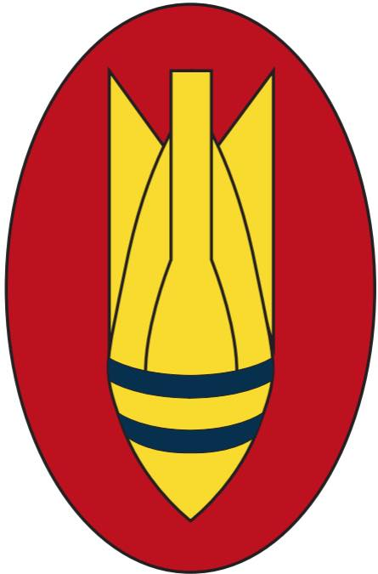
Photo credit: Julian Allerhead BEM
At the outbreak of WW2, there was no badge to identify the men of the Royal Engineers Bomb Disposal: ‘the bomb’ came into being through the interest of Queen Mary when she came across a Bomb Disposal Section unexpectedly. Her Majesty asked the driver to stop and call the NCO across. Much interested, Queen Mary asked what they had be doing and what unit they were from. When informed they were Bomb Disposal, she commented that they had no badge to identify them. On here return to Badminton House, work commenced designing a suitable BD Badge (an image of which is held by the Imperial War Museum, https://www.iwm.org.uk/collections/item/object/205474902 When complete, it was shown to the King and passed, with His Majesty’s approval to the relevant authority. Queen Mary often visited local Bomb Disposal Units and the photograph (page) records a meeting with two BD Officers: Lt. Clark and Lt. Fensome.
Because of its origins, the original BD Badge is regarded widely as a Battle Honour - rather than simply a trade patch. Army Council Instructions stated it was to be issued to BD Personnel to indicate the dangerous work on which they were employed. At around the same time Bomb Disposal vehicles had their wings and mudguards painted red so they could be easily recognised and waved through to incidents. The Army’s new BD Badge was made public on the 4 December1940; initially only to be worn by Royal Engineers BD Personnel. However, this changed in 1941 when the members of the Non-Combatant Corps, serving with BD Units were permitted to wear the it in recognition of the common dangers they faced when attached to BD Sections.

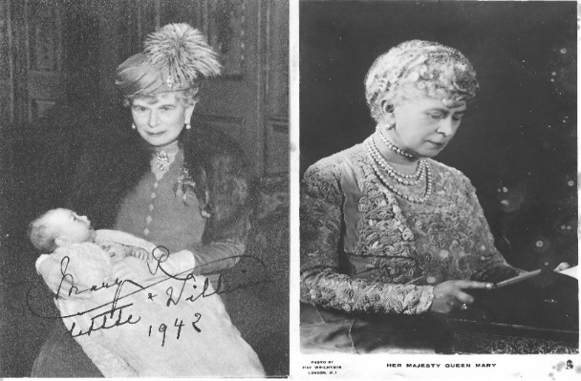
Two photographs enclosed within a letter sent by Queen Mary to Lt H C W Clarke, 148 BD Section, 7 BD Company
Peter Markham Collection

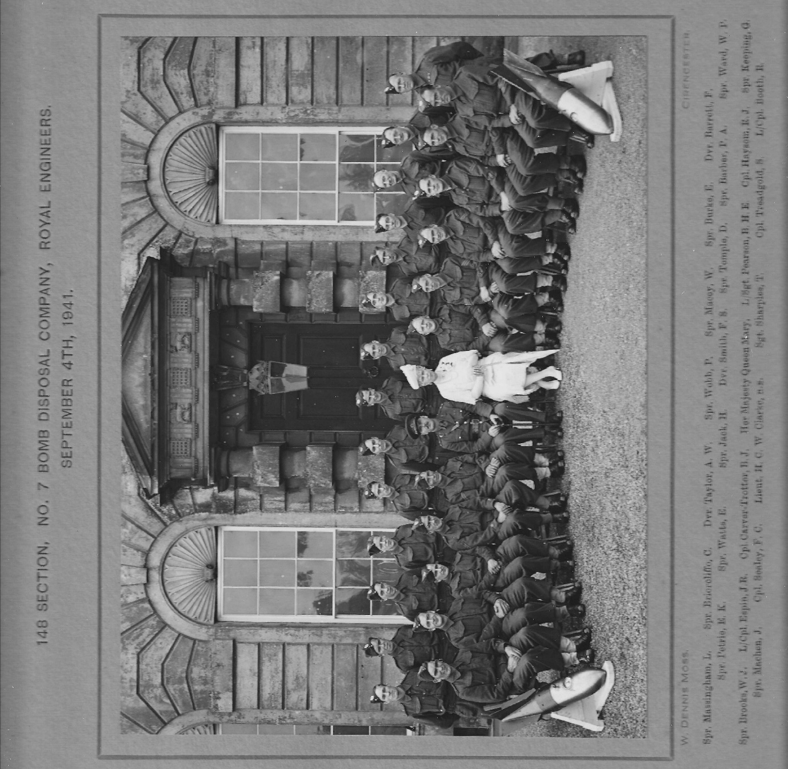
Her Majesty Queen Mary at Badminton House, with 148 Bomb Disposal Section, 7 Bomb Disposal Company
Peter Markham Collection

Part 1 Awards during World War II: 1940 to VJ Day

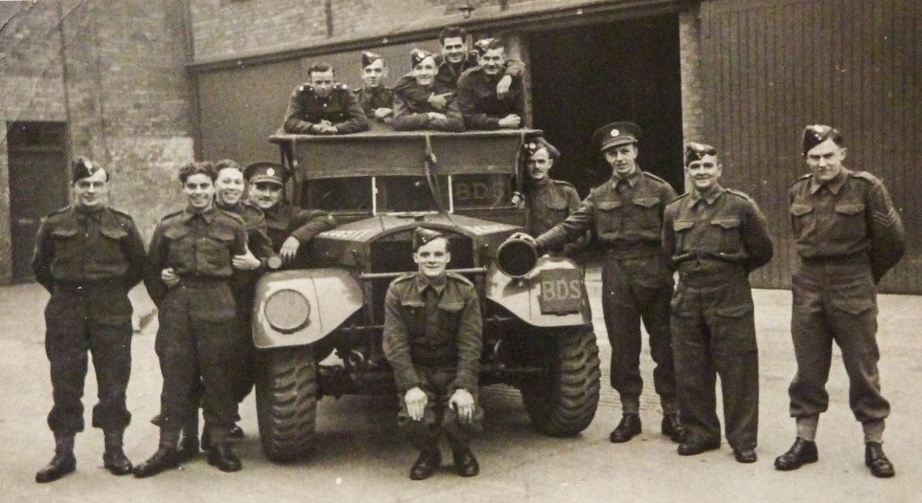

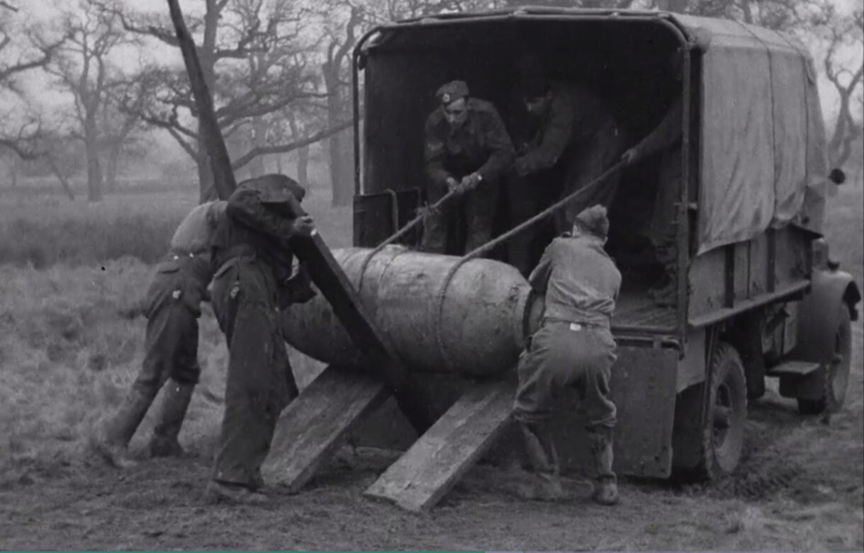

Photos from Historic Military Vehicle Forum <Forums - HMVF - Historic Military Vehicles Forum>

Medals for BD
In reviewing the following awards, it is worth considering the work of BD Sections as commented upon by Churchill. He noted that:

The Unexploded Bomb Detachments presented themselves wherever I went
on my tours. Very quickly, but at heavy sacrifice of our noblest the devotion
of the UXB Squads mastered the peril. Somehow or other their faces seemed
different from those of ordinary men, however brave and faithful. They were gaunt, they were haggard, their faces had a bluish look, with bright gleaming
eyes and exceptional compression of the lips; all without the perfect
demeanour. In writing of our hard times, we are apt to overuse the word
“grim”. It should have been reserved for the UXB Disposal Teams.

That ‘heavy sacrifice’ was recognised widely and, as is set out below, publicly honoured with medals: from the Empire Gallantry medal through to the George Cross. However, because BD activities were not regarded as actions ‘in the face of the enemy’ (something those labouring to deal with delay action bombs and booby traps - often as the Blitz ragged above – must have regarded as somewhat harsh) there could be no Victoria Crosses. Many great feats of heroic endeavour also went unrecognised completely. As Churchill went on the comment later in the war, medals issued freely are ‘of less value. There must, therefore, be heartburning’s and disappointments on the border line.’ What follows is therefore a record only of those events judged to have fallen on the ‘right’ side of that subjectively-drawn line.
Peter Markham served with 49 and 58 EOD Squadron, Royal Engineers.

The Empire Gallantry Medal.
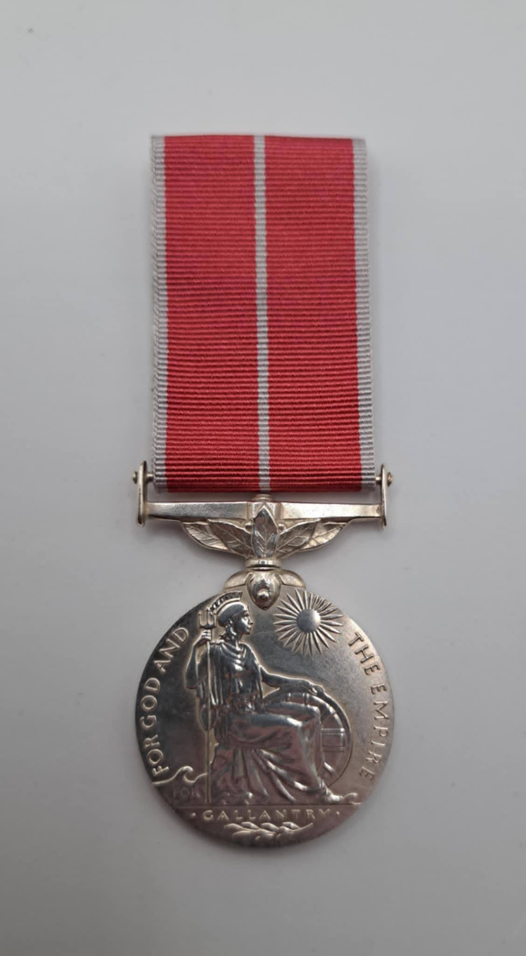

Photo Credit: Julian Allerhead BEM

In 1922, the original Medal of the Order of the British Empire was discontinued and replaced by two separate awards:
- The Medal of the Order of the British Empire for Gallantry (EGM), and
- The Medal of the Order of the British Empire for Meritorious Service, known as the British Empire Medal.

The EGM had been ranked after the Sea Gallantry Medal, Albert Medal, and Edward Medal in order of wear but was superseded by the George Cross in 1940.

On 24 September 1940 King George VI created the George Cross, to rank immediately after the Victoria Cross, to recognise gallantry not in the presence of the enemy. The EGM ceased the same day. In April 1941, it was announced that, except for honorary recipients, all living recipients and the next-of-kin of those posthumously awarded the EGM after 3 September 1939, were to change their insignia for the George Cross.

The original ribbon was plain purple with the addition of a thin vertical red stripe for military awards. A silver laurel branch was added diagonally to the ribbon for both types of award in 1933, and was worn on the ribbon bar when ribbons alone were worn. The ribbon changed to rose pink with pearly grey edges in July 1937.

The Royal Engineer Bomb Disposal teams were awarded 4 Empire Gallantry Medals, these being Second Lieutenant Andrews, Lance Sergeant Button, Lieutenant Reynolds and Second Lieutenant Talbot. Under the terms of the Warrant for the George Cross. All four of these Empire Gallantry Medals were exchanged for the George Cross.

George Cross

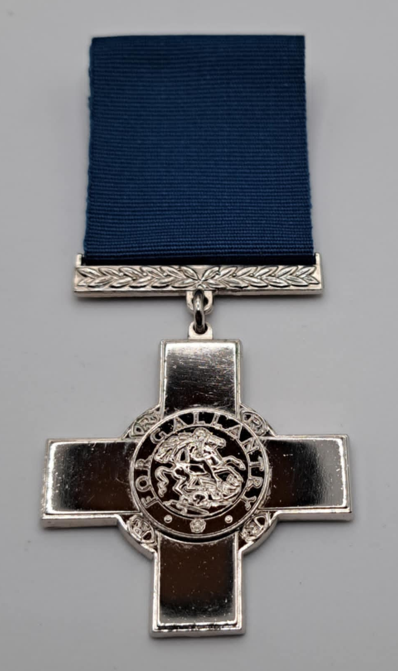

Photo credit: Julian Allerhead BEM

The George Cross was instituted on 24 September 1940 by King George VI. At this time, during the blitz, there was a strong desire to reward the many acts of civilian courage. The existing awards open to civilians were not judged suitable to meet the new situation. It was therefore decided that the George Cross and the George Medal would be instituted to recognise both civilian gallantry in the face of enemy action and brave deeds more generally.

The medal was designed by Percy Metcalfe. The Warrant for the GC (along with that for the GM), dated 24 September 1940, was published in the London Gazette on 31 January 1941.

The GC replace the Empire Gallantry Medal (EGM); all holders of the EGM were instructed to exchange their medals for a GC: this was a substitution of awards unprecedented in the history of British Decorations.

The Royal Engineers Bomb Disposal teams were awarded 12 George Crosses, five of the recipients died during the War period.

ANDREWS, Wallace Launcelot (115829) Second Lieutenant GC, Royal Engineers.

No file could be found at National Archives.
Placed in the London Gazette on the 17th September 1940. Supplement 34947. Page 5537/5538

Citation taken directly from his London Gazette entry.

On the 26 August, 1940, Second Lieutenant Andrews was in charge of No 22 and 23 Bomb Disposal Sections, Royal Engineers. Whilst trying to extract the fuse of a bomb in order to forward it to the Department of Scientific Research, some difficulty was experienced. After withdrawing it about 1 1/2 inches the fuze dropped back into position actuated by what appeared to be magnetism or a spring. Removal was attempted several times without success. Second Lieutenant Andrews then placed his section under cover, and after tying a piece of cord to the ring of the fuze discharger pulled, with the result that the bomb exploded. He was blown a considerable distance, and two of the men received splinter wound. Throughout Second Lieutenant Andrews displayed great coolness and keenness in the interests of the service.

Originally for this action, Second Lieutenant W.A. Andrews was awarded the Medal of the Military Division of the Most Excellent Order of the British Empire for Gallantry, (EGM) which later was exchanged for the George Cross. He also received the Defence Medal 1939–1945.

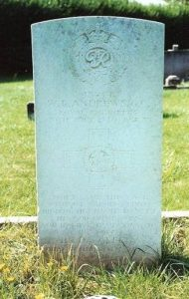 | On the 30th of July 1944, the now Major Andrews died of a heart attack, whilst training, using diving breathing apparatus on the River Ure, while Chief Instructor Bomb Disposal, School of Military Engineering, Ripon. Just two weeks before his promotion to Colonel. Major (the rank held when he died) W A Andrews, George Cross, is buried at Saint Mary’s Cemetery, Taunton, Grave 2/4242.  His medals including the George Cross were donated by his widow to the Royal Engineers Museum.  Photo credit: Dave Blyth

ARCHER, Bertram Stuart Trevelyan GC OBE, ERD, FRIBA (126305). Acting Lieutenant, 104 Bomb Disposal Section, Royal Engineers.

03 February 1915 to 2 May 2015.

The Citation is taken from file WO373/66/1346 held at the National Archives.

Placed in London Gazette on the 30th September 1941. Supplement 35292. Page 5653.

Lieutenant Archer has been employed on bomb disposal work since June 1940 and has dealt with some two hundred bombs, in addition to a number of incidents mentioned below. He provided the War Office with the numbers 17, 25, 26, 38 and 50 fuzes and Zus anti-handling device for experiments, at a time when little was known about the nature of German fuzes.

On 15 July 1940 four 250-kilogram bombs were dropped on St. Athan aerodrome, South Wales, two of them within ten yards of some vitally important assembly shed. Lieutenant Archer immediately went to the scene and the first bomb was excavated. As its fuze, was expected to be a booby trap, it was loaded, with the fuze still in, on to a lorry; Lieutenant Archer himself drove the lorry to a site some two miles away and the bomb was detonated. The other bomb was dealt with in the same way.

On the 17 August 1940, at Moulton, South Wales, a 250-kilogram bomb was excavated down to the fuze pocket, which contained a number 50 fuze. As this fuze required for War Office experiments, an attempt was made to extract it by means of a cord, and, when this failed, Lieutenant Archer removed it by hand by means of a pick head; although well aware that the fuze might be a booby trap.

On the 27 August 1940, at Port Talbot Docks, this officer was instrumental in recover the first No. 38 fuze for experimental purposes.

On the 2 September 1940, a vast fire was started in six oil tanks after a heavy raid on the National Oil Refineries at Skewen, near Swansea. There were unexploded bombs in and around the oil tank farm and Lieutenant Archer and his party went to work some eight hours after the raid. In spite of the fact that three bombs exploded, he and his men remained working. One 250 kilogram had fallen two feet from the side of an oil tank and when uncovered was found to contain a number 17 fuze, which was ticking. Lieutenant Archer was able to remove the filler cap, scrape away the explosive and remove the whole fuze pocket, which had sheared. As the fuze was required for experiment, he removed it by hand from the exploder tube and found inside a Zus anti-handling device which had not functioned, and this too he removed by hand. This was apparently the first Zus to be successfully extricated.

In addition to the above incidents. Lieutenant Archer has on three occasions driven lorry’s containing bombs with number 17 fuzes in order to remove them from sites.

The Inspector of Fortifications and Director of Bomb Disposal, states that the fact that Lieutenant Archer has enjoyed much remarkable immunity from death in no what detracts from his record of deliberate and sustained courage, coupled with devotion to duty of the highest order.

Further Information
He served as a Lieutenant with 104 Bomb Disposal Section, Captain with 6 Bomb Disposal Company, OC 12 Bomb Disposal Company, retired from the forces in 1945. Rejoined Army Emergency Reserve in 1950, with 137 AER Regiment in 1951, 1953 CO of 142 Bomb Disposal Regiment.

List of Awards. OBE 1961, Defence Medal 1939 – 1945, War Medal 1939 – 1945, GSM Bomb and Mine Clearance 1945 – 1949, Coronation Medal 1953, Jubilee Medal 1977, Golden Jubilee Medal 2002, Diamond Jubilee Medal 2012, Army Emergency Reserve Decoration with three clasps.

Lieutenant Colonel BS Archer died aged 100.

BAREFOOT, Herbert John Leslie GC A.R.I.B.A, Acting Captain, Bomb Disposal Royal Engineers.

15th May 1887 to 23rd December 1958

The Citation is taken from file WO373/66/341 held at the National Archives.
Placed in the London Gazette on the 22nd January 1941. Supplement 35050. Page 461.

Captain Barefoot was a pioneer of bomb disposal. He dealt with the first unexploded bombs which fell in this country, and by his disregard of personal safety very valuable information was obtained. He has experimented with all types of bombs. With a Naval, officer he worked on the first suspended parachute magnetic mine. For two hours he clung to the mine to secure it in a safe position. At the time of this act, the bomb disposal authorities had very little knowledge of the mechanism of these mines and much was learned at this stage. When necessary, he has ignored the safety period, especially when clearing an important railway line. His bravery and devotion to duty, has done much to maintain a high standard of courage in his Company.

Further Information
He was also awarded the British War Medal, Victory Medal with Oak Leaf, Defence Medal and War Medal for his service, and later the 1953 Coronation Medal.

Interestingly Barefoot also served in WW 1 in both the RNVR and the Sanitary Company of the RAMC.

BLANEY, Michael Flood GC Posthumous Award, (119978) Acting Captain, Bomb Disposal, Royal Engineers.

19th November 1910 to 13th December 1940.

The Citation is taken from file WO373/66/859 held at the National Archives.
Placed in the London Gazette 15th April 1941. Supplement 35136. Page2177.

The work performed by Captain Blaney and the many acts of heroism to his credit is a continual story of gallantry and outstanding bravery and devotion to duty. He was the finest type of Bomb Disposal Officer, combining the highest personal courage with the greatest possible regard for the safety of others.

He was responsible for the adaption of the policy of removing bombs wherever practicable in preference to blowing them up where they sat, by this means saving hundreds of people anxiety and loss of valuable property. He always personally insisted on removing a fuse unaccompanied.

Further Information
After the War, a road nearby to where he lost his life was named after him.
Acting Captain M F Blaney is buried at Newry Old Chapel, RC Cemetery, Old Ground.

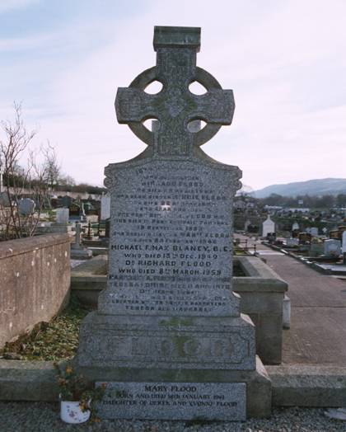 | On 5th December 1940, an unexploded bomb fell in the premises immediately abutting the main London-Chelmsford Road (Romford Road Manor Park). On the 13th December 1940, in view of the serious dislocation of important traffic, Captain Blaney proceeded to attempt to remove the fuze (one time fuze). The alternative method of sterilizing the bomb was not at the time available and at great personal risk, and with full knowledge of the grave danger, he personally entered the crater to carry out the process. Unfortunately, the bomb exploded and Captain Blaney lost his life.

BUTTON, William John GC, (737038) Lance Sergeant, 48 Bomb Disposal Section, Royal Engineers.

1904 to 10th March 1969.

No file found on the National Archives.
Placed in the London Gazette 17th September 1940. Supplement 34947. Page 5538.

Citation taken directly from his London Gazette entry

On the morning of the 18th August 1940, Lance Sergeant Button was ordered with his Section to continue the work of excavating an unexploded bomb. Although he knew full well that, owing to the time already spent on the excavation the bomb was liable to explode at any moment, he continued the work of his section with great coolness. The bomb eventually exploded, killing five sappers of the Section, and throwing Lance Sergeant Button a considerable distance. Although considerably shaken he behaved with great coolness, collected the rest of his Section at a safe distance, ascertained that none of them were injured, notified the First Aid Detachment, and reported to his Section Officer by telephone.

Further Information
Originally for this action, Lance Sergeant W. J. Button was awarded the Medal of the Military Division of the Most Excellent Order of the British Empire for Gallantry, (EGM) Empire Gallantry which later was exchanged for the George Cross.

CAMPBELL, Alexander Fraser GC, (135004) Second Lieutenant, 68 Bomb Disposal Section, 9 Bomb Disposal Company, Royal Engineers.

2nd May 1898 to 18th October 1940

The Citation is taken from file WO373/66/682 held at the National Archives.
Placed in the London Gazette on the 22nd of January 1941. Supplement 35050. Page 461.

Second Lieutenant Campbell was engaged with his Section on the removal of a 250 Kilogram unexploded bomb at the Triumph Engineering Company’s Works, Coventry, situated in the centre of the city. This bomb had caused cessation of war production in two factories involving some 1,000 workers and the evacuation of a number of residents. For this reason, Second Lieutenant Campbell worked practically without rest for nearly 48 hours until the bomb was removed. On Thursday 17 October, the bomb was finally exposed and examined by 2/Lieutenant Campbell; it was fitted with a delayed-action fuse which it was impossible to remove. He decided to remove it to a safe place for destruction.

Recognising the extreme danger involved he removed the bomb by lorry for a distance of approximately a mile, himself laying alongside the bomb listening for action by the clock mechanism. The bomb was safely disposed of.

He was thoroughly experienced in the work of bomb disposal and knew exactly the risks he was taking. In view of all the circumstances, his instant decision to act as described and complete lack of consideration for his personal safety constitutes an act of gallantry of the highest degree and I strongly recommend an immediate award fitting to the act.

It was with the deepest regret that this Officer was killed the following day (18 October) whilst dealing with another bomb.

Further Information
His other service awards were 1914/15 Star, British War Medal, Victory Medal, Defence Medal and War Medal 1939/45.

As noted, Second Lieutenant Campbell, Sergeant M. Gibson, Sappers W. Gibson, R. Gilchrest, J. Plumb, and R. W. Skelton were all killed the next day, 18 October 1940. In 2006 a memorial plaque at Whitely Common, Coventry was dedicated to the Remembrance of these brave men by the local Historical Society.

The original tasking to this 250kg bomb was on 14 October 1940, at Chapel Street, Coventry. After nearly 4 days it was uncovered, it was fitted with standard fuzes, so badly damaged that they could not be removed. After this period the electrical charge was thought to have dissipated; but, 2 Lt Campbell applied a discharge tool just in case. On the 18 October 1942, 2 Lt Campbell believed the bomb was inert and could be moved. It was loaded onto a lorry and taken to a safe place (Whitley Common). As it was being unloaded it exploded killing all.2 Lt A F Campbell is buried alongside his Section at London Road Cemetery, Coventry, Square 348, Collective Grave 46. Photo credit: Colin Norburn.

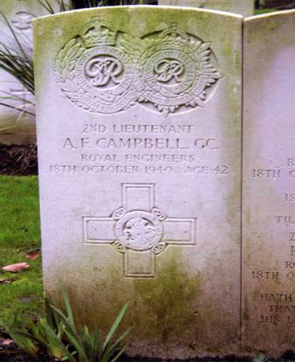

DAVIES, Robert John GC, Second Lieutenant, Bomb Disposal, Royal Engineers.

3rd October 1900 to 27th September 1957.

No file found on the National Archives
Placed in the London Gazette on the 30th of September 1940. Supplement 34956. Page 5767/8.
Citation taken directly from the London Gazette entry.

Lieutenant Davies was the Officer in Charge of the party detailed to recover the bomb which fell in the vicinity of St Paul’s Cathedral. So conscious was this officer of the imminent danger to the Cathedral that regardless of personal risk he spared neither himself nor his men, in their efforts to locate the bomb. After unremitting effort during which all ranks knew that an explosion might occur at any moment, the bomb was successfully extricated
In order to shield his men from further danger, Lieutenant Davies himself drove the vehicle in which the bomb was removed and personally carried out its disposal.

Further Information
Sapper G.W. Wylie was also awarded the George Cross, Sergeant J. W. Wilson and Lance Corporal H Leigh were awarded the British Empire Medal for this incident. See separate entries.

Lieutenant R J Davies two years after the award of his George Cross, was convicted of improperly receiving money from Messrs Charrington and Co, sentenced to two years imprisonment. He emigrated to Australia in 1950 with his second wife and daughter followed in 1951.

His George Cross, Defence Medal 1939-1945 and War Medal 1939-1945 are held by Lord Ashcroft and were displayed in the Imperial War Museum.

Both Davies and Wylie’s George Crosses were brought together for a service in St Pauls to mark the 75 Anniversary of the formation of Royal Engineers Bomb Disposal.

GIBSON, Michael GC, (4445289) Sergeant, 68 Bomb Disposal Section, 9 Bomb Disposal Company, Royal Engineers.

The Citation is taken from file WO373/66/689 held at the Nation Archives.
Placed in the London Gazette on 21st January 1941. Supplement 35050. Page 461.

On 14th September, 1940, a large unexploded bomb fell in an important factory. Excavation supervised by Sergeant Gibson was begun, during which time another bomb which had dropped nearby exploded. Despite the knowledge that the bomb on which he was engaged was of a similar type the Non-Commissioned Officer persevered and eventually, the bomb was uncovered. On uncovering it an unusual hissing noise was heard coming from the bomb, whereupon Sergeant Gibson sent his men away and immediately set to work on the fuse. This he extracted safely and the bomb was eventually removed. His prompt and courageous action saved a very dangerous situation.

Further Information
Initial citation, recommended the Immediate Award of the Military Medal by Colonel L.G. Trench. D.S.O. C.M.G Commanding Birmingham and South Staffs Sub-Area on the 07 January 1940. However, this was amended to the George Cross.

On the 14 October 1940 at Chapel Street, Coventry the Section were tasked to deal with a 250 kg unexploded bomb. After nearly 4 days it was uncovered, it was fitted with standard fuzes, these were so badly damaged that they could not be removed. The electrical charge was thought to have dissipated by now. Just in case 2 Lt Campbell applied a discharge tool just in case. On the 18 October 1942, Lt Campbell believed the bomb was inert and could be moved. It was loaded onto a lorry and taken to a safe place, Whitley Common. As it was being unloaded it exploded killing all. Sergeant M Gibson is buried alongside his Section at London Road Cemetery, Coventry, Square 348, Collective Grave 46. Photo credit: Colin Norburn.

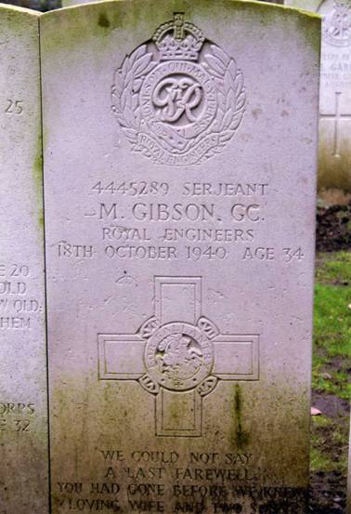

Second Lieutenant BST Archer, GC. | 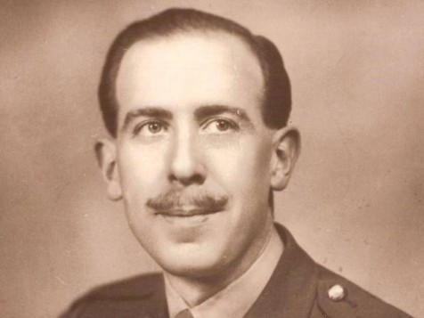
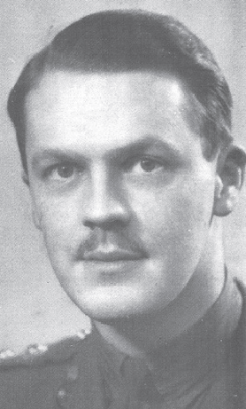 | Lieutenant E W Reynolds, GC.  Photo taken from Edward Womersley REYNOLDS GC
Sapper G C Wylie, GC.  Photo taken from https://www.mystiwot.nl/myst/upload/persons/%7B459955CD-5F6A-45AF-9D3D-6BB0CBE58514%7D_wylie_00247g.jpg | 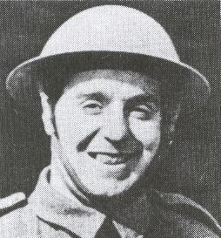

Three George Cross Recipients.

MARTIN, Cyril Arthur Joseph GC, Lieutenant, Bomb Disposal, Royal Engineers.

23 July 1897 to 29 November 1973

No file located at the National Archives.
Placed in the London Gazette on the 9 March 1943. Supplement 35934. Page 1175.

During the air attack on the night 17/18 January, 1943, a large calibre bomb fell in the warehouse of the Victoria Haulage Company at Battersea and after tearing its way through the roof girders, machines and packing cases came to rest unexploded immediately beneath the bed plate of a very large lathe. Owing to the fact that the warehouse was full of new and heavy machine tools from the USA the Ministry of supply applied to the Regional Commissioner for Category A 1. This was granted and on the morning of 18 January, 1943 a work party began disposal operations. During the day 18 January another A 1 Category bomb had been found to contain an entirely new type of fuze which on examination during the night 18/19 January, was found to embody characteristics which indicated it not only to be more formidable as an anti-handling and booby trap than any other so far met, but to be proof against any technique of equipment. On the same night the bomb at Battersea was identified as a 500 kg with two fuzes and the casing so distorted as to render their removal impossible, and on further examination one of the fuzes was found to be of the new type. This necessitated shutting down the machinery of a large flourmill next door to the Victoria Haulage Company, owing to the excessive vibration, and work on the bomb was temporarily suspended. In view of the urgent necessity of getting the flour mill to work again and for removing the treat to machinery of the upmost importance to the war effort, it was decided to attempt to remove the base plate of the bomb and extract the main explosive filling. Major Martin, who was a fully aware of the extremely formidable characteristics of the new fuze, undertook the task and was assisted by Lieutenant Deans on the 20 January, succeeded in removing the base plate only to find the bomb contained solid cast TNT, which could only be removed by the application of high temperature steam. It was considered that the risk of detonating the bomb would be too great if the normal steaming out process was used by remote control owing to the very high temperatures generated and the excessive force of the steam jet, the effect of which on a possible loosened fuze pocket could not be foreseen. It was decided, therefore, that the only way was to apply the steam nozzle by hand, and only long enough at a time to soften the TNT sufficiently to allow it to be scraped away in small quantities. This not only entailed further excavation to make working space and supporting the bomb in such a way that it could not slip or be moved, but also involved two men being constantly in the bomb pit to manipulate the steam and cooling water pipes and to scrape away the softened explosive. This extremely hazardous work was undertaken by Major Martin who assisted by Lieutenant Deans, worked continuously from the afternoon of Wednesday, 20 January, through the night till 8.30 am on the 21 January, by which time they had succeeded in removing the entire main filling cast of TNT from the bomb. The work was carried out in a cramped hole filled with steam and water in which they had to lie alongside the bomb for nearly 24 hours, during which time both officers had every reason to believe they were in extreme danger. Throughout the long and hazardous operation Major Martin displayed cold blooded courage and tenacity of purpose with complete disregard for the appalling risks involved.

Another 500 kg bomb fell on the night of 17/18 January, 1943, and came to rest 8 to 10 feet under the road surface in a side street adjacent to the Old Kent Road. This was subsequently found to contain one of the new type fuzes. On Tuesday, 2 February, 1943, Major Martin, using newly developed technique and apparatus attempted to withdraw the fuze. The fuze was stuck fast and on force being applied the head of the fuze broke off leaving the body inside the fuse pocket. In order to avoid attempting to remove the bomb through the streets in a potentially dangerous condition and to try out for experimental purposes a method of rendering the damaged fuze safe, Major Martin undertook the task of operating on the fuze with improvised apparatus and tools and was fully aware of the great danger involved. The successful completion of the operation called for the utmost care, cool courage and dogged perseverance under conditions of great physical and mental strain over a long period.

On Thursday, 4 February, 1943, Major Martin was superintending the use of newly developed apparatus on another 500 kg unexploded bomb containing one of the new type of fuzes. The bomb was lying at the bottom of a deep and badly ventilated shaft underneath a house. The process had reached a critical stage, and an officer under instruction of Major Martin was at the bottom making final preparations when he found his clothing to be on fire and flames coming from the apparatus on the bomb. The officer managed to climb the ladder which was now also on fire and give warning Major Martin, assisted by another officer, put out the flames and dispatched the officer to hospital. The cause of the fire was unknown but was thought to be connected with certain chemicals used in the new process. Notwithstanding this Major Martin went to the bottom of the shaft and continued to work until the fuze had been successfully dealt with. As he did not know the actual cause of the fire and realised the probability of a recurrence with grave risk of subsequent detonation, to continue this operation called for courage and endurance of a very high order.

Since the night of 17/18 January, 1943, Major Martin, has rendered invaluable assistance by carrying out trials of newly developed apparatus on eight bombs found to contain fuzes of the new type so far with complete success, but in all cases the element of grave personnel risk has been high, calling for sustained courage and tenacity of purpose over long periods at a time. Major Martin has been intimately concerned on Bomb Disposal operations in the London Area since September, 1940. During the heavy raids of 1940/1941 he personally dealt with a large number of unexploded bombs many of which were of the delayed action type. His contribution to the technical development of Bomb Disposal technique have been valuable and at all times he has displayed the same cool deliberate courage with complete disregard for personnel danger.

Further Information
He was also awarded the Military Cross 1918, British War Medal 1914-1920, Victory Medal 1914-1920, Defence Medal 1939-1945, War Medal 1939-1945, Coronation Medal 1953. Bomb Disposal School, SME, Ripon, Demob in 1945.

REYNOLDS, Edward Womersley GC, Lieutenant, 101 AND 102 Bomb Disposal Sections, Royal Engineers.

27th June 1917 to 16th December 1957

No file located at the National Archives.
Placed in the London Gazette on the 17th of September 1940. Supplement 34947. Page 5537.
Initially awarded the Medal of the Military Division of the Most Excellent Order of the British Empire Medal, (EGM). Empire Gallantry Medal.

Citation taken directly from the London Gazette entry.

On the 17th August 1940, a 250-kilo bomb fell in a garden amongst some council houses; it did not explode and Lieutenant Reynolds was sent to investigate. On digging down 17 ft, he found that it had a new type of fuze about which no instructions had at that time been received. Finding that traffic was suspended on the road and that the inhabitants had had to be cleared out of their houses, he removed the fuze and found that it had a clockwork delayed action. The risk that he took was great, and merit of his action was the greater for lack of exact knowledge of the type of fuse he was dealing with.

On the 3rd September 1940. - A large bomb fell in a street just before midnight on September 1940: it wrecked the front of some business premises and was supposed to have exploded. About 16.30 hours on the 3 September, a 250-kilo unexploded bomb was found in the debris. Lieutenant Reynolds was at once summoned, found that it had a clockwork fuse which was still ticking and according to orders applied to Regional H.Q. for instructions suggesting that the sooner it was dealt with the better, and stating that he was willing to do so forthwith. In view of the damage to property that would have been caused by the explosion of such a large bomb in such a congested area and especially of the possible effect on the public morale, permission was given and Lieutenant Reynold immediately extracted the fuse and rendered the bomb inoperative. The risk in doing this was very considerable.
Further Information
Originally, for this action Lieutenant E. W. Reynolds was awarded the Empire Gallantry Medal (EGM) exchanged later for the George Cross. Lieutenant Reynolds was also awarded the Burma Star, Defence Medal 1939-45 and the War Medal 1939-45. Coronation Medal 1953.

TALBOT, Ellis Edward Arthur Chetwynd GC OBE, 103 Bomb Disposal Section, Royal Engineers.
22nd March 1920 to 9th October 1941.

No file found on the National Archives.
Placed in the London Gazette on the 17th September 1940. Supplement 34947. Page 5537.

Citation taken directly from his London Gazette entry

2nd Lieutenant Talbot after being present for the whole time (12 ½ hours) taken to dig down to an unexploded bomb, diagnosed, on the bomb being brought to the surface, that it was of the delay action type and ordered his men to a safe distance while he examined it.

As the bomb appeared to be of a new type, Lieutenant Talbot decided to remove it to a place where it could do no damage if it exploded. Still keeping his men under cover, he carried the bomb on his shoulder for some 200 yards and placed it in a safe spot. From the start of the work there was a risk of the bomb going off and Lieutenant Talbot set a fine example of courage and devotion to duty.

Further information
Originally, for this action 2nd Lieutenant Talbot was awarded the Empire Gallantry Medal (EGM) exchanged later for the George Cross.

Lt Talbot was also awarded the MBE in May 1941 for Bomb Disposal work in Malta.
Also awarded the 1939-45 Star, Africa Star, War Medal 1939-45.

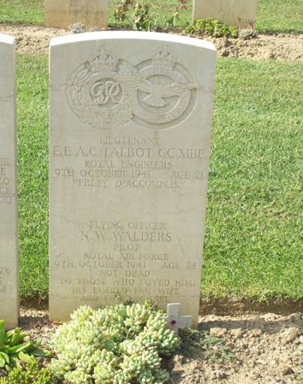 | Second Lieutenant Acting Lieutenant Ellis Edward Arthur Chetwynd Talbot, was after a rest period made a Liaison Officer to the RAF, through the Governor of Malta, as he was concerned that Lt Talbot would come to harm on his Bomb Disposal duties. He died whilst assigned to the RAF, on a shipping sweep.  He is buried at Catania War Cemetery, Italy. Grave 1 H 19 with the other crew members. A fitting tribute is that his headstone has both the Royal Engineers and the RAF badges inscribed upon it.  Photo credit: Richard Brown.
WYLIE, George Cameron GC, (1942531) Sapper, Bomb Disposal, Royal Engineers.
25th December 1908 to 1 February 1987

No file found on the National Archives.
Placed in the London Gazette on 30 September 1940. Supplement 34956. Page 5767

Sapper Wylie was a member of the Bomb Disposal Section engaged upon the recovery of the bomb which fell in the neighbourhood of St Pauls Cathedral.

The actual discovery and removal of the bomb fell to him. Sapper Wylie’s untiring energy, courage, and disregard for danger were an outstanding example to his comrades

Further information
Due to its weight and the soft soil, the job of removing the bomb from the ground was an arduous task, which took three days. The task was made that bit more hazardous by a broken gas main, on fire, being nearby.

Lieutenant R Davies was also awarded the George Cross, Sergeant J. W. Wilson and Lance Corporal H Leigh were awarded the British Empire Medal for this incident. (See separate entries.) His George Cross was later put up for auction. Businesses around St Pauls pulled together and brought the medal, which is now in the custody of St Pauls.
Both Davies and Wylie’s George Crosses were brought together for a service in St Pauls to mark the 75 Anniversary of the formation of Royal Engineers Bomb Disposal.

The Military Medal.

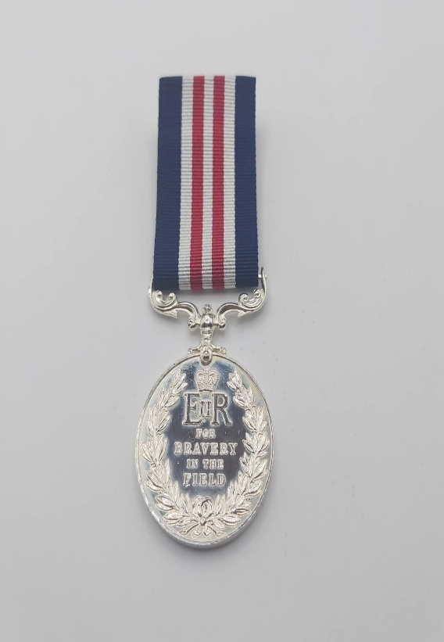

Photo taken by Julian Allerhead BEM.

The Military Medal (MM) was established on 25 March 1916, with retrospective application to 1914, for Acts of Gallantry and Devotion to Duty Under Fire. It was awarded to other ranks including Non-Commissioned Officers and Warrant Officer’s and ranked below the Distinguished Conduct Medal.

The Royal Engineers Bomb Disposal teams were awarded 1 Military Medal, during the War period.

CROOKES, John MM, (789725) Sergeant, 5 Bomb Disposal Company, Royal Engineers

The Citation is taken from file WO373/56/165 held at the National Archives.
Placed in the London Gazette on 20th January 1946. Supplement 37442. Page 642.

This Non-Commissioned Officer has been the Platoon Sergeant of a sub-unit of this Company throughout the campaign. During the whole of this time, he has displayed powers of leadership of a high order and was largely responsible (by his example of personal fearlessness and devotion of duty) for maintaining the high morale of his platoon in very exacting circumstances.

For several weeks last summer in Normandy, the platoon was engaged on continuous minefield clearance operations in the Caumont area under very trying conditions. The whole region was thickly strewn with all types of mines – German, British, and American, without any adequate records as to how or where they were laid. Accidents were occurring at frequent intervals to civilians, members of other army units, and within the unit itself, whilst engaged on actual mine-clearance. There was one such accident in Sgt Crookes Platoon.

In spite of all these hazards, the Platoon continued its slow deliberate nerve trying progress, day by day, accounting during the period 21August 1944 to 16 October 1944 for a total of 6,843 mines cleared. This excellent record of achievement was due in no small measure to Sergeant. Crookes leadership and his personal share in the work of actual clearance and location of minefields.

On another occasion near Meppen in Germany in April 1945, whilst operating in support of “T” Force, a Utility in which this NCO together with his Platoon Commander, another Non-Commissioned Officer, and Driver, were driving, was ambushed and fired on by enemy machine-gun posts from very close range. The vehicle was evacuated but Sergeant. Crookes remained in the back of the truck, which by this time was being riddled with bullets and with accurate rifle fire enabled the other three occupants to reach safety where he later re-joined them. This complete disregard of his own safety was typical of this NCO’s high sense of duty and personal bravery which was a source of admiration to his Officers and inspiration to his men.

George Medal

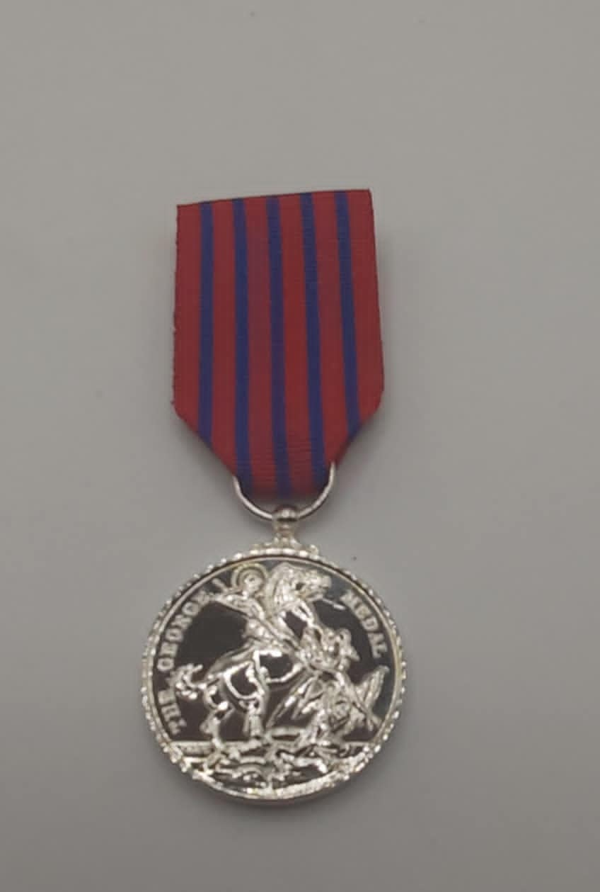

Photo credit: Julian Allerhead BEM

Instituted by King George VI on 24 September 1940, along with the George Cross to recognise, in particular, the large number of acts of gallantry being displayed during the Blitz - but also in other areas where military awards were not appropriate. Although primarily a civilian award at the second level, it can be awarded to Service personnel. (To date around 50% of all awards made have been to civilians.) Approximately 2,200 George Medals have been awarded since its inception. The original Warrant for the George Medal did not permit it to be awarded posthumously. This was changed in November 1977 and the George Medal has been awarded posthumously several times since this date.

The Royal Engineers Bomb Disposal teams were awarded 98 George Medals, during the War period.

ALLEN, James Girton GM, (166527) Lieutenant, 17 Bomb Disposal Company, Royal Engineers

The Citation is taken from file WO373/68/437 held at the National Archives.
Posted in the London Gazette on the 5th May 1944. Supplement 36498. Page 2049

At Salerno between 2nd October and 9th October 1943, Lieutenant Allen defuzed and removed seven British bombs fitted with long delay fuzes and anti-handling devices. The bombs were situated adjacent to the Salerno-Naples Road and a railway, and were impending the military operations. By his successful removal of these bombs, without causing an explosion, a serious hindrance to operations was avoided.

Between 9th October and 15th October 1943, this officer and his Section investigated many buildings for mines and booby traps; they found eighty-five, all of which they cleared. Lieutenant Allen was also called to examine some barracks where he discovered and neutralized a German timed firing mechanism connected to about fifteen hundred pounds of high explosives. During all these operations this officer displayed great gallantry, well knowing the great personal risks he was taking.

Further details
At the time of dealing with the British Bombs, the design of fuzes and the necessary measures to defuze them had not been released to the Bomb Disposal Teams. This seemingly extraordinary decision was taken in case BD personnel were captured and divulged said information.

ANDERSON, Derek Hawley GM, (100212) 106 Bomb Disposal Section, Royal Engineers

The Citation is taken from file WO373/66/681 held at the National Archives
Posted in the London Gazette on the 21stJanuary 1941. Supplement 35050. Page 461.

Whilst attached to this unit he has been engaged daily in digging out unexploded bombs, with a total disregard for his own safety, on Wednesday, July 3rd, 1940 at Stoke-on-Trent, 2/Lieut Anderson with a complete disregard for his own personal safety, unsuccessfully attempted to remove the fuze of an unexploded bomb on the premises of Messrs. The Wagon Repairs Ltd. The fuze was of an unfamiliar type an resisted all efforts at removal and eventually the bomb was successfully removed from side and destroyed in a safety area. Again, on Oct, 9th 1940 at the Works of English Electric Coy. At Stafford, 2LT. Anderson showed great gallantry in dealing with a U.X.B. whose detonation on site would have caused most serious dislocation to work of vital importance.

He has for some considerable time been engaged almost daily in dealing with U.X.Bs. and has at all times shown a total disregard for his own safety.

ASHMORE, Arthur James GM, (2009340) Sergeant, 3 Bomb Disposal Company, Royal Engineers

The Citation is taken from file WO373/68/152 held at the National Archives.
Posted in the London Gazette on the 16th November 1943. Supplement 36253. Page 5067.

Sergeant Ashmore was engaged continuously on bomb disposal operations for a period of four weeks following the enemy air raids on Grimsby and Cleethorpes on the morning of the 14th of June 1943. He disposed personally of more than 60 fully armed 2-kilogram anti-personnel bombs, 41 of them during the period 14th to 21 June, when he was intensely engaged in this work during all the hours of daylight. He displayed great courage and resource in dealing with bombs fuzed to detonate on the slightest movement, many of them in unstable and awkward positions.

One bomb fell on a Cleethorpes railway siding beneath a wagon of valuable goods. Sergeant Ashmore crawled beneath the wagon and by means of skilful sandbagging and protective work completely averted damage to the wagon and the goods it contained when the bomb was detonated. Another bomb which fell at the side of a signal box in Grimsby Goods Yard was insecurely poised and liable to roll over if subjected to the smallest vibration. Sergeant Ashmore carried out protective sandbagging, laid a charge, and detonated the bomb successfully with only superficial damage to the signal box and one overhead wire cut. A further bomb that was dropped was found suspended by its drogue over the false roof of a building. The bomb was inaccessible from inside and had to be approached from the roof. Sergeant Ashmore cleared the room adjacent to the bomb of all valuable fitting and furniture and furniture and rigged a tackle from the chimney stack to pull the bomb clear. After the slight movement of the bomb the tackle jammed and Sergeant Ashmore at great risk of further disturbing the bomb climbed over the roof and freed the tackle. On pulling again the bomb immediately exploded.

BAILEY, William Henry GM, 7 Bomb Disposal Company, Royal Engineers

The Citation is taken from file WO373/68/331 held at the National Archives
Posted in the London Gazette on the 10th March 1944. Supplement 36416. Page 1151.

Sergeant Bailey has been employed on bomb disposal duties since October 1940. He has worked on approximately two hundred unexploded bombs. He made a large number of reconnaissance’s, whilst raids were still in progress. He has shown himself to be absolutely fearless and shown a fine example and spirit to the men employed under him.
During the raid on Plymouth on 12 August 1943, he assisted his officer (Captain Gray) in dealing with a 500-kilogram unexploded bomb which had been dropped and had caused the closing of the main Exeter to Plymouth Road. He took his turn at scraping away with his bare hands a quantity of concrete whilst gas was escaping from a broken gas pipe nearby, in order to get at the fuze of the bomb. At times he was compelled to break off from this work because of having been overcome by the fumes. The fuze was eventually extracted and the bomb removed to a safe place. By working under such adverse conditions, it called for a high degree of courage, determination and devotion to duty on the part of this non-commissioned officer.

Further information
Lieutenant John Henry Havelock Gray was also awarded the George Medal for this incident (see separate entry).

BAINBRIDGE, Alexander George GM, (123013) Lieutenant, Bomb Disposal, Royal Engineers

The Citation is taken from file WO373/66/1349 held at the National Archive.
Posted in the London Gazette on the 30th September 1941. Supplement 35292. Page 5653.

In September 1940, a large bomb fell in Woolwich. In view of the proximity of the bomb to the railway and municipal centre, Captain Bainbridge immediately dealt with the bomb himself. The bomb proved to have two of the most dangerous fuzes, and whilst attempting to remove them the bomb exploded, seriously injuring him.
In October 1940, a bomb of the highest priority fell in the Southern Outfall Sewer for which he was responsible. Although he had scarcely recovered from his accident, he hastened back to duty before the expiration of his sick leave, in order to deal with this bomb.

Many instances of gallantry by this officer could be recorded, including one in October 1940, in High Street, Plumstead. After lighting the fuze which had to demolish a bomb, an old lady emerged from an unexpected quarter into the danger area. He ran back to this person and just succeeded in getting her to a place of safety when the bomb exploded.

Captain Bainbridge has made approximately one hundred reconnaissance of unexploded bombs, from time to time by night under blitz conditions.

He continues to maintain well the very high standard and gallantry and devotion to duty which has characterized all his work.

BARNES, James GM, Second Lieutenant, Bomb Disposal, Royal Engineers

The Citation is taken from file WO373/66/365 held at the National Archives
Placed in the London Gazette 22 January 1941. Supplement 35050. Page 462.

On the 6 November 1940, ten bombs were dropped on the factory of Vauxhall Motors Limited at Luton. One of the bombs had fallen on the heat-treatment department. Realising the seriousness of the situation, Lieutenant Barnes immediately volunteered to enter the building and remove the fuze from the bomb. This was successfully achieved and removed a very serious danger. After further investigation, another unexploded bomb was discovered in close proximity to a large A.R.P control room. Without hesitation, Lieutenant Barnes proceeded to excavate the ground around the bomb until he was able to defuze it. It was due to his cool and courageous action that the Company, engaged on important Government production, was working full again the next morning, with practically no time lost.

BAYS, Phillip Arthur GM, (253407), 6 Bomb Disposal Company, Royal Engineers

The Citation is taken from file WO373/69/686 held at the National Archives
Placed in the London Gazette 19th October 1945. Supplement 37311. Page 5105.

Since joining 6 Bomb Disposal Company, on 6th December, 1942, Lieutenant Bays has been engaged almost continuously on work of a very dangerous nature. He had at all times displayed ingenuity, presence of mind and outstanding courage, and his resource in difficult situations has been a major contribution to the safety of his men and the success of the many operations carried out by him. In all operations Lieutenant Bays has displayed courage and initiative of a high order.

BEAN, William Owen GM, (2968034) Corporal, 77Bomb Disposal Section, 10 Bomb Disposal Company, Royal Engineers

The Citation is taken from file WO373/66/147 held at the National Archives.
Posted in the London Gazette on the 17th December 1940. Supplement 35014. Page 7053.

On August 31, 1940, at Middleton, several High Explosive Bombs dropped near a thickly populated area, eight of the bombs failing to explode. Digging operations were commenced for the recovery of the bombs which had fallen on the bank of the railway and after digging a few feet bad ground was encountered which slowed up the progress of the work. Corporal Bean, by his example and coolness, expedited operations, and recovered the bombs which were successfully defused, thus expediting the return to their homes of several hundred people who had been evacuated.

BIGGS, Alfred John GM, (56967) Temporary Captain, 8 Bomb Disposal Company, Royal Engineers

The Citation is taken from file WO373/66/353. Held at the National Archives.
Posted in the London Gazette on 22 January 1941. Supplement 35050. Page 462.

When a 250-kilo bomb fell through the railway viaduct at Birmingham, Captain Biggs immediately set off and found the bomb partially buried beneath the viaduct, and in such a position that its explosion would seriously dislocate traffic for a considerable period. Captain Biggs uncovered the fuze which was still ticking and attempted to take it out, but the locking ring had jammed. By means of a hammer and chisel, the filling cap was taken off and the T.N.T. washed out with a hosepipe. With a crowbar he then levered out the fuze pocket. The fuse exploded seven minutes after removal. This is only one of many instances of equally courageous action by Captain Biggs who, by his conduct, inspires all ranks of the Company under his Command.

BLACKSHAW, Thomas GM, (210258) Lieutenant, 22 Bomb Disposal Company, Royal Engineers

The Citation is taken from file WO373/68/49 held at the National Archives.
Posted in the London Gazette on the 17th August 1943. Supplement 36136. Page 3690.

On the night of the 3/4 March 1943, enemy aircraft dropped approximately 350 anti-personal bombs on Essex. The bombs fell in open country and mostly on the surface. It was necessary to dispose of these bombs as soon as possible as they were holing up agriculture and could not be adequately guarded in the rural areas in which they fell. Owing to an exercise the only officers available to deal with these bombs were Major Gerhold, Lieutenant Clinton and Lieutenant Blackshaw. Owing to this shortage of officers Sergeant Hall was called to assist in the work which normally would be performed by an officer.

At the time in question little was known regarding the action of these anti-personnel bombs, and instructions as to their disposal were by no means complete. The anti-personnel bombs were fitted with two new types of fuzes which had not hitherto been encountered in England. One type, fuze 70B, was an anti-handling fuze designed to set off the bomb at the slightest touch. The other type was a long delay fuze 67, designed to explode the bomb at any time up to half an hour after falling. Owing to faulty action. These fuzes are liable to stop and subsequently restart if the bomb is disturbed, or even if other bombs within 25 yards exploded.

When possible, these three officers and Sergeant Hall threaded a cord round or through projecting portions of the bombs and jerked them by remote control. When this was not practicable, or the bomb with which they were dealing did not explode on being jerked, they placed an explosive charge against the bomb and blew it up. In such cases, the charge had to actually touch the bomb to ensure 100% efficiency. In instances where bombs are buried, it is necessary to find them by hand and remove any earth that may be laying on them. A charge can then be laid on these bombs which will destroy them. The danger lies in the risk of disturbing the bombs which may set them off.
These three officers and Sergeant Hall between them dealt successfully with 314 of bombs which fell. Of this number, 67 were dealt with by Major Gerhold 69 by Lieutenant Clinton, 95 by Lieutenant Blackshaw and 83 by Sergeant Hall. In disposing of this bomb each of these officers and N.C.O. displayed sustained courage of a high order as the disposal of each bomb constituted a very real risk.

BLACKWELL, Thomas Walter Townsend GM MBE, (169038) Lieutenant, 21 Bomb Disposal Company, Royal Engineers

The Citation is taken from file WO373/67/463 held at the National Archives.
Posted in the London Gazette on the 6th November 1942. Supplement 35775. Page 4825.

At about 10 p.m. on the night of the 30th July, 1942, a number of delayed action bombs were dropped on Birkirham. One of these bombs partially demolished a house in a very built-up area, thereby burying a number of civilians. The bomb remained partially exposed, Lieutenant Blackwell on arriving at the site discovered that the bomb contained two delayed action fuzes, the clocks of which were both working. He decided that the proper course of action was to remove the bomb as soon as possible to a less vulnerable area, so that efforts could be made to rescue the entombed people. As no lifting tackle was available Lieutenant Blackwell decided that the bomb must be towed away. It was necessary first to clear a passage for the bomb, and in this he was assisted by a local constable. Lieutenant Blackwell then tried to haul the bomb clear by means of a truck and towing rope. The layout of the street only permitted of a towing rope of twelve feet in length. The first attempt failed owing to the bomb becoming stuck in the debris. It then became obvious that two persons were required. The constable volunteered to drive the truck, which he did, and with Lieutenant Blackwell guiding the bomb, the operation was completed. The fact that the people buried under the debris of the house on which the bomb had fallen, were, when extricated, found to be dead, does not detract from the gallantry of the action of Lieutenant Blackwell and the constable.

Further Information
Lieutenant T W T Blackwell was also awarded the Member of the Order of the British Empire see separate entry.

BORTHWICK, William Sangster GM, (311379) Lieutenant, 11 Bomb Disposal Company, Royal Engineers

The Citation is taken from file WO373/69/742 held at the National Archives
Posted in the London Gazette on the 25th December 1945. Supplement 37404. Page 6275.

Lieutenant Borthwick has been engaged in the clearance of minefield for the past twelve months and has dealt with approximately 1600 mines. On the 27th April 1945, whilst he was clearing a minefield south of Dunbar, he received a message that an accident had occurred in a minefield north of Dunbar. He immediately proceeded to the scene and on arrival found that two mines had exploded killing three Prisoners of War and injuring nine others. Accompanied by a Sergeant, Lieutenant Borthwick swept in with a mine detector and removed all the Prisoners of War and those that had been killed, from the minefield. This was a particularly dangerous operation as the Prisoners of War did not understand English and tended to move about in the live minefield when they saw the clearance party approaching towards them with stretchers.

On the 14 September 1945, he received a message regarding another accident which had occurred on Peffer Sands minefield. He proceeded to this minefield with another Sergeant and swept in and removed the bodies of 4 men of his Company who had been killed in this particular incident. In both of these incidents Lieutenant Borthwick ran a considerable risk, but by his initiative and gallant action, he ensured that the men who had been wounded were removed with the greatest possible speed and sent to hospital. This officer set a fine example of courage and determination, which inspired those who were privileged to witness his deed.

Further information
Sgt Craik was awarded the British Empire Medal for his part in the Dunbar operation. See separate entry.

BOURNE, Edward Louis GM, (154267) Temporary Captain, 4 Bomb Disposal Company, Royal Engineers

The Citation is taken from file WO373/68/207 held at the National Archives.
Placed in the London Gazette on the 21st December 1943. Supplement 36279. Page 5572.

During August 1943, the enemy dropped over two hundred and fifty anti-personnel bombs on districts in Norfolk, and Captain Bourne personally dealt with one hundred and forty-two of them. His disposal of 31, 2-kilogram anti-personal bombs at Wells-on-Sea, constituted a very heavy risk, and each of the remaining bombs which he dealt with also entailed a slight though none the less real risk. The cumulative danger in disposing of 142 bombs, was, however, high, and Captain Bourne’s action called for sustained courage. This officer has been employed on bomb disposal duties since October 1940, and disposed of three hundred and forty-six other bombs of various calibre, many of them under highly dangerous conditions.

Further Information
A note handwritten on the citation states: Not for publication in the Press.
His Sergeant, Fred Fisher, was awarded the British Empire Medal for this incident (see separate entry).

BRABIN, John GM, (1990980) Sergeant, 3 Bomb Disposal Company, Royal Engineers

The Citation is taken from file WO373/68/652 held at the National Archives.
Placed in the London Gazette on the 12st September 1944. Supplement 36279. Page 5572.
Sergeant Brabin has been employed on bomb disposal duties since October, 1940. During this time, he has helped to deal with over two hundred and sixty unexploded high explosive bombs and one hundred and two S.D.2 anti-personnel bombs. He has at all times proved that his thoughts for the safety and well-being of his men are foremost in his mind. His personal courage and disregard for his own safety, has always been of the highest of the highest order, and acted as a tonic and inspiration to the many junior N.C. Os placed under his charge. Hid performance in personally disposing of twenty-six unexploded S.D.2 bombs with70B fuzes at Caston, of which seven were hanging in hedges and three in corn stooks was one calling for very considerable coolness and steady courage, as the disposal of one of these bombs constitutes a risk and of twenty-six, many in awkward positions, a very real risk.

His performance in September and December1943, in disposing of seventy-five further S.D.2 bombs confirms his devotion to duty and willingness to accept necessary risks

BRISTOW, Charles Frederick GM, (13005511) Corporal, Bomb Disposal, Royal Engineers

This Citation is taken from file WO373/67/188 held at the National Archives.
Placed in the London Gazette on the 17th February 1942. Supplement 35460. Page 773.

Corporal Bristow has been employed on bomb disposal work for the past eleven months and has been consistently at the side of his Section Officer in the hazardous work carried out. He has been consistently reliable and unheeding of danger, thereby setting a fine example to the men working under him.

He was in charge of operations during two incidents under the direction of an officer, and with another N.C.O. the conditions under which he worked in one of these incidents were appalling since apart from the danger of asphyxiation, there was a grave danger of fire and explosion in a gas holder, with the additional knowledge that should the bomb on which he was working detonate, the result would be certain death. The bomb on this occasion was fitted with the most dangerous combination of delay-action and anti-handling fuzes.

The same degree of dogged courage and complete disregard for personal danger is evident in other incidents in which this N.C.O has been concerned, and where work was carried out on delayed-action bombs over a period of many hours during which there was the ever-increasing risk of detonation.

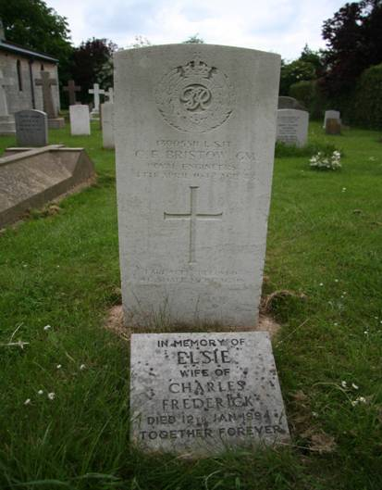 | Further Information  Corporal C F Bristow, died on the 4 April 1942. On the 1 April 1942 he was working with Lt J P Walton GM, dealing with a Yellow Peril Ballon Bomb at Halfway House Marshes, near Great Wakering, when there was an explosion. Lt J P Walton was killed and Corporal C F Bristow injured; he passed away from his wounds 3 days later.  He is buried at St Andrews Churchyard, Cranwell, Plot 1 Row B Grave A. Photo credit: Christine Hasman.

BUTLER, Frank Herbert GM, Acting Lieutenant, 11 Bomb Disposal Company, Royal Engineers

This Citation is taken from file WO373/66/1372 held at the National Archives.
Placed in the London Gazette on the 30th September 1941. Supplement 35292. Page 5653.

Lieutenant Butler has done excellent work in connection with bomb disposal, and has reconnoitred one hundred and fifty-nine incidents of this nature, many of them during the blitz period.

On the night of 7th May, 1941, a number of unexploded bombs were dropped on the Imperial Chemical Industries factory at Ardeer. These bombs were A.1. category, as two were in the black powder plant. Work commenced on the 9th May under extremely difficult conditions due to tidal water and running sand. In spite of this Lieutenant Butler persevered and excavated to a depth of fifteen feet, removing the bomb, a 250-kilogram, in one hundred and twenty hours, thus allowing production to continue. A further category A.1 bomb fell just outside a manufacturing shop for black powder. After completion of other A.1 category bombs in this are work was commenced on May the 12th. Excavation was carried out to a depth of sixteen feet through running sand and water. The work was most difficult. As the tide came in water and sand boiled up from beneath the shuttering. Shafts were sunk to a depth of twenty-one feet and a bomb of 1,000 kilograms was found with a 35 fuze. The bomb was recovered and removed on the 13th June. Another bomb of 250-kilograms which had a 17 and 50 fuze and had penetrated fourteen feet was removed in forty-two hours.
On another occasion an unexploded bomb weighing 50-kilograms dropped on Blackburn Aircraft Factory at Dunbarton. It was necessary to cut through six inches of concrete and to evacuate to a depth of four feet so as to remove this bomb. The bomb was removed in four working hours thus enabling production at the factory to continue. Lieutenant Butlers’ record of outstanding courage and devotion to duty, sustained over a long period and under the heavy attack of the enemy, merits the highest praise.

CANN, Charles GM, (2067513) Sergeant, 8 Bomb Disposal Section, 4 Bomb Disposal Company, Royal Engineers.

The Citation is taken from file WO373/66/360. Held at the National Archives.
Posted in the London Gazette on the 22nd January 1941. Supplement 35050. Page 462.

On the 28th October, 1940. Sergeant Cann was ordered to investigate an entirely new type of small anti-personnel bomb. Which had been dropped in considerable numbers. With full knowledge of the possible fatal consequences, he secured a complete bomb, the mechanism of which was within a hairs breadth of operating the detonating fuse. In consultation with, and in the presence of an officer, he dismantled the bomb and rendered it harmless. This was all done after police officers had handled the bombs with fatal results. The valuable information obtained was the first to be received and allowed of precautionary orders being issued.

Further Information
Sergeant C M Cann GM incident was in Ipswich area where the first Butterfly Bombs were dropped a number of policemen were killed investigating the new devices.

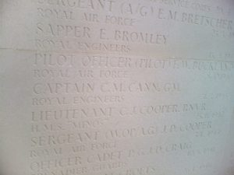 | Sergeant Cann in July 1945 he went into hospital to have his tonsils removed, tragically he passed away anaesthetic. (Some years later his son died under the same circumstances.)  Commemorated at Woodvale Crematorium, Brighton.  Photo credit: Pete Mason
CARTER, John William GM, (1880745) Sapper, 2 Bomb Disposal Group, Royal Engineers

The Citation is taken from file WO373/66/778. Held at the National Archives.
Posted in the London Gazette on the 11th March 1941. Supplement 35009. Page 1427.

At Gravesend on the 17 December, 1940, when the Section Officer was attempting to defuse an unexploded bomb fitted with a No. 17 fuse, the top of the fuze came away, and the officer, owing to consideration of saving property, decided to extract the fuze by hand, a difficult and dangerous operation. Sapper Carter knowing the danger, volunteered his aid and gave his officer all help, both practical and moral, that could possibly be given in a trying and hazardous task, without any thought to his personal danger.

Further Information
Sapper Carter also supported his officer on several incidents these included two 250kg bombs in a school playing field, a Flam 250 incendiary at Bowater Paper Mills, close to the River Thames, and another bomb in a back garden in Dashwood Road, Gravesend. This last bomb was discovered with its fuze visible but so badly damaged as to be unidentifiable. Later it was found to be a no 17 Long Delay fuze, which was removed by hammer and cold chisel, standard practice at the time, the fuse fired ten minutes after removal.

CHESHIRE, Stanley GM, (2006164) Sapper, 96 Bomb Disposal Section, Royal Engineers

The Citation is taken from file WO373/66/151. Held at the National Archives.
Placed in the London Gazette on the 17th December 1940. Supplement 35014. Page 7053

The conduct of Sapper Cheshire, under conditions of extraordinary difficulty and danger, has been especially meritorious. He has never allowed considerations for his personal safety to interfere with his work and no situation, however perilous, has been able to affect his nerve. He has shown himself to be as ready to face hard work as he is to meet risk and it has been found more difficult to persuade him to come out of a bomb hole than to get him to enter one. On 18 August, Sapper Cheshire worked for 9 hours, stripped and up to his waist in water, in order to reach a large High Explosive delayed action bomb which had fallen in a pond.

CHESTER, Robert John GM, (1888309) Acting Sergeant, Bomb Disposal, Royal Engineers.

The Citation is taken from file WO373/67/45. Held at the National Archives
Placed in the London Gazette on the 28th October 1941. Supplement 35362. Page 6247.

Sergeant Chester has been employed on bomb disposal for twelve months. From August to September 1940, he worked in the heavily blitzed areas around Tilbury. His example has been an inspiration to his men. He has reconnoitred and dealt with three parachute mines and 200 bombs, including 19 Category” A” bombs, many of which were fitted with No. 17 fuzes.

In August 1940, he recovered the first 250-kilogram bomb experienced by his Section, and the information gained formed the basis of subsequent operations of his Section.

In September 1940, five Category “A” bombs fell on the London North East Railway at Rims Park Station, Hornchurch. Sergeant Chester worked for eight hours on these bombs which were successfully removed thereby enabling the line to be re-opened for traffic.

At Warley in October 1940, he was called upon to demolish a parachute mine. Disregarding his own safety and knowing that any disturbance would operate the mine fuze, he excavated the loose soil covering the mine and laid the charge.

The Director of Bomb Disposal states that Sergeant Chester has shown himself to be possessed of fine qualities of leadership, determination, and cool courage in the face of danger under difficult circumstances.

CLINTON, Michael Arthur GM and Bar, (130514) Lieutenant, 22 Bomb Disposal Company, Royal Engineers.

The Citation is taken from file WO373/67/186.Held at the National Archives.
Placed in the London Gazette 17th February 1942. Supplement 35460. Page 773.

Lieutenant Clinton has been engaged continuously on bomb disposal work for the past eleven months and has disposed of approximately 200 bombs of all types and sizes. He has always displayed consistent eagerness to deal with “A” category bombs and to assist the Royal Navy in the disposal of parachute mines. In two incidents brought to notice, Lieutenant Clinton accepted the risk of certain death with sustained courage and complete disregard for personal danger. The bomb which he dealt with on one occasion was in an extremely sensitive condition. In dealing with this particular bomb Lieutenant Clinton ran the gravest risk, especially after the mechanism had started and stopped again since it is unusual to expect in this event that the mechanism has but a few moments to run before the striker is released.
Lieutenant Clinton’s actions in withdrawing the 17a and 50 fuzes by hand as described in another incident was extremely hazardous since it was known that there was the strong possibility of an anti-withdrawal device being fitted behind the 17A fuze and that the slightest vibration was likely to activate the 50 fuze. That these known risks were accepted by Lieutenant Clinton denotes cool courage and tenacity of purpose of a very high order. His regard for the safety of the men working under him has always been a primary consideration.

Citation to the Bar to the George Medal
The Citation is taken from file WO373/68/49. Held at the National Archives.
Posted in the London Gazette on the 17th August 1943. Supplement 36136. Page 3690.

On the night of the 3/4 March 1943, enemy aircraft dropped approximately 350 anti-personal bombs on Essex. The bombs fell in the open country and mostly on the surface. It was necessary to dispose of these bombs as soon as possible as they were holing up agriculture and could not be adequately guarded in the rural areas in which they fell. Owing to an exercise the only officers available to deal with these bombs were Major Gerhold, Lieutenant Clinton, Lieutenant Blackshaw, and Sergeant Hall.

At the time in question little was known regarding the action of these anti-personnel bombs, and instructions as to their disposal were by no means complete. The anti-personnel bombs were fitted with two new types of fuzes which had not hitherto been encountered in England. One type, fuze 70B, was an anti-handling fuze designed to set off the bomb at the slightest touch. The other type was a long delay fuze 67, designed to explode the bomb at any time up to half an hour after falling. Owing to faulty action. These fuzes are liable to stop and subsequently restart if the bomb is disturbed, or even if other bombs within 25 yards exploded.

When possible, these three officers and Sergeant Hall threaded a cord round or through projecting portions of the bombs and jerked them by remote control. When this was not practicable, or the bomb with which they were dealing did not explode on being jerked, they placed an explosive charge against the bomb and blew it up. In such cases, the charge had to actually touch the bomb to ensure 100% efficiency. In instances where bombs are buried, it is necessary to find them by hand and remove any earth that may be laying on them. A charge can then be laid on these bombs which will destroy them. The danger lies in the risk of disturbing the bombs which may set them off.

These three officers and Sergeant Hall between them dealt successfully with 314 of bombs which fell. Of this number, 67 were dealt with by Major Gerhold 69 by Lieutenant Clinton, 95 by Lieutenant Blackshaw and 83 by Sergeant Hall. In disposing of this bomb each of these officers and N.C.O. displayed sustained courage of a high order as the disposal of each bomb constituted a very real risk.

Captain Temporary Major Lewis Gerhold GM also awarded a Bar to his George Medal and Lieutenant Thomas Blackshaw and Sergeant Thomas Hall were awarded the George Medal for this action. See separate entries.

DAVIES Charles Ernest Davies GM (127300) Second Lieutenant Acting Lieutenant
23 Bomb Disposal Company, Royal Engineers

The Citation is taken from file WO373/67/44 held at the National Archives.
Posted in the London Gazette on the 28th October 1941. Supplement 35326. Page 6247.

Lieutenant Davies has been engaged continuously on Bomb Disposal since August 1940. During this period, he has dealt with over 400 bombs of all sizes, including 35 Category “A” incidents. Nearly all the Category “A” incidents were dealt with before the requisite instruments for dealing with such bombs had been brought into use, and every bomb was a potential booby trap. He has at all times shown a splendid spirit, and by his courage and devotion to duty has set a fine example to the men under his command.

On the 21 September, 1940, at Weybridge, two 250-kilogram bombs were dropped on the Hawkers Aircraft Factory. One of the bombs which had not penetrated was removed, the other bomb was under the concrete floor in a workshop, and excavation was commenced immediately, continuing all night until 8 am, next morning. This bomb was successfully extracted. The destruction of twenty-five British aircraft was, without doubt, saved through the perseverance of Lieutenant Davies.

On 27 October 1940, at Onslow Village, Guildford, a 250-kilogram bomb had fallen at the rear of a house, under a sewer and also under cables and pipes carrying all the main services. This bomb was fitted with a No. 17 fuze and a plain green fuze. Both fuzes stuck when Lieutenant Davies made an attempt at defusing. The bomb was, however, removed to a safe spot and demolished.
On 28 October, 1940, at Ormonde Road, Godalming, a 250-kilogram bomb fell in a passageway in the middle of a row of houses. This bomb was fitted with Numbers 17 and 50 fuzes. It was removed into the roadway, loaded on to a lorry and taken to an open site for demolition. Lieutenant Davies personally helped in this operation.

On the 10th of May, 1941, at Air Speed Factory, Christchurch, twelve bombs were dropped. All the bombs, some of which were Category “A”1, were cleared by 12.30 p.m. the same day. The two-pin plug discharger was used by Lieutenant Davies on all the fuzes but on testing two of them afterward they were found to be alive.

The Director of Bomb Disposal states that Lieutenant Davies has an outstanding record of courageous action and fine leadership during which his own safety has been completely disregarded

DEANE, Tom James GM, (87982) Lieutenant, Bomb Disposal, Royal Engineers

The Citation is taken from file WO373/67/187 held at the National Archives.
Placed in the London Gazette on 17th February 1942. Supplement 35460. Page 773.

Lieutenant Deane has been continuously on bomb disposal work for the past twelve months, during which time he has most successfully dealt with over 200 bombs of all types. He has also assisted the Royal Navy in the removal and destruction of over 35 parachute mines when very little was known about them.

Lieutenant Deane has displayed an outstanding degree, cool deliberate courage, and devotion to duty, with the utmost consistency. His assistance to the Royal Naval Mine Disposal Officers in dealing with unexploded mines is worthy of note, since very little was known of the characteristics of such missiles at this time, excepting that they were extremely sensitive to movement and vibration, which made the work of digging down and moving into position to enable the Naval Officer to get at the fuses, the most hazardous part of the operation. Typical incidents of this kind are described in one of the operations with which Lieutenant Clinton was concerned, and the danger which he accepted so coolly and with utter disregard for self cannot be too emphasised. This officer’s fearlessness, courage, and cheerfulness, established early, has been maintained throughout the whole period and has proved a tonic of immense value to his brother officers and his section.

DEANS, Ralph Willis GM, (204212) Lieutenant, Bomb Disposal, Royal Engineers

The Citation is taken from file WO373/67/524 held at the National Archives.
Posted in the London Gazette on the 11th March 1943.

During the air attack on London on the night 17/18th January, 1943, a large calibre bomb fell in the warehouse of the Victoria Haulage Company at Battersea, and after tearing its way through girders, machines and packing cases came to rest unexploded immediately beneath the bed plate of a very large lathe. Owing to the fact that the warehouse was full of new and heavy machine tools from the U.S.A the Ministry of Supply applied to the Regional Commissioner for Category A.1. This was granted and on the morning of 18th January, 1943, Lieutenant Deans with a working party began disposal operations. During the night of 18/19th January, 1943. The bomb was identified as a 500-kilogram with two fuzes; the casing being so distorted as to render their withdrawal impossible. During the day 18th January another Category A.1. bomb had been found to contain an entirely new type of fuze, which on examination during the night of 18/19th January was found to embody entirely new features of great potential menace and for which no technique or plant could be used. The 500-kilogram bomb at Battersea was then found to contain one of the new type’s fuzes. This necessitated shutting down the machinery of a large flour mill next door owing to vibration. The bomb could not be moved without grave risk of destroying much valuable Machinery, and there was no known method of rendering the fuze inactive., so it was decided to attempt to remove the base plate and extract the main explosive filling. Lieutenant Deans assisted Major Martin to do this but the bomb was found to contain solid cast T.N.T which could only be removed by the application of steam. It was considered dangerous to attempt this by the normal remote control steam jetting method owing to the high temperatures generated inside the bomb and the force of the steam jet. It was decided therefore that the only way was to apply the steam nozzle by hand and only long enough at a time to soften the T.N.T sufficiently to allow it to be scraped away in small quantities. This entailed further excavating and supporting the bomb so that it could not slip or be inadvertently moved. It also involved two men being in close contact with the bomb in order to manipulate the steam and cooling water pipes and to scrape away the T.N.T after each application of steam. Lieutenant Deans was fully aware of the appalling risks involved but he remained throughout the evening and night with Major Martin at the bottom of the cramped hole which was filled with steam and water in which they had to lay for nearly 24 hours without a break. During the night 20/21st January, 1943, Lieutenant Deans whilst lying in the water and mud at the bottom of the hole came into contact with a bared part of the flex to their working light and suffered a severe shock which rendered him momentarily unconscious and badly shaken, but notwithstanding this he insisted in continuing to assist Major Martin until the task was successfully accomplished. Throughout the operation and knowing the risks involved Lieutenant Deans displayed a very high order of sustained courage, endurance and tenacity of purpose under most difficult circumstances.

DENNISON, Peter Neville GM, (2068288) Company Quarter Master Sergeant, 1 Bomb Disposal Company, Royal Engineers

The Citation is taken from file WO373/66/1434 held at the National Archives.
Posted in the London Gazette on the 21st October 1941. Supplement 35319. Page 6107.

Company Quartermaster-Sergeant Denison has been engaged in Bomb Disposal for twelve-months and has shown consistent courage, determination, and good leadership during the whole of that period.

At Sunderland on the 12 August 1940, an unexploded bomb which weighed 250 kilograms, it fell close to a battery of radial drilling machines in a shipyard. This bomb penetrated to a depth of 15 feet under some steel plates. Work was carried on by improvised artificial light provided by a motor-cycle headlamp screened by a greatcoat throughout an air raid, and in spite of bombs and splinters falling, and the difficulty of position of the bomb. The bomb was, however, successfully recovered and defused, thereby enabling the shipyard to start work.

Company Quartermaster-Sergeant Denison also carried out continuous reconnaissance of unexploded bombs during the heavy air raids on Sheffield between the 13th and 16th December 1940. He worked on the disposal of five unexploded bombs with delayed action 17 fuses during this period, and continued work during the second heavy air raid whilst bombs were falling in the vicinity, on a 250-kilogram delayed action bomb near large petrol tanks.

The Inspector of Fortification and Director of Bomb Disposal states that he considers Company Quartermaster-Sergeant Denison has shown a high degree of courage and devotion to duty.

DICKENSON, Kenneth GM, Lieutenant, 10 Bomb Disposal Section, 4 Bomb Disposal Company, Royal Engineers

The Citation is taken from WO373/66/354.
Posted in the London Gazette on the 22nd January 1941. Supplement 35050. Page 462.

When an unexploded bomb fell within the confines of Shoeburyness Garrison. Lieutenant Dickinson immediately sent to the spot with a Sergeant and a Sapper. Despite the fact that a very severe air raid was in progress, he collected the bomb, placed it in a lorry and drove the dangerous cargo to a safe spot where he defused the bomb and rendered it harmless. Lieutenant Dickinson has been operating under constant air raids regardless of his personal safety.

DIXON, William Arthur MC GM, Temporary Captain, 3 Bomb Disposal Company, Royal Engineers

The Citation is taken from file WO373/66/1350 held at National Archives.
Posted in the London Gazette on the 30th September 1941. Supplement 35292. Page 5653.

On the 9 December 1940, a bomb fell in Holburn. Captain Dixon inspected the bomb the following morning and found that it was lying in a partly broken condition near the surface. As the bomb was causing serious dislocation of traffic it was decided that it should be dealt with at once in spite of the risks involved. The bomb was found to have a most dangerous fuze of the clockwork variety, and the clock was still ticking. It was not possible to stop the clock owing to the irregular shape of the bomb which has been distorted by impact with the pavement. Captain Dixon successfully removed the explosive and then made the bomb safe by detonating the fuze in the crater. This act of gallantry is typical of many which has been carried out by this officer, whose work has been specially brought to notice by the Civil Group which he is employed.

Captain Dixon has carried out over one hundred reconnaissance of unexploded bombs and has personally supervised the rendering safe of all of them. He has constantly displayed courage and determination of a very high order, and has been an inspiring example to the officers and men working under him.

FEATHER, William Anderson GM, (119063) Lieutenant, 4 Bomb Disposal Company, Royal Engineers

The Citation is taken from file WO373/67/42 held at National Archives.
Posted in the London Gazette on the 28th October 1941. Supplement 35326. Page 6247.

Lieutenant Feather has worked continuously on Bomb Disposal for 12 months and has successfully dealt with approximately 200 bombs of all descriptions. From June to September, 1940, he was stationed at Harwich and at times worked under heavy ‘blitz ‘conditions with great courage and with total disregard for his personal safety. His fine leadership, great care for detail, and intelligent advice, have been the means of ensuring the safety of his men under all conditions.

On the 21st August, 1940, he carried out a reconnaissance of eleven 50-kilogram bombs which had fallen just outside and inside the Royal Naval Mine Depot at Wrabness, in which loaded mines were stored at the time. It was due to his energetic leadership and encouragement that the bombs were recovered in two days. One of the bombs was fitted with a No.17 fuze.

On the 9th September, 1940, he reconnoitred in the middle of the night ten Category A bombs which had dropped in the middle of the Explosive and Chemical Products works at Great Oakley, Harwich. Three of the bombs were of 500 kilograms and the reminder 50 kilograms. The majority of the bombs were within 50 yards of one on ton of stored guncotton. Lieutenant Feather worked for four days with his squad under constant air attack. The site, however, was cleared of the bombs and the factory re-opened in the minimum time.

On the 17 July 1941, At Bury St Edmunds, an explosion occurred in the bottom of an anti-tank ditch in which some rubbish had been fired. Having ordered the area to be evacuated by Bomb Disposal personnel, Lieutenant Feather, with great courage, jumped into the ditch and with the help of another officer, removed a full 50 Kilogram bomb which had become overheated and was known to be in a dangerous state.

The Director of Bomb Disposal states the Lieutenant Feather has displayed dogged courage and devotion to duty of a very high order over a long period, under difficult and dangerous conditions.

FORD, James GM, (130518) Second Lieutenant, 2 Bomb Disposal Group, Royal Engineers

The Citation is taken from file WO373/66/763. Held at National Archives.
Posted in the London Gazette on the 11thMarch 1941. Supplement 35099. Page 1427.

On the 18th October 1940. A large unexploded bomb fell into the Boiler flues of the power house at the Bexley Mental Institution, and with great decision Second Lieutenant Ford set about its removal as the bomb lay in the flue where the temperature was considerably higher than 100 degrees, and where the atmosphere was polluted with gasses, the work presented many difficulties in the addition to the risk of explosion. Second Lieutenant Ford displayed great courage and devotion to duty.
GARSIDE, Samuel GM, Temporary Captain, Bomb Disposal Divisional Officer, Royal Engineers

The Recommendation is taken from file WO373/66/1351. Held at National Archives.
Posted in the London Gazette on the 30th September 1941.

In September 1940, Captain Garside carried out a most hazardous operation in destroying by demolition a magnetic mine which had fallen in the Creek at Barking. Owing to the submerged condition of this mine it was not possible to defuze it in the normal way. It was therefore decided to use countermining measures. Captain Garside was provided with a diving suit and carried out the work. He placed the charge in position at low water and then fired it at the top of the tide; advantage being taken of the extra depth of water thus provided to lessen the effect of the blast. The fixing of the charge was a most difficult operation and a false step on Captain Garside’s part might well have caused the mine to explode giving him no prospect whatever of escape. In carrying out this work as he did, with cheerfulness, precision and complete success, Captain Garside showed a courage which has characterized all his work. His act of gallantry was a magnificent example to the men working under him.

Since taking over his Group as Divisional Officer, he has had a number of difficult tasks to perform, in particular when dealing with a Category A unexploded bomb which fell in Twickenham High Road. The bomb fell in a position which endangered A.R.P operational cables. Captain Garside was present throughout the period of excavation and did all the actual work on the bomb when it was exposed.
Since November, 1940 Captain Garside has carried out approximately two hundred reconnaissance’s of unexploded bombs, and has personally supervised the rendering safe of all bombs in his area which presented abnormal conditions of difficulty or danger.

GAYLOR, George Henry GM, 23 Bomb Disposal Company, Royal Engineers

The Recommendation is taken from file WO373/69/370. Held at National Archives.

Posted in the London Gazette on the 20th April 1945. Supplement 37041. Page 2083.
On the 6th November 1944, at Hasselt, reconstruction of the demolished railway bridge was stopped owing to the presence of an unexploded bomb under 30 feet of water in the Albert Canal.

Lieutenant Gaylor went down and located the bomb half buried in the mud underneath torn railway lines, steel girders and wreckage. To do so he had to squeeze himself between damaged girders at the risk of tearing his diving suit or fouling the air or life line and so being trapped. In spite of nil visibility, he identified the tail fuze by touch, found it was in a dangerous condition, and since technical equipment could not be used under water, he unscrewed the fuze by hand. Due to mud and the damaged condition of the nose, Lieutenant Gaylor was unable to ascertain whether the bomb had a nose fuze, but acting on the assumption that it had, he again went down and guided the bomb through the wreckage, inch by inch, as it was hauled out, knowing that any movement of the bomb might set it off.
Further Information
On the 7 August 1946, Lt G H Gaylor, whilst clearing British Beach Mines at Rattery Head, north of Aberdeen, volunteered with Corporal J Fordyce and Sapper A Hurley, to defuse some mines. During the process of the mines exploded killing all three. His body was transferred to London and lays buried in Abney Park Cemetery, Stoke Newington, London.
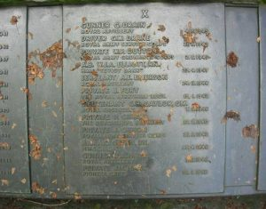

GERHOLD, Lewis GM and Bar, (131777) Second Lieutenant, 11 Bomb Disposal Company, Royal Engineers

George Medal. The Recommendation is taken from file WO373/66/1373 held at the Nation Archives. Posted in the London Gazette on the 30th September 1941. Supplement 35292. Page 5654.

Lieutenant Gerhold has carried out two hundred and seventeen reconnaissance’s in connection with bomb disposal and dealt with seventy-two unexploded bombs. During the heavy raids on the West of Scotland area – March to May, 1941, he has carried out extensive reconnaissance duties whilst bombs were falling.

Of the seventy-two bombs with which this officer and his Section have dealt, three incidents are worthy of mention:

A category A. 1 bomb dropped at Bishopston on 2nd October, 1940. Commencing operations on October 4th and working in blue clay, and with the section having little experience in timbering, the removal of this bomb was most difficult. Work was carried on continuously, and after three separate shafts had been sunk the bomb was removed. The weight of the bomb was 250 kilograms, and operations for its removal lasted 51 days.

On the 7th May, 1941, a bomb dropped at Tannochside Colliery, stopping the pit. Work on the bomb was commenced on the 9th May. This bomb was also of 250 kilograms and had a 17 and 50 fuze. The fuze was discharged, clock stopper fitted and bomb sterilized.

On the night of the 13/14 March, 1941, at No. 2 High Level Rothesay Docks, a bomb was dropped which was found to possess a 17A and 17 fuze. Great difficulty was experienced in dealing with this bomb due to tidal water. Nevertheless, Lieutenant Gerhold persisted in his effort and due to his exertions and example to his men, the bomb was removed and destroyed on 3rd April, 1941.

Apart from these three incidents, this officer has always shown consistent keenness and utter disregard of danger whilst carrying out his duties.

Bar to the George Medal. The Recommendation is taken from file WO373/68/49 held at the Nation Archives. Posted in London Gazette on the 17th August 1943. Supplement 36136. Page 3690.

On the night of the 3/4 March 1943, enemy aircraft dropped approximately 350 anti -personal bombs on Essex. The bombs fell in the open country and mostly on the surface. It was necessary to dispose of these bombs as soon as possible as they were holding up agriculture and could not be adequately guarded in the rural areas in which they fell. Owing to an exercise the only officers available to deal with these bombs were Major Gerhold, Lieutenant Clinton, Lieutenant Blackshaw, and Sergeant Hall.

At the time in question little was known regarding the action of these anti-personnel bombs, and instructions as to their disposal were by no means complete. The anti-personnel bombs were fitted with two new types of fuzes which had not hitherto been encountered in England. One type, fuze 70B, was an anti-handling fuze designed to set off the bomb at the slightest touch. The other type was a long delay fuze 67, designed to explode the bomb at any time up to half an hour after falling. Owing to faulty action. These fuzes are liable to stop and subsequently restart if the bomb is disturbed, or even if other bombs within 25 yards exploded.

When possible, these three officers and Sergeant Hall threaded a cord round or through projecting portions of the bombs and jerked them by remote control. When this was not practicable, or the bomb with which they were dealing did not explode on being jerked, they placed an explosive charge against the bomb and blew it up. In such cases, the charge had to actually touch the bomb to ensure 100% efficiency. In instances where bombs are buried, it is necessary to find them by hand and remove any earth that may be laying on them. A charge can then be laid on these bombs which will destroy them. The danger lies in the risk of disturbing the bombs which may set them off.
These three officers and Sergeant Hall between them dealt successfully with 314 of bombs which fell. Of this number, 67 were dealt with by Major Gerhold 69 by Lieutenant Clinton, 95 by Lieutenant Blackshaw and 83 by Sergeant Hall. In disposing of this bomb each of these officers and N.C.O. displayed sustained courage of a high order as the disposal of each bomb constituted a very real risk.

Further Information
Lieutenant Michael Arthur Clinton also awarded a Bar to his George Medal.
Lieutenant Thomas Blackshaw and Sergeant Thomas Hall were awarded the George Medal for this action. (See separate entries).

GRAY, John Henry Havelock GM, (146273) Temporary Captain, 7 Bomb Disposal Company, Royal Engineers

The Citation is taken from file WO373/68/331 held at the Nation Archives.
Posted in the London Gazette on the 10th March 1944. Supplement 36416. Page 1151.

Captain Gray has been employed on bomb disposal duties since October, 1940. He has displayed a readiness to tackle any job at any time of the day or night and has been an excellent example to his men as regards steadiness in face of danger.

During the raid on Plymouth on 12th August, 1943, this officer successfully dealt with a 500-kilogram unexploded bomb which had been dropped and had caused the closing of the main Exeter and Plymouth Road. In order to get at the fuze of this bomb he had to scrape away with his bare hands a quantity of concrete, and the work within a few feet of a broken gas pipe from which gas was escaping. In carrying out this operation he displayed a high degree of courage, determination and devotion to duty.

Captain Gray also successfully dealt with nine other un-exploded bombs which were dropped on the same occasion, at great risk and in very short time.

GREEN, Clifford Henry GM, (134891) Second Lieutenant, 23 Bomb Disposal Company, Royal Engineers

The Citation is taken from file WO373/66/177 held at the Nation Archives.
Posted in the London Gazette on the 11th March 1941. Supplement 35099. Page 1427.
At Gravesend on the 17th December, 1940, Lieutenant Green decided to defuse, by remote control, a 250-kilogram unexploded bomb fitted with a No. 17 fuze, prior to removal to a suitable place for disposal, owing to the close proximity to a large amount of property. Having removed the locking ring, the top of the fuze came away in his hand. Realising that the position was dangerous and that the fuze was liable to go off any minute, he immediately started the slow and difficult job of removing the fuze by hand which was successfully extracted and thus saved a large amount of property.

Further Information
This was at Dashwood Road, Gravesend, Kent.

GROVER, Henry Arthur GM, Acting Captain, 32 Bomb Disposal Section, Royal Engineers

The Citation is taken from file WO373/66/1355 held at the National Archives
Posted in the London Gazette on the 30th September 1941. Supplement 35929. Page 5654.

Captain Grover arrived in London on the 8th September, 1940, in charge of No 32 Bomb Disposal Section. On one occasion the Brentford police were very much concerned when a 259-kilogram bomb with a number 17 and 15 fuzes was discovered in a thickly populated road in the vicinity of a gas works. At this period the only method of dealing with this type of bomb was either to destroy it in situ or to remove and blow it up in some adjacent open space. After sufficient time had elapsed to render one of the fuzes inert, Captain Grover took charge of the operation and having loaded the bomb on to a 15cwt truck he drove it himself to an open space and then detonated it.

Captain Grover has an excellent record of gallant service as a Section Officer.

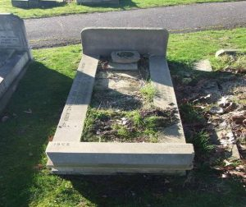 | Further Information  Major HA Grover, died on 7 July 1942, when attending a timbering shaft demonstration, the shaft collapsed killing him.  He is at buried Loughton Burial Ground, Section K Grave 2360.  Photo credit: David Blyth

HALL, Thomas GM, (1894353) Sergeant, 22 Bomb Disposal Company, Royal Engineers

The Recommendation is taken from file WO373/68/49 held at the National Archives
Posted in the London Gazette on the 17th August 1943.

On the night of the 3/4 March 1943, enemy aircraft dropped approximately 350 anti-personal bombs on Essex. The bombs fell in the open country and mostly on the surface. It was necessary to dispose of these bombs as soon as possible as they were holing up agriculture and could not be adequately guarded in the rural areas in which they fell. Owing to an exercise the only officers available to deal with these bombs were Major Gerhold, Lieutenant Clinton, Lieutenant Blackshaw, and Sergeant Hall.

At the time in question little was known regarding the action of these anti-personnel bombs, and instructions as to their disposal were by no means complete. The anti-personnel bombs were fitted with two new types of fuzes which had not hitherto been encountered in England. One type, fuze 70B, was an anti-handling fuze designed to set off the bomb at the slightest touch. The other type was a long delay fuze 67, designed to explode the bomb at any time up to half an hour after falling. Owing to faulty action. These fuzes are liable to stop and subsequently restart if the bomb is disturbed, or even if other bombs within 25 yards exploded.

When possible, these three officers and Sergeant Hall threaded a cord round or through projecting portions of the bombs and jerked them by remote control. When this was not practicable, or the bomb with which they were dealing did not explode on being jerked, they placed an explosive charge against the bomb and blew it up. In such cases, the charge had to actually touch the bomb to ensure 100% efficiency. In instances where bombs are buried, it is necessary to find them by hand and remove any earth that may be laying on them. A charge can then be laid on these bombs which will destroy them. The danger lies in the risk of disturbing the bombs which may set them off.

These three officers and Sergeant Hall between them dealt successfully with 314 of bombs which fell. Of this number, 67 were dealt with by Major Gerhold 69 by Lieutenant Clinton, 95 by Lieutenant Blackshaw and 83 by Sergeant Hall. In disposing of this bomb each of these officers and N.C.O. displayed sustained courage of a high order as the disposal of each bomb constituted a very real risk.

Further Information
Lieutenant Michael Arthur Clinton and Captain Temporary Major Lewis Gerhold also awarded a Bar to their George Medal.
Lieutenant Thomas Blackshaw was awarded the George Medal for this action. See separate entries.
Awarded for an incident at Mountnessing, Essex between the 4/9 March 1943.On the night of the 3/4 March 1943, 364 Butterfly bombs, S.D.2’s was dropped on Essex. Sgt Hall disposed of 32 of these at Mountnessing on the 5th then thirty-two more on the 6th and nineteen on the 7th, for this he was awarded the George Medal.

HALSTEAD-HANBY, Evlyn Jolliffe GM, 8 Bomb Disposal Section, 4 Bomb Disposal Company, Royal Engineers

The Citation is taken from file WO373/66/358 held at the National Archives
Posted in the London Gazette on the 22nd January 1941. Supplement 35050. Page 461.

When enemy aircraft bombed Norwich on the 19th September, 1940, a large delay action bomb fell in Theatre Street and another in Mousehold. When making an examination of one of the bombs it exploded, causing a crater thirty feet across. Lieutenant Halsted-Hanby was close to the bomb when it exploded, but was uninjured. Despite his experience he began to excavate the bomb in Theatre Street, and he and his men, regardless of their personal danger, successfully excavated and removed the bomb, which was found to be fitted with a new type of clock-work fuze. Owing to the gallant conduct and devotion to duty of this officer and his men the bomb, which had fallen in a thickly populated district, was safely removed.

HENNINGS, Philip Richard GM, (222728) Lieutenant, 12 Bomb Disposal Company, Royal Engineers

The Recommendation is taken from file WO373/69/257 held at the National Archives
Posted in the London Gazette on the 2nd February 1945. Supplement 36918. Page 685.

Lieutenant Hennings has been personally responsible for clearing mined areas in South Eastern Command during the past 12 months. No accurate records were available, nor were the position of the mines known. The areas were subjected to tidal action, causing mines to be disturbed, in some cases beyond detectable depth.

Lieutenant Hennings showed grim determination and out-standing leadership in carrying out the task. His initiative and methodical methods created the highest respect among his men and he successfully detected and rendered safe more than two thousand five hundred beach type mines whose mechanisms had been rendered very sensitive.
Subsequently he has cleared many areas and on one occasion when an unavoidable accident had occurred to his men on a mine-field, he unhesitatingly and immediately entered the field to render aid to the injured, without considering the personal danger to which he was exposing himself, thus restoring the confidence of his men.

Lieutenant Hennings has at all times inspired his men; his cool courage and fine example of leadership under circumstances of extreme danger is deserving of the highest praise.

HEWITT, William Mark GM, (73550) Temporary Captain, 56 Bomb Disposal Section, 11 Bomb Disposal Company, Royal Engineers

The Recommendation is taken from file WO373/66/810 held at the National Archives
Posted in the London Gazette on the 25th March 1941. Supplement 35116. Page 1733.

On the 1st November, 1940, an unexploded 550-pound bomb fell in the River Tyne close to the bridge at East Linton carrying the main road over the river. Captain Hewitt repeatedly dived into the river, which was in flood, to locate the bomb. When found, he held the bomb between his legs to ensure its location. He then made several attempts to place a discharger on to the fuze; as the water was very muddy, he had no idea whether the fuze he was tackling was the type which detonated when the plungers were pressed by the discharger or not. With a Lance Corporal and a Sapper, he finally got a clove hitch fastened on to the bomb and with the help of the rest of the Section pulled the bomb out and then discharged the fuze and sterilized the bomb. The fact that the bomb had fallen in muddy ground increased the chance of it exploding when moved, even if it was not already working on a delayed action system.

Captain Hewitt also the Lance Corporal and Sapper showed exceptional courage in dealing with this bomb in very difficult circumstances and in extremely cold and muddy water. An important bridge on a main road was saved from possible damage.

Further Information
Sapper Ramsay and Sapper J Smith were awarded the British Empire Medal for this incident see separate entries.

HINTON, John Henry GM, (2021663) Lance Sergeant, 68 Bomb Disposal Section, 9 Bomb Disposal Company, Royal Engineers

The Recommendation is taken from file WO373/66/683 held at the National Archives
Posted in the London Gazette on the 22nd January 1941.

Lance Sergeant Hinton was engaged with his officer Second Lieutenant A. F. Campbell in removing a 250-kilogram unexploded bomb at the Triumph Engineering CO’s Works, Coventry, for two days prior to the following incident.

The bomb was found to be fitted with a delayed action fuze which could not be removed. His officer decided that the bomb must be removed at once to a safe place for detonation and Lance Sergeant Hinton volunteered to drive the lorry to the selected site, a mile away, knowing full well the immense risk he was running. This he did, with his officer, and the bomb was safely disposed of.

I consider his unhesitating act of gallantry is worthy of immediate award, which I strongly recommend.

Further Information
Initially the recommendation was for the Distinguished Conduct Medal, then the Empire Medal for Gallantry by Colonel Commanding Warwickshire and Coventry Sub-Area Commander. However, the final decision was that he was to be awarded the George Medal.

HOLLANDS, Leonard Charles Clarence GM, (1892128 Sergeant, 3 Bomb Disposal Company, Royal Engineers

The Recommendation is taken from file WO373/68/150 held at the National Archives
Posted in the London Gazette on the 19th November 1943. Supplement 36253. Page 5067.

Sergeant Hollands was engaged continuously from the 14th to 22nd June, 1943, on intensive bomb disposal operations following the enemy air raid on Grimsby and Cleethorpes on the morning of the 14 June, 1943. During the period of operations Sergeant Hollands dealt with 56 fully armed 2-kilogram anti-personnel bombs, most of which were in unstable positions and difficult of access, and fuzed to detonate on the slightest movement. He performed his work as leader of a disposal party, tirelessly, efficiently. And with great personal courage and resource. He was responsible for the introduction of original methods which effected considerable reduction of damage to property.

On the 16th June, 1943, a bomb in the circle of a cinema had been covered with sandbags by wardens in misinterpretation of their instructions. Although risk of detonation was involved, it was necessary to remove the sandbags in order to deal with the bomb, and Sergeant Hollands attempted to do this by remote control by means of Tackle. The friction of the tackle was too great and Sergeant Hollands entered the false roof over the bomb to pull from a nearby position. On his first pull the bomb detonated and he only escaped possible fatal injury through the screening effect of the sandbags. On the 17th June, 1943, a bomb was balanced on the edge of the gutter of a school. On order to place a demolition charge Sergeant Hollands crawled along the sloping roof at considerable risk of slipping on to the bomb or of dislodging a slate which would have caused detonation. Four other bombs fell on the Tramway Depot Wharf. This wharf is constructed of old rotting and rocky sleepers. In order to minimise damage to nearby buildings, Sergeant Hollands built sandbag screening walls. This was an extremely hazardous task as one false step on a rocking rafter could have caused a detonation of one or more bombs. Sergeant Hollands successfully laid charges and detonated the bombs, the total resultant damage being only two broken windows.

HONE, William GM, (1880443) Corporal, 9 Bomb Disposal Company, Royal Engineers

The Recommendation is taken from file WO373/66/1358 held at the National Archives
Posted in the London Gazette on the 30th September 1941. Supplement 35292. Page 5654.

Corporal Hone has been engaged on bomb disposal work since August, 1940. At all times he displays cheerful readiness to tackle any task, and he has been a fine example and encouragement to the men of his Section. He has been involved in two incidents which resulted in fatal casualties, but has carried on his work with no slackening of effort.

On one occasion when an unexploded bomb passed through two feet reinforced concrete and came to rest under a lathe in a factory engaged on vital government work, a pneumatic tool had to be used in the initial work of excavation. Corporal Hone carried out this work himself. The bomb was successfully dealt with. It was suspected that this particular bomb contained numbers 17 and 50 fuzes, which was later found to be correct.

On another occasion the successful disposal of a 1000-kilogram bomb from a factory was again due to the energy, initiative and example displayed by Corporal Hone.

HUDSON, John Pilkington GM and Bar MBE, (154286) Major, 8 Bomb Disposal Section, 4 Bomb Disposal Company, Royal Engineers

George Medal. The Recommendation is taken from file WO373/67/535 held at the National Archives. Posted in London Gazette on the 20th April 1943.

Major Hudson showed devotion to duty and sustained cool deliberate courage of a high order over a period of two and a half hours, during which time he disposed of an enemy bomb fitted with a new type fuze, by an entirely new process, hitherto only partially explored in the laboratory, fall knowing the risks he ran.

On the night of 17/18th January, 1943, the enemy dropped bombs containing a new type of anti-handling fuze, designed to function if the bomb is moved or subjected to shock or vibration. By chance a sample similar fuze which did not function was recovered, owing to its nature an entirely new method of disposal had to be devised in the laboratory without delay, as nine similar unexploded bombs awaited disposal in London, most of these in positions where early disposal was called for. For this reason, and as only one fuze was available for research and experiment, it was not possible to carry out the customary exhaustive tests before introducing a new disposal process. It fell to Major Hudson to continue the experiments in which he had actively assisted in the laboratory, by attempting to dispose of a live bomb which had been assigned a high priority.

On the 24th January, 1943, Major Hudson, using improvised appliances, mainly of his own devising, commenced work on a 500-kilogram category B bomb which denied the use of the Albert Bridge Road and access to a flour works. The process relied on the temporary immunisation of the fuze for a period sufficient to enable it to be extracted by remote control. It was anticipated and Major Hudson knew this, that unequal contraction of the bomb casing and fuze pocket might result in a sudden fracture, the shock due to which might well cause the fuze to function and the bomb explode. At the end of two hours, during which Major Hudson was necessarily in contact with the bomb for periods totalling about an hour, it was estimated as a result of previous laboratory experiments, that that the fuze would have become sufficiently immune to justify extraction. An attempt was made to extract it by remote control, but owing to an anti-withdrawal device being fitted this proved to be impossible. With the light failing, Major Hudson, exercising considerable force, succeeded by wrenching and turning it, in extracting it by hand after which he removed the detonator, thus rendering the fuze permanently immune and recovering a second fuze urgently required for further research. Extraction took twenty-three minutes instead of the maximum twenty had previously been agreed on as giving a reasonable factor of safety before the fuze again became active. During the course of disposal Major Hudson, at the bomb, telephoned a full, clear and critical account of his actions including proposed future modifications to the process.

It is due to Major Hudson that the new process, since improved as a result of his observations at the time, could be released without delay to selected Bomb Disposal officers as being a reasonably safe one. This has already enabled eight similar 500-kilogram bombs which fell on London. Mostly in positions where clearance was called for without undue delay, to be disposed of successfully.

Bar to George Medal. The Citation is taken from file WO373/68/678 held at the National Archives. Posted in London Gazette on the 15th September 1944. Supplement 36700. Page 4253.

On the 24 June, 1944, Major Hudson, assisted by Mr. Hurst and Doctor. Dawson and others commenced work on the investigation of fuzes fitted to the first complete War head of a Flying Bomb which had, up till then, been found. Two of the three fuzes were of a type found in previous incomplete flying bombs, and these two successfully dealt with by Major Hudson. The third fuze, contained in the rear side fuze pocket, was unmarked and of an unknown type, and Major Hudson was instructed to recover it without fail. Radiographs by Dr Dawson showed the existence of a clockwork movement in the third fuze similar to that used in German long delay fuzes. The operation started on 24th June and proceeded continuously during the hours of daylight until the evening of the 2nd July. Intermittently during this period Flying Bombs were being attacked by aircraft overhead and being brought down in the neighbourhood, a most disturbing factor for those working on the bomb trying to avoid disturbance which might start the clockwork mechanism of the fuze.

Major Hudson was in charge of this hazardous operation, the successful conclusion of which called for a high degree of sustained courage and determination, combined with clear thinking. He was well aware of the danger and a great strain was placed on him during the nine days in question, more especially after he became affected by the toxic nature of the explosive Nevertheless the technical excellence of his work and his clear observation recorded under these circumstances were of the highest order. His work has undoubtedly contributed in no small degree to a knowledge of the fuzing system and how to deal with the fuzes.

Further Information
Was also awarded the Member of the Order of the British Empire (see separate entry).

JELLEY, John Sidney GM, (1883537) Sergeant, 8 Bomb Disposal Section, 4 Bomb Disposal Company, Royal Engineers.

The Citation is taken from file WO373/66/361 held at the National Archives.
Posted in the London Gazette on the 22nd January 1940. Supplement 35050. Page 462.

On 19th September, 1940, enemy aircraft bombed Norwich. One large delay action bomb fell in Theatre Street in a thickly populated district, a large area of which had to be evacuated at once. It was decided to wait until 23rd September before commencing to excavate the bomb. Sergeant Jelley, who was in charge of the party showed a total disregard of personal safety and, well knowing that the bomb might explode at any moment, carried on without interruption until it was finally removed. The bomb had penetrated the ground to a depth of 20 feet and was found to be of a new type with clock-work fuze. Owing to Sergeant Jelly’s conduct and devotion to duty, and also that of the men working under him, the bomb was safely removed thereby enabling the inhabitants to return home.

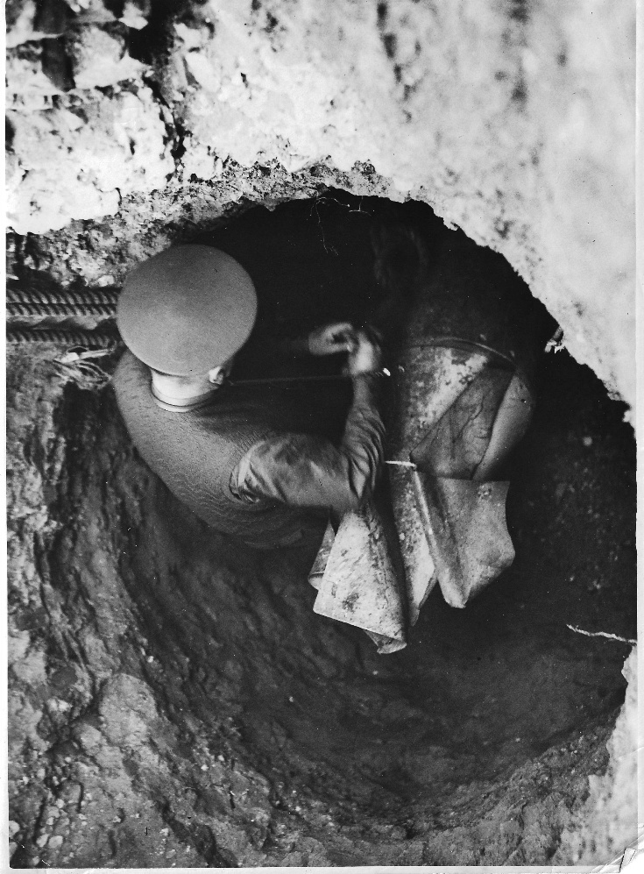 | Image to Left  German Hospital London. Lieutenant R Davies attaching lifting equipment to a 1200 lb bomb. Lieutenant R Davies and his Section were responsible for the removal of the bomb at St Pauls Cathedral.  Image below: The 1200 lb bomb being lifted from the shaft.  Photos from Peter Markhams Collection.

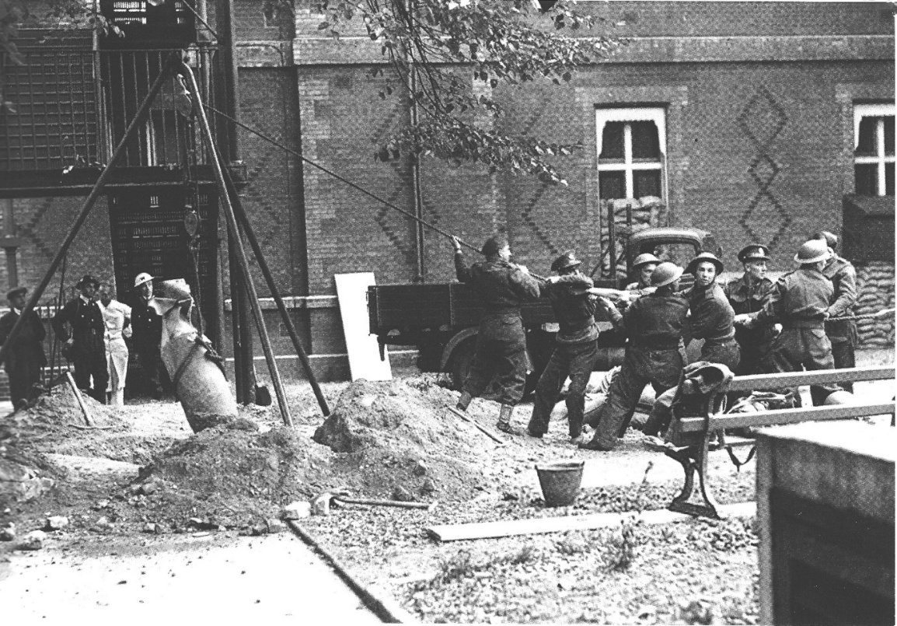

JENSEN, Gordon Martin GM, (179170) Lieutenant, 3 Bomb Disposal Company, Royal Engineers

The Citation is taken from file WO373/68/148 held at the National Archives.
Posted in the London Gazette on the 19th November 1943. Supplement 36253. Page 5067.

Lieutenant Jenson was engaged continuously from the 15t to 22nd June, 1943, on intensive bomb disposal operations following the air raid on Grimsby and Cleethorpes on the morning of the 14th June, 1943. This raid was the first of its kind an presented many new problems in bomb disposal. During the period of operations, which covered all the hours of daylight each day, Lieutenant Jensen dealt with more than sixty fully armed 2-kilogram anti-personnel bombs, most of which were in unstable positions, and fuzed to detonate on the slightest movement.

This officer displayed great coolness and ingenuity in devising and carrying out methods by which disposal could be affected with safety to the public and the minimum damage to property.

Of the number of bombs dealt with by this officer, one with anti-handling was resting near the base of a valuable piece of Belgian machinery in a timer yard. The floorboards were too loose to permit of placing sandbags without causing movement of the bomb. Lieutenant Jensen attached a cord to the arming spindle of the bomb in an attempt to pull it clear before detonation took place. The bomb exploded almost immediately on pulling but sufficiently far from the machinery to minimise greatly the resultant damage. Another bomb fell underneath valuable equipment in a cinema. Explosions in situ would have caused damage to irreplaceable parts of the equipment. Lieutenant Jensen constructed a sandbag enclosure round the bomb and a sandbag tunnel from this to the nearest door. He then placed a small mesh landing net, looped with a running bowline in place of a steel ring over the bomb and attached a cord to the free end. On pulling from a distance the bomb was successfully mover from the vicinity of the equipment before detonation took place, the only resultant damage being five broken windows.

Another bomb landed in a seven-junction manhole, and explosion in situ would have caused extensive damage. Lieutenant Jensen constructed a chimney of compressed straw trusses round the top of the manhole and suspended an electro-magnet in the centre of the chimney over the bomb. This was lowered on the bomb from distance and raised with the bomb attached until one of the straw trusses could be drawn underneath it, screening the manhole. Lieutenant Jensen released the bomb and detonated it on the truss. No damage was sustained.

Lieutenant Jensen’s outstanding personal courage, resourcefulness, and leadership were an example to his men and a valuable contribution towards restoration of public confidence and morale.

JONES, William GM, (2128323) Corporal, 23 Bomb Disposal Company, Royal Engineers

The Citation is taken from file WO373/69/160 held at the National Archives.
Posted in the London Gazette on the 2 March 1945. Supplement 36918. Page 685.

The Platoon which Corporal Jones was serving was engaged during the month of September, 1944, in the clearance of mines and booby traps from the village and neighbourhood of Orbios. Corporal Jones was responsible for clearing 11 traps, personally rendering 7 of them, 2 of which were in an extremely sensitive condition.

Although an accident occurred in a field of ‘Schumines’ in which the officer was severely wounded, Corporal Jones continued the work in the same field, although the officer concerned had expressed a doubt as to the efficiency of the apparatus being used.

When a Lance Corporal was killed and a Sapper injured by the explosion of an ‘S’ mine whilst it was being rendered safe, Corporal Jones immediately took charge of the situation and continue work in the same place in spite of the considerable danger occasioned by fallen branches and various pieces of equipment with which the area was littered.

Corporal Jones maintained a very high standard of devotion of duty and appeared completely unaffected by the risks to which he exposed himself. His leadership and initiative were a most important factor in maintaining a very high standard of morale amongst the men over a very trying time, and was a source of inspiration to other sub-units of the Company who heard of his conduct.

JONES, William Arthur GM, (1924892) Sergeant, 97 Bomb Disposal Section, Royal Engineers

The Citation is taken from file WO373/106/503 held at the National Archives.
Posted in the London Gazette on the 17 December 1940. Supplement 35014. Page 7053.

Sergeant Jones gave great assistance to his Section Leader in trying to de-fuze two 250 Kilo bombs. He has shown at all times courage, keenness and determination and has set an example to his men.

LAING, Edward GM, (22170711) Sergeant, 9 Bomb Disposal Company, Royal Engineers

The Citation is taken from file WO373/66/1357 held at the National Archives.
Posted in the London Gazette on the 30th September 1941. Supplement 35292. Page 5654.

Sergeant Laing has been engaged on bomb disposal work since June, 1940. He has always displayed a tremendous enthusiasm for his work and also a complete disregard of personal danger. He has undertaken approximately one hundred reconnaissance’s of bombs, and his keenness, steadiness, physical and moral courage have been a splendid example to his Section.

On the 4th September, 1940 at Birmingham, a 250-kilogram bomb fell on a factory and penetrated to a depth of thirty-two feet beneath the foundations. During excavation a stratum of old calcium carbide was encountered. One of his Section was overcome by the fumes, but Sergeant Laing extricated him, at great personal risk, from the bomb crater. He then went into the crater again and cleared the remaining carbide. The bomb was finally cleared by Sergeant Laing.

On two other occasions Sergeant Laing and his party responsible for the removal of unexploded bombs from factories at Birmingham, one of them being fitted with a number 17 and the other with a number 25 fuze. During these operations Sergeant Laing showed energy, initiative, and steadiness.

Sergeant Laing has shown a great capacity for inspired leadership and consistent courage of a very fine order.

LANHAM, Kenneth, GM, (166473) Lieutenant, 17 Bomb Disposal Company, Royal Engineers

The Citation is taken from file WO373/68/437 held at the National Archives.
Posted in the London Gazette on the 5th May 1944. Supplement 36498. Page 2049.

At Taranto, between 16^{8h} September and 16th October, 1943, Lieutenant Lanham defuzed and removed six British unexploded bombs fitted with long delay fuzes and anti-handling devices. The bombs could not be blown up, in situ without serious interference with Naval and Military Operations, as one of the was near the main aqueduct, four were on a railway and one in a gasworks. Great courage and ingenuity were required in carrying out the task, which Lieutenant Lanham successfully carried out, thereby preventing serious hinderance to operations.

Further information
No information at this time was given to the teams in regard to British fuzing systems in case BD personnel were captured

LAWSON, Bertie McIntyre GM, (1986577) Corporal, 8 Bomb Disposal Section, 4 Bomb Disposal Company, Royal Engineers

The Citation is taken from file WO373/66/363 held at the National Archives.
Posted in the London Gazette on the 5th May 1944. Supplement 36498. Page 2049.

When enemy aircraft bombed Norwich on the 9th September, 1940, a large delay action bomb, which was fitted with a clockwork fuze, dropped in Theatre Street, penetrating to a depth of twenty feet below the road surface. Corporal Lawson was one of a party which excavated and removed the bomb. It had fallen in a crowded residential and business area, a large portion of which had to be evacuated. Where all the party showed the coolest courage and devotion to duty, Corporal Lawson easily led the way: heartening the others by his gallant example. His act is through an acumination of more than two months constant devotion to duty and courage in the face of imminent danger.

LEA, Charles William GM, (65769) Temporary Captain, Bomb Disposal, Royal Engineers

The Citation is taken from file WO373/66/1353 held at the National Archives.
Posted in the London Gazette on the 30th September 1941. Supplement 35292. Page 5654.

On the 9th November 1940, a German aeroplane, carrying a load of bombs, crashed at Bromley, demolishing two houses and trapping certain of the occupants in the debris. Captain Lea gave immediate assistance regardless of the difficulty and danger involved. Nearly thirty bombs required to be disposed of, some of them were in the debris and others entangled in the wreckage of the aeroplane. Captain Lea took the matter in hand himself and in the course of the night and following morning by skilful and courageous work, he completed the disposal of all the bombs, so making it possible for the rescue of the trapped persons to proceed in safety. This case is typical of many others in which gallantry of this officer has been a safeguard to the whole neighbourhood.

On another occasion when a parachute mine fell at Loring Hall, North Cray, Captain Lea, with the concurrence of the Superintendent Naval Officer, approached the mine and placed under its nose a charge of six slabs of guncotton and connected up the exploder. The work was extremely dangerous as the bomb fuze mechanism had started to run on two previous occasions, and only a few seconds were left before exploding. The mine was successfully detonated.
This officer has carried out over three hundred reconnaissance’s of unexploded bombs and has personally supervised the rendering safe of all the bombs in his area, which have presented abnormal conditions of difficulty and danger.

LEE, Ralph Henry GM, (135081) Second Lieutenant, 9 Bomb Disposal Company, Royal Engineers

The Citation is taken from file WO373/66/359. held at the National Archives.
Posted in the London Gazette on the 22nd January 1941. Supplement 35050. Page 462.

When a 500-pound delay action bomb fell in the machine shop of a factory employed on vital aircraft production, the fuze was found to be still ticking. O wing to the time (45 hours) which had elapsed, explosion was probable at any moment. Second Lieutenant Lee cleared his men away and himself made a determined effort to remove the fuze, but found he could not do so. He then got a crowbar and managed to extract the electrical part, but the essential clockwork part, still ticking, remained immovable with the detonators. He then decided to fill the fuze pocket with water in order to make the clock stop, and subsequently he filled the hole too, so as to provide a greater water pressure. This was successful and the bomb removed next morning. He worked for 35 minutes alone in what well knew was most imminent danger.

MAITLAND, Reginald James GM, (140277) Acting Lieutenant, 23 Bomb Disposal Company, Royal Engineers

The Citation is taken from file WO373/67/276. held at the National Archives.
Posted in the London Gazette on the 24th March 1942. Supplement 35489. Page 1330.

This officer has been continuously engaged on Bomb Disposal duties since September, 1940; since when he has dealt with two hundred and fifty bombs, and carried out a similar amount of reconnaissance’s. On two occasions he escaped by minutes bombs which spontaneously exploded whilst they were being dealt with.

He has been in charge of a Section at Southampton during the time that the heaviest raids were made on that city, and has borne a large share of the work. He has consistently displayed cool courage and dogged devotion to duty despite several narrow escapes from death during the execution of his duties. On four different occasions, although the extremely dangerous characteristics of the bombs which he was dealing with was known, the necessary equipment and techniques for dealing with them was not available. And grave risks which he took to render the bombs safe were deliberate and cold blooded, demanding a high degree of personal courage and tenacity of purpose.

MANSER, Harold Arthur GM, Second Lieutenant, 93 Bomb Disposal Section, 1 Bomb Disposal Company, Royal Engineers

The Citation is taken from file WO373/66/149 held at the National Archives
Posted in the London Gazette on the 17th December 1940. Supplement 35014. Page 7053.

Second Lieutenant Manser has displayed great qualities of courage and endurance on many occasions in dealing with unexploded bombs. On 18th August, a bomb fell in a factory and embedded itself deeply in concrete. The bomb which weighed 250-kilogram was of a delay type and could be heard ticking. Second Lieutenant Manser, assisted by Sergeant Jones, uncovered the bomb and worked on it for a considerable time, in an attempt to render it harmless. He discontinued his efforts on instruction from H.Q. On 2nd September, another delay action bomb still remained unexploded in a different area. Lieutenant Manser assisted by Sergeant Thorne, disregarding the considerable risk of accident, skilfully removed the fuze. Lieutenant Manser has worked extremely hard over a long period under conditions of great difficulty and danger.

The Recommendation is taken from file WO373/106/502 held at the National Archives.

Recommendation is similar to the above. It would seem a duplicate held on the National Archives files. Recommendation WO373/66/149 this is the one the George Medal award was made to.

On 18 August, 1940, Second Lieutenant Manser assisted by a Sergeant uncovered a 250-kilogram bomb which was ticking. After working on it for considerable time he desisted only on receiving orders to do so. On 2nd September again helped by the same Sergeant, he removed the fuze from a delay action bomb.

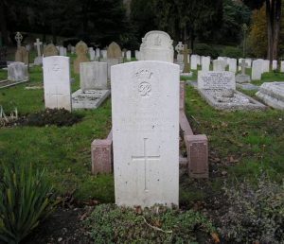 | Further Information  Second Lieutenant Manser was unfortunately killed on 08 November 1944 while working on an unexploded bomb, with Corporal H A Wood. Died aged 22, buried at Aldershot Military Cemetery, Grave AA 40.  Photo credit: David Williams

MARTIN, Frances Robert GM, (120736) Second Lieutenant, 5 Bomb Disposal Section, Royal Engineers

The Citation is taken from file WO373/106/501 held at the Nation Archives.
Posted in the London Gazette on the 13th December 1940. Supplement 35014. Page 7053.

Second Lieutenant Martin was informed that an unexploded bomb had fallen on a private residence where a lady was lying dangerously ill and could ne be removed. He had recently lost four of his men in dealing with a similar bomb and decided to recover this one by himself, so as not to risk any further lives. After several hours of solitary excavation, he succeeded in extracting the fuze (which he found to be still ticking) and removed the bomb. It is considered that Second Lieutenant Martin’s action undoubtedly saved the lady’s life at the imminent risk of his own. Second Lieutenant Martin has frequently worked until the early hours of the morning rendering delayed action bombs harmless which have fallen near buildings of national importance. Second Lieutenant Martin was unfortunately killed during the month of October whilst working on an unexploded bomb.

Further Information
There is a second recommendation held on file at the National Archives for this same incident - WO373/66/110 - recommending the award of the George Cross. It is superseded by WO/373/106/501 and the awarded of the George Medal. It reads:
On the 16th September, 1940, Second Lieutenant Martin was informed (as Officer Commanding 5 Bomb Disposal Section, RE) that an unexploded bomb had fallen on Lord Stanhope’s residence at Chevening where Lady Stanhope was lying so dangerously ill that she could not be moved from the house.
Second Lieutenant Martin had recently lost four of his men in dealing with a similar bomb and decided to recover this one by himself so as not to risk any further lives. After several hours if solitary excavation he succeeded in extracting the fuze (which he found to be still ticking) and removed the bomb. It is considered that Second Lieutenant Martins action undoubtedly saved Lady Stanhope’s life at imminent risk of his own.

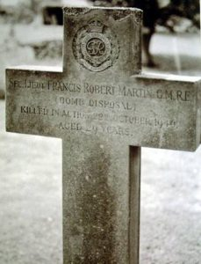 | Further Information  Second Lieutenant F R Martin died on the 22 October 1944 age 29 and is buried Cuckfield Cemetery, Sussex, Plot 2 SE Grave 76. He was dealing with a UXB reported by the local air raid wardens. At a large detached property call ‘Flaneswood’, situated just of the A25 road on Seal Chart, near Stone Street, Sevenoaks. Whilst defuzing the UXB it exploded.  Photo credit: Pete Mason
McCARTNEY, John Richard Filgate GM, Temporary Captain, 3 Bomb Disposal Company, Royal Engineers

The Citation is taken from file WO373/66/354 held at the Nation Archives.
Posted in the London Gazette on the 22nd January 1941. Supplement 35050. Page 462.

During the night of 28th August, 1940, eleven bombs were dropped at Hartshorne. Two of the bombs failed to explode and had penetrated to a depth of nearly thirty feet into the ground. It was only after a considerable amount of hard and hazardous work had been carried out that Captain McCartney and the men of his Company were able to recover the bombs and render them harmless. Captain McCartney’s gallant conduct was again brought to notice for dealing with another bomb that fell at Staveley.

MEYNELL, Lionel Charles GM, (93424) Lieutenant, 9 Bomb Disposal Company, Royal Engineers

The Citation is taken from file WO373/66/1357 held at the Nation Archives.
Posted in the London Gazette on the 30th September 1940. Supplement 35292. Page 5654.

Lieutenant Meynell has been employed on bomb disposal work since September 1940.He has carried out approximately 150 reconnaissance’s of bombs, and on one occasion missed an explosion by three minutes. He has been in charge of a Section permanently stationed at Coventry since October 1940, and has thus borne a large share of the work in that City.

On the 16th October 1940, at Church Lawford, an oil incendiary was reported to have fallen amongst the hangers at the aerodrome. When Lieutenant Meynell arrived on the scene, he found that it was not an incendiary, but a 250-kilogram bomb fitted with a number 17 fuze, which was ticking He successfully removed the fuze and rendered the bomb harmless, therefore saving important buildings and equipment.

On another occasion when an unexploded bomb was dropped on some works engaged on vital production, Lieutenant Meynell, assisted by a Sergeant, lifted the bomb onto a lorry and then drove it personally to a site nearly a mile away, where it was detonated.

Lieutenant Meynell’s record of service in a heavily raided City constitutes an outstanding record of sustained courage and devotion to duty.

MITCHELL, Harry GM OBE, (131795) Temporary Captain, 95 and 96 Bomb Disposal Sections, Royal Engineers

The Citation is taken from file WO373/66/112 held at the Nation Archives.
Posted in the London Gazette on the 17th December 1940. Supplement 35014. Page 7053.

On 13t August, 1940, Second Lieutenant Mitchell received instructions to deal with several unexploded bombs. One of these a 250-kilogram bomb was found to have a new type of fuze with a” ticker” delay action, the first of its kind to be encountered, about which no information was available. Second Lieutenant Mitchell decided to dismantle rather than demolish the bomb, in order to preserve the fuze and delay action mechanism for examination. This he did personally at a very great risk.

Second Lieutenant Mitchell has dealt personally with a large number of other bombs and has set a splendid example of courage and tireless energy to his men.

Citation WO373/106/501 for the same incident awards made to Citation WO373/66/112.

Further Information
Second Lieutenant H Mitchell was also awarded the Officer of the Order of the British Empire (see separate entry).

MORGAN, Lionel Hayden GM, (327881) Lieutenant, 7 Bomb Disposal Company, Royal Engineers

The Citation is taken from file WO373/69/645 held at the Nation Archives.
Posted in the London Gazette on the 5th October 1945. Supplement 37294. Page 4889.

This officer has been working on Bomb Disposal and Minefield clearance in Southern Command since joining 7 Bomb Disposal Company in September, 1944.

On the 8 December, 1944, he was in charge of the minefield party working on a very difficult minefield at Wyke Regis, Dorset, when there was an accident in which a N.C.O lost his life. Lieutenant Morgan, although himself injured attended to the needs of other personnel who had been more seriously injured. He entered the live part of the minefield in order to remove the injured and the body of the dead N.C.O, whose body was badly mutilated, and later carried on the work of clearing the remainder of the minefield.

Lieutenant Morgan fearlessly tackled the most dangerous fields which were left to be cleared of mines, and when in charge of this work and carrying out the removal of other dangerous missiles, he has always performed the most difficult tasks without regard for personal safety. In all the operations Lieutenant Morgan has displayed courage and initiative of a high order. By his confidence and keenness, he has set an example and been an inspiration to the men working under him; at the same time earning the confidence of his superior officers.

Further Information
Sergeant Cann was awarded the George Medal for the incident mentioned on the 28th October 1940.

NEWITT, Clive Neville GM, (139087) Second Lieutenant, 5 Bomb Disposal Company, Royal Engineers

The Citation is taken from file WO373/67/274 held at the Nation Archives.
Posted in the London Gazette on the 24th May 1942. Supplement 35498. Page 1330.

Lieutenant Newitt commenced Bomb Disposal work in September, 1940, since when he has dealt with approximately 230 bombs and carried out a large amount of reconnaissance’s in London Civil Defence Region, many of these at night and under blitz conditions.

He has always shown a complete disregard for danger, and has at all times displayed a cheerful readiness to tackle any job at hour of the day or night. He has been a wonderful example to the men in his Section.

Lieutenant Newitt’s record over many months of Bomb Disposal operations, including the period of heavy and sustained raids on London, discloses gallantry and devotion to duty and of a very high order. A particularly good example was when he dealt with a bomb which was fitted with both delayed action and anti-handling fuzes; the bomb may have exploded at any moment during the entire operation. Lieutenant Newitt’s action on this occasion was deliberate and calculated requiring exceptional courage and devotion to duty in face of grave danger. He has on four occasions narrowly escaped destruction by delayed action bombs which have detonated during disposal operations.

Further Information
Was also awarded the Member of the Order of the British Empire.

PARKER, Reginal Charles Mons GM, (1871236) Lance Sergeant, Malta Fortress Company, Bomb Disposal Section, Royal Engineers.

The Citation is taken from file WO373/66/1004 held at the Nation Archives.
Posted in the London Gazette on the 27th May 1941. Supplement 35173. Page 3019.

A 2,000pond unexploded bomb was wedged in the doorway of a house in a very congested area (at Malta). A new type of cap was found to cover the fuze and a booby trap was suspected. The fuze was underneath and to remove it, it was necessary to turn over the bomb by hand. Lance Sergeant Parker was particularly prominent in this operation.

On two occasions he worked on clearing aerodromes of unexploded bombs after heavy attacks. Owing to the urgent necessity of getting the aerodrome fit for use many of the usual safety precautions had to be omitted. On both occasions he worked all day in close proximity to unexploded bombs of which the fuzes were unknown

PARKER, William Gregg GM MBE, (135029) Temporary Major, 5 and 6 Bomb Disposal Company, Royal Engineers.

The Citation is taken from file WO373/69/647 held at the National Archives.
Posted in the London Gazette on the 2nd October 1945. Supplement 37294. Page 4889.

Major Parker has been employed on the clearance of minefields for the past eighteen months and has carried out his duties with great skill. He has also shown great ingenuity and resource on all occasions and has maintained a high morale in the men working under him in spite of distressing accidents.

One particular minefield in the vicinity of a magazine at Corsham he considered so difficult to clear that he decided to do the work himself. This particular minefield was situated in a tunnel some 150 feet deep in complete darkness. Artificial light was provided. The field consisted of sixteen Anti-Tank Mark 1 mines fitted with mechanism. Boards were laid across the field which was covered with felt and gravel. The problem of clearing was made more difficult by the lack of knowledge of the pressure at which the mechanism would work after such a length of time, the field was laid in 1940. Accepting all risks, Major Parker personally and alone attacked the field and successfully cleared it. The field was causing great anxiety and its clearance proved to be a great benefit. Too much credit cannot be given to Major Parker for his courage, determination and skill, he having worked under such demoralising conditions. This officer has persistently carried out Bomb Disposal operations with great skill and courage since 1940.

Further Information
Was also awarded the Order of the Medal of the British Empire (see separate entry).

PRICE, Brompton Hucker Philip GM, (152404) Lieutenant, 7 Bomb Disposal Company, Royal Engineers

The Citation is taken from file WO373/67/43 held at the National Archives.
Posted in the London Gazette on the 28th October 1941. Supplement 35326. Page 6247.

Lieutenant Price has been engaged continuously on Bomb Disposal work since October, 1940. After the heavy raids which took place on Plymouth and Devonport in April, 1941, he made reconnaissance’s and dealt with 13 Category “A”, 147 Category “B” and 69 Category “C” and “D” unexploded bombs, 20 of which exploded by delayed action. Reconnaissance’s on the Category “A” bombs were made immediately after they were reported, in many cases at night and whilst raids were in progress. Two incidents are mentioned: -

At Plymouth on the 22nd and 23rd April, 1941, a suggested Category “A” bomb was reported near the Police Divisional Headquarters. Lieutenant Price alone, drove his utility van from its billet to the site through the streets almost blocked by bomb craters and surrounded by burning and collapsing buildings. The bomb, which weighed 250-kilograms and had a No.15 fuze, was found lying on the surface. This bomb Lieutenant Price defused and removed. During operations bombs of all calibres were dropping in the neighbourhood. His prompt action prevented the evacuation of the Guildhall and also serious dislocation of important Civil Defence Services.

At Avonmouth on the 15th January 1941, a Category “A” bomb was reported in a Silo at the National Smelting Works. Lieutenant Price excavated inside the Silo, through 100 tons of phosphate and part of the structure, and removed a 1000-kilogram bomb fitted with a No 28 fuze. The works were in full production 12 hours after the bomb had fallen.

The Commander-in-Chief, Plymouth states that Lieutenant Price has worked tirelessly, and has shown great skill, personal courage and leadership while dealing with the many unexploded bombs which fell on Plymouth on the 21st and 22nd March, 1941, and also in later raids.

The Director of Bomb Disposal, Home Forces, adds that Lieutenant Price has displayed conspicuous gallantry and devotion to duty under appalling conditions during the extremely heavy raids on Plymouth; that he has on several occasions missed death by minutes when engaged on reconnaissance of unexploded bombs, and that he has at all times placed duty before his own safety.

QUARENDON, Gordon Harold GM, (1895955) Sergeant, 14 Bomb Disposal Company, Royal Engineers

The Citation is taken from file WO373/67/277 held at the Nation Archives.
Placed in the London Gazette on the 24th March 1942. Supplement 35489. Page 1330.

This N.C.O has been engaged on Bomb Disposal duties since September, 1941, he has been occupied on work of an exceptionally dangerous character during and immediately after heavy air raids.

Together with his Section Officer, he has been instrumental in saving a great deal of property and lives during extremely savage air attacks on Hull, with complete disregard for personal safety, and under conditions of extreme peril. On one occasion he accompanied his officer on a truck when removing a bomb in which the fuze was jammed, and which was in a highly dangerous state, to a place of safety for disposal. On another occasion this N.C.O by his cool courage and dogged determination, dealt successfully with a delayed action bomb which was a potent menace during the entire operation.

This N.C.O has proved himself to be a fine example to the men working under him.

RABY, Eric Russell GM, Lieutenant, 75 and 76 Bomb Disposal Sections, Royal Engineers

The Citation is taken from file WO373/106/409 held at the National Archives.
Posted in the London Gazette on the 17th December 1940. Supplement 35014. Page 7053.

Lieutenant Raby has dealt with a very large number of unexploded bombs, and personally immobilised every bomb himself, and by his example has set a hight standard of coolness and courage which is essential in the carrying out of his work.

On September 6th, in Manchester area he recovered a 250-kilogram bomb, the clockwork mechanism of which was still working after the fuze had been removed by remote control, 16 hours after falling. Within two minutes of removing the E.I.A.Z (17) body, and gaine attached to the clockwork mechanism, it exploded in his hands.

Further Information
National Archives holds a duplicate entry WO373/66/111. This file shows that the initial recommendation was for the award of the George Cross superseded by WO373/106/409 and awarded the George Medal.

RADFORD, Frederick GM, (135034) Acting Lieutenant, 66 Bomb Disposal Section, 4 Bomb Disposal Company, Royal Engineers

The Citation is taken from file WO373/66/1210 held at the National Archives.
Posted in the London Gazette on the 22nd July 1941. Supplement 35225. Page 4212.

Lieutenant Radford displayed conspicuous gallantry in carrying out hazardous work in a very brave manner. He is one of the pioneers of bomb disposal and has been doing this work for ten months. He has shown undaunted courage in assisting with the defusing and demolition of the first parachute mines and has dealt with over one hundred and sixty bombs of dangerous types. He has always displayed complete disregard of danger and has obtained much valuable information for intelligence purposes. His example over a long period has been an inspiration to his men.

Further Information
Second Lieutenant F Radford also received a Kings Commendation for Bravery.

RAMAGE, Daniel Hunter GM, (135035) Second Lieutenant, 81 and 82 Bomb Disposal Sections, Royal Engineers.

The Citation is taken from file WO373/66/761 held at the National Archives.
Posted in the London Gazette on the 11th March 1941. Supplement 35099. Page 1427.

On the 4 September, 1940, when an enemy bomb fell on the works of Messer Pilkington Bros. at St Helens, Lieutenant Ramage, in very difficult circumstances, removed the fuze and picric acid from the bomb. The bomb had penetrated twelve feet, and when it was reached it was found that the fuze could not be removed in the usual manner as the fuze sleeve had sheered. As production at the works was being held up, he decided that another method must be attempted. He, therefore unscrewed the filling cap and removed sufficient explosive to enable him to take out the sleeve with its fuze and picric acid. His conspicuous courage has come to notice on various occasions, and he has led the men of the Bomb Disposal Sections under his command with coolness, ability, and disregard of danger worthy of the highest praise.

RAYNER, Douglas Stanley Frederick GM, (135406) Lieutenant, 81 and 82 Bomb Disposal Section, Royal Engineers.

The Citation is taken from file WO373/66/358 held at the National Archives.
Posted in the London Gazette on the 21st January 1941. Supplement 35050. Page 462.

On the 3 Sept 1940 six unexploded bombs fell in and around an important aeroplane factory necessitating an extensive stoppage of work. Lieu. Rayner was on the spot within a short time, supervised the excavation of the bombs and personal removed the fuzes of all six. His work was carried out so speedily that only one-half day of production was lost at the factory, by his skill and courage a large portion of a works of national importance was saved from production.

On 6 Sept 40. In a congested factory area, a 250-kilogram (550lbs) bomb was uncovered having a delayed action fuze. The clock was still ticking and it was realised that the danger of explosion with great damage to the factory production was imminent.

Fully realising the danger, this Officer began to withdraw the fuze but found this had become damaged in falling and could not be moved by hand whereupon he resorted to the use of a marlinespike and succeeded after 35 minutes in prising out the fuze. The bomb was safely removed.

Further Information
Duplicate report held at National Archives file WO37366/687.
Initially recommended for the Military Cross (Immediate Award) by Colonel L.C. Trench DSO CMG. Commanding Birmingham & South Staffs Sub Area.

RENFREW, James Baird, (2127158) Acting Lance Sergeant, 3 Bomb Disposal Company, Royal Engineers

The Citation is taken from file WO373/68/153 held at the National Archives.
Posted in the London Gazette on the 19th November 1943. Supplement 36253. Page 5067.

Lance Sergeant Renfrew was engaged continuously on bomb disposal operations for a period of four weeks following the enemy air raid on Grimsby and Cleethorpes on the morning of 14 June, 1943. He disposed of more than fifty fully armed 2-kilogram anti-personnel bombs, 38 if these during the period 16th to 21st June, when he was intensely engaged on this work during all the hours of daylight. He displayed ingenuity on this work, presence of mind, and outstanding courage in dealing with bombs fuzed to detonate on the slightest movement, many of them in unstable positions where laying a charge or even approach to the bomb involved great risk.

RICHARDS, Brian Leolin GM, (152176) Acting Lieutenant, 25 Bomb Disposal Company, Royal Engineers

The Citation is taken from file WO373/66/1133 held at the National Archives.
Posted in the London Gazette on the 8th July 1941. Supplement 35213. Page 3920.

In May 1941, Lieutenant Richards removed an unexploded bomb from the Ballroom of the Yorkshire Grey Hotel, Eltham. The bomb was dealt with after the usual safety period and found to be of the 250-kilogram type with its nose uppermost. One (17) fuze was exposed in the top pocket, which was found to be ticking. Lieutenant Richards promptly withdrew all his men and decided to leave the bomb for a further 96 hours.

On completion of this second safety period the bomb was again tackled. Water had collected in the excavation and this had to be pumped out before work could be carried out on the bomb itself. The hard “marly” gravel had turned soft through the action of the water and slid in under the runners completely covering the bomb.

Lieutenant Richards insisted upon doing all the digging himself. Fresh timbers were run inside the existing shuttering and were gently pushed into the gravel. This eventually prevented the threatening collapse. Eventually the bomb was exposed to the nose weld. Some driving of the timbers next to the bomb now became necessary in order to make further excavation possible. He then drove the timbers with the assistance of the supervising officer. This did not start the clock and the excavation proceeded. For no apparent reason, however, the clock started to tick intermittently. It was obvious that the bomb was in an extremely precarious state, and the nature of the second fuze was unknown. A very important road junction had been closed for 9 days so a further safety period could hardly be considered. The only solution therefore was to blow up the bomb if the clock should stop clicking. It was considered that it would be reasonably safe if the clock should stop for not less than ten minutes. He prepared his charge and lashed it on board. The clock eventually stopped and Lieutenant Richards ran in with his charge. He found great difficulty in the water and the dark in placing the charge, so he decided to go down the hole and place the charge on the bomb. This was particularly gallant as the gravel was of a gluey nature and there was very real danger of getting stuck. More ever the water was three feet above the bomb. In spite of this he succeeded in laying the charge successfully, and the bomb was blown.

Lieutenant Richards behaved in an exemplary manner throughout the whole operation which involved almost continuous work for above eighteen hours. He never risked his men, taking the risk himself whenever it became necessary.

ROBINSON Kenneth Hugh GM, (166532) Lieutenant, 3 Bomb Disposal Company, Royal Engineers

The Citation is taken from file WO373/68/563 held at the National Archives.
Posted in the London Gazette on the 28th July 1944. Supplement 36628. Page

Lieutenant Robinson has been employed on bomb disposal work since January, 1941, both in London and Norwich areas. Since then, he has personally dealt with nearly two hundred high explosive bombs and one hundred and fifteen anti-personal bombs. Lieutenant Robinson has always proved himself an excellent leader and his cheerfulness and courage have at all times inspired great confidence in his brother officers and the personnel of the Sections he has commanded.

Of the one hundred and fifteen anti-personnel bombs which Lieutenant Robinson dealt with, seventy-five called for sustained courage and coolness, as the disposal of each bomb which were fitted with 70B Fuzes, constituted a risk. The remaining sixty-five constituted a considerable cumulative risk in their being dealt with. It is considered that this one performance merits award, although Lieutenant Robinson’s other actions in disposing of a large number of unexploded high explosive bombs and clearing of beach mines, serves to support the recommendation

RUTH, Horace Cecil GM, (152400) Lieutenant, 14 Bomb Disposal Company, Royal Engineers

The Recommendation is taken from file WO373/67/128 held at the National Archives.
Posted in the London Gazette on the 13th January 1942. Supplement 35416. Page 231.

Lieutenant Ruth was posted to Hull with No. 11 Bomb Disposal Company, at the beginning of January, 1941, since when Hull and district has been subjected to air raids of varying severity.

O the 16th February, 1941, an unexploded bomb was reported to have fallen on Bridlington Railway Station. Lieutenant Ruth made a reconnaissance and work on the bomb was started. This bomb weighed 250-kilograms and was fitted with a number 17 and 50 fuzes. Lieutenant Ruth defuzed the bomb and rendered it harmless, thereby enabling the Railway to be in full operation by 6pm the same day.

On the 27th March, 1941, an unexploded bomb fell on Messrs Quiblings yard at Hull. Lieutenant Ruth made a reconnaissance and started to work on the bomb immediately. This bomb also weighed 250-kilograms, but was fitted with two number 17 fuzes, which were still ticking. The bomb was recovered and taken to the bomb cemetery where it detonated immediately afterwards.

On the 19th July, 1941, an unexploded bomb was reported to have fallen immediately outside, the Central Fire Station at Hull during a heavy raid. Lieutenant Ruth carried out investigations at once. This bomb proved to be one of a stick of four, one of which had detonated in the immediate vicinity, whilst he was making his reconnaissance. It was concluded that the unexploded bomb contained a number 17 fuze. Bombs were occasionally falling round about and a large fire was raging. It was therefore absolutely essential that the Fire Brigade should go out without delay. Lieutenant Ruth stood by the unexploded bomb and directed operations until the firefighting appliances were safely out of danger. The bomb detonated later as Lieutenant Ruth was returning to the incident after making a reconnaissance of another bomb. Owing to Lieutenant Ruth’s work in directing safety precautions during the raid, no damage whatever was caused to firefighting appliances.

Again, on the 19th July, 1941, Lieutenant Ruth found a 500-kilogram unexploded bomb which had fallen on some premises. This bomb was buried four feet below the surface. With the help of a Sergeant, he dug up this bomb which was found to be fitted with two unidentified fuzes with broken tops. In one hour, work on the premises of vital national importance was able to resume.

Lieutenant Ruth has at all times displayed a high standard of leadership and shown a complete disregard for personal safety. His continuous fine work and splendid example, has shown his men, together with his powers of leadership, are deserving of recognition.

SANDERS, Andrew GM, Corporal, 9 Bomb Disposal Company, Royal Engineers.
The Citation is taken from file WO373/66/1359 held at the National Archives.
Posted in the London Gazette on the 30th September 1941. Supplement 35292. Page 5654.

Sergeant Sanders has been engaged on bomb disposal work since August, 1940 He has always displayed a cheerful disregard of personal danger and his example has been of incalculable value. He has taken charge of at least five Category “A” excavations, and has been twice injured during operations, but this has had no effect on his keenness and capacity for tackling any task.

On one occasion when a 250-kilogram bomb fell alongside the condensers at a gas works, Sergeant Sanders volunteered to take charge of a working party, and by his steadiness and energy he kept the party working until the bomb was finally disposed of. This bomb was found to have a number 17 fuze.

On another occasion when a bomb lodged beneath the foundations of a house, a water main burst during excavation operations. One man who was pinned in the hole was extricated by Sergeant Saunders, who secured himself by a rope and descended into the crater. During the rescue of this man there was imminent danger of a wall collapsing into the hole made by the bomb. Sergeant Sander’s prompt action saved the man’s life as the wall later collapsed.

Sergeant Sander’s record is an outstanding example of cold-blooded courage and continuous devotion to duty.

SHARMAN, Thomas Henry GM, (71764) Temporary Captain, 9 Bomb Disposal Company, Royal Engineers

The Citation is taken from file WO373/66/1353 held at the National Archives.
Posted in the London Gazette on the 30th September 1941. Supplement 35292. Page 5654.

Captain Sharman has been continuously on bomb disposal work since June 1940. Since that date he has extracted approximately two hundred bombs and carried out the same amount of reconnaissance’s. He has always displayed a readiness to tackle any task at any time of the day or night.

On the 19th October 1940, he successfully dealt with a bomb weighing 250-kilograms, which had fallen on the G.E.C works at Witton, Birmingham. This bomb had a number 17 fuze and had only been down for about two and a half hours.

Again, at Birmingham on the 12th December, 1940, when a bomb fell on the B.S.A (Guns) Factory, this officer took a party to the site and despite the fact that a very heavy raid was in progress and bombs were being concentrated on the district, he located the bomb and commenced to work on it. This bomb also had a number 17 and 50 fuze, but it was successfully dealt with.

On the 10th April, 1941, at Birmingham, Captain Sharman successfully dealt with a Category “A” bomb which fell on the Wolseley Motor Factory. The bomb weighed 250-kilograms and had both number 17 and 50 fuzes. The removal of the bomb enabled work at the factory to proceed uninterrupted. This officers record is considered to be outstanding for sustained and cold-blooded disregard for personal safety.

SHARP, Robert GM, (16227) Lieutenant, 3 Bomb Disposal Company, Royal Engineers

The Citation is taken from file WO373/68/151 held at the National Archives.
Posted in the London Gazette on the 19th November 1943. Supplement 36253. Page 5067.

Lieutenant Sharp displayed courage and devotion to duty of a high order during bomb disposal operations following the enemy air raid on Grimsby and Cleethorpes on the 14th June, 1943. The raid was the first of its kind and presented many new problems in bomb disposal.

On the morning of the raid two railways in the vicinity of Grimsby and a section of the Power Station were held up by 2-kilogram anti-personnel bombs, all with fully armed 70B. fuzes, and in an extremely sensitive condition. By 4.30 a.m. Lieutenant Sharp had personally disposed of ten bombs, and restored the services to full operation.

On the 15th June, 1943, after disposing of eight bombs, he was wounded in the hand and leg by an unsuspected anti-personnel bomb. In spite of considerable pain, and against medical advice, he insisted in carrying on, and during the remainder of that day and part of the next he disposed of five more bombs. It was not till ordered to do so on the evening of the 16th June, 1943, that he reported to hospital. He was released from hospital on 19th June, 1943, and on that and the following day defuzed thirty bombs and detonated fifteen others. On the 22nd June he defuzed one hundred and thirty bombs at a farm.

Throughout the operations Lieutenant Sharp’s confidence and resource were a major contribution towards the restoration of public morale.

SHELBOURNE, Clifford Percy GM, (120604) Temporary Captain, 9 Bomb Disposal Section, 4 Bomb Disposal Company

The Citation is taken from file WO373/66/669 held at the National Archives.
Posted in the London Gazette on the 21st January 1941. Supplement 35047. Page 401.

On 2nd September, 1940, unexploded bombs were dropped on the main railway line between Brentwood and Shenfield stations, blocking the main line to the East coast. Owing to the extreme urgency the usual safety period was waived and Captain Shelbourne with others recovered his share of the bombs, defuzed them and helped in opening the line in ten hours, during the whole time being fully aware that an explosion might take place at any moment. Captain Shelbourne was one of the first officers to be engaged in the demolition of parachute mines both after they had been dealt with by the Admiralty and also when that had been found to be impossible.

Further Information
Initially recognised with the Kings Commendation see separate entry.

SIMPSON, Frank Cecil GM, (2009432) Sergeant, 3 Bomb Disposal Company, Royal Engineers

The Citation is taken from file WO373/68/151 held at the National Archives.
Posted in the London Gazette on the 16th November 1943. Supplement 36253. Page 5067.

Sergeant Simpson was engaged continuously on bomb disposal operations for a period of four weeks following the enemy air raid on Grimsby and Cleethorpes on the morning of the 14th June, 1943. He disposed personally of more than sixty fully armed 2-kilogram anti-personal bombs, forty-three of them during the period 14th to 21st June, when he was intensively engaged on this work during all hours of daylight. He displayed exceptional courage and resource in dealing with bombs in difficult situations, where disposal operations, and even approach to the bombs involved the risk of detonation by vibration or movement.

One bomb fell inside the panelling of the organ in a Chapel. At great risk of vibrating the bomb Sergeant Simpson removed a portion of the organ panelling and placed a hook round the arming spindle. He succeeded in drawing the bomb free of the organ by remote control but it detonated before reaching the window. There was minor damage but the organ sustained no damage. Another bomb fell in a downstairs front room of a house. At risk of vibrating the bomb Sergeant Simpson personally removed all moveable furniture and fittings etc. As the bomb detonated immediately on attempting to move it by remote control these articles would otherwise have been irreparably damaged. Another bomb became buried in a rock garden. At grave risk of detonation owing to loose stones, Sergeant Simpson uncovered the bomb. Before detonating it in situ he built an enclosure of straw trusses round the bomb and although a house was only five feet away no damage was caused.

SIVIL, Eric Wilfred GM, (P/245978), 14 Bomb Disposal Company, Royal Engineers

The Citation is taken from file WO373/69/158 held at the National Archives.
Posted in the London Gazette on the 2nd February 1945. Supplement 36818. Page 685.

Lieutenant Sivil has been employed on active Bomb Disposal work for the past two years, during which time he has been personally responsible for dealing with two hundred unexploded enemy bombs. In addition to this he has been he has also recovered a similar number of anti-aircraft shell, and carried out work on British Minefields. In spite of the difficult and dangerous nature of his tasks, this has all been carried out without involving a single causality. His keenness and energy, combined with his coolness and leadership of a high order, have been an inspiration and example to all the men who worked under him.

In July, 1944, at the height of the Flying Bomb attacks, Lieutenant Sivil was detailed to neutralise a Flying Bomb that had fallen unexploded in the centre of a residential area, necessitating the evacuation of some hundreds of the civil population. Although this was the first occasion on which he had been called upon to deal with this type of bomb, he unhesitatingly undertook and successfully completed this task without incident.

His conduct and personal example on this occasion were such as to earn the highest praise of all concerned.

SMITH, Francis GM (4967723) Acting Company Sergeant Major, 14 Bomb Disposal Company, Royal Engineers

The Citation is taken from file WO373/66/1433 held at the National Archives.
Posted in the London Gazette on the 21st October 1941.

Company Sergeant Major Smith has been engaged in Bomb Disposal for twelve months, and during this period he has displayed outstanding leadership, keenness, determination and devotion to duty.

At Sunderland, on 12th August, 1940, an unexploded bomb which weighed 250-kilograms, fell close to a battery of radial drilling machines in a shipyard. This bomb penetrated to a depth of fifteen feet under some steel plates. Not long after work had commenced an air raid occurred and most of Company Sergeant Major Smiths working party took cover, but Company Sergeant Major Smith and three others volunteered to continue work. This was done by the light of a motor-cycle headlamp screened by a great coat. During this time bombs were falling, there was also much gunfire and splinters were falling all round. Work proceeded right through the raid under considerable handicap. The bomb, however, was recovered and defuzed, thereby enabling the shipyard to start work.

Company Sergeant Major Smith also carried out continuous reconnaissance of unexploded bombs during heavy enemy air raids on Sheffield between the 13th and 16th December, 1940. He and his working party disposed of six delayed action bombs which had Number 17 fuzes. One of these bombs became partially buried and very near to large petrol storage tanks. Suring operations bombs were falling in the vicinity. By his prompt action and continuous work Company Sergeant Major Smith and his party, a large conflagration was undoubtedly avoided.

The Inspector of Fortifications and Bomb Disposal states that Company Sergeant Major Smith had displayed dogged courage and unwavering devotion to duty, sustained over long period of time, and that his actions during reconnaissance on the night of the heavy blitz on Sheffield and in subsequent dealing with delayed action bombs without being in possession of the latest technical equipment, are worthy of highest praise.

SMITH, James Boyd GM, (103969) Acting Captain, Bomb Disposal, Royal Engineers

The Citation is taken from file WO373/67/412 held at the National Archives.
Posted in the London Gazette on the 4th August 1942. Supplement 35653. Page 3403.

Captain Smith displayed gallantry and continued devotion to duty at Mersa Matruh over the period 27th May 1941 to 12th September 1941. During this period, he, without thought of personal safety undertook the most hazardous work in the investigation, defusing and subsequent removal and destruction of several hundreds of enemy unexploded bombs of all types, sizes and weights up to 1000-kilograms. After the uncovering of an unexploded 1000-kilogram bomb in the fortress area, he drilled and removed the fuze at a depth of twenty-two feet in the ground. Further digging to twenty-eight feet freed the bomb which was then removed by means of a crane. He then washed out a portion of the powered T.N.T. filling and successfully burnt out the remainder.

On the 28th August, 1941, two five-hundred-kilogram time bombs were dropped in the fortress area. Captain Smith personally investigated and “stethoscoped” these bombs despite the constant danger of explosion at any moment. This officer’s timely orders and precaution saved any possible damage to personnel and defences when these bombs exploded a few hours later. Two unexploded Italian sea mines were also safely dealt with, as were anti-personnel general purpose and incendiary bombs of all types and mines. In every case Captain Smith was the first to approach and investigate these unexploded bombs and, after satisfying himself, then only were members of the Bomb Disposal Section allowed into the danger area.

STEWART, Charles Coulton GM, (119053) Lieutenant, 9 Bomb Disposal Company, Royal Engineers

The Citation is taken from file WO373/66/1355 held at the National Archives.
Posted in the London Gazette on the 30th September 1941. Supplement 35292. Page 5654.

On the 15th August, 1940, seventeen bombs, which failed to explode, fell in the vicinity of Kingston-By-Pass Road. Seven of these were extracted from the premises by Captain Stewart, two of them most skilfully from awkward positions under foundations, while two others had penetrated a large acid tank. The acid had permeated the ground around the bombs and this produced the danger that they might explode through the corrosive action of the acid while work was still in progress.

This officers devotion to duty is well illustrated by the fact that when a 500-kilogram bomb lodged itself twenty-eight feet under a public house at Mitcham. Captain Stewart remained on duty and destroyed the bomb two days after he had been instructed to take sick leave and completed this urgent work because he was not prepared to pass on the responsibility for its execution to anyone else.

Captain Stewart has carried out over one hundred and thirty reconnaissance of unexploded bombs and has personally supervised the rendering safe of all the bombs in his area, under abnormal conditions of difficulty and danger. He has consistently displayed courage and determination of a very high order, and has been an inspiring example to the officers and men working under him.

SUTTLE, Ernest Wilfred GM, (1883145) Lance Corporal, 9 Bomb Disposal Company, Royal Engineers

The Citation is taken from file WO373/66/1360 held at the National Archives.
Posted in the London Gazette on the 30th September 1941. Supplement 35292. Page 5654.

Lance Corporal Suttle has been employed on bomb disposal work since September, 1940, and has shown himself to be absolutely fearless and a source of confidence to the other personnel of the Section, amongst whom he has always been an outstanding figure. He has worked on at least three Category “A” bombs.

On one occasion a two-hundred-and-fifty-kilogram bomb fell in the test laboratory and transformer house of the English Electric Company at Stafford. After hitting a girder, the bomb came to rest on the floor. This particular bomb was fitted with both number 17 and 50 fuzes, the number 17 fuze was still ticking. As at the time there was no appliance for dealing with the number 50 fuze, it was found necessary for the bomb to be removed very carefully to a site approximately two hundred yards away. Lance Corporal Suttle volunteered for this work, which was successfully completed. His steadiness and example contributed in great measure to the success of the operation.

On another occasion whilst working with a party on an unexploded bomb, Lance Corporal Suttle lowered himself into the crater on the end of a rope and rescued a member of the working party who had been overcome by escaping gas. His prompt action undoubtedly saved the man’s life.

SWINSON, Walter Charles GM, (232126) Lieutenant, 3 Bomb Disposal Group, Royal Engineers

The Citation is taken from file WO373/68/650 held at the National Archives.
Posted in the London Gazette on the 15th September 1944. Supplement 35292. Page 5654.

Since joining 3 Bomb Disposal Group in May 1942, Lieutenant Swinson has personally dealt with over one hundred unexploded bombs and fifty S.D.2 anti-personnel bombs. He has always proved himself an excellent leader and his unfailing cheerfulness, courage and devotion to duty have at all times inspired great confidence in his brother officers, and the N.C.O’s and men under his command. In April and May 1943, he personally dealt with forty of some eighty high explosive bombs when Chelmsford was heavily raided. On 23rd August, 1943, he dealt with forty of oner one hundred anti-personnel bombs which were dropped at Colchester and Helmingham. These bombs were all fitted with the 70B type anti-disturbance fuze and had fallen in corn and undergrowth. In December, 1943, Lieutenant Swinson took a leading part in the disposal of four 500-kilogram unexploded bombs which fell at Harlow, Essex. The disposal of a S.D.2 bomb fitted with a 70B fuze constitutes a definite risk and, to dispose of forty of these bombs, some of which were lying in shrubs, constituted a cumulative risk calling for very considerable coolness and steady courage.

TAYLOR, Louis Nowell GM Kings Commendation for Bravery, (102894) Second Lieutenant, 4 Bomb Disposal Company, Royal Engineers

The Citation is taken from file WO373/66/1210 held at the National Archives.
Posted in the London Gazette on the 22nd July 1941. Supplement 35225. Page 4212.

Lieutenant Taylor showed conspicuous bravery in carrying out hazardous work in a very brave manner. He is one of the pioneers of bomb disposal, and has been doing this work for ten months. He was for the first part of this period under heavy bombing conditions in the Tilbury Area, during which he did excellent work. He assisted with defusing the first anti-personnel bombs in this country, and has obtained valuable information for intelligence purposes. Working in a heavily bombed area, he has always been an excellent example to those under his command in connection with dealing with unexploded bombs.

Further Information
Second Lieutenant L N Taylor was also given a Kings Commendation for Bravery see separate entry.

TAYLOR, Thomas GM, (1864311) Sergeant, 22 Bomb Disposal Company, Royal Engineers.

The Citation is taken from file WO373/67/209 held at the National Archives.
Posted in the London Gazette on the 10th March 1944. Supplement 35483. Page 111.

Sergeant Taylor has been employed on bomb disposal work since January 1941. By his quiet manner and the efficient way in which he has dealt with a large number of bombs, he has earned the respect and confidence of the men of his Section, and proved an outstanding example of leadership.

At Lowestoft, on 15th April, 1941, Sergeant Taylor’s Section Officer was defusing a 500-kilogram bomb in a deep shaft. There was a partial collapse of the shaft and the officer was completely buried. Sergeant Taylor assisted by other members of the Section, immediately went to the officer’s rescue and after working in a superhuman manner succeeded in extricating him. The officer was taken to hospital, but Sergeant Taylor went on to deal with another bomb which had already been uncovered during the morning. The officer insisted on returning to his work, and it whilst defusing the latter bomb that he and a Corporal were killed. Sergeant Tylor supervised immediately digging operations to find the officers’ body, but without success.

On the 16th April, 1941, at Lowestoft, and undeterred by the two mishaps of the previous day, Sergeant Taylor led two parties out to work on the 500-kilogram bomb referred to above and on another 250-kilogram bomb. Both were successfully disposed of.

The above two incidents ate magnificent examples of outstanding courage, endurance and devotion to duty under the most daunting and nerve-racking circumstances. Sergeant Taylor’s utter disregard for personal danger and fatigue set an example that was followed without hesitation, despite the harrowing and depressing events, and the fact that the bombs with which he and his Section had to deal were as potentially dangerous as the one which killed the officer and the Corporal.

This display of high endeavour and cold-blooded courage is worthy of the highest praise.

THOMAS, Alexander Charles GM, (161582) Lieutenant, 3 Bomb Disposal Company, Royal Engineers.

The Citation is taken from file WO373/68/147 held at the National Archives.
Posted in the London Gazette on the 19th November 1943. Supplement 36523. Page 5067.

Lieutenant Thomas was engaged continuously from 15th to 22nd June, 1943, on intensive bomb disposal operations following the enemy raid on Grimsby and Cleethorpes on the morning of the 14th June 1943. This raid was the first of its kind and presented many new problems in bomb disposal.

During the period of operations, which covered all the hours of daylight each day, Lieutenant Thomas dealt with seventy-three fully armed 2-kilogram anti-personnel bombs and removed from unopened containers and defused a further 46 bombs. Many of the bombs were lying or hanging in unstable positions where the slightest false move would have caused detonation. He exercised great ingenuity and incurred additional risk in employing methods of minimising damage to property where no alternative existed but to detonate bombs in situ.

Two bombs fell in the attic of a store; one was suspended from the ceiling and the other was on the floor. A scaffold was built by Lieutenant Thomas to the former and a demolition charge placed in position. The other bomb was well sandbagged and both were detonated simultaneously. Two seconds after detonation a third bomb, previously unlocated, exploded in the roof thirty yards away. Another bomb fell through a false roof of a building. This Lieutenant Thomas attempted to remove by attaching a cord and pulling it along a shute constructed with boards through the roof. The fins of the bomb fouled after pulling by remote control and the cord jammed and broke. Although this bomb was insecurely poised Lieutenant Thomas again approached it and attached a stronger cord. On tension being applied to this cord the bomb exploded.

Other bombs fell on the roof of the Ministry of food office. The drogue and arming vane of these bombs were detached. Lieutenant Thomas constructed a sling of adhesive tape and placed it round the bomb at considerable risk of movement of the latter. The bomb was then lifted by means of a cord attached to a sling and carried over a scaffold. The bomb exploded almost immediately but was sufficiently clear of the roof to minimise greatly the resultant damage.

Throughout these operations Lieutenant Thomas contributed greatly to their success by his outstanding example in resourcefulness, courage and leadership.

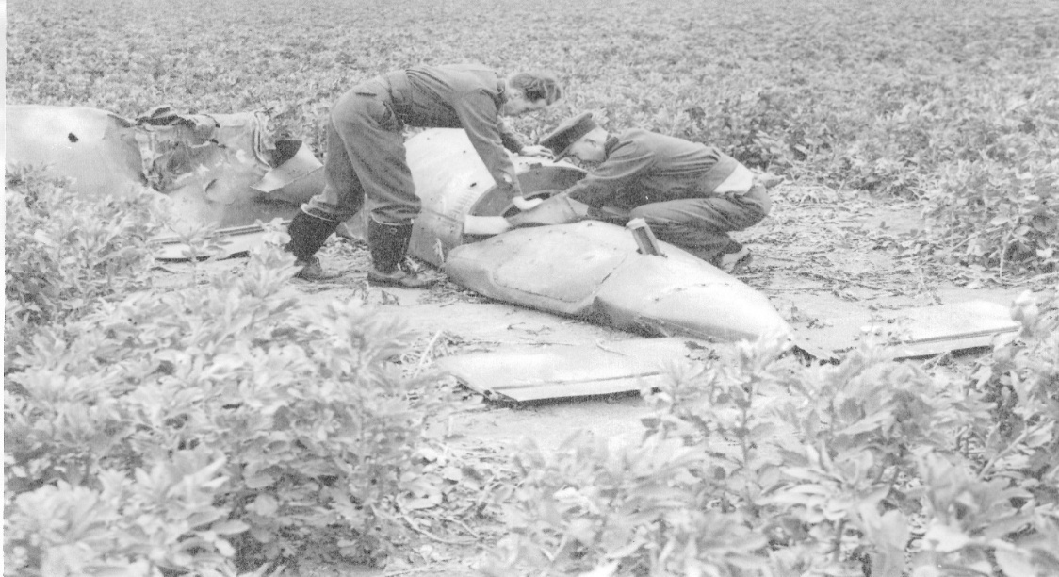

Investigating the wreckage of a V1. Date, location and personal unknown.
Photo credit: Peter Markham Collection
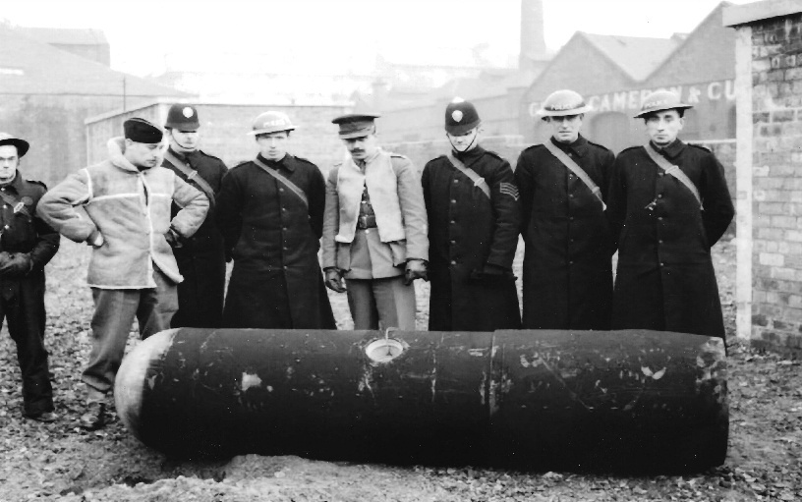 | Parachute mine, Scotland, date and personal unknown.  Photo credit: Peter Marham’s Collection

THORNE, Sidney Ernest Jones GM, (1453071) Sergeant, 97 Bomb Disposal Section, Royal Engineers

The Citation is from file WO373/106/503 held at the National Archives.
Placed in the London Gazette on the 17th December 1940. Supplement 35014. Page 7053.

Sergeant Thorne displayed marked ability and courage in dealing with a delay action bomb. While the bomb was being removed the clock action started ticking, but he removed the bomb to a safe locality where he detonated it. Sergeant Thorne also rendered invaluable help in dealing with a 250-kilogram bomb on September, 1940.

Further information
The Citation is from file WO373/66/113 held at the National Archives for the same incident above. The recommendation was for the George Cross to be awarded. However, the awarding body decided that the George Medal was more appropriate.

Sergeant Thorne has displayed marked technical and practical ability in dealing with unexploded bombs. His disregard for personal safety was shown on 18th August, when a delay action bomb was removed from a position in a Camp where it would have caused considerable damage and dislocation had it exploded. Whilst the bomb was being taken in Sergeant Thorn’s charge to a safe locality. It started ticking. None the less, Sergeant Thorne completed the journey. The bomb was successfully unloaded and it detonated harmlessly a few minutes later. On 2nd September Sergeant Thorne was of great help to Second Lieutenant Manser who had decided to recover a delay type fuze from a 250-lilogram bomb which had fallen some time before. With complete disregard for the risk involved, Sergeant Thorne ably assisted Lieutenant Manser in cutting out the fuze.

WALKER, Ronald George GM, (210292), 5 Bomb Disposal Company, Royal Engineers

The Citation is taken from file WO373/69/156 held at the National Archives.
Posted in the London Gazette on the 30th January 1945. Supplement 36918. Page 685.

On the 7th September, 1944, examination of a captured German document revealed the presence of a field of ‘Schu’ mines in an orchard at Orbois. This officer’s Unit had previously suffered casualties in the clearing of ‘Schu’ mines and a certain apprehension existed in the minds of the rank and file about the efficiency of the mine detector and also the ‘prodding’ method of detection. Lieutenant Walker volunteered to work with the Detector on this field to restore confidence in its use throughout the Company. He started work on the following day and shortly afterwards was seriously injured by the explosion of a ‘Schu’ mine, which amputated his left foot and caused injury to his right eye which is likely to prove permanent.

During nine months in which Lieutenant Walker served under command of No 5 Bomb Disposal Company, he has shown the same devotion to duty and courage of a high order. His work has been an inspiration to all officers and men of the Unit.

WALTON, John Percy GM, (120416) Acting Lieutenant, 22 Bomb Disposal Company, Royal Engineers

The Citation is taken from file WO373/67/41 held at the National Archives.
Posted in the London Gazette on the 28th October 1941. Supplement 35326. Page 6247.

Lieutenant Walton has been continuously on Bomb Disposal work since October, 1940, during which time he has personally defuzed over one hundred bombs. Twenty-one of these, including four Category “A” were dealt with within fourteen days. His total disregard for personal danger has been a fine example to all ranks of his Company. He has always displayed a readiness to tackle any job at any time of the day or night and on more than one occasion he commenced work whilst the raid was in progress.

At Romford, on the 5th November, 1940, Lieutenant Walton disposed of four category “A” bombs in twenty-four hours. Two of these were in the gas works and it was necessary to enter a gas holder to remove one of them. This was a 250-kilogram, with a No 17 fuze and No 50 fuze was rendered safety under air conditions so bad that work could only be continued in twenty-minute shifts. This hazardous work, most of which was done whilst enemy planes were overhead, with possible fatal consequences from gas, ensured the minimum damage to the gas works and allowed service to be resumed in the shortest possible time.

At the Tunnel Cement Works, Purfleet, on the 12th March, 1941 a 250-kilogram bomb, fell adjacent to the main3000 volt transformer and switchgear station. Twelve hours were taken to dig through twelve feet of solid chalk. There was a continuous influx of surface water and with pups going it was never less than twelve inches deep in the excavation. The bomb when exposed was found to have a No 17 fuze and a No 50 fuze and the clock was ticking. The inrush of water made defuzing difficult, and as an explosion in situ would have wrecked the switchgear and put the works out of action for a considerable time the risk was taken of moving the bomb to a site about two hundred yards away. The No 17 fuze exploded ten hours after being taken out. Lieutenant Walton was present the whole time this work was being carried out and by his personal example obtained the fullest co-operation from his Section in this dangerous task.

The Director of Bomb Disposal Branch, Home Forces, states that he considered that Lieutenant Walton has displayed deliberate and cold-blooded courage of the highest order.

WARDROPE, George Anderson GM, (2205689) Sergeant, 5 Bomb Disposal Company, Royal Engineers

The Citation is taken from file WO373/67/278 held at the National Archives.
Posted in the London Gazette on the 24th March 1942. Supplement 35498. Page 1330.

This N.C.O, commenced Bomb Disposal work in June, 1940. He has a strong sense of duty, and is an excellent asset on dangerous jobs. He has always been the first to volunteer for Category “A” work, and his coolness and fearlessness in face of danger have been an inspiration to the other men in his sections.

During the past 17 months he has displayed a high degree of personal courage and devotion to duty.

On one occasion a 250-kilogram bomb which he was dealing with was fitted with two clockwork fuzes, both of which were operating at the time. There was no means available of arresting the clockwork mechanism and during the entire operation there was the double risk of explosion. This N.C.O, however, faced this grave risk unflinchingly and with cold blooded courage worthy of the highest praise.

WARREN, John GM, (251867) 22 Bomb Disposal Company, Royal Engineers

The Recommendation is taken from file WO373/68/600 held at the National Archives.
Posted in the London Gazette on the 25th August 1944. Supplement 36669. Page 3941.

On the 7th April, 1944, urgent clearance of eight minefields was ordered to be carried out at Greatstone-on-Sea. The mines had been laid at surface depth in shingle and grassland, but due to sand drifts and tidal action they were found to be laying between of three and a half to thirteen feet. Lieutenant Warren unhesitatingly commenced work on the mines, encountering most difficult conditions. By determined resolution and systematic control of the whole operation, he was able to complete the task of recovering one thousand three hundred mines without casualties being caused to personnel working with him. On another occasion under conditions of extreme danger he cleared five hundred and fifty mines which had to be recovered at Cuckmere Haven. In all, Lieutenant Warren has been responsible for the clearance of over nine thousand mines, carrying out initial work himself before instructing his men to proceed with their part of the operation.

WATERS, Alwyn Brunow GM MBE, (152179) Temporary Captain, 23 Bomb Disposal Company, Royal Engineers

The Recommendation is taken from file WO373/68/792 held at the National Archives.
Posted in the London Gazette on the 10th November 1944. Supplement 36786. Page 5133.

In Normandy on 21st June, 1944, Captain Waters volunteered to dispose of a German parachute mine, which he knew was fitted with a new and unknown type of fuze and for dealing with which normal bomb disposal equipment and methods might be of little avail.

After application of the standard drill to remove the fuze, which he could see was booby-trapped, he pulled it out by remote control, but his foot was severely injured by delayed action explosion of the new-type of fuze.

The immediate acceptance of risk by this officer in order to save interruption to an important line of communication, crowded with transport, near which the mine fell, undoubtedly prevented loss of life and dangerous delay to vital supplies. His devotion to duty and personal courage were outstanding.

Further Information
Lieutenant A B Waters was also awarded the Member of the Order of the British Empire

WHITE, Frederick GM, (2191812) Lance Sergeant, 12 Bomb Disposal Company, Royal Engineers

The recommendation is taken from file WO373/69/157 held at the National Archives.
Posted in the London Gazette on the 30 January 1945. Supplement 36918. Page 685.
On the 6 August, 1944, at Brighton, the beach was being cleared of sea washed mines which had been buried beyond detectable depth. Due to Sergeant White’s fine example of leadership in personally locating the first few mines, and directing the workover a period of two weeks, many mines were removed which otherwise would have remained a continual source of danger. The condition of the beach, due to tides, demanded resourcefulness and cool courage, which was displayed at all times by Sergeant White, who personally dealt with the dangerous situations, therefore assuring the safety of his men.
Sergeant White has been responsible for the clearance of 6,000 mines, the majority uncharted, disturbed by sea and in a highly dangerous state.

WILKINSON, Donald Alfred GM, (154306), 6 Bomb Disposal Company, Royal Engineers

The Recommendation is taken from file WO373/67/185 held at the National Archives.
Posted in the London Gazette on the 17th February 1942. Supplement 35460. Page 773.

Captain Wilkinson has been engaged continuously om bomb disposal work since October, 1940, and has carried out approximetely370 reconnaissance’s of unexploded bombs of various types. He has dealt with most of the really dangerous bombs which he and his Section have been called upon to deal with when little was known about them and technical equipment non-existent.

The resolution and tenacity with which Captain Wilkinson has continued without pause, to carry out this kind of work and despite the fact that he was almost blown up and narrowly escaped death on three occasions in two and a half weeks is outstanding and demanded cold blooded courage and devotion to duty of a very high order. His great conscientiousness and persistence undoubtedly prevented many casualties to boys of Eton College, when a bomb exploded on the 4th December, as described in one of the incidents in which this officer was concerned.

Captain Wilkinson has always displayed the greatest readiness and enthusiasm in his work and his courage and cheerfulness have been a source of inspiration to those working under him.

WILLIAMS, Joseph GM, (1903322) Sapper, 50 and 51 Bomb Disposal Sections, Royal Engineers

The Citation is taken from file WO373/66/764 held at the National Archives.
Posted in the London Gazette on the 11th March 1941. Supplement 35009. Page 1427.

On the 14th August, 1940 a 500-kilogram bomb fell into the electricity depot at Lyndhurst. Sapper Williams assisted the Bomb Disposal Officer to excavate the bomb and remove the fuzes, which proved to be one of the first, if not the first, no 17 R.H.S. 1940 clockwork mechanism fuze to be obtained, and has been of great value to other Disposal Sections throughout the country. The work was carried out at considerable personal risk and with the full knowledge of what he was undertaking. This is only one of many examples of his good work before he was wounded. His devotion to duty has been a fine example and inspiration to other men of his Section.

Further Information
Second Lieutenant Charles Russel Wood was the Officer on this incident and was also awarded the George Medal.

WILLIAMS, Thomas James GM, (2326064) Sergeant, 4 Bomb Disposal Company, Royal Engineers

The Citation is taken from file WO373/67/45 held at the National Archives
Posted in the London Gazette on the 28th October 1941. Supplement 35326. Page 6247.

Sergeant Williams has for twelve months consistently displayed the utmost courage and devotion to duty in dealing with two hundred bombs, including twenty-three Category “A”. He has always shown completed disregard for his personal safety, and his conduct has been an inspiration and encouragement to his men.

On the 28th October, 1940, he led a working party which successfully dealt with two Category “A” bombs in a factory at Norwich. One was found to be fitted with a No.17 fuze which was ticking. He dealt with this personally, showing the greatest coolness and courage in doing so.

On the 10th May, 1941, in Chelmsford, he successfully disposed of a 500-kilogram Category “A” bomb buried under the debris and wreckage caused by explosion of other bombs. The fuze in this bomb was also ticking, but again he showed his usual disregard for his own safety.

The Director of Bomb Disposal, Home Forces, states that Sergeant Williams has shown outstanding devotion to duty, coupled with tenacious courage determination of the highest order.

WOOD, Charles Russell GM, Second Lieutenant, 50 and 51 Bomb Disposal Sections, Royal Engineers

The Citation is taken from file WO373/66/762 held at the National Archives
Posted in the London Gazette on the 11th March 1941. Supplement 35099. Page 1427.

On the 14th August, 1940, a 500-kilogram bomb fell into the electrical depot at Lyndhurst. Realising the danger to life and property in the vicinity, Second Lieutenant Wood, assisted by a Sapper, immediately set to work and excavated the bomb and removed the fuzes, which were found to be No 17 R.H.S 1940, containing clockwork mechanism, and thereby obtained one of the first specimens, if not the first specimen, of this type, which has been of paramount importance to the Experimental Section, and subsequently to other Bomb Disposal Sections throughout the country.

Second Lieutenants Wood’s devotion to duty and prompt decision and disregard of personal danger did much to steady the morale of the civilian population, and was a fine example to his men. This is only one of many occasions when he has, by his prompt action, saved many lives and considerable property.

Further Information
Sapper Joseph Williams who assisted in this incident was also awarded the George Medal (see separate entry).

WOODS, Robert Alfred John GM, (167932) Lieutenant, 6 Bomb Disposal Company, Royal Engineers

The Citation is taken from file WO373/69/583 held at the National Archives
Posted in the London Gazette on the 24th August 1945. Supplement 37326. Page 4273.

Lieutenant Woods joined a Bomb Disposal Company in December, 1941, and during his period of service has repeatedly carried out work of a highly dangerous nature with the greatest courage and resources. He has neutralized and removed a large number of enemy bombs, the task of immunising the bomb fuzes being carried out personally by Lieutenant Woods, often under difficult and hazardous conditions.
On 3rd June, 1944, he was instructed to remove the bodies of two Canadian Air Force personnel who had been killed on a minefield at Tilly Whim Caves, near Swanage. Using a mine detector, Lieutenant Woods personally cleared a path into the field, detecting and marking all mines met with, and removed both bodies successfully, although one was found to be almost on top of a mine.

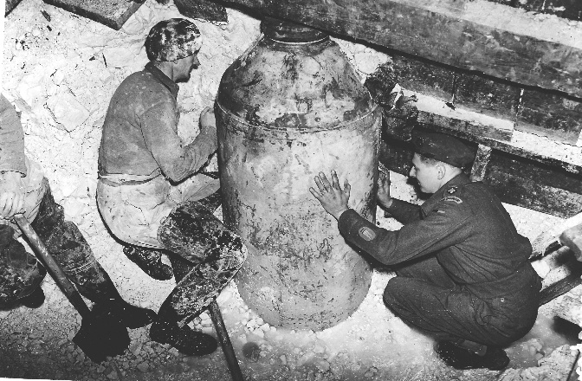 | Further Information  Satan - 4,000 lb bomb - removed after 200 days work.  150 people evacuated at crucial stages of the work.  The bomb fell in 1941 in South Croydon. The carcass was removed to the BD Section Depot at Balham.  Photo credit: Peter Markham Collection

Knight Commander of the Most Excellent Order of the British Empire

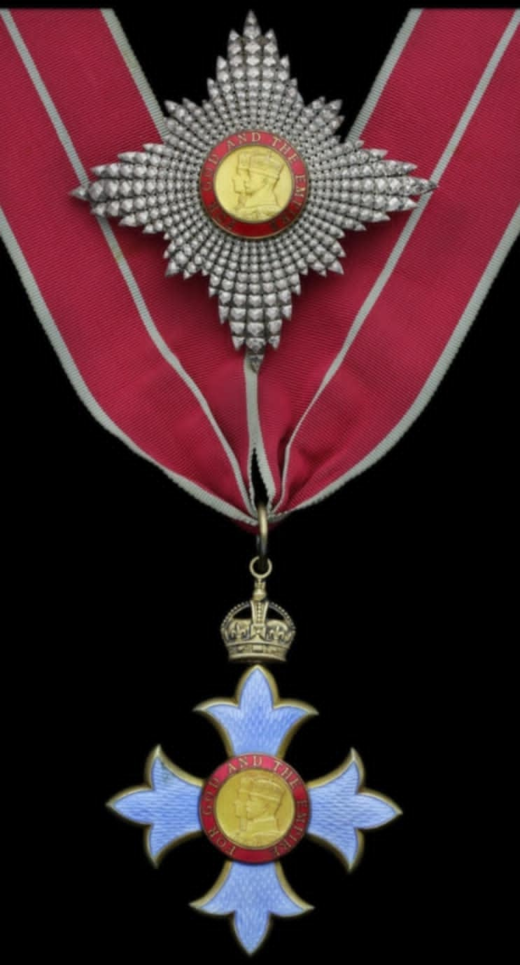

Photo credit: Julian Allerhead BEM.

Knight Commander of the British Empire (KBE) is a prestigious title awarded for significant contributions to society, established as part of the Order of the British Empire in 1917.

The Order of the British Empire was Instituted by King George V on June 4, 1917, to honour individuals for their valuable services to the Empire, particularly during World War 1. The Order recognises both civilian and military contributions and comprises if five classes with the KBE being one of the higher ranks.

The Royal Engineers Bomb Disposal teams were awarded 1 Knight of the British Empire, during the War period

TAYLOR, George Brian Ogilvie KBE MID, Major General, Director of Bomb Disposal Lance Forces, Royal

Awarded whilst Director of Bomb Disposal Home Forces

Commander of the Most Excellent Order of the British Empire.

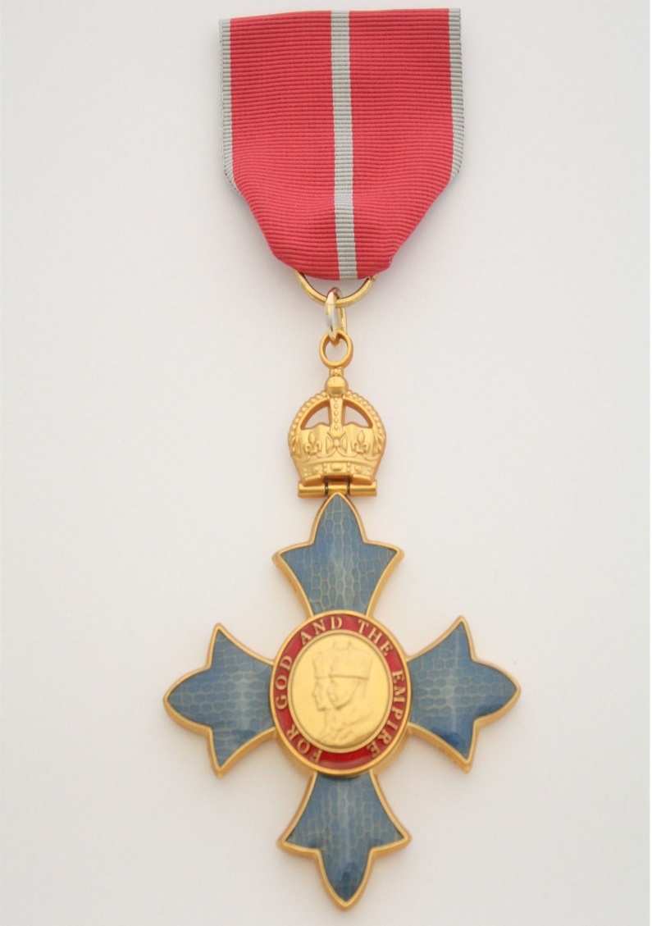

Photo credit: Julian Allerhead BEM

The Most Excellent Order of the British Empire was established on the 4 June, 1917, by King George V to honour individuals for their valuable services, particularly during World War 1. The Order comprises of five classes, with the CBE being the third highest rank.

The Royal Engineers Bomb Disposal teams were awarded 1 Commander of the British Empire, during the War period

BATEMAN, Harold Henry CBE, (4226) Temporary Brigadier. Director of Bomb Disposal Directorate. Royal Engineers

This citation is taken from file WO373/157/423 held at the National Archives.
Posted in the London Gazette on the 14 June 1945, Supplement 37119. Page 2942.

Brigadier Bateman has served in the Bomb Disposal Directorate since its inception in July 1941. He was Deputy Director for the first eighteen months and has been Director since January, 1942. He has taken a leading part in the build-up and organisation of bomb disposal at home.

Since 1941he has been also concerned in the expansion of the Bomb Disposal Service and the provision, training and maintenance of Bomb Disposal Units for overseas theatres. In addition, he has had considerable responsibility in regard to research and experimental side of bomb disposal work.

Brig Bateman’s work has been of a very high order, and it is largely through his energy, enthusiasm and technical ability that Bomb Disposal Units have done such excellent work in the past. The frequent changes in types of equipment, devices etc., had been a constant source of difficulty, and the high state of technical training of Bomb Disposal Units is largely due to the able sympathetic and efficient leadership of Brigadier Bateman.

He gives up the appointment off Director Bomb Disposal on the 1 April, 1945 on account of reduction in the War Establishment. He deserves recognition for his valuable work over a long and difficult period.

Officer of the Order of the Most Excellent Order of the British Empire

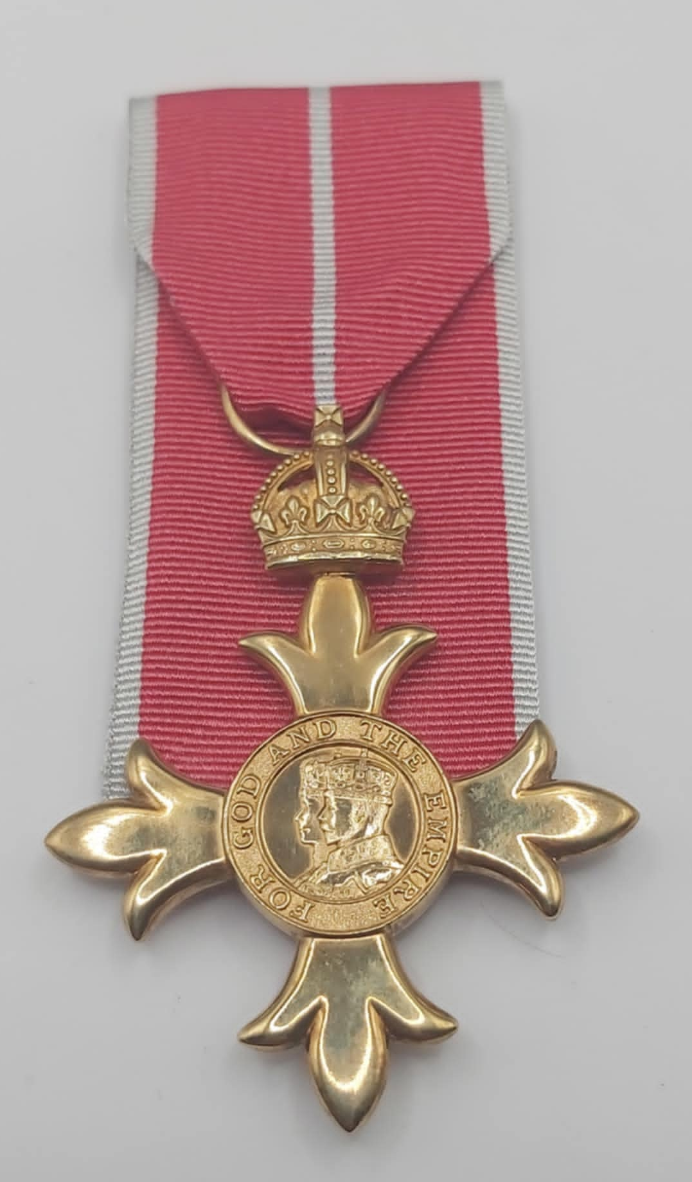

Photo credit: Julian Allerhead BEM

The Most Excellent Order of the British Empire was established on the 4 June, 1917, by King George V to honour individuals for their valuable services, particularly during World War 1. The Order comprises of five classes with OBE being the second highest rank.

The Royal Engineers Bomb Disposal teams were awarded 5 Officer of the British Empire, during the War period.

KING, Horace Thomas Stewart OBE, (13411) Lieutenant Colonel, Chief Royal Engineer Bomb Disposal, London Area, Royal Engineers

No file found in National Archives Catalogue.
Posted in the London Gazette on the 27 June 1941. Supplement 35204. Page 3739.
Awarded while serving as Chief Royal Engineer Bomb Disposal, London Area.

McDONALD, Ean OBE, (22029) Temporary Lieutenant Colonel, Bomb Disposal, Royal Engineers

The Citation is taken from file WO373/76/436 held at the Nation Archives.
Posted in the London Gazette on the 18th February 1943. Supplement 35908. Page 858.

This officer is in charge of all Bomb Disposal and R.E. experimental work in the Middle East. He has organised Bomb Disposal almost from its beginning in the Middle East and its present efficiency is largely due to his efforts. His most outstanding work, however, has been on the experimental side. As President of the Anti-Tank Mines Committee his work and inventiveness have contributed very largely to the present huge production of Anti-Tank mines. This work has entailed a great deal of co-ordination of the many means of supply and manufacture which go to the making of these mines and great credit must be given to this officer for efficiency of these mines and for the fact that it has been possible to produce them in such large quantities. He has also been concerned with devices for clearing minefields such as mechanical attachment to AFV, s and Detectors and the wok he has done on these has been on utmost value.

Lt-Col McDonald has worked extremely hard to achieve the desired end and the contribution that he has made to all that appertains to land mines has been of greatest value and merits recognition.

MITCHELL, Harry GM OBE, (131795) Temporary Captain, 95 and 96 Bomb Disposal Section, 17 Bomb Disposal Company, Bomb Disposal Advisor to Chief Royal Engineer in Italy, Royal Engineers

The Citation is taken from file WO373/72/86 held at the Nation Archives.
Posted in the London Gazette on the 19th December 1944. Supplement 36850. Page 5844.

In addition to commanding No 17 Bomb Disposal Company, Major Mitchell acts as technical advisor in bomb disposal to the Chief Engineer AAI and the Chief Engineers of Districts in which the sections of his Company are located. For the first part of the period under review he was responsible for twice the normal number of sections, as a second Company headquarters was not available. Major Mitchell’s responsibilities have thus been widespread and heavy and the fact that he has met them successfully has only been possible because of his untiring energy. He has been personally responsible for conducting, without regard to the risks involved many highly dangerous investigations into new types of enemy bombs and fuzes and into allied bombs which had failed to explode due to unexplained failures of their fuzes. Much valuable information, for which the RAF have expressed their appreciation, has been obtained as a result of his researches.

The Citation is taken from file WO373/66/112 held at the Nation Archives.
Posted in the London Gazette on the 17th December 1940. Supplement 35014. Page 7053.

Further Information
Second Lieutenant H Mitchell also was awarded the George Medal see separate entry.

Citation WO373/106/501 for the same incident awards made to Citation WO373/66/112.

STANTON, Ernest OBE, (51351) Temporary Lieutenant Colonel, 1 Bomb Disposal Group, Royal Engineers

The Citation is taken from file WO373/156/117 held at the National Archives.
Posted in the London Gazette on the 8th June 1944. Supplement 36544. Page 2576.

This Officer has been employed in connection with bomb disposal since the start of that activity in August, 1940, first as Staff Officer to C.E. Northern Command, then as Assistant Director of GHQ Home Forces and now as CRE Bomb Disposal, London.

In each capacity he has displayed unbounded energy and enthusiasm, and his work has been outstanding.

As Staff Officer in Northern Command, at a time when little was known about German bomb fuzes and when equipment, since developed to deal with them was non-existent, he first gained an insight into the problem by dealing with bombs with his own hands, at considerable personal risk, and therefore trained and controlled the bomb disposal Units there. His efforts were largely instrumental in the rapid clearance of unexploded bombs in Northern Command during the winter of 1940-41.

As Assistant Director at GHQ he did valuable work in connection with the consolidation of the Bomb Disposal Organization, necessitated by its hurried start during a period of intense bombing.

As CRE Bomb Disposal, London, he has in the past 18 months raised the level of discipline, administration and training in the Units under his command) the strength of which has been as much as 94 Officers and 1773 O.Rs.) to a high state of efficiency: besides which he has rendered valuable assistance in organising and carrying out training of mobilised units, civil defence personnel, Aux B.D. Squads H.G. and certain officers from other Commands, and in undertaking experimental work to advance the technique of bomb disposal.

The scope and volume of this latter work far exceed that which could be allotted to a single CRE and his personal efforts to obtain the desired results have been unremitting. In spite of his already very large command he has met every new demand made of him by the Director of Bomb Disposal with characteristic enthusiasm and thoroughness.

The effect of his efficiency and organising power have made themselves apparent after various enemy air raids on London, notably that of 17th January, 1943, after which unexploded, bombs have been cleared quickly, with the minimum disturbance to the war effort and to civilian morale.

YATES, Geoffrey Hartley OBE, (40602) Temporary Major, Bomb Disposal Royal Engineers

The Citation is taken from file WO373/66/1347 held at the National Archives
Posted in the London Gazette on the 30th September 1941. Supplement 35292. Page 5653.

Major Yates was posted to London to command No 2 Bomb Disposal Company on the 14th September 1940. This was at a time when the whole life of the Capital was gravely threatened by the large and rapidly increasing number of unexploded bombs. The number of bombs was, in fact, out of all proportion to the number of trained personnel available to deal with them. In these conditions of stress an organisation had to be built up. In which the work of the Civil Services should be linked effectively with that of the Military units responsible for the disposal of the bombs. The successful development of this organisation over the whole of the London Region, at a time when the actual removal of an ever-increasing number of bombs was in itself a very formable problem, was due in a very great measure to Major Yates outstanding energy, courage and ability; his forceful personality and charm of manner were potent factors in establishing relation of confidence and goodwill between the military and civilian bodies with whom they had to deal. It was by this co-operation alone, that the menace of the unexploded bomb in London has been effectively brought under control.

Since November, 1940, Major Yates has controlled the work of a large number of less experienced officers. He has made a point of going to their assistance, whenever they were engaged on any operation of a doubtful or dangerous nature. He has constantly gone out of his way to share the risk of his subordinates, and to relieve them of those risks as far as possible, himself.

During a heavy air attack a bomb penetrated a hospital and came to rest, unexploded. Although it was out of his area, Major Yates went to the hospital and rendered the bomb safe, single handed. This incident is typical of many in which, by his enthusiasm for the work, his skill in technique, his sound judgement, his complete disregard of personal danger in the execution of his duty. Disregard of personal danger in the execution of hid duty, and his never-ending cheerfulness, he encouraged his men and set an example to all those who served with him.

Further Information
Captain G H Yates also received a Kings Commendation for Bravery (see separate entry).

Member of the Most Excellent Order of the British Empire

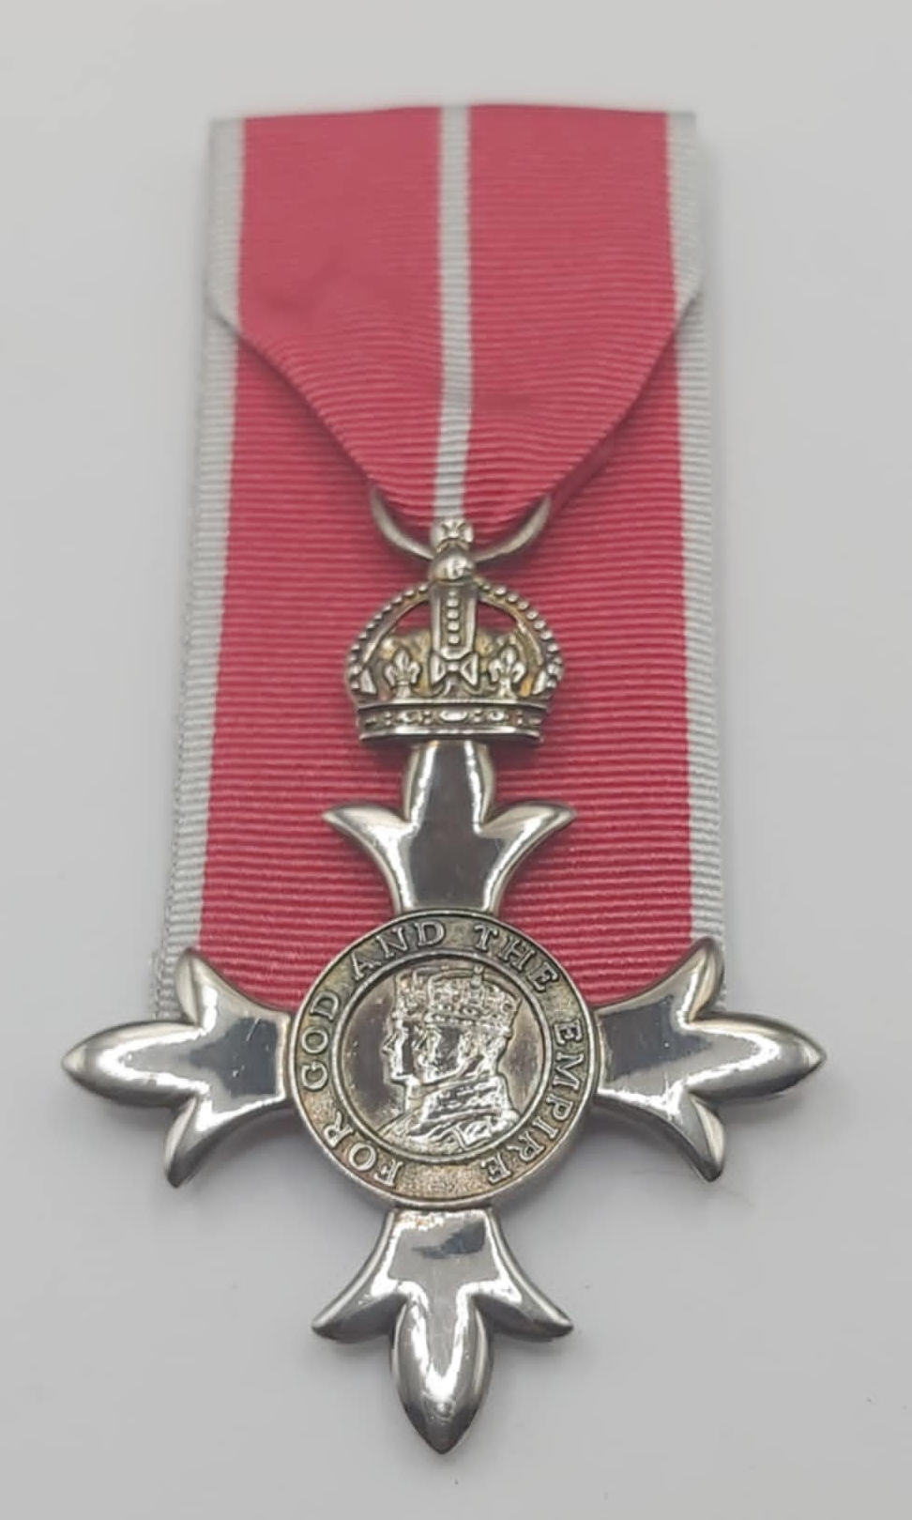

Photo credit: Julian Allerhead BEM.

The Most Excellent Order of the British Empire was established on the 4 June, 1917, by King George V to honour individuals for their valuable services, particularly during World War 1. The Order comprises of five classes with MBE being the third highest rank.

The Royal Engineers Bomb Disposal teams were awarded 30 Member of the British Empire, during the War period.

ASHALL, Frederick William MBE, (166504) Lieutenant, 127 Bomb Disposal Section, Royal Engineers

The Citation is taken from file WO373/78/226 held at the National Archives.
Posted in the London Gazette on the 18th February 1943. Supplement 35908. Page 859.

Lieut. Ashall has been on Bomb Disposal work for the past three months, and shown marked courage, self-reliance and initiative. By his example he has maintained the very high standard of confident efficiency which in now expected from the men of the Malta Bomb Disposal Sections. He personally has dealt with nine Priority’s, 24 Delay Action Bombs and hundreds of Anti-Personnel bombs in a highly dangerous condition.

BEARMAN, William Charles Victor MBE BEM, (2193307) Sergeant, Bomb Disposal, Royal Engineers

The Citation is taken from file WO373/72/697 held at the National Archives.
Posted in the London Gazette on the 17th April 1945. Supplement 37039. Page 2069.

This officer is recommended in recognition of his gallant conduct in carrying out most hazardous work in a very brave manner.

Between 30 Aug 1943 and 30 Aug 44 in Sicily and Italy this Coy disposed of 2400 Allied Unexploded bombs. Of these 2400 bombs, 520 fuzes and pistols (Note Pistol is a technical term denoting a slight operational difference between a fuze), were examined and sectioned to disclose reasons for failure, whether due to faulty assembly or faulty mechanism.

Inherent faults were discovered in various fuzes and pistols and full reports were forwarded to the proper authorities thought C.E. A.A.1. This was the first occasion whereby first-hand information became available regarding effectiveness of Allied fuzes and pistols.

The criterion of this work and Intelligence which was entirely initiated by the Coy was acknowledged in a letter from Air Ministry O.10, who stated that the information given was invaluable.

The stripping and examination of these fuzes and pistols is a very hazardous job and numerous casualties have been caused. Lt. Bearman well knew the risks he was taking but by his skill and courage factual evidence was obtained of faulty design and assembly which has had an important effect on efficiency of Allied bomb fuzes.
Further Information

At this period of time, very little information as to the fuzes and pistols in Allied Bombs had been passed to the Bomb Disposal Teams in case they were captured.

Further Information
Sergeant W C V Bearman also was awarded the British Empire Medal see separate entry.

BESWICK, Robert Eascott Edward MBE, (188474) Lieutenant, 53 Bomb Disposal Platoon, 19 Bomb Disposal Company, Royal Engineers

The Citation is taken from file WO373/83/634 held at the National Archives.
Posted in the London Gazette on the 29th March 1945. Supplement 37004. Page 1705.

Lt. Beswick is O i/c 53 BD Pln. From 21 July to 23 Sep 44 this platoon was continuously employed on minefield clearance in Arromanches Area.

Lt. Beswick was at all times extremely careful for the safety of his platoon, in most cases finding the first mine of a new minefield himself and never allowing any party on a field until he had satisfied himself about the contents. On 18th Aug the L/Sgt and a Sapper were killed and a Cpl injured on a minefield at Longues. The next morning Lt Beswick immediately proceeded, with two volunteers, to clear the minefield and by his example so inspired the rest of the Pl that their morale suffered no loss from the accident. It was certainly due to his action and subsequent leadership that the Pl was able to continue at a high rate of efficiency for the remainder of the period.

This officer has consistently shown great devotion to duty, ability and courage as a Bomb Disposal Officer.

Further Information
Lance Sergeant Hillyard and Sapper EA Turner were the two fatalities.

BLACKWELL, Thomas Walter GM MBE, (169308) Lieutenant, Bomb Disposal, Royal Engineers.

The Citation is taken from file WO373/67/339 held at the National Archives.
Placed in the London Gazette on the 19 May 1942. Supplement 35565. Page 2177.

At Malta on the 2 January 1942, Lieutenant Blackwall displayed conspicuous gallantry and devotion to duty in dealing with a completely new type of enemy rocket bomb. He personally removed the fuze from one of these bombs which had failed to explode, and at the same time did invaluable work in reconstructing the pieces of the apparatus, thereby obtaining valuable information. In order to enable him to extract the fuze of the bomb he had to cut through the casing with a hacksaw. He has dealt with over 300 unexploded bombs and shells personally defusing a large number of them.

BRENTNALL, Ralph Herbert MBE, (116259) Acting Lieutenant, Bomb Disposal Royal Engineers

The Citation is taken from file WO373/67/274 held at the National Archives.
Placed in the London Gazette on the 24th March 1942. Supplement 35498. Page 1330.

Lieutenant Brentnall commenced Bomb Disposal work in November, 1940. On the 10th March, 1941, he was injured while dealing with a Category “A” bomb, and has not yet recovered sufficiently to enable him to return to duty.

His record discloses outstanding personal courage and tenacious devotion to duty. This is particularly illustrated in one incident when he was detailed to work on a Category “A” bomb which was diagnosed as of 250 or 500-kilogram, with a strong possibility that it was fitted with a delayed action fuze. He, however, accepted the grave risks and shared them fully with his working party. This action alone demanded cold blooded courage of a very high order.

COMYN, Nugent Gerald Ward MBE, (189498) Lieutenant (V) S.A.E.O, 158 Bomb Disposal Platoon, 17 Bomb Disposal Company, Royal Engineers

The Citation is taken from file WO373/72/730 held at the National Archives.
Placed in the London Gazette on 14th April 1945. Supplement 37039. Page 2069.

This officer is strongly recommended for an award I recognition of gallant conduct in carrying out most hazardous work in a very brave manner, well knowing the great personal risks he was taking.

Between 29th Feb and 4 Aug 44 he has dealt with seventy-three UXB’s, many of which were in a most dangerous condition and required great courage and ingenuity in disposal.

On the 4th August 44 Lt Comyn and his detachment were amongst the priority units to enter Florence. Their task being to commence immediate operations on booby traps and mine-clearance. Information was received that the city surroundings was heavily mined and this proved to be true.

Fonte Vecchio Area was heavily sown with A/P and A/T mines. Normal detection was out of the equation due to amounts of metal in the rubble. Clearance was essential and Lt. Comyn, by his skilful organisation, leadership and coolness under fire from S.A and mortars succeeded in effecting the clearance of the approaches. The Mugnone Line was heavily sown with ‘S’ mines, -Schumines and Tellermines, very cunningly concealed. Successful clearance was carried out in the area and again under enemy fire.

More than 100 buildings were vetted for booby traps and mined charges Booby Traps were prolifically laid and in a most ingenious manner. Charges were wired to doors, floor boards, windows, electric light switches, lavatory pans, tec. The approaches to these houses, and pathways were very cleverly wired making detection a most difficult task.

By his personal example, instance on strict discipline and safety precautions Lt. Comyns carried out extremely valuable work of a most difficult and hazardous nature.

Under his direct supervision, 300 Tellermines, 122 Schumines, 292 ‘S’ mines and more than 100 booby traps were cleared from Bridges Roads, Buildings etc. of great importance to military operations.

CONNORS, Colin Richard James MBE Posthumously, (42192) Temporary Captain, Bomb Disposal, Royal Engineers.

The Citation is taken from file WO373/156/165 held at the National Archives.
Posted in the London Gazette on the 8th June 1944. Supplement 36544. Page 2577.

He has been employed for the last 18 months as Field Engineer for the Area of N. Riding District and has shown great capacity, initiative and energy I his work particularly during the last six months when engaged in tracing, locating and wiring in the minefield laid in the East Coast of the District. This often involved work of a dangerous nature as in some cases the records of the exact location of the minefields were found to be incorrect, necessitating the use of a detector.

Two O.Rs working under him were actually killed on this work and it was only the fact that he was called away to another duty saved his life on this occasion.

Further Information
This citation was hand written, bar a typed section in italics.

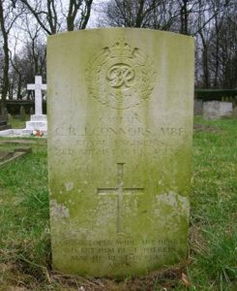 | Died on the 3rd August 1944, aged 46. Buried at Leeds Roman Catholic Cemetery. Section E Grave 275.  Captain Conners was killed while defusing a bomb on a beach in Yorkshire after distinguished service with the Royal Engineers since WW1 and had been involved with Bomb Disposal since the start of the blitz in London. He was awarded the MBE posthumously and this was given to his son Terrance by the then Princess Elizabeth. Captain Connor’s father James was as a Bandsman with the Border Regiment while serving in India.

CROTHALL, Paul Frederick MBE, (171297) Lieutenant, 24 Bomb Disposal Company, Royal Engineers

The Citation is taken from file WO373/83/669 held at the National Archives.
Placed in the London Gazette on 29th March 1942. Supplement 37004. Page 1706.

Lieutenant Crothall throughout the last three months has been consistently employed on Bomb Disposal operations. During the whole of that time, he has shown the utmost gallantry and has been a fine example to the Pl under his command. He has been responsible for the removal of 218 U.X.B’s and has personally defuzed the majority of these. Much of his work has been in close proximity to the enemy, and during the advance from Caen to Falaise, he worked constantly under fire.

These operations entailed much physical and mental strain on him, but despite this, he was always willing and eager to tackle fresh jobs. On 14th Aug, 1944 during an Allied air attack, an ammunition dump, a few hundred yards away from his Pl bivouac was area was hit, and exploding ammunition set fire to a nearby vehicle. This Officer immediately organised a fire-fighting party, and despite exploding petrol and ammunition succeeded in preventing the flames from spreading.

On one occasion, when removing a clockwork fuze from an enemy bomb, the withdrawal equipment failed to work correctly, and it was only this officer’s prompt action which prevented the bomb from exploding. This was carried out at considerable risk to himself.

DAVIES, Peter Brangwyn MBE, (96067) Lieutenant, Bomb Disposal, Royal Engineers

The Citation is taken from file WO373/83/280 held at the National Archives.
Placed in the London Gazette on 15th February 1944. Supplement 36384. Page 837.

Whilst stationed at Messina Lieutenant Davies has been responsible for the disposal of over two hundred unexploded bombs of various sizes which were in very inaccessible places. Had the bombs exploded great damage would have been caused and there would also have been a serios delay in carrying out essential work, as well as considerable loss of life. Lieutenant Davies fully realised what a hazardous task he was undertaking as most of the bombs were Allied bombs, details of which are not given to Bomb Disposal Companies, and information of which is very superficial in this theatre.

This officer has carried out his duties without regard to either personal danger or fatigue, and has throughout maintained the highest moral with the men under his command. His unfailing courage and devotion to duty well merits recognition.

Further Information
The reason given to not sharing information of fuzes and pistols of Allied Bombs is said to be that there were concerns that members of the teams could be captured by the enemy.

DIXON, Norman Frank MBE, (219691) Lieutenant, 19 Bomb Disposal Company, Royal Engineers

The Citation is taken from file WO373/83/680 held at National Archives.
Posted in the London Gazette on the 29th March 1945. Supplement 37004. Page 1706.

In his position of I.O. of this unit he carried out many difficult and dangerous recces without hesitation. He also discovered, took to pieces and reported on two new enemy devices, the LUX 0250 Float and the XP 1000 ariel device. In particular at Le Havre on 6th October 44 he was engaged with Major Skilling SOPAD, 11 L of C Area in recce of UXB’s and minefields when he was ordered to clear a length of road required for access to an electric power station at Montivilliers. The minefield was seen to be in an exceptionally dangerous condition owing to nearby damage and blast but he continued. The last mine of the field detonated killing the Sapper who was neutralising it. Lt Dixon whom had the mine detector was injured and subsequently had his left arm amputated.

DRAKE, Joseph Elton MBE, (152403) Temporary Captain, 9 Bomb Disposal Company, Royal Engineers
1918 to 2007.

No Citation Found in the National Archives Catalogue.
Posted in the London Gazette on the 1 January 1945. Supplement 36866. Page 14.

Posted into 9 Bomb Disposal Company in May 1943 as 2 i/c.
Posted to 1 Bomb Disposal Group 17 October 1944.

As his posting was only 3 months before he was awarded, it seems that his recommendation came from his service with 9 Bomb Disposal Company.

Further Information
He enlisted as a Sapper 31 August 1931, at the age of 15. His service shows 31 August 1931 M Company Depot Battalion, Sapper 14 February 1934 at C Company Training Battalion, Lance Corporal 22 June 1935, Temporary Corporal 4 February 1937, Corporal 27 February 1937, Lance Sergeant 21 November 1937, Temporary Sergeant 28 August 1938. He served with 7 Railway Battalion in February 1940. Discharged to take a Commission 11 October 1940.

London Gazette shows him as a Lieutenant 12 October 1940. Captain as of 1 October 1946. To be Major 12 October 1953 and finally relinquishes command 1 February 1946.

ELLINGTON, Frank MBE, Lieutenant, Bomb Disposal, Royal Engineers

The Citation is taken from file WO373/67/366 held at National Archives.
Posted in the London Gazette on the 2nd June 1942. Supplement 35580. Page 2373.

Lieutenant Ellington has been employed on bomb disposal work since October, 1940, and has personally dealt with approximately three hundred unexploded bombs of various categories.

In, October. 1940, he took a working party to deal with a bomb which was buried 12 feet between the rails of a main railway line at Hatfield. This bomb was fitted with No. 17 and 50 fuzes, and the clock was still ticking. Assisted by a N.C.O. of his Section he lifted the bomb out and rolled it down the bank. It was then loaded on to a lorry and driven away by this officer to a safe place where it was detonated. Another bomb which fell on this main line in November, 1940, was treated in the same way, except on this occasion it exploded spontaneously a few hours after being placed on site.

Again, in October, 1940, a bomb fell in an ammunition factory at Waltham Cross. The fuze of this bomb jammed and could not be removed. This bomb he and a Corporal wheeled out of the factory on a wheelbarrow to a safe place where it was successfully disposed of.

In each of these incidents this officer displayed outstanding personal courage and devotion to duty in carrying out operations on delayed action bombs which were at the time in a highly dangerous condition. He accepted the very grave risks of removing these bombs to sites where no damage would result from the explosion. That these risks were accepted personally by him and only one volunteer is further proof of his fine sense of devotion to duty and disregard for personal danger

FIRTH, Harold Whiteley MC MBE, (135014) Temporary Captain, Bomb Disposal, Royal Engineers

The Citation is taken from file WO373/67/377 held at National Archives.
Posted in the London Gazette on the 16th June 1942. Supplement 35598. Page 2651.

Captain Firth has been engaged continuously on bomb disposal work since June 1940. He dealt with a large number of unexploded bombs at a time when very little was known about the fuzes, and before safety devices came into existence.

In August 1940, he obtained for experimental purposes by the War Department, a new and dangerous type of fuze from an unexploded bomb.

On another occasion in December, 1940, when an unexploded bomb fell on a Printing Works and penetrated to a depth of twenty-two feet, he worked for several hours in a cramped position scrapping clay from the bomb in order to get at the fuzes. After the bomb had been successfully uncovered, he constantly remained in attendance supervising the work of sterilisation. As this work took longer than anticipated, he left off work for the day with the intention of returning the next morning to deal with the fuzes. On his return next day, however, he found that the bomb had self-detonated.

During the period in which he has been employed on bomb disposal work, this officer has consistently displayed commendable courage and devotion to duty, and these qualities have been well illustrated during several incidents, including those mentioned above, when he has acted with cool courage and deliberation under circumstances involving grave risks.

HANDS, P J MBE, (130522) Temporary Major, 18 Bomb Disposal Company, Royal Engineers

No file found in the National Archives Catalogue.
Posted in the London Gazette on the 8 June 1945. Supplement 37119. Page 2945.

Awarded while Officer Commanding 18 Bomb Disposal, Middle East.

HARDHAM, C R MBE, (152395) Temporary Major, 20 Bomb Disposal Company, Royal Engineers

No file found in the National Archives Catalogue.
Posted in the London Gazette on the 08 June 1945. Supplement 37119. Page 2945.

Awarded while serving with 20 Bomb Disposal Company.

HUDSON, John Pilkington MBE, (154286) Major, Bomb Disposal, Royal Engineers.

No file found in the National Archives Catalogue.
Posted in the London Gazette on the 1 January 1943. Supplement 35841. Page 12.

Received for assisting the American in Bomb Disposal techniques. Was sent to the United States and in 1942 lectured at the Aberdeen Proving Grounds.

HUNT, Herbert James MBE MID, (135515) Temporary Major, 1 Bomb Disposal Group, Royal Engineers

The Citation is taken from file WO373/67/76 held at the National Archives.
Posted in the London Gazette on the 18th November 1941. Supplement 35350. Page 6633.
Captain Hunt was appointed Divisional Officer in charge of No 7 Civil Defence Group, London, in December 1940 a group which has suffered particularly heavily by enemy bombing. He was formerly employed as Reconnaissance Officer with a Bomb Disposal Company.

As a Divisional Officer he has been responsible for the technical reconnaissance of all the unexploded bombs which have fallen in the various Boroughs of the Group, and for their subsequent disposal. He has carried out almost all the most dangerous operations by himself, often at the risk of his life. On several occasions bombs have exploded simultaneously very shortly after he has reconnoitred them. He has dealt with at least one Category “A” bomb, and has also reconnoitred a considerable number of parachute mines, often by night under blitz conditions. His work has been done with unfailing cheerfulness, reliability and courage, deserving of high praise.

The Inspector of Fortifications and Bomb Disposal states that Captain Hunt has displayed tenacious courage and devotion to duty of a very high order, and that he has narrowly escaped death on numerous occasions when engaged on bomb reconnaissance during heavy raids on London. Also, that he has always displayed complete disregard for his personal safety, and has strenuously resisted any suggestions of leave or rest.

HUNT, J C MBE, (295550) Lieutenant, 71 Bomb Disposal Platoon, 12 Bomb Disposal Company, Royal Engineers

No Citation found in the National Archives Catalogue.
Posted in the London Gazette on the 28 January 1945 Supplement 37407. Page 27.

No further information available.

JONES, John Hulbert Emlyn MBE, Second Lieutenant, 46 Bomb Disposal Section, 4 Bomb Disposal Company, Royal Engineers

The Citation is taken from file WO373/66/630 held at the National Archives.
Posted in the London Gazette on the 21st January 1941. Supplement 35050. Page 461.

On 31st August, 1940, 2nd Lieutenant. Jones discovered a new type of fuze of a highly dangerous character in a bomb which had fallen at Gt. Livermore, Suffolk. Although aware of the danger, in order to obtain further details, he de-fused the bomb and the information he obtained proved of great value. He has been engaged on Bomb Disposal duties since June, 1940.

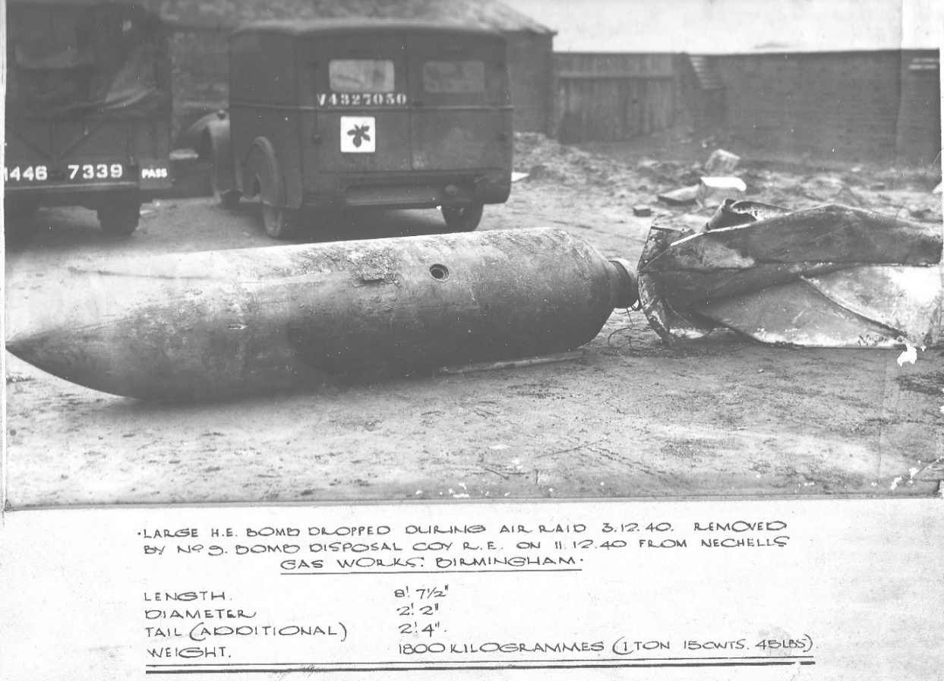

Photo credit: Peter Markham’s Collection/

MACHIN, Walter MBE, (97022) Temporary Major, Bomb Disposal, Royal Engineers

The Citation is taken from file WO373/68/382 held at the National Archives
Posted in the London Gazette on the 31st March 1944. Supplement 36446. Page 1479.

Major Machin has been employed on bomb disposal duties since January, 1941. These duties constantly exposed him to personal risk, especially during the major raids on Portsmouth and Southampton. He has always displayed readiness to tackle any job at any time of the day or night and has made many reconnaissance’s whilst raids have been in progress. During the time which he has been engaged on this kind of work he has supervised the disposal of twelve category “A” and over four hundred bombs, without any casualties being incurred. By his courage, cheerfulness and devotion to duty he has been a souse of great inspiration to the officers, non-commissioned officers and men of his Group, especially when very little was known about bombs and the technical equipment to deal with them was scarce. Over a period of three years this officer has carried out his duties in a most able and exemplary manner and frequently under highly dangerous conditions.

MIDSON, Charles Henry MBE, (154272) Lieutenant, Bomb Disposal, Royal Engineers

The Citation is taken from file WO373/67/365 held at the Nation Archives.
Posted in the London Gazette on the 2nd June 1942. Supplement 35580. Page 2373.

Lieutenant Midson has been employed on bomb disposal work since October, 1940, and during this period he has dealt with around two hundred unexploded bombs of varying categories.

It was due to his leadership that it was possible successfully to remove approximately one hundred unexploded bombs which fell on Coventry during the raids on that city during November, 1940.

On the 5th January, 1941, he was detailed to remove a parachute mine which fell near a railway station at Cardiff. This mine became damaged in falling and in consequence it could not be rendered harmless by the Naval Mine Disposal party. Although this mine was considered to be in a highly sensitive and dangerous condition, this officer drove it to a site about 12 miles from the city where it detonated on being burnt out.

On the 24th January, 1941, he dealt with a 250-kilogram bomb which was fitted with a No 17 and 50 fuzes. Several other bombs which subsequently fell at the same place and which were also fitted with No 17 fuzes, were subsequently dealt with by him.

This officer has displayed outstanding courage, determination and coolness in his work, and he has set a very fine example to the men working under him.

NEWITT, Clive Neville GM MBE, (139087), Bomb Disposal Directorate and 5 Bomb Disposal Company, Royal Engineers

The Citation is taken from file WO373/69/440 held at the Nation Archives.
Posted in the London Gazette on the 5th June 1945. Supplement 37113. Page 2881.

Captain Newitt’s duties, in the capacity of Intelligence Officer in the Bomb Disposal Directorate since June, 1943, have included the identification, prior to immunisation, of those enemy bombs and fuzes reported as being previously unknown, or with, markings obliterated or suspected to have been purposely disguised by the enemy. He has personally identified twenty-six of such fuzes in unexploded bombs (three of which were in Category A 1by obtaining radiographs of them, a process necessitating contact with the bomb for an average 1 ½ hours in each case, during which time the nature of the fuzing system remains unknown.

Captain Newitt also took charge and personally dealt with the first 1000-kg. Parachute Bomb, and the first Radio-controlled Glider Bomb dropped in England, a 500 Kg. bomb with a disguised anti-handling fuze, and four Flying Bombs. He carried out the above and other duties of a hazardous nature with a fine disregard for his personal safety, and with complete success. His work has been outstanding and invaluable, enabling accurate intelligence regarding new enemy weapons to be disseminated with the least possible delay.

Further Information
Second Lieutenant C N Newitt was also awarded the George Medal see separate entry.

PARKER, W G GM MBE, (135029) Major, 16 Bomb Disposal Company, Royal Engineers

No file found in the National Archives Catalogue.
Placed in the London Gazette on the 1 January 1944. Supplement 36309. Page 15

Believe that his MBE was awarded for the clearance of SD2 (Butterfly Bombs) in Grimsby in June 1943.

Further Information
Major WG Parker was also awarded the George Medal see separate entry.

PERRY, Dillwyn David Llewellyn MBE, (77302), 16 Bomb Disposal Company, Royal Engineers

The Citation is taken from file WO373/156/260 held at the Nation Archives.
Posted in the London Gazette on the 2nd June 1944. Supplement 36554. Page 2580.

Commenced B.D. operations 24th June 1940 – has carried out extensive Bomb Disposal Operations as a result of enemy raids at Ashton-u-Lyne Sept, 1940 – Birmingham Nov, 1940 – Manchester Dec, 1940 – Coventry Nov, 1940 – Wallasey March 1941 – Liverpool May 1941 – Cardiff May1941.

Approx. number of H.E bombs dealt with one hundred and fifty many of which were fitted with delayed action and anti-handling type fuzes Additionally has dealt with many types of incendiary bombs, flares and other enemy missiles. Narrowly escaped serious injury or being killed when a bomb, from which the fuze was being extracted detonated – suspected anti-withdrawal devices fitted to this type of fuze. Runcorn 23rd September. 40. He has carried out extensive reconnaissance duties of suspected unexploded bombs. At all times this officer has carried out his hazardous duties in a steadfast courageous manner.

REVIS, Claude Kenneth MBE, (165376) Captain, Bomb Disposal, Royal Engineers.
1917 to 2002

No Citation found at the National Archives.
Posted in the London Gazette on the 1st January 1944. Supplement 36309. Page 15.

Awarded for duties on Bomb Disposal.

Further Information
Captain Claude Kenneth Revis taken from his book The Blinding Flash.
Posted to Bomb Disposal at Haywards Heath 6 January 1941. Was sent almost immediately on a Bomb Disposal Course and on return posted to a detachment at Battle, Sussex. First bomb was a 500-kilogram outside Hastings.

ROBSON, Oswald Leonard MBE, (135211) Temporary Captain, Bomb Disposal Royal Engineers

The Citation is taken from file WO373/67/75 held at the National Archives.
Posted in the London Gazette on the 18th November 1941. Supplement 35350. Page 6633.

Captain Robson has been responsible for the reconnaissance of all the unexploded bombs in No. I Civil Defence Group, since September 1940. The majority of the reconnaissance’s and almost all of the most dangerous operations have been carried out by him. He has worked through periods of most severe raiding with unfailing cheerfulness, reliability and courage deserving of very high praise.

On no less than five occasions he has been called upon to deal with unexploded bombs without waiting for the expiry of the prescribed safety period. On one occasion a bomb exploded soon after it had been located and before operations on it could be commenced. On another occasion a bomb exploded during operations, but fortunately Captain Robson and his working party had withdrawn for a period from the site. In addition, Captain Robson has also incurred similar risks through voluntarily taking action on his own initiative in dealing with bombs which could he considered needed immediate action.

Captain Robson has gained a great reputation with the local authorities. He has always been on the spot immediately either day or night, and by his coolness and imperturbability has been an inspiration to those with whom he has been associated. The technical officers of the local authorities have received the greatest measure of help from him.

The Inspector pf Fortifications and Bomb Disposal states that, Captain Robson’s record since being employed on Bomb Disposal in London, discloses exceptional devotion to duty, together with sustained courage and inspiring leadership, and also that Captain Robson has risked his life with cool deliberation, whilst on several occasions he has narrowly escaped being blown up.

STRINGFELLOW, Douglas MBE, (135041) Temporary Major, 1 Bomb Disposal Company, Royal Engineers

The Citation is taken from file WO373/156/302 held at the National Archives.
Posted in the London Gazette on the 2nd June 1941. Supplement 36544. Page 2581.

For continuous work on bomb disposal over a period of 3 ½ years, frequently carried out under highly dangerous conditions.

Starting in early summer 1940, when little was known about German bomb fuzes, and when special equipment subsequently developed for this purpose was non-existent, he showed considerable resource, and courage, in the acceptance of very real risks in personally disposing of many bombs.

As Officer Commanding, No 1. Bomb Disposal Company, R.E, and Senior Bomb Disposal Officer in No. 1 (Civil) Region for the past 3 years, he has by his personal supervision of the difficult and dangerous incidents ensured that disposal has been affected with the minimum casualties to his men and in the shortest possible time.

After four heavy enemy raids on the N.E. coast in March 1943 his Unit, reinforced with additional Sections, disposed of no less than 406 incidents in 50 days besides dealing with 63 false reports – an outstanding performance which reflects the spirit he has installed into his men, and the efficiency of his organisation and training methods.

H.H. Bateman Brigadier Director of Bomb Disposal.

A consistently high standard of achievement maintained without variation over the last three years justifies, in the opinion of the Reginal Commissioner, recognition for Major Stringfellow in the forthcoming Birthday Honours List by the conferment of some such award as the O.B.E.

The Regional Commissioner would be obliged if the recommendation could be forwarded to the proper quarter.

I have shown your memorandum and enclosure of 2nd March, 1944, to the Regional Commissioner, who directs me to say that he strongly supports the proposal that suitable recognition should be accorded to the work of Major Stringfellow as O.C. No 1 Bomb Disposal Company, R.E., in this region. Major Stringfellow’s work has The Citation is taken from file WO373/66/1355 held at the National Archives.
Posted in the London Gazette on the 30th September 1941. Supplement 35292. Page 5654.

Conspicuous by its unobtrusive efficiency, and there has never been any avoidable delay or inconvenience caused by the presence of unexploded bombs in this region owing to the zeal and energy with which Major Stringfellow and those under his leadership have carried out their duties. In addition, Major Stringfellow has rendered notable service to the civil administration by the close and ready co-operation which he has rendered at all times to the Civil Defence and other civilian services, and by the invaluable assistance he has given in training Bomb Reconnaissance Officers and giving advice on the technical aspects of such difficult questions as search for unexploded anti-personnel bombs.

Brigadier, Chief Engineer, Northern Command.

TALBOT, Ellis Edward Arthur Chetwynd GC MBE, (1004211) Second Lieutenant, 103 Bomb Disposal Section, Royal Engineers

The Citation is taken from file WO373/66/1003 held at the National Archives.
Posted in the London Gazette on the 27th May 1941. Supplement 35173. Page 3019

Lieutenant Talbot has displayed courage and resource of the highest order. He has been in charge of all bomb disposal work (at Malta) for the last three months and has invariably done the most dangerous work himself. He has personally disposed of some fifty bombs, representing about sixty tons, of which twenty had to be done soon after dropping, when there was a grave risk of delay action or booby traps. He has inspired his men by his constant example of calm courage and efficiency.

Second Lieutenant E E A C Talbot was also awarded the George Cross (see separate entry).

Further Information
Lt Talbot was also awarded the MBE in May 1941 for Bomb Disposal work in Malta.
Also awarded the 1939-45 Star, Africa Star, War Medal 1939-45.
Second Lieutenant Acting Lieutenant Ellis Edward Arthur Chetwynd Talbot, was, after a rest period, made a Liaison Officer to the RAF. The Governor of Malta, impressed by his work, was concerned that Lt Talbot would come to harm on his Bomb Disposal duties. He died whilst assigned to the RAF, on a shipping sweep.

He is buried at Catania War Cemetery, Italy. Grave 1 H 19 with the other crew members. A fitting tribute that his headstone has both the Royal Engineers and the RAF badges inscribed upon it.
Photo credit: Richard Brown
THORNTON, Frank Martin MBE, (83601) Lieutenant, 113 Bomb Disposal Platoon, Royal Engineers

The Citation is taken from file WO373/77/403 held at the National Archives.
Posted in the London Gazette on the 23rd November 1943. Supplement 36261. Page 5172.

Acting on a request for assistance from N.O.I.C. Sousss, to deal with a floating enemy mine, Lieut. Thornton with a party of two Sappers went to Nonaster (Tunisia) on 15th May 1943.

An enemy horned mine was found within seven feet of the cliff side to the South of town, floating in two feet of water amongst rocks. Lieut. Thornton attempted to fix a prepared charge on to the mine, but found he could not hold the mine owing to the motion of the water. He called Sapper Fowler to his assistance. Sapper Fowler grasped the mine by the base of the horns and held it steady while Lieut. Thornton fixed the prepared charge. The fuze of the prepared charge was lit and the party escaped by ladder up the face of the cliff. The demolition was successful.

This operation was carried out in the face of the considerable danger of crushing one of the horns on the rocks. Lieut. Thornton is not trained in the disposal of marine mines. His initiative and courage in trying circumstances were outstanding and a fine example to his men.

Further Information
Lieutenant F M Thornton was also given a Kings Commendation for Bravery.
Lieutenant Thornton served with the South African Engineer Corps and was seconded to Bomb Disposal.
Corporal Eardley was also recognised by the Kings Commendation for Bravery for this incident.

WATERS, Alwyn Brunow GM MBE, 23 Bomb Disposal Company, Royal Engineers

No Citation found at the National Archives
Posted in the London Gazette on the 28th April 1943. Supplement 36033. Page 2429.

No detail available at this time.

Lieutenant A B Waters also was awarded the George Medal (see separate entry).

WATSON, Walter MBE, (288080) Lieutenant, 40 Bomb Disposal Platoon, Royal Engineers

The Citation is taken from file WO373/73/448 held at the National Archives.
Posted in the London Gazette on the 26th June 1945. Supplement 37151. Page 3371.

During the period 1 Sept – 43 31 Dec Lt Watsons Platoon carried out extensive minefield clearance of a particularly hazardous nature in and around Leghorn. This wok was of great operational importance and included the petrol pipe line route along S bank of Arno. That this route, through a maze of anti-pers mines on the enemy defensive line between Ponteder and S. Romano, was cleared during Nov was due to the exceptional courage, high sense of duty, and unflagging zeal of Lt Watson who carried on without relief despite casualties to his Platoon, whom he led personally.

In the course of this valuable work Lt. Watson devised an ingenious method of defusing Tellermines which is described in AFHQ Intel Summary No 53 para 12 – which in itself is considered worthy of award.

WRIGHT, Leslie Thomas May MBE, (62348) Temporary Captain, Bomb Disposal, Royal Engineers

The Citation is taken from file WO373/68/323 held at the National Archives
Posted in the London Gazette on the 10th March 1944. Supplement 36416. Page 1151.

Captain Wright has been engaged in bomb disposal since 1941, since when he has disposed of many bombs which have been dropped during raids on London, Plymouth and Exeter.

The way in which he handled the bomb disposal situation during and after a raid on Plymouth on the night of the 11/12 August, 1943, was outstanding. As Detachment Commander he reconnoitred a large number of unexploded bomb incidents, during and immediately following the raid. On this occasion the proportion of time bombs was exceptionally high and their reconnaissance was attended with a correspondingly high degree of risk. Afterwards, he displayed great energy and courage in supervising the rapid clearing up of the situation, and it was undoubtedly due to this that normal conditions were so rapidly restored.

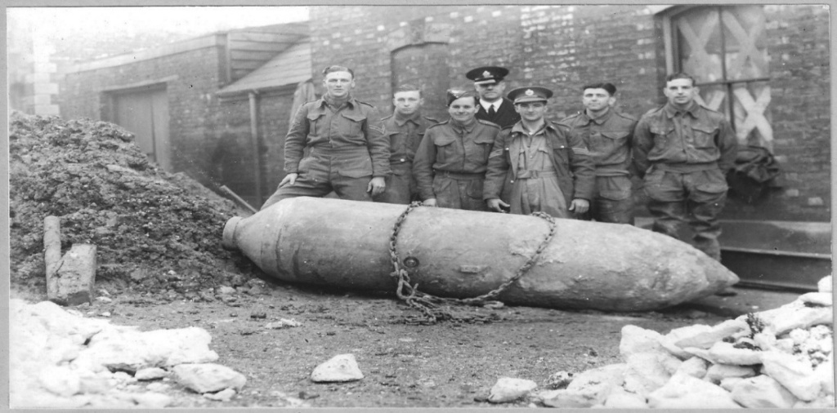

Cross Street, Strood, Kent. 1941 (Unit and personnel details unknown)
Photo credit: Peter Markham’s Collection.

British Empire Medal

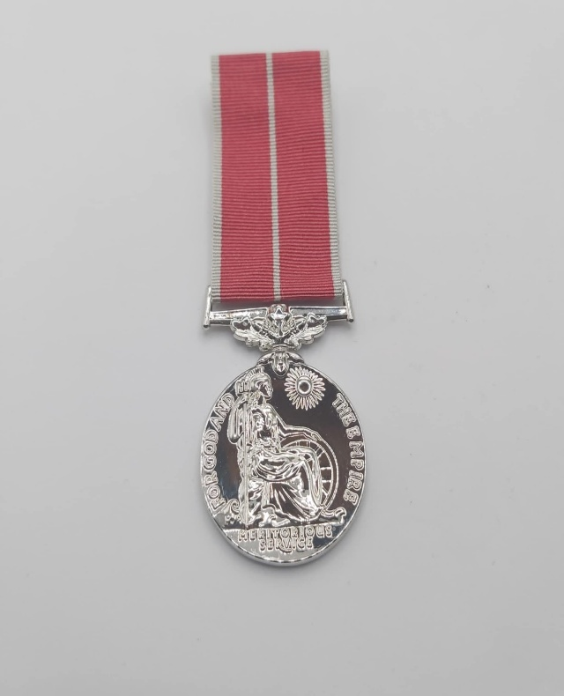

Photo credit: Julian Allerhead BEM

The British Empire Medal (BEM) - formerly the British Empire Medal for Meritorious Service - is awarded for meritorious service civil or military service worthy of recognition by the Crown. The current honour was created in 1922 to replace the original medal, which had been established in 1917 as part of the Order of the British Empire.

Between 1993 and 2012 it was not awarded to citizens of the United Kingdom. The awarding to British citizens was re-started in 2012.

The Royal Engineers Bomb Disposal teams were awarded 57 British Empire Medals, during the War period.

ANDREWS F BEM, (18888694) Corporal, Bomb Disposal, Royal Engineers

The Citation is taken from file WO373/67/53 held at the National Archives.
Posted in the London Gazette on the 28th October 1941. Supplement 35326. Page 6247.

Corporal Frederick Andrews during ten months has at every opportunity volunteered for bomb disposal involving an element of danger and has thus set a fine example to his men. He has dealt with paramines and a number of bombs containing delayed action fuzes.

When urgent reconnaissance work was required to be carried out during a heavy air attack during September, 1940, at Thameshaven, Corporal Andrews, disregarding all danger to himself drove a lorry containing a working party, under fire, to the site, thus disposing of a bomb in the minimum time.

On another occasion he drove a bomb which contained two number 17 fuzes to a suitable site for demolition. The bomb had fallen in a built-up area.

The Director of Bomb Disposal states that Corporal Andres has displayed qualities of leadership, devotion to duty and courage of a high order and sustained over a considerable period of time.

ATKINSON, Charles BEM, (7342527) Sergeant, 44 Bomb Disposal Section, 4 Bomb Disposal Company, Royal Engineers

The Citation is taken from file WO373/66/643 held at the National Archives
Posted in the London Gazette on the 21st January 1941. Supplement 35326. Page 6247.

Sergeant Charles Attkinson has been on bomb disposal duties since its commencement. In August a new type of bomb was discovered and he voluntarily assisted his officer to de-fuze this bomb in order to obtain new information. The fuze proved to be one of the first clock-work delay action types of a highly dangerous character and valuable data was obtained.

He has assisted in de-fuzing many different types and sizes of new bombs and has encouraged the men under him in every way.

BARR, James BEM, (2110915) Sapper, Bomb Disposal, Royal Engineers

The Citation is taken from file WO373/67/285 held at the National Archives
Placed in the London Gazette 24th March 1942. Supplement 35498. Page 1330.

Sapper Barr has been employed on bomb disposal duties for a period of twelve months, eight of which were spent at Hull. No matter how dirty or dangerous a job that had to be tackled on numerous occasions, it was noted that Sapper Barr was always one of the first to volunteer to be included in the working party. He has displayed a high degree of personal courage and devotion to duty in assisting his Section Officer and Sergeant to dispose of extremely dangerous delayed action bombs during the very heavy raids on Hull.

The conditions in Hull and after the raids were appalling and the determination and tenacity with which this Sapper assisted his superior officers was undoubtedly instrumental in saving valuable property and lives.

BARTON, John Roland BEM, (1861721) Sergeant, 7 Bomb Disposal Company, Royal Engineers

The Citation is taken from file WO373/69/319 held at the National Archives
Placed in the London Gazette 23 March 1945.
During the period from the 10 August to the 20 September, 1944, Sergeant Barton was in charge of a party engaged on clearance of Beach Minefields in the vicinity of Abbotsbury, Dorset. The miners were of the 36-1h. Beach anti-personnel type fitted with sensitive bow spring firing mechanism. Portions of the field were particularly difficult owing to the presence of strong undergrowth. It was due to Sergeant Bartons leadership efficiency and ready acceptance of personnel risk that 341 of these mines were removed by his party without accident.
In his work Sergeant Barton combines safety with courage and is a source of great confidence to the parties working under him.

BEARMAN, William Charles Victor BEM, (2193307) Sergeant, Bomb Disposal, Royal Engineers

The Citation is taken from file WO373/67/53 held at the National Archives.
Posted in the London Gazette on the 28th October 1941. Supplement 35326. Page 3247.
Sergeant Bearman has been employed continuously for twelve months on bomb disposal and has always carried out his duties with keenness and enthusiasm. During a period when his Section was without an officer, he took entire responsibility with excellent results. He has dealt with over two hundred and fifty bombs of all types and has defuzed many at a time when information and equipment were practically non-existent. From August to October, 1940, he worked in the heavily blitzes area of Shoeburyness and Southend and was mentioned in Command Orders for distinguished conduct and devotion to duty. From November, 1940 to May, 1941, he handled approximately twenty-five Category A.1. bombs of all calibres. During the whole of the above period, he has by his fine leadership, set a great example to his men.

On the 6th January, 1941, three category A.1. 50 – Kilogram bombs fell on the track at Swaffon Station, closing the line. Sergeant Bearman started on these bombs immediately and defuzed them in very short time.

On the 1st February, 1941, Sergeant Bearman rendered great assistance to his Section Officer in the removal of two Category A.1 50-kilogram bombs from a silk factory at Great Yarmouth, when in spite of great danger from fire and burning wreckage, both bombs were successfully dealt with. He set a fine example of personal courage to the working party.

On the 4th March, 1941, at Langham Aerodrome, he recovered four 50-kilogram bombs with number 15 fuzes classified as category A.1. from the landing ground, in the short space of two hours.

The Director of Bomb Disposal states that Sergeant Bearman had displayed outstanding qualities of leadership, courage and initiative over a long period and under most difficult conditions.

Further Information
Sergeant Bearman was later promoted and awarded the MBE (see separate entry).

BRISCOE, Walter BEM, (2126473) Lance Corporal, Bomb Disposal, Royal Engineers

This Citation is taken from file WO373/69/323 held at the National Archives/
Placed in the London Gazette on the 20th March 1945, Supplement 36995. Page 1573.

Lance Corporal Briscoe has been employed on bomb disposal and minefield clearance since January, 1941.

In June, 1944, he worked on a very difficult and dangerous minefield at Holywell Bay, Cornwall, and also as chief detector man at Charmouth, Seaton, Portland and Wyke Regis from August to November, 1944. In all he has detected approximately four hundred mines and has lifted and defuzed about one hundred and fifty.

Lance Corporal Briscoe has proved himself to be most reliable and efficient. On many occasions he has had charge of the minefield clearing party and always acted with the greatest confidence in those working under his supervision.

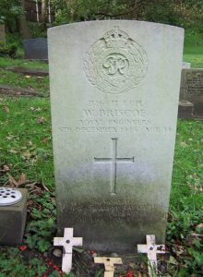 | On the 18th December 1944, a minefield at Wykes Regis was being cleared. Lieutenant L.H. Morgan was in charge of this operation. There, was an explosion and Lance Corporal W. Briscoe was killed a number of others including Lieutenant Morgan were wounded. Lieutenant Morgan entered the live section of the minefield to remove the wounded and Lance Corporal Briscoe’s body.  Lance Corporal W Briscoe is buried at Crompton Cemetery, Plot 77 Grave 12071.

BROWN, Charles Ernest BEM, (2069144) Sergeant, 7 Bomb Disposal Company, Royal Engineers

The Citation is taken from file WO373/68/333 held at the National Archives.
Placed in the London Gazette on the 10th March 1944. Supplement 36416. Page 1151.

Sergeant Brown has been employed on bomb disposal duties since, October, 1940. He has worked on over two hundred unexploded bombs, in raids on Bristol, Bath, Plymouth and Weston-Super-Mare. He has set an excellent example to his men and his determination to get the bomb, whatever the condition has been invaluable.

He was in charge of a party working on an unexploded bomb which was dropped during the raid on Plymouth 12th August, 1943. He was in the excavation when the first fuze was uncovered. During the process of excavation one side started to crumbling and to prevent any portion hitting the bomb and actuating the fuze, he leant against the crumbling side and prevented any fall on the bomb. He ordered his men aside and dealt with the falling shale piece by piece with his hands. The bomb was eventually blown up.

CARMAN, Henry William BEM, (2090614) Sapper, 68 Bomb Disposal Section, 9 Bomb Disposal Company, Royal Engineers

The Citation is taken from file WO373/66/684. Held at the National Archives
Placed in the London Gazette on the 21st January 1941. Supplement 35050. Page 462.

17th October, 1940. Coventry.

Sapper Carman with his Section was engaged in the removal of an unexploded bomb from the works of the Triumph Engineering CO. Ltd, Coventry, for a period covering forty-eight hours, in shifts. The bomb was removed on the 17th and found to be fitted with a delayed action fuze. Second Lieutenant A. F Campbell, (unfortunately killed the following day) reported the extraordinary devotion to duty displayed by the Section in removing the bomb which had penetrated twenty-seven feet.

They had to work in most difficult conditions, including gas, and they cheerfully took risks in the knowledge that over one thousand work people had been stopped producing was material. Their unhesitating willingness to work without rest is a credit to the Section as a whole, and their officer asked that one name might be put forward for an immediate award as representing the Section. I strongly recommend this.

Further Information
On the citation was a recommendation for the immediate award of the Military Medal. Then the George Medal or the OBE for Meritorious Service. The final decision was the British Empire Medal.

CHADWICK, John BEM, (2126201 Lance Sergeant, Bomb Disposal, Royal Engineers.

The Citation is taken from file WO373/69/321. Held at the National Archives.
Posted in the London Gazette on the 20th March 1945. Supplement 36995. Page 1573.

Early in 1944, Lance Sergeant Chadwick was working on a very difficult minefield at Perranporth, Cornwall, when there was an accident in which a Sergeant was killed. Lance Sergeant Chadwick carried on work. He also did good work at Mawganporth when recovering one hundred and fifty mines which were buried in sand drifts 3-feet six-inches deep.

In June, 1944, he was in charge of a party clearing mines at Holywell Bay, Cornwell. Again, this was most a difficult field, with deep sand over the mines, and the position was further complicated by the fact that some of the mines had been blown up in an attempt to clear the field.

When in charge of minefield clearance, Lance Sergeant Chadwick also personally performed the most difficult tasks and by his confidence and keenness was an inspiration to the men working under him.

CHAINEY, Arthur BEM, (2073641) Lance Corporal, 3 Bomb Disposal Section, Royal Engineers

The Citation is taken from file WO373/66/770. Held at the National Archives.
Posted in the London Gazette on the 7th March 1941. Supplement 35099. Page 1428.

On the 26th October 1940, Corporal Chainey voluntarily went forward with other members of his Section and removed a high explosive bomb, which had fallen that morning, on premises in Eastbourne. In order to allow immediate rescue operations for the recovery of the bodies of three members of No 3 Bomb Disposal Section and a policeman, all of whom had been buried by the explosion of another bomb. Corporal Chainey took a leading and vigorous part in carrying out the operation of removal.

On the 30th October, 1940, he carried out instruction for the removal of railway coaches at Eastbourne Station which were covering a large high explosive bomb. This bomb fell at the same time as the two mentioned above and had become wedged between the rails below the platform.

CLARK, Arthur Andrew BEM, (2194034) Lance Sergeant, Bomb Disposal, Royal Engineers

The Citation is taken from file WO373/66/1134. Held at the National Archives
Placed in the London Gazette on the 8th August 1941. Supplement 35213. Page 3920.

On the night of the 3rd March 1941, a 250-kilogram bomb which failed to explode on impact, was dropped in the centre of Cardiff, only nine yards from the emergency telephone exchange and twenty yards from the main thoroughfare of the city.

Owing to the possibility of damage to the main telephone exchange, it was decided that the bomb should, if possible, be prevented from exploding. On the following morning, therefore, the work of excavating was commenced with Lance Sergeant Clark in charge. Although all the time men were working there was the uncertain risk of the bomb exploding. Lance Sergeant Clark by his cheerfulness and optimism both in the direction and execution of the work set a very fine example to his men.

Owing to the nature of the soil and the presence of water, the work proved to be very slow and rather disappointing, but these difficulties did not daunt Lance Sergeant Clark, whose resourcefulness and perseverance helped enormously towards the successful conclusion of the job.

COX, Albert Charles BEM, (2076508) Acting Sergeant, Bomb Disposal, Royal Engineers

The Citation is taken from files WO373/69/653 held at the National Archives.
Placed in the London Gazette on the 2 October 1945. Supplement 37294. Page 4889.

On the 1 April’ 1945, it was reported that two German women were laying injured in a minefield at Mehr, which place at that time was situated behind Allied lines, and none of the enemy were present. Sergeant Suter immediately organised a rescue party and accompanied by Sergeant Cox commenced prodding a way through the minefield to one of the injured women who was lying in a hysterical condition with one of her legs partly blown off. These two NCOs searched all around her for mines, but when being moved onto a stretcher she set off a Schumine which her body had been concealing. As a result, both of the injured women were killed and Sergeant Suter and Sergeant Cox were both blown into the air, Sergeant Suter received severe injuries to his legs but Sergeant Cox escaped without injury.

These two NCOs in spite of severe shock, remained where they had landed and with complete calmness directed rescue operations. This was the first occasion on which either of the NCO, had ever entered a minefield, but they carried out their task unflinchingly and displayed great devotion to duty.

Further Information
Sergeant J T Suter was also was awarded the British Empire Medal.

CRUMP, Edward Thomas BEM Kings Commendation for Bravery Posthumously,
(66569) Captain, Divisional Bomb Disposal Group

The Citation is taken from file WO373/66/1255 held at the National Archives.
Placed in the London Gazette on 26th August 1941. Supplement 35562. Page 2156.

Recommended by the Secretary of State for War.
The late Captain Crump’s record is undoubtedly one of the finest examples of
sustained, cold-blooded courage and unselfish devotion to duty. In each of the
incidents described in the attached statement’s “A” to “E”, this officer coolly and
deliberately, having first assessed the risks involved and ensured that he alone should
take them, placed himself in extreme danger. In each case the action taken was the
only one possible.
The statement at “F” illustrates the high regard in which he was held by the
community in which he worked.
The late Captain E T Crump RE
The incident referred to, which it is desired to bring to the notice of higher
authorities for posthumous recognition, is that which occurred at Deptford west
Power Station about the middle of December last.
It will be remembered that damage had been done by enemy action to many of the
Power Stations, and it was essential that the Deptford Station should be kept on
load. It was therefore with very real concern that the authorities heard that a 250-
kg. bomb had been found within 4ft. of the main outgoing transmission lines; as a
result, the Bomb Disposal Unit were informed that demolition in situ could not be
accepted, and that the bomb must be removed – and that with all possible speed.
A steriliser was obtained and the drilling gear attached to the bomb in situ. After
steaming for some time, it became obvious that the machine was not working
properly, and although Captain Crump had been warned that the bomb was
considered to be in a highly dangerous state, he, without hesitation, climbed down
the hole to make an attempt to restart the drill, only to find that the stoppage had
been caused by the “falling in” of the hole. Subsequently excavation and steaming
successfully disposed of the incident.
9
th May 1941.
Endorsement.

142

As Engineer-in-Chief of the London Power Company, and being present personally at
Deptford during the above incident, I can fully endorse the foregoing statement.
5 May, 1941.

a. Note I have ascertained that the bomb had a (17) fuze J. Carmen Lt
Col RE
26.5.41 CRE (Bomb Disposal) London
Incident 1 & 2.
Parachute Mine at Bermondsey.
Extract from letter dated 4

th February, 1941, from the Controller Civil Defence, to

Major Yates, D.C.R.E South for Bomb Disposal, London.
“At Messer’s. Cartwrights’ premises, Lower Road, where a land mine settled Captain
Crump personally fixed the lashings for preventing the mine from slipping before it
was raised, examined the fuzes and took all the necessary measures to prevent the
mine from exploding whilst being removed. He took the precautions of keeping the
men of the party out of danger and would only allow a Sergeant to be near him
whilst these operations were carried out. Similarly at Messer’s. Gilman and Spooners
premises in the Borough, a mine landed and was embedded in sacks of sago. There
was evidently some difficulty in removing the fuzes. A Naval Officer was unable to
remove the fuze thereupon Captain Crump, at the imminent risk of his life
supervised the fixing of ropes to the top of the mine and prevented it from tilting
and falling when the sacks of sago were removed. After ascertaining that the mine
was held safely, he removed the bags himself, refusing to allow the men of his party
to take the risk in case the mine should move and explode.
Signed? E Baker. Controller Civil Defence.
“C”
Incident NO. 3 – 250 kg. Bomb at Scotsdale Road, Woolwich.
Extract from letter dated 24th

, January, 1941, from Lieutenant. A.G Bainbridge, R.E.

D.C.R.E. South for Bomb Disposal, London.
“At Scotsdale Road Woolwich; a 250 kg. bomb had been removed from a hole and
was found to have a 17 and 50 fuze. The rope holding the bomb broke and it dropped
to the bottom of the hole. Captain Crump was contacted and reached the site later
in the day; without hesitation he descended the hole, cleaned the fuzes and
confirmed their numbers as 17 and 50. Because the vibration of the falling bomb in
the hole might very easily have started the 17, clock, he removed all other personal
from the danger area and satisfied himself that the clock was not working. This was
an operation extending over at least an hour, as his medical stethoscope could not

143

be relied upon and it was necessary to send for the electrical apparatus. His
disregard for danger and his quick grasp of all situations, gave all who worked under
him the utmost confidence in him and themselves”.
Signed. A.C. Bainbridge. Lieutenant RE
“D”
Incident NO. 4 1000-KG Bomb at R.A. Barracks. Woolwich.
Extract from letter dated 15th January, 1941, FROM Major C. H. Yates, R.E. D.C.R.E.
South for Bomb Disposal G.H.Q Home Forces.
“Captain E.T Crump. R.E. has disposed of bombs in Woolwich area since June last
year and has been subjected to consistent attacks ever since. First class leadership
and control were called for under such circumstances that required long hours of
work with no rest and very little sleep, because of persistent night raids. Captain
Crump by his coolness during raids and his courage and initiative in the disposal of
bombs consistently set a high example to the officers working with him and to the
men working under him, thereby giving the load which was so essential to the rapid
and efficient clearing of bombed areas.
The outstanding case occurred when the first 100 kilo bomb was exposed. This fell
into the barrack square of the R.A. Barracks at Woolwich. Before removing the fuze,
which was unknown, sterilisation appeared to be the obvious precaution. Captain
Crump carried out this operation, though it was the first time he had actually worked
the plant. After considerable difficulty, sterilisation was completed, and the bomb
removed, when Captain Crump helped to extract the fuze.
Signed C.H. Yates, Major, R.E. D.C.R.E. South.
“E”.
Incident NO.5 His death whilst disposing of 250 KG. Bomb at White’s Ground,
Bermondsey.
Report dated 18th January, 1941, from Major C.H. Yates, R.E. D.C.R.E. South for
Bomb Disposal, London, to the Inspector of Fortifications and Director Bomb
Disposal.
Further Information
The final page 277 from file WO373/66/1255 is missing from the National Archive
files so the incident of his death is unknown. All that is know is that he died on the

144

16th January 1941. His wife gave birth to their daughter Phoebe in the summer of
1941.
Captain ET Crump also received a Kings Commendation for Bravery (see separate
entry).
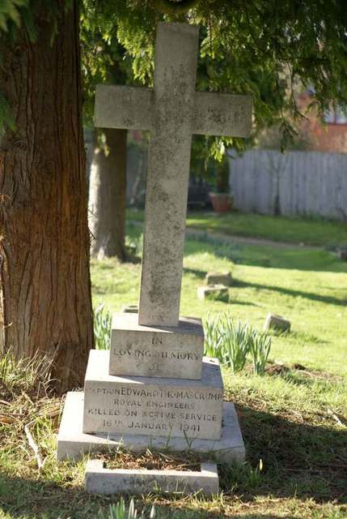

2036952 Sergeant Dears, Henry British Empire Medal, Bomb Disposal, Royal Engineers

The Citation is taken from WO373/67/367 held at National Archives.
Posted in the London Gazette on the 2nd June 1942. Supplement 35580. Page 2373.

Sergeant Dears has been employed on bomb disposal work since June, 1940. In the early days of bomb disposal, he proved himself to be invaluable as a Section Sergeant. He has at all times been the first to carry out most arduous work, while fully appreciating the danger involved. He has also set an excellent example to the men of his Section by his steadiness and cheerfulness, especially when dealing with bombs containing dangerous fuzes. He has displayed outstanding devotion to duty, powers of leadership, and cool courage over a long period.

On three particular occasions while dealing with unexploded bombs he has accepted the risk of certain death under extremely difficult and dangerous conditions, without hesitation and with complete disregard for himself.

EARDLEY, Ernest BEM, (13054231) Corporal, 22 Bomb Disposal Company, Royal Engineers

The Citation is taken from file WO373/67/191 held at National Archives.
Posted in the London Gazette on the 17th February 1942. Supplement 35460. Page 773.

Corporal Eardley has been constantly employed on bomb disposal work since October 1940, and has proved himself to be a most consistently courageous and efficient N.C.O. He inspires the complete confidence of the men working under him. He has been constantly been praised by his officer for his reliability and skill and proved the greatest assistance to his officer in recovering a parachute mine, which had to be withdrawn with great difficulty from ten feet of mud and water before it could be gagged by Naval Officers.

Corporal Eardley on one occasion, by his complete disregard for fatigue, nerve strain, and personal danger both prior to and after the death of his Section Officer when he was buried alive and subsequently to search for his body. By his cool courage and magnificent example, he was equally responsible with the same Sergeant in causing the Section to work on without faltering under the most nerve racking and exhausting conditions.

ELLIOTT, Horace BEM, (2036910) Lance Sergeant, Bomb Disposal, Royal Engineers

The Citation is taken from file WO373/66/1366 held at National Archives.
Posted in the London Gazette on the 30th September 1941. Supplement 35292. Page 5654.

Lance Sergeant Elliott has worked continuously on bombs since, August 1940. He has displayed great courage and initiative in his work. He was engaged on one bomb which exploded causing fatal casualties. Although badly shaken himself, he refused, owing to pressure of work, to remain off duty. His sense of duty and personal disregard of danger has been of immense value in maintaining a very high standard of morale in his Section.

On the 12th December, 1940, at Birmingham, he played a very prominent part when a bomb fell at B.S.A (Guns). He worked continuously on the bomb with very brief intervals for rest owing to his anxiety to see the work completed. His keenness and energy contributed very largely to the bomb being successfully disposed of.

On another occasion when a 250-kilogram bomb, which failed to explode, fell on the Singer Motor Works, it was chiefly due to Lance Sergeant Elliott’s initiative and energy that this bomb was also successfully dealt with. The fact that the bomb contained two number 15 fuzes was not known to him and his party until after it had been uncovered.

EVANS, Horace BEM, (219887) Sergeant, 18 Bomb Disposal Section, Royal Engineers

The Citation is taken from file WO373/76/628 held at National Archives.
Posted in the London Gazette on the 18th February 1943. Supplement 35908. Page 862.

During the period 8th to 27th April, 1942, he supervised the excavation of a priority bomb in the mid of petrol tanks at MRX, giving no thought to personal danger which was greatly increased by petrol fumes and running sand.

When it seemed as if the attempt to remove the bomb would have to be abandoned owing to increased petrol fumes and landslides, Sgt Evans persisted in continuing without any thought for great personal risks he was taking.

Thanks to this it was possible to remove the bomb and permit work essential to the war effort.

Further Information
Initial citation recommended the award of the George Medal; this was changed to the British Empire Medal. He had been Mentioned in Dispatches on the 15th December 1942.

FISHER, Frederick BEM, (2015146) Sergeant, Bomb Disposal, Royal Engineers.

The Citation is taken from file WO373/68/286 held at National Archives.
Posted in the London Gazette on the 15th February 1944. Supplement 36384. Page 837.

Sergeant Fisher has been engaged on bomb disposal duties for three years. During this period, he has worked in heavily blitzed areas around Tilbury, Brentwood and Norwich. He has always volunteered at every opportunity for work involving any element of risk and by his example has been an inspiration to all ranks. During a fall of anti-personnel bombs, which are fitted with two types of fuzes, he worked with his officer for three days running and helped to dispose of two hundred and thirteen bombs.

GILKS, Henry Thomas BEM, (1883508) Sergeant, Bomb Disposal, Royal Engineers

The Citation is taken from file WO373/67/368 held at the Nation Archives.
Posted in the London Gazette on the 2nd June 1942. Supplement 35580. Page 2373.

Sergeant Gilkes has been employed on bomb disposal work since the end of June, 1940, and during this period, he has worked on approximately two hundred and fifty bombs of varying categories. He has always shown outstanding courage and devotion to duty, and he has always been one of the first to volunteer for any dangerous work.

This N.C.O. has on various occasions displayed fine powers of leadership, energy and courage of a very fine order in face of grave danger and risk of instant death. He has always shown complete disregard for personal danger, coupled with a fine sense of duty over a long period of work in bomb disposal.

GREEN, Arthur Ellis BEM, (2014169) Driver, Bomb Disposal, Royal Engineers

The Citation is taken from file WO373/66/1366 held at the Nation Archives.
Posted in the London Gazette on the 30th September 1941. Supplement 35292. Page 5654.

Since September, 1940, it has been Driver Green’s duty to drive his officer on night and day reconnaissance’s of bombs, both in Birmingham and Coventry. He has been out during nearly every major raid on both of these cities and has always displayed remarkable steadiness and personal disregard of danger. He has never hesitated to render assistance when debris had to be cleared for the recognition of suspected unexploded bombs.

On one occasion during a heavy air raid on Coventry. He arrived with his officer at that City only to find nearly all the roads impassable and a heavy concentration of bombs falling. By his determination he managed to get his officer to his destination. After this reconnaissance further progress could only be made on foot, but he accompanied his officer throughout the night. A bomb fell approximately fifty yards away from them which threw Driver Green to the ground severely shaking him.

On another occasion when a mine was being detonated, there was a misunderstanding, but not due to the fault of Driver Green. The officer, after lighting the safety fuze of the demolition charge was left stranded about eighty yards away from the mine with very little cover for safety. Driver Green drove the car back over some three hundred yards of open ground. The officer was able to jump on the running board of the car and escaped an explosion which followed about a minute after he had been picked up.

Driver Green has shown a capacity for sustained courage and devotion to duty of a very high order.

GURNEY, James Henry BEM, (2093073) Lance Corporal, 3 Bomb Disposal Unit, Royal Engineers

The Citation is taken from file WO373/66/673 held at the National Archives
Posted in the London Gazette on the 21st January 1941. Supplement 35050. Page 462.

Lance Corporal Gurney assisted in the removal of a delay action bomb at the works of Staveley Coal and Iron CO. Ltd. This bomb of 50-kilograms had fallen within 15 feet of a blast furnace, and its explosion there would undoubtedly have caused very serious damage. The bomb was finally located in a drain underneath a blast furnace has main ten feet, in diameter, having pierced some brick steps, then two feet, of solid concrete. The work necessitated the use of pneumatic air drills. Throughout the operation he worked extremely well and set a very fine example to the men of his party.

Further Information
Originally recommended for a mention in dispatches or a commendation.

HALLIGAN, Frederick, (2022284) Sergeant, 46 Bomb Disposal Section, 4 Bomb Disposal Company, Royal Engineers

The Citation is taken from file WO373/66/644 held at the National Archives
Posted in the London Gazette on the 2^{1st} January 1941. Supplement 35050. Page 462.

Sergeant Frederick Halligan was engaged during September in dealing with a 1,000-kiligram bomb at a depth of thirty-two feet. In a main road between Dovercourt and Harwich. No officer being available he defuzed the bomb and removed it to a place of safety.

The following message was received from Harwich A.R.P Report Centre: -

“Members of the Civil Defence of the Borough of Harwich unite in expressing their admiration of the bravery, initiative and skill displayed by the N.C.O’s and party responsible for removing the large bomb dropped by enemy aircraft. Such an example of cool devotion to duty and cheerfulness in the face of constant danger and difficulties remain an inspiration to us all”

Sergeant Halligan has been engaged for some months on this work.

HIORNS, Ernest BEM, (2079532), Bomb Disposal, Royal Engineers

The Citation is taken from file WO373/67/369 held at the Nation Archives.
Posted in the London Gazette on the 2nd June 1942. Supplement 35580. Page 2373.

Sergeant Hiorns has been continuously employed on bomb disposal work since June, 1940, and he has always displayed great courage and keenness in his work. His expert knowledge has been most valuable in the lifting and handling of heavy bombs. His record constitutes a fine example of sustained courage and devotion to duty over a long period.

In each of three particular incidents in which Sergeant Hiorns has been concerned with bomb disposal he has displayed complete disregard for personal danger, with dogged tenacity under highly dangerous conditions involving the risk of almost certain death.

HODGSON, Frances Eric BEM, (1983668) Corporal, Bomb Disposal, Royal Engineers

The Citation is taken from file WO373/68/603 held at the Nation Archives.
Posted in the London Gazette on the 22nd August 1944. Supplement 36669. Page 3941.

Corporal Hodgson has been engaged on bomb disposal operations since May 1941. Throughout this period, he has always displayed tremendous enthusiasm for his work, and a complete disregard for personal danger. His keenness and moral courage have been a splendid example to the men working with him.

On one occasion he took his turn at intervals with two officers in the actual task of adjusting the steam nozzle inside an unexploded bomb which was being sterilized, and also helped to remove the bomb filling by hand as it softened. In order to do this, he had to lie on his back in wet ground with his head actually beneath the bomb. The assistance he gave on this occasion was no small contribution to the success of the operation.
HOY, R BEM, (11425714) Corporal, 7 Bomb Disposal Company, Royal Engineers

The Recommendation is taken from file WO373/69/325 held at the National Archives
Posted in the London Gazette on the 23rd March 1945. Supplement 36995. Page 1574.

In January, 1944, Lance Corporal Hoy was a member of a working party engaged upon clearing mines in the Sidmouth area, where he detected, lifted and defuzed a large number of mines. He worked minefields at Polridmouth in February, 1944, also at Mawganporth in March, 1944. In June, 1944, he worked both as Detector and Digger man at Holywell Bay, a very dangerous and difficult minefield. From July to November, 1944, he worked on all minefields at Seaton, Portland and Wyke Regis. In all he has detected, lifted and defuzed approximately three hundred mines.

Lance Corporal Hoy has always been a most confident and steady worker, at home in any role on a minefield, and one who inspires confidence in those who work for him.

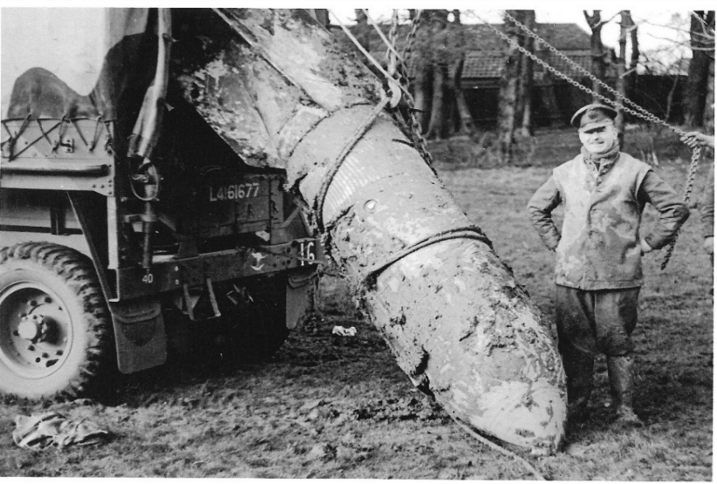 | Images left and below  Holywell Park, Ipswich. 7 January 1944. Unit and personnel unknown.  Photo credit: Peter Markham’s Collection.
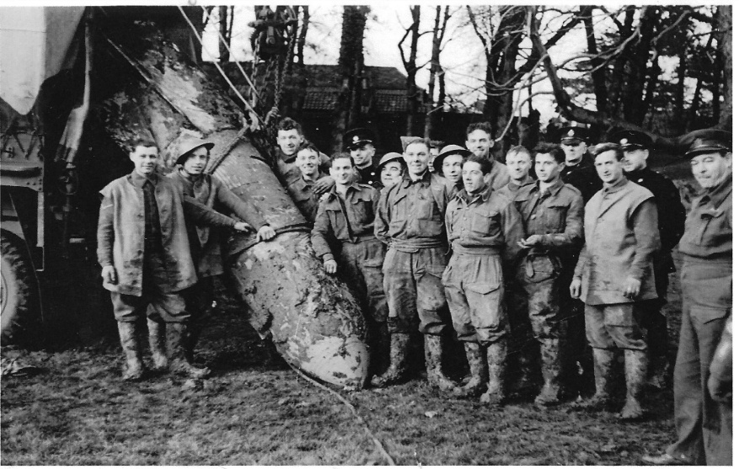

JOY, Edward Henry BEM, (1910114) Corporal, Bomb Disposal, Royal Engineers

The Citation is taken from file WO373/67/281 held at the National Archives.
Posted in the London Gazette on the 24th March 1942. Supplement 35498. Page 1330.

Corporal Joy commenced Bomb Disposal work in June, 1940. He has a strong sense of duty, and has proved an excellent asset on dangerous jobs. He has always been one of the first to volunteer for Category “A” work, and his coolness and fearlessness in face of danger have been an inspiration to the rest of his Section.

On one occasion in particular this N.C.O. acted with coldblooded courage and devotion to duty of the highest order in assisting his Section Sergeant to remove a 250-kilogram delayed action bomb fitted with two long delay fuzes, both of which were operating. The very grave risk of explosion was known and accepted in order to attempt to avoid severe damage to a railway and a hospital, both vital services and a matter of necessity at this time.

KIRK, Robert William BEM, (27817) Sergeant, 65 Bomb Disposal Section, 4 Bomb Disposal Company, Royal Engineers

The Citation is taken from file WO373/66/245 held at the National Archives.
Posted in the London Gazette on the 21st January 1941. Supplement 35050. Page 462.

Sergeant Kirk has been the N.CO. in charge of Bomb a Disposal Section since work began. He has proved himself invaluable by the calm and efficient manner in which he has carried out his duties in a very important industrial area when the presence of unexploded bombs would interfere with the war effort.

He was the N.C.O. in charge of the Section which dealt with twenty unexploded bombs in the Vauxhall Motor Works, Luton, some of which exploded while digging was in progress, indicating delayed action.

LEIGH, Herbert BEM, (23855) Lance Corporal, 101 and 102 Bomb Disposal Sections, Royal Engineers

No Citation found in the National Archives Files.
Posted in the London Gazette on the 27th September 1941. Supplement 35050. Page 462.

Citation taken from his London Gazette entry.

Lance Corporal Leigh was a member of the Bomb Disposal Section responsible for the recovery of the bomb, which fell, close to St. Paul’s Cathedral; and was responsible for assisting Lieutenant Davies in the subsequent disposal of the bomb when it has been moved from the excavation.

His personal example of courage and contempt of danger in working over a bomb which might have exploded at any moment was of untold value in Maintaining the morale of his team.

Further Information
Lieutenant Davies and Sapper Wylie were both awarded the George Cross and Sergeant Wilson the British Empire Medal also for this incident, see separate entries.

LLEWELLYN, George BEM, (2811272 Sergeant, 3 Bomb Disposal Group, Royal Engineers

The Citation is taken from file WO373/157/241. held at the National Archives.
Posted in the London Gazette on the 29th December 1944. Supplement 36886. Page 38.

This N.C.O. has been employed for over four years on Bomb Disposal Duties.

As a Sapper and Junior N.C.O., his cheerfulness and courage, has always inspired confidence in his section. Since his promotion to Sergeant, in Nov, 1941 he has proved himself to be a great leader, whose thoughts are for his men before any other consideration.

In the latter part of 1940 and early 1941 he was engaged in Essex on extensive Bomb Disposal Operations which were the result of the Battle of Britain Later in 1941 he was transferred to Norwich and worked all through the heavy raids on that town and the surrounding districts when the dangerous condition of blitzed houses and water-logged ground required the utmost care and attention to details to prevent accidents.

In all he has worked on over two hundred and fifty Unexploded Bombs of all sizes with every known type of fuze, never once hesitating to undertake any job.

This N.C.O. has also been engaged for a considerable time on Beach Minefield Clearance.

MEAD, George Thomas BEM, (2071183) Sergeant, Bomb Disposal, Royal Engineers

The Citation is taken from file WO373/66/938 held at the Nation Archives.
Posted in the London Gazette on the 29th April 1941. Supplement 35148. Page 2441.

On the 24th October, 1940, a bomb was located in Coventry and Sergeant Mead was detailed to the work of disposal. The bomb had penetrated a sewer and Sergeant Mead, whilst directing operations during the morning, was overcome by gas. The attack was not very severe and after a few hours, during which he partially recovered, he resumed his work. During the afternoon he was again overcome by gas and was removed from the site in a collapsed condition. He received medical attention for two days in his billet, but as recovery was slow, he was despatched to hospital, where he eventually recovered.

On the 6th November, 1940, two bombs of 560-pound, weight were being disposed of by burning at Binley Sandpits, Coventry. An officer was in charge of the operation and assisted by Sergeant Mead. During the process both bombs exploded killing one man and injuring the officer, Sergeant Mead and three other members of the party. Although in severe pain due to his injuries, Sergeant Mead assisted by the office in attending to the other injured men, but shortly collapsed and was removed to hospital suffering from head and other injuries. It is doubtful whether he will again be physically fit. He has, whilst in hospital, expressed his wish to again resume his duties with the Section.
The conduct of Sergeant Mead, who has been engaged on bomb disposal work from the very first days, has been in keeping with the very high tradition of the Corps; his example and spirit have been beyond praise. Such a man as this has proved to be the backbone of his unit, and is in large measure responsible for what success has been attained in operations within the Area.

MEAGER, Cyril Thomas BEM, (1872626) Lance Corporal, 127 Bomb Disposal Section, Royal Engineers

The Citation is taken from file WO373/78/254 held at the Nation Archives.
Posted in the London Gazette on the 27th October 1942. Supplement 35763. Page 4688.

L/Cpl Meager has been working on bomb disposal for more than a year and has, on many occasions, shown exceptional coolness and efficiency in danger. During the last few months, he has been driving the truck of Lt Blackwell’s reconnaissance party and became Lt Blackwell’s personal assistant. By his enthusiasm and readiness to work at all hours over long periods, he has set a magnificent example to his Section.

MITCHELL, Herbert Henry BEM, (1883094) Acting Sergeant, Bomb Disposal, Royal Engineers

The Citation is taken from file WO373/67/370 held at the Nation Archives.
Posted in the London Gazette on the 2nd June 1942. Supplement 35580. Page 2373.

Sergeant Mitchell has been actively engaged on bomb disposal duties since June 1940, and has worked on at least two hundred and fifty unexploded bombs of varies categories. His fine example of courage and devotion to duty has always been of great assistance when engaged upon work of a hazardous nature. His courage and cheerfulness while employed on bomb disposal work at Coventry during November and December, 1940, set a good example to his comrades.

On two occasions in particular Sergeant Mitchell has displayed sustained, cold-blooded courage, and devotion to duty of a very high order while assisting his Section Officers in work of bomb disposal.

NUTALL, Geoffrey Barlow BEM, (1893938) Acting Sergeant, Bomb Disposal, Royal Engineers

The Citation is taken from file WO373/67/371 held at the Nation Archives.
Posted in the London Gazette on the 2nd June 1942. Supplement 35580. Page 2373.
Sergeant Nuttall has been continuously engaged on bomb disposal duties since October, 1940, and during that time his initiative and eagerness in volunteering to assist his Section Officer in any job irrespective of its dangers, has been an inspiration and marked example to the other N.C.Os and men of his Section.

This N.C.O. has an outstanding record of personal courage, powers of leadership and devotion to duty on bomb disposal operations over a long period. In each of three incidents particularly brought to notice in which he has been concerned; he volunteered to assist his Section Officer to remove delayed action bombs to a place where explosion could not cause damage. That he was fully aware of the highly dangerous condition of the bombs which were being dealt with, and grave risks involved, renders his actions all the more meritorious.

OXFORD, Edwin Charles BEM, (1920394) 9 Bomb Disposal Company, Royal Engineers

The Citation is taken from file WO373/66/673 held at the Nation Archives.
Posted in the London Gazette on the 2^{1st} January 1941. Supplement 35050. Page 462.
On 6th September, 1940, an unexploded bomb fell outside a factory on priority work stopping the work there and a road leading to other important factories. Other bombs dropped at the same time in the vicinity were exploding at short intervals. Lance Corporal Oxford who was in charge of the party immediately dealt with this bomb.
Further Information
Initially recommended for a Mention in Dispatches or Commendation.

PALMER, Sidney George BEM, (6912690) Lance Corporal, 7 Bomb Disposal Company, Royal Engineers

The Citation is taken from file WO373/69/325 held at the Nation Archives.
Posted in the London Gazette on the 2^{0th} March 1945. Supplement 36995. Page 1574.
Early in 1944 Lance Corporal Palmer was a member of a working party clearing mines in Sidmouth area, and as the detector man was responsible for detecting over 200 mines. He was at Polridmouth where he cleared approximately one hundred mines.

Lance Corporal Palmer was within twenty yards of an explosion which killed one man and injured his Company Commander. Though suffering from the effects of severe blast, he behaved with outstanding coolness and gave valuable assistance after the accident. Since then, he has worked almost continually on the clearance of minefields and is an outstandingly reliable detector operator, and a man who inspires confidence in those working with him.

POWELL, Frederick James BEM, (1983232) Acting Lance Corporal, Bomb Disposal, Royal Engineers

The Citation is taken from file WO373/67/281 held at the Nation Archives.
Posted in the London Gazette on the 1st March 1942. Supplement 35498. Page 1330.
Lance Corporal Powell commenced Bomb Disposal work in September, 1940, and continued to be employed on this kind of work until March, 1941, when he was seriously injured by the explosion of a bomb, of which details are given below.

At the Post Office in King Edward Street, London in March, 1941, Lance Corporal Powell was detailed to take charge of a party to dig down to a bomb which was threatening the G.P.O. Tube Railway. During operations the bomb exploded causing him severe skull injuries. On this this occasion Lance Sergeant Powell acted with great courage and dogged tenacity of purpose, completely disregarding the extreme danger of the task in hand. He has always displayed great coolness and courage, and absolutely fearlessness, with complete disregard for his own safety, although fully aware of the dangers involved.

PRATT, Frederick Walter BEM, (723655) Sergeant, Bomb Disposal, Royal Engineers

The Citation is taken from file WO373/67/189 held at the Nation Archives.
Posted in the London Gazette on the 17th February 1942 December 1945. Supplement 35460. Page 773.
Sergeant Pratt has been, bomb disposal Section Sargent for over eleven months, during which time he was stationed on the Thames Estuary where enemy activity has been heavy. On one occasion he displayed a high degree of personal courage and devotion to duty when he volunteered to assist an officer to withdraw by hand a 17A and 50fuze from a 250-kilogram bomb. That he fully realised the possibility of an anti-withdrawal device being fitted behind the 17A fuze and that the slightest vibration might activate the 50 fuze accentuates the bravery of his action.

Sergeant, Pratt has consistently disregarded personal danger and has been of the greatest assistance to his Section Officer in carrying out reconnaissance work. He has been an inspiration to the men of his Section, and has always shown such care for their safety that no accidents have occurred, in spite of two hundred incidents on which his Section has been engaged.

RAMSAY, John BEM, (2040042) Acting Lance Corporal, 56 Bomb Disposal Section, 11 Bomb Disposal Company, Royal Engineers

The Citation is taken from file WO373/66/813 held at the National Archives.
Posted in the London Gazette on the 25th March 1941. Supplement 35116. Page 1733.

On the 1st November, 1940, a 550-poundbomb fell in the River Tyne close to the bridge at East Linton carrying the main road over the river. Lance Corporal Ramsay and Sapper Smith, together with Lieutenant Hewitt dived into the extremely cold and muddy water to locate the bomb. When the bomb was found they assisted to fix a rope round the bomb. When first pulled out the rope slipped and they had to dive in again and re-fix it. The bomb was finally pulled out, the fuze discharged and the bomb sterilised. The whole operation exhibited extreme courage under very cold water and difficult conditions. The bomb was lying in muddy water and it was not possible to see what type of fuze it contained or how it would react. The fact that it had fallen in soft mud made it more liable to explode when moved even if there was no delay action. By their personal courage, an important bridge on a main road was saved from possible damage.

Further Information
Also, Lieutenant Hewitt was awarded the George Medal and Sapper J Smith the British Empire Medal for this incident.

ROBERTS, Jack BEM, (1900409) Sergeant, 16 Bomb Disposal Company, Royal Engineers

The Citation is taken from file WO373/68/440 held at the National Archives.
Posted in the London Gazette on the 5th May 1944. Supplement 36498. Page 2049

Sergeant Roberts commenced bomb disposal operations in November 1940, and assisted in operations as a result of enemy air raids on Cardiff and Swansea areas. Additionally, he assisted with the clearing of many beach minefields, involving approximately two thousand mines. Despite the fact that a number of his comrades had been killed whilst clearing minefields, he continued to carry out his duties in the most steadfast and courageous manner, setting a magnificent example to the men in his charge. Sergeant Roberts was unfortunately killed in a mine explosion on 28th February, 1944, which date was subsequent to that on which his name was put forward for an award.

Further Information
Died in South Wales with Corporal J Nelson.

ROBINSON, Allan John BEM, Acting Lance Sergeant, Bomb Disposal, Royal Engineers

The Citation is taken from file WO373/67/189 held at the National Archives.
Posted in the London Gazette on the 17th February 1942. Supplement 35460. Page 773.

Lance Sergeant Robinson has been engaged on bomb disposal work since January 1941. His personal courage has been of a very high order and he has always exercised great care and thought for the safety of working parties under him. He has constantly volunteered to do difficult work involving danger and has set a fine example to his Section. By following the example set by his Section Officer, he has been largely responsible for securing the maximum output of work from his Section, which in some cases has been remarkable.

On one occasion he was in charge of the working parties under the direction of his Section Officer when digging down to and moving into position, paramines to enable the Naval Mine Disposal Officer to get at the fuzes. It was known that paramines are extremely sensitive to movement and vibration and that the slightest error would result in disaster to the working party. These risks were accepted by Lance Sergeant Robinson with deliberate and cold-blooded courage worthy of the highest praise.

RODGERS, Arthur BEM, (1869665) Sergeant, Bomb Disposal, Royal Engineers

The Citation is taken from file WO373/68/286 held at the National Archives.
Posted in the London Gazette on the 15th February 1944. Supplement 36384. Page 837.

Sergeant Rodgers has displayed conspicuous courage in dealing with mine, booby traps and bombs. During the whole of his service in North Africa, since 23rd March, 1943, he has taken upon himself the task of dissecting every new type of enemy bomb, mine and booby trap which has come to him. He has disarmed innumerable mines many of which were in poor condition. He has shown outstanding ability, courage and resource, and since hostilities ceased in North Africa, he has done valuable work in the instruction of units of all arms in this field of warfare.

SELLENS, Ernest William, (2092109) Sergeant, 10 Bomb Disposal Company, Royal Engineers

The Citation is taken from file WO373/157/310 held at the National Archives.
Posted in the London Gazette on the 29th December 1944. Supplement 36866. Page 39.

For carrying out hazardous work on Bomb Disposal and Mine-clearance. In January 1944 he took charge of a Minefield party after a fatal accident had occurred, removing the bodies, regardless of his own safety controlled the whole operation until the arrival of his O.C.

This N.C.O. has been recommended for an award on a previous occasion

SMITH, Arthur Whiting BEM, (5173065) Sergeant, Bomb Disposal, Royal Engineers

No file found in the National Archives Catalogue
Placed in the London Gazette on the 2 June 1943. Supplement 36033. Page 2440.
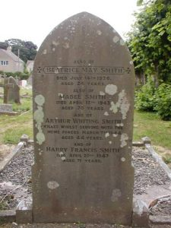 | Further Information  Sergeant A W Smith died on the 7 March 1944. Beach mine-clearance of anti-invasion mines. At Lowestoft, Suffolk.  Court of inquiry findings were; the instructions laid down for the clearance of beach mines were being properly carried out.  Photo credit: Alan Calton.

SMITH, Herbert BEM, (1864420) Corporal, 9 Bomb Disposal Section, 4 Bomb Disposal Company, Royal Engineers

The Citation is taken from file WO373/66/646 held at the National Archives.
Posted in the London Gazette on the 21st January 1941. Supplement 35050. Page 462.

Lance Corporal Herbert Smith has been on bomb disposal work since its inception, showing marked coolness and disregard for personal safety at all times.

During the week 20 – 27th September, 1940, he led a volunteer working party at digging up, at great personal risk, three unexploded parachute mines buried deep in the ground at Laindon, Essex, much of the work being carried out during the hours of darkness.

SMITH, John BEM, (2078741) Sapper, 56 Bomb Disposal Section, 11 Bomb Disposal Company, Royal Engineers

The Citation is taken from file WO373/66/814 held at the National Archives.
Posted in the London Gazette on the 25th March 1941. Supplement 35116. Page 1733.

On the 1st November, 1940, a 550-poundbomb fell in the River Tyne close to the bridge at East Linton carrying the main road over the river. Lance Corporal Ramsay and Sapper Smith, together with Lieutenant Hewitt dived into the extremely cold and muddy water to locate the bomb. When the bomb was found they assisted to fix a rope round the bomb. When first pulled out the rope slipped and they had to dive in again and re-fix it. The bomb was finally pulled out, the fuze discharged and the bomb sterilised. The whole operation exhibited extreme courage under very cold water and difficult conditions. The bomb was lying in muddy water and it was not possible to see what type of fuze it contained or how it would react. The fact that it had fallen in soft mud made it more liable to explode when moved even if there was no delay action. By their personal courage, an important bridge on a main road was saved from possible damage.

Further Information
Also, Lieutenant Hewitt was awarded the George Medal and Sapper J Ramsay the British Empire Medal for this incident, see separate entries.

SMITH, James BEM, (2128909) Lance Sergeant, 158 Bomb Disposal Platoon, 17 Bomb Disposal Company, Royal Engineers

The Citation is taken from file WO373/72/972 held at the National Archives.
Placed in the London Gazette on the 19th April 1945. Supplement 37039. Page 2072.

This NCO is strongly recommended for an award in recognition of his gallant conduct in carrying out most hazardous work in a very brave, manner, well knowing the great personal risks he was taking. Between 3rd October and 10th October 43 he defuzed and removed six British Bombs fitted with long delay fuzes and anti-handling devices. These bombs were adjacent to the Salerno-Naples Road and Salerno-Naple’s railway and their clearance avoided serious hinderance to military operations.

Extracting British long delay fuzes and anti-handling devices is a most dangerous task which has caused many casualties. Great courage and ingenuity are required D.B.D Instructions lay down these bombs should always
Be destroyed in situ unless the explosion is likely to cause damage that would impede military operations.

In addition, between 9th Oct and 15th Oct 43 at Naples he very ably assisted his officer in locating an enemy F Feder (clockwork delay device) which was cunningly hidden in Prince Piedmont Barracks and connected to 1590 lbs of H.E. and timed to explode the following day. By locating this mine many lives were saved as the building had previously been vetted and declared clear by other troops and would have been occupied that night.

L/Sgt Smith’s platoon was one of the first to enter Florence and from 4th Aug to 20th Sept 44 he has been in charge of mine clearance parties. His attention to safety precautions, alertness and coolness under shell and S.S fire in carrying out essential mine clearance, greatly assisted military operations and avoided casualties. In addition, L/Sgt Smith was i/c booby trap clearance under the direction of his O.C. and was outstanding in his abilities, keenness and control of men. This type of work calls for courage and alertness of a very high order.

Further Information
At this time very little information had been passed on to BD units concerning British Fuzes (in case the operatives were captured).

SUMMERS, Jack Coligny BEM, (2187577) Corporal, Bomb Disposal, Royal Engineers

The Citation is taken from file WO373/68/604 held at the National Archives.
Placed in the London Gazette on the 22nd August 1944. Supplement 36669. Page 3941.

Corporal Summers commenced bomb disposal work in November 1940. He has at all times displayed a cheerful readiness to tackle any job and has been a fine example of encouragement to the men of his Section, especially during the early days of the “blitz”. On one occasion he helped to deal with an unexploded bomb which was fitted with a new kind of anti-handling fuze. This particular bomb which had fallen on the premises of the Victoria Haulage Company at Battersea, was in a very unstable position under a large lathe. I was only with great difficulty it was propped up and slung with a view to making it immobile during subsequent operations. There was a very great risk of the bomb moving during the operation as the fuze was designed to function at the slightest movement or vibration. Corporal Summer’s record of work with bomb disposal has been a very fine one.

SUTER, J T BEM, (2091843) Sergeant, Bomb Disposal, Royal Engineers

The Citation is taken from files WO373/69/653 held at the National Archives.
Placed in the London Gazette on the 2 October 1945.

On the 1 April’ 1945, it was reported that two German women were laying injured in a minefield at Mehr, which place at that time was situated behind Allied lines, and none of the enemy were present. Sergeant Suter immediately organised a rescue party and accompanied by Sergeant Cox commenced prodding a way through the minefield to one of the injured women who was lying in a hysterical condition with one of her legs partly blown off. These two NCOs searched all around her for mines, but when being moved onto a stretcher she set off a Schumine which her body had been concealing. As a result, both of the injured women were killed and Sergeant Suter and Sergeant Cox were both blown into the air, Sergeant Suter received severe injuries to his legs but Sergeant Cox escaped without injury. These two NCOs in spite of severe shock, remained where they had landed and with complete calmness directed rescue operations. This was the first occasion on which either of the NCO, had ever entered a minefield, but they carried out their task unflinchingly and displayed great devotion to duty.

Further Information
Sergeant A C Cox also was awarded the British Empire Medal.

WAKEFIELD, John Frederick BEM, (2191798) Corporal, Bomb Disposal, Royal Engineers

The Citation is taken from file WO373/67/281 held at the National Archives.
Posted in the London Gazette on the 24th March 1942. Supplement 35498. Page 1330.

Corporal Wakefield commenced Bomb Disposal work in June, 1940 and has always shown initiative and courage in the face of danger.

When a German aeroplane crashed at Bromley in November 1940, Corporal Wakefield’s section was called out to remove unexploded bombs from the wreckage. Before the bombs could be removed it was necessary to extricate one of the crew who was alive, but trapped, Corporal Wakefield assisted in this operation and then helped in the removal of the bombs.

It is considered that Corporal Wakefield acted with splendid courage and displayed outstanding devotion to duty on this occasion. There was grave risk of both fire and explosion and conditions of work were rendered all the more difficult by the darkness and heavy raid which was in progress at the time.

WALLACE, John Roger, (2194162) Sapper, 3 Bomb Disposal Section, Royal Engineers

The Citation is taken from file WO373/67/51 held at the National Archives.
Posted in the London Gazette on the 28th October 1941. Supplement 35326. Page 6247.

This young Sapper has, by his persistent gallantry and zeal in Bomb Disposal work during the past twelve months, set a fine example to his comrades. He has assisted in dealing with approximately two hundred bombs, sixty of which were dealt with when little information on the most dangerous types was available. He has on every opportunity volunteered for work of a hazardous nature. On one occasion he assisted his Section Sergeant in dealing with a 250-kilogram bomb fitted with a No 17 fuze which was ticking. The bomb was successfully disposed of in face of great danger.

The Director of Bomb Disposal states that Sapper Wallace has displayed cold blooded courage and tenacity of purpose of a very high order over a long period of time, and that these qualities were particularly evident during the incident described above.

WHITINGTON, Richard Charles Thomas BEM, (2077494) Lance Sergeant, Bomb Disposal, Royal Engineers

Sergeant Whitington has been engaged on the clearance of minefields along the coast of England for the past nine months. The majority of the mines which he has helped to clear were found to be sea washed, buried below detectable depths and uncharted. The systematic control, cool courage and leadership while dealing with mines, some of which were found to be buried between depths of two to twelve feet, is deserving of the highest praise. Under his supervision his party has been responsible for the clearance of eight thousand mines of the highest priority.

WILDSMITH, Brian BEM, (2126759) Sergeant, Bomb Disposal, Royal Engineers

The Citation is taken from file WO373/68/601 held at the National Archives
Posted in the London Gazette on the 22 August 1944. Supplement 3669. Page 3941.

At Cuckmere Haven on the 12 February, 1944, mines had been recovered along the coast which had been subjected to tidal action and cliff erosion, which caused many of the mines to be buried beyond detectable depth. Sergeant Wildsmith led his men to detect the mines, showing cool courage and a fine example of leadership. During the operation he was always ahead of his men, personally locating the mines and directing their clearance. Under such conditions five hundred and fifty mines were recovered in twelve hours. Sergeant Wildsmith’s party have helped to clear over forty minefields the majority of the mines being in a very highly dangerous state. Sergeant Wildsmith has at all times shown outstanding devotion to duty and great initiative. Under his supervision, nine thousand mines have been recovered.
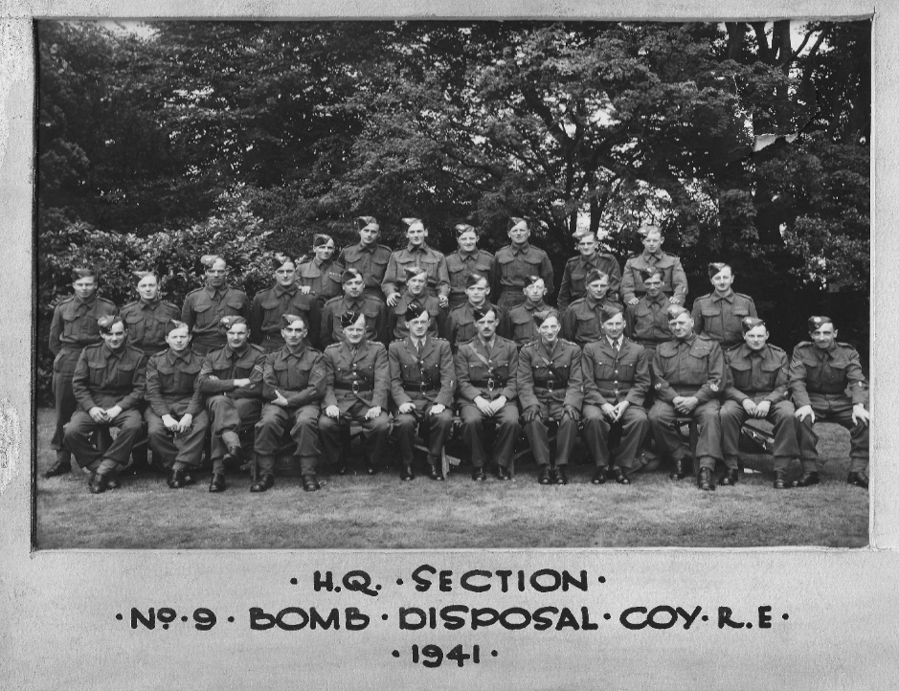
Photo credit: Peter Markham’s Collection.

WILLIAMSON, H BEM, (2210148) Sergeant, Bomb Disposal, Royal Engineers

The Citation is taken from file WO373/67/280 held at the National Archives
Posted in the London Gazette on the 24th March 1942. Supplement 49583. Page 1331.

Sergeant Williamson has been employed continuously on Bomb Disposal work since November, 1940, apart from the short time he was in hospital as a result of injuries which he has received when a bomb which he was dealing exploded. His Section Officer speaks highly of his coolness and fearlessness in face of danger.

At Holburn in November, 1940, this N.C.O. assisted in dealing successfully with an unexploded bomb which was causing serious interference with vital traffic. Throughout the operation he showed neither fear or hesitation, although fully aware of the danger involved. On another occasion he assisted in dealing with an unexploded bomb which had fallen on a platform at Victoria Station. After work on excavating the bomb had been abandoned for the night it exploded spontaneously. Sergeant Williamson was in charge of the working party. On both these occasions Sergeant Williamson displayed a very high order of cold-blooded courage. In both cases the delayed action fuze was functioning and the bombs may have detonated at any moment during operations. The fact that one bomb did explode, but fortunately after work had ceased due to darkness, serves to emphasis the degree of danger during the entire period.

WILLCOT, George Henry BEM, (1872211) Acting Warrant Officer II, (Company Sergeant Major), Bomb Disposal, Royal Engineers

The Citation is taken from file WO373/67/49 held at the National Archives
Posted in the London Gazette on the 28th October 1941. Supplement 35326. Page 6247.

Company Sergeant Major Willicott has been engaged continuously on Bomb Disposal since June 1940, and he has during this period dealt with some two hundred bombs, including sixteen Category A.1. incidents. Most of the A.1. incidents were dealt with before the necessary instruments for dealing with the various types of German fuzes were put into use, and when every bomb was a potential booby trap. Company Sergeant Major Willicott has at all times shown himself to possess the highest courage and devotion to duty, and has set a fine example to the men working under him.

On the 17th August, 1940 a 250-kilogram bomb was dropped on the Farnborough Aerodrome Landing Ground. On excavating the bomb was found with the fuze underneath; the fuze could not be seen but could be heard ticking. Instructions were issued from higher authority for work on this bomb to be abandoned. Company Sergeant Major Willicott showed great courage whilst working on this bomb.

On the 14th October, 1940, at Granleigh, Company Sergeant Major Willicott was called upon to deal with a 250-kilogram bomb which had fallen in the middle oof eight houses. The bomb on being excavated was found to be fitted with a number 17 fuze which was under water. It was, however, found impractible to remove this bomb which exploded after a sandbag wall had been built around it. Littles damage was done to surrounding property. Company Sergeant Major Willicott by his personal courage during these operations set a fine example to his men.

The Director of Bomb Disposal, states that during thirteen months of continuous service on Bomb Disposal Company Sergeant Major Willicott has displayed outstanding courage and devotion to duty.
WILSON, James BEM, (2217014) Sergeant, 101 and 102 Bomb Disposal Section, Royal Engineers

No Citation found at the National Archives
Posted in the London Gazette on the 27th September 1940. Supplement 34596. Page 5769.

Citation taken from his London Gazette entry.

Sergeant Wilson was the senior non-commissioned officer of the Bomb Disposal Section detailed to recover the bomb which fell in the vicinity of St Paul’s Cathedral.

With complete disregard to his own safety, he supported his section officer untiringly until the bomb was located and brought to the surface.
Sergeant Wilson’s determination and personal example off courage and devotion to duty were inestimable value to the morale of his men and were largely responsible for the success of the operation.

Further Information
Lieutenant Davies and Sapper Wylie were both awarded the George Cross and Sapper Leigh the British Empire Medal also for this incident (see separate entries).

WILSON, John BEM, (2007363) Acting Lance Corporal, Bomb Disposal, Royal Engineers

The Citation is taken from file WO373/285 held at the National Archives
Posted in the London Gazette on the 24th March 1942. Supplement 35489. Page 1331.

Lance Corporal Wilson has been employed on bomb disposal work since August, 1940. As a member of a sterilisation crew, he has played a prominent part in the sterilisation of many bombs fitted with No 17 and 50 fuzes, especially in the early months of bomb disposal, when electrical stethoscope and clock stoppers were not available. He has always shown extreme willingness, combined with coolness and courage, in this difficult and hazardous work.

In each of several incidents brought to notice which Lance Corporal Wilson has been concerned, there was every possibility of the bombs which were being dealt with exploding at any time during steaming out operations lasting several hours, and the fact that the anti-handling fuze did not explode the bomb being dealt with in one incident when it was moved is quite extraordinary.

WOOD, Kenneth William John BEM, (1889904) Sergeant, 7 Bomb Disposal Company, Royal Engineers

The Citation is taken from file WO373/67/51 held at the National Archives
Posted in the London Gazette on the 28th October 1941. Supplement 35326. Page 6247.

Sergeant Wood has been continuously engaged in bomb disposal since June, 1940, during which time he has dealt with over three hundred bombs, including twenty -five Category A.1. incidents. Most of the .1. incidents were dealt with before the necessary instruments for dealing with the varying types of German fuzes were put into use. His courage and devotion to duty, has at all times set and maintained a very high standard for men engaged on this work.

On the 21st September, 1940, two 250-kilogram bombs fitted with number 17 fuzes were dropped on Hawkers Aircraft Factory at Weybridge. One of the bombs which had no penetrated was removed by Sergeant Wood to a crater in the airfield. The other bomb was under the concrete floor in a workshop. Work on this bomb commenced and continues throughout the night and it was successfully extracted. Sergeant Wood by his example and devotion to duty in persevering with the excavations and was undoubtedly of help in saving at least twenty-five British aircraft.
On the 10th May, 1941 ten 50-kilogram bombs and two 250-kilogram bombs were dropped on the Air Speed Factory at Muddiford. All the bombs were cleared. The 250-kilogram bombs contained number 25 fuzes, and the 50-kilogram bombs no 15 fuzes. The two-pin plug discharger was used by the officer in charge on all the fuzes but on testing two of them they were found to be alive. Sergeant Wood was on duty throughout the removal of all these bombs and showed the highest courage and devotion to duty.
The Director of Bomb Disposal states that Sergeant Wood’s record of service on bomb disposal operations shows exceptional qualities of leadership, determination and cool courage in the face of grave danger.

Croix de Guerre

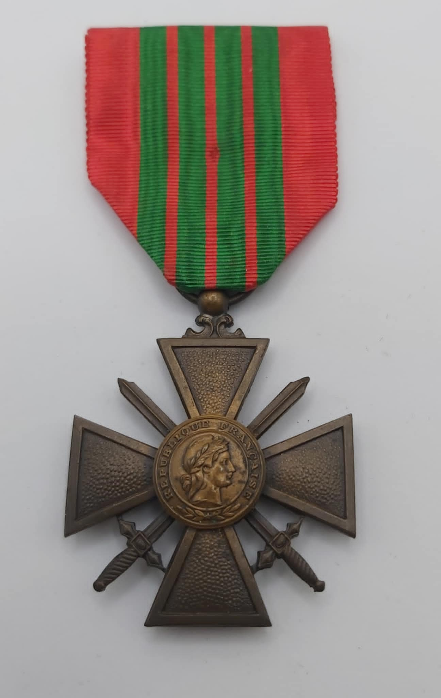

French Croix de Guerre
Photo credit: Julian Allerhead BEM

The Croix de Guerre is a French award created in 1915, first awarded during World War 1. It was also commonly bestowed upon foreign military forces allied to France. It may be awarded either as an individual award or as a unit award to those soldiers who distinguish themselves by acts of heroism involving conduct with the enemy.
The Royal Engineers Bomb Disposal teams were awarded 3 Croix de Guerre, during the War period.

ABRAM, George CDG, (1795577) Corporal, 5 Bomb Disposal Company, Royal Engineers

The Citation is taken from file WO373/111/1171 held at the National Archives.
Posted in the London Gazette on the 18th December 1945. Supplement 37761. Page 5142.

During September 1944 this N.C.O was in charge of a section of Bomb Disposal Platoon working with an Airfield Construction Group. He was responsible for the clearance of delayed action bombs and charges which were found on airfields evacuated by the enemy, so that the airfields could be handed over in the shortest time to forward tactical units of the Royal Airforce.
During the period he cleared over a hundred incidents from airfields at Antwerp, Grimberghen, and Le Culot, south of Louvain, on many occasions carrying on with his dangerous task while the airfield was under fire.
That this work was completed successfully and without incident is due in no small measure to Cpl Abram’s promptness of action, his personal courage always a source of inspiration to his men and his high sense of duty.

CORNWELL, Frederick John CDG, (2055686) Corporal, 14 Bomb Disposal Platoon, 19 Bomb Disposal Company, Royal Engineers - attached to T Force

The Citation is taken from file WO373/111/1182 held at the National Archives.
Posted in the London Gazette on the 8th December 1945. Supplement 37761. Page 5142.

On 14th September 44 14 B.B. Plt RE entered Ostend to assist in clearing the port of bombs mines and anti-invasion works. The amount of work to be done was considerable and since speed was vital casualties were experienced.

Particularly on 11th October 44 when a lane had to be cleared through mine belts on the race-course for a signal cable in 24 hrs. At the onset the Plt Sgt and two Sappers were badly injured but Cpl Cornwell carried on and by his energy and determination nerved the rest of the party to complete the job on time.

Before the Pln were withdrawn on 26th Oct 44 there had been further casualties including the Pln Officer and the new Plt Sergeant killed. In all this Cpl Cornwell remained steady and unshaken and it was largely his conduct and example that re-strengthened the morale of the platoon.

MILLER, William CDG with Bronze Star, (14350317) Lance Corporal, 53 Bomb Disposal Platoon, 19 Bomb Disposal Company, Royal Engineers

The Citation is taken from file WO373/186/1720 held at the National Archives.
Posted in the London Gazette on the 8th December 1945. Supplement 37761. Page 5142.

Immediately on landing in Normandy, 19 July, L/Corporal Millers platoon was engaged in clearing the beach area of mines. As a Lance Corporal he was continually employed either with the mine detector or on a neutralizing number. Up to 31 Aug the working party of which he was a member of lifted 2213 mines, including 1859 anti-personnel mines, of which a considerable number had been booby-trapped.
On Friday Aug 18 an accident occurred on an anti-personnel minefield when one sapper was killed and the platoon lance sergeant and a Corporal seriously injured. The lance sergeant died from his wounds in hospital and L/Cpl Miller found himself the only NCO left of the party but immediately and efficiently took control of the situation. After doing what he could for the injured men he went for medical aid and then conducted the MO through the minefield.
Later that day on his own initiative, he had the presence of mind to return to the mine-field and carefully mark the extent of the clearance and blow up the mines previously lifted. He subsequently took a leading part in the complete clearance of this dangerous field and by his example undoubtably helped to rebuild the morale of the platoon.

Kings Commendation

The Kings Commendation for Brave Conduct was a gallantry award instituted by King George VI in 1939 to recognise acts of bravery by civilians and members of the armed services in non-frontline circumstances. It was the lowest level of bravery awarded in the British Honours system (alongside a mention in dispatches).

BINGHAM, Raymond Charles, (126308) Captain,

No Citation found in the National Archives Catalogue.
Posted in the London Gazette on the 9 July 1943. Supplement 36085. Page 3103.

No further information available.

BROWN, John Edward, King Commendation Posthumously, (2196474) Sapper, 9 Bomb Disposal Company, Royal Engineers

The Citation is taken from file WO373/66/685 held at the National Archives.
Placed in the London Gazette on the 17th January 1941. Supplement 35047. Page 401.

On Thursday Sept. 19th 1940, at Corbishley Farm, Coventry whist excavation was taking place for a suspected unexploded bomb the ground suddenly collapsed exposing a hole into which L/Cpl Kirby fell and was overcome by gas. Without hesitation Sapper Brown jumped into the cavity in an effort to rescue his insensible comrade and with complete disregard for his own safety. He too was overcome and when eventually rescue was affected. Efforts to restore consciousness were unavailing and it became evident that Sapper Brown had sacrificed his own life in his efforts to save that of his Non-Commissioned Officer.

Further Information
Initial recommendation was Medal of the Order of the British Empire for Gallantry underneath it states George Medal; the actual award was a Kings Commendation.
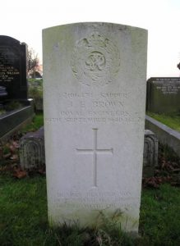 | Died through the action of an enemy’s bomb.

CRUMP, E T Kings Commendation, (66569) Captain, Bomb Disposal, Royal Engineers

No Citation found in the National Archives Catalogue.
Posted in the London Gazette on the 19 May 1942. Supplement 35562. Page 2156.

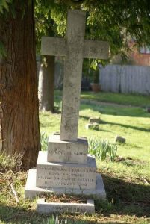 | No Further Information

CUNLIFFE, Samuel King Commendation, (7782719) Sergeant, 76 Bomb Disposal Section, Royal Engineers

The Citation is taken from file WO373/66/146 held at the National Archives.
Posted in the London Gazette on the 13th December 1940. Supplement 35014. Page 7054.

On 1st September, 1940, when digging out a bomb embedded deeply in foundations of a hotel at Millington on the main Chester-Manchester Road, he encouraged the men and worked himself down in the 29. ft hole, knowing the fuze to be probably delayed action.

EARDLEY, Harry King Commendation, (191001) Corporal, 113 Bomb Disposal Section, Royal Engineers

The Citation is taken from file WO373/70/144 held at National Archives.
Posted in the London Gazette on the 19th June 1945. Supplement 37138. Page 3243.

Cpl Eardley has over a long period carried out much difficult and dangerous work in a very brave manner, including bomb disposal, investigating booby traps, mine clearance, and neutralising of enemy ammunition and bomb dumps.

On 10th Nov 1944 he assisted Lieut Thornton, SAEC, in dealing with a large dump of mines and bombs near Athens. These had been elaborately booby-trapped and could only be dealt with safely by destruction on the site. As this would have caused such damage to civilian houses, Lieut Thornton decided to attempt to neutralise the mines and traps. Cpl Eardley, who fully understood the risks involved, assisted him. They dealt successfully with 7 out of 9 heaps of mines, and then an accident occurred. A trip wire was pulled, through no fault on their part, and both sustained severe cuts and burns.

Cpl Eardley has always set an excellent example of cheerful acceptance of risks.

Further Information
Lieutenant Frank Martin Thornton was also recognised by the Kings Commendation for Bravery for this incident.

RADFORD, Frederick King Commendation, (135035) Acting Lieutenant, 66 Bomb Disposal Section, 4 Bomb Disposal Company, Royal Engineers

The Citation is taken from files WO373/66/670 held at the National Archives.
Placed in the London Gazette on the 17th January 1941. Supplement 35047. Page 401.

2nd Lieut, Radford is one of the pioneers of Bomb Disposal work and has done many courageous acts without regard to personal safety, amongst which was working for 7 hours on the main railway line between Brentwood and Shenfield, de-fuzing removing unexploded mines. He was one of the first to undertake de-fuzing of highly dangerous bombs, the presence of which was holding up the war effort, and he was one of the first officers to destroy parachute mines, both after they had been dealt with by the Admiralty and also when that was impossible, the latter a highly dangerous task.

Further Information
Second Lieutenant F Radford was also awarded the George Medal see separate entry.

SHELBOURNE, Clifford Percy King Commendation, Lieutenant, 9 Bomb Disposal Section, 4 Bomb Disposal Company, Royal Engineers

The Citation is taken from files WO373/66/333 held at the National Archives.
Placed in the London Gazette on the 17th January 1941. Supplement 35047. Page 401.

On the 2 September, 1940, unexploded bombs were dropped on the main railway between Brentwood and Shenfield stations, blocking the main line to the East Coast. Owing to the extreme urgency the usual safety period was waived and Captain Shelbourne with others recovered his share of the bombs, defused them and helped in opening the line in ten hours, during the whole time being fully aware that an explosion might take place at any moment. Captain Shelbourne was one of the first officers to be engaged in the demolition of parachute mines both after they have been dealt by the Admiralty and also when that has been found to be impossible

TAYLOR, Louis Norwell King Commendation, (102894), 4 Bomb Disposal Company, Royal Engineers

The Citation is taken from files WO373/66/671 held at the National Archives.
Placed in the London Gazette on the 17th January 1941. Supplement 35047. Page 401.

On 28th October, 1940, at Ipswich 2nd Lieutenant Taylor was present (in close proximity) with Sgt Cann when the latter rendered harmless a new type of small anti-personnel bomb. This was done after the Police had suffered several fatal casualties. The valuable information secured was the first to be available on this new type.

2nd Lieutenant. Taylor who has been employed on Bomb Disposal work since its commencement was concerned, with others, in de-fuzing and removing bombs from the main railway between Brentwood and Shenfield in 10 hours, during which time he was fully aware that an explosion might take place at any moment.

In addition, he has done extraordinarily good work at Tilbury, where unexploded bombs have been dropped near oil tanks, under extremely dangerous conditions.

Further Information
Sergeant Cann was awarded the George Medal for the incident mentioned on the 28th October 1940.

THORNTON, Frank Martin MBE King Commendation, (83601) Lieutenant, 113 Bomb Disposal Platoon, Royal Engineers

The Citation is taken from file WO373/70/145 held at the National Archives.
Posted in the London Gazette on the 17th June November 1945. Supplement 37138. Page 3243.

Lieutenant Thornton has been responsible for dealing with all unexploded bombs in and near Athens, for investigating booby traps, for mine clearance, and for dealing with ammunition and bomb dumps, some of which have been in a dangerous condition. He has carried out much dangerous work in a very brave manner.

On 10th November 1944 he examined a large dump of mines and bombs, which had been elaborately booby-trapped and could only be dealt with safely by destruction on the site. As this would have caused much damage to civilian houses, he decided to attempt to neutralise the mines and traps. Assisted by No. 1991001 Cpl Eardley H, RE, he dealt successfully with 7 out of 9 heaps of mines, and then an accident occurred. A trip wire was pulled, through no fault on their part, and both sustained severe cuts and burns.

Lieutenant Thornton has at all times shown the highest sense of responsibility for the safety of others, and his coolness and confidence have been an inspiration to all who have worked with him.

Further Information
Lieutenant F M Thornton also was awarded the George Medal.
Lieutenant Thornton served with the South African Engineer Corps and was seconded to Bomb Disposal. Corporal Eardley was also recognised by the Kings Commendation for Bravery for this incident.

TODD, John King Commendation, (1942454) Sapper, 9 Bomb Disposal Company, Royal Engineers

The Citation is taken from file WO373/66/686 held at the National Archives.
Posted in the London Gazette on the 17th January 1941. Supplement 35047. Page 401.

On Sept 19th 1940, after two of his comrades had been overcome by gas in a cavity exposed in the search for an unexploded bomb, Sapper Todd lowered himself into the cavity in an effort to reach them and drag them to safety. Unfortunately, his efforts were unavailing and he had to be hauled to safety himself but he is highly commended by his commanding officer but his gallant effort to affect a rescue, especially in view of the fact that he entered the cavity before adequate apparatus for drawing him to the surface had actually reached the spot.

WRATHMELL, T B King Commendation, (217536) Lieutenant, 22 Bomb Disposal Company, Royal Engineers

The citation was not found in the National Archives Catalogue.
Posted in the London Gazette on the 22 October 1944. Supplement 36669. Page 3941.

WOOD, Charles Russell, (135048), Temporary Major, 25 Bomb Disposal Company, Royal Engineers.

The Citation is taken from files WO373/186/1204 held at the National Archives.
Placed in the London Gazette on the 10 May 1945. Supplement 37072. Page 2459.

As the only Bomb Disposal Company in Second Army (North West Europe) he organised and, in many cases, personally supervised the removal of all unexploded bombs in the Second Army Area.

In addition many minefields and booby-trapped localities have been cleared, these more difficult tasks being allotted to this company. Many of these bombs and devices have been of types not previously encountered, consequently greater risk in their removal. The work off removal and neutralisation has at times to be carried out under enemy shell, mortar and small arms fire as was the case at Caen.

Major C R Wood has displayed the ? most leadership of command with ?

Further information Major Wood was also earlier in the War awarded the George Medal.

WILLIAMS, Eric Arthur Kings Commendation, (2053912) Sapper, 52 Bomb Disposal Section, 1 Bomb Disposal Company, Royal Engineers.

The Citation is taken from file WO423/595339 held at the National Archives, closed file till 1 January 2036. .
Posted in the London Gazette on the 22 March 1944. Supplement 35496. Page 1321. Page 3941.
A bomb had been dropped outside a Catholic School, Morpeth, Northumberland. Sergeant Glover went into the crater to defuse and make it safe. The bomb had penetrated a disused mine-shaft. He was overcome and died by carbon monoxide poisoning. Sapper A E Williams, a member of the Section, donned his service respirator and attempted a rescue. He also died of monoxide poisoning as the respirator was not suitable for this type of gas. It was one on many casualties of War.

YATES Geoffrey Hartley, OBE King Commendation, Legion of Merit, (40602) Temporary Major, Bomb Disposal, Royal Engineers

On Friday 13 September, 1940, Captain Yates, telephoned H.Q. Northern Command to say that a German 500 Kg. Bomb was lying unexploded in the Majestic Hotel, Harrogate and that in the circumstances he proposed to blow it in situ.

In view of the damage to the hotel which would result the Chief Engineer, York, advised against this action and asked for further information concerning the type of bomb and fuzes fitted. From the information given the opinion formed at H.Q. was that there was a good chance of removing the fuze and Captain Yates was advised that an effort should be made to defuze the bomb.

Captain Yates, acting on the advice given, successfully removed the fuze which, owing to the awkward situation he had taken out by hand.

Further Information
Captain GH Yates was also awarded the OBE and the Legion of Merit.
Part 2 : VJ Day to the Present

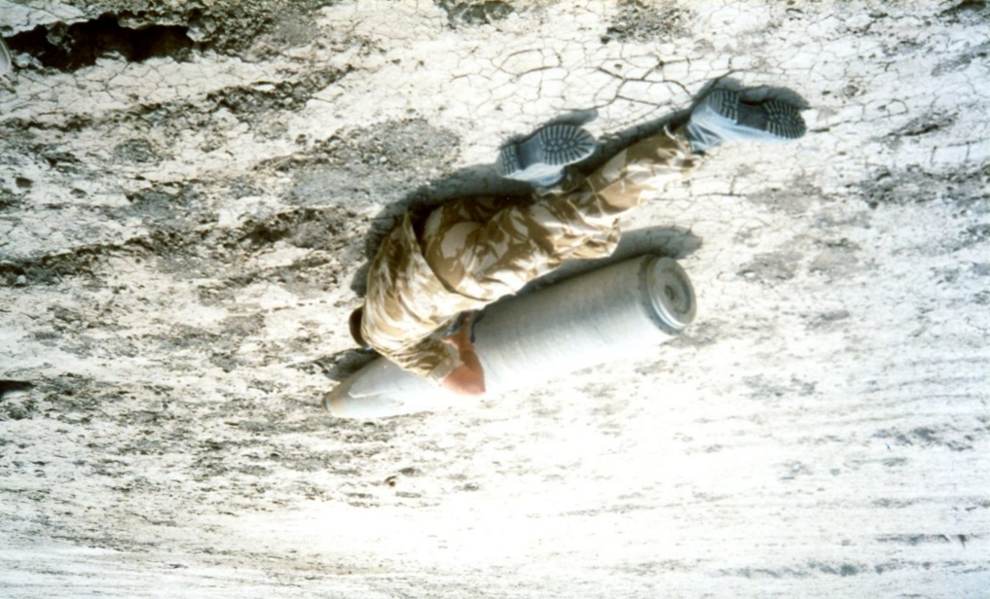

Image: Iraq, Operation Telic, Staff Sergeant A Wyles QGM
Photo Credit Rey Fadil

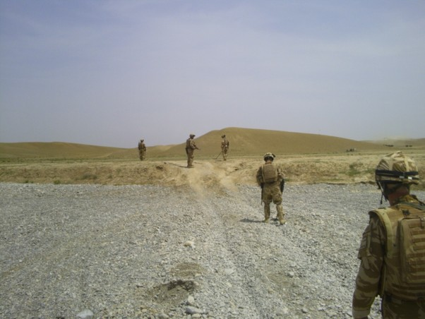

Image: Afghanistan, Operation Herrick

The Military Cross

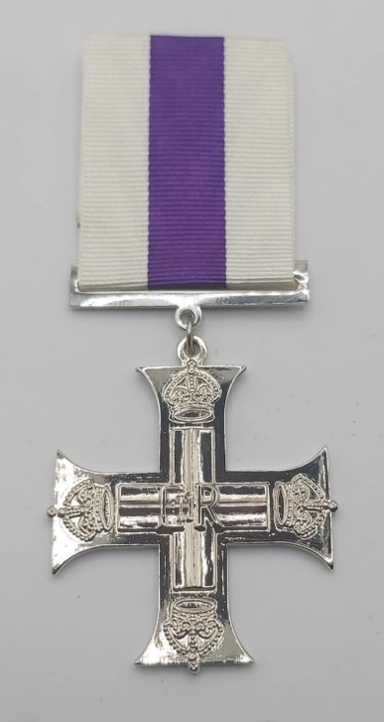
Photo credit: Julian Allerhead BEM

The Military Cross (MC) is a prestigious military decoration. It is awarded to officers and, since 1939, to other ranks of the British Armed Forces for acts of exemplary gallantry during active operations against the enemy on land.

It was instituted on December 28, 1914, by King George, V, to recognise distinguished and meritorious service in battle that did not merit the Victoria Cross. The Military Cross can be awarded to commissioned officers of the substantive rank of Captain or below, as well as Warrant Officers.

The Royal Engineers Bomb Disposal teams were awarded 2 Military Crosses, during the Post War period.

BASSETT P J MC, Captain, 33 Engineer Regiment (EOD), Royal Engineers

Awarded for Services in the Former Republic of Yugoslavia.

RIDER, T C R MC, 33 Engineer Regiment (EOD), Royal Engineers

No Citation found in the National Archives Catalogue.
Posted in the London Gazette on the 31 October 2003. Supplement 35014. Page 7054.

Information below taken from The Corps of Royal Engineers. Operation Telic. October 2002 -July 2003 Publication.
Lieutenant Rider had been a Troop Commander and Bomb Disposal Officer (BDO) in the Joint EOD Group since February 2003, deploying to Iraq on Operation Telic as part of 16 Air Assault Brigade. His Troop was responsible for providing EOD support to the Brigade in order to enhance freedom of manoeuvre and force protection. On 23 March, he was deployed to the North Rumaylah Bridge (NRB), a strategic target for the Brigade that needed to be secured intact and made safe from Iraqi demolitions designed to destroy it,
With the far bank not yet secure and enemy artillery fire still incoming, Lieutenant Riders mission was to make safe the NRB that had been hastily prepared for demolition by the Iraqi Army. This required him to gain access to the bridge surfaces and piers that had been rigged for demolition and remove both the means of initiation and the explosives. This in itself was an extremely demanding task due to the dimensions of the bridge and the positioning of the charges, but he was also under considerable time pressure to complete the task. Without yet having clear eyes on the bridge of definitive confirmation of the location of the enemy demolition firing point, Lieutenant Rider clambered down the home bank without any real care for his own safety and began to access the charges. The sheer scale of the problem soon became evident and he set up a small reconnaissance boat ‘ferry and line’ in order that the explosives could be removed from the bridge and carried to safety. The scope of the task and the possibility of enemy action meant that he had to constantly go back to first principles and improvise, however his margins for error were almost non-existent.
The Iraqi demolitions had been hastily prepared, with hundreds of detonators thrust haphazardly into the explosives as the primary means detonation. At this stage, only one of the demolitions had functioned, causing a single span of the six-span bridge to collapse, leaving the majority of the bulk explosives to be removed. Throughout this operation, if any of the detonators had functioned, there could have been a huge sympathetic detonation of all the bulk explosives and the bridge potentially lost to Coalition forces, as the bridge and resulting gap would have been too big to have been bridged by UK assets. This would have been a major setback for the Brigade and this further added to the pressures placed upon Lieutenant Rider. Throughout this operation, Lieutenant Rider would have known that his actions could easily lead to the detonation of the explosives and his own death. The tiring removal of over 200 Kilograms of PE4(A) explosives, with hundreds of detonators in varying states of decay which were therefore inherently unsafe, was conducted under cover of darkness, further complicating the operation. After a continuous 30-hour operation and under considerable stress, Lieutenant Rider declared the site clear and the bridge was secured.
Lieutenant Rider’s actions were witnessed by CO 3 PARA Battle Group; Lieutenant Colonel J G Lorimer and he confirms that this bravery under extreme conditions was for in excess of that expected of someone of his relatively junior rank and he was fundamental to the successful seizure of this key target. His contribution to the operation, during which the risk of his life has been significant, his total commitment, courage and professionalism was
inspirational and he is most strongly recommended for formal recognition of his actions.
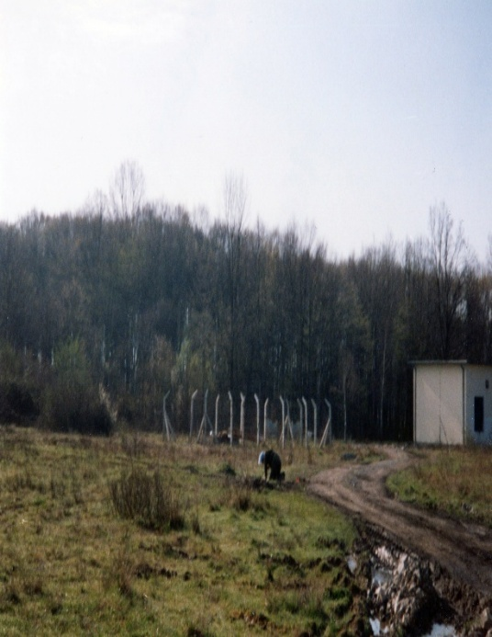 | 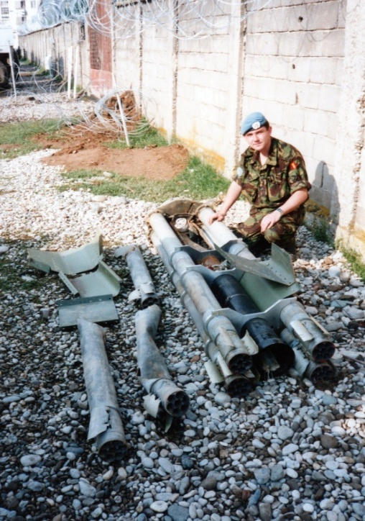
Minefield Clearance around Tuzla Airfield Parts of a Serbian Rocket, Gorazde.
Photos given by Colin Dawson
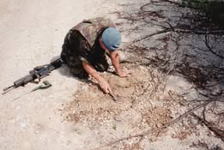 | 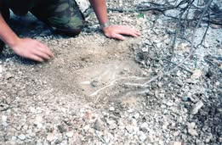
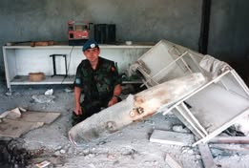 | 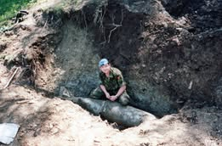
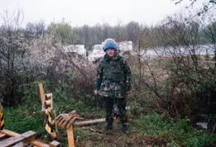 | 21 Field Squadron (EOD) March to September 1994  Top Left and Right: Improvised anti-tank mine.  Middle Left: MK 82 500lb bomb, Gorzade.  Middle Right: 1000lb bomb from a crashed Sea Harrier, outside Gorzade.  Bottom Right: Tuzla Airport - another minefield.  Photos from Colin Dawson (who is shown in the photographs).

Distinguished Service Cross

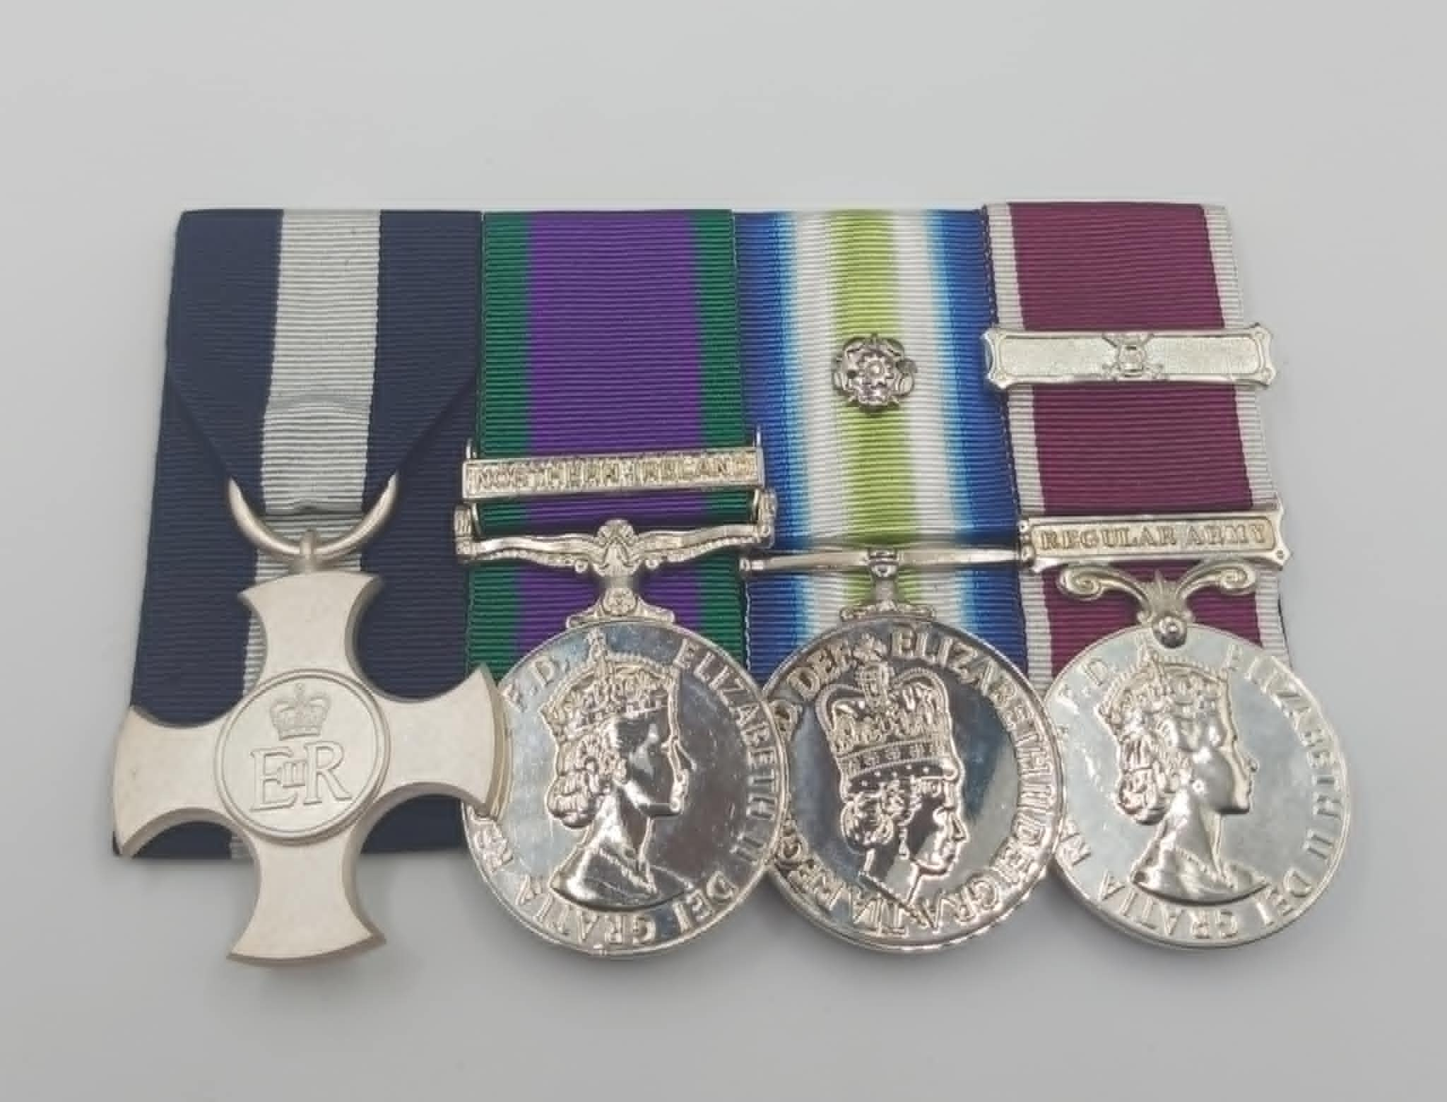
Photo credit: Julian Allerhead BEM
The Distinguished Service Cross (DSC) – shown left, above - is a prestigious military decoration awarded for exemplary gallantry during active operations against the enemy at sea. It was created in 1901 as the Conspicuous Service Cross and was renamed in 1914.
The Royal Engineers Bomb Disposal teams were awarded 1 Distinguished Service Cross, during the Post War period

PHILLIPS, J H DSC, Warrant Officer Class II. 49 Field Squadron (EOD), 33 Engineer Regiment (EOD), Royal Engineers

The Citation is taken from file WO373/188/233 held at the National Archives.
Placed in the London Gazette on the 8th October 1982. Supplement 49134. Page 642.

WO2 Phillips and Staff Sergeant Prescott of 49 EOD Sqn RE were attached to 59 Cdo Engr Sqn for explosive ordnance disposal duties in the Falkland Islands. On 22nd May 1982, they were tasked to deal with an unexploded bomb in the boiler room of HMS Argonaut. Another unexploded bomb lay in a flooded missile magazine nearby. Working in extraordinarily cramped conditions and in very unfamiliar surroundings Phillips and Prescott successfully remotely rendered safe the bomb which was later removed from the ship. This action enabled the damaged to the boiler room to be repaired, so that HMS Argonaut regained propulsion and was able to manoeuvre defensively for further air attacks.

On 23rd May 1982, WO2 Phillips and Staff Sergeant Prescott were tasked to neutralise two unexploded bombs in HMS Antelope. The first bomb examined could not be approached until extensive clearance of debris had taken place. They therefore set about rendering safe the second bomb which was situated near the centre of the ship. The bomb had been slightly damaged and was assessed as being in a dangerous condition. They tried three times to render the bomb safe using a remote method, having to approach the bomb after each attempt to adjust the equipment, but on each occasion, the fuze could not be withdrawn. After a fourth attempt, which involved using a small charge, the bomb unexpectantly exploded. The blast was considerable. Despite a blast route of open doors and hatches up through the ship, the fully clipped steel door to the forward end of the passageway, where the bomb disposal team was standing, was completely blown of and nearly bent double. Staff Sergeant Prescott died instantly, and WO2 Phillips was seriously injured.

In successfully disposing of one unexploded bomb and the following day attempting to neutralise a second. Warrant Officer 11 J H Phillips showed considerable courage, determination and leadership. He is strongly recommended for the award of the Distinguished Service Cross.

J D E Fieldhouse Admiral

They displayed great courage of the highest order when dealing with both bombs. The responded without hesitation to calls for assistance and willingly carried out their work in an unfamiliar environment. The fact that they persevered with attempt to defuse the bomb in HMS Antelope. Fully aware that its condition was particularly dangerous, deserves the fullest recognition.

Warrant Officer J H Phillips is most strongly recommended for the award of the Distinguished Service Cross.

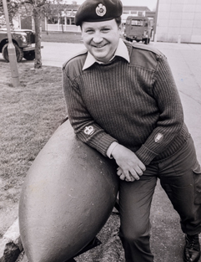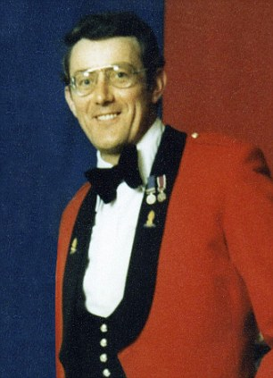
Captain J Phillips DSC (left)
and
Staff Sergeant J Prescott CGM (right)

Conspicuous Gallantry Medal

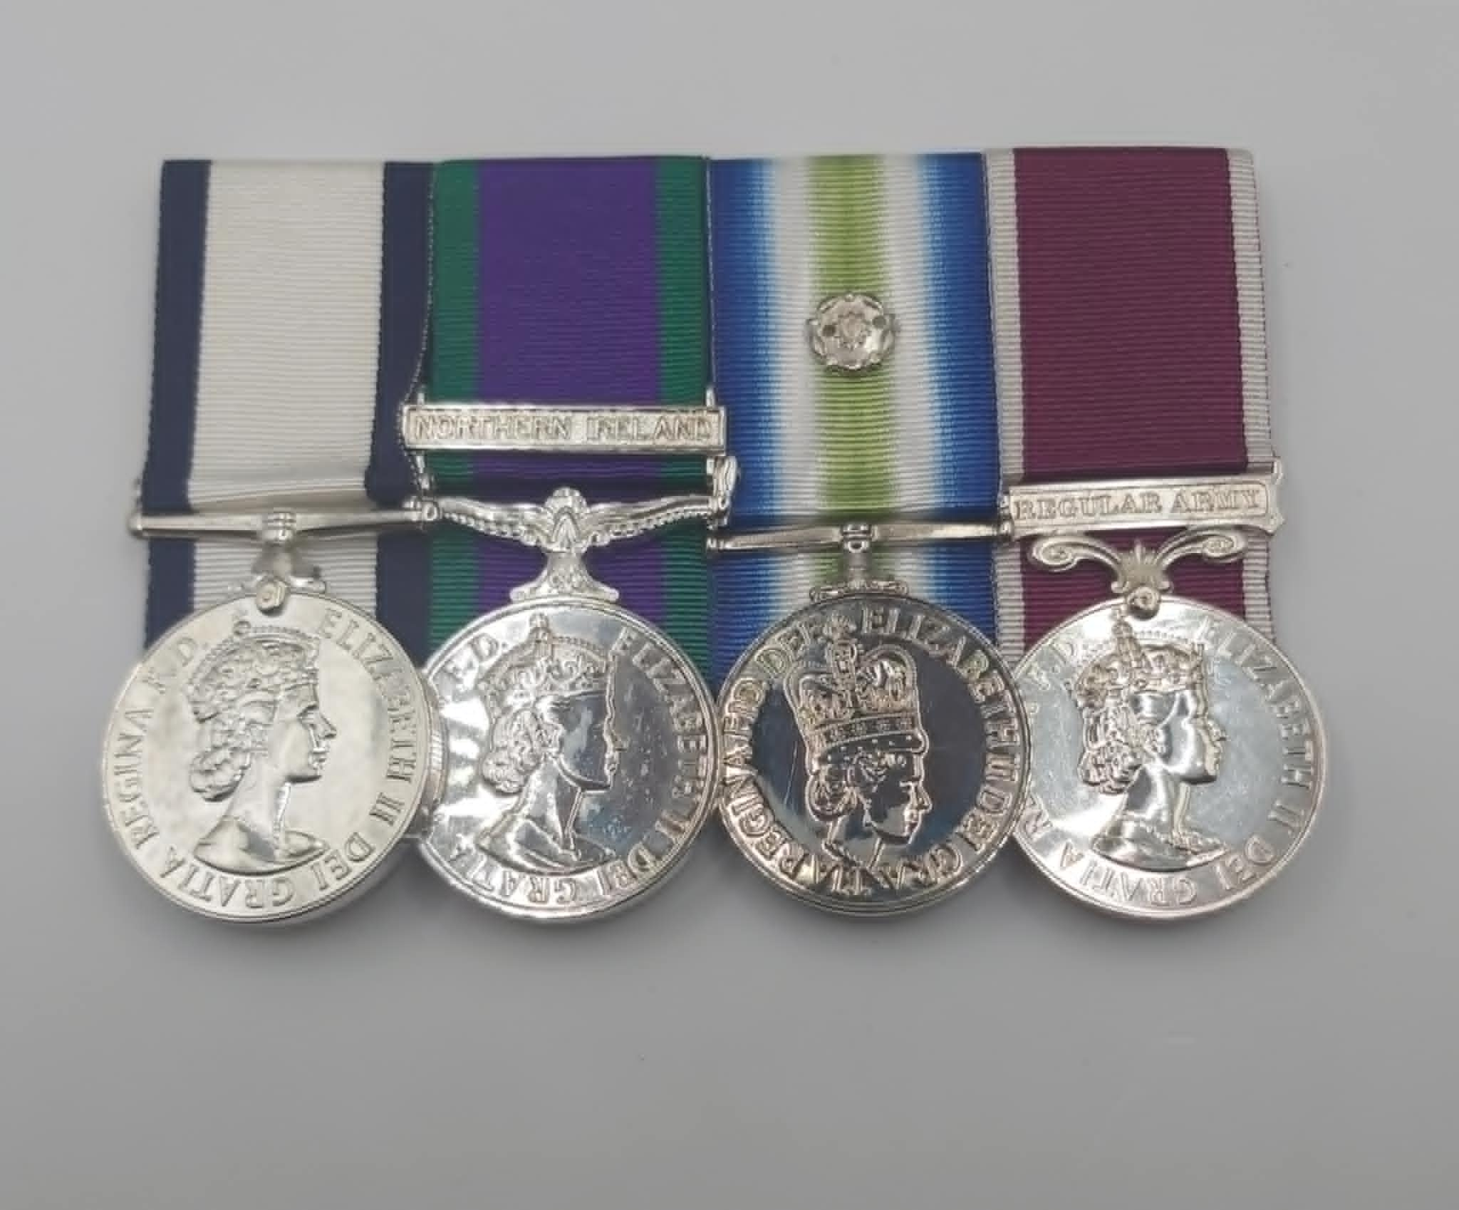
Photo credit: Julian Allerhead BEM
The Conspicuous Gallantry Medal (CGM) – shown left, above – was, originally, a military decoration awarded for gallantry in action against the enemy at sea or in the air. Instituted in 1855 by the Royal Navy, it was initially awarded to petty officers and seaman, later extending to other ranks of the Royal Marines and Commonwealth navies.
From April 1940 it was extended to include Royal Air Force serving with the Fleet Air Arm and Army personnel serving afloat and, in 1942, to rating of the Merchant Navy.
The Royal Engineers Bomb Disposal teams were awarded 1 Conspicuous Gallantry Medal, during the Post War period.

PRESCOTT, G CGM Posthumously, (23834301) 49 Field Squadron (EOD), 33 Engineer Regiment (EOD)
Royal Engineers.

The Citation is taken from file WO373/188/254 held at the National Archives.
Placed in the London Gazette on the 8th October 1982. Supplement 49134. Page 12849.

WO2 Phillips and Staff Sergeant Prescott of 49 EOD Sqn RE were attached to 59 Cdo Engr Sqn for explosive ordnance disposal duties in the Falkland Islands. On 22nd May 1982, they were tasked to deal with an unexploded bomb in the boiler room of HMS Argonaut. Another unexploded bomb lay in a flooded missile magazine nearby. Working in extraordinarily cramped conditions and in very unfamiliar surroundings Phillips and Prescott successfully remotely rendered safe the bomb which was later removed from the ship. This action enabled the damaged to the boiler room to be repaired, so that HMS Argonaut regained propulsion and was able to manoeuvre defensively for further air attacks.

On 23rd May 1982, WO2 Phillips and Staff Sergeant Prescott were tasked to neutralise two unexploded bombs in HMS Antelope. The first bomb examined could not be approached until extensive clearance of debris had taken place. They therefore set about rendering safe the second bomb which was situated near the centre of the ship. The bomb had been slightly damaged and was assessed as being in a dangerous condition. They tried three times to render the bomb safe using a remote method, having to approach the bomb after each attempt to adjust the equipment, but on each occasion, the fuze could not be withdrawn. After a fourth attempt, which involved using a small charge, the bomb unexpectantly exploded. The blast was considerable. Despite a blast route of open doors and hatches up through the ship, the fully clipped steel door to the forward end of the passageway, where the bomb disposal team was standing, was completely blown of and nearly bent double. Staff Sergeant Prescott died instantly, and WO2 Phillips was seriously injured.

Staff Sergeant Prescott assisted Warrant Officer 11 Phillips in the successful neutralisation of one bomb in difficult and dangerous circumstances and is surroundings which were totally unfamiliar. The following day he volunteered to neutralise a second bomb in another ship; in spite of his skill and determination the bomb exploded before they could complete the operation and Staff Sergeant J Prescott was killed instantly. For his gallantry, skill and determination, Staff Sergeant J Prescott is recommended for the posthumous award of the Conspicuous Gallantry Medal.

J D E Fieldhouse Admiral

They displayed courage of the highest order when dealing with both bombs. They responded without hesitation to calls for assistance and willingly carried out their work in an unfamiliar environment. The fact that they persevered with attempts to defuse the bomb in HMS Antelope, fully aware that its condition was particularly dangerous, deserves the fullest recognition.

Staff Sergeant J Prescott is strongly recommended for the posthumous award of Conspicuous Gallantry Medal.

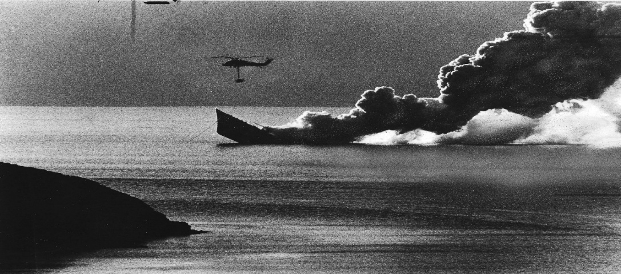

HMS Antelope
Photo credit: Peter Markham’s Collection

George Medal

Photo credit: Julian Allerhead BEM.

Instituted by King George VI on 24 September 1940, along with the George Cross to recognise, in particular, the large number of acts of gallantry being displayed during the Blitz but also in other areas where military awards were not appropriate. Although primarily a civilian award at the second level, it can be awarded to Service personnel and to date around 50% of all awards made have been to civilians. Approximately 2,200 George Medals have been awarded since its inception. The original Warrant for the George Medal did not permit it to be awarded posthumously. This was changed in November 1977 and the George Medal has been awarded posthumously several times since this date.

The Royal Engineers Bomb Disposal teams were awarded 12 George Medal, during the Post War period.

BRIGGS, Harold GM, (210243) Captain, 11 Bomb Disposal Company, Royal Engineers

The Citation is taken from file WO373/69/955 held at the National Archives.
Placed in the London Gazette on the 9th September 1946. Supplement 37643. Page 3493.

Captain Briggs has been engaged on the clearance of minefield for over twelve months and has dealt with some difficult mines. On several occasions his working party failed to locate deep mines. Captain Briggs working with one man located these mines and disarmed them, thereby showing a fine example of gallantry and leadership. On 14th September, 1945, an accident occurred at this particular minefield: the officer and three men killed: another officer removed the bodies and the minefield was wired up. The morale of the men employed on clearance had been badly shaken by the accident. It was still necessary, however, to remove the remaining mines and it was known that this would be a difficult and hazardous undertaking since the mines were in rocky ground, and the mine locators in consequence were likely to prove unreliable. On the 27th September, 1945, Captain Briggs took the party back to the minefield and alone, in view of his men located and disarmed the mines. Captain Briggs fully appreciated the dangers he was facing, but realising the urgency of the task, and the need to restore the confidence of his men, he never faltered in setting a fine example of courage and devotion to duty. As a result, the men subsequently turned to their task with confidence and determination, and the minefield has now been cleared without further accident. That this been achieved is almost entirely due to Captain Briggs fine example of courage.

BROWN, Walter Messer GM, (152387) Lieutenant, 11 Bomb Disposal Company, Royal Engineers

The Citation is taken from file WO373/69/818 held at the National Archives.
Placed in the London Gazette on the 12th March 1946. Supplement 37500. Page 733.

During a heavy storm in the early part of 1945, a portion of the minefield in Fergus, north of Aberdeen, collapsed into the sea. Two mines were left hanging on the end of the recovery wires down the face of a steep cliff, approximately one hundred feet high. The remaining mines were on the edge of the cliff in an extremely dangerous position.

Lieutenant Brown personally crawled down the very unstable cliff and successfully disarmed the two mines. He then successfully dealt with twelve very dangerous mines on the edge of the cliff which was liable to collapse at any moment, with the added possibility of the detonation of the whole minefield.

Had it not been for Lieutenant Brown’s gallant action, carried out at grave personal risk, a considerable portion of the minefield would probably have collapsed creating a situation of extreme danger not only to the whole clearing party, but to any public in the vicinity.

COOKE, Horace Edward GM, (1906111) Sergeant, Bomb Disposal Unit (UK), Royal Engineers

The Citation is taken from file WO373/169/138 held at the National Archives.
Placed in the London Gazette on the 29th January 1961. Supplement 44223. Page 305.

Staff Sergeant Cooke has been continuously engaged upon Bomb Disposal and Minefield Clearance since August 1957. Since 1st January 1958 he has been the Senior NCO of a Bomb Disposal Troop RE. Such duty calls for qualities of leadership, courage and technical ability usually associated with Officer Rank.

During this period, he has been on constant call for Bomb and Mine Disposal operations, and he has assisted with, and in many cases personally dealt with, several hundred incidents of unexploded bombs and mines anywhere in the United Kingdom at immediate notice. He has carried out these duties with the greatest skill and success, often under the most arduous conditions.

His technical knowledge, ability, experience and enthusiasm have been an inspiration to all ranks. This has been particularly apparent when he has accompanied junior officers under training on operations, when his skilful and competent guidance on dangerous tasks has been an outstanding example of complete loyalty. His obvious ability and confidence have dispelled the fears of the Police, Local Authorities and the Public as to the danger which existed to themselves and their property.

He has also been particularly successful in maintaining a very high standard of morale among both the military and civilian personnel employed on these tasks, by forming them into well-knit, integrated teams. This has been achieved by his exemplary devotion to duty and his readiness to accept responsibility for the most difficult tasks and to carry them out successfully.

Further Information
Sergeant HE Cooke was also awarded the George Medal.

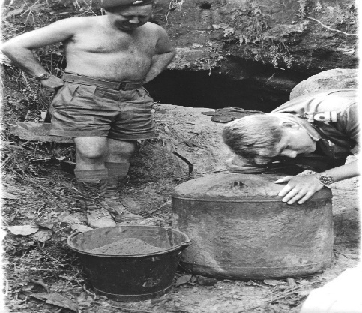

Sergeant H E Cooke GM (left) in Penang
Taken from Peter Markham’s Collection.

DEACON, John Ernest Arthur GM MBE, (166507) Lieutenant, 23 and 27 Bomb Disposal Company, Royal Engineers

The Citation is taken from file WO373/69/773 held at the National Archives.
Placed in the London Gazette on the 25th January 1946. Supplement 37444. Page 659.

On the 25 October 1945, a 250. KG bomb containing a delay action and anti-handling fuzes was uncovered at Belmont Road, Belfast. The site was adjacent to the Automatic Telephone Exchange serving the Northern Ireland Parliament at Stormont and two other buildings. The anti-handling fuze was dealt with, but it was found necessary to move the bomb away from site for destruction with the delay action fuze in position but neutralized by an electro-magnetic “clock stopper”.

During the operation of moving the bomb the clock stopper became damaged rendering the completion of the task extremely hazardous. In spite of this with great devotion to duty and regardless of personal safety, Captain Deacon and Sergeant Parker completed this most hazardous work, thereby removing the danger to the telephone exchange and enabling large numbers of people, who had been evacuated at short notice, to return to their home.

Further Information
Sergeant A Parker was also awarded the George Medal for this incident, see separate entry.
Lieutenant J E A Deacon was also awarded the George Medal see separate entry.

FLETCHER, George Raymond GM MBE, (377837) Major, Bomb Disposal Unit (UK), Royal Engineers

The Citation is taken from file WO373/123/4 held at the National Archives.
Posted in the London Gazette on the 21st April 1970. Supplement 45083. Page 4466.

On 1st October 1969, following a report from Kentish Town Police, Major G R Fletcher lead a Bomb Disposal Team to a building site at Burghley Road, Camden. There he found, in an excavation some ten feet deep, a large object which he was immediately able to identify as a German Parachute Mine. Such mines were fitted with an outstandingly dangerous combination of firing mechanisms. Until evidence is found to the contrary it has to be assumed that many of the following devices may be fitted; a magnetic and or Acoustic system, a clockwork bomb fuze “booby-trapped” with an ant-removal device, a six-to-eighty-day timing circuit, and a light sensitive mechanism.

The mine was located within 30 yards of an underground railway, and within fifty yards of a surface railway. Within one hundred and fifty yards were three high blocks of flats, many terraced houses and two busy roads.

After arranging for the safety of the public by evacuation, Major Fletcher and tree of his team started to uncover the mine to establish its exact identity. After about half an hour very careful work the uncovered nose of the mine revealed that it was a type “C”. This type contains a charge of 1536 pounds of Hexamite explosive. It appeared to be in excellent condition so that detonating devices must be assumed to be still active.

Because of the large quantity of explosives and the nature of the site, exploding the mine where it lay was out of the question. There were, therefore, two choices.

  - To dig down, uncover and render safe all detonating devices and then steam out the explosive filling.
  - To leave the mine embedded in the clay and steam out the explosives with the fuze systems intact.

The first course would take 30-40 hours with the entire team at risk, and cause great inconvenience to local population and travelling public.

The second course, which would take 10-12 hours, would involve two or three people in great but incalculable risk due to the effects of steam and extreme changes of temperature on the presumed intact detonating devices and the Hexamite filling. A clock which had stuck would be particularly likely to restart.

Major Fletcher chose the second course. In full co-operation with the Police, Emergency Services and Local Authorities he made his plan, arranging for maximum safety and minimum inconvenience to all those required on the site.

At about 1545 hrs he himself, with one assistant, removed the filling plate of the mine to gain access to the explosive, then started the slow and dangerous task of steaming out and removing the heximite. This lasted throughout the night. Adjustments to the steam generator, placing the explosives in a sandbag and removing it, and revetment of the excavation required Major Fletcher and the minimum number of assistants to approach the mine at never less than half hour intervals. He was therefore exposed to great danger for about a third to a quarter of the entire period of the operation.

At about 0600 hrs on 2 October the mine case was virtually free of explosives. At 0700 the fuze pocket was exploded successfully causing no damage or inconvenience.

As far as records show this was the first occasion since the war that the army has dealt with a German Parachute Mine.

Major Fletcher was in command throughout. He showed outstanding skill and leadership and by exposing himself to great risk over a long period so as to reduce the risk to others displayed outstanding gallantry in the highest traditions of the service.

Further Information
Major George Raymond Fletcher was also made a Member of the Order of The British Empire in 1961; however, this was not for work in Bomb Disposal.

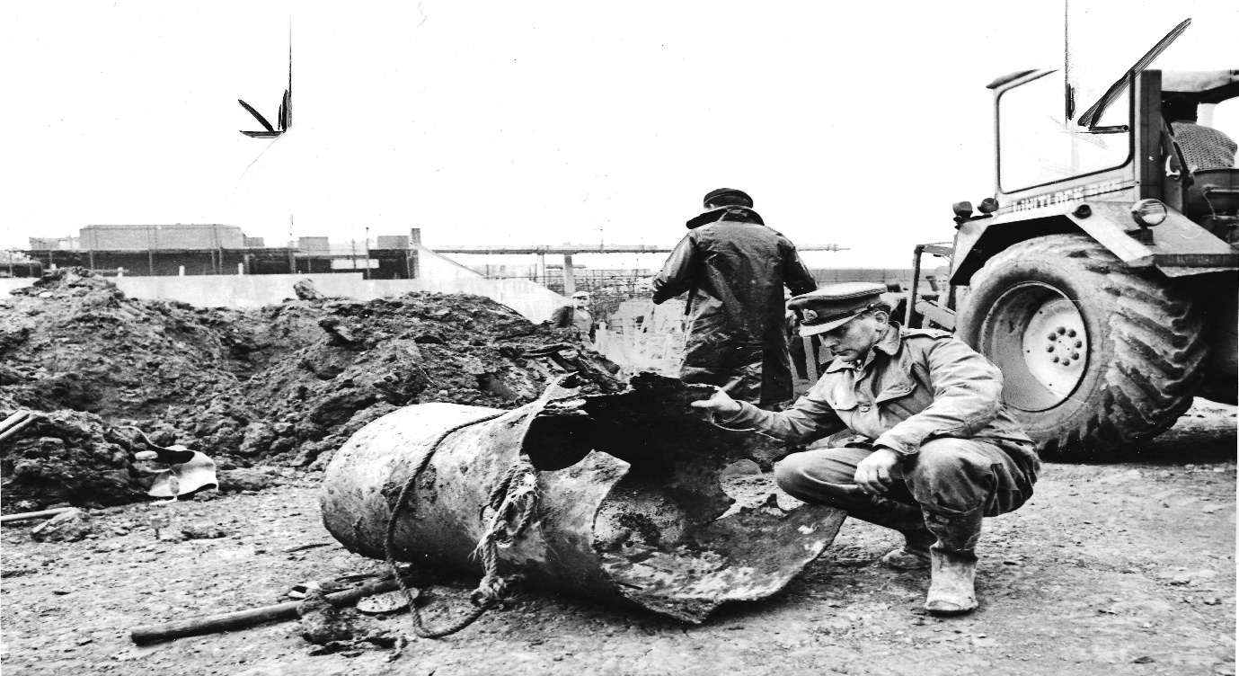
Major G Fletcher GM
Photo credit: Peter Markham’s Collection.

HAMBROOK, Stephen David GM MBE, (23056357) WOII, Bomb Disposal Unit (UK), Royal Engineers

The Citation is taken from file WO373/182/56 held at the National Archives.
Posted in the London Gazette on the 17th April 1970. Supplement 45083. Page 4466.

WO2 Hambrook has been employed as Squadron Sergeant Major in Bomb Disposal since September 1986. During this time, he has personally dealt with some two hundred missiles and ten bombs. On three occasions he displayed outstanding courage.

In August 1969 he was in charge of a team excavating in search of a buried bomb near Petworth. Because of the particularly wet and marshy conditions specialised pumping equipment had to be in continuous use to prevent the excavation from flooding.

On 9th August a German 250-kilogram bomb was found and a No 17 clockwork fuze identified in excellent condition. This type of fuze is particularly dangerous as the clock which has stopped can be re-started by any shock, and can then explode the bomb in a matter of seconds. The bomb could not be blown up where it lay because of the proximity of dwellings

Sergeant Major Hambrook summoned the assistance of an officer and these two then arranged for a complete evacuation from the area of everyone but themselves.

Because of the noise made by the pumping sets, (which could not be stopped without the risk of immediate flooding and collapse of the shaft), it was impossible to use the electronic stethoscope. Therefore, there would have been no warning if the clock re-started ticking at any time during the operation.

After the fuze was immunised, the base plate of the bomb was removed. This revealed that the powder explosive filling had deteriorated to such an extent that some two gallons of Nitro-glycerine (an exceedingly unstable explosive) had been formed and that the remaining two hundred pounds of powder was floating in it as lumps or sticking to the casing. This combination could only be removed by hand. Apart from the extreme risk of explosion which could be caused by any small shock or friction, working conditions were made appalling by the fumes which cause constant retching and nausea. By the time the explosive had been removed Sergeant Major Hambrook had worked continuously for twenty-nine hours without rest or warm food, and had been exposed to extreme danger for eleven hours.

On 1st October 1969 WO2 Hambrook as second in command to his Squadron Commander was called to deal with a Parachute Mine in London. This mine was found on a congested building site contained over 1500 pounds of Hexamite explosives, and was the type normally fitted with any combination of detonating devices sensitive to light, sound and metal tools as well as clockwork delay mechanism. It was decided that the device could not be exposed and neutralized because of the prolonged risk to many people this procedure would cause. Therefore, the explosive was removed by steam from the mine with the detonating systems still intact. This involved few people but greater risk; due to the uncertain effects of steam and extreme changes of temperature on the device, any of which could have caused an immediate explosion.

WO2 Hambrook was required to assist in operating the steam generators and removing the explosive. He had to approach the mine at intervals never greater than half an hour throughout the period of some twelve hours.

On 11th December 1969 WO2 Hambrook was second in command of a team called to deal with a 500-kilogram bomb at Fleet. This bomb was found to be fitted with a type 17 clockwork fuze and type 50 anti-disturbance fuze. This combination of fuzes was specifically designed to kill Bomb Disposal personnel.

WO2 Hambrook and the Troop Commander together fitted a magnetic clock stopper and immunised both fuzes. This task involved three hours of extremely dangerous work.

These are three examples of the skill, calmness and gallantry displayed by WO2 Hambrook.

His example has been an inspiration to other members of the Bomb Disposal Unit.

Further Information
Major Stephen David Hambrook was also made Member of the Order of the British Empire whist serving with 101 (London) Engineer Regiment (Explosive Ordnance Disposal (Volunteer) in June 1991.

Major Fletcher was awarded the George Medal for the parachute mine on the 1st October 1969.

HARTLEY, Arthur Bamford GM MBE, (276453) Bomb Disposal Unit (UK), Royal Engineers

The Citation is taken from file WO373/123/4 held at the National Archives.
Posted in the London Gazette on the 25th March 1960. Supplement 41991. Page 2193.

At 1510 hrs 1st July 1959, Major Hartley was informed by Putney Police that workmen excavating in Bendemeer Road had found a sewer broken and fins of a bomb laying in the break. He left Broadbridge Heath Camp immediately and by 1630 hrs had identified the bomb as a 250 Kg S.C UXB.

He ordered special equipment, which arrived by 1910 hrs, and by this time had arranged for roads to be closed and for houses and shops to be evacuated. To help him he had obtained a scratch crew of clerks and fitters from the HQ staff of his unit – all that were available at the time. He had lost no time in tackling this particular incident, because he knew that this type of bomb would almost certainly contain a (17) series clockwork fuze, which had stopped ticking.

The danger of this type of fuze is that a small movement or vibration may re-start the clock, and usually the clock has stopped only a few ticks before it fires the mechanism, although this is quite unpredictable. In addition, the clockwork fuze is invariably fitted with a booby-trap, the Z.U.S 40 anti-handling device, which prevents withdrawal of the fuze. These clockwork fuzes do not deteriorate after many years in the ground.

He applied an electric-stethoscope to give warning if ticking should start. After carefully deepening the excavation and digging round the bomb, he discovered by 2115 hrs that the bomb contained, not one, but two (17) series clockwork fuzes. Neither were ticking.

Major Hartley was faced with an extremely difficult and dangerous operation. He was a sick man, suffering from diabetes, though the nature of his illness had not been diagnosed at that time. He knew he had several hours of strenuous but very delicate, work ahead of him, where any false or careless move could be fatal. In addition, darkness had fallen.

The bomb was lying awkwardly with fuzes underneath it and towards the side of the shaft. In order to apply two light clock stoppers to the two fuzes further digging was required. At about 2230 hrs it was possible to start moving the bomb, but this resulted in the blocked sewer releasing its contents into the shaft. From then on work continued knee deep in sewage. Major Hartley was severely hampered by the stench and fumes in the dark confined space at the bottom of the workman’s shaft, which was considerably smaller that the Service type.

He passed a sling round the bomb, and it was lifted clear of the sewage. Due to exhaustion of the battery’s the light clock stopped had come off and he replaced them eventually by heavy clock stoppers with fresh batteries. At about 0100 hrs he started steaming out and the explosive filling of the bomb and it was completed by 0300 hrs. At about 0500 hrs he detonated the fuzes in the fuze pockets in the bomb casing at the bottom of the shaft, after the melted filling had been removed, and the police warned the public of the impending explosion.

Major Hartley’s courage, determination and disregard of danger during several hours of highly dangerous and difficult work under the most appalling conditions was an inspiration to his men, the police and the public, and was a fine example of selfless devotion to duty in the best tradition of Bomb Disposal operations.

HOSKINS, M J Y GM, (464530) Captain, Bomb Disposal Team (FARELF), Royal Engineers

The Citation is taken from file WO373/182/38 held at the National Archives.
Posted in the London Gazette on the 22nd May 1969. Supplement 44854. Page 547

On 3rd September 1968 the Government of Brunei requested the assistance of the British Army to deal with an unexploded bomb in a petrol distribution depot in Brunei Town. Major M.J.V Hoskins was despatched together with Staff Sergeant J.C.V Wood.

Having uncovered the bomb Major Hoskins identified it as an unexploded American 250 pond General Purpose Bomb, AN-M57 with a tail impact fuze M115. The fuze arming stem and vane had broken off. This fuze is described in the Bomb Disposal Manual as having a very sensitive striker plate, and he was now faced with a new problem for which he knew the correct immunisation equipment was not available. In the Far East.

Rather than delay the disposal of the bomb which was now exposed, and which he knew might well be in a very sensitive state close to the petrol tanks, Major Hoskins decided to remove the fuze by unscrewing it himself by hand. Taking full consideration for the safety of others, he remained alone with the bomb, and with complete disregard for his own safety he applied penetrating oil and proceeded to unscrew the fuze. This took some fifteen minutes of careful calm work until the fuze was extracted.

Major Hoskins showed courage and coolness of a very high order, equal to the finest traditions of Bomb Disposal operations.

This example is only one of a number of bomb disposal operations in which Major Hoskins has demonstrated his qualities. He has been, for the last nine months, in charge of the special team which has dug out and disposed of some four thousand bombs, mines, torpedo war heads and other assorted explosives from old Japanese dumps on Penang Island. The explosive has been old and often in a very dangerous state, and throughout this exacting task Major Hoskin’s leadership and judgement have been of a very fine order. He has constantly dealt personally with any situation of more than ordinary danger.

HOUGH, Richard Hedley GM, (334426) Captain, 1 Bomb Disposal Troop, Royal Engineers

No Citation on the National Archives files.
Posted in the London Gazette on the 30th October 1953. Supplement 40004. Page 5855.

Recommendation taken from the London Gazette entry.
On 6th May, 1953, Captain Hough was acting as Officer Commanding, No1 Bomb Disposal Troop, Royal Engineers, which was clearing Mundesley Minefield, Norfolk, when a Beach Mine containing 25 pounds of High Explosives exploded killing Sergeant O’Doherty and Corporal Braddock.

Realising an accident had occurred Captain Hough ran to the scene and seeing Corporal Braddock’s body about twenty-five yards inside the minefield where it had been thrown by the explosion, he immediately crawled to the body through the Minefield, to see if he could render aid. Finding Corporal Braddock was dead, he withdrew again by crawling till until he reached the swept lane. After informing his Commanding Officer by telephone he swept his way in and recovered the body.

Captain Hough was accompanied throughout by Sergeant Major Thomas, the Sergeant Major in charge of the Minefield. Sergeant O’Doherty’s body was blown into the sea and recovered on the beach at the next high tide. Captain Hough was of course aware that the mines in this particular Minefield were of a type and in a state which made them liable to be set off at very low pressures. Furthermore. At this part of the Minefield, they were for the most part laid comparatively close together.

Captain Hough’s action in crawling through the Minefield was correct and courageous as time was vital if aid was to be of any use. It was also an inspiration to his men, at the time that their morale most required it. Throughout he showed presence of mind, leadership of a high order and courage.

As reported in the Eastern Daily Press: “One does not mourn brave men; one salutes them”, declared the Dereham District Coroner (Mr L. H. Allwood). This was at the inquest at Trimingham of Corporal Kenneth Braddock and Sergeant Albert O’Doherty who lost their lives in minefield. The coroner said that the men were on a particularly dangerous job which they faced with cool-headed courage, and they earned the gratitude of the people of the village and Norfolk’. He continued that they died just as much for their country in 1953 as if the accident had happened in
1943.

Further Information
Sergeant Major Edward Emlyn Thomas was awarded the British Empire Medal for this incident.

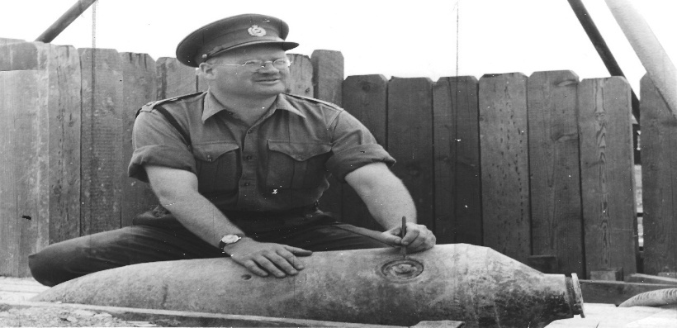

Captain R H Hough GM
Photo credit: Peter Markham’s Collection

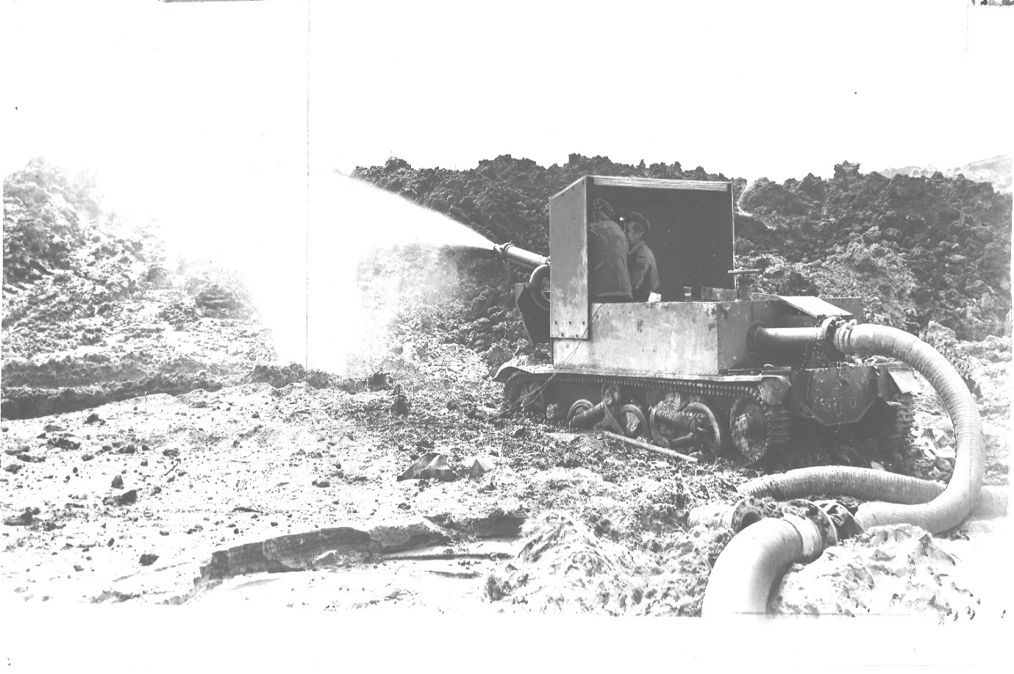
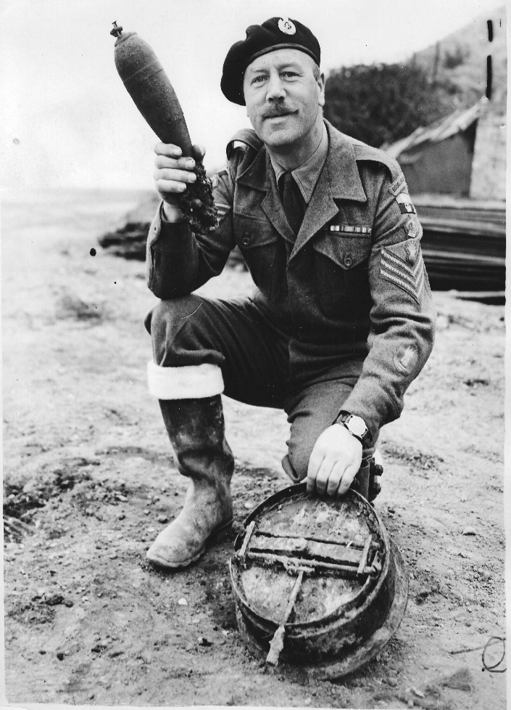 | Images  Top: Beach Clearance April 1953. Water Jetting at Folkestone Kent. Clearing anti invasion minefields.  Left: Staff Sergeant Patterson, April 1953. Showing items found on the beach clearance. Bottom right is a B Type C mine laid in 1941.  From Peter Markham’s Collection.

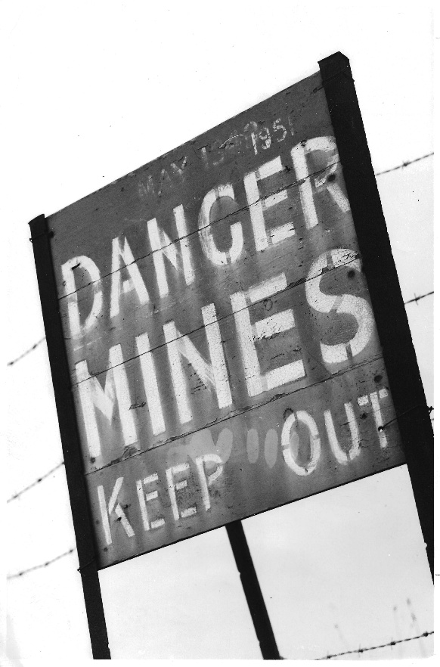 | Images  Left: Trimingham, Norfolk, October 1953. The sign was still needed as Trimingham was the last Beach to be cleared in the UK.  Below: Fairlight Glen, near Hastings, Sussex. Detector being used to locate mines, laid as part of the anti-invasion measures.  Photos from Peter Markham’s Collection.

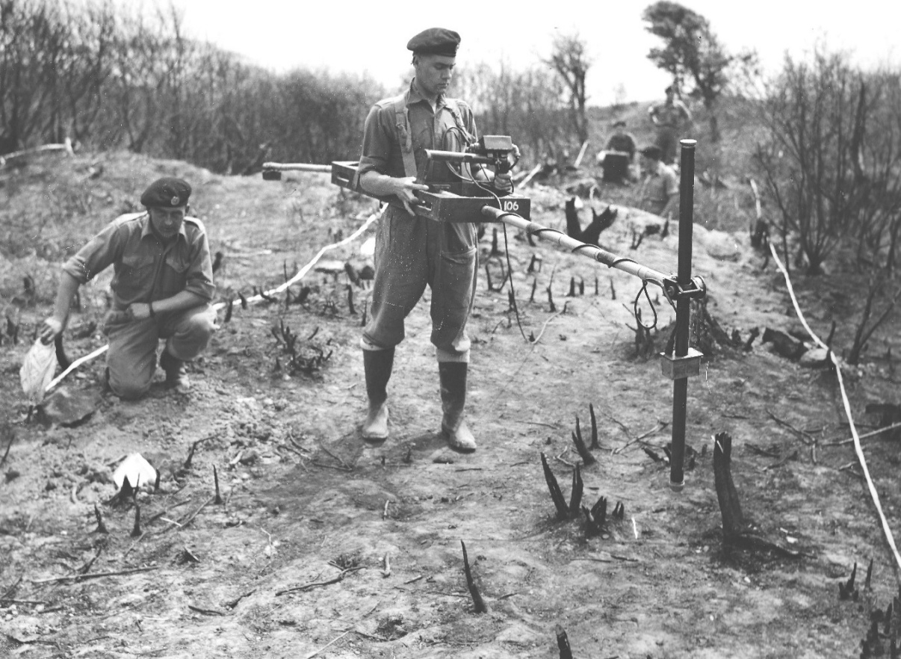

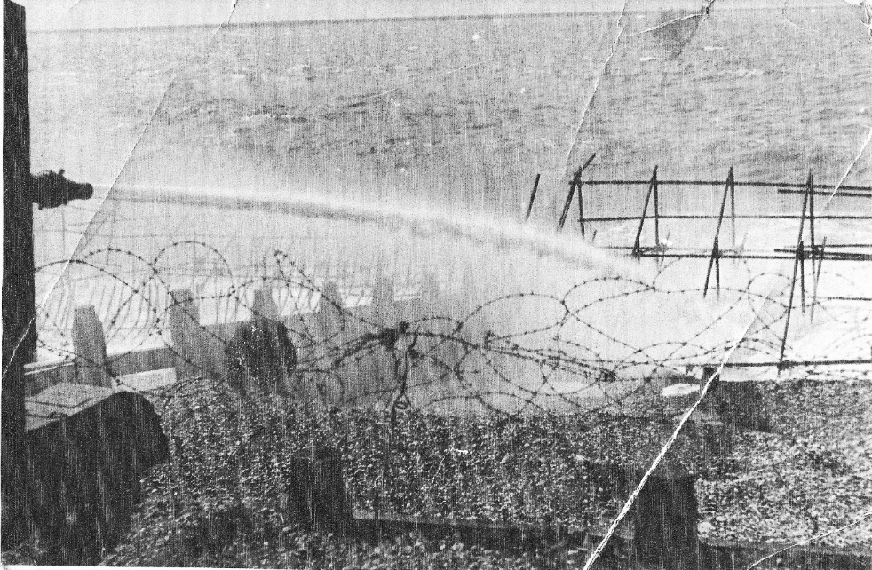

High Pressure Watter Jetting use to uncover Beach Mines laid as anti-invasion measures between 1940 and 1942. Brighton Beach.

Photo credit: Peter Markham’s Collection.
PARKER, Alfred GM, (1895857) Sergeant, 27 Bomb Disposal Company, Royal Engineers

The Citation is taken from file WO373/69/773 held at the National Archives.
Placed in the London Gazette on the 25th January 1946. Supplement 37444. Page 659.

On the 25 October 1945, a 250. KG bomb containing a delay action and anti-handling fuzes was uncovered at Belmont Road, Belfast. The site was adjacent to the Automatic Telephone Exchange serving the Northern Ireland Parliament at Stormont and two other buildings. The anti-handling fuze was dealt with, but it was found necessary to move the bomb away from site for destruction with the delay action fuze in position but neutralized by an electro-magnetic “clock stopper”.

During the operation of moving the bomb the clock stopper became damaged rendering the completion of the task extremely hazardous. In spite of this with great devotion to duty and regardless of personal safety, Captain Deacon and Sergeant Parker completed this most hazardous work, thereby removing the danger to the telephone exchange and enabling large numbers of people, who had been evacuated at short notice, to return to their home.

Further Information
Captain J E Deacon was also awarded the George Medal for this incident, see separate entry.

PETTIT, N GM QGM, Warrant Officer Class I, 33 Engineer Regiment (EOD), Royal Engineers

No file found in the National Archives Catalogue.
Placed in the London Gazette on the 23 April 2004. Supplement 57269. Page 5132.

Information from the Corps of Royal Engineers Operation TELIC October 2002 – July 2003. Publication.

WO1 N K Pettit has been employed as the Regimental Sergeant Major (RSM) of the Joint EOD Group on Operation Telic in Iraq. The Group is responsible for providing EOD support to 1 (UK) Armoured Division in order to enhance freedom of manoeuvre and force protection. He has frequently operated in particularly hazardous environments in the combat zone, where his strong leadership and command skills come to the fore. In addition, he was responsible for extracting four RAF personnel from a minefield at night and in contact.
At approximately 2300 on 21 March 2003, RSM Pettit reported to the Command Vehicle of 5131 (BD) Squadron and was briefed about a mine strike on a road near Safwan Hill, which was the initial objective for the Joint Helicopter Force’s (JHF) advance in Iraq. It was not clear whether there were any casualties or whether the airmen had managed to extract themselves from the minefield. Whilst deploying to the mine strike, he came under fire, but the enemy were successfully driven off. On arrival at the mine strike, he was informed that there were actually four personnel still in a Land Rover in the minefield, one of whom was seriously injured, whilst the others were suffering from shock. In addition, the road had been blocked, causing a major traffic jam that was significantly slowing down deployment. The vehicle itself was blown over at a 45-degree angle to the ground and was severely damaged. He set up an Incident Control Point (ICP) in order to ensure that no other personnel deployed accidentally into the minefield and from where the operation would be controlled. As it was dark, he set up 2 Land Rovers at an angle with their headlights pointing at the damaged vehicle and ensured that all soldiers took up protective positions behind their vehicles.

Once all safety precautions had been taken, he proceeded to clear a lane into the minefield using the look, feel, prod method, with a Maglite torch and constantly updated the other soldiers on his progress, at all times encouraging them to stay calm and not move panic. At night, mine clearance is an extremely hazardous and stressful task. He marked his route with mine marking tape and whenever he came across any anti-tank mines or time delayed action fuzes, he marked them for subsequent disposal. On reaching the vehicle, he helped the driver and then led him to safety along the cleared route. He then had to re-enter the minefield and deal with the casualty, who by this time was slipping in and out of consciousness. He placed the injured airman on his shoulder and carried him out to a waiting nurse who then dealt with the injuries. The remaining 2 airmen were still in shock and refused to walk out unaided, so he had to re-enter the minefield a further two times and lead them successfully to safety. They were then taken to the Regimental Aid Post for treatment and the road was successfully re-opened for traffic. The next day it was confirmed that he had cleared a total 26 VS 1.6 Italian mines and time pencils in the minefield that were subsequently destroyed.

WO 1 Pettit’s actions were witnessed by Wing Commander Driver from JHF who confirmed that the risk to his life has been significant and that his bravery and calming influence under real stress was of the highest order. At no stage could WO1 Pettit have been sure that his actions would not lead to the detonation of the mines and his own death. Despite this, he continued to work with a relentless determination, speed and resolve under the most arduous conditions that was an example to all. He showed sustained courage and coolness of the very highest order and is most strongly recommended for formal recognition of his actions.

Further Information
Was also awarded a Joint Commanders Commendation and Queens Gallantry Medal, whilst serving in Gorni Vakuf on two different tours.

QUALTROUGH, Henry Percival GM MBE, (304206) Major, Bomb Disposal Unit (UK), Royal Engineers

The Recommendation is taken from file WO373/123/9 held at the National Archives.
Placed in the London Gazette on the 20th September 1960. Supplement 42148. Page 6417.

Member of the Order of the British Empire.
Staff Officer to Commander, Royal Engineers
Headquarters Land Forces, Hong Kong.

On 19th October 1959, 20th January 1960 and 30th March 1960 three unexploded bombs, of approximately 500 to 600 lbs weight, were found in Kowloon and successfully disposed of by a bomb disposal squad working under the direction of Major Qualtrough.

The first was found on a building site. As the impact nose fuze was distorted and could not be removed, the fuzed bomb was driven in a truck to the docks, embarked in a landing craft and carefully dumped at sea under Major Qualtrough’s personal control.

The second was picked up in Hong Kong Harbour by a dredger. When brought ashore it was found to have, in addition to the impact nose fuze, a tail fuze which had the appearance of a chemical delay type; Major Qualtrough therefore removed this fuze by remote means.

The third was found on a building site and Major Qualtrough personally supervised the removal of the nose and tail fuze. In this instance, also, the tail fuze could not be positively identified before removal.

The bombs were identified as being of American type, dropped in 1944 or 1945. They did not however conform exactly to the data to the data available in instructional manuals, and the presence of Chinese markings on one fuze indicated the possibility of unrecorded variations in design. The age of the bombs, therefore, and the lack of reliable information intensified the element of hazard always present in this type of operation.

Throughout the work Major Qualtrough took personal charge at all stages involving danger. By his confident handling of each incident, and by his disregard for his own safety, he set an example which gave immense encouragement to the less experienced British and Chinese members of the squad, as well as to the Hong Kong Police officers and constables cordoning the area. His concern was always that his men should as far as possible, add to their own knowledge by doing the work themselves, and they should get praise for it. His actions reflected great credit on himself and were in keeping with the best traditions of his Corps.

Officer of the Most Excellent Order of the British Empire

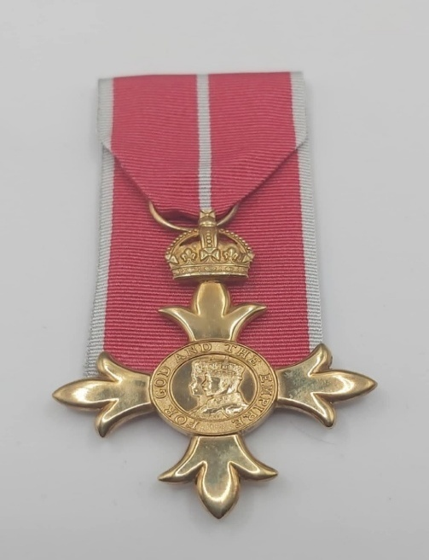

Photo credit: Julian Allerhead BEM

The Most Excellent Order of the British Empire was established on the 4 June, 1917, by King George V to honour individuals for their valuable services, particularly during World War 1. The Order comprises of five classes with OBE being the second highest rank

The Royal Engineers Bomb Disposal teams were awarded 9 Officer of the British Empire Medals, during the Post War period

ARCHER, Bertram Stuart Trevelyan Archer GC OBE, (126305) 142 Bomb Disposal Regiment (Army Emergency Reserve), Royal Engineers

The Citation is taken from file WO373/168/360 held at the National Archives.
Placed in the London Gazette on the 2nd June 1961. Supplement 42370. Page 4149.

Lt-Col B.S.T. Archer, GC, ERD, RE (AER), and he is due to finish his tenure of command 142 Bomb Disposal Regiment RE (AER) and his service with the AER in July 1961.

He is a Commanding Officer of a considerable character and personality, who at all times has set the very highest example to all ranks, both of the three regiments of Bomb Disposal (AER) and of the regular staff of the Bomb Disposal Unit (UK) RE, by his sincere enthusiasm, loyalty, integrity, efficiency and high sense of duty. This has been an outstanding effect upon morale in the AER and therefore upon recruiting in the AER.

He is a very hardworking and conscientious trainer of men, never sparing himself on schemes and exercises, both at annual camps and at every voluntarily weekend training period, to ensure that the highest possible standard is reached and that every moment of the training time is spent profitably. All ranks have the greatest respect and admiration for him.

Plans for the mobilisation of Bomb Disposal (AER) in aid of Civil Defence in the UK in global war had to be changed very considerably during 1960 to ensure that the hazard of unexploded enemy guided missiles was adequately countered through the UK. This necessitated a good deal of original thought. Imaginative planning and the re-writing of establishments and equipment tables into a realistic re-organisation, based on past experiences and likely future requirements. This could not be done satisfactorily without consulting the three Commanding Officers of the AER regiments. Lt-Col Archer took charge of these proceedings and working in his own time, held a series of meetings and conducted considerable correspondence which resulted in his producing two papers which had a very material and valuable effect on the final proposals approved by the War Office.

Of all the AER officers in Bomb Disposal, he is the one to whom it matters most that the fine traditions of Bomb Disposal (short though its history is) should be upheld and fostered in the future by the new recruits of all ranks who have joined since the last war. It is largely due to his outstanding efforts, example and leadership that this branch of the AER, which has no counterpart in civilian life (unlike other branches of the AER), flourishes so enthusiastically and successfully.

Further Information
Lieutenant BST Archer had been awarded the George Cross in World War II, see separate entry.

BROOKE, M H H OBE, Lieutenant Colonel, 33 Engineer Regiment (EOD), Royal Engineers

No file found in the National Archives Catalogue.
Placed in the London Gazette on the 28 December 1990. Supplement 53282. Page 5.

Awarded for services to EOD whilst Commanding Officer 33 Engineer Regiment (EOD)

CLEGHORN, Alexander OBE, (48133) Temporary Lieutenant Colonel, Chief Royal Engineer Bomb Disposal, Royal Engineers

Citation taken from file WO373/157/557 held at the National Archives.
Placed in the London Gazette on the 6 June 1947, Supplement 37997. Page 2579
Lieutenant Cleghorn has been in Bomb Disposal since Jan 1941 and there is no doubt that his work has been of exceptional merit. In view of his rank the credit has gone to his subalterns but it is beyond question that his organising ability, tact and leadership as a Company Commander and as a CRE have been a very high order and are, in the main responsible for the successes which his units have achieved both in Southern Command and Northern, were he was previously.

Since the end of hostilities his difficulties have in many ways increased. Strong local pressure to clear beaches etc has coincided with the heavy burden of the release scheme and the consequent shortages and frequent changes in experienced BD personnel.
Lt Col Cleghorn has in spite of these difficulties achieved a high degree of success, which in some cases has been recognise by official thanks of the local authorities concerned.

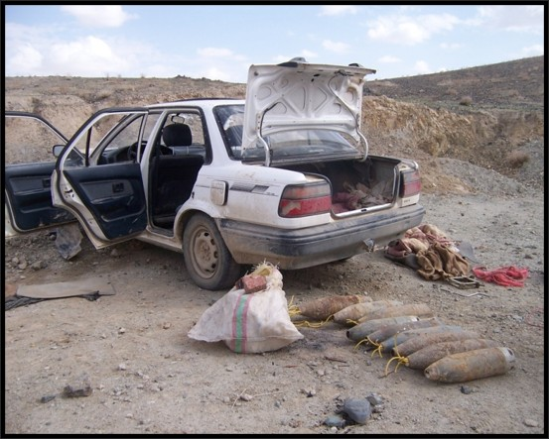 | 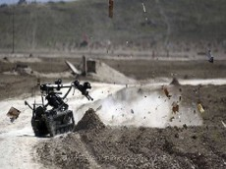
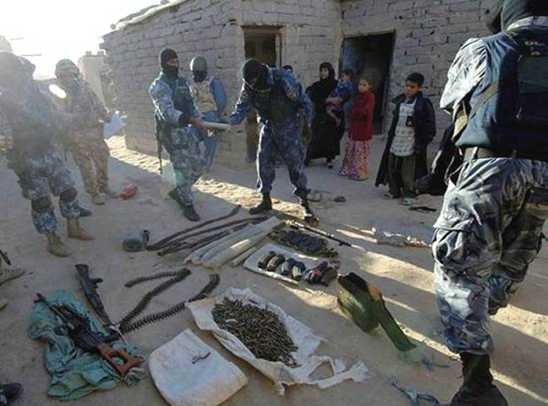 | 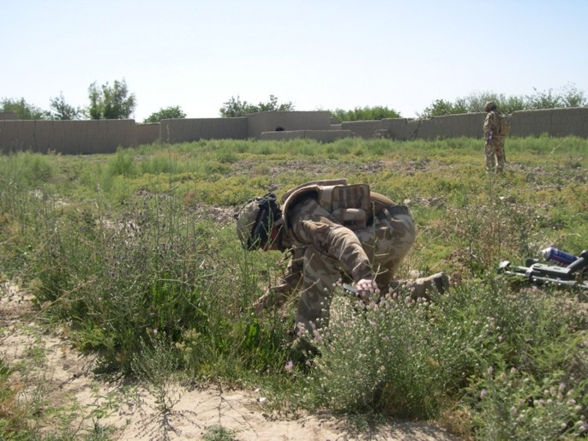
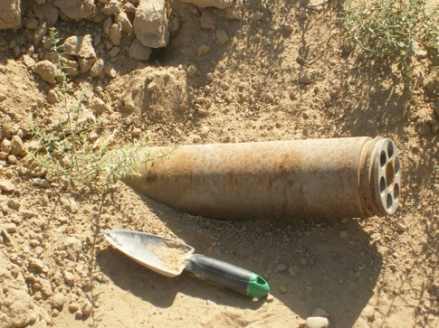 | 

Afghanistan, Operation Herrick 8
Photos taken from a Power Point Presentation by Jimmy Freil and passed on by Rey Fadil.

FOX, A S K OBE, Lieutenant Colonel, 33 Engineer Regiment (EOD), Royal Engineers

No citation found in the National Archives Catalogue.
Placed in the London Gazette on the 13 June 2015. Supplement 61256. Page 6.

For services in Syria.

LEWIS, D W OBE, Lieutenant Colonel, 101 (City of London) Engineer Regiment (EOD) (TA) Royal Engineers

No citation found in the National Archives Catalogue.
Place in the London Gazette in the June 1993.
Confirmed as awarded whilst serving with EOD as entered on the awards board in the Regimental RHQ.

MARSHALL, RO Saint George OBE, (47751) Temporary Lieutenant Colonel, Chief Royal Engineer Bomb Disposal, 2 Bomb Disposal Group, Royal Engineers

No citation found in the National Archives Catalogue.
Placed in the London Gazette on the 4 June 1946. Supplement 37598. Page 2770.

No other information available.

SHANAHAN, J W OBE, Lieutenant Colonel, Commanding Officer Joint Forces EOD, Iraq, Royal Engineers

No citation found in the National Archives Catalogue.
Placed in the London Gazette on the 30 October 2003. Supplement 57100. Page 3.

No other information.

SOUTHALL, D W OBE, Lieutenant Colonel, Commanding Officer 33 Engineer Regiment (EOD). Joint Forces EOD Afghanistan, Royal Engineers

No citation found in the National Archives Catalogue
Placed in the London Gazette on the 25 March 2003. Supplement 59737. Page 5639.

Information from Regimental update to the Royal Engineers Bomb Disposal Branch, Bulletin April 2011.

During his time as commander of the Counter-IED Task Force the frequency of incidents concerning homemade bombs reduced as a result of new initiatives that he introduced. Analysing all from blasts and intelligence he ensured lessons were learnt quickly. Undoubtedly saving lives. His encyclopaedic knowledge of his field of expertise led him to develop and deploy small expert Counter-IED tiger teams.

He was also responsible for training the first Afghan National Army and Police BD and Seach teams in Helmand. He motivated and encouraged those under his command, leading by example in his pursuit of excellence through his operational tour.

His citation stated “that he presided over a major decline in IED events and an impressive reduction in deaths.

STOCKLEY, SP OBE, Lieutenant Colonel, 101 (City of London) Engineer Regiment (EOD) (TA) Royal Engineers.

No citation found in the National Archives Catalogue
Placed in the London Gazette in January 2013.

WILSON, A A, OBE, Colonel, 33 Engineer Regiment (EOD), Royal Engineers.

This Citation is taken from file WO373/181/163 held at the National Archives.
Placed in the London Gazette on the 30 December 2008.

Lieutenant Colonel Wilson has commanded 33 Engineer Regiment (EOD) during a most difficult and demanding period with conspicuous success. Currently the only one of its kind. his Regiment consists of 3 Regular and 4 TA Squadrons and is responsible for all RE EOD tasks worldwide wide, in peace and war. Both the number and complications of these tasks have escalated to high levels during his time in command.

Peacetime operational tasks undertaken by the regular soldiers and 160 civilian searchers in his Regiment have been especially varied and dangerous. The disposal of two large Second World War German bombs in London involved the evacuation of hundreds of civilians, whilst in each case his teams struggled for more than 24 hours with the difficulties of rendering the bomb safe. A team successfully dealt with booby trapped anti-tank mines exposed on a Norfolk Beach, mines which were of a type that caused scores of deaths even when in better conditions some 40 years ago. 58 Squadron has worked for two years continuing to clear pipe mines laid under wartime airfields which contain nitro-glycerine and are now most unstable., a task which is political sensitive because of the current civilian use of most of the areas. 49 Squadron carried out the dangerous task of clearing chemical munitions at Bramley in the full glare of the press and television and went on to clear the remains of an old detonator factory in Yorkshire after a council workman had been killed in an explosion. Two further explosions occurred during the clearance.

Following the Brighton Bomb, High Risk Search tasks to protect the Royal Family, the Prime Minister and her Cabinet and other senior officers and public figures have become a new but unavoidable commitment for his unit. Running at more than one a month, they involve a large team and take considerable planning and preparation in conjunction with Chief Constables. The Home Office and many other organisations at home and abroad.

Operational tasks such as these examples together with the preparation and training of his Regiment for an increasing General War threat, for Out of Area operations, which include newly raised commando and parachute EOD troops, and foe exacting classified counter-terrorism roles, plus his contributions to EOD in the Falkland’s, Belize and Cyprus to raising new TA Squadrons and to urgent equipment development, have all produced a severe overload on Lieutenant Colonel Wilson as an individual during the last two years. The overload has now been recognised and the Regiments splits shortly into a Regular regiment and a TA regiment and each will be commanded by a full-time officer.

Lieutenant Colonel Wilson has carried this exceptionally heavy and continuous responsibility with great skill and determination, despite the almost constant worry that his men were either at risk themselves or were leaving others at risk if they should fail to detect an explosive device or, once found, fail to defuze it safely. He has worked successfully with a wide range of military and police commanders and senior civilians, all of whom have held him in the very highest regard. Throughout, he has shown skilled leadership and given his hard-pressed officers and men clear direction and excellent motivation. As a result, he has been a magnificent example to everyone.

For his outstanding and dedicated contributions To Explosive Ordnance Disposal worldwide and to the safety of others, Lieutenant Colonel Wilson fully merits public recognition.

Member of the Most Excellent Order of the British Empire

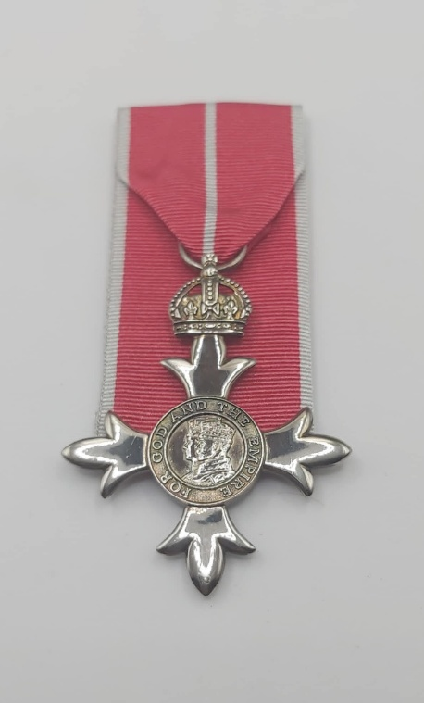
Photo credit: Julian Allerhead BEM.

The Most Excellent Order of the British Empire was established on the 4 June, 1917, by King George V to honour individuals for their valuable services, particularly during World War 1. The Order comprises of five classes with MBE being the third highest rank.

The Royal Engineers Bomb Disposal teams were awarded 78 Members of the British Empire during the Post War period

BANKS, A J MBE, Captain, 101 (City of London) Engineer Regiment (EOD) (V), Royal Engineers

The Citation is taken from file WO373/181/308 held at the National Archives.
Placed in the London Gazette on the 17th June 1989. Supplement 51772. Page B6.

Captain Banks joined the Royal Engineers Bomb Disposal TA in 1980 after retiring from the Regular Army, and has given quite outstanding service. He became the Permanent Staff Administrative Officer (PSAO) of 580 Explosive Ordnance Disposal (Volunteers). Between 1980 and 1987 the number of TA Squadrons increased from one to four and Captain Banks was made responsible for three of them. He took on the responsibility of raising the extra squadrons and worked long hours to ensure that they quickly became able to take their place in the BAOR and UK order of battle it was not till 1987 that more PSAOs were appointed and the immense work load at Squadron level was lifted from his shoulders.

However, in 1987 it became clear that a TA Regimental Headquarters would be formed to command the TA Explosive Ordnance Disposal Squadrons and Captain Banks was given the task of organising the Headquarters prior to its formation on 1ST June 1988. Alone he had to organise every aspect of the Headquarters until the regular staff were appointed. It was due to his efforts that the formation of 101 (London) Engineer Regiment was achieved so smoothly.

Even though his charter does not require him to become involved in operational aspects of Bomb Disposal he has willingly taken part in all major UK and BAOR exercises and had it not been for his enthusiasm and drive the Army’s awareness off Explosive Ordnance Disposal would not be what it is today. He has willingly and cheerfully worked extremely hard over a period of 8 years, often without help or supervision, to meet the ever-increasing demands on RE EOD in war which the developing threat was generated.

Captain Bank’s reaches retirement in 1989 and his magnificent and sustained efforts in bringing the Royal Engineers TA Explosive Ordnance Disposal to its current position fully merits recognition.

BENGER, Roy Henry MBE, (243838) Lieutenant, 30 Bomb Disposal Platoon, 17 Bomb Disposal Company, Royal Engineers

The Citation is taken from file WO373/74/353 held at the National Archives.
Placed in the London Gazette on the 11 December 1946. Supplement 37386. Page 6060.

In addition to the many UXB’s (approx. 115). Many of high priority, dealt with by this officer during the normal course of his hazardous duties Lieutenant Berenger is recommended for an award for his excellent work during April 1945in removing saboteur equipment fitted with short delay time clocks placed to damage petrol pipelines and railway installations, at Falconara and Sennigallia – supply routes to Eighth Army. There were five separate incidents. The self-detonation of two incidents gave the indication that charges had been laid and that others might be in the vicinity. An exhaustive search by Lieut Benger revealed three others – charges which were immediately removed from the military installations, one of which detonated a few minutes later; the remaining two charges were rendered safe by the removal of the time clocks. Lieut Benger was aware of the great personnel risk he was taking, by reason that the remaining charges were still active; but by his prompt action further damage to military instillations was avoided.

BIBBY, Gerald Joseph MM MBE, (1985031) Warrant Officer Class II, No 2 Bomb Disposal Troop, Headquarters Bomb Disposal Unit (UK), Royal Engineers

The Citation is taken from file WO373/166/260 held at the National Archives.
Placed in the London Gazette on the 1st January 1959. Supplement 41589. Page 7.

WO2 Bibby enlisted in February 1939 and after the outbreak of war quickly reached NCO rank. He served in overseas theatres for the whole of the war during the latter part of which he was trained as a sabotage agent and parachuted into enemy occupied Greece. Whilst serving in Greece as an agent he was awarded the Military Medal for gallantry. Since the war he has, on two separate occasions, been selected to represent his country abroad and served with the British Military Mission, Greece and the British Training Staff, Turkey. In February 1958 he was awarded the Long Service and Good Conduct Medal.

He is, at present, Troop Sergeant Major of No.2 Bomb Disposal Troop, Royal Engineers. He has occupied this appointment for four years and for two years of this period was in charge of a detachment located in London. This Troop is responsible for disposing of all old German Unexploded Bombs in the United Kingdom, isolated mines on beaches, and the removal and disposal of other explosive missiles. During the whole of this time WO11 Bibby has constantly been personally called upon to dispose of such dangerous objects, in the interests of public safety, often exposing himself to considerable hazards because of the extreme sensitivity of many of these explosive objects, such as beach mines which have become so sensitive through age and the action of the sea and tide. He has shown a constant willingness to undertake such duty anywhere in the United Kingdom at immediate notice.

These duties call for high qualities of leadership, courage and technical ability. His enthusiasm and dependability have been an inspiration to all ranks of his unit, particularly so when giving guidance and technical advice to officers when new to this type of operation. He has been successful in maintain a very high standard of morale among both Military and Civilian personnel employed on these operations. This has been achieved by the example of his readiness to accept responsibility for the most difficult tasks and by his devotion to duty which he has placed before all personal considerations.

BOWER, William Albert MBE, (58583) Major, Bomb Disposal, Royal Engineers

The Citation is taken from file WO373/69/924 held at the National Archives
Placed in the London Gazette on the 18 June 1946. Supplement 37613. Page 3057.

Major Bower has completed three years of exceptional merit in the disposal of unexploded bombs and clearance of defensive minefields In the United Kingdom. He has for the last three years been responsible for the efficiency of the electrical (bomb and mine locator) mechanical and hydraulic equipment used in Southern Command for the clearance of beach minefields and disposal of enemy bombs. His untiring meticulous devotion to duty particularly creditable for a man of his years (58) is responsible for the confidence all ranks in the use of equipment used for locating displaced beach minefields and can be said to have contributed to a very large extent to the success, with comparatively few fatal casualties, of the hazardous work already completed. His duties have necessitated the checking and adjustment of mine locators on live minefields; his example and efficiency have been of a strong moral support to the operators and cannot be spoken of too highly.

BRENT R P MBE, Major, 49 Field Squadron (EOD), 33 Engineer Regiment (EOD), Royal Engineers

No Citation found in the National Archives Catalogue.
Placed in the London Gazette on the 31 December 2003. Supplement 57155. Page B5.

Officer Commanding 49 Field Squadron (EOD) awarded for work with the International Security Assistance Force, Afghanistan.
BYRNE, Thomas MBE, (24066552) Warrant Officer Class II, 58 Field Squadron (EOD), 33 Engineer Regiment (EOD), Royal Engineers

The Citation is taken from file WO373/180/171 held at the National Archives.
Placed in the London Gazette on the 13^{h} June 1986. Supplement 50551. Page 5.

WO11 Byrne has been the Squadron Sergeant Major of 58 Explosive Ordnance Disposal since the Squadron was first raised two years ago. He has been an outstanding Sergeant Major in all respects, helping mould the character of the squadron in its infancy. His leadership, discipline and vast experience in a wide range of trades, has made a professional and efficient operational unit. He has taken the time to guide and advise his SNCOs and handle a number of welfare problems within the squadron. No task has appeared to be difficult or time consuming for this, and his acceptance of responsibility is exceptional.

In addition to the normal duties of Sergeant Major, WO 2 Byrne has qualified and performed the duties of Bomb Disposal Officer and Improvised Explosive Device operator throughout his tour. He has always undertaken a number of unique operational responsibilities in a highly technical field and developed the procedures and training for the specialist search role.

He is one of the primary Search Advisors to the Police. In a year when search operations in Great Britain have increased considerably, he has been actively involved in these operations. As his squadron commander has been advising and planning future tasks with other Police Forces. He was in charge of the search at the Association of Conservative Councils Meeting in Newcastle, at Victoria Station on the occasion of the state visit of the President of Mexico and the Conservative Party Conference in Blackpool. He has been involved in the planning and conduct of search operations in conjunction with police officers of far higher rank and advising Chief Constables. He has received the respect and admiration of many agencies outside the Army and has been a most able example of its professionalism and dedication to duty.

WO2 Byrne in addition to his duties in the raising and training of 58 EOD Squadron has carried out operational tasks far above those that might be expected of someone of his rank and service. His work in support of Security in Great Britain is fully deserving of recognition.

CASTLE, J W MBE, Major, SO2 EOD Engineer Branch, Headquarters, United Kingdom Land Forces,
Royal Engineers.
No Citation found in the National Archives Catalogue.
Placed in the London Gazette on the 10 June 2004. Supplement 53696. Page B 6.

Awarded whilst working as SO2 EOD Engineer Branch HQ UKLF

CHARLESWORTH, Harry MBE ERD, (231299) Major, Headquarters Bomb Disposal Unit (UK), 144 Bomb Disposal Regiment (Army Emergency Reserve), Royal Engineers

The Citation is taken from file WO373/169/228 held at the National Archives.
Placed in the London Gazette on the 28th December 1962. Supplement 44870. Page 7.

Major Charlesworth joined Bomb Disposal AER in 1952 and has served continuously as a volunteer, with the rank of Captain from 1952 to 1954 and as a Squadron Commander from 1954 until 1961. He has been Second-in-Command of 144 Bomb Disposal Regiment (AER) FROM 1961 UNTIL THE PRESENT DATE. In this latter appointment he has been responsible for the training of volunteer personnel in the Regiment as a whole.

He has actively engaged in bomb disposal and minefield clearance from 1942 until 1946. This experience coupled with his tremendous enthusiasm and drive, have been invaluable in the effective training of officers and other ranks volunteers in bomb disposal techniques. His contribution has been far in excess of normal duties of a volunteer officer. In addition, he has undertaken investigations into unexploded bomb incidents at the request of Bomb Disposal Unit (UK) RE.

He willingly extended his service by6 years beyond his normal retirement age in order hat his skill, experience, and invaluable knowledge, which are of such high order, could be imparted to the new and younger members of the Regiment. He has done this by his outstanding qualities as a volunteer officer and his readiness to undertake tasks and carry them out successfully. His guidance, loyalty, and devotion to duty have made a most successful contribution to the training of the Regiment, and his example has been an inspiration to all ranks.

Major Charlesworth retires on age this year from the Army Emergency Reserve.

CLEWLEY, S J MBE, Staff Sergeant, 101 (City of London) Engineer Regiment (EOD) (V), Royal Engineers

No Citation found in the National Archives Catalogue.
Placed in the London Gazette on the 29 April 2002. Supplement 56920. Page 5272.

For Services to Bomb Disposal.

Further Information
Queens Commendation for Bravery for saving the lives of eight soldiers while serving in Afghanistan.

COLLINS RG MBE, Staff Sergeant, 33 Engineer Regiment (EOD), Royal Engineers

No Citation found in the National Archives Catalogue.
No entry found in the London Gazette.

Entry confirming this award the in The Corps of Royal Engineers History Volume XI 1960 to 1980 Page 415.
A member of the Territorial Army.

COLTART, A J MBE, Captain, 33 Engineer Regiment (EOD), Royal Engineers

No Citation found in the National Archives Catalogue.
No entry found in the London Gazette.

Minefield mapping, Operation Grapple Bosnia.

DALBY, Derek James William MBE, (398140) Captain, Bomb Disposal Section, Malta Fortress Company, Royal Engineers

The Citation is taken from file WO373/122/63 held at the National Archives.
Posted in the London Gazette on the 24th May 1967. Supplement 41077. Page 3075.

At 4 pm on the 21 December 1956, Captain Dalby received information through the Malta Police that workmen engaged in excavating at (cannot read the location). He collected some essential items of the bomb disposal equipment and a few men an went straight to the site.
On arrival they dug away the soil surrounding the object and revealed a 250-kilogram German General-Purpose bomb. The fuzes could not be seen since they were underneath so he carefully rolled the bomb over.

On cleaning off the tops of the fuzes these were revealed as being a clockwork long delay fuze fitted with an anti-handling device and also an anti-disturbance fuze similarly fitted. This was the type of bomb which caused so many casualties to Bomb Disposal personnel during the last war.

The bomb was situated in the middle of a large built-up area and Captain Dalby therefore decided that it could not possibly be demolished in situ and that he must make every effort to neutralise it where it lay despite the considerable danger to himself which would necessarily result.

Accordingly, he personally drilled a small hole by hand into each fuze in turn and poured into a liquid to neutralise it. This action did not of course affect the anti-withdrawal device or the sensitive explosives in the fuze pockets. He next cut out a large hole through the outer casing of the bomb itself using a trepanning machine operated by a steam generator and finally steamed out the main explosive filling. During both these last operations the steam generator gave considerable trouble necessitating Captain Dalby’s presence in the danger area in the vicinity of the bomb for more than would normally have been the case.

Throughout the whole of this operation which lasted 17 hours (until 9 O’clock the following morning), Captain Dalby showed a complete and utter disregard for his personal safety both in the decisions he took and in carrying out all the more dangerous tasks himself. He set an example to others who were working with him and their confidence in his ability to carry out this dangerous operation, through to a successful conclusion was obvious to all who were present.

Captain Dalby’s courage and devotion to duty were exemplary, an inspiration to all, and in the highest traditions of the service.

Further Information
Staff Sergeant Mander was awarded the British Empire Medal for this incident see separate entry.

DEACON, John Ernest Arthur GM MBE, (166507) Temporary Captain, 23 and 27 Bomb Disposal Company, Royal Engineers

The Citation is taken from file WO373/86/329 held at the National Archives.
Placed in the London Gazette on the 24th January 1946. Supplement 37442. Page 620.

This officer has shown great gallantry in disposing of bombs and mines during North Western Europe Campaign. He dealt with a German contact Mine on a beach at Longues together with an extremely dangerous minefield on the cliff face. By his example and courage, and in spite of casualties to his men, he enabled the first Submarine Telephone Cable from England to France. To be brought ashore.

During the period 7th June – 28th June 44 this officer dealt with over 67 bombs in the Beach-head area.

In addition, for the period 28th June onwards this officer has carried out administration of his Company with great zeal and efficiency. Owing to the Platoons being dispersed his difficulties were greater than normally would be.

DEVINE, John Mitchell MBE, (23940981) Warrant Officer Class II, Defence Explosive Ordnance Disposal School, Royal Engineers

The Citation is taken from file WO373/180/588 held at the National Archives.
Placed in the London Gazette on the 30th December 1987. Supplement 51771. Page 6.

WWO2 Devine joined the Corps of Royal Engineers as a boy soldier in 1962. Since then, he has seen service in Germany, Norther Ireland, Saudi Arabia, the Falkland Islands immediately after the conflict and United Kingdom. In all he served for 5 years in bomb disposal, firstly with 33 Engineer Regiment (EOD) and more recently, from December 1983; as a specialist instructor at Defence Explosive Ordnance Disposal School.

His duties and those of his small Royal Engineers bomb disposal team have required him personally to render safe 5 World War 2 German bombs and other items of land service ordnance too numerous to mention. In the Falkland Islands he was wounded by a mine which exploded, severely injuring his Officer Commanding. Despite his wounds and without further thought for his own safety in an area where other mines could have caused him further injury, WO2 Devine calmly and with courage administered first aid to his Officer Commanding whilst arranging their evacuation by helicopter. Throughout he displayed exceptional leadership and a high sense of duty.

As an instructor at the Defence Explosive Ordnance Disposal School, through his personal effort and by devoting many long hours of his off-duty time, he has created a cell of expertise in both land service ordnance and making safe bomb fuzes that remain a focus for the 3 Services long after his retirement. His exceptional qualities as an instructor, exactness of method and attitude have constantly served as an inspiration to international students and other staff of all ranks from the 3 Services. Such is his standing that other NATO Explosive Ordnance Disposal Schools frequently ask for the assistance of WO2 Devine to prepare new training programmes. It is to his very high standards, positive approach and fine sense of judgement that all unconsciously aspire.

Throughout the last 5 years WO2 Devine has been totally dedicated to bomb disposal and to his soldiers to a degree that could not be expected or anticipated. In addition to faithfully and zealously performing his routine duties., by his enthusiasm, energy and leadership he has been outstanding amongst a team of hard-working soldiers and an inspiration to all. He deserves both for himself and bomb disposal formal recognition of his outstanding achievements and for his courage shown whilst dealing with unexploded ordnance.

EASTOUGH, ME MBE, Warrant Officer Class II, 101 (City of London) Engineer Regiment (EOD) (V), Royal Engineers

No Citation found in the National Archives Catalogue.
Placed in the London Gazette on the 31 December 2001. Supplement 1. Page S5.

Services to the Regiment, whilst Regimental Sergeant Major.

FAHEY, Godfrey Laurence Christopher MBE, (180069) Second Lieutenant, Attached 47 Bomb Disposal Platoon, Indian Engineers

The Citation is taken from file WO373/81/238 held at the National Archives.
Placed in the London Gazette on 15th January 1946. Supplement 37443. Page 495.

This officer has during the last three months disposed of over (think five) hundred bombs and booby traps. He has displayed courage and ability of a high order and it is largely due to his work that casualties from booby traps have been remarkably small.

FOX, A S K, MBE, Major, 58 Field Squadron (EOD), 33 Engineer Regiment (EOD), Royal Engineers

No Citation found in the National Archives Catalogue.
Placed in the London Gazette on 11 June 2005. Supplement 57665. Page 5.

For Services to High-Risk Search as Officer Commanding 58 Field Squadron (EOD).

Further Information
Major A S K Fox was also awarded the OBE in 2015.

FROST, R B MBE, Major, 101 (City of London) Engineer Regiment (EOD) (V), Royal Engineers

No Citation found in the National Archives Catalogue.
Placed in the London Gazette on January 2016.

No further information available.

GODDARD, C S MBE, Captain, 33 Engineer Regiment (EOD), Royal Engineers

No Citation found in the National Archives Catalogue.
Placed in the London Gazette on the 28 June 1991. Supplement 52588. Page 25.

HAMBROOK, Stephen David GM MBE, Major, 101 (City of London) Engineer Regiment (EOD) (V), Royal Engineers

No Citation found in the National Archives Catalogues.
No London Gazette entry found.

Major SD Hambrook through his service was also awarded the General Service Medal Northern Ireland and a Commendation for Bravery.

HARRIS, William Seymour MBE, (132068) Temporary Major, 19 Bomb Disposal Company, Royal Engineers

The Citation is taken from file WO373/86/439 held at the National Archives.
Placed in the London Gazette on 24th January 1946. Supplement 37442. Page 621.

This officer has been continuously employed on Bomb Disposal since Sept 1940, has comd of 19 BD Coy RE throughout the NW European campaign. From its arrival in Normandy in Jul 1944, the unit was immediately and continuously engaged in its normal role, and also in the deliberate clearance of large areas of mixed minefields and booby-trapped areas in the crowded beachhead. This involved severe nervous strain on the whole unit, but by personally taking part in the recce of such areas, and by his constant presence, powers of leadership and dogged courage, Major Harris maintained the morale of his Coy at a high level, despite heavy casualties. Similar work was subsequently carried out in the clearance essential port areas in Le Haves and the Pas de Calais. Again, Major Harris’s precept and example were a vital factor in sustaining the unit’s morale, despite the strain imposed by frequent casualties, and by the cold-blooded nature of continuous employment on this type of work, far removed from the excitement of actual battle.

Following specialist training for the role, the unit joined T Forces in Mar 1945. Although much of the new work involved was largely outside the usual scope of work assigned to a BD Coy, Major Harris by his outstanding administrative ability and his personal contact with his pls, ensured that the work was successfully concluded. In spite of the risks involved not a man was lost from his Coy between Mat and 8th May, which reflects great credit on the training given by their Commanding Officer.

HARTLEY, Arthur Banford, (276453) Temporary Major, Headquarters Bomb Disposal Unit (UK), Royal Engineers

The Citation is taken from file WO373/160/249 held at the National Archives
Posted in the London Gazette on the 1st January 1953. Supplement 39732. Page 8.

Since 1943 Major Hartley has been continuously employed on hazardous work disposing of Unexploded Bombs and Beach Minefield. Since November 1950, as Field Engineer of the B.D. Unit (UK) Royal Engineers, he has been in charge of all operations of this nature in the United Kingdom. During this period forty-four unexploded Bombs were rendered safe.

Major Hartley invariably makes a practice of attending the dangerous part of the operation, when at all possible, to minimise the risk of accident by making his experience available to the officers neutralising the bomb. Very largely as a result of his disregard of danger and devotion to duty, no accidents have occurred while he has been Field Engineer.

Further Information
He later wrote of his exploits Unexploded Bomb. The story of Bomb Disposal Major. A B Hartley, MBE, RE.

HAWKES, R W MBE, (210272) Major, 4 Bomb Disposal Squadron, Royal Engineers

No Citation found in the National Archives Catalogue.
Posted in the London Gazette on the 4 April1946. Supplement 37598. Page 2775.

No further Information available.

HILL, William Kenneth MBE, (2075440) Lieutenant, 18 Bomb Disposal Platoon, 19 Bomb Disposal Company, Royal Engineers

The Citation is taken from file WO373/86/445 held at the National Archives
Posted in the London Gazette on the 24 January 1946. Supplement 37442. Page 621.

When Lt Hill took over 18 BD Platoon, in March 1945 he had a big task in front of him. The morale of the platoon had deteriorated several months of duty as a Stores Section at Bayeux during the winter and the platoon Sergeant had left to take a commission. Nevertheless, by the time the Company joined T Force about 3 weeks later he had revolutionised the outlook and efficiency of the platoon solely by his own enthusiasm and example.

As a platoon they worked on examining targets for booby traps and prepared charges and a safe breaking at Rheine, Hannover and Munster Lager giving complete satisfaction.
At Hanigsen X6034, near Hannover on 13 April an underground Ordnance Store had to be examined for booby traps and explosives before the T Force investigators could operate. The only entrance to this target was down a 700 meters deep lift shaft. The lift had been left at the top. Civilian workers stated that a large charge had been placed to demolish the lift shaft connected so as to detonate when the lift descended.
Any deliberate examination of the bottom of the shaft, which would have had to have been reached without moving the lift would have taken much more time than could be spared, especially in view of the possibility of the delay mechanism being also present. Lt Hill therefore, fully realising the hazards involved, decided to test the civilian’s story by descending himself in the lift this he did safely.
The fact that no explosive had actually been placed in position in no way minimises the courage of the action, for the presence of electric leads running down the shaft showed the demolition had been planned but interrupted by the speed of our advance. It was by taking risks and short cuts such as this that Lieut Hill was able to the high concentration of targets near Hannover to investigators in an exceptional short time.

HOGGART, Noel MBE, (2075440) Warrant Officer Class II, 7 Bomb Disposal Company (Prisoner of War), Royal Engineers

The Citation is taken from file WO373/69/4929 held at the National Archives
Posted in the London Gazette on the 18 June 1946. Supplement 37613. Page 3057.

Company Sergeant Major Hoggarth has rendered service of exceptional merit in the disposal of unexploded enemy bombs, and in the clearance of defensive minefields in the United Kingdom. He joined a Bomb Disposal in the very early days of the war and can be regarded as one of the pioneers of this class of work. From June 1940 until October 1943, he worked in the blitzed areas of Cardiff, Swansea, London Bath and Exeter, and was actually in charge of the removal of 250 bombs. Thee bombs included a number which were fitted with clockwork fuzes and others with anti-handling devices.
Any additional duties which were thrown upon him he assumed happily and his whole work has been carried out quietly and thoroughly. From October 1943 until his release from the army in the latter part of 1945, he carried out duties in connection with the clearance of minefields.
On one occasion in 1944, when an explosion occurred in a minefield it to his lot to both the dead and injured clear of the danger zone,
Company Sergeant Major Hoggarth’s character and general bearing throughout his service in connection with Bomb Disposal has been beyond reproach and his cheerful disregard of danger has been an example that was needed to inspire his men. His conduct and devotion to duty, has been of the very highest order.

HOLT, C MBE, Captain, 49 Field Squadron (EOD), 33 Engineer Regiment (EOD), Royal Engineers

No Citation found in the National Archives Catalogue
Posted in the London Gazette on the 30 December 2004.

Captain Holt has been a Squadron Second in Command and a Bomb Disposal Officer in 33 Engineer Regiment (EOD) since May 2002. His Unit provides Explosive Ordnance Disposal (EOD) support to the Field Army on deployed operations. In addition, they contribute to the Defence of the United Kingdom (UK) against international terrorism in their Maritime Interdiction (MI) role in support of UK Special Forces (UKSF) and the Police. During this period Captain Holt has also had to fill the posts of Adjutant for 6 months and the Officer Commanding of the Joint Force (EOD) Group on Operations in Iraq for 2 months.

Captain Holt has consistently shown great dedication, self-sacrifice and dynamic leadership during this period. As the Squadron Second in Command, he was central to the effective provision of assault search support on MI operations whilst simultaneously planning and training elements of his sub unit to deploy in support of 3 Commando Brigade Royal Marines on Operation TELIC 1. He then filled the post of Adjutant which coincided with the Land War, a post that he had not been trained for. This was a particularly frantic period for the only Regular Royal Engineers (EOD) Regiment and he was key to the Unit coping with supporting 7 military operations at home and abroad. In addition, he had a critical role in ensuring that the Regiment maintained its focus and dealt effectively and compassionately with the publicity and associated problems when 2 of our soldiers were killed in action in Iraq.

Captain Holt then returned to his Squadron to deploy to Iraq as Commanding Officer during their deployment on Operation TELIC 2. This was another demanding employment with many a challenge, where he was reporting to both a Commanding Officer at Brigade Headquarters and the Divisional EOD staff under Commander Royal Engineers at Headquarters 3 UK Division. His leadership was inspirational and his Squadron, which in effect was a tri-service Joint Force EOD Group, was instrumental in providing force protection across the UK Area of Responsibility. This was a massive task given the amount of Unexploded Ordnance but also the constant threat of attack, which had become a reality on several occasions. Captain Holt’s determination and careful co-ordination in tasking and deploying his Bomb Disposal teams across a very large area in what was a hostile environment was a tremendous achievement. Additionally, before he left Theatre, he produced a verry effective plan that would restructure the Joint Force EOD Group and enable future deployments to operate more effectively in terms of risk, man power and EOD delivery.

Captain Holt has had to perform well beyond the threshold of his rank and appointment, particularly when he was the Officer Commanding of the Joint Force EOD Group. His conduct and professionalism in various appointment, in different Theatres, and under periods of extreme stress and at times danger has been exceptional. His dedication and inspirational leadership throughout this period have been of the highest order and recognised by senior officers across the 3 services. He gets my strongest recommendation for formal recognition of his actions.

HORSFALL, G F MBE, (166514) Temporary Captain, 2 Bomb Disposal Company (Prisoner of War), Royal Engineers

No Citation found in the National Archives Catalogue
Posted in the London Gazette on the 4 June 1946. Supplement 38139. Page 2775.

Possibly for work on beach mine clearance in the UK

No further Information

HUGHES, William MBE, (166514) Temporary Major, Bomb Disposal Company (UK), Royal Engineers

The Citation is taken from file WO373/70/75 held at the National Archives
Posted in the London Gazette on the 1 December 1947. Supplement 38139. Page 5751.

On the 11 August, 1947, in the Alexandra Docks at Liverpool a dredger brought up a German 500-kilogram unexploded bomb with a fuze of the highly dangerous 17 type. This requires the constant persona; attention of the senior officer on the spot.
Considerable alarm was caused and the Mersey Harbour Board had to suspend shipping activities. Major Hughes, however, on being called on for assistance, took charge of what was rapidly becoming a serious situation, with utmost calmness. Displaying outstanding qualities of courage and leadership he, with a small party, worked at the bomb during the night 11/12 August and had rendered it safe by the next morning.
But for his skill and gallantry much damage and dislocation to shipping would have been caused. Major Hughes and his squadron have worked ceaselessly and with unhesitating courage in Western Command and have constantly been engaged on dangerous work.
This citation is strongly supported by Mersey Harbour Board. That have expressed their gratitude and their high appreciation of Major Hughes’s calm and gallant attitude, in what was, for the Harbour Board, a major shipping emergency.
Further Information
Lance Corporal Ireland was awarded the British Empire Medal for this incident, see separate entry.

JEFFREY, K M MBE, Major, Quartermaster 33 Engineer Regiment (EOD), Royal Engineers

No Citation found in the National Archives Catalogue
Posted in the London Gazette on the 28 December 1945. Supplement 37407. Page 27.

No Further Information

LAMBERT, Ronald George MBE, (265366) Major, Hong Kong Bomb Disposal Troop, Royal Engineers

The Citation is taken from file WO373/169/79 held at the Nation Archives.
Posted in the London Gazette on the 29th June 1961. Supplement 42552. Page 7.

Major R.G. Lambert enlisted in the Corps of Royal Engineers in 1926, and early on in his career made an impression by his soldier-like qualities and his prowess at rugby football, at which he frequently represented the Corps.

In 1938 his ability as an instructor earned his appointment as Sergeant Instructor at Sandhurst, and later as a Warrant Officer Class II teaching officers at the School of Military Engineering.

He received an Emergency Commission in 1943 and served with a field unit in Germany as second-in-command, until finally commanding a field squadron for two years. He was then appointed to a Regular Quartermaster’s commission in 1951, but his qualities of leadership and instructing ability continued to mark him for more combatant duties until 1954. In that year he started the first posting as a Quartermaster and served in that capacity in North Africa, Korea and Christmas Islands.

From 1958 to early 1961 Major Lambert commanded 306 Engineer Stores Depot, and under his experienced and firm direction both stores and workshop departments became models of efficiency. His outstanding achievement has been to train up a Troop of locally enlisted Chinese into a smart, happy and versatile of combat engineers and plant operators.

It is typical of his loyal and hardworking attitude that in addition to his own duties, he voluntarily took command of another RE unit’s rear party for five months while they were out of Colony, together with all the welfare problems connected with some forty British families whose menfolk were away. He also took on, with his Chinese Troop, the engineer support of a Brigade Group left for five months without their own engineer squadron: this burden was greatly increased when the Troop Commander was accidentally killed, and the whole detailed supervision of the Troop’s work fell to him personally, as well as the duty of winding up the dead officers’ affairs’.

Major Lambert is now facing six months of running the Troop single handed, as the new civilian post of Administrative Officer cannot immediately be filled. With the same cheerful efficiency and drive he contrives to do two men’s work in a climate and season which sap the energy of many a younger officer.

His high standards of hard work, foresight and detailed planning reflect the quality of his early training and his thirty-four years’ experience. No period in his service has shown these standards to better advantage than his two years in Hong Kong.

LAUDER, M A MBE, Major, Officer Commanding 58 Field Squadron (EOD), 33 Engineer Regiment (EOD), Royal Engineers

No Citation found in the National Archives Catalogue
Posted in the London Gazette on the 12 June 1962. Supplement 52952.

Awarded for High-Risk Search.

LEES, Charles Thomas Robinson MBE, (89464) Temporary Captain, 4 Bomb Disposal Group, Royal Engineers

The Citation is taken from file WO373/69/925. held at the National Archives.
Posted in the London Gazette on the 14th June 1946. Supplement 37613. Page 3057.

Captain Lees has rendered services of exceptional merit in the disposal if unexploded enemy bombs in the United Kingdom. From May 1941 until April 1944, he was actively engaged in the disposal of some thirty unexploded enemy bombs and parachute mines in the heavy air raids on London, Bristol and Plymouth. This work included incidents containing delayed action fuzes categorised from the war effort point of view as of highest priority. His acceptance of danger, example and devotion to duty were in full accord with the standard established by Bomb Disposal personal throughout the country.

Since 1944, to the present date (September, 1945) his administrative ability, readiness to help and unflagging energy have been of extreme value in his capacity as Adjutant of No. 4 Bomb Disposal Group, Royal Engineers, and have contributed largely to the effective execution of clearance of beach minefields and abandoned enemy bombs being carried out by the Group.

LLOYD, Brian MBE, (510724) Captain, 1 Troop 49 Field Squadron (EOD), 33 Engineer Regiment (EOD), Royal Engineers

The Citation is taken from file WO373/179/54 held at the National Archives.
Placed in the London Gazette on the11th June 1983. Supplement 49375. Page 6.

Captain Lloyd is a Bomb Disposal Officer commanding 1 Troop, 49 Explosive Ordnance Disposal Squadron, Royal Engineers based at Brackenbury Camp, Felixstowe. The Troop consists of ten military and 50 civilian persons, including twenty-seven Ukrainians.

During the period of the citation Captain Lloyd has been responsible for the successful disposal of over forty thousand items of Unexploded Ordnance in the United Kingdom. From June to September 1982, he did a similar job in the Falkland Islands, dealing with a large quantity of unexploded objects including bombs, missiles, rockets and mortars. On several occasions, in both locations, the conditions were particularly hazardous and dangerous. He achieved the safe disposal of all of these items without injury to personnel, with minimum damage to property, and at no risk to the community at large. His performance, example and leadership have inspired confidence in all those who have come in contact with his, and have been the main reason for the total success of those under his command.

In addition to his normal duties Captain Lloyd has taken an intense personal interest in the welfare of the Ukrainian elements of his Troop. He has spent many hours of his men assisting them in their personal, social and recreational affairs. Nothing has been too much trouble for him, and he has become a trusted father figure in their community. In the Falkland Islands, too, he exhibited the same qualities in his unceasing efforts to make the very best of the spartan facilitates for his Troop. Captain Lloyd has shown constant courage, inspiring leadership and a high professionalism in the safe despatch of a large number of dangerous unexploded objects in both the United Kingdom and the Falkland Islands. He has gone out of his way to care for his men in a manner far beyond that expected of him. His selfless, courageous and devoted-service deserve special recognition.

LUCAS, Guy Spenser MBE, Major, 49 Field Squadron (EOD), 33 Engineer Regiment (EOD), Royal Engineers

The Citation is taken from file WO373/180/603 held at the National Archives.
Placed in the London Gazette on the 30th December 1987. Supplement 51171. Page 6.

Major Lucas re-joined Royal Engineers Bomb Disposal in December 1980 as Officer Commanding 49 EOD Squadron having previously served as a bomb disposal officer in 1971 and 1972. In March 1981 he led a bomb disposal section to Trinidad to clear over 1000 items of unexploded wartime munitions from pond and jungle areas. He was also personally responsible for the safe disposal of over 50 pipe mines from around the south coast of Britain during 1981 and 1982.

In July 1982 Major Lucas was sent to the Falkland Islands to organise EOD clearance. He was responsible for setting up the Joint Services Explosive Ordnance Disposal Operations Centre and co-ordinating tri-service EOD assets. In September 1982 Major Lucas returned to the UK having been responsible for the clearance of all unexploded ordnance from Port Stanley and the settlements. In January 1983 he returned to the Falkland Islands when to replace an officer who had lost his leg on a mine. In February 1983 he returned to Britain having personally disposed of 5 x 1000-pound bombs and 6 x 250-kilogram Argentinian bombs, as well as many other mines, missiles, rockets and grenades. During the total period of his detachment disposed of over a million items of unexploded ordnance.

In February 1985 he was appointed Second in Command of 33 Engineer Regiment (EOD) with a part time desk officer appointment in a MOD Land Service Operational Requirements branch dealing with EOD equipment. Over his period as Second in Command the Regiment expanded from one Regular Army squadron to two and from two TA squadrons to four. At the same time the majority of EOD equipment, which had not changed since World War 11, had to be brought up to date as a result of lessons learnt from the Falkland Islands conflict. From February 1985 until he left the Regiment in March 1987 Major Lucas worked tirelessly at this task.

In 1984 as a result of the Brighton bomb the Regiment was given the additional responsibility of providing High Risk Search Support to the UK mainland. This required Major Lucas to take on an additional workload in stating the requirement for a whole new range of equipment’s for the Regiment. At the same time a classified operational role required yet more technical equipment to be identified and purchased for the Regiment. He took the additional work in his stride, though it meant extremely long hours and much separation from his family. There is no doubt that without Major Lucas’s ceaseless endeavours the contribution to this Regiment to National security would have been dangerously less effective than is now the case.

Throughout his service in Royal Engineers Bomb Disposal Major Lucas has brought cool courage, effective leadership, boundless energy and determined professionalism to his various tasks. He has given his work a personal dedication well beyond that which could rightly be expected. He fully merits recognition for his outstanding contribution to the Nation’s EOD effectiveness.

MANLEY, John Robert MBE, (100982) Major, 101 (London) Engineer Regiment (EOD) (V), Royal Engineers

The Citation is taken from file WO373/181/612 held at the National Archives.
Placed in the London Gazette on the 16th June 1990. Supplement 52173. Page 6.

Major Manley joined the Territorial Army in June 1976 and was commissioned in 1977. In 1982 he commanded 579 Explosive Ordnance Disposal Squadron (Volunteers). The Squadron had only recently formed and over the four years in command he built it up to be a visible unit. In 1986 he became the first TA second in Command of 33 Engineer Regiment (Explosive Ordnance Disposal) with particular responsibility for the TA Explosive Ordnance Disposal Squadrons. He had little help in this task because of the Regiment’s commitment to high priority operational work. He attacked the problem with tremendous enthusiasm, giving up every spare minute of his time.

In 1987 it became clear that a TA Regimental Headquarters would be formed to command the TA Squadrons. As TA Second in Command, Major Manley’s job became very demanding and until 1st June 1988 he was virtually the Commanding Officer of the TA Squadrons. On the formation of 101 (London) Engineer Regiment, there should have been some respite to his workload. However, this was not to be.

Sadly, the Regular Regimental Training Officer was suffering from a debilitating illness and could not take on all the duties expected of him. True to form Major Manley stepped into the breach. He shared the Training Officers’ load with the Regimental Quartermaster Sergeant Instructor. He was everywhere planning, planning Regimental exercises, carrying out reconnaissance’s and writing officers promotion examinations, taking part in formation command post exercise. He turned his hand to every aspect of training, officer and NCO development and EOD equipment. Nothing was too much for him.

Major Manley has given his all to the Territorial Army. In February 1989 he suffered from a heart attack and was hospitalised. No sooner had he recovered than he returned to the Regiment, probably he was fully fit. He went to Germany to carry out reconnaissance for the Regimental Annual Camp. Immediately on his return he was involved in a very successful Regimental weekend. During all this time he held a responsible job with a local authority.

He is coming to the end of his TA Career. Short though it has been, he has crammed more into his thirteen years’ service than most TA officers have in twice that time; he has averaged 100 days per year for the last 10 years. Major Manley leaves 101 (London) Engineer Regiment in November 1989 and his magnificent and sustained effort to the Territorial Army fully merits recognition.

MAWDSLEY, P MBE, Warrant Officer Class II, 33 Engineer Regiment (EOD), Royal Engineers.

No Citation found in the National Archives Catalogue.
Placed in the London Gazette on the 31 December 2012. Supplement 56795. Page 6.
ME C3S 33 Engineer Regiment (EOD)

McNEE, I A, MBE, Sergeant, Sergeant I A McNee MBE, 33 Engineer Regiment (EOD), Royal Engineers

No Citation found in the National Archives Catalogue.
Placed in the London Gazette on the 17 June 2006. Supplement 58014. Page B6.

No Further Information
MILLER, E N MBE, Major, Officer Commanding 58 Field Squadron (EOD), 33 Engineer Regiment (EOD), Royal Engineers

No Citation found in the National Archives Catalogue.
Placed in the London Gazette on the 18 March 2002. Supplement 2. Page 6.
Afghanistan no Further Information

MOORE, Thomas Irvine MBE, (479112) Captain, 1 Bomb Disposal Troop, 49 Bomb Disposal Squadron, Bomb Disposal Unit (UK), Royal Engineers.

The Recommendation is taken from file WO373/173/402. Held at the National Archives.
Placed in the London Gazette on the 1st January 1970. Supplement 44999. Page 6.

Captain T.I. Moore has commanded No 1 Bomb Disposal Troop, Royal Engineers continuously since 30th September 1965. This Command is unusually independent for a Troop its headquarters at Felixstowe is some one hundred miles from Squadron headquarters at Rochester, Kent.

No 1 Troop has Bomb Disposal and Explosive Ordnance Disposal responsibilities for North and East England, Scotland and Northern Ireland. Sections of the Troop are based at Felixstowe, Trimingham and Scarborough and operate temporarily at other location throughout the United Kingdom as required.

Since Captain Moore has been in Command, no 1 Troop has dealt with 35 ariel bombs, and 1492 other items of explosive ordnance. In addition, calls for assistance from the Police and public have been received and investigated at a rate of one every two days. Captain Moore has personally rendered safe and disposed of 27 unexploded bombs 29 anti-tank mines and 15 beach mines.

Every one of these items is a danger to the life of any individual who approaches it. The risk increases with the age of the object, as exposure to the element’s causes mechanisms to decay and explosive to exude and become unstable. Each incident calls for skill, experience, coolness, and intense concentration often over long periods of work in confined spaces and in filthy conditions.

As well as dealing with emergency calls, no 1 Troop has a routine task of clearing battle areas and beach mines. This work is both monotonous and dangerous, so demanding the most exact command and control of the teams involved and the maintenance of very high morale.
Despite the exacting nature of his own duties of personally dealing with emergencies and of being continuously on call, Captain Moore has devoted all his available time to the wellbeing of his troop. Half of the Troop are European Volunteer Workers (former prisoners of war) of Central European origin. The Director of Projects, Elderly Refugee Campaign, reported after a visit “… Morale is high … they have responded to good leadership, and the excellent task they perform reflects highly upon all concerned” The person concerned with No 1 Troop is Captain Moore.

Throughout nearly four years Captain Moore has carried out a dangerous and continuous task with complete disregard for his own safety, and his own interests. It is a measure of his skill, fortitude and courage that the incidents have remained undramatic. It is due to his selfless devotion to duty that No 1 Troop is such a well-disciplined, self-respecting and effective body.

Captain Moore is to retire from the Army this year. I recommend that his achievements in Command of No 1 Troop be recognised.

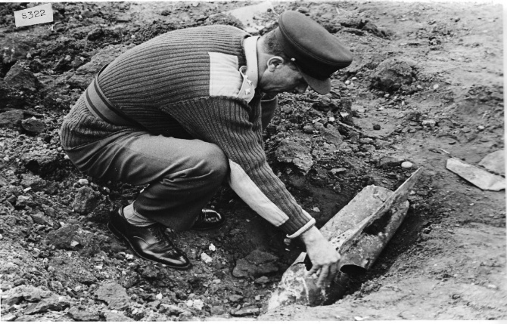
Captain T I Moore
Photo credit: Peter Markham’s Collection.

O’GRADY T F MBE MSN, Staff Sergeant, 33 Engineer Regiment (EOD), Royal Engineers

No further information available

ORGILL, Roy George MBE, (188351) Captain, 579 Bomb Disposal Squadron, Royal Engineers

The Citation is taken from file WO373/168/268 held at the National Archives.
Placed in the London Gazette on the 31st December 1960. Supplement 42231. Page 8895.

During his twenty-three years of loyal and devoted service to the Regular Army, Captain R.G. Orgill rose from boy apprentice to the rank of Major. He served with distinction throughout the Second World War and his regular service took him to India, Burma and the Middle East.

Since 1954, when he joined the Territorial Army, he has been the administrative officer of 579 (Cinque Ports) Bomb Disposal Squadron RE (TA) which appointment he continues to fill with exceptional zeal and enthusiasm. As the only permanent officer in a small and highly specialised unit he has faced the many vicissitudes connected with the squadrons re-emergence as an all-volunteer force with outstanding loyalty and patience. His unusually wide knowledge and experience of the Corps, has provided the stability and his unfailing attendance the continuity on which the unit ultimately depends.

For reasons beyond the unit’s control, he has always carried more responsibility than is normally associated with his appointment and for long periods he has cheerfully and efficiently acted as unit second-in-command and MT officer in addition to his duties.

His unquenchable enthusiasm is an inspiration to all and his example deserves the highest recognition.

PANTON, Frances Harry MBE, Lieutenant, 1 Bomb Disposal Company, Royal Engineers

No Citation found at the National Archives. Placed in the London Gazette on the 30th December 1948. Supplement 38163. Page 47.

Taken directly from his London Gazette entry:

The King has been graciously pleased to give orders for the following appointments to the Most Excellent Order of the British Empire, in recognition of Mine Clearance and Bomb Disposal Services since the end of the War –
To be Additional Members of the Military Division of the said Most Excellent Order –
Lieutenant Frances Harry Panton (334223). Corps of Royal Engineers

PERKINS, Fred MBE, (176563) Lieutenant, 23 Bomb Disposal Company, Royal Engineers

The Citation is taken from file WO373/86/632 held at the National Archives.
Placed in the London Gazette on the 20th January 1946. Supplement 37442. Page 623.

This officer has shown great gallantry in disposing of Bombs and Mines during the N.W. Europe Campaign over a long period sine landing on 7th June ‘44. The total number of Bombs dealt with by him personally amounts to three hundred and ten. His example and disregard for danger inspired his men to work in extremely bad conditions, thereby keeping the Lines of Communications open. This total number of Bombs includes ten UXB’s which were recovered from under bridges on the Albert Canal, which he personally dealt with by diving.

His continued perseverance and leadership throughout the campaign, has been more than can be expected of a Bomb Disposal Officer.

Further Information
His citation records he was originally recommended for the British Empire Medal.

PICKARD, Robert James MBE, (346941 Lieutenant, 11 Bomb Disposal Company (POW), Royal Engineers

The Citation is taken from file WO373/157/627 held at the National Archives.
Placed in the London Gazette on the 6th June 1947. Supplement 37977. Page 2580.

Lieut. Pickard has shown outstanding courage and determination whist in charge of minefield clearance at Rattray Head, Aberdeenshire, since October 1945. Despite fatal accidents on the field, he has persevered in an unpleasant task. His task has been complicated by the great depth of the mines and extreme weather conditions.

His disregards for his own safety have been a splendid example to all ranks.

POLSON, Andrew Gordon MBE, (152369) Temporary Captain, Bomb Disposal Technical Staff Officer, Headquarters 21 Army Group, Royal Engineers

The Citation is taken from file WO373/86/642 held at the National Archives.
Posted in the London Gazette on the 22nd January 1946. Supplement 37442. Page 624.

Captain Polson has been Technical Staff Officer for Bomb Disposal at the HQ throughout the whole campaign. His previous training and experience fit him to be considered the most competent expert we have on all forms of enemy fuzes and devices and means of countering them. His outstanding qualities as an individual have led him throughout to exert a far greater influence than could be expected from his staff appointment, for with complete disregard for his own safety he has repeatedly brought his own technical skill into direct contact with the most dangerous and unknown forms of enemy devices, at the first possible moment, whether in forward areas, as in the case of enemy floating mines at Nijmegen or in Antwerp dealing with unexploded V missiles. His unceasing search for first-hand knowledge also led him personally to discover and disarm delayed action mechanisms, placed by enemy saboteurs, in large underground bomb stores at Xanten, just in time to save large explosions and loss of life.

Throughout the whole period, Capt. Polson, by his disregard of his own safety, and by his display of the highest qualities of an officer has built up a liaison with Technical Officers of the other Services and our Allies, which could not otherwise have existed.

POWELL, Ivor MBE, (152382) Major, 7 Bomb Disposal Company, Royal Engineers

The Citation is taken from file WO373/157/512 held at the National Archives.
Posted in the London Gazette on the 31st December 1946. Supplement 37835. Page 9.

For services in connection with the removal of beach mines in the United Kingdom

I March 1945 Major Powell was appointed to command a special unit; and entrusted with the task of evolving a new technique for employing high pressure water jets to wash away accretions of shingle or sand that had covered beach minefields to a depth beyond the range of mine-detectors and which for political and public reasons, it was most desirable should be cleared.

Resulting from Major Powell’s investigation of the problem, pumping equipment and ancillary gear was delivered to Major Powell’s unit and then made up into suitable sets and issued to Bomb Disposal Coy’s. Certain parts of the equipment had to be covered by armour plate to protect the operator against mines exploded by the impact of the jet.

Major Powell was responsible for drawing up and issuing instructional pamphlets on the theory and practice of jetting and for organising and running courses of instruction to selected officers and N.C. Os, on the subject.

The maintenance of plant and provision of spares was another undertaking successfully carried out by Major Powell.

The introduction of water jetting and the technique evolved for its use has undoubtedly solves the problem of how to clear buried minefields a problem which otherwise could only have been tackled at the cost of many valuable lives and to the great risk run by those engaged on clearing operations.

Minefields can now be cleared which were at one time considered to be too dangerous to clear, and which, in consequence, would have had to remain closed to the public, and be an over present source of danger.

Towards the endo of 1945 Maj. Powell carried out operational jetting on South Coast minefields to test out and develop the technique he had evolved, and it was proved that the method was speedy, effective and safe.

Since the beginning of March 1946, Major Powell has commanded No 7 B.D. Coy. RE. where he has been able to put his valuable knowledge and experience into effective operations on mine fields on the Cornish Coast.

POWELL, S MBE, Sergeant, 58 Field Squadron (EOD), 33 Engineer Regiment (EOD), Royal Engineers

No Citation found in the National Archives Catalogue.
No London Gazette entry found.

Confirmed award for services on Operation Herrick 10 Afghanistan.

QUALTROUGH, Henry Percival GM MBE, (304206) Major, Bomb Disposal Unit (UK), Royal Engineers

The Recommendation is taken from file WO373/123/9 held at the National Archives.
Placed in the London Gazette on the 20th September 1960. Supplement 42148. Page 6417.

Member of the British Empire.
Staff Officer to Commander, Royal Engineers
Headquarters Land Forces, Hong Kong.

On 19th October 1959, 20th January 1960 and 30th March 1960 three unexploded bombs, of approximately 500 to 600 lbs weight, were found in Kowloon and successfully disposed of by a bomb disposal squad working under the direction of Major Qualtrough.

The first was found on a building site. As the impact nose fuze was distorted and could not be removed, the fused bomb was driven in a truck to the docks, embarked in a landing craft and carefully dumped at sea under Major Qualtrough’s personal control.

The second was picked up in Hong Kong Harbour by a dredger. When brought ashore it was found to have, in addition to the impact nose fuze, a tail fuze which had the appearance of a chemical delay type; Major Qualtrough therefore removed this fuze by remote means.

The third was found on a building site and Major Qualtrough personally supervised the removal of the nose and tail fuze. In this instance, also, the tail fuze could not be positively identified before removal.

The bombs were identified as being of American type, dropped in 1944 or 1945. They did not however conform exactly to the data to the data available in instructional manuals, and the presence of Chinese markings on one fuze indicated the possibility of unrecorded variations in design. The age of the bombs, therefore, and the lack of reliable information intensified the element of hazard always present in this type of operation.

Throughout the work Major Qualtrough took personal charge at all stages involving danger. By his confident handling of each incident, and by his disregard for his own safety, he set an example which gave immense encouragement to the less experienced British and Chinese members of the squad, as well as to the Hong Kong Police officers and constables cordoning the area. His concern was always that his men should as far as possible, add to their own knowledge by doing the work themselves, and they should get praise for it. His actions reflected great credit on himself and were in keeping with the best traditions of his Corps

RADFORD, R I GM MBE, (373137) Major, 71 Bomb Disposal Squadron (EOD), 33 Engineer Regiment (EOD), Royal Engineers

The Recommendation is taken from file WO373/175/182 held at the National Archives.
Placed in the London Gazette on the 31 December 1944. Supplement 46444. Page 7.

Major Radford has commanded 71 EOD Squadron since it was established in 1972 to clear the Maplin Sands of missiles and fragments in preparation for construction of the Third London Airport. This area has been used as a rang for about 150 years, and among the 1,350 tons of debris already excavated many items have been potentially dangerous.
Major Radford was personally responsible for the high degree of confidence which the main Maplin Development Authority felt able to attach to the level of clearance being achieved and the promise of safe operations during subsequent phases of the project and eventual safe of the airport/seaport. This was made possible by the high standards he always exacted, which also ensured that the clearance task was accident-free.
Apart from the element of danger, the whole clearance programme was carried out under most unpleasant working conditions. Nevertheless, Major Radford managed to weld his mixed military/civilian personnel into a very hard-working unit with exceptionally high morale. This was only achieved by commendable devotion to his men, coupled with intensive effort well outside the normal calls of duty.
Much of the work was new. The technical details of some of the older ordnance which was excavated presented fresh problems which he approached with the correct balance of zest and caution. The same may be said for his efforts in the field of civilian labour relations, where without previous experience in such matters he gained the goodwill of all.
Had the clearance work continued Major Radford would probably have completed his military appointment in this appointment. As it is, he approaches the end of thirty years faithful and devoted service, in the Army with the disappointing task of dispersing his workforce. Even the problems of seeking re-employment for his redundant civilian employees he has tackled with the same diligence and infectious enthusiasm which has characterised the rest of his work, and which had made clearance the success it undoubtably was.
Further Information
Work stopped on the clearance in 1974 as the Government decided not to build the airport. The civilian workers were mostly employed in the Regiments Civilian Explosive Ordnance Clearance Team.

RAKE, Peter Edward Tudor MBE, (161576) Lieutenant, Bomb Disposal, Royal Engineers

The Citation is taken from file WO373/69/927 held at the National Archives.
Placed in the London Gazette on the 18th June 1946. Supplement 37613. Page 3057.

This officer has rendered services of exceptional merit in the disposal of unexploded bombs in the United Kingdom. IN April and during the following three-month 1944, he was intensively engaged on the disposal of unexploded enemy bombs resulting from scattered enemy raiding in the Bristol area prior to the invasion of the continent. During this period, he personally disposed of 38 large and medium sized bombs, some of them under exceptionally difficult and dangerous conditions. Throughout this work he displayed a cheerful acceptance of personal risk which set an outstanding example to his men. In the London Area during the period January to July 1942, he was actively and directly engaged in the disposal of more than 100 bombs, the fuzes of which were immunised by him personally. Bombs dealt with by Captain Rake included many which were not only in a highly sensitive condition, but for which methods and suitable equipment had not then been developed. Six of the bombs successfully disposed of by this officer contained a combination of long delay and anti-handling fuzes. He also uncovered the fourth “G/Mine to be dropped in the country and excavated to a depth of twenty feet for a damaged parachute mine which was eventually dealt with by a Naval Officer.

During the whole of his service in Bomb Disposal his courage, resource and devotion to duty, his powers of leadership and his ready acceptance of personal risk in the performance of dangerous work have set an outstanding example.

REES, MBE, Warrant Officer Class 11, 33 Engineer Regiment (EOD), Royal Engineers

No Citation found in the National Archives Catalogues.
No London Gazette entry found.

We believe this was awarded for work in the Training Wing.

REUBY, R MBE, Warrant Officer Class II, 101 (London) Engineer Regiment (EOD) (V), Royal Engineers

No Citation found in the National Archives Catalogues.
Placed in the London Gazette January 1994.

No further information available.

RICHARDS, Frederick Henry MBE, (146084) Lieutenant, 1 Bomb Disposal Company, Royal Engineers

The Citation is taken from file WO373/157/514 held at the National Archives.
Placed in the London Gazette on the 31 December 1946. Supplement 37853. Page 9.

This Officer has been employed on Bomb Disposal operations in Hull since 1943, and has executed his difficult and dangerous tasks with painstaking care and efficiency. Since the end of the war, he has been successfully engaged in removing abandoned bombs from the Hull area. In particular, might be mentioned the disposal of a German 100 kg at Hawthorne Avenue, Hull on the 7 June 46, and 250 kg at Princess Walk, Craven St, Hull on 14th July 1946. Both these bombs were dropped in 1941 and were abandoned as unobtainable.
The recovery of these required from Lt. Richards a high degree of skill and resourcefulness entailing excavation in silt with Stell Piling, and culminating in the successful making safe and removal of fuzes, and the bombs.

ROBERTS, D M MBE, Sergeant, 33 Engineer Regiment (EOD), Royal Engineers

No Citation found in the National Archives Catalogues.
Placed in the London Gazette 30 January 2007. Supplement 58196. Page 5.

For services through the 7/7 bombing in 2005.

SANDERSON, Peter A MBE, (24098220) Warrant Officer Class II, 33 Engineer Regiment (EOD), Royal Engineers

No Citation found in the National Archives Catalogues.
Placed in the London Gazette 30 December 1992. Supplement 53153. Page 6.

For services to Explosive Ordnance Disposal (EOD).

SANGER, A J MBE, Captain, 101 (London) Engineer Regiment (EOD) (V), Royal Engineers

No Citation found in the National Archives Catalogues.
Placed in the London Gazette January 2013.

For services with the Regiment.

SEAWARD, Brian Annesley MBE, (295564) Lieutenant, 1 Bomb Disposal Company (Prisoner of War), Royal Engineers

The Citation is taken from file WO373/157/633. Held at the National Archives.
Placed in the London Gazette on the 12th June 1947. Supplement 37977. Page 2580.

This officer was engaged on minefield clearance from early 1944 to 1946 over an area stretching from Alnwick to Scarborough, during which time he worked on over fifty different minefields and has shown great devotion to duty and courage. During the period of January 1945 to February 1947, he was in charge of minefield clearance and bomb disposal operations in the Redcar area and by his personal courage, technical skill and inspired leadership has effected clearance of extremely difficult beach mine fields containing anti-personnel mines )on which lives had been previously lost in attempted clearance) without sustaining loss of life or injury to the men under command, and has successfully completed bomb disposal operations of a difficult nature.

Further Information
At the top of this citation, it reads in block capitals and heavily underlined THIRD RECOMMENDATION

SHARP, Robert MBE, (162270) Lieutenant, Bomb Disposal, Royal Engineers

No Citation found at the National Archives.
Placed in the London Gazette on the 30th December 1948. Supplement 38163. Page 47.

Taken directly from his London Gazette entry;

The King has been graciously pleased to give orders for the following appointments to the Most Excellent Order of the British Empire, in recognition of Mine Clearance and Bomb Disposal Services since the end of the War –
To be Additional Members of the Military Division of the said Most Excellent Order –
Lieutenant Robert Sharp (162270). Corps of Royal Engineers

SHORTER, R A MBE, (152385) Temporary Major, Bomb Disposal, Royal Engineers

No Citation found at the National Archives.
Placed in the London Gazette on the 4 June 1948. Supplement 38163.

For Services to Bomb Disposal 1945 to 1947.

SHAWYER, A E S MBE, (255583) Temporary Captain, Bomb Disposal, Royal Engineers

No Citation found at the National Archives.
Placed in the London Gazette on the 28 December 1949. Supplement 38163.

For Services to Bomb Disposal Post War.

SHIELDS, P MBE, Captain, 33 Engineer Regiment (EOD), Royal Engineers.

No Citation found in the National Archives Catalogue.
No London Gazette entry found.

No further information found.

SHRIMPTON, Charles Leonard MBE, (312216) Lieutenant, Bomb Disposal, Royal Engineers

No Citation found in the National Archives Catalogue.
Placed in the London Gazette on the 28 December 1945. Supplement 37407. Page 30.

Lieutenant Shrimpton was engaged in minefield clearance of anti-invasion mines, when he died on the 17 September 1945. Seeing as his Gazette entry is for December 1945 it is understood his MBE was for this work.
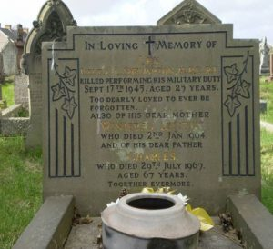 | Further Information  Lieutenant Shrimpton died on the 17 September clearing beaches of anti-invasion mines in Norfolk.  He is buried at Saint Mary Church Cemetery, Aberavon, Row 7, Grave 10.  Photo credit: Bev Lewis.

SHUTER, J A MBE, Captain, EOD Unit, Royal Engineers

The Citation is taken from file WO373/174/486 held at the National Archives.
Placed in the London Gazette on the 29 December 1972. Supplement 45860. Page 6.

Captain Shuter has been Quartermaster and Support Troop Commander of the EOD Unit RE since 15 April 1969. As Quartermaster Captain Shuter has been responsible for the maintenance and readiness of all EOD equipment, as Support Troop Commander he has exercised control over all Unit transport, plant and supporting operators training. He has in addition been responsible for the administration of all civil labour.

In the discharge of this wide range of responsibilities Capt Shuter has displayed an exceptional sense of duty and has been an outstanding example to others. He sets very high standards in everything he undertakes and encourages all those under him to achieve the same high performance as himself. Those civilians working under him are invariably willing to help in every possible way during EOD operations whatever the danger. This attitude stems very much from the example and standard of leadership set by Captain Shuter.

Capt Shuter also regards it as a personnel challenge that his men, vehicles and plant are always ready to support normal and emergency operations throughout the United Kingdom. In any emergency operation Capt Shuter personally ensures that the supporting element of the unit emergency team is promptly and efficiently turned out. Whenever possible Capt Shuter accompanies the emergency team himself to see that the bomb disposal officer in charge of the operation is afforded immediate support when required. He was present in this role at Kentish Town, London on 1 October 1969 when his Squadron Commander and Squadron Sergeant Major were both awarded the George Medal for disposing of a particularly dangerous German parachute mine. In September 1971 he aided another officer in the disposal of a 50 kg bomb in Sheffield. Also, 4/5 July 1972 near Grantham he played a personal part in helping to dispose of a very large 1000 kg German Herman bomb containing 1300 lb of high explosive. In all these operations Capt Shuter was exposed to considerable danger and especially when helping to steam the explosive main charge from the Herman Bomb.

As Quartermaster Capt Shuter has continued to show and display those qualities which earlier in his service he displayed as a very good Regimental Sergeant Major. Despite some recent illness Capt Shuter during his period with the EOD Unit has been an inspiration and example to others in performing his normal duties and in the outstanding
Support he has given EOD operations by the Royal Engineers.
Further Information
Major Fletcher and WO2 Hambrook were those awarded the George Medal for the incident on the 1 October 1969 at Camden, London.

SMITH, A E MBE, (114180) Temporary Major, 2 Bomb Disposal Company (Prisoner of War), Royal Engineers

No Citation found at the National Archives.
Placed in the London Gazette on the 28 December 1945. Supplement 37407. Page 30.

No other information available, possibly Beach mine clearance in the United Kingdom, found mentioned in the History of the Corps of Royal Engineers Volume X Page 364.

Smith, F C, Major, Bomb Disposal, Royal Engineers

No Citation found in the National Archives Catalogue.
Not found in the London Gazette.

Further Information.
Mentioned under awards to Bomb Disposal History of the Corps of Royal Engineers, Volume X Page 364.

TAVENER, W A MBE, Lieutenant, 9 Bomb Disposal Company, Royal Engineers

No Citation found at the National Archives.
Placed in the London Gazette on the 28 December 1945. Supplement 37407. Page 31.

No further information

THOMPSON, K MBE, Corporal, 33 Engineer Regiment (EOD), Royal Engineers.

No citation found in the National Archives Catalogue.
Placed in the London Gazette in January 2012.

Information taken from the Royal Engineers Association Bomb Disposal Branch Bulletin January 2012.

Corporal K Thompson at the time of his award had spent 10 years with the Corps, eight being in EOD. He had served in Northern Ireland, Iraq and Afghanistan. His tour in Afghanistan saw him leading a team specialised in searching for IED’s.

His award of the MBE came in the New Years Honours list, modestly he said “I think the lads in the team below me deserve recognition”

TOUHEY, B P MBE, Captain, PSAO 221 Headquarters and Support Squadron (V), 101 (London) Engineer Regiment (EOD) (V), Royal Engineers

No Citation found at the National Archives.
Placed in the London Gazette on the 30 December 2004. Supplement 57509. Page 6.

Captain B Touhey RE is Permanent Staff Administration Officer of 221 Field Squadron (EOD) (V) and between February 2003 and February 2004 he was the Unit Welfare Officer, following the mobilisation of over 80 members of 101 Engineer Regiment (EOD) (V) in support of Op TELIC. This is a post that the Regiment is not established for and which he has done as a volunteer in addition to his job.

Captain Touhey is a remarkable individual who is loyal, unselfish and whose endless motivation has made him indispensable to the Regiment during the past year. Fallowing the initial phase of mobilisation, families and individuals mobilised required support in the form of information, counselling, financial aid and friendship. This in itself proved to be a problem as, the families were dispersed from Bournemouth to Dover and even Italy. For most, the mobilisation was unexpected and for a high majority, it was their first experience of separation Captain Touhey immediately dealt with this; in particular he produced an informative welfare magazine which was later adopted as a template for other units. He gained the families confidence by phoning, visiting and organising events such as family days and BBQs, he also ensured they felt at ease to contact him at any time. This proved to be a great comfort especially during the first phase of Operation Telic when he was contacted constantly at unsociable hours during the night and day, he dealt with each case individually showing professionalism, tact and discretion.

For the personnel mobilised, Captain Touhey has attended every mobilisation from the regiment and has been at as many demobilisations as possible despite extreme short notice and great inconvenience to his own personnel life. He has also taken on some of the problems of soldiers from other regiments providing advice with the same wholehearted dedication. He has gained the trust and greatest respect from the soldiers and had made their transition in and out of mobilised service as stress free as possible by dispelling their anxieties and providing guidance and calm.

Captain Touhey has displayed a phenomenal performance over a sustained amount of time and in effect has been on duty 24 hours, 7 days a week for the last year. He has done this whilst doing an admirable full-time job, playing and umpiring squash and Hockey for the Corp and taking on the role as chairman for a local squash club. In addition, he has organised a ball for the Par Har Trust for Nepalese children, ran in the London Marathon and raised enough money to buy 2 chemotherapy treatment beds at Maidstone Hospital. If this was not enough of a demand on his time, he has also helped as a supervisor on outings for a nearby secondary school and does voluntary work for young autistic adults at a local special needs home by teaching social skills during trips.

His enthusiasm and dedication, is exceptional, he has shown a selfless commitment to the families within the regiment and the local community and has continually acted above and beyond what is expected. He has provided first class support to the families, soldiers and the chain of command during what has been, an extraordinary difficult time, and he very strongly merits nation recognition.

Further Information
Mrs Maria Plumridge was awarded the General Officer Commanding London District, Certificate of Commendation for Welfare Support during the Regiments mobilisation.

VAUGHAN, T D MBE, Major, 49 EOD Squadron, 33 Engineer Regiment (EOD), Royal Engineers.

No Citation found at the National Archives.
Placed in the London Gazette on the 31 December 1999. Supplement 55710. Page 7.

Whilst Officer Commanding dealt with a chemical task next to Porton Down.

VENN, D C T MBE, Captain, 4 Bomb Disposal Company, Royal Engineers.

No Citation found at the National Archives.
Placed in the London Gazette on the 28 December 1945. Supplement 37407. Page 31.

No further information, possible Beach Mine Clearance.

WADDINGTON, J MBE, Major, 58 EOD Squadron, 33 Engineer Regiment (EOD), Royal Engineers

The Citation is taken from file WO373/181/202 held at the National Archives.
Placed in the London Gazette on the 30th December 1988. Supplement 51578. Page 6.

Major Waddington joined 33 Engineer Regiment (EOD) in January 1986 with no prior knowledge of Bomb Disposal work. After training he was immediately placed in command of the recently established 58 EOD Squadron which was developing new and demanding operational roles.

The first role was to deal with the clearance of pipe mines left behind after the war under airfields in the South East, most of which are no longer MOD property. These large mines contain a nitro-glycerine-based explosive and are extremely dangerous. Proper command and control are essential, as is the requirement not to unnecessarily alarm the local population. Major Waddington approached the task with true professionalism developing sound plans, a tactful approach and an assured manner. During his time, he has cleared 6 airfields completely and 6 partially. This has involved locating and dealing with 55 live pipe mines.

The second task facing Major Waddington was that of High-Risk Search support to British and other police forces, a task which came to the fore with the Brighton Bomb. His Squadron is unique in the equipment and training it receives to detect terrorist bombs and they are frequently deployed to search vulnerable areas which are to be visited by VIP’s who are under threat of terrorist attack. He has planned and executed 28 such tasks over the past 3 years, all with maximum efficiency and minimum fuss or public awareness. Key examples of his work are: the Conservative Party Conference to protect the Prime Minister and the Cabinet, Gleneagles to protect the Nuclear Planning Group, and Berlin to protect Her Majesty the Queen during her attendance at her Birthday Parade in June 1987. The technique and equipment used were for such searches have to be constantly modified and updated. He has worked unceasingly to ensure only the best support is available and in doing so has won the respect and admiration of Chief Constables everywhere.

The third major operational task he has had to train for is classified and counter-terrorist in nature. It employs his Squadron for at least eight weeks training a year. The likely success of the countermeasures should they ever be used, would in a large part result from the application, inventiveness and professional skill shown by Major Waddington in preparing his Squadron. There operational tasks have been undertaken over and above his normal EOD Squadron commander responsibilities and training for his Squadrons war role in BAOR. Over 60% of his time is spent on peacetime operations and he himself has been on 3 hours’ notice to move for them throughout his whole time in command. Because of the rapidly escalating threats and the progress needed to counter them it was felt that he could not be effectively replaced at the end of his normal 2-year tour and despite the severe strain on his family he was asked to continue for a further year

Major Waddington’s Squadron has played a major part in ensuring the safety of very many VIP’s and other citizens and is constantly prepared to counter the most devastating possible terrorist threats. Throughout he has not stinted himself, working long hard hours and carrying enormous responsibility on his own shoulders and in most instances with the additional strain of not knowing if he and his men had done everything needed to defeat the terrorist.

Major Waddington has shown exceptional dedication to this dangerous, difficult and extremely demanding appointment and fully deserves recognition.

WARD, G E, Major, 33 Engineer Regiment (EOD), Royal Engineers

The Citation is taken from file WO373/181/487 held at the National Archives.
Placed in the London Gazette on the 30th December 1989. Supplement 51981. Page 6.

Major Ward was sent on an Explosive Ordnance Disposal (EOD) course in September 1982 having had no previous experience of Bomb Disposal. After successfully completing the course, he was posted as Officer Commanding 49 EOD Squadron in January 1983. He had two months to settle into his job before being sent on an emergency operational tour to the Falkland Islands in April 1983. He commanded the detachment of 30 men on Port Stanley responsible for all unexploding ordnance, bombs and mines left over from the conflict and he also acted as the EOD Staff Officer to Commander BFFI. He quickly won the respect of both military and civilians in the Falkland Islands, not only for his calm assured manner and excellent PR broadcasts but also for personally disposing of a number of mines and booby traps which were discovered outside previously fenced areas.

In July 1983 he was conducting a reconnaissance of the perimeter of a minefield in the Port Stanley area. This was a necessary precaution to identify any movement of the mines and to ensure the integrity of the minefield fence. Unfortunately, he stood on a P48 anti-personnel mine which had been washed out of the minefield and covered with a layer of sand. The injury required amputation of the lower half of his right leg and he had to be evacuated back to the UK.

There was a period of extreme trauma for Major Ward and it was greatly to his credit that he overcame his operation and quickly adapted to the use of his artificial leg. This enabled him to resume command of his Squadron in September 1983. The enthusiasm and vigour with which he pursued his duties until the end of his tour in January 1985 was a great inspiration to all with whom he came into contact.

After a successful operational tour in Northern Ireland, he re-joined Bomb Disposal as Second in Command of the Regiment in March 1987. His duties have included all those of 2IC of a very heavily committed operational unit, but he has also taken his place on the roster of Senior EOD Commander on standby for operations. In this capacity he has ably commanded a number of EOD tasks, including a high profile rendering safe of a World War 2 bomb in Billingsgate in November 1988, during which over 400 people were evacuated and the Police, Local Authorities and the Media required very careful handling by him over some 32 Hours. In addition, he steered the split of 33 Engineer Regiment (EOD) into two parts to form also a new TA EOD Regiment. This required a great deal of extra work and dedication, involving the rewriting of regimental establishments for men, vehicles, weapons and radios.

Over and above all his very heavy duties Major Ward manages to devote much of his time to counselling and supporting others who have undergone traumatic amputation. His ceaseless good humour and iron resolve in face of all difficulties has proved to be an inspiration not only to other amputees, but also to all the Bomb Disposal community. His personal resilience and exceptional service to Bomb Disposal over many years, together with his devotion to the rehabilitation of others, is fully deserving of recognition.

WARR, A R MBE, Captain, 33 Engineer Regiment (EOD), Royal Engineers

The Citation is taken from file WO373/175/499 held at the National Archives.
Placed in the London Gazette on the 16th June 1975. Supplement 46593. Page 7375.

Since June 1971 Captain Warr has commanded a Bomb Disposal Troop at Felixstowe. During this time, he has regularly been Duty Bomb Disposal Officer, having complete responsibility for all emergency calls throughout the country were suspect arial bombs, mines or missiles have been found. Many of these calls of course are false alarms, but Captain Warr has personally had to dispose of 9 bombs, 24 mines and 67 missiles, all of which were presenting a hazard to persons or property and which presented a danger to the officer while rendering them safe or removing them. On all such occasions Captain Warr has displayed a high level of technical confidence and bravery. He is modest and calm under pressure, but brings a cheerfulness and enthusiasm to bear no matter how adverse the conditions.

The second half of Captain Warr’s work has been the routine clearance of ranges and other military property for safe return to civilian use. Part of his work force has been dispersed throughout the country, but one section consisting of Ukrainians captured after the war and unable to return to their homeland, is based at Felixstowe. Captain Warr has made tremendous effort to bring some happiness to this community, which is isolated from families and friends, having little hope of ever seeing them again. His selfless dedication to their welfare is worthy of high commendation.

Captain Warr is due to leave the army during 1975, having served for 30 years. He has been notably conscientious and loyal throughout that period, and has now culminated his service with a long period in Bomb Disposal, distinguished not only by success and bravery in the bomb disposal of bombs and missiles, but also by his contribution to the lives of a group of people less fortunate than most.

WATKINSON, J P MBE, Captain, 33 Engineer Regiment (EOD), Royal Engineers

No Citation found at the National Archives.
Placed in the London Gazette on the 12 June 1992. Supplement 52952. Page 6.
Services in the Gulf.

WEBSTER, Robert Leslie MBE, (168956) Lieutenant, 16 and 21 Bomb Disposal Companies, Royal Engineers
The Citation is taken from file WO373/69/928 held at the National Archives.
Placed in the London Gazette on the 18th June 1946. Supplement 37613. Page 3057.

Lieutenant Webster has rendered services of exceptional merit in the disposal of unexploded enemy bombs in the United Kingdom. From September 1944 to the present date, he has been actively engaged without interruption as officer in charge of a Bomb Disposal platoon employed on the recovery of old enemy bombs in several counties which had been earlier abandoned owing to the extreme difficulty of access. During this period, he has recovered and dealt with 15 bombs which he had defeated earlier efforts. Gaining safe access to these bombs in unstable and treacherous ground at depths varying from 15 to 40 feet called for great skill and care. The bombs were finally immunised by Lieutenant Webster personally an operation involving risk of explosion.

This officer first entered a Bomb Disposal unit in January 1941, and during the subsequent period of heavy bombing raids was personally responsible for the disposal of more than 200 bombs in the London Area at a time when urgency often demanded continuous work day and night even when raids were actually in progress. He has also disposed of several new types of bombs, the functioning and details of which were then unknown. In the first week of March 1943, he disposed of twenty Butterfly bombs. These bombs were fuzed to explode on the slightest movement. In June 1944 this officer was employed as a specialist in X-Ray photography of bombs in different parts of the country where unusual features of booby traps were suspected.

During the whole of his services in connection with Bomb Disposal, Lieutenant Webster’s cheerful and unhesitating acceptance of great personal risk and his outstanding devotion to duty have been of the highest order.

WILLIAMS, Ronald Ian MBE, (185544) Temporary Captain, Bomb Disposal, Royal Engineers.

The Citation is taken from file WO373/69/926 held at the National Archives.
Placed in the London Gazette on the 18th June 1946. Supplement 37613. Page 3057.

Captain Williams has rendered services of exceptional merit in the clearance of defensive minefields in the United Kingdom and the disposal of unexploded bombs. In June 1944, he cleared a minefield near Grimsby containing anti-personnel mines which had been subjected to enemy attack in the form of Butterfly bombs. Although the presence of unexploded Butterfly bombs greatly added to the already considerable risk of clearance, this officer succeeded by his organisation, leadership and personal example in clearing the fields without casualties. He was subsequently engaged on the clearance of minefields at various other places and was in all responsible for the successful clearance.

WHITTY, G J MBE, Major, 49 EOD Squadron, Royal Engineers.

The Citation is taken from file WO373/181/63 held at the National Archives.
Placed in the London Gazette on the 11th June 1988. Supplement 5I365. Page B6.

During the period covered by this citation, Major Whitty has been employed as Officer Commanding 49 (EOD) Sqn RE on Operation Apple. This operation concerned the excavation and removal of chemical munitions, some of which contained the lethal agent phosgene, from a site at the former A D Bramley. Many of these munitions were still fused, presenting a problem and hazard never previously encountered in the United Kingdom. All were in a poor and corroded condition, rendering them yet more dangerous and making identification almost impossible.

From the initial discovery of the munitions, Maj Whitty played a leading part in planning and implementing the strategy for their safe disposal. He rapidly evolved and refined techniques to minimise the very significant hazards involved, both to the civilian population and to his own troops. The professionalism and flexibility he displayed in doing this were outstanding and considerably reduced both the danger and the disruption to local inhabitants.

Once the operation began, Maj Whitty led his Squadron outstandingly well. His meticulous planning bore fruit and in dealing with the inevitable changes forced by the reactive nature of the situation, he proved more than capable of rising to any challenges. Working long hours, he also led his sections on site with great professionalism, that leadership maintaining rapid and safe progress in appallingly difficult conditions.

His obvious competence, rapport, common sense and good humour inspired confidence in the many other agencies involved. He rapidly ensured consensus, cooperation and support from local authorities, police and other government agencies. Without his contribution, the massive difficulties inherent in planning and mounting a joint operation of this nature would have taken far longer to surmount, thereby increasing the possibility of a serious accident. In daily liaison with the police and local authorities he took the lead and ensured the efficient coordination of technical operational aspects.

Maj Whitty demonstrated outstanding dedication, flexibility and leadership in a difficult hazardous and quite unique situation. Over 400 munitions, of which over 150 were fuzed, were removed in this highly successful operation. Maj Whitty’s contribution to this success was quite critical and is considered highly worthy of official recognition.

Further Information
Sapper P S McDougall, Corporal K R Murphy, Sergeant D G Percy, Corporal P W Syme and Staff Sergeant D J Taylor were recognised for their part in this operation, by General Officer Commanding Commendations.

Images from Op TELIC
Photos taken by Rey Fadil.

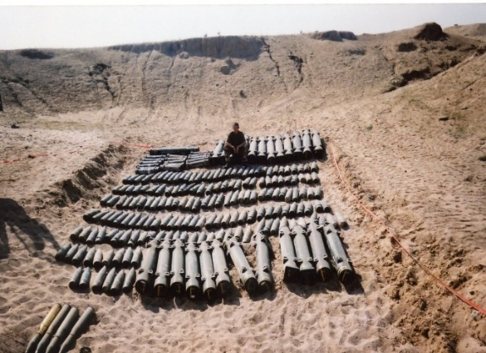 | 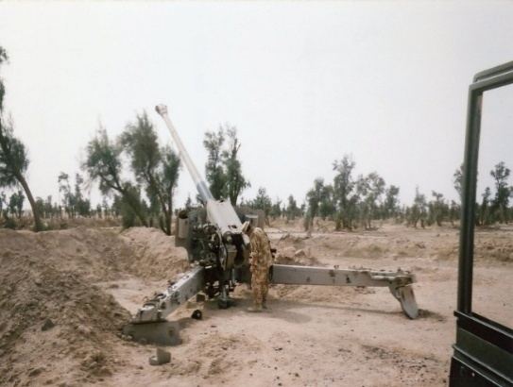
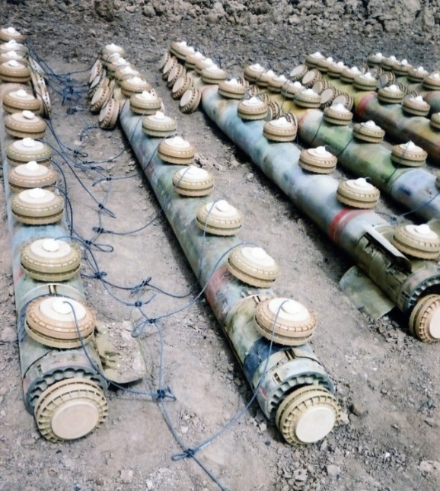 | Top Left: Demolition Pit.  Top Right: Iraq Artillery piece, it was about to have the barrel spiked.  Middle: Demolition of rockets (RCL and RE Task).  Bottom Left: Mines indiscriminately scattered. Shows the desperation and panic - as well as looting as the Iraq Forces retreated.  Bottom Right: Anti-Aircraft weaponry hidden in an ISO Container.
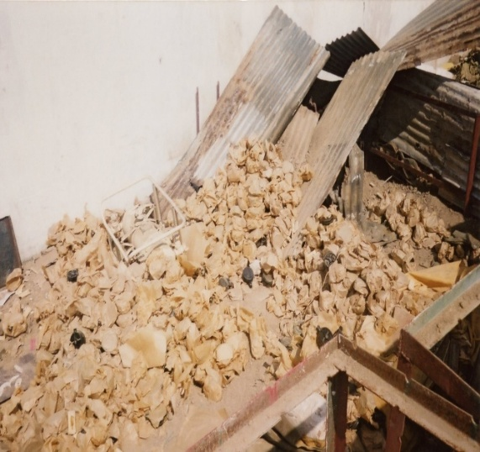 | 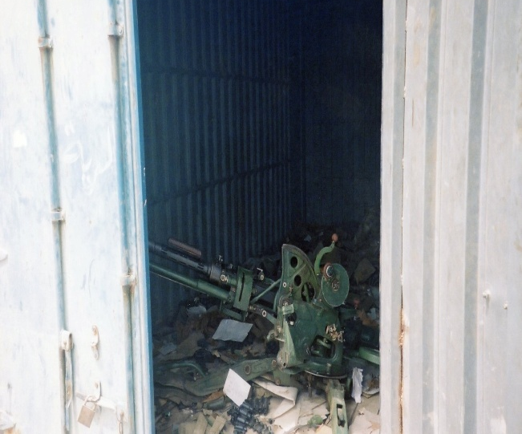

WRIGHT, S M MBE, Captain, 29 EOD and Search Group, Royal Engineers.

No Citation found at the National Archives Catalogue.
Placed in the London Gazette on the 31 December 2013. Supplement 50361. Page 6.
For work on Operation Olympics.

WYATT, J R MBE, Major, 58 EOD Squadron, 33 Engineer Regiment (EOD), Royal Engineers.

The Citation is taken from file WO373/180/69 held at the National Archives.
Placed in the London Gazette on the 30th December 1985. Supplement 50361. Page 6.

Major Wyatt is the first officer commanding of the newly raised 58 EOD Squadron. As such he has been responsible for forming up the squadron, which has yet to be officially established; the squadron has suffered through this period from a shortage of management posts, accommodation and equipment. Despite these serious shortfalls the squadron has, since its formation, been heavily tasked with operations, many of the sensitive in nature. It is much to Major Wyatt’s credit that the squadron became operational so rapidly and has performed its very varied task so efficiently.

One of the added responsibilities which has fallen to 58 EOD Squadron is that of conducting specialist RE Search Operations in Great Britain. The Royal Engineers have for some years provided a search capability in Northern Ireland, to locate terrorist arms caches or explosive devices, but in recent months, it has become necessary to provide military search support for the Police in Great Britain. Although similar in principle to Search Operations in Northern Ireland there are significant differences in the approach to such operations in Great Britain. Special sophisticated electronic Detection equipment has been introduced and Major Wyatt has been directly responsible for the development of techniques and procedures for the employment of this equipment.
The Regiment was first employed in this role for the entry to the Libyan People’s Bureau after the siege, but following the Brighton Bomb, the number of requests for search assistance from the police has increased considerably. Following such requests Major Wyatt has conducted a number of reconnaissance’s and advised the Police on the setting up of a search plan.

Successful deployments of search teams from 58 EOD Squadron have included the Economic Summit meeting at Lancaster House, Wellington Barracks for Remembrance Weekend the Young Conservatives Conference at Bournemouth, the Conservative Council Meeting at Newcastle and the Scottish Conservatives Conference at Perth. He is already planning for other conferences and the major party conference at Blackpool.

Major Wyatt has played the leading role in the development of military search assistance to the Police in Great Britain. Police Forces throughout the country have been most appreciative for the expert advice and assistance which he has given to them in planning operations in this new field. In much of this work, he has made the running and tactfully developed with Chief Constables a sound plan. Thereafter he has directed the specialist RE teams in support of the Police operations.

Major Wyatt’s work in raising and training 58 EOD Squadron and his major contribution to Security in Great Britain fully merit public recognition.

YOUNG, Norman Charles MBE, (287657) Lieutenant, 7 and 16 Bomb Disposal Company, Royal Engineers.

The Citation is taken from file WO373/69/998 held at the National Archives.
Placed in the London Gazette on 13th December 1946. Supplement 37815. Page 6063.

This officer has been continuously and actively engaged in the disposal of unexploded bombs in Plymouth and Southampton areas since June 1945. The incidents on which he has been employed have in all cases been those previously abandoned as impossible to recover. In all he has successfully reached and dealt with fifteen unexploded bombs of this category. His tenacity of purpose, determination and his personal disregard of danger and conduct under the most hazardous circumstances have been an example to all.

His most recent achievement was in the recovery of a 1000-Kg. Armour Piercing Bomb in Hannover Buildings, Bargate, Southampton. The bomb had been uncovered, and was found to be fitted with a fuze extension cap covering the fuze so that the fuze could not be identified. Under the circumstances it had to be regarded a
potentially dangerous. On the night of 21st/22nd August, 1945 a severe storm broke over Southampton, and at 01.00 hours on the 22nd August the night piquet at the excavation telephoned Company Headquarters and reported that the pumps had failed, the excavation was filling with water, and the timbering appeared to be in danger of collapsing. Lieutenant Young immediately proceeded to the excavation, in company with the Non – Commissioned Officer in charge of the work, and investigated the situation. He found that due to excessive rain liquid had begun to well up inside the excavation, and to cover the bomb. At first light, he and his Non – Commissioned descended into the excavation, a depth of forty-two feet, and regardless of the very great risk he ran due to the uncertain danger of the fuze, and the very real danger of the timbering collapsing and working up to his waist in the slimy mud was successful in shoring up the timber and strengthening the structure generally.

There is no doubt that the prompt action taken by Lieutenant Young and the Non-Commissioned Officer prevented the timbering from collapsing and so made the eventual recovery of the bomb possible.

Further Information
The Non-Commissioned Officer was Lance Sergeant William George Spicer awarded the British Empire Medal for his part in the incident.

Lieutenant Norman Charles Young later became Officer Commanding Bomb Disposal Troop

Queens Gallantry Medal

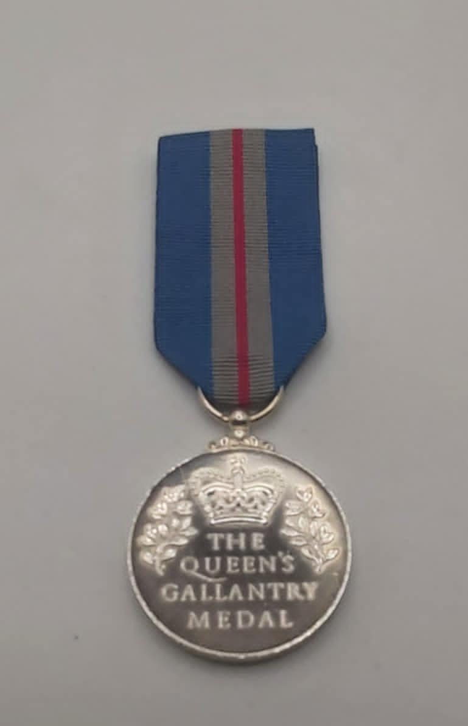
Photo credit: Julian Allerhead BEM.

The Queens Gallantry Medal (QGM) was Instituted on the 20June, 1974, and is awarded to civilians for acts of exemplary bravery at a level below that of the George Medal. The QGM is also awarded to military personnel for acts which military honours would not be normally granted such as acts of exemplary bravery not in the presence of the enemy.
It was Instituted to replace the Order of the British Empire for Gallantry.
The Royal Engineers Bomb Disposal teams were awarded 21 Queens Gallantry, during the Post War period

CRAIB, J A QGM, Major, 33 Engineer Regiment (EOD), Royal Engineers

Taken from file WO373/183/33 held at the National Archives.
Place in the London Gazette on the 28 September 1985. Supplement 50265. Page 13155.

Major Craib is the Operations Officer of 33 Engineer Regiment (EOD). Since January1984 he has personally dealt with 8 major bombs in the Falklands, in Germany during Exercise Lionheart and in the United Kingdom. On 8 February 1985, a 1,000-kilogram Herman bomb was discovered at the Lancing Roadbuilding site in Sheffield. Some 300 people had to be evacuated from their homes; the Sheffield United football match was cancelled and there was high media interest. The bomb which usually had a clockwork fuze, was lying in a trench and had to be dug out by hand. The fuze was on the underside of the bomb which was lying at an angle of 30 degrees. It took seven hours to dig out the bomb to a state where the fuze was exposed. The fuze was covered by an extension cap and therefore could not be identified. Excavation continued for a further seven hours until the trepanner could be fitted to cut of the fuze cap. Although the fuze was damaged it was then be identified as a capacitor fuze. All this time Major Craib had no indication that the fuze would not be activated by the slightest movement and set off the bomb. The fuze pocket was then neutralised and the bomb lifted out of the trench. The Herman bomb usually has an explosive filling which is a mix of cast and powdered explosive. This is very sensitive at the interface and the powder cannot be steamed out. When holes had been cut in the bomb it was found to contain a cast filling which was then steamed out. For more than 24 hours Major Craib and his team worked non-stop in atrocious weather conditions with temperatures down to 7degrees C to make safe the bomb. Some of their equipment froze and this situation, further compounded by the unknown nature of the fuze the filling, stretched the team mentally and physically as the worked in the full glare of TV and Press coverage to reduce the risk to others and damage to property. In the face of extreme personnel danger Major Craib led his team faultlessly and displayed a high degree of leadership. And professional competence. His selfless gallantry is in the highest traditions of the Bomb Disposal service.

Further Information
Taken from For Exemplary Bravery, Nick Metcalfe MBE QGM, Page 294 -295.
Major Craib said, “During the task, although quite complex and undertaken in freezing cold weather. I was supported by an excellent team throughout. I am, therefore, a bit ambivalent about the award; I was doing my job, which I loved, and I saw nothing remarkable in it”.

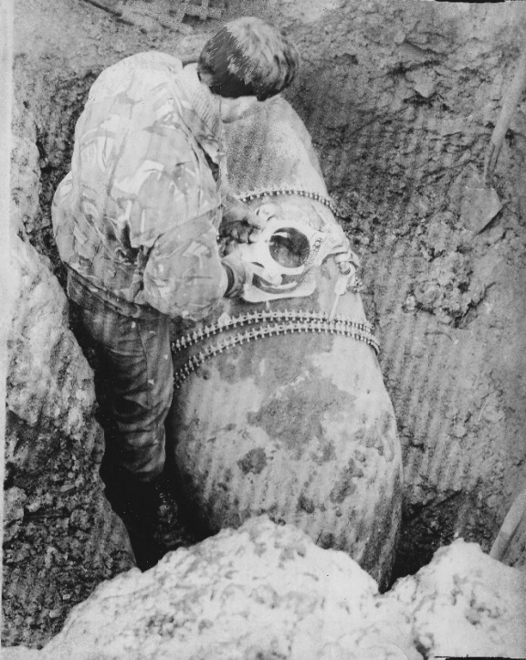

Sheffield 1985, Trepanner being fitted to the UXB.
Photo credit: Peter Markham’s Collection.

CRAWFORD, Anthony James QGM, (522953), 33 Engineer Regiment (EOD), Royal Engineers.

The Citation is taken from file WO373/183/66 held at the National Archives.
Placed in the London Gazette on the 4th December 1989. Supplement 51956. Page 14047.

Captain Crawford, the Duty Bomb Disposal Officer, was called out to an emergency at the Isle of Dogs, London on 13th November 1988 where a contractor had exposed a bomb during the construction of a new sewer tunnel. The site was 25 yards from the Docklands Light Railway and close to both the A13 main road and Billingsgate Fish Market.

Captain Crawford arrived on site at 1230 hours. Only the rear 12 inches of the bomb had been uncovered at the end of a 135-foot-long sewer pipe just 4 feet in diameter which was itself 20 feet below ground. It was identified as a 500 lb World War 2 German bomb but no fuzes were visible. Captain Crawford took control of the situation and advised the police on evacuation and the disconnection of power services. The Docklands Light Railway and surrounding roads were closed and he then concentrated on dealing with the bomb.

When the evacuation of over 400 people was completed, Captain Crawford, assisted by Lance Corporal Porter, commenced excavation of the bomb which lay horizontally. At this time, he did not know whether the bomb contained one or two fuzes or whether one of them could have been a very sensitive clockwork fuze. The two men dug out the clay by hand, shoring up the roof with timbers as best they could. After one hour’s digging the roof collapsed and they had to start again. Throughout the remainder of the task, they were always under the threat of a cave-in and two further collapses of the clay face occurred. They uncovered the bomb after some 3 hours digging in very cramped and claustrophobic conditions. The bomb was coated in a thick crusted layer and they had no option but to scrape and finally chisel this material away to gain access to the then confirmed single fuze. Which lay underneath the bomb. During this operation he devised a technique using hot water and salt to try to dissolve any highly dangerous picric acid crystals that may have leaked from within the fuze.

They managed to turn the bomb with considerable difficulty and discovered the fuze was very corroded and it was impossible to identify its type. To immunise the fuze, they had to drill by hand into the fuze head to create a vacuum using a pump, and introduce a solution to dissolve the very sensitive crystals of explosive which had formed over the years. The corrosion around and within the fuze was so hard that it took Captain Crawford over 5 hours to drill into the fuze, which was finally achieved when a slight hiss was heard and tiny bubbles were emitted. The immunising liquid was then quickly injected into the fuze. For the whole of the operation both men were in a very dangerous situation, which was aggravated since never before had it taken so long to drill into a fuze of this type.

At 0500 hours Captain Crawford declared that the fuze was immunised. The subsequent operation to remove the bomb from the sewer leading to its final disposal was commenced. This phase was both difficult and dangerous since the risk of the bomb exploding from the detonation of any remaining unstable picric acid crystals was ever present. He led his team throughout the rest of the hazardous operation which was completed after 32 hours non-stop work in the full glare of the national press and television.

Captain Crawford’s courage, leadership, determination and level headedness were above and beyond those normal required during a bomb disposal operation of this nature. His actions were an inspiration to all concerned and were in the very highest traditions of the Service. His utterly unselfish action in face of imminent danger under extremely difficult physical conditions is most worthy of official recognition.

Further Information
Lance Corporal Keith Porter was also awarded the Queens Gallantry Medal for his part in this incident, see separate entry.

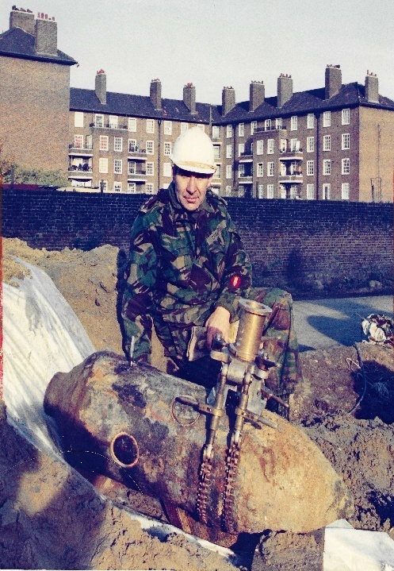

Captain A J Crawford QGM.
Photo credit: Peter Markhams Collection.

DALY, Nigel Howard QGM, Staff Sergeant, 33 Engineer Regiment (EOD), Royal Engineers

The Citation is taken from file WO373/183/52 held at the National Archives.
Placed in the London Gazette on the 8th February 1988. Supplement 51235. Page 1495.

Staff Sergeant Daly joined Royal Engineers Bomb Disposal in December 1985 and immediately qualified as a Bomb Disposal Engineer. As a trained diving supervisor, he is regularly deployed with the unit’s diving team to tasks involving underwater unexploded ordnance.

On 21st November at Beckton Gas Works, East London a civilian maintenance diver located what was thought to be a bomb under 40 feet of water inside a large gasometer. The bomb appeared to be obstructing the working of the gas holder. Staff Sergeant Daly was sent to Beckton with a team of bomb disposal divers under the Bomb Disposal Officer, Major Hall. They entered the gas holder through a small airlock on the top and were lowered 100 feet by winch to the surface of the water. The interior was pitch black, the atmosphere was heavy with gas and fumes and the water had become extremely stagnant and polluted with poisons after more than 50 year’s use. Even if time had allowed the millions of gallons of water involved could not have been pumped out since it would have severely contaminated the River Thames and would have required neighbouring gasometers which were still full of gas to be taken out of service. There was no visibility in the water and all work was conducted by touch alone.

After a quick search the nose section of a very large bomb containing decomposing explosive was found and a sample sent for analysis. This showed that it was active explosive indicating that the bomb had not exploded. The team was now faced with a major bomb disposal incident. On 24th November 1986 Major Hall, Staff Sergeant Daly and Sapper Wright dived to recover the nose section. It was identified as a German World War 11 500 kg bomb that had entered through a hole in the crown of the gasometer which was patched at the time.

Early on 26th November they began a systematic search of the sloping floor of the gasometer working up to 50 feet below the surface to attempt to locate the rest of the bomb. At 1300 hours they discovered the crumpled fins and at 1400 hours the main section of the bomb. Major Hall confirmed by feel that the fuze was intact but could not be identified as it was facing down into the mud. It became clear that the defuzing operation, normally the task of the Bomb Disposal Officer alone, would require the presence of 2 men underwater and one on the surface to supervise the diving equipment and lifting equipment. At 1800 hours the 3-man team returned and dived down to the bomb which was known to be extremely dangerous. Shackles were attached and with great difficulty the bomb prised from the mud, winched to the surface and manhandled into a rubber dingy. At this stage all 3 men were in intimate contact with the bomb. The Bomb Disposal Officer then set about defuzing the bomb, whilst Sapper Wright held the torch and Staff Sergeant Daly steadied the dingy. The hiss as the hand drill pierced the vacuum in the fuze indicated that it was in perfect order, as had been feared. After a further hour the bomb was completely defuzed.

The half-ton bomb had still to be removed from the gasometer. It was winched up to the top of the gasometer, eased by Major Hall through the very small air lock and lowered 100 feet down the outside. This was a period of 1 hours of extreme physical effort by the tired team; they were constantly at risk of being crushed by the swinging bomb or falling of the structure. Eventually at 0130 hours they delivered the bomb to others to be steamed out.

Throughout Staff Sergeant Daly displayed professionalism and bravery of the highest order. He was fully aware of the risks but supported his team leader unhesitatingly. His superb gallantry during this extremely dangerous operation was an inspiration to Royal Engineers Bomb Disposal personnel and earned the greatest admiration of the civilians and authorities involved.

Further Information
Major Hall and Sapper Wright were also awarded the Queens Gallantry Award for this incident, see separate entries.

FISHER, GA QGM, Corporal, 33 Engineer Regiment (EOD), Royal Engineers.

The Citation is taken from file WO373/183/58 held at the National Archives.
Placed in the London Gazette on the 3rd October 1988. Supplement 51489. Page 11107.

Corporal Fisher was the Duty Bomb Disposal Officer’s Assistant in 33 Engineer Regiment (EOD) on 28th June 1987. In Bermondsey, London, a contractor’s excavator had exposed as what was later identified as a one ton “Herman” German Bomb, one of the largest bombs dropped on London during the Blitz. The site was 450m from Tower Bridge and close to the A200 and main line railway line into London Bridge.

Corporal Fisher accompanied the Bomb Disposal Officer to the site and assisted him in cleaning the bomb in order to identify the fuze. Having arrived at 1435 it was not till 2230 that the immunisation process could begin. This was due to the number of people who had to be evacuated from the area.
To immunise the fuze, the Bomb Disposal Officer had to drill into it while his assistant maintained a listening watch at a safe distance. The Bomb Disposal Officer was unable to complete the operation within the normal 30 minutes as the fuze proved to have been ruptured on impact. Extremely sensitive picric acid crystals had formed in the fuze and as a result any vibration, friction or overheating would cause detonation to occur which would in turn have devastated a large industrial and residential area.

The Bomb Disposal Officer had to develop an improvised technique to deal with the bomb. This involved washing out the crystals using a medical syringe and salt solution. As two men were required to implement this improvised technique, Corporal Fisher knowing the danger presented by the crystals and knowing that the method of immunisation was untested, nevertheless volunteered to assist.

Corporal Fisher remained for a total of 5 ½ hours in intimate contact with the bomb until immunisation was completed. Despite the high chance of detonation, he remained completely calm throughout the operation and thus enabled the Bomb Disposal Officer to complete the task successfully. He demonstrated the highest level of courage in order to save the homes and livelihood of hundreds of people.

Corporal Fisher, as a trained Bomb Disposal soldier, was fully aware of the risks involved and that in normal bomb disposal circumstances he would not need to be in such a dangerous situation. His outstanding dedication to duty in supporting his officer showed bravery of the highest order. His actions deserve to be recognised.

Further Information
Captain Christopher Stanley Goddard was also awarded the Queens Gallantry Medal for this incident, see separate entry.

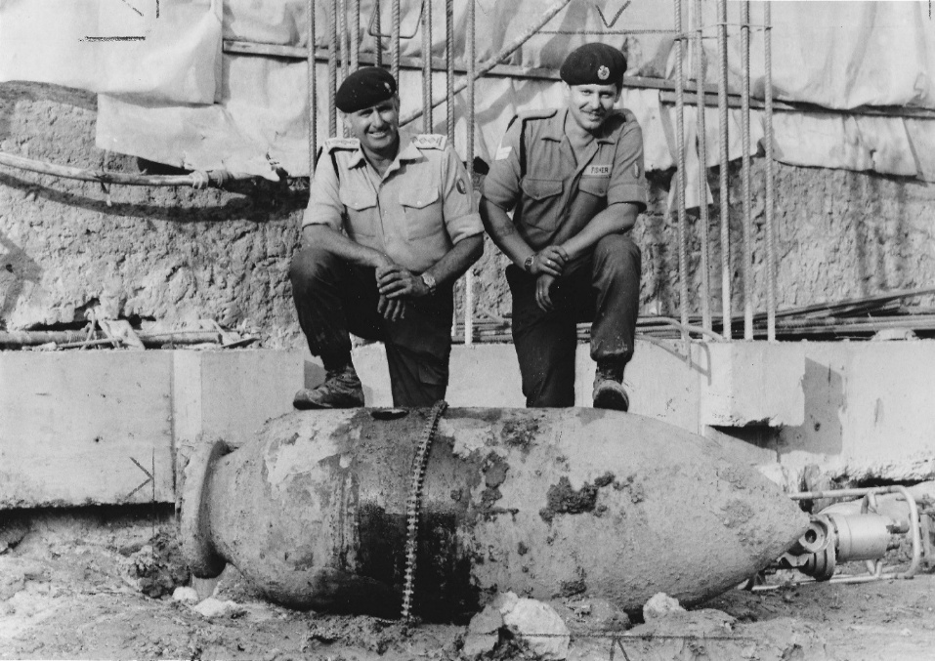

Captain C S Goddard and Corporal G Fisher.
Photo credit: Peter Markham’s Collection.

GODDARD, C S QGM, Captain, 33 Engineer Regiment (EOD), Royal Engineers.

The Citation is taken from file WO373/183/58 held at the National Archives.
Placed The Citation is taken from file WO373/181/669 held at the National Archives.

Captain Goddard was the Royal Engineers Bomb Disposal Officer on duty in 33 Engineer on 28th June 1987. He was called out to an emergency In Bermondsey, London, where a contractor’s excavator had exposed a bomb. The site was 450m from Tower Bridge and close to the A200 and main line railway line into London Bridge.

He arrived on site at 1435 hours and identified the bomb as a “Herman” World War 2, German, 1 ton device, one of the largest bombs dropped on London during the Blitz. He immediately took control of the situation and advised the police on evacuation and size of the cordon that would be required.

On further inspection of the bomb, it was found that the damage caused during its descent made it impossible to identify the fuze. By process of elimination, he chose the safest method of fuze immunisation which he commenced at 2230 when the evacuation of over 500 people was completed. To immunise the fuze, he had to drill by hand into the fuze head, create a vacuum in the fuze using a pump, and introduce a solution to dissolve the very sensitive crystals of explosives that had formed over the years. This process normally takes about 30 minutes but, in this case, the fuze had deteriorated to such a degree that a vacuum could not be produced and Captain Goddard had to resort to pumping fluid into the fuze. He soon found that he was washing out large quantities of highly dangerous picric acid crystals which should not have been present within the fuze. He deduced the fuze that the fuze must have ruptured and that over the years the explosive around the fuze had leaked into the cavity and recrystalised. There was no recognised procedure for dealing with this.

Captain Goddard was in a very dangerous situation and had to devise a new means of removing all the crystals from the fuze in order to render it safe. Picric acid crystals are likely to explode, thus detonating the bomb, if they are vibrated, overheated or if any friction is caused. He knew that if the bomb detonated a large industrial and residential area would be devastated.

He decided to obtain a medical syringe and repeatedly inject a warm brine solution until, hopefully, all the dangerous crystals in the fuze had been washed out. The whole procedure took 5 ½ hours during which he was assisted by Corporal Fisher. He paused only for occasional rest and remained completely calm throughout the operation in spite of the constant danger. After 3 hours it was suggested that he might be relieved, but he was confident he now had the measure of the bomb and that he should see this new method of immunisation through. In doing this he avoided further delay in getting the evacuated families back into their homes. At 0500 hours he was able to declare the fuze immunised and the ordered subsequent operation to begin. He led his team throughout the rest of the operation which was eventually completed after 31 hours non-stop work.

Captain Goddard demonstrated outstanding leadership, planning ability and cool, calm courage in the face of extreme danger over an extended period of time. His professionalism and bravery were of the highest order and saved the homes and livelihood of hundreds of people. He devised a new method of neutralisation and had courage to put it into effect. His actions were an inspiration to all concerned with bomb disposal and fully deserve to be recognised.

Further Information
Corporal Gary Fisher also received the Queens Gallantry Medal for his part in this incident, see separate entry.

GOULDING, S R QGM, Sergeant, 33 Engineer Regiment (EOD), Royal Engineers

No Citation found in the National Archives Catalogue.
Placed in the London Gazette on the 18 March 2005. Supplement 57588. Page 3374.

Information from For Exemplary Bravery. Nick Metcalfe MBE QGM

Details taken from For Exemplary Bravery, Nick Metcalfe MBE, QGM

In 2004 Sergeant Goulding was deployed to Iraq (Operation TELIC 5) in command of an Explosive Ordnance Disposal team responsible for the clearance of conventional munitions. Operation BRACKEN was undertaken by a UK Battlegroup, based on 1 Battalion, The Black Watch (The Royal Highland Regiment), in support of the 1 Marine Division (United States) during the second battle of Fallujah (Operation AL-FARJR/Operation PHANTOM FURY). On 5 November 2004 Sergeant Goulding cleared a buried 107 mm Type 63 Chinese rocket that had impacted, but not detonated, beside the operations centre that was controlling part of that operation.

Whilst on Op Telic 5, myself and three others Corporal Charlie Brown (my number 2), Lance Corporal Rowe and Lance Corporal Murphy – deployed with the Black Watch Battlegroup on Operation BRACKEN in support of US Forces. We set up in camp Dogwood in central Iraq, near Fallujah. The area was known as the ‘Triangle of Death’ and we were continuously attacked by suicide bombers, and bombarded with indirect fire rockets. The main ordnance that the enemy used against us were 107mm Type 63 Chinese Rockets. There was a large number of blinds when the rocket did not function on impact, probably due to the improvised methods of firing and poor storage of fuzes.

Almost every day we were bombarded, and almost every attack led to the team having to apply Render Safe Procedures (RSP) to make the ordnance safe. In most circumstances the safest way was too ‘High Order’ the rocket. This involved digging down to the munition and applying three explosive charges – one of the warhead, one on the propellant section, and one on the tail to cut the venturi off to stop the possibility of the rocket being propelled further. This would then blow up the rocket as it was meant to function, but under a controlled explosion.

On the evening of the 4 November 2004 came another rocket attack, and amongst the explosions was another blind. The next morning an entry hole of a rocket was found in close vicinity to the Operations Room. It was buried approximately 1-1.5m deep. I guided a plant operator to dig down to approximately 300 mm away from the rocket and from there I dug down to the rocket by hand. I knew that the shockwave from any blast could potentially damage some of the delicate communications equipment and fibre optic cables that were in close proximity around the Operations Room, and thus threaten the security of the deployed patrols. Removal of that equipment was an option but that would have meant the Operations Room being off line while I dealt with the rocket.

When I realised that I could not ‘High Order’ the rocket without the risk of damaging the equipment, I began to plan another option. The next safest option is to ‘Low Order’ the rocket. This is a method where an explosive, copper lined, shaped charge is fired at the rocket body. The aim is that the molten copper (known as a slug)
Formed by the explosives, fires into the rocket body and splits open the casing, and the explosives deflagrate. Deflagration is where there is a detonation at a lower than-normal velocity, or a partial detonation where the shockwave does not have enough energy to maintain the chain reaction, and some of the explosives are thrown out the casing.

Due a logistical error our supply of shaped charges that were sent to us were missing a vital component – the discs that form the slug. So, another option had to be sought. All that remained was to defuse the rocket – defusing is always the last option because of the inherent risk. I checked or EOD database to see if there was a particular RSP proven to work against the fuze – at that time no procedure had been verified, so it would have to be a gamble and I had to think what to do.

I opted for a method called ‘Cracker Barrel’, an improvised method I learned in Sierra Leona, where a sheet of plate stell is cut to a square of approximately 80mm square, and a tamper of plastic or foam and then sheet explosives are stuck to it. The Cracker Barrel is then lined up against the fuze. The aim is that the explosives are detonated, propelling the sheet into the fuze which then hopefully, smashes the fuze off, removing it from the weapon body.

In order for this to work there has to be enough clearance around the fuze for it to be smashed clear by the sheet of plate steel as it is fired forward. Without the right clearance the danger was that the steel would smash into the fuze and the striker would have nowhere to go, other than hit the detonator. The fuze was embedded well into the baked rock-hard sand, and was totally encased apart from the little bit I had cleared earlier in order to identify it as an MJ-I Fuze.

The MJ-1 fuzes on impact and graze. It works in the way that many fuzes do in that, when it is fired, forces exerted on it move safety features out of line after a set distance where it the arms. The striker (firing pin) is then in line to fire against an explosive detonating pellet and initiates the explosive train to function the fuze and then the munition. What can happen in the event of a blind is that the striker flies forward but catches on an obstruction before hitting the pellet, so it is still cocked and ready to function but only if it is dislodged from its ‘hung up’ position. A simple knock or vibration is enough to do this, which some EOD operators have found to their cost.

I had to fist dig away with a trowel and then with a screwdriver to carefully remove the encrusted sand around the fuze to get enough clearance for it to fly clear when hit by the sheep metal. Once or twice, I slipped with the screwdriver and knocked the fuze a little harder than I would have wanted to, risking dislodging the striker. This was a bit of a heart in the mouth time. It was then that I started using the point of a mine prodder as if it was a small snooker cue, which was very slow, deliberate movements to gain better control. A I nervously dug away I did think to myself whether it was worth the risk for the sake of some signal equipment, and after a few hours, out of concern, my No 2, Charlie, asked me if it was worth it, as it was clear that I was feeling the effects of the heat. I persevered; I’m not really sure if it was out of a sense of duty or because all the way through the EOD course every scenario tests you in your ability to achieve an objective against similar high-risk odds, and the need for succeeding in the mission is always deemed critical. It took approximately 4 hours to painstakingly remove enough of the rocky sand to gain the clearance I needed.

Once I had the clearance required, I set up the charge. I fired it from behind a building and the small pop of an explosion told me that the fuze and rocket had not functioned, as is always a risk. On inspecting the fuze, it was cleanly removed and lay beside the rocket in the cleared space. Enormous relief swept over me; if the fuze had not come off cleanly, I would have had another dilemma – whether the rocket was safe to move or not. The shock had also freed the rock from around the rocket and dislodged it, making it easier for me to remove it to a safe location away from the Operations Room and personnel. I then demolished it using explosives in the conventional way.

GRANTHAM, K J, MBE QGM, Warrant Officer Class II, 33 Engineer Regiment (EOD), Royal Engineers.

No Citation found in the National Archives Catalogue.
Placed in the London Gazette on the 7 May 1999. Supplement 55477. Page 5084.
Citation given by Kevin Grantham.

Whist on duty as the Royal Engineer duty Bomb Disposal Officer, Warrant Officer Class 2 (Squadron Sergeant Major) Grantham demonstrated extraordinary personnel courage, leadership and technical skill commanding an operation to render safe and subsequently destroy an unstable and highly dangerous 250 kg German World War 2 bomb at Dover’s Corner, North London. Warrant Officer 2 Grantham, whilst in the gaze of the national media, displayed qualities of leadership, coolness and gallantry which were a magnificent example to his subordinates and many civilian agencies involved at the scene.

The bomb had been discovered by a civilian plant operator on a piece of ground only 100m from a main gas pipeline, 150m from residential properties and 200m from the A13, a major London commuter route. On arrival at the scene, Warrant Officer Class 2 Grantham quickly took control of the incident and confirmed the identity of the bomb. He immediately realised that he would have to render the bomb safe by immunising the fuzes prior to cutting the bomb open and steaming the unstable explosives out. Two fuzes were visible, although their poor condition made precise identification impossible; it was only at the end of the operation that they were confirmed as a Series 50 anti-disturbance fuze and a Zus-40 anti-withdrawal fuze, both specifically designed to kill the bomb disposal officer.

Calmly and without fuss, Warrant Officer 2 Grantham set about planning the task, inspiring the many civilian personnel present with his confident and positive air. The evacuation, conducted under the glare of the national media, required the closure of the A13 and over 5,000 people to be moved from their homes, Warrant Officer 2 Grantham, fully aware that with a bomb of this age the degradation of the explosive fill could result in an increase in the bombs susceptibility to shock induced detonation, led his team in preparing the site. Next, over a period of two hours with great skill and courage, he set about rendering the weapon safe. This required him to drill by hand into the fuzes of the 55-year-old unstable bomb. Then, bringing his men forward, he demonstrated superb leadership and technical ability by rapidly trepanning two holes in the bomb casing.

The final critical phase of the operation required steam to be introduced into the bomb to melt out the explosive fill. This operation, during which temperature fluctuations can cause the bomb to detonate, was dogged by equipment failure resulting in Warrant Officer 2 Grantham foregoing the remote steaming equipment and having to stand at the bomb to steam out the explosives. His coolness in the face of such obvious danger was magnificent as he skilfully used the hand-held steamer to melt the 55-year-old explosives.

In all, this operation took four gruelling days. Throughout, Warrant Officer 2 Grantham displayed leadership, personnel courage and cool headedness of the highest order. Through his own actions and example, he safely disposed of an immensely powerful and dangerous weapon containing fuzes specifically designed to kill him, in circumstances where the disruption to the local residents and commuters was minimised. Warrant Officer 2 (Squadron Sergeant Major) Grantham’s courageous actions and outstanding leadership were in the highest traditions of his Corp and deserve the highest official recognition.

Further Information
The Rainham Team was made up of
Bomb Disposal Officer WO2 (SSM) Kev Grantham.
BDO Engineer Lance Corporal Jim Moynan.
Crash Crew Commander Lance Corporal Wayne Bye.
Crash One Sapper Ross Watkins.
Crash Two Sapper Si Chivers.
Crash Three Sapper Jamie (Beavis) Mcdowell.
Crash Driver Sapper Darrell Short.
Crash Fitter Lance Corporal Tony Standish. (22 HQ Squadron (EOD)

As a WO 1 he was also awarded the MBE for service in the Former Republic of Yugoslavia. See separate entry.

HALL, Robert George Russell QGM, )502435 Acting Major, 33 Engineer Regiment (EOD), Royal Engineers.

The Citation is taken from file WO373/183/52 held at the National Archives.
Placed in the London Gazette on the 8^{h} February 1988. Supplement 51253. Page 1495.

Major Hall was trained as a Bomb Disposal Officer before becoming the Training Major of 33 Engineer Regiment (Explosive Ordnance Disposal) at the age of 29 with acting rank. Just four months later he dealt with a large and dangerous German bomb in extremely hazardous and unusual circumstances.

On 21 November 1986 at Beckton Gas Works, East London, a civilian maintenance diver located what was thought to be a bomb under 40 feet of water inside a large gasometer. Major Hall, a trained diver, was sent with a team of bomb disposal divers to Beckton. They entered the gas holder through a small airlock on the top and were lowered 100 feet by winch to the surface of the water. The interior was pitch black, the atmosphere was heavy with gas and fumes and the water had become extremely stagnant and polluted with poisons after more than 50 year’s use. Even if time had allowed the millions of gallons of water involved could not have been pumped out since it would have severely contaminated the River Thames and would have required neighbouring gasometers which were still full of gas to be taken out of service. There was no visibility in the water and all work was conducted by touch alone.

After a quick search the nose section of a very large bomb containing decomposing explosive was found and a sample sent for analysis. This showed that it was active explosive indicating that the bomb had not exploded. The team was now faced with a major bomb disposal incident. On 24th November 1986 Major Hall with a Staff Sergeant and Sapper dived to recover the nose section. It was identified as a German World War 11 500 kg bomb that had entered through a hole in the crown of the gasometer which was patched at the time.

Major Hall coolly organised a complex operation to find and deal with the bomb. Early on 26th November they began a systematic search of the sloping floor of the gasometer working up to 50 feet below the surface to attempt to locate the rest of the bomb. At 1300 hours they discovered the crumpled fins and at 1400 hours the main section of the bomb. Major Hall confirmed by feel that the fuze was intact but could not be identified as it was facing down into the mud. By 1800 hours he had positioned the emergency services and arranged for the area to be evacuated. He returned with his two assistants and they dived down to the bomb which was now known to be extremely dangerous. Shackles were attached and with great difficulty the bomb prised from the mud, winched to the surface and manhandled into a rubber dingy. Major Hall was then able to set about defuzing the bomb, working by the light of a small torch whilst balancing on the unstable boat. The hiss as his hand drill pierced the vacuum in the fuze indicated that it was in perfect order, as had been feared. After a further hour the bomb was completely defuzed.

The half-ton bomb had still to be removed from the gasometer. It was winched up to the top of the gasometer, eased by Major Hall through the very small air lock and lowered 100 feet down the outside. This was a period of 1 hours of extreme physical effort by the tired team; they were constantly at risk of being crushed by the swinging bomb or falling of the structure. Eventually at 0130 hours they delivered the bomb to others to be steamed out.

Throughout Major Hall displayed leadership and bravery of the highest order. He was fully aware of the risks but never faltered in his determination to deal with the bomb. His superb gallantry during this extremely dangerous operation was an inspiration to Royal Engineers Bomb Disposal personnel and earned the greatest admiration of the civilians and authorities involved.

HOGBEN, Arthur, Stephen QGM, (408599 Major, 33 Engineer Regiment (EOD), Royal Engineers.

The Citation is taken from file WO373/182/95 held at the National Archives.
Posted in the London Gazette on the 16th December 1974. Supplement 46433. Page 12881.

On 1st August 1974 it was reported that a bomb had been excavated on a building site in Plaistow, London E13. Major A S Hogben lead a bomb disposal team to the site, where he found a German 1000 kg bomb, commonly known as a Herman. It was located in a trench about 20 m from a public road, in a densely populated area, with high-rise flats close by and a trunk road and main railway lone nearby.

Major Hogben arranged evacuations of the danger area with the police and local authorities, and in order to cause minimum disruption to public transport neutralisation of the bomb did not start till midnight.

The single transverse fuze was covered by a cap which was badly corroded. The exact nature of the fuze was therefore in doubt, and with only three such bombs encountered in twenty years, there was not available great experience to draw on. Although this might have been an electrical fuze, Herman bombs have also been known to contain a 17-clockwork fuze. Which is commonly regarded as a particularly dangerous item to deal with. Rather than risk detonation by a sudden movement while removing the corroded cap, Major Hogben decided to remove the explosive by steaming it out with the fuze still live. This operation was particularly hazardous because the mixed powder/cast explosive filling did not conform with that found in the past in similar bombs. Although the normal filling in the Herman can be steamed out, this is the exception, and the general rule is that such mixed fillings are extremely sensitive to heat at the interface. Major Hogben elected to steam out this bomb, knowing the extra hazard that this entailed.

Just after midnight Major Hogben began the tedious and dangerous task of steaming out the main filing, consisting of about 600 lb of explosive. This took 5 hours, during most of the time he was required to be working either on the bomb or in its immediate vicinity.

At about 6 o’clock on the morning of 2 August, the bomb case was free of explosives, and the fuze pocket was detonated. This caused a degree of damage in the way of broken windows to immediately-surrounding houses, but this was insignificant compared to the damage which would have resulted from a full detonation of the bomb.

Major Hogben was in command of this operation throughout, and personally completed the most hazardous part of the task. He displayed a degree of competence, as well as gallantry in the best traditions of the service, thereby reducing the risk of other people and their property.

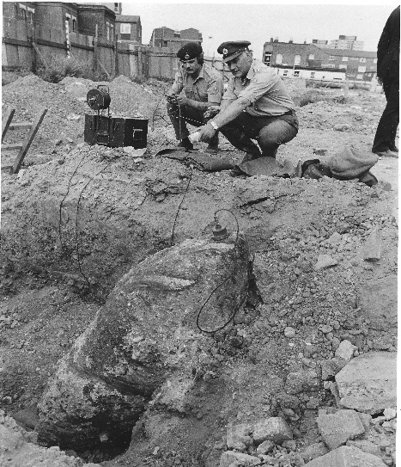

Major A S Hogben QGM
Phot from Peter Markham’s Collection.

KENNEDY, M J R QGM, Captain, 33 Engineer Regiment (EOD), Royal Engineers

No Citation found in the National Archives Catalogue.
Placed in the London Gazette on the 21 March 2014. Supplement 60813. Page 5386.

Information from For Exemplary Bravery. Nick Metcalfe MBE QGM

On his third tour of operations in Afghanistan, Captain Kennedy and his Improvised Explosive Device Disposal team were supporting a Brigade Operations Company that had landed by helicopter at a compound. After scaling the compound walls using ladders, a search revealed bomb-making equipment and a number of concealed IEDs. As he and his team prepared to neutralise the IEDs remotely in the hope of recovering the items intact, a message came through that he had five minutes before the patrol would be extracted by helicopter. With time now a major obstacle to retrieving the IEDs intact, he decided to destroy them. Insurgents were now reported to be in the area and preparing to detonate a concealed command wire IED. Noting a patch of disturbed earth near the ladder used to scale the compound walls, he discovered a large artillery shell with a command wire running off to a tree-lined area that insurgents were moving toward. Realising he had minutes to neutralise the device before it was detonated, he shouted to patrol commander to evacuate the area. Once his colleagues were out of harm’s way he set about defusing the device, cutting the command wire and carefully removing the detonator. With time running out before the extraction of the patrol he quickly placed explosive charges near the remaining IEDs detonating them from a safe vantage point. All of this was completed within just five minutes.

LEAK, D QGM, Sergeant, 33 Engineer Regiment (EOD), Royal Engineers

No Citation found in the National Archives Catalogue.
Placed in the London Gazette on the 7 March 2008. Supplement 58633. Page 3619.

Information from For Exemplary Bravery. Nick Metcalfe MBE QGM

For Exemplary Bravery in the dismantling of a Second World War bomb between 14 and 17 May 2007 in Bethnal Green, London.

LEE, T R, QGM, Warrant Officer Class II, 33 Engineer Regiment (EOD), Royal Engineers

No Citation found in the National Archives Catalogue.
Placed in the London Gazette on the 12 August 1997. Supplement 54863. Page 3619227.

Information from For Exemplary Bravery. Nick Metcalfe MBE QGM

On Wednesday, 21 August 1966, AT 1622 hours Warrant Officer T R Lee of 33 Engineer Regiment (EOD) was tasked with the disposal of a World War 2 German 250kg aircraft bomb in Spital Street, Sheffield. The bomb had been excavated by building contractors and was minus the tail and rear of the bomb case. Asa result of such rough handling the bomb was in an extremely sensitive and dangerous unstable condition. The task was his first bomb disposal operation since qualifying as a Bomb Disposal Operator.

The exposed rear section of the bomb allowed clear sight of the explosive fill which had decayed to an extremely sensitive condition in a chemical reaction with the bomb casing. The bomb, located in a housing estate, presented him with a technically difficult and dangerous challenge. In addition, he had the pressure of advising the Police Incident Commander. His initial reconnaissance of the bomb established it had two fuzes one of which he suspected to be a type 17 clockwork fuze, the most dangerous of all German bomb fuzes. The condition of the bomb allowed him to identify positively only one of the fuzes. The most likely combination of fuzing was two type 15 fuzes, but these matters are never certain. Despite the obvious risks he continued with the disposal of the bomb whilst monitoring for the presence of a clockwork fuze.

Sergeant Major Lee began to immunise the fuzes at 2330 hours and unusually he encountered considerable difficulty in penetrating the fuze with a hand drill. Fully aware of the dangers he had to try several times to drill a hole in each fuze before he was successful. Eventually after two hours on his own in close proximity to an unstable weapon, at 0030 hours on Thursday 22 August 1996, Sergeant Major Lee was successful in immunising both fuzes.

The steaming out of the explosives began at 0130 hours. For steaming to be successful the temperature of the steam at the bomb should be a constant 110 degrees C; should it rise above this the explosives can detonate. Fluctuations in temperature of steam delivered at the bomb either resulted in the explosive either not melting or reaching dangerously high temperatures. Sergeant Major Lee had to make repeated approaches to the bomb to affect the steaming out. After several hours a flange of explosives at the front of the bomb refused to melt. Undeterred by the obvious danger and displaying leadership of the highest quality Sergeant Major Lee stood next to the bomb holding the nozzle of the steamering place within the bomb carcass to effect total clearance of the remaining explosives. The steaming operation was completed at 0500 hours by which time he had been on site for nine, physical demanding and dangerous hours. He then carried out the final of the clearance which involves movement of the bomb carcass, detonation of the live fuzes and the burning of the explosive residue. At 0830 hours on Thursday, 22 August 1990, he declared the area clear and the local population were allowed to return to their homes.

Sergeant Major Lee displayed great technical skill, coolness and courage under pressure in keeping with the very highest traditions of bomb disposal operations. The leadership, devotion and courage beyond the call of his normal duties and the disregard he showed for his own life is worthy of public recognition.

LOBB, M J QGM, Captain, 33 Engineer Regiment (EOD), Royal Engineers

No Citation found in the National Archives Catalogue.
Placed in the London Gazette on the 21 November 1995. Supplement 54219. Page 15745.
Information from For Exemplary Bravery. Nick Metcalfe MBE QGM

Captain Lobb was the Duty Bomb Disposal Officer 33 Engineer Regiment (EOD) ON 21 March 1995 when he was tasked to an unexploded on the Island of Portland. Dorset.

Reconnaissance revealed that it was German Second World War Spreng Dicken wand five-hundred-kilogram bomb with an unidentified fuze. On Captain Lobb’s advice Dorset Police decided to evacuate all personnel within one thousand metres radius of the bomb during the period that he would attempt to render it safe, the date for the operation set for 1 April to allow police time to formulate and carry out the evacuation.

Most German fuzes are easily recognisable by manufacturers markings, and standard procedures are followed to immunise then. In this case however the fuze was masked by an extension cap and no attempt to remove it could be made, for fear of detonation, until the operation started. Captain Lobb was therefore faced with the problem of starting the operation without knowing what type of fuze he would find, or indeed whether he would be able to reach the fuze at all. He advised the Police that he would need 48 hours to carry out his task.

On the morning of Saturday 1 April 1995 Dorset Police evacuated four thousand people from the homes around Portland. The operation had attracted the attention of the national media which had started around the clock reporting the day before. On his first approach to the bomb his worse fears were realised. First, climatic weathering had deteriorated explosives in the fuze pocket to a form highly sensitive to heat and friction. Worse, he was unable to remove the extension which over the years had corroded into the fuze head. Therefore, not only did he not know what type was present but its neutralization would have to be carried out through the cap itself. He therefore, decided to immunise the fuze by drilling through the fuze cap into the fuze and injecting a saline solution to jam its mechanism. This process required considerable skill to achieve a precise depth of drilling within exacting tolerances; any disruption to the booster charges in the fuze pocket would cause the bomb to explode with him next to it. Equally, if the fuze had been clockwork, a fact he was never able to verify, it could have restarted at any time without warning. Displaying personnel courage of the highest order and with total disregard for his own safety, Captain Lobb neutralised the fuze successfully.

Captain Lobb then had to trepan out a section of the bomb casing and steam out the explosives, a process which should have only required two approaches to the bomb. In the event, due to the extreme thickness of the casing and hardness of the steel, Captain Lobb had to make twenty-two approaches to the bomb over a period of 15 hours during trepanning alone to clear the swarf and realign the trepanner. In doing so he put himself at the point of greatest danger, refusing to allow any of his soldiers to deputise for him. He could then have placed a stem nozzle into the bomb and retired to safety while the explosives melted and were flushed away, but Captain Lobb decided, ignoring the risk to himself, that he carried out the whole process manually so that he could monitor the temperature’s and minimise the risk to those soldiers around him. He did this continuously for 5 hours, heedless to the danger of detonation and of molten explosives cascading around him.

After a continuous thirty-two-hour operation Captain Lobb declared the area clear. Throughout the whole operation Captain Lobb sacrificed his own safety to ensure that the danger, to his men and local people who had stubbornly chosen to remain within the evacuated area were kept to an absolute minimum. Due to the peculiarly poor condition of the bomb Captain Lobb could at no stage have been sure that the action he was taking would not lead to its detonation and his own death, yet he continued to work with relentless determination and a cheerful optimism which was an inspiration to his men and an example to all. He showed courage of the very highest order.

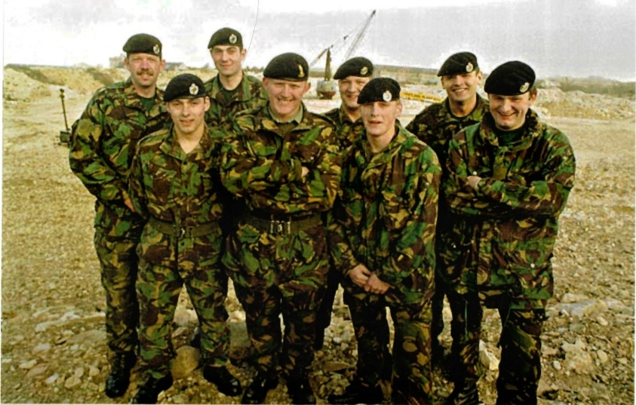
Captain M Lobb (4 from left) QGM.
Photo credit: Peter Markham’s Collection.

MCMASTER, D S QGM, Lance Corporal, 33 Engineer Regiment (EOD), Royal Engineers

Details are the same as Lieutenant P A Ness below.

NESS, P A QGM, Lieutenant, 33 Engineer Regiment (EOD), Royal Engineers

No citations found in the National Archives Catalogue.
Placed in the London Gazette on the 29 October 2002. Supplement 56734. Page 5.

Information from For Exemplary Bravery. Nick Metcalfe MBE QGM.

For bravery in disposing of an unexploded bomb Second World War bomb at Lingfield 7/8 January 2002.

On 9 February 1943 during a German bombing attack on a nearby munitions factory, a number of bombs were dropped on Lingfield village. One bomb hit the school and killed two teachers acting as fire watch and two eleven-year-old girls. One of the bombs exploded on Mount Pleasant Road killing one.

In 2002 an unexploded bomb from the attack was discovered by builders digging foundations for an extension to another house in Mount Pleasant Road.

Lieutenant P Ness commented about his part in the incident: The bombs mechanical fuze was suspected to have been re-started, having been struck by the JCB’s back bucket prior to being drawn out of the ground and dropped in the house’s back garden. I was very surprised when the stethoscope picked up sounds of a mechanical system operating, which was confirmed by Lance Corporal MacMaster. I’m certainly glad that during the ‘bomb course’ I spent time practising the physical skills that included using a hand drill to access the fuze body, as this was required prior to injecting fluids into the body of the fuzing system on the bomb. The clock stopper worked well, including my own analogue watch – until its battery ran out. The problem was resolved by accessing the house and utilising its mains electrical supply. Moving the bomb was made easier thanks to a borrowed fire brigade stretcher, but once the bomb was placed in the disposal pit, I was not minded to try and extract it from under the device, so I had to apologise to them afterwards.

Further Information
Corporal D S McMaster also was awarded the QGM for this incident. Sapper SR Smith was awarded the Queens Commendation for Bravery for this incident.

PORTER, K QGM, Lance Corporal, 33 Engineer Regiment (EOD), Royal Engineers.

The Citation is taken from file WO373/183/65 held at the National Archives.
Placed in the London Gazette on the 4th December 1989. Supplement 51956. Page 14047.

On 13th November 1988 Lance Corporal Porter, as assistant to the Duty Bomb Disposal Officer (BDO), was called out to an emergency at the Isle of Dogs, London where a contractor had exposed a bomb during the construction of a new sewer tunnel. The site was 25 yards from the Docklands Light Railway and close to both the A13 main road and Billingsgate Fish Market.

Captain Crawford and Lance Corporal Porter arrived on site at 1230 hours. Before work could start it was necessary to evacuate the local population and disconnect power services. Only the rear 12 inches of the bomb had been uncovered, which was 20 feet underground at the end of 4-foot diameter sewer pipe 135 feet long.

When the evacuation of over 400 people had been carried out, Lance Corporal Porter assisted the BDO to start the excavation of the bomb. At this time, he did not know whether the bomb contained one or two fuzes or whether one of them could have been a very sensitive clockwork fuze. The two men dug out the clay by hand, shoring up the roof with timbers as best they could. After one hour’s digging the roof collapsed and they had to start again. Throughout the remainder of the task, they were always under the threat of a cave-in and two further collapses of the clay face occurred. They uncovered the bomb after some 3 hours digging in very cramped and claustrophobic conditions. The bomb was coated in a thick crusted layer and they had no option but to scrape and finally chisel this material away to gain access to the then confirmed single fuze. Which lay underneath the bomb.

They managed to turn the bomb and discovered the fuze was very corroded and it was impossible to identify its type. To immunise the fuze they had to drill by hand into the fuze head to create a vacuum using a pump, and introduce a solution to dissolve the very sensitive crystals of explosive which had formed over the years. The corrosion around and within the fuze was so hard that it took Captain Crawford and Lance Corporal Porter over 5 hours to drill into the fuze, which was finally achieved when a slight hiss was heard and tiny bubbles were emitted. The immunising liquid was then quickly injected into the fuze.

For the whole of the operation both men were in a very dangerous situation, which was aggravated since never before had it taken so long to drill into a fuze of this type. During this time Lance Corporal Porter volunteered to remain with Captain Crawford throughout. Despite the high chance of detonation, he remained for a total of 12 hours in the sewer in intimate contact with the bomb assisting and enabling the Bomb Disposal Officer to complete the task successfully.

At 0500 hours the fuze was declared immunised and the subsequent operation to remove the bomb from the sewer leading to its final disposal was commenced.

Further Information
Captain Anthony James Crawford was also awarded the Queen’s Gallantry Medal for his part in this incident, see separate entry.

SHIELDS, P QGM, Captain, 33 Engineer Regiment (EOD), Royal Engineers

No citations found in the National Archives Catalogue.
Placed in the London Gazette on the 7 May 1999. Supplement 52753. Page 519753.

Information from For Exemplary Bravery. Nick Metcalfe MBE QGM

For bravery in defusing two World War 2 bombs in Chippenham between 13 and 15 February 1998.

On 13 February 1998, two unexploded bombs that had been dropped during an air raid in in 1942 were discovered at the site proposed for the building of Abbeyfield School. Over 1,000 nearby residents were evacuated. Attempts were made over two days to defuze the larger 1,100 lb bomb but these were abandoned when it began to sink deeper into the soft mud. The bomb was destroyed in a controlled explosion.

Captain Shields said at the time: “This is a failure as far as I am concerned because we did not manage to render the bomb safe and present the school with the carcass. However, it has produced an excellent result with no damage or loss of life. The crater was very cramped – we had a form of safety route to escape if the clay came in, which it did on the odd occasion. It was a very difficult decision to detonate to explode it because everyone’s safety is paramount in an operation like this. In this case, with a nine-metre depth and with a layer of rock above the bomb, we were lucky because we had ideal conditions to send everything in the air”.

SLAUGHTER, K P QGM, Sergeant, 33 Engineer Regiment (EOD), Royal Engineers

No citations found in the National Archives Catalogue.
Placed in the London Gazette on the 15 December 2006. Supplement 58183. Page 17361.

Information from For Exemplary Bravery. Nick Metcalfe MBE QGM

Sergeant Slaughter commented about the Incident.

“I was a recently promoted Sergeant serving with 33 Engineer Regiment (EOD) AS A Bomb Disposal Operator (BDO), I was standing in for another BDO on call out duty, expecting a relaxing weekend, when I was tasked to a secondary school in Kesgrave, near Ipswich on Friday 31 March 2006.

A team of archaeologists were digging on the site of a bronze age settlement but they came across something quite unexpected. Early reports suggested it may be a German SC 50kg. After my arrival, subsequent set up and now well into my reconnaissance, I discovered it was, in fact a German SC 500KG high explosive bomb, fitted with two transverse fuzes (one clockwork and one short delay). My intention was to place some protective works around it, provide a cordon plan and an evacuation plan for the local residents, and then administer a render safe procedure on these two fuzes. So far so good – that is, until word came of a similar electronic reading 20m away. After a brief excavation it turned out there were now two 500kg bombs, both with similar fuzing.

With protective works in place and the public evacuated, my task was to gain entry into all four fuzes by hand drilling them and administrating a solution to immunise them, thus rendering the bombs safer. Come daybreak, with the aid of Suffolk Constabulary and my Bomb Disposal section. I was able to transport both bombs to the wildlife reserve near Aldeburgh were, under controlled measures, I detonated both bombs. Just a working weekend really.

I would like to thank Major Keith Lowerson for his guidance and assistance.

WALKER, D G QGM, Captain, 33 Engineer Regiment (EOD), Royal Engineers

No citations found in the National Archives Catalogue.
Placed in the London Gazette on the 19 April 2002. Supplement 56541. Page 4811.

Information from For Exemplary Bravery. Nick Metcalfe MBE QGM.

In recognition of gallant and distinguished service in the United Kingdom and the former Yugoslavia during the period 1 July 1998 to 30 September 2001.

Awarded for defusing a 2,200lb Second World War bomb on a building site in Woodley, near to the Reading and London railway line, in October 1999, and for clearing unexploded munitions in Kosovo in 2001.

WRIGHT J P QGM, Sapper, 33 Engineer Regiment (EOD), Royal Engineers

The Citation is taken from file WO373/183/53 held at the National Archives.
Placed in the London Gazette on the 9th February 1988. Supplement 51235. Page 1495.

Sapper Wright joined Royal Engineers Bomb Disposal in April 1984 as a trained Engineer and Army diver. He is regularly deployed with the unit’s diving team to tasks involving unexploded ordnance.

On 21st November at Beckton Gas Works, East London a civilian maintenance diver located what was thought to be a bomb under 40 feet of water inside a large gasometer. The bomb appeared to be obstructing the working of the gas holder. Sapper Wright was sent to Beckton with a team of bomb disposal divers under the Bomb Disposal Officer, Major Hall. They entered the gas holder through a small airlock on the top and were lowered 100 feet by winch to the surface of the water. The interior was pitch black, the atmosphere was heavy with gas and fumes and the water had become extremely stagnant and polluted with poisons after more than 50 year’s use. Even if time had allowed the millions of gallons of water involved could not have been pumped out since it would have severely contaminated the River Thames and would have required neighbouring gasometers which were still full of gas to be taken out of service. There was no visibility in the water and all work was conducted by touch alone.

After a quick search the nose section of a very large bomb containing decomposing explosive was found and a sample sent for analysis. This showed that it was active explosive indicating that the bomb had not exploded. The team was now faced with a major bomb disposal incident. On 24th November 1986 Major Hall, Staff Sergeant Daly and Sapper Wright dived to recover the nose section. It was identified as a German World War 11 500 kg bomb that had entered through a hole in the crown of the gasometer which was patched at the time.

Early on 26th November they began a systematic search of the sloping floor of the gasometer working up to 50 feet below the surface to attempt to locate the rest of the bomb. At 1300 hours they discovered the crumpled fins and at 1400 hours the main section of the bomb. Major Hall confirmed by feel that the fuze was intact but could not be identified as it was facing down into the mud. It became clear that the defusing operation, normally the task of the Bomb Disposal Officer alone, would require the presence of 2 men underwater and one on the surface to supervise the diving equipment and lifting equipment. At 1800 hours the 3-man team returned and dived down to the bomb which was known to be extremely dangerous. Shackles were attached and with great difficulty the bomb prised from the mud, winched to the surface and manhandled into a rubber dingy. At this stage all 3 men were in intimate contact with the bomb. The Bomb Disposal Officer then set about defuzing the bomb, whilst Sapper Wright held the torch and Staff Sergeant Daly steadied the dingy. The hiss as the hand drill pierced the vacuum in the fuze indicated that it was in perfect order, as had been feared. After a further hour the bomb was completely defuzed.

The half-ton bomb had still to be removed from the gasometer. It was winched up to the top of the gasometer, eased through a very small airlock and lowered 100 feet down the outside. This was a period of 4 hours of extreme physical effort by the tired team; they were constantly at risk of being crushed by the swinging bomb or falling of the structure. Eventually at 0130 hours they delivered the bomb to others to be steamed out.

Throughout Sapper Wright displayed professionalism and bravery of the highest order. He was fully aware of the risks but supported his team leader unhesitatingly. His superb gallantry during this extremely dangerous operation was an inspiration to Royal Engineers Bomb Disposal personnel and earned the greatest admiration of the civilians and authorities involved.

WYLES, A QGM, Staff Sergeant, 101 (City of London) Engineer Regiment (EOD) (V), Royal Engineers

No citations found in the National Archives Catalogue.
Placed in the London Gazette on the 23 April 2004. Supplement 57269. Page 5133.

Information from For Exemplary Bravery. Nick Metcalfe MBE QGM.

In recognition of gallant and distinguished services in Iraq during the period 1st April to 30th September 2003.

During the invasion of Iraq in 2003, Staff Sergeant A. M. Wyles was serving with the Joint Force Explosive Ordnance Disposal Group. He was recognised for his conduct in two actions: Firstly, the clearance of sub-munitions from the site of multi-launch rocket system that had caused the death of a number of Iraqi children. Secondly, the clearance operation to recover the bodies of two British soldiers. On 23 March 2003 Staff Sergeant S. Cullingworth and Sapper L. D. G. Allsopp, both serving with 33 Engineer Regiment (Explosive Ordnance Disposal), had been captured by militia fighters in an ambush on a convoy on the outskirts of Al Zubayr. Murdered that day, their bodies were discovered several weeks later in a shallow grave near the town.

British Empire Medal

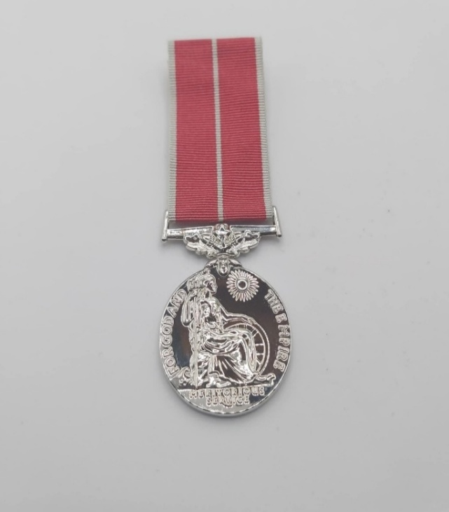

Photo credit: Julian Allerhead BEM.

The British Empire Medal (BEM) formerly the British Empire Medal for Meritorious Service, is awarded for meritorious service civil or military service worthy of recognition by the Crown. The current honour was created in 1922 to replace the original medal, which had been established in 1917 as part of the Order of the British Empire.

Between 1993 and 2012 it was not awarded to citizens of the United Kingdom. The awarding to British citizens was re-started in 2012.

The Royal Engineers Bomb Disposal teams were awarded 93 British Empire Medals, during the Post-War period.

ADAM, Robert Greenhill BEM, (2002351) Corporal, Bomb Disposal, Royal Engineers.

The Citation is taken from file WO373/70/19 held at the National Archives.
Placed in the London Gazette on the 31 December 1946. Supplement 3780. Page 95.

This Non-Commissioned Officer was employed on beach minefield clearance from October 1944 to March 1946 and showed throughout a fine standard of work and leadership. He showed particular courage and skill when dealing with deeply buried mines in Lincolnshire in March and May 1945.
In March, 1945 at a minefield near Mablethorpe. Corporal Adam was largely responsible for the successful clearance of many deeply buried mines. These mines were over three feet deep in sand and therefore beyond detector range and in a dangerous condition, work proceeded by trenching along wires connecting the mines and this required so much care that only two or three mines each day could be found.
In May 1945 Corporal Adam was the Non-Commissioned Officer at another minefield and worked for a month under even more exacting conditions. He showed confidence in leading men to complete the clearance of the field after a fatal accident occurred on it. This field was complicated by deeply drifted sand and the growth of elder and sea thorn. The hazardous method of trenching along the wires was again followed and made extremely difficult due to the rusting away or destruction by mine explosions of these wires that they were seldom continuous. Corporal Adam also encountered a mine suspended upside down its guide wire a clear yard above the ground, and skilfully discovered a case where of two mines laid on top of one another.
Trenching as a method of exposing mines has now been abandoned due to its danger. Corporal Adam’s safe and extensive use of this method fully shows his skilful devotion to duty in a hazardous,

ALLERHEAD, J A BEM, Corporal, 33 Engineer Regiment (EOD), Royal Engineers

The Citation is taken from file WO373/179/355 held at the National Archives.
Placed in the London Gazette on the 16th June 1984. Supplement 49768. Page B20.

Corporal Allerhead joined his squadron as a section commander in May 1980. He immediately set about the task with enthusiasm and, through his leadership and his professional ability he quickly raised the training standard of his section to an exceptionally high level. He constantly displayed boundless energy and outstanding devotion to his duty as section commander, and his personal example was an inspiration to his men, and to many others within the squadron.

In October 1982, he was selected as a member of a troop handpicked for the high qualities necessary to be detailed for four months to Antarctica to assist the British Antarctic Survey. The task was the construction of a new survey station by a joint military and civilian force. Corporal Allerhead again stood out. His leadership and example overcame the difficulties experienced from the severe weather conditions, the long working hours and the remoteness of the area. He very quickly earned the respect and affection of military and civilian members of his team, who worked side by side to achieve in four months far more of the project than was expected of them. He remained cheerful whatever the conditions, and was a constant source of inspiration and strength for members of his team.

Moreover, because of his recognised ability throughout the period he has frequently been called upon to fulfil responsibilities well above his rank. In particular, for long periods during the last 12 months he carried out his duties of squadron reconnaissance sergeant. On no such occasion, when shouldering the burden of higher rank, has he ever been found wanting.

His exceptional response to the demands of his job in the way of inspiring leadership and example, outstanding devotion to duty and acceptance of higher responsibility, mark out Corporal Allerhead as particularly worthy of recognition by an award.

ALEXANDER, J A BEM, (1941172) Sergeant, 5 Bomb Disposal Company, Royal Engineers

No Citation found in the National Archives Catalogue.
Placed in the London Gazette on the 4 June 1946. Supplement 37598. Page 2800.

No further information, possibly awarded for work on beach mine-clearance.

ARCHER, J H BEM, (14261671) Lance Corporal, 3 Bomb Disposal Group, 4 Bomb Disposal Company, Royal Engineers

No Citation found in the National Archives Catalogue.
Placed in the London Gazette on the 4 June 1946. Supplement 37598. Page 2800.

No further information, possibly awarded for work on beach mine-clearance.
ASKHAM, W BEM, (46122291) Sapper, 5 Bomb Disposal Company, Royal Engineers

No Citation found in the National Archives Catalogue.
Placed in the London Gazette on the 4 June 1946. Supplement 37598. Page 2800.

No further information, possibly awarded for work on beach mine-clearance.

BALDOCK, J A BEM, Warrant Officer Class II, 33 Engineer Regiment (EOD), Royal Engineers

No Citation found in the National Archives Catalogue.
Placed in the London Gazette on the 12 June 1992. Supplement 52952. Page 19.

Services as a Search Advisor, Counter Terrorist Operations.

BATCHELOR, W BEM, (1885656) Sapper, Bomb Disposal, Royal Engineers

The Citation is taken from file WO373/69/938 held at the National Archives
Placed in the London Gazette 18th June 1946. Supplement 37613. Page 3057.

Sapper Batchelor has rendered services of exceptional merit in the clearance of unexploded enemy bombs, and the clearance of defensive minefields in the United Kingdom. He has actively and directly engaged in the disposal of more than one hundred bombs during the period July 1940 to October 1943, and thereafter in the clearance of beach minefields and further unexploded bombs. He was in the “Blitzes” at Liverpool, Birkenhead and Wales. During the whole of this period, he cheerfully and unhesitatingly accepted the unique and dangerous hazards of the work and continued so despite the fact that he had been involved in two explosions causing fatal injuries to other members of the working party. His general conduct and devotion to duty under dangerous and hazardous circumstances has been of the highest order.

BEWLEY, H W BEM,)2257721 Sergeant, 22 Bomb Disposal Company and 21 Bomb Disposal Squadron, Royal Engineers

No Citation found in the National Archives Catalogue.
Placed in the London Gazette on the 4 June 1946. Supplement 37598. Page 2800.
No further information, possibly awarded for work on beach mine-clearance.

BORTHWICK, R BEM, (2129001) Lance Sergeant, 20 Bomb Disposal Company, Royal Engineers

No Citation found in the National Archives Catalogue.
Placed in the London Gazette on the 4 June 1946. Supplement 37598. Page 2800.

No further information, possibly awarded for work on beach mine-clearance.

BRABIN, J GM BEM, (1990980) Sergeant, 4 Bomb Disposal Company, Royal Engineers

No Citation found in the National Archives Catalogue.
Placed in the London Gazette on the 28 December 1945. Supplement 37412. Page 2800.

No further information, possibly awarded for work on beach mine-clearance.

BRIGGS, Arthur William BEM, (2004864) Sapper, Bomb Disposal, Royal Engineers

The Citation is taken from file WO373/70/20 held at the National Archives.
Placed in the London Gazette on the 30 December 1946. Supplement 37840. Page 95.

Sapper Briggs was actively employed on the clearance of beach minefields for over twelve months and carried out his duties with a noteworthy keenness and ability.
In particular he has shown great skill and devotion to duty during May 1945 when engaged on a difficult task in Lincolnshire. This minefield had much thick vegetation on it, such as sea thorn and cedar trees, which had grown up among the mines, and elsewhere windblown sand had accumulated to depths up to five feet above the level at which mines were laid. Of 500 mines originally in the field, about 100 had exploded due to the sand and 70 more beyond detector range had to be traced.
Sapper Briggs set a high example of cheerful and courageous work when clearance continued after a fatal accident to a previous party. He had to dig down to follow the guide wires linking mines. These were often four and five feet deep and rusted away or destroyed by exploded mines so that tracing became a slow and dangerous task. Sapper Briggs worked willingly at this trying duty until its completion.

BURLISON, George BEM, (1921189) Sapper, 5 Bomb Disposal Company, Royal Engineers

The Citation is taken from file WO373/86/877 held at the National Archives.
Placed in the London Gazette on the 24th January 1946. Supplement 37422. Page 626.

This Sapper has served continuously with the company throughout the campaign. During the whole period he has cheerfully and enthusiastically carried out all duties assigned to him, and on several occasions displayed courage of a high order. The platoon in which Spr Burlison was serving was engaged over a long period in Normandy in mine clearance operations. On one occasion in October, near Evrecy he was working with a junior NCO in a S-mine field. About midday a lorry in which the platoon sergeant and three other men were riding blew up about two hundred yards away. They immediately went across to the scene of the accident, but could find no trace of the men and little of the lorry. Although affected by this loss of their comrades, the two men then quietly proceeded with the work of detection and marking of the S-mines. During this time, they were quite alone; no other troops were in sight, the nearest being another section of the platoon who were working about three miles away. An hour or so later the junior NCO was badly wounded by an exploding S-mine which he disturbed in some way, and carried over the tapes into the upswept portion of the minefield. Spr Burlison who was only five yards away from the mine was badly shaken and affected by blast but not actually hit. He immediately went to the NCO’s assistance in the minefield and removed him to safety, dressed his wounds, and tended him until the arrival of transport. On the following day he insisted on continuing work with another section.

This Sapper has maintained a consistently high standard of devotion to duty at all times. Whilst engaged on ‘T’ Force operations in April and May 1945 he always volunteered for any special task of booby trap searching which came along. His courage was an example to all members of his platoon and was in fact well known throughout the company.

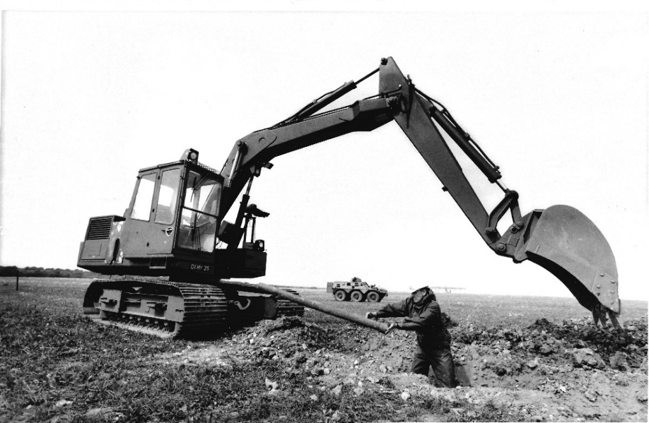

Operation Crabstick, removal of pipe mines laid on UK Airfields through the War as anti-invasion measures. Shown here at Detling, Kent in August 1989.
Photo credit: Peter Markham’s Collection.

BURNHAM, J C BEM, (14616851) Lance Sergeant, 2 Bomb Disposal Group, 20 Bomb Disposal Company, Royal Engineers.

No Citation found in the National Archives Catalogue.
Placed in the London Gazette on the 9 January 1946. Supplement 37412. Page 308.

No further information available, possibly for Beach mine clearance.

BURROWS, C I BEM, (2013838) Sergeant, 4 Bomb Disposal Company, Royal Engineers.

No Citation found in the National Archives Catalogue.
Placed in the London Gazette on the 4 June 1946. Supplement 37598 Page 280.

No further information available, possibly for Beach mine clearance.

CLAXTON, George Alfred BEM, (2154794) Corporal, Bomb Disposal, Royal Engineers

The Citation is taken from file WO373/70/23 held at the National Archives.
Placed in the London Gazette on the 31 December 1946. Supplement 37840. Page 95.

This Non-Commissioned Officer has been in charge of minefield working parties since 1944, and has constantly done excellent work. From January 1945 to November, 1945, he worked in a very difficult anti-personnel minefields in Filey, Yorkshire area, and by his unflinching courage and determination has accomplished every task set him however difficult and dangerous it may have been.
He sets a fine example to his men in his performance of, and devotion to an unpleasant duty.

COLLINS, Raymond George BEM, (23884478) Staff Sergeant, 590 Explosive Ordnance Disposal Squadron (V), 33 Engineer Regiment (Explosive Ordnance Disposal), Royal Engineers

The Citation is taken from file WO373/176/546 held at the National Archives.
Placed in the London Gazette on the 31st December 1977. Supplement 47418. Page B24.

SSgt Collins has during the past 16 years given faithful and devoted service first to the Territorial Army and ten more recently to the Territorial Army and Volunteer Reserve.

He is an extremely enthusiastic, loyal and hardworking senior non-commissioned officer who has throughout his service contributed a very great amount of his time and effort to the attainment of extremely high standards of training. He has great the great ability to get the very best out of his subordinates and can always be relied upon to see any task successfully completed.

His contribution to the training of recruits during the past year has been of an exceptional quality, to which the excellent standards achieved have been a very clear testimony. In addition, he has been responsible for ensuring that his Section has produced the best all round performance in the Squadron.

SSgt Collin recent services have been exceptionally valuable both to his Unit in particular and to the TAVR in general. His devotion to duty continues to be an inspiration to others.

COLPITTS, J BEM, (14164036) Corporal, 4 Bomb Disposal Company, Royal Engineers.

No Citation found in the National Archives Catalogue.
Placed in the London Gazette on the 9 January 1946. Supplement 37412. Page 3094.

No further information, possibly awarded for work on beach mine-clearance.

COOKE, Horace Edward BEM, (1906111) Sergeant, Bomb Disposal Unit (UK), Royal Engineers.

The Citation is taken from file WO373/169/138 held at the National Archives.
Placed in the London Gazette on the 29th January 1961. Supplement 44223. Page 305.

Staff Sergeant Cooke has been continuously engaged upon Bomb Disposal and Minefield Clearance since August 1957. Since 1st January 1958 he has been the Senior NCO of a Bomb Disposal Troop RE. Such duty calls for qualities of leadership, courage and technical ability usually associated with Officer Rank.

During this period, he has been on constant call for Bomb and Mine Disposal operations, and he has assisted with, and in many cases personally dealt with, several hundred incidents of unexploded bombs and mines anywhere in the United Kingdom at immediate notice. He has carried out these duties with the greatest skill and success, often under the most arduous conditions.

His technical knowledge, ability, experience and enthusiasm have been an inspiration to all ranks. This has been particularly apparent when he has accompanied junior officers under training on operations, when his skilful and competent guidance on dangerous tasks has been an outstanding example of complete loyalty. His obvious ability and confidence have dispelled the fears of the Police, Local Authorities and the Public as to the danger which existed to themselves and their property.

He has also been particularly successful in maintaining a very high standard of morale among both the military and civilian personnel employed on these tasks, by forming them into well-knit, integrated teams. This has been achieved by his exemplary devotion to duty and his readiness to accept responsibility for the most difficult tasks and to carry them out successfully.

Further Information
Staff Sergeant H E Cooke had also previously been awarded the George Medal.

COOKE, R BEM, (2004829) Sapper, 4 Bomb Disposal Company, Royal Engineers.

No Citation found in the National Archives Catalogue.
Placed in the London Gazette on the 28 December 1945. Supplement 37412. Page 3094.

No further information, possibly awarded for work on beach mine-clearance.

CRAIK, Harold Drummond BEM, (2075067) Sergeant, 11 Bomb Disposal Company, Royal Engineers

The Citation is taken from file WO373/69/750 held at the National Archives.
Posted in the London Gazette on the 28th December 1945. Supplement 37404. Page 6275.

On the 27th April, 1945, Sergeant Craik accompanied his Platoon Officer, to the scene of a minefield accident. They both swept into the minefield of which they had no charts and removed nine injured Prisoners of War and three dead bodies. Sergeant Craik personally assisted his officer (Lieutenant Borthwick) in sweeping the field and laying the tapes and removing the injured. This was an extremely hazardous operation as the Prisoners of War could not understand English and tended to move towards the clearance party as they approached. If any of the Prisoners of War had chanced to move onto a mine, the clearance party would have been blown up. By his gallant action Sergeant Craik personally saved the lives of nine wounded men and ensured that they were sent to hospital immediately.

COWAN, James BEM, (14282769) Lance Corporal, Bomb Disposal, Royal Engineers

The Citation is taken from file WO373/70/25 held at the National Archives.
Placed in the London Gazette 3rd January 1947. Supplement 37840. Page 95.

This Non-Commissioned Officer has been engaged in Bomb Disposal since October 1954 during which time he has been engaged in many unexploded bomb incidents of a varied nature.

His high sense of duty, coupled with courage, has been undaunted at all times.
For many months he has been engaged on Minefield Clearance on field which presented many difficulties, and here he has shown those qualities which are essential to the safety of all concerned in this hazardous work. At all times his cheerful manner and leadership have been an inspiration to all who worked with him.

COYNE, James Patrick BEM, (1912240), 28 Bomb Disposal Company, Royal Engineers

The Citation is taken from file WO373/85/452 held at the National Archives.
Placed in the London Gazette on the 11 October 1945. Supplement 37302. Page 4996.

Corporal Coyne has been employed on bomb disposal duties for nearly five years. He is an outstanding personality who has done much to maintain the Esprit du Corps of all those men with whom he is associated. Since his arrival in this theatre of operations, he has worked untiringly, and conscientiously carried out with capable efficiency and courage many tasks of an extremely dangerous nature. Both in bomb disposal and mine-clearance. He has always been extremely eager and willing to accept this work without regard to his personnel safety, and in fact had to be restrained for doing too much.

Above all, he has an unbounded cheerfulness and good humour, This, together with his courage and determination under arduous conditions, have been responsible for the successful conclusion of many of his tasks. A week ago, he was wounded and admitted to hospital, he was so anxious to return to his unit, that he pleaded for his release and after three days was discharged. Then despite the fact that some shrapnel was still lodged in his leg, he immediately commenced work.

DAVIES, Steven Robert BEM, (24328637) Sergeant, 33 Engineer Regiment (EOD), Royal Engineers

The Citation is taken from file WO373/181/225 held at the National Archives.
Placed in the London Gazette on the 31 December 1984. Supplement 51578. Page 19.

For the last three years Sergeant Davies has served as an Instructor at the Royal School of Military Engineering. He occupied a particularly demanding post working as a high-risk Search Instructor as a specialist in the equipment needed to detect and locate terrorist arms, explosives and equipment. He not only carried out this vitally important work in an exemplary manner, but also demonstrated in a highly sensitive international operation and in charity work for the local community, a degree of commitment to Her Majesty’s Service which far outweighed the call of duty.

Late in 1987 a quantity of British search equipment prepared under supervision of Sergeant Davies was provided to the Irish Security Forces. In October that year he was sent covertly to the Republic of Ireland to take charge of a team of Irish soldiers receiving, checking and preparing the equipment and Sergeant Davies was ordered to unpack and reissue it. Working long hours with minimal assistance and acting on his own initiative, he checked the items required, carried out emergency repairs and trained a number of individuals in the operation of the equipment. His performance greatly impressed the Irish authorities and was awarded by the gratitude of Her Majesty’s Ambassador in Dublin. The work he did contributed significantly to the success of the subsequent operation by the Irish Security Forces and reflected great credit on the British Army and practically endorsed the spirit of cooperation of Her Majesty’s Government.

It was also in 1987 that Sergeant Davies showed what could be achieved by an individual prepared to use his talent for organisation in the services of the community. During his free time, he personally organised and took part in a Joint Army, Kent Fire Service and Kent Police charity run from London to Paris. His efforts to encourage sponsorship including making successful arrangements for runners to meet the Prime Minister and to be photographed with her at No 10 Downing Street. As a result, the event succeeded in raising almost £8,000 to be divided between the National Society for the Prevention of Cruelty to Children and the Kent Ambulance Service.

For his exceptional service both to his country and to charity Sergeant Davies is very strongly recommended for the award of the British Empire Medal.

DAVIS, E J BEM, Corporal, (2126897) Corporal, 16 and 20 Bomb Disposal Company, Royal Engineers

No Citation found in the National Archives Catalogue.
Placed in the London Gazette on the 28 December 1945. Supplement 37412. Page 3094.

No further information, possibly awarded for work on beach mine-clearance.
DICKEN, R C BEM, Sergeant, 33 Engineer Regiment (EOD), Royal Engineers

No Citation found in the National Archives Catalogue.
Placed in the London Gazette on the 29 June 1991. Supplement 52588. Page G30.

Entry and Clearance of the British Embassy, Kuwait.

DUNCAN, G BEM, 23478365 Staff Sergeant, Bomb Disposal Team (FARELF), Royal Engineers

The Citation is taken from file WO373/182/39 held at the National Archives.
Posted in the London Gazette on the 22nd May 1969. Supplement 44854. Page 5480.

Staff Sergeant Duncan was a member of the original Bomb Disposal Team RE (FARELF) which started the clearance of the World War II Japanese bomb and storage sites on Penang Island in the Spring of 1967, and for the first three months he was the Senior NCO of the team. He served on this task for nineteen months, including crucial early stages of the work when drills were being established for dealing with hazardous largely unknown. During this time, he was personally responsible for the process of digging out and disposing of over a thousand bombs and other explosive devices. He displayed determination, energy and loyalty of the highest order, and his exceptional qualities were an inspiration to all who served with him. His courage and coolness in the face of obvious danger were an example to all and it is very largely due to his skill and technical proficiency that the task went so well from the start.

In January 1968 Staff Sergeant Duncan was badly injured when explosive from a sea mine ignited by accident. Whilst in hospital and whilst recuperating he maintained a close and cheerful interest in the progress of the work and as soon as possible, he returned to duty. His ability, devotion to duty and uncomplaining endurance of tedious and dangerous work made him an outstanding example to all.

EDGAR, Robert Mackay BEM, (14515475) Acting Sergeant, Bomb Disposal, Royal Engineers

The Citation is taken from file WO373/70/23 held at the National Archives.
Placed in the London Gazette 31st January 1969. Supplement 44854. Page 5480.

This Non-Commissioned Officer has been continuously employed on the clearance of Beach Minefields since July 1944 at Perranporth, Isle of Wight and Dorset Coast; during this period, he has personally lifted over five hundred Beach Mines, and some two hundred Anti-Tank Mines. His cool and deliberate personality has been an inspiration to others when entering dangerous Minefields where accidents have previously taken place, and these minefields which have been left due to landslips causing disturbance and tilting of Mines. His cheerful demeanour and devotion to duty have undoubtedly been an influencing factor in clearance of these Minefields with almost totally inexperienced men under his control.

ELLIOT, Sidney BEM, (4040429) Sapper, 7 Bomb Disposal Squadron (POW), Royal Engineers

The Citation is taken from file WO373/69/938 held at National Archives.
Posted in the London Gazette on the 18th June 1946. Supplement 37613. Page 3057.

Sapper Elliot has rendered services of exceptional merit in the clearance of defensive minefields in the United Kingdom. He had been actively and directly engaged for about eighteen months on the clearance of beach mines from difficult minefields in North Wales during the years 1943 and 1944. During this period, he was involved in no less than seven explosions on minefields which he was engaged in clearing. On each of these occasions’ fellow members of the clearing party were fatally injured. Despite these narrow escapes Sapper Elliot continued with his work cheerfully and always accepted without question the dangerous hazards of the work. Since that time and until his release from the Army at the end of 1945 he has been employed on the same class of work in Southern Command. His general conduct and devotion to duty in all these circumstances throughout his Army career has been of the highest order.

FISHER, J BEM, (2128046) Sergeant, 4 Bomb Disposal Company, Royal Engineers

No Citation found in the National Archives Catalogue.
Placed in the London Gazette on the 4 June 1946. Supplement 37598. Page 2803.

No further information, possibly awarded for work on beach mine-clearance.

GARNER, R J M BEM, (2128050) Lance Sergeant, 4 Bomb Disposal Company, Royal Engineers

No Citation found in the National Archives Catalogue.
Placed in the London Gazette on the 4 June 1946. Supplement 37598. Page 2803.

No further information, possibly awarded for work on beach-mine clearance.

GILES, A T BEM, (217201), 4 Bomb Disposal Company, Royal Engineers

The Citation is taken from file WO373/69/837 held at the Nation Archives.
Placed in the London Gazette on 16th April 1946. Supplement 3753. Page 1897

Sapper Giles has been continuously engaged on Bomb disposal operations since October 1940. From October, 1940, until January 1945, he worked on a very large number of unexploded bombs, during which period he has always displayed keenness allied with a coolness which has considerably assisted the men with whom he was engaged. Since January 1945 he has been employed on the clearance of minefields and he has maintained the high standard that he had previously displayed on removal of unexploded bombs. On the 14th September, 1945, he was a member of a squad working on a minefield at Peffer Sands, Dunbar. This minefield was particularly hazardous due to the presence of metallic ore in the ground which was interfering with the efficiency of detection. An accident occurred killing the officer and three men with whom Sapper Giles was working. Sapper Giles was working fifteen yards from the mine that exploded and was blown into a ditch, being the only survivor. In spite of his shocked state, he efficiently carried out his duty of obtaining medical assistance and was then himself taken to hospital. On his return from hospital, he requested that he be allowed to resume work on the minefield clearance and has since carried out these duties efficiently and at the same time set a fine example to his comrades.

GISBORNE, H D BEM, (2128050) Lance Sergeant, 2 and 22 Bomb Disposal Company, Royal Engineers

No Citation found in the National Archives Catalogue.
Placed in the London Gazette on the 4 June 1946. Supplement 37598. Page 2803.

No further information, possibly awarded for work on beach mine-clearance.

GLEESON, Gerard Anthony BEM. (23872055) Staff Sergeant, 591 Explosive Ordnance Disposal Squadron (EOD (V)), 101 (City of London) Engineer Regiment (EOD) (V), Royal Engineers

The Citation is taken from file WO373/181/379 held at the National Archives.
Placed in the London Gazette on the 16th June 1989. Supplement 51772. Page 19.

SSgt Gleeson joined 591 Explosive Ordnance Disposal Squadron (Volunteers) when it formed in 1979, having completed 22 years exemplary service in the Regular Army. His appointment is Squadron Quartermaster Sergeant. During the early part of the Squadron’s formation, he was the only member of the permanent staff and for many months had to undertake all the administrative and pay duties as well as his own at a time when the unit’s vehicles and equipment were being delivered. He worked long hours uncomplainingly and it is due to his efforts alone that the Squadron began its existence so successfully. Until 1985 the Squadron had no dedicated permanent Staff Administrative Officer (Captain) and as the unit expanded the administrative and training load on SSgt Gleeson increased. He took all this in his stride. No work seemed too much for him, and for the whole period he held responsibility far beyond that which should be expected from his rank or experience.

Eventually a Permanent Staff Administrative Officer was appointed and relieved SSgt Gleeson of the work load that should not have been properly his. He did not relax and looked for other challenges to absorb his boundless energy. The Squadron moved location in 1987 and it was necessary to mount a major recruiting campaign. Although not his responsibility he threw himself at the task, working 5 nights a week and every weekend over a period of 2 months to visit potential recruits. The result was the most cost-effective recruiting campaign held in the South East. At the same time, he masterminded the administrative arrangements for the formal opening of the TA Centre. On that day shortly before the opening he was told that his wife and daughter had been admitted to hospital following a road traffic accident. His presence at the TA Centre was critical for the success of the opening and true to form he remained at the event and it was over 6 hours after, that he visited his family.

From the time he joined his Squadron SSgt Gleeson has given his all. He has carried out duties far in excess of what might be expected from a soldier of his rank and experience. He has devoted himself to the Service, putting the needs of others before his own. His efficiency and dedication have been an example to others and are worthy of public recognition.

GRAHAM, Robert BEM, (22845232) Staff Sergeant, 1 Troop, 49 Squadron (EOD), Royal Engineers

The Citation is taken from file WO373/175/85 held at the National Archives.
Posted in the London Gazette on the 22nd May 1973. Supplement 45984. Page 6496.

S/Sgt Graham has served with the Explosive Ordnance Disposal Unit RE since April 1970. For most of his tour he has been employed as NCO in charge of an area clearance section responsible for the detection and disposal of explosive ordnance on former range, field firing and wartime coastal minefield areas.

For the past two years S/Sgt Graham’s section has been based at Scarborough 200 miles north of his Troop HQ at Felixstowe. During this period his section has undertaken 23 separate clearance tasks and has cleared some 2,700 acres of land including the safe disposal of 15,000 items of ordnance, many of which were explosive filled blinds. Most of this work has been carried out in isolated and exposed areas which have been particularly bleak in winter.

S/Sgt Graham has run his section of 25 individual civilian Yorkshiremen in an exemplary way. He has maintained hight standards of work and safety, and has personally disposed of most of the explosive items of ordnance discovered.

He has undoubtedly rendered extremely valuable service to his country in making such a large area of land safe and he has set a personal example to all others in the EOD Unit RE of how an efficient area clearance section should be run.

He is strongly recommended for an award for these services.

GRANT, S J BEM, (2126919) Lance Corporal, 20 Bomb Disposal Company, Royal Engineers

No Citation found in the National Archives Catalogue.
Placed in the London Gazette on the 4 June 1946. Supplement 37598. Page 2803.

No further information, possibly awarded for work on beach mine-clearance.

GREENHAIGH, William BEM, (13023981) Sapper, Bomb Disposal, Royal Engineers

The Citation is taken from file WO373/69/1000 held at the Nation Archives.
Posted in the London Gazette on the 13th December 1946. Supplement 37815. Page 6063.

For services of exceptional merit in the disposal of unexploded bombs and the clearance of defensive minefields in the United Kingdom. This soldier was actively and directly engaged in Unexploded Bomb clearance and the clearance of Beach minefields from January, 1945, to his release in April, 1946. His conduct and devotion to duty was outstanding. He displayed great courage when assisting to recover mines at Polridmouth, Cornwall, in May, 1945.

The minefield composed of Beach type “C” mines was laid adjacent to an artificial lake, and some mines were actually under water. The water level of the lake was lowered to expose the place where the mines lay, but due to flooding the land was now a quagmire. Sapper Greenhaigh, in company with his platoon officer, who searched the ground with a mine detector, waded knee deep in the mud, cut with a sickle the rushes to allow the detector to proceed, and when the detector located a mine Sapper Greenhaigh rendered the mine safe and removed it, all by feel, as the mines, having sunk to a depth of about two feet into the mud, could not be dug out in the normal way.

His determination and example in this instance were undoubtedly a factor which contributed to the eventual successful clearance of a most difficult and dangerous task.

GRUBB, M I BEM, (2156905) Lance Sergeant, 4 Bomb Disposal Company, Royal Engineers

No Citation found in the National Archives Catalogue.
Placed in the London Gazette on the 4 June 1946. Supplement 37598. Page 2803.

No further information, possibly awarded for work on beach mine-clearance.

HARTSHORN, H G BEM, (2191715) Warrant Officer Class II, 12 Bomb Disposal Company, Royal Engineers

No Citation found in the National Archives Catalogue.
Placed in the London Gazette on the 4 June 1946. Supplement 37598. Page 2803.

No further information, possibly awarded for work on beach mine-clearance.
Further Information.
Also awarded the Bomb and Mine Clearance Medal in 1947, which suggest his BEM was for this work.

HAWKRIDGE, John Frederick MBE, (1888737), Bomb Disposal, Royal Engineers

The Citation is taken from file WO373/69/931 held at the National Archives
Posted in the London Gazette on the 14th June 1946. Supplement 37613. Page 3057.

Sergeant Hawkridge has rendered services of exceptional merit in the disposal of unexploded enemy bombs in the United Kingdom. He has been engaged continuously on the recovery of old enemy bombs which had been earlier abandoned owing to the extreme difficulty of access. His experience in difficult excavation combined with his energy and enthusiasm have contributed to the successful disposal of many bombs which had defeated earlier attempts. He has also dealt with bombs which required the greatest Skill on his part to ensure safe access in highly unstable and treacherous ground. Sergeant Hawkridge commenced bomb disposal work in July, 1940 and has assisted in the disposal of more than two hundred and fifty enemy bombs in the London Area. He was intensively engaged on this type of work during the whole of the blitz period, and many of the bombs handled by him were fitted with delayed action and anti-handling devices.

During his entire service in Bomb Disposal over a period of more than five years, Sergeant Hawkridge has been employed on work entailing a high degree of personal risk, but he has cheerfully and unhesitatingly accepted the special hazards involved. His courage and devotion to duty under difficult and dangerous circumstances have set a very high standard.

HEATON, Roger David BEM, (22816971) Staff Sergeant, 579 Squadron (EOD), 101 (London) Engineer Regiment (EOD) (V), Royal Engineers

The Citation is taken from file WO373/181/669 held at the National Archives.
Placed in the London Gazette on the 15^{h} June 1990. Supplement 52173. Page 19.

Staff Sergeant Heaton joined 579 Explosive Ordnance Disposal Squadron (Volunteers) at Greenhithe in 1983 after 22 years exemplary service in the Royal Engineers. Hi is the Non-Regular Permanent Staff Squadron Quartermaster Sergeant. The Squadron had only been formed relatively recently and he was faced with all the problems of brining on a new unit. The Territorial Army Centre had been an old Post Office and due to a moratorium on spending the building, which had fallen into disrepair, could not be renovated to the required standard. SSgt Heaton was undismayed by this and set to work bring the Squadron up to scratch despite the problems that faced him. He built offices and stores and decorated the messes. He became involved in the training of the Squadron. Added to these tasks were the many duties he had to carry out as SQMS. He worked long hours and over many weekends uncomplainingly and under his firm guidance the Squadron prospered.

In November 1987, the Squadrons Permanent Staff Administration Officer (Captain) moved to another squadron in preparation for the formation of 101 (London) Engineer Regiment. SSgt Heaton had to assume his duties as well as his own. He shouldered the extra burden without complaint and quietly got on with both jobs. For nearly a year he had responsibility which should not have been his. He organised a most successful annual camp and ensured the Squadron obtained the very best support. Eventually in September 1988 a new Permanent Staff Administrative Officer was appointed. However, more problems followed. In March 1989, the Headquarters of 101 (London) Engineer Regiment moved from its temporary location to Greenhithe. SSgt Heaton was faced with another reorganisation of offices and stores. Again, he carried out his work uncomplainingly and efficiently without prejudice to his Squadron’s ability to train or be operationally ready.

From the time that he joined his Squadron, SSgt Heaton has committed himself totally. In 1987 and 1998, he carried out his duties far in excess of what might reasonably be expected from a NTPS soldier of his rank and experience. His efficiency and dedication have been an example to all and merit recognition.

HILLIER, Ivor Roland BEM, (14460216) Staff Sergeant, Bomb Disposal Squadron, Royal Engineers

The Citation is taken from file WO373/171/251 held at the National Archives.
Posted in the London Gazette on the 12th May 1965. Supplement 43667. Page 5498.

This NCO has been employed on duties, which involve searches for and disposal of Beach Mines, in the East Anglian Area for some four and a half years. The mines dealt with are standard MK 11 Anti-Tank and the highly treacherous and unpredictable B Type C, which are considered the most dangerous items this unit is called upon to dispose of. The passage of time makes disposal of these miners progressively more difficult to deal with.

During the period under consideration, he has carried out disposal of more than 100 mines, over half being B Type C. despite the dangers involved he has zealously worked in all conditions of weather in sea water and the deep clinging mud of the East Anglian foreshores. In addition, he has willingly worked on experimental processes to develop new render safe procedures, well knowing the hazards involved.

Throughout the whole of his work, he has carried out his duties with maximum calmness despite his inner feelings. His bearing at all times being a credit to his Corps and reassuring to his detachment and the civilian population.

In addition to his operational work, he has commanded an independent detachment, of mixed military and civilian staff, in an exemplary manner maintaining a contented and hardworking unit.

As he is now the senior representative of Bomb Disposal in East Anglia the responsibilities, which would normally be undertaken by a commissioned officer, have been placed with him through circumstances. He has not failed, if anything, the liaison with the Police and Local Councils is now at the best level for many years.

Some of the tasks carried out by this NCO might possibly have justified a recommendation for a gallantry award but because he has worked on his own the true scope of his actions have been reduced to hard facts in his official reports. This is typical of his unselfishness and industry on administration and operations.

HOLE, Francis BEM, (3224) Corporal, Bomb Disposal Section, Malta Fortress Company, Royal Engineers

The Citation is taken from file WO373/122/64 held at the Nation Archives.
Posted in the London Gazette on the 21st May 1957. Supplement 41077. Page 3075.

On the afternoon of the 21st December1956, a report was received by Malta Fortress Squadron, Royal Engineers, from the Malta Police that a suspected unexploded bomb had been uncovered during construction at (location not readable on the document). The Bomb Disposal Officer went straight to the site taking with him, amongst others Corporal Hole.

On arrival they dug away the earth and rocks to reveal a 250-kilogram German General-Purpose Bomb which they had to roll over to reveal the fuzes. These turned out to be a long delay clockwork fuze and an anti-handling fuze both booby-trapped as to prevent their withdrawal. It was this extremely dangerous combination which resulted in many exploding and killing Bomb Disposal personnel during the last war.

The slight movement to the bomb which had been necessary to uncover the fuzes might have been enough to restart the clock. Accordingly, Corporal Horne was the task of listening with stethoscope that if this happened it would immediately be known. This duty he performed for several hours with complete (missing word) whist the complicated disposal kit necessary to tackle this bomb was brought to the site.

The actual task of neutralizing the bomb was naturally performed by the Bomb Disposal Officer personally, but there were times when he needed assistance in his dangerous work. Corporal Hole throughout the night remained constantly at hand to provide with help wherever required. The tasks concerned included the boring of a small hole into both of the fuzes, the cutting of a large hole through the outer casing of the bomb itself and finally the steaming out of the main explosive filling, if at any of these stages the heat and vibration to which the bomb was necessarily subjected could have easily caused its detonation.

The bomb was not finally rendered safe until 9 am on the 22nd December after 17 hours work during the whole of which Corporal Hole was present on the site and took a leading part in the work. Throughout his example of, coolness, courage and willingness to tackle any job given to him was an inspiration to all others engaged on this tricky operation British and Maltese alike. He well understood the dangers and difficulties with which the Bomb Disposal Officer and his team were confronted and his demeanour and devotion to duty were in the highest traditions of the Service.

Further Information
Transcribed as best as can be due to original being a poor copy. S/Sgt Mander was also awarded the British Empire Medal for this incident, see separate incident.

HUMPHREY, Daniel BEM, (2126863) Sapper, Bomb Disposal, Royal Engineers

The Citation is taken from file WO373/69/938 held at the National Archives.
Posted in the London Gazette on the 14th June 1946. Supplement 357613. Page 3057.

Sapper Humphray has rendered services of exceptional merit in the disposal of unexploded bombs and the clearance of defensive minefields in the United Kingdom. He joined Bomb Disposal in its early days - December, 1940, and served in several of the main target areas throughout the height of the “Blitzes”. He assisted his platoon in the work on over 100 bombs of all types. On one occasion the bomb on which he was engaged self-detonated before clearance had been affected and caused fatal injuries to other members of his platoon. Despite this he continued to work with the same enthusiasm, never complaining about the type of job that was given him, however unpleasant. In 1944 and onwards until his release in the latter part of 1945, he was taken off bomb disposal operations and put on to work in connection with clearing parties on many minefields and has always showed the same undaunted courage whilst acting as detector man or whilst disarming mines as he did when on bomb disposal work. He has proved himself to be a steady and reliable Sapper and N.C. Os were glad to have him in their sections as he gave confidence to his fellow workers, and never drew back when called upon to do dangerous work. His general conduct and devotion to duty under dangerous and hazardous circumstances has been of the very highest order.

HUSBAND, Robert BEM, (2003884) Acting Sergeant, 11 Bomb Disposal Company, Royal Engineers

The Citation is taken from file WO373/69/751 held at the National Archives.
Posted in the London Gazette on the 25th December 1945. Supplement 37404. Page 6275.

Sergeant Husband has dealt with numerous bombs and since June 1944 he has been engaged in the clearance of mine fields. He has worked on the clearance of approximately two thousand mines and on many occasions has worked alone or with his Platoon Office in dealing with deeply buried mines; a very hazardous operation requiring great confidence and skill. On the 6th February, 1945, at St. Fergus, North of Aberdeen, he assisted his Platoon officer in dealing with difficult mines which had fallen down a cliff due to collapse of sand caused by rough weather. It is considered that this N.C.O. has shown great gallantry on very many occasions both on difficult bombs and dangerously buried mines.

IRELAND, John BEM, (19019357) Lance Corporal, Bomb Disposal, Royal Engineers

The Citation is taken from file WO373/70/75 held at the National Archives.
Placed in the London Gazette 2ndDecember 1947. Supplement 38139. Page 5751.

A German unexploded bomb was discovered in the Alexander Docks at Liverpool on 11th August, 1947, and Lance Corporal Ireland worked continuously throughout the night, with a total disregard for his own safety on the bomb which was in a highly sensitive state, and which he knew might have detonated at any moment. He accompanied the Officer in Charge – Major Hughes – at all times, and was reluctant to move to a place of safety when ordered.

Further Information
Captain William Hughes was awarded the Member of the British Empire for this incident, see separate entry.

JACKSON, J E BEM, (2133407) Lance Sergeant, 4 Bomb Disposal Company, Royal Engineers

No Citation found in the National Archives Catalogue.
Placed in the London Gazette on the 28 December 1945. Supplement 37412. Page 3057.

No further information, possibly awarded for work on beach mine-clearance.

JONES, Charles Henry BEM, (2126799) Lance Sergeant, Bomb Disposal, Royal Engineers.

The Citation is taken from file WO373/69/932 held at the National Archives.
Posted in the London Gazette on the 14th June 1946. Supplement 37613. Page 3057.

Lance Sergeant Jones has rendered services of exceptional merit in the disposal of unexploded enemy bombs and the clearance of defensive minefields in the United Kingdom. During the period October, 1940 to October, 1943, he has been actively and directly engaged in the disposal of approximately two hundred bombs, a large proportion of which fell in the Bristol Areas. In at least four cases the bombs on which he was employed contained fuzes of the clockwork variety and in all these cases he personally assisted in the immunising of the fuzes and the final disposal of the bombs. On two occasions fatal injuries occurred amongst the personal of his working party when explosions occurred and it was only by a narrow margin that he himself escaped injury. Despite these narrow escapes and the strain of the work Lance Sergeant Jones has never hesitated when given a difficult job to handle. He has inspired his squad with confidence and shown by the example he has set that he was a N.C.O above average. Towards the end of 1943 he was taken of Bomb Disposal and put on Beach Mine Clearance until his release from the Army at the end of 1945. Throughout his five years spent on the clearance of mines and bombs, his general conduct and devotion to duty under dangerous and hazardous circumstances has been of the highest order and an inspiration to the less experience members of his section.

LEWIS, Thomas BEM, (1991656) Corporal, 7 Bomb Disposal Company, Royal Engineers.
The Citation is taken from file WO373/69/936. held at the National Archives.
Posted in the London Gazette on the 18th June 1946. Supplement 37613. Page 3057.
Corporal Lewis has rendered services of exceptional merit in the disposal of unexploded enemy bombs, and the clearance of defensive minefields in the United Kingdom. He has actively and directly engaged in the disposal of more than two hundred bombs during the period November 1940 to October 1943, and therefore up to the present date in the clearance of beach minefields and further unexploded bombs. He was in the “Blitzes” in Bristol, Devonport, Plymouth, Exeter and Bath and worked on approximately ninety bombs with clockwork delayed fuzes. During the whole of this period, he cheerfully and unhesitatingly accepted the unique and dangerous hazards of the work and continued to despite the fact that he had been involved in five explosions and carries four wound stripes. His general conduct and devotion to duty, has always been of the very finest order.

LEWIS, Alfred Victor Sidney BEM, (1877164) Corporal, Bomb Disposal, Royal Engineers

No Citation found in the National Archives Files.
Posted in the London Gazette on the 01st January 1948. Supplement 38163. Page 47.

Citation taken from his London Gazette entry.

The King has been graciously pleased to approve the award of the British Empire Medal (Military Division), in recognition of Mine Clearance and Bomb Disposal service since the end of the War.

MANDER, W BEM, (1895256) Staff Sergeant, Bomb Disposal Section, Malta Fortress Company, Royal Engineers

The Citation is taken from file WO373/122/64 held at the Nation Archives.
Posted in the London Gazette on the 21st May 1957. Supplement 41077. Page 3075.

On 21st Dec1956 a 250-kilogram German bomb was discovered at [location cannot be read], had uncovered part of what appeared to be an unexploded bomb. On uncovering it this particular bomb was found to be fitted with two fuzes, one a long delay clockwork type and the other an anti-disturbance fuze, both of which were booby-trapped to prevent withdrawal. This was the type of bomb which caused many casualties to Bomb Disposal personnel in their efforts to dispose of them during the last war.

Being in a large built-up area the Bomb Disposal Officer decided that demolition in situ was not feasible and that every effort must be made to render the bomb safe despite the danger to which personnel working on the bomb would therefore be exposed. Staff Sergeant Mander accepted this decision as the natural and correct [next three words unreadable] and to work to render every assistance possible to his officer. First, they bored a small hole into each fuze and poured in a liquid to render it inoperative. Since the anti-withdrawal devices and the highly sensitive explosives located in the fuze pockets could not be neutralised the bomb still remained very dangerous. They next cut a hole through the outer casing of the bomb using a steam operated trepanning machine and finally steamed out the main explosive filling. The heat necessarily generated in the vicinity of the fuze pockets by these operations meant that detonation whilst they were in progress was by no means unlikely. Although for much of the time it was possible to watch what was going on from a relative safe distance it was necessary to make several visits to the site to ensure that all was going properly. Such visits had to be made more frequently than normal as a result of the temperamental performance of the steam generator.

During the whole of the operations Staff Sergeant Mander was always actively assisting his officer. Throughout this 17-hour task he displayed the greatest personal courage and coolness. He was fully aware of the danger of the task and the risks involved yet his demeanour and devotion to duty were exemplary and the greatest encouragement to all others present.

Transcribed as best as can be due to original being a poor copy. Corporal Hole was also awarded the British Empire Medal for this incident, see separate incident.

Further Information
Captain Dalby was awarded the Member of the British Empire for this incident see separate entry.

MANN, Leonard Mitchell BEM, (1924842) Sergeant, 16 Bomb Disposal Company, Royal Engineers

The Citation is taken from file WO373/169/931 held at the Nation Archives.
Posted in the London Gazette on the 18 June 1946. Supplement 37613. Page 3057.

Sergeant Mann has rendered service of exceptional merit in the disposal of unexploded enemy bombs in the United Kingdom.
As a result of his skill and experience this NCO was employed on the recovery of old enemy bombs in three different counties, which had been earlier abandoned owing to the extreme difficulty of access. He has had an outstanding record of success in the disposal of bombs which had defeated previous attempts. In July, 1944, Sergeant Mann restarted work on a large armour piercing bomb which had been dropped the previous April and which had been excavated to a depth of 50 feet. Working alone and knowing the danger of collapse of the shaft which had been sunk, he attempted to insert additional support, but after two hours work the shaft caved in. He eventually recovered the bomb by sinking a further shaft.
Sergeant Mann was actively and directly engaged in the disposal of more than 250 enemy bombs in three other counties from August, 1940 until July, 1942, taking little or no rest during operations. During the whole of his service, he has cheerfully and unhesitatingly accepted the special hazards of the work and his quiet determination, powers of leadership and readiness to undertake personally the most dangerous tasks have earned the admiration of his officers and the confidence of his men.

MANNION, Thomas BEM, (4210389) Lance Sergeant, Bomb Disposal, Royal Engineers

The Citation is taken from file WO373/70/25 held at the Nation Archives.
Placed in the London Gazette on the 31st December 1947. Supplement 37840. Page 95.

This Non-Commissioned Officer has served for a long time in Bomb Disposal and since cessation of hostilities has been responsible for dealing with many hundreds of mines. By his fine bearing and determination, he has strongly influenced younger men under his command. He has approached the hazardous task of Minefield Clearance in the United Kingdom with a high sense of responsibility and undeterred by casualties has concluded every task set him with success.

MOORCROFT, B BEM, (14573910) Corporal, 4 Bomb Disposal Company, Royal Engineers

No Citation found in the National Archives Catalogue.
Placed in the London Gazette on the 4 April 1946. Supplement 37589. Page 2805.

No further information, possibly awarded for work on beach mine-clearance.

MORGAN, W S BEM, (1918105) Sergeant, 4 Bomb Disposal Company, Royal Engineers

No Citation found in the National Archives Catalogue.
Placed in the London Gazette on the 4 April 1946. Supplement 37589. Page 2805.

No further information, possibly awarded for work on beach mine-clearance.

M’QUOID, J A, Sergeant BEM, 33 Engineer Regiment (EOD), Royal Engineers

No Citation found in the National Archives Catalogue.
Placed in the London Gazette on the 12 June 1992. Supplement 52173. Page B19.

For work after the Liberation of Kuwait.

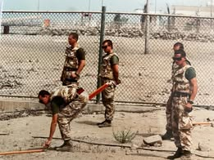 | 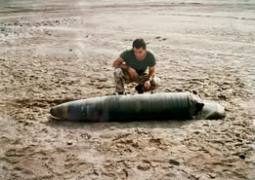

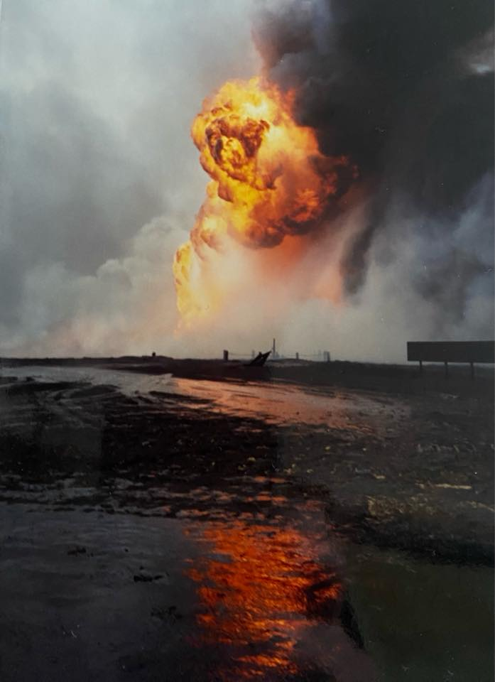 | 21 Field Squadron (EOD) Kuwait.  Photo’s given by Mike Croll

OWEN, Arthur BEM, (1969904 Acting Lance Corporal, 79 Bomb Disposal Section, Royal Engineers

The Citation is taken from file WO373/69/935 held at the Nation Archives.
Posted in the London Gazette on the 18th June 1946. Supplement 37613. Page 3057.

Lance Corporal Owen has rendered services of exceptional merit in the disposal of unexploded enemy bombs and the clearance of defensive minefields in the United Kingdom. He was actively and directly engaged in the disposal of approximately two hundred enemy bombs in the London Area during the whole of the blitz period from September 1940 onwards and thereafter to the present date in the clearance of beach minefields and further enemy bombs. During the whole of this period, he cheerfully and unhesitatingly accepted the special hazards of the work, continuing to do so despite the fact that on at least two occasions he was associated with bomb explosions in which members of his unit lost their lives. His general conduct and devotion to duty in circumstances of great danger have been of the highest order.

PAVEY, Horace BEM, (2027710) Staff Sergeant, 159 Bomb Disposal Platoon, Royal Engineers

The Citation is taken from file WO373/75/179 held at the Nation Archives.
Posted in the London Gazette on the 11th December 1945. Supplement 37386. Page 6072.

Sgt Pavey has been Platoon Sergeant in 158 B.D. Pl., RE since May 1942. During April 45 the Platoon was engaged on Bomb Disposal work and mine clearance in support of 5 Corps and Polcorps, their main commitment being the clearance of mines for the signal line along Route 9 to Bologna.
No matter what speed the advance, so well did Sgt Pavey organise his men and press forward as far as the tactical situation would permit, that at no time were the Royal Signals delayed in opening up those vital 8 Army telephone communications.

In particular, while clearing the area round the Senio crossing which was heavily mined with many types of mines, Sgt Pavey distinguished himself on two occasions by the cool manner and exceptional speed with which he reorganised and encouraged his men after casualties had occurred. There is no doubt that his courageous leadership and sound judgement were on these occasions as well as previous ones responsible for preventing any panic and probable further casualties so that work could proceed without delay.

PEACOCK, H W BEM, (14384553) Corporal, 4 Bomb Disposal Company, Royal Engineers

No Citation found in the National Archives Catalogue.
Placed in the London Gazette on the 4 December 1946. Supplement 37589. Page 2805.

No further information, possibly awarded for work on beach mine-clearance.

PILKINGTON, T BEM, Staff Sergeant, 101 (London) Engineer Regiment (EOD) (V), Royal Engineers

No Citation found in the National Archives Catalogue.
Placed in the London Gazette on the 1 June 1991.

No Further Information

POMEROY, C BEM, Staff Sergeant, 4 Bomb Disposal Company, Royal Engineers

No Citation found in the National Archives Catalogue.
Placed in the London Gazette on the 4 December 1946. Supplement 37589. Page 2805.

No further information, possibly awarded for work on beach mine-clearance.

POWELL, B BEM, (2113945) Sergeant, 4 Bomb Disposal Company, Royal Engineers
No Citation found in the National Archives Catalogue.
Placed in the London Gazette on the 4 December 1946. Supplement 37589. Page 2805.

No further information, possibly awarded for work on beach mine-clearance.

PRISTON, H BEM, (14336572) Lance Sergeant, 20 Bomb Disposal Squadron
Royal Engineers
No Citation found in the National Archives Catalogue.
Placed in the London Gazette on the 4 December 1946. Supplement 37589. Page 2805.

No further information, possibly awarded for work on beach mine-clearance.

REGAN, H BEM, (4688151) Sergeant, 20 Bomb Disposal Company, Royal Engineers

No Citation found in the National Archives Catalogue.
Placed in the London Gazette on the 4 December 1946. Supplement 37589. Page 2805.

No further information, possibly awarded for work on beach mine-clearance.

RICHARDS, A J BEM, (2127095) Sapper, 20 Bomb Disposal Company, Royal Engineers

No Citation found in the National Archives Catalogue.
Placed in the London Gazette on the 4 December 1946. Supplement 37589. Page 2805.

No further information, possibly awarded for work on beach mine-clearance.

RICHARDS, Charles John BEM, (1942668) Lance Corporal, Bomb Disposal, Royal Engineers

The Citation is taken from file WO373/69/937 held at the National Archives.
Posted in the London Gazette on the 14th June 1946. Supplement 37613. Page 3057.

Lance Corporal Richards has rendered services of exceptional merit in the disposal of unexploded enemy bombs and the clearance of defensive minefields in the United Kingdom. He was actively and directly engaged in the disposal of approximately two hundred enemy bombs in the Bristol, Stroud and Plymouth areas from January 1941 to July 1942 and thereafter on the clearance of beach minefields and further unexploded bombs. During the blitz period he was engaged intensively on bomb disposal work of the highest priority and his cheerful and unhesitating acceptance of special hazards provided a high example to his fellows and a very valuable contribution to the progress of the work. His role in minefield clearance was of detector man on whom the safety of the whole clearing party depended. He has carried out this role for a total period of about eighteen months on many minefields in Dorset and Cornwall and has earned and maintained the complete confidence of his party in his skill and leadership. His general conduct and devotion to duty in dangerous and difficult circumstances have been of the highest order.

RICHES, William Stanley BEM, (2128081) Lance Sergeant, Bomb Disposal, Royal Engineers

The Citation is taken from file WO373/69/933 held at the National Archives.
Placed in the London Gazette on the 14th June 1946. Supplement 37613. Page 3057.

Lance Sergeant Riches has rendered services of exceptional merit in the disposal of unexploded bombs and the clearance of defensive minefields in the United Kingdom. In October 1944 he was in charge of s Section engaged in the recovery of old enemy bombs in the Berkshire and Oxfordshire counties which he had earlier abandoned owing to extreme difficulty to access. His resources and experience have contributed to the successful disposal of many bombs which had defeated earlier attempts. Between February and September 1944, he was engaged on clearance of defensive minefields at various places.

Following scattered enemy raids during May 1944, Sergeant Riches with a party of two men disposed of thirty-five German Butterfly bombs which were fully armed and highly sensitive. He also engaged in the disposal of approximately forty bombs in the Southampton and Portsmouth areas between May 1941 and July, 1942, as well as on three Category “A” operations, where the importance to the war effort of clearing the bombs was so great that at the instance of the Regional Commissioner, work was commenced without waiting for the expiry of the four-day danger period.
During the whole of his service in Bomb Disposal, he has cheerfully undertaken great personal risk and continued to do so after having had experience of an explosion involving fatal injuries to members of his unit. His high standard of leadership as an N.C.O. and his devotion to duty in hazardous circumstances have set an example to his fellows and have contributed very greatly to the success of the dangerous work on which he has been engaged.

RIDER, A E BEM, (2126813) Corporal, 4 Bomb Disposal Squadron, Royal Engineers

No Citation found in the National Archives Catalogue.
Placed in the London Gazette on the 4 June 1946. Supplement 37589. Page 2805.

No further information, possibly awarded for work on beach mine clearance
ROLFE, F T BEM, (14524293) Sapper, Bomb Disposal, Royal Engineers

No Citation found in the National Archives Catalogue.
Placed in the London Gazette on the 4 June 1946. Supplement 37589. Page 2805.

No further information, possibly awarded for work on beach mine clearance

ROOKS, Arthur Basil BEM, (1924400) Corporal, Bomb Disposal, Royal Engineers

The Citation is taken from file WO373/69/933 held at the National Archives.
Placed in the London Gazette on the 14th June 1946. Supplement 37613. Page 3057.

Corporal Rooks has rendered services of exceptional merit in the disposal of unexploded enemy bombs in the United Kingdom.

He joined a Bomb Disposal unit in the very early days of the war and from August to December 1940 worked continuously on disposal of bombs mainly on the East Anglian aerodromes. At the end of 1940 he moved to Liverpool to assist in the clearance of bombs after heavy raiding, and later he was again moved to the East of London Area at Romford to assist in similar work there. During this whole period his platoon was responsible for the clearance of about seventy bombs and Corporal Rooks himself was actively employed with them on actual clearance for the whole time. Amongst those on which he worked was a Category “A” bomb on the railway at Royston and another at Bishop Stortford which self-detonated. His job has always been a responsible one entailing long hours of work. Laterly his task has included the keeping of Minefield records and plans. Notwithstanding the difficulties under which at time he has had to work, Corporal Rooks has always operated in a very willing and cheerful manner. His devotion to duty and example he has set to all ranks has been outstanding. He was awarded the Commander-in-Chief’s Commendation for good service in 1943.

Post-War EOD Work in The Falkland Islands

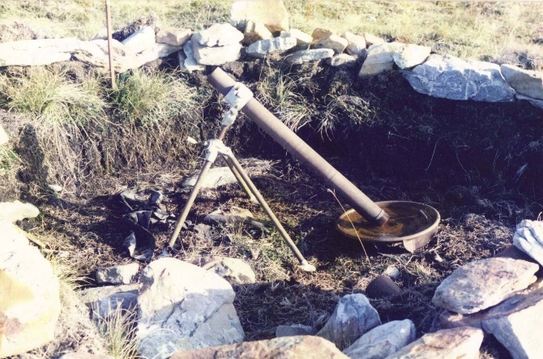 | 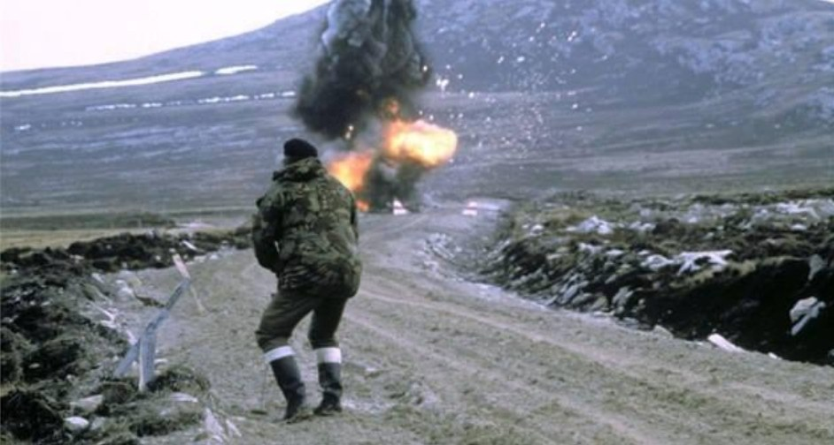
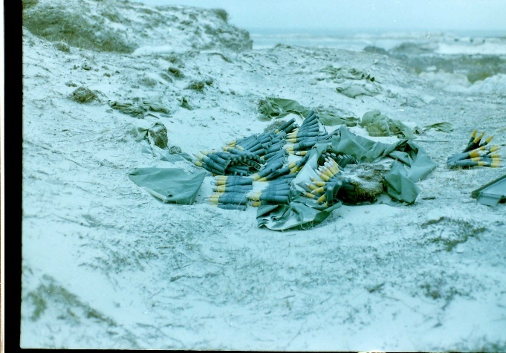 | 

Top Left: Argentinian Mortar Position Mount Harriett. Top Right: Demolition.
Middle Left: Abandoned munitions. Middle Right: Anti-tank mine.

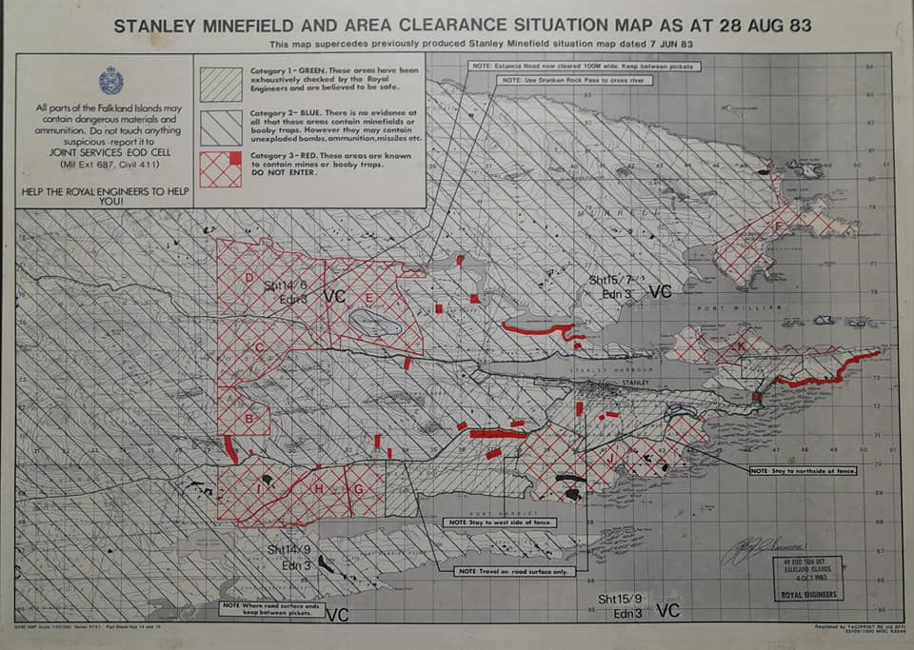

An early version of a Minefield Situation map.

SAWYER, Joseph Olukunle BEM, (24179971) Sergeant, 33 Engineer Regiment (EOD), Royal Engineers

The Citation is taken from file WO373/179/545 held at the National Archives.
Placed in the London Gazette on the 31st December 1988. Supplement 49969. Page 20.

Between June and October 1983 Sgt Sawyer was an Explosive Ordnance Section Commander in the Falkland Islands. As such he was directly responsible for several outstanding actions. For example, on 13th July 1983 Sgt Sawyer was tasked to investigate a report of unexploded bomblets north of Sapper Hill. A thorough search was completed by his section and a total of 14 bomblets were discovered, all in a highly dangerous state. Many were under mud or water and were either corroded or broken open, although the fuzes were believed to be intact. During 4 days he personally destroyed each bomblet without regard for his own life. The bomblet is known to be highly sensitive to any disturbance and each explosive charge had to be placed very delicately by hand. On 15th September 1983 whilst he and his section were carrying out Battle Area Clearance on Mount Longdon, a member of his section stood on an Anti-Tank mine. Sgt Sawyer immediately ordered his men to stand still and not to move. He investigated and identified the mine and instantly called for helicopter assistance. Each soldier was winched to safety from where he stood. His calm, confident and decisive approach during both incidents undoubtedly ensured that no loss of life or injury was sustained by his men. He displayed considerable personal courage throughout without regard for his personal safety.

SCOTTOCK, C BEM, (1922242) Lance Sergeant, 4 Bomb Disposal Squadron, Royal Engineers

No Citation found in the National Archives Catalogue.
Placed in the London Gazette on the 4 June 1946. Supplement 37589. Page 2805.

No further information, possibly awarded for work on beach mine-clearance

SIDEBOTTOM, David BEM, {2092109) Corporal, Bomb Disposal, Royal Engineers

The Citation is taken from file WO373/70/25. Held at the National Archives.
Placed in the London Gazette on the 29th December 1947. Supplement 36866. Page 39.

For services of exceptional merit in the Disposal of Unexploded Bomb and the clearance of Defensive Minefield in the United Kingdom.
The Non-Commissioned Officer has worked continuously since November 1944 on the Clearance of Beach Minefields and the Disposal of Unexploded Bombs until his release in August 1946. He has personally supervised the excavation down to at least fourteen Bombs and has assisted in the clearance of over five hundred Beach Mines on the Isle of Wight and Dorset Coasts, some of which were recovered from Whitecliffe Isle of Wight, where the Minefield had been laid with Anti-Personnel Mines, and further had been disturbed by enemy Bombing which piled debris over the Mines. His cheerful demeanour and devotion to duty undoubtedly contributed to a successful clearance without mishap. Further, at Swanage he personally carried out burning of undergrowth on an area where forty Mines were unaccounted for, and no plans existed of their position, and displayed courage and endeavour of a very high order.

SMETHURST, Edgar BEM, (2126353) Lance Corporal, 90 Bomb Disposal Platoon, Royal Engineers

The Citation is taken from file WO373/75/214 held at the National Archives.
Posted in the London Gazette on the 13th December 1945. Supplement 37386. Page 6072.

Whilst clearing Arezzo Rail Yards in Apr 45 in order that they could be opened up as a supply base L/Cpl Smethurst discovered a 500-pound bomb fitted with anti-handling pistol and anti-disturbance fuze which fitments made the bomb likely to explode at any time particularly if disturbed in anyway. With fine disregard for his own personal safety, he dispersed the other men working with him and personally investigated the bomb inserting a charge for blowing it in situ. Throughout L/Cpl Smethurst showed outstanding courage and devotion to duty and set a fine example to the men working with him.

SMITH, D K BEM, (1900853) Company Quarter Master Sergeant, 4 Bomb Disposal Squadron, Royal Engineers

No Citation found in the National Archives Catalogue.
Placed in the London Gazette on the 4 June 1946. Supplement 37589. Page 2805.

No further information, possibly awarded for work on beach mine-clearance

SMITH, Frank BEM, (1910024) Lance Sergeant, Bomb Disposal, Royal Engineers

The Citation is taken from file WO373/67/280 held at the National Archives.
Placed in the London Gazette on the 4 June 1946. Supplement 37589. Page 2805.

Sergeant Smith has been engaged continuously on bomb disposal work since July, 1940. He has always displayed tremendous enthusiasm for his work, and a complete disregard of personal danger. He has carried out numerous reconnaissance’s and his sound judgement and his skill in timbering has been of inestimable value. His cheerful readiness to tackle any job and his determination has been a fine example to the men working with him.

This N.C.Os record over 14 months continuous employment on bomb disposal discloses a high degree of personnel courage and devotion to duty. Judged by present day technique, the methods adopted by him and his Section Officer to render the bomb safe on two particular occasions brought to notice were extremely hazardous, and being premeditated called for a very high degree of cool courage.

SMITH, W J BEM, (2128535) Sergeant, 4 Bomb Disposal Squadron, Royal Engineers

No Citation found in the National Archives Catalogue.
Placed in the London Gazette on the 4 June 1946. Supplement 37589. Page 2805.

No further information, possibly awarded for work on beach mine-clearance

SPICER, William George BEM, (14338369) Lance Sergeant, Bomb Disposal
Royal Engineers.

The Citation is taken from files WO373/182/999 and WO373/182/1000 held at the National Archives.
Placed in the London Gazette on the 10th December 1946. Supplement 37815. Page 6063.

This Non-Commissioned Officer has been actively and directly engaged in the disposal of Unexploded Bombs in Plymouth, Bristol and Southampton since January, 1944. During the whole of this period, he has cheerfully and unhesitatingly accepted all the dangerous hazards of the work, particularly those of incidents previously abandoned as impossible to recover.

In these cases, his conduct and disregard of personal risk under hazardous circumstances, has been outstanding; His endurance and tenacity of purpose culminated in an act on 22nd August, 1946 at Southampton in connection with the recovery of a 1000-kilogram Armour Piercing Bomb in Hanover Buildings, Bargate, Southampton.

The bomb had been uncovered, and was found to be fitted with a fuze extension cap covering the fuze, so that the fuze could not be identified. Under the circumstances it had to be regarded as potentially dangerous. On the night of 21st/22nd August, 1946, a severe storm broke over Southampton, and at 0100 hours on the 22nd August, 1946, the night piquet telephoned Company Headquarters and reported that the pumps had failed, the excavation was filling with water, and the timbering appeared to be in danger of collapsing. The Officer Commanding Bomb Disposal Platoon carrying out the work informed Lance Sergeant Spicer, who was Non-Commissioned Officer in charge of the work and together they went to Southampton to investigate the situation. It was found that due to excessive rain liquid mud had begun to well up inside the excavation and to cover the bomb. At first light Lance Sergeant Spicer descended into the excavation, a depth of forty-two feet, and regardless of the very great risk he ran due to the uncertain danger of the fuzes, and the very real danger of the timbering collapsing, and working up to his waist in slimy mud, was successful in shoring up the timber and strengthening the structure generally.

There is no doubt that the prompt assistance given by Lance Sergeant Spicer prevented the timbering from collapsing and so made the eventual recovery of the bomb possible.

Further Information
Lieutenant Norman Charles Young was awarded the Member of the British Empire for his part in this incident.

STEER, G R BEM, (2014940) Corporal, 4 Bomb Disposal Squadron, Royal Engineers.

No Citation found in the National Archives Catalogue.
Placed in the London Gazette on the 4 June 1946. Supplement 37589. Page 2805.

No further information, possibly awarded for work on beach mine clearance

STEPHENS, J BEM, (2126960) Corporal, 20 Bomb Disposal Company, Royal Engineers.

No Citation found in the National Archives Catalogue.
Placed in the London Gazette on the 4 June 1946. Supplement 37589. Page 2805.

No further information, possibly awarded for work on beach mine clearance

TAYLOR, Samuel John BEM, (14235545) Sapper, 4 Bomb Disposal Group, 6, 7 and 16 Bomb Disposal Company, Royal Engineers

The Citation is taken from files WO373/69/326 held at the National Archives.
Placed in the London Gazette on the 20 December 1945. Supplement 36995. Page 157.

On the 13 September, 1944, Sapper Taylor was a member of a part engaged on the clearance of a beach minefield at Mudeford, Hampshire, when an explosion occurred, killing two Sappers instantly. Sapper Taylor was detailed, with other members of the party to, pick up the bodies. Sapper Taylor volunteered to enter the upswept field with a mine detector and to sweep a path. He performed this task with coolness and deliberately and finally assisted in the removal of the bodies. In view of the fact that Sapper Taylor had just witnessed the sudden death of two of his comrades, his immediate action and the coolness displayed in his performance was outstanding. He set a high standard of courage and efficiency to other members of his party.

Further Information
The identity of the two casualties has not so far been established.

THOMAS, Edward Emlyn BEM, (1912588) Warrant Officer Class II, 1 Bomb Disposal Troop, Royal Engineers

No Citation on the National Archives files.
Posted in the London Gazette on the 30th October 1953. Supplement 40004. Page 5855.

Warrant Officer Thomas was Sergeant Major in charge of the work of clearing Mundesley Minefield when two of his N.C.O. s who formed a team for detecting and uncovering mines, were killed by the explosion of a Beach Mine.
Warrant Officer Thomas was with his Troop Officer Captain Hough when the accident occurred. He ordered up the ambulance crew before following Captain Hough to the site. He accompanied Captain Hough into the Minefield which they both crossed by crawling to ascertain whether any assistance could be given to one of the N.C.O. s, whose body had been thrown some 25 yards into the Minefield. In the subsequent recovery of the body the re-opening of the Minefield Warrant Officer Thomas took a part second only to Captain Hough. Warrant Officer Thomas was well aware that the mines in the neighbourhood while set originally to explode under a weight of 50 lbs, were likely to be set of at a much lower pressure on account of their age. He also appreciated that the mines in this part of the Minefield were for the most part laid comparatively close together. By his coolness and courageous devotion to duty, Warrant Officer Thomas contributed very considerably to the restoration of morale to the Troop.

See the GC entry for Captain Hough. In particular, the comments of The Coroner,
who said that the men were on ‘a particularly dangerous job which they faced with cool-headed courage, and they earned the gratitude of the people of the village and Norfolk’. He continued that they died just as much for their country in 1953 as if the accident had happened in 1943.

THOMAS, J BEM, (2091592) Lance Corporal, 4 Bomb Disposal Squadron, Royal Engineers.

No Citation on the National Archives files.
Posted in the London Gazette on the 28 December 1945. Supplement 37412. Page 316.

No further information, possibly awarded for work on beach mine-clearance.

THOMAS, S M BEM, (1879227) Corporal, 4 Bomb Disposal Squadron, Royal Engineers.

No Citation on the National Archives files.
Posted in the London Gazette on the 4 June 1946. Supplement 37598. Page 2807.

No further information, possibly awarded for work on beach mine-clearance.

UPTON, J G BEM, (14272226) Sergeant, 4 Bomb Disposal Squadron, Royal Engineers.

No Citation on the National Archives files.
Posted in the London Gazette on the 26 November 1946. Supplement 37412. Page 308.

No further information, possibly awarded for work on beach mine-clearance.

VAUGHAN, William BEM, (1903909) Corporal, 4 Bomb Disposal Company, Royal Engineers.

The Citation is taken from files WO373/68/532 held at the National Archives.
Placed in the London Gazette on the 07 July 1944. Supplement 36596. Page 3169.
Whilst engaged on the clearance of Brach Mines from a minefield on the East Coast, Corporal Vaughan heard an explosion in another portion of the field. He immediately ran to the spot and found that a mine had detonated, causing casualties to the working party. He quickly appreciated the situation and took complete charge of all rescue operation.
One member of the works party had been blown into a portion of the minefield already swept and Corporal Vaughan detailed a party to go to his assistance. Another Sapper had however, been thrown into an unswept area of the minefield. Corporal Vaughan called for a Polish Mine Detector to enable a safe path to be made into the field for the rescue party, but on seeing that this injured man was in great distress, apparently blind and at any minute liable to move onto a mine, Corporal Vaughan, without waiting for the detector and regardless of his own personal safety, crawled into the minefield and successfully brought the injured Sapper to safety.

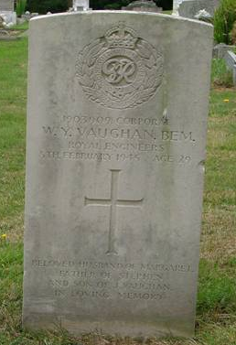 | Further Information  Corporal W Y Vaughan BEM died with Lance Sergeant L Holbrook, Lance Corporal G Sweetman on the 5 February 1945 whilst clearing beach mines laid as anti-invasion measures, at Waxham, Norfolk.  He is buried at Haycombe Cemetery, Bath, Plot 28 Section F, Row A, Grave 295.

VIOLET, F A BEM, (14625456) Lance Corporal, 4 Bomb Disposal Squadron, Royal Engineers

No Citation on the National Archives files.
No London Gazette entry found.

Awarded for work on beach mine-clearance.

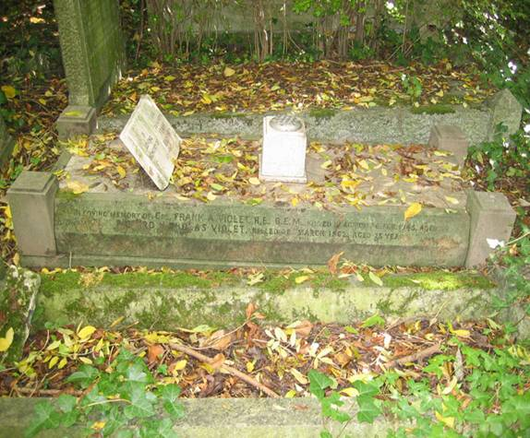 | Further Information  Died clearing Beach mines at Horsey, Norfolk. On the 26 February 1945.  Buried at Highgate Cemetery, Square 70, Grave 48753.  Photo credit: Phil Seaton.

WEBB, W A BEM, (2078344) Corporal, 20 Bomb Disposal Company, Royal Engineers

No Citation on the National Archives files.
Placed in the London Gazette on the 4 June 1946. Supplement 37598. Page 2580.
No further information, possibly awarded for work on beach mine-clearance.

WEBBER, Albert Edward BEM, (203413) Company Quartermaster Sergeant, 20 Bomb Disposal Company (POW), Royal Engineers

The Citation is taken from file WO373/157/686 held at the National Archives.
Placed in the London Gazette on the 10th January 1960. Supplement 44223. Page 305.

CQMS. A.E Webber has served with this Unit for more than five and a half years of his seven and a half years Army Service and for five and a half years been employed in complete charge of the Company Stores. In view of the specialised nature of the Unit Tasks the volume and multiplicity of stores, equipment and machinery etc held on charge has been very considerable in excess of a Unit of similar strength.

Apart from the assistance of a storeman, CQMS Webber has carried out his wide range of duties including the whole of the accounting for the stores of a number of widely scattered Plns, entirely alone, and the commendation from inspecting Officers and boards have testified to the proven success of his zealous efforts.

His keen sense of duty and unflagging enthusiasm under very difficult conditions have made a real contribution to administrative efficiency of the Unit, as a whole and in view of the unspectacular nature of his duties, this conduct and example are worthy of the highest praise.

WHEDDON, H A BEM, (1913661) Sergeant, 10 Bomb Disposal Company, Royal Engineers

No Citation on the National Archives files.
Placed in the London Gazette on the 4 June 1946. Supplement 37598. Page 2580.
No further information, possibly awarded for work on beach mine-clearance

WILKINSON, Stephen Gordon BEM, Lance Corporal, 33 Engineer Regiment (EOD), Royal Engineers

The Citation is taken from file WO373/179/278 held at the National Archives.
Placed in the London Gazette on the 30th December 1983. Supplement 49583. Page21.

LCpl Wilkinson is a Bomb Disposal Engineer in 33 Engineer Regiment Explosive Ordnance Disposal (EOD). He led the initial phase of the current development of thermal imagery for detection of buried objects especially plastic mines. He developed the technique and equipment involved; set up, carried out and reported on trials; dealt with the Ministry of Defence, civilians’ firms and research establishments and trained equipment operators. Throughout the period he has suffered great pain and discomfort from pancreatitis which led to the partial removal of his pancreas.

LCpl Wilkinson has impressed a wide selection of senior civilians and military officers with his technical knowledge and personal performance. His verbal briefings and written reports have been clear and to the point. He has worked largely unsupervised. The project would not have been initiated when it was, and progressed as it has, without his efforts. The timely assessment of the value of thermal imagery is EOD, particularly in the context of the Falklands mine clearance task, has been due largely to LCpl Wilkinson’s initiative, determination and acceptance of responsibility.

He has constantly put his work before his own needs and has exerted himself cheerfully in spite of the continuing pain and other debilitating effects of the surgery and treatment he has undertaken. That a phase of such important development should have been led by a lance corporal is itself little short of astounding; feat beyond what could be imagined from one of his, rank. That he should have done it under such physical handicap doubles its worth. His contribution throughout the period has been quite outstanding, and richly deserves special reward.

Further Information
Stephen passed away on the 14th May 1987. By then promoted to Sergeant and is remembered on the National Memorial Arboretums Roll of Honour.

WOOD, John Charles Vernon, (23548262) Staff Sergeant, Bomb Disposal Team (FARELF), Royal Engineers

The Citation is taken from file WO373/182/40 held at the National Archives.
Placed in the London Gazette on the 22nd May 1969. Supplement 44854. Page 5480.

Staff Sergeant Wood joined the Bomb Disposal Team RE (FARELF) in June 1967, and assumed the responsibilities of Senior NCO of the Team. Since there was only one officer in the Team he was, effectively second in command.
He has been closely involved with the digging out and disposal of over three thousand six hundred bombs, sea mines, torpedo warheads and other explosive devices, left in collapsed tunnels on Penang Island by the Japanese at the end of World War II. All these explosive items were at least 25 years old, and may in critical condition.

He has at all times shown exceptional ability, a very strong sense of duty and unfailing cheerfulness. His skill, courage and determination in all aspects of this hazardous task and his standard of leadership and devotion to duty throughout this continuously testing period of seventeen months have been of the highest order, and in the finest traditions of Bomb Disposal operations.

He has been an outstanding example to the men working with him and a continual inspiration to the whole team.

Young, Edmond Francis Rouen BEM, (1882128) Squadron Quartermaster Sergeant, 2 Bomb Disposal Troop, Headquarters Bomb Unit (UK), Royal Engineers

The Citation is taken from file WO373/163/191 held at the National Archives.
Placed in the London Gazette on the 9th June 1955. Supplement 40497. Page 3286.

Warrant Officer Young has been continuously engaged upon Bomb Disposal and Minefield Clearance duties since April 1949. Since 1st January 1950 he has been second in command of a Bomb Disposal Troop RE. Such duty’s calls for qualities of leadership, courage, and technical ability usually associated with Officer rank.

He has been on constant call for Bomb and Mine Disposal operations for 4 years and during that period has assisted, and in some cases personally dealt with, more than 200 incidents of Unexploded Bombs or Mines. He has carried out these duties in a most commendable and successful manner, often under the most arduous conditions.

His enthusiasm and ability are an inspiration to all Ranks of his Unit, and have been particularly so when accompanying junior officers under training on operations, when his complete loyalty has been exemplified by his skilful and competent guidance on dangerous tasks.

He has been particularly successful in maintaining a very high standard of morale among both Military and Civilian personnel employed upon Bomb and Mine Disposal operations. This is due wholly to his exemplary devotion to duty, and his readiness to accept responsibility for, and to carryout successfully the most difficult tasks.

YOUNG George BEM, (2129049) Sapper, Bomb Disposal, Royal Engineers

The Citation is taken from file WO373/69/752 held at the National Archives
Placed in the London Gazette 28th December 1945. Supplement 37404. Page 6275.

Sapper Young has been employed on bomb disposal work for nearly five years and has assisted in the removal of hundreds of unexploded bombs often under difficult and hazardous conditions. He has also worked extensively on the clearance of minefields, and his aptitude for this latter type of work has resulted in his being frequently called upon by his Platoon Commander in cases of difficult” sweeps. At Dover in September, 1945, he was again leading man of the sweeping party detailed to undertake a special re-sweep for a “missing” unchartered mine. In spite of the danger involved, Sapper Young did not hesitate to carry out this task with the utmost bravery. On all occasions his courage has been of the highest order and has been a splendid example to the remainder of his Platoon.

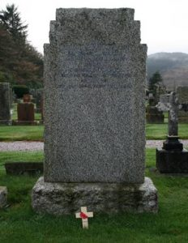 | Further Information  Sapper G Young died on 3 September 1945, no information as to how.  Sapper J Haynes also died at this incident.  When you look at the date his British Empire Medal was awarded, it indicates that they were clearing Beach Mines laid as anti-invasion measures.  Photo credit: Martin Briscoe.

YOUNG, Robert, (2070815) Sapper, 2 Bomb Disposal Company, Royal Engineers.

No Citation found in the National Archives Catalogue.
Placed in the London Gazette 9 January 1946, Supplement 37412. Page 318.

Served from 1942 to 1945. Was based in London Balham and Norwood areas. Involved with a UXB at Elstree Film Studio, involved with the first VI in Romford and a V2 at Walthamstow.
Beach mine clearance at Gorleston on Sea Norfolk, which he probably was awarded the BEM for.

British Empire Medal Civilian Division

GLEW, A MM BEM, Mister, Civilian Section, Bomb Disposal Unit (UK), Royal Engineers

No Citation found in the National Archives Catalogue.
No London Gazette entry located. Believe to be in 1963.

Mr Alfie Glew was a member of the civilian section, clearing the beaches of mines, in Norfolk, which were part of the anti-invasion measure.

He was awarded the British Empire Medal for his work. He used to do a visual check on the beaches after certain tides to see if mines had been uncovered. One night around Christmas time he spotted uncovered mines, he reported these to the Bomb Disposal Headquarters and it was agreed that military personnel would be sent out in the morning to deal with them. He spent the night observing the mines and ensuring that nobody walked into them.
One of those sent was a young Lance Corporal John Phillips later to become RSM of 33 Engineer Regiment (EOD).

Further Information
Alfie Glew had been awarded the Military Medal in World War 2, for operating a bulldozer under fire in North West Europe.

Loenhardt J S K BEM, Mister, Civilian Section, Bomb Disposal Unit (UK), Royal Engineers

No Citation found in the National Archives Catalogue.
Placed in the London Gazette 8 June 1963. Supplement? Page 4821.

Mr Loenhardt was a Romanian, who was taken captive and brought to the United Kingdom. Many Romanians fought alongside the Germans on the Eastern Front against the Russians as they saw this to be the way forward in keeping Russia away from its borders. After the war, due to the political climate, many remained in the United Kingdom and worked in Bomb Disposal. Many Ukrainians did the same.

He was born in Romania on the 3 March 1919 at Devs.

On the 29 April 1957 he was issued his Certificate of Naturalisation and became a British Citizen. He had by then married Eileen Robinson in September 1956, a local lady from Horsham, where the War Office’s, Bomb Disposal Unit, where he was employed as an electrician, and was based they lived at the

Corner House
Broadbridge Heath
Near Horsham
Sussex.

Further Information

His BEM, copies of his naturalisation papers and letter from Queen Elizabeth II (cut down) are in the safe keeping of Mr Peter Markham.

King George VI Commendation for Brave Conduct

The Kings Commendation for Brave Conduct was a gallantry award instituted by King George VI in 1939 to recognise acts of bravery by civilians and members of the armed services in non-frontline circumstances. It was the lowest level of bravery award in the British Honours system, alongside a mention in dispatches.

DAVIES, William Rhys Kings Commendation, (3954494) Temporary Sergeant, 1 Bomb Disposal Squadron (UK), Royal Engineers.

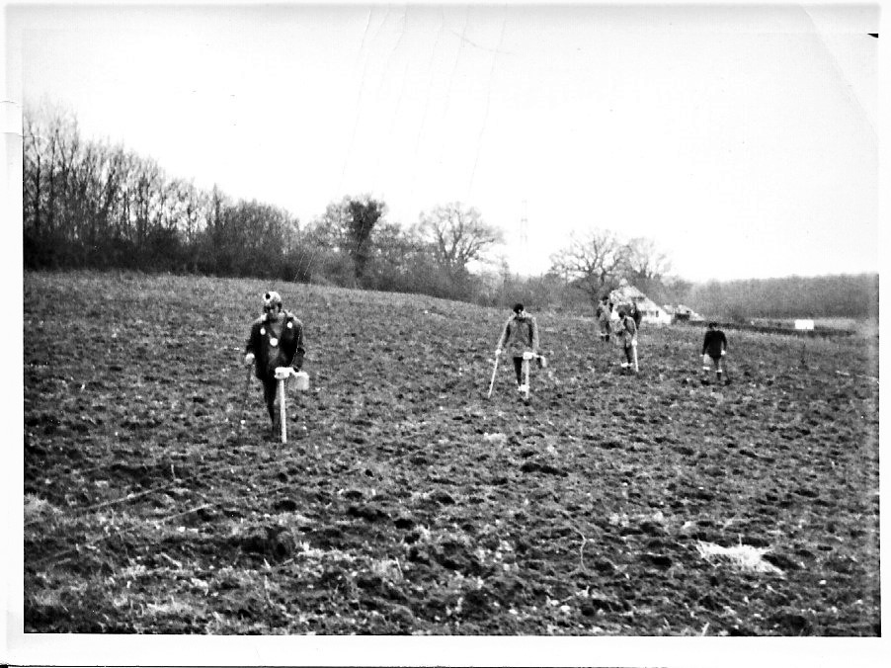 | 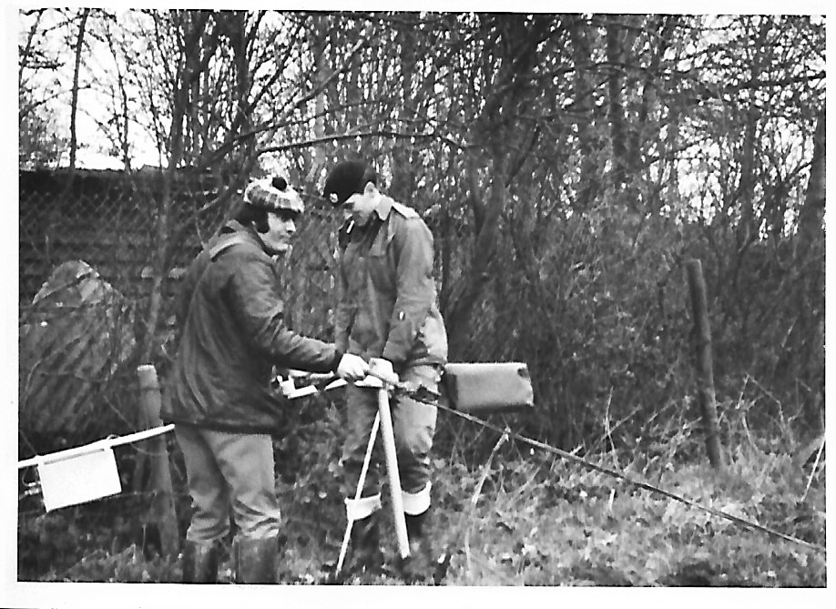
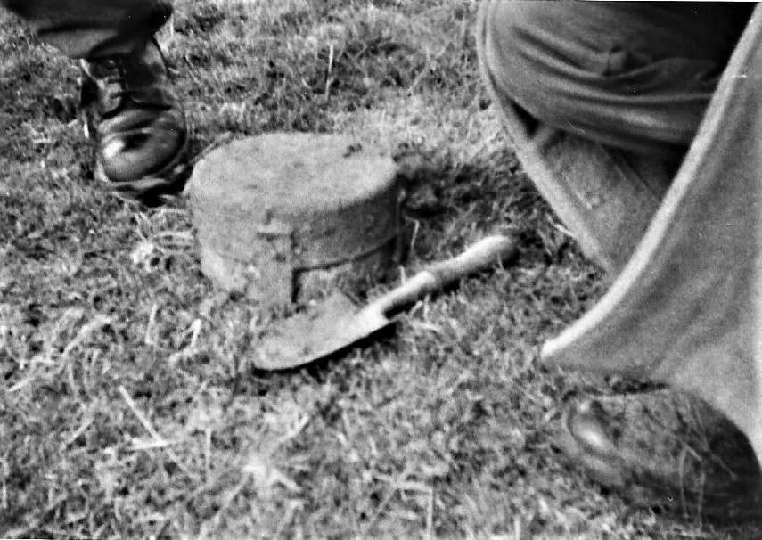 | Images:  Tilshead Section, Outstations, 1973 Bushylees Farm, Farham.  Bottom left: an Anti-Tank GS Mark IV Mine.  Photos from John Green.

The Citation is taken from file WO373/121/84 held at the National Archives
Placed in the London Gazette 20 May 1949. Supplement 38615. Page 2461.

Sgt Davies was largely concerned with the removal of an unexploded bomb at Little Rytham. After the fuze had been uncovered examination was carried out of the fuze head which had become corroded. In scrapping away, the corroded portion to further details, the corroded portion crumbled and the fuze pocket detached itself from the fuze head and fell into the powder filling. This ruled out the use of special equipment normally used for dealing with this particular fuze. It was found fortunately, that the base plate was loose and placing the stethoscope as near to the broken fuze pocket as possible, the powder filling war removed by hand from the base. Arrangements were made for blowing the fuze pocket directly as it was recovered. After removal of the powder filling the fuze pocket was taken to a prepared site where it was blown. The small crater resulting showed that the fuze containing the clock and booby trap had, in fact, been in good condition. The work by Sgt Davies displayed coolness and resource of a high order.

Queen Elizebeth II Commendation for Brave Conduct

The Queens Commendation for Bravery formerly the Kings Commendation for Brave Conduct was a gallantry award instituted by King George VI in 1939 to recognise acts of bravery by civilians and members of the armed services in non-frontline circumstances. It was the lowest level of bravery award in the British Honours system, alongside a mention in dispatches.
Renamed the Queens Commendation for Bravery in 1952, the award was discontinued in 1994 on the creation of the Queen’s Commendation for Bravery.

ALEXANDER, J L Queens Commendation, (23181638) Sapper, Headquarters Bomb Disposal Unit (UK), 2 Bomb Disposal Troop, Royal Engineers.
The Citation is taken from file WO373/123/14 held at the National Archives
Placed in the London Gazette 11 October 1957. Supplement 41201. Page 5989.

Sapper Alexander was on duty close to the bomb shaft throughout the final phase of disposing of the 250kg German unexploded bomb at the District Court House, Hampton Court, on the night of 10/11 April, 1957.
It was his duty to keep in operation the pump which was removing water seeping into the bomb shaft from the Thames. Had the pump stopped for more than a minute or two during the five hours in which the explosive was being removed, it would have been impossible without undue risk to remove the remaining explosives. The bomb would have had to be exploded where it lay, in a built-up area.
The bomb was in a dangerous condition. It was fitted with a clockwork fuze, the mechanism of which might have been started by vibration or movement. Furthermore, the fuze had been displaced and might have had beneath it an anti-withdrawal device which would have exploded the bomb if the fuze itself had been moved further.
Sapper Alexander was the only man who had to remain close to the bomb throughout the removal of the explosives. His work, successfully accomplished, of keeping the pump working was vital to the success of the operation, He well knew the risk involved, yet he was cheerful, unperturbed, and an inspiration to others. It is therefore most strongly recommended that he be granted the immediate award of the British Empire.
Further Information
Recommended for a BEM downgraded to the Queens Commendation.
CAYLESS, M Queens Commendation, Sergeant, 33 Engineer Regiment (EOD), Royal Engineers.

The Citation is taken from file WO373/183/50 held at the National Archives.
Posted in the London Gazette on the 30 November 1987. Supplement 51138. Page 14785.

Sergeant Cayless commands one of the Sections of civilian Explosive Ordnance Disposal searcher in 33 Engineer Regiment (EOD) based at Lodge Hill Camp, Rochester. The section is employed throughout Great Britain on Battle Area Clearance tasks. They are responsible for the systematic searching of areas used for live firing, mining, and other similar purposes involving explosives during both World Wars and in peacetime, and then for dealing with live items found.
On 18 November 1986 at Winterton-On-Sea, Norfolk, Sergeant Cayless’s Section whilst engaged on a planned search, came across a previously unknown Second World War minefield. During the investigation that followed, 16 Beach Mines and 2 Anti-Tank Mines were found. All were at a depth of approximately three feet in heavy marshy ground with a water table that quickly rose to approximately one foot over the top of the mines.
The fuzing method of the mines and their condition which had deteriorated over the last 40 years, meant that the slightest pressure during excavation could have detonated them. Furthermore, there was no means of telling if any of the mines had been booby-trapped as was often the case. Sergeant Cayless was fully aware that the task facing his Section was notoriously one of the most dangerous that a Bomb Disposal Engineer can be called upon to perform. He knew that very heavy casualties were caused after World War Two in lifting our own beach minefields. Records show that over 200 casualties, of which 151 were deaths, were sustained on these minefields, representing over 35% of all EOD casualties over the period concerned.
Sergeant Cayless decided that he alone would carry out the final excavation of each of the mines. This was done with a shovel and by using his hands below the water which quickly became murky and forced him to work by touch. He had then to place an explosive charge in contact with each mine and retire to, effect the detonation. He had had to repeat this 18 times.
He carried out these very hazardous duties with professionalism and without hesitation, displaying extreme courage over a 48-hour period in the process. His dedication and acceptance of danger set up the highest example to his men and all bomb disposal personnel. His actions fully merit recognition.

CLEWLEY Queens Commendation, Sergeant, 101 (City of London) Engineer Regiment (EOD) (V), Royal Engineers

For saving the lives of eight soldiers while serving in Afghanistan.

The following 7 Gentlemen of the Corps all received the Queens Commendation for the same Service in Penang.
The Citation is taken from file WO373/183/41 - 42 – 43 – 44 – 45 – 46 - 47 held at the National Archives.
Posted in the London Gazette on the 3 June 1969.

BUCK, John Gerrard Queens Commendation, (24098552) Sapper, Bomb Disposal Team (FARELF), Royal Engineers.

FLOYD, Thomas Queens Commendation, (24001703) Lance Corporal, Bomb Disposal Team (FARELF), Royal Engineers.

FLYNN, Bernard Joseph, (24108120) Sapper, Bomb Disposal Team (FARELF), Royal Engineers.

HAWKINS, John Joseph Queens Commendation, (23981664) Sapper, Bomb Disposal Team (FARELF), Royal Engineers.

HOLLIDAY, J M Queens Commendation, (237362160 Sergeant, Bomb Disposal Team (FARELF), Royal Engineers.

MEIGHAN, Eric Queens Commendation, (23981171) Lance Corporal, Bomb Disposal Team (FARELF), Royal Engineers.

REES, Peter James Queens Commendation, (24098552) Lance Corporal, Bomb Disposal Team (FARELF), Royal Engineers.

In August 1968, a tunnel being excavated by the Bomb Disposal Team re (FARELF) on Penang Island was found to contain about two hundred pounds of picric explosive. This was over 25 years old and in a very badly deteriorated condition. Picric is a hazardous explosive which Western countries ceased to use many years ago because of the dangers inherent in its use even in new conditions. In a deteriorated state it forms picrate’s which are even more sensitive. It is toxic and it attacks the skin.
Under normal circumstances it would have been preferable to demolish the explosive in situ. Unfortunately, the rotting boxes which had contained the picric were stacked on top of a row of torpedo warheads, alongside a row of sea mines. Demolition of the picric would have detonated all this explosive, estimated to total some five tons, which would have destroyed a nearby village.

Sergeant Holliday volunteered to lead a small team to remove the picric by hand. The team consisted of Lance Corporal’s Floyd, Meighan, Rees, Sapper’s Buck Flynn and Hawkins. To complete this hazardous task, they had to work slowly and carefully within the confines of the tunnel encumbered by rubber aprons and gloves. After extracting the explosives from the tunnel, they had to pack it in steel boxes prior to it being sea dumped. They completed the task efficiently and safely.

All concerned were fully aware of the obvious dangers and showed considerable courage and devotion to duty. Their cool acceptance of risk and their highly professional teamwork achieved completion of a very unpleasant task without incident.

MORRIS, M Queens Commendation, Lance Corporal, 58 Field Squadron (EOD), 33 Engineer Regiment (EOD), Royal Engineers

No citation found in the National Archives Catalogue.
No entry located in the London Gazette.

Information taken from the Royal Engineers Association Bomb Disposal Branch Bulletin April 2010.

Lance Corporal M Morris was the lead searcher in his team with the Counter IED Task Force. He volunteered daily to be the front man in the most-deadly of high threat areas. During his tour he led a nine-week operation to repeatedly clear a vital supply route, often having to search for IED’s whilst under fire. He was on his second tour of Afghanistan, he also led a search to isolate a 500lb bomb, the largest IED found in Helmand. Dering another operation he located nine hidden devices. These had virtually no traces of metal content which meant a fingertip search of the ground inch by inch. This needed a high level of concentration despite intense heat and obvious risk.

SMITH, S R Queens Commendation, Sapper, 33 Engineer Regiment (EOD), Royal Engineers

Lance Corporal D S MacMaster and Lieutenant P A Ness were awarded the Queens Gallantry Medal for the same task. Lieutenant P A Ness comments of the task are below.

On 9 February 1943 during a German bombing attack on a nearby munitions factory, a number of bombs were dropped on Lingfield village. One bomb hit the school and killed two teachers acting as fire watch and two eleven-year-old girls. One of the bombs exploded on Mount Pleasant Road killing one.

In 2002 an unexploded bomb from the attack was discovered by builders digging foundations for an extension to another house in Mount Pleasant Road.

Lieutenant P Ness commented about his part in the incident: The bombs mechanical fuze was suspected to have been re-started, having been struck by the JCB’s back bucket prior to being drawn out of the ground and dropped in the house’s back garden. I was very surprised when the stethoscope picked up sounds of a mechanical system operating, which was confirmed by Lance Corporal MacMaster. I’m certainly glad that during the ‘bomb course’ I spent time practising the physical skills that included using a hand drill to access the fuze body, as this was required prior to injecting fluids into the body of the fuzing system on the bomb. The clock stopper worked well, including my own analogue watch – until its battery ran out. The problem was resolved by accessing the house and utilising its mains electrical supply. Moving the bomb was made easier thanks to a borrowed fire brigade stretcher, but once the bomb was placed in the disposal pit, I was not minded to try and extract it from under the device, so I had to apologise to them afterwards.

WESTON, W Queens Commendation, Sapper, 33 Engineer Regiment (EOD), Royal Engineers

No citation found in the National Archives Catalogue.
No entry located in the London Gazette.

Information taken from the Royal Engineers Association Bomb Disposal Branch Bulletin April 2010.

Sapper M Weston was seriously injured in Afghanistan in 2009.

King Charles III Commendation for Brave Conduct

The Kings Commendation for Brave Conduct was a gallantry award instituted by King George VI in 1939 to recognise acts of bravery by civilians and members of the armed services in non-frontline circumstances. It was the lowest level of bravery award in the British Honours system, alongside a mention in dispatches.
This then became the Queens Commendation for Brave Conduct in 1952 till her death and in 2022 was once more the Kings Commendation for Brave Conduct.

DRAPER C and PETERSON R Kings Commendation, Lance Corporals, 33 Engineer Regiment (EOD & S), Royal Engineers.

No Citation found in the National Archives Catalogue.
No London Gazette details at this time.
Awarded for their support after a 500 lb Unexploded Bomb was found in February 2025, in the Keyham District of Plymouth in a garden as excavations were being dug for foundations.

General Service Medal 1918 to 1962. Bomb and Mine Clearance 1945 to 1953.

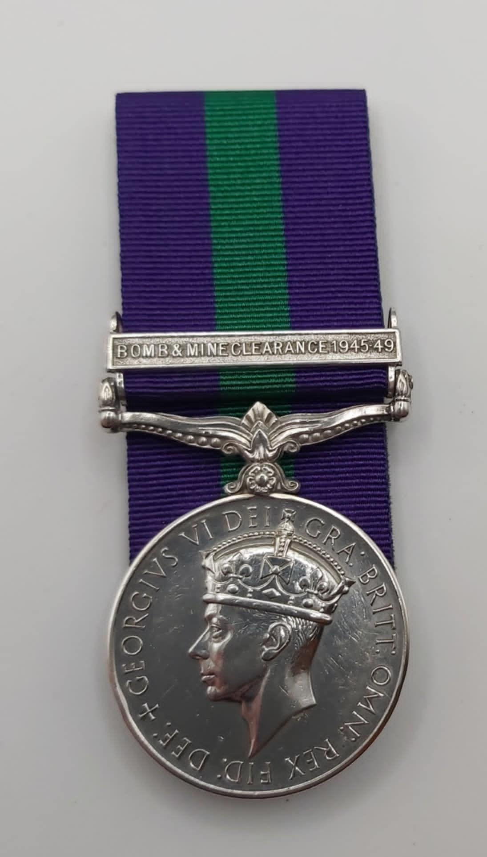

Photo credit: Julien Allerhead BEM.

The clasp, issued under Army Order 31, 1947, can be found on Third and Forth type medals. The qualification for this award was originally an aggregate of 180 days active engagement in the clearance of bombs and mines in the United Kingdom and Northern Ireland, 9 May1943 to 31 December 1949. In May 1956, the Queen approved the extension of the period of eligibility to 1 January 1955 for service in the Mediterranean. Any member of the Royal Navy and Royal Air Force employed on this work on land qualified on this work on land qualified under the same conditions of those for the Army.
The term ‘active engagement’ was taken to mean the progress of digging down to a bomb or its removal or final disposal. In the case of mines, it meant entering the perimeter of live minefields, disarming the mines or acting as a water jet operator.
It should be noted that being a member of a unit so employed did not, in itself, count as a qualification. To be eligible, the recipient must have personally been engaged in one or all of the process from reaching to the final disposal of bombs and mines.
Death or curtailment of the qualifying period through wounds or disability due to service did not debar eligibility and those receiving a Kings Commendation or a Mention in Dispatches also qualified, even though they may not have completed the necessary 180 days aggregate service.
Approximately 1400 of these medals were awarded to the Royal Engineers.
Below shows the Bomb Disposal Units involved in this work. Some other Royal Engineer Units were involved as previously stated some Royal Naval and Rail Airforce personnel were involved. Also working on these tasks were Prisoners of War, of whom for example the Ukrainians remained in the UK and continued in this task well into the 1980’s.
The minefield clearance task was an arduous task, resulting of 150 casualties, in the clearance of the anti-invasion measures around the coast of the United Kingdom and Northern Ireland, the number of injured is not known.
Work carried on with beach minefields into the 70’s and many mines have continued to appear ever since.
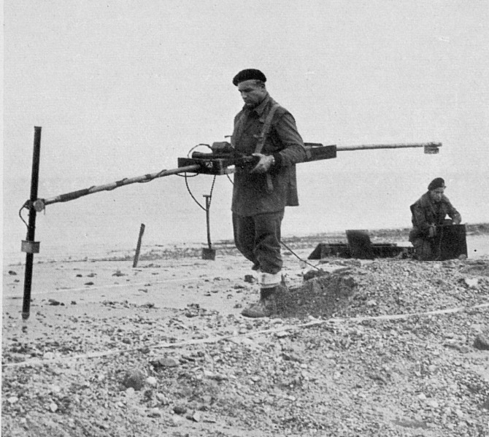
Polish Mine Detector, Mundesley Norfolk.
Photo credit: Victor Gowler.

1 Bomb Disposal Company | 9 Bomb Disposal Company
1 Bomb Disposal Squadron | 10 Bomb Disposal Company
2 Bomb Disposal Company | 10 Bomb Disposal Company (POW)
2 Bomb Disposal Squadron (POW) | 11 Bomb Disposal Company
3 Bomb Disposal Company | 11 Bomb Disposal Company (POW)
4 Bomb Disposal Company | 12 Bomb Disposal Company
4 Battle Area Clearance Unit | 16 Bomb Disposal Company
6 Bomb Disposal Company | 16 Bomb Disposal Company (POW)
7 Bomb Disposal Company | 20 Bomb Disposal Company
7 Bomb Disposal Company (POW) | Bomb Disposal Unit (Ukraine)
Bomb Disposal Units involved in the clearance operations

Meritorious Service Medal

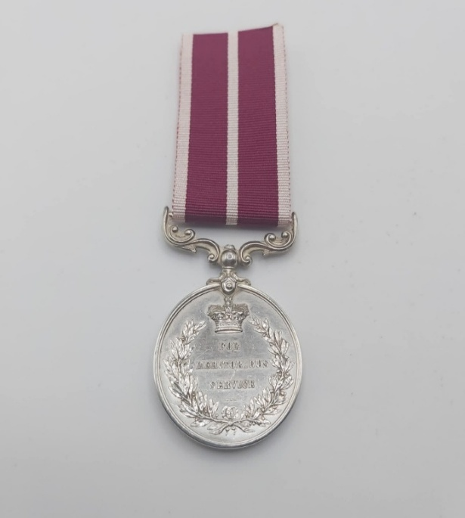
Photo credit: Julian Allerhead BEM.

The Meritorious Service Medal was instituted on 19 December 1845 for the British Army, to recognise long and meritorious service by Warrant Officers and Non-Commissioned Officers of the rank of Sergeant and above, with a small number of early awards bestowed for Gallantry. Recipients were granted an annuity, the amount of which was based on rank.

HEATON, Roger David MSM, Staff Sergeant, 101 (London) Engineer Regiment (EOD) (V), Royal Engineers.

No Citation found in the National Archives Catalogue.
No entry found in the London Gazette.

No further information available.

Legion of Merit Degree of Officer

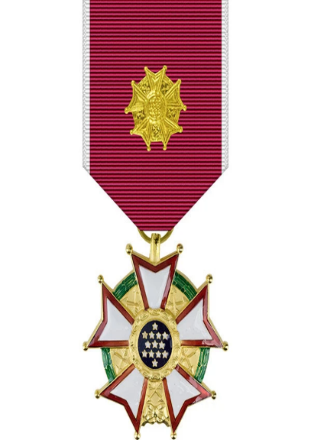

The Legion of Merit is a military award of the United States Armed Forces which is given for exceptionally meritorious conduct in the performance of outstanding services and achievements. The decoration is issued to members of the eight uniformed services of the United States as well as to military and political figure of foreign governments.

YATES, Geoffrey H, (40602) Lieutenant Colonel, Bomb Disposal, Royal Engineers.

The Citation is taken from file WO373/148 held at the National Archives.
Posted in the London Gazette on the 11 November 1947. Supplement 38122. Page 5353.

Lieutenant Colonel Geoffrey H Yates, Royal Engineers, British Army performed meritorious services to the United States from January to July 1942. As a specialist in Bomb Disposal methods he rendered invaluable assistance in establishing procedures, and, during a visit to the United States made a material contribution the establishment of the American Civilian Defence Program.

Further Information.
As the Major G H Yates, was also awarded the OBE.

Annex A. Other Awards and Commendations

This Annex does not benefit from access to the same documentary evidence as cited in previous sections. Much important information seems to be either inaccessible or otherwise unavailable. However, as this is a living document we urge people with information to let us know so we can rectify and wrong details and expand details in all that are named.

Queens Commendation for Valuable Service

ARNOLD G J, Captain believed for support to 45 Commando during Operation Jacana, Afghanistan.

ATKINSON P, Staff Sergeant P Atkinson

DRAPER D R J, Captain

FLETCHER M A, Captain

MCCONNACHIE R J, Major

TAYLOR R C, Warrant Officer Class I. Information taken from Operational Honours March 2010.

WILSON, D Lieutenant Colonel

Mention in Dispatches

COX D J, Lance Corporal

DAVIES L E, Sergeant

FOSSEY, J E, Major

HOLMES, S, Sapper

HOOPER, H R, Captain Information taken Operational Honours March 2010.

KNIGHT, K K, Lance Corporal

LUTON, J D, Sapper.

McINTOSH, J E, Sapper, Information taken from Operational Honours March 2010.
Engineer in Chief (A) Commendation

Information for all six below came from the Royal Engineers Association Bomb Disposal Branch Bulletin April 2011.

No citation found in the National Archives Catalogue.
No entry located in the London Gazette.

HODGSON, Sapper, 101 Engineer Regiment (EOD) Counter IED Force.

HOLDEN, S, Lance Corporal, 33 Engineer Regiment (EOD) Counter IED Force.

KENNEDY, M R, Captain, 101 Engineer Regiment (EOD) Counter IED Force.

MCMILLAN, M, Sergeant, 33 Engineer Regiment (EOD) Counter IED Force.

RICHARDS, J, Lance, 33 Engineer Regiment (EOD) Counter IED Force.

SHERRETT, T, Corporal, 33 Engineer Regiment (EOD) Counter IED Force.

Joint Operations Commendation

KOWALEWSKI, Sergeant 21 Field Squadron (EOD) for services to the Personnel Recovery Unit.

TAYLOR, N, Sapper, 21 Field Squadron (EOD) for services to the Personnel Recovery Unit.

General Officer Commanding Commendations

TAYLOR, D J, Sergeant, Operation Apple.

PERG, D J, Sergeant, Operation Apple.

SYME, P W, Corporal, Operation Apple.

MURPHY, K R, Corporal, Operation Apple.

MCDOUGALL, P S, Corporal, Operation Apple.

CIC Land Forces Commendation.

CURTIS, T J M, Captain.

Other Awards, Categories Unknown.

PERCY, D G, Sergeant, Operation Apple.

PRESCOTT, K, 49 Field Squadron (EOD) Bosnia.

SECCOMBE, A, Sergeant.

SINCLAIR, Sapper, 49 Field Squadron (EOD).

THOMAS, C V, Lance Corporal, Operation TELIC 1 while working with A Wyles QGM.

Annex B. Awards to BD/EOD personnel not directly serving as Royal Engineers Bomb Disposal

George Cross
Earl of Suffolk Jack Howard GC, Ministry of Scientific Research.
Merriman A D, Doctor GC DFC, Ministry of Scientific Research.

Member of the British Empire
MOODY, N C MBE, Major, assisting in setting up the EOD Cell in Kuwait, whist serving with 29 Field Squadron, Royal Engineers.

GRANTHAM, K MBE, Warrant Officer Class 1, Tactical Headquarters 29 Engineer Brigade, Royal Engineers.

No Citation found in the National Archives Catalogue.
Placed in the London Gazette on the 13 April 2000. Supplement 55819. Page 4252.

The citation was provided by K Grantham.

Warrant Officer Class 1 Grantham is normally employed as the Sergeant Major Instructor in Headquarters 29 (Corps Support) Engineer Brigade and Royal Engineers Territorial Army. At the start of June 1999, Tactical Headquarters 29 Engineer Brigade was deployed on Operation JOINT GUARDIAN at very short notice to reinforce the staff in Engineer Branch Headquarters ACE Rapid Reactions Corps. At the time, there was no cover in the Branch for the established post of Staff Grade Officer Grade 2 Explosive Ordnance Disposal (EOD). Warrant Officer Class 1 Grantham had previous experience as a Bomb Disposal Officer in an EOD Field Squadron; despite his rank, he was therefore tasked to fill this key major’s post.

It is entirely due to the work carried out by Warrant Officer Class 1 Grantham that KFOR has a structured and coordinated approach to EOD. Starting from a clean sheet of paper, and despite an almost total lack of staff experience, he has single-handedly written all the EOD instructions and orders which have permitted the start to a safe environment. He has carried out meticulous coordination with all the deployed EOD units to ensure that the orders are usable and relevant. He has formed outstanding relationships with the staffs of the Multi National Brigades (MNB) and the United Nations Action Coordination Centre (UNMACC). For the latter, he has provided exceptional awareness training, particularly in the early stages of the operation when UNMACC was very thinly spread. For mines awareness, he has written instructions and produced presentations for use by both military and civilian agencies. The validity of these has been evident in the very low number of casualties from mines and unexploded ordnance. He is widely acknowledged by the Non-Governmental Organisations as a font of expert and clear advice on all EOD matters.

Warrant Officer Class 1 Grantham has displayed outstanding initiative in developing the vital EOD staff role within the HQ. He has used all his persuasion and resourcefulness to acquire training material and information on a wide range of both NATO and Serbian munitions which have been used in the province. He has, without ant prompting, organised an EOD Study Day for all EOD troops and a mine awareness training day for all MNBs in order to train the trainers in this life saving area. These sessions have succeeded in raising both the training standards and exchange of best practice between all concerned.

Warrant Officer Class 1 Grantham has been a shining example of an exceptional and resourceful warrant officer who has risen admirably to assume the additional responsibilities required in this post in a demanding operational environment. Fir the exemplary work that he has carried out in coordinating EOD throughout Kosovo and for his assistance in establishing the UNMACC, he is strongly commended for recognition.

Further Information
WO1 K Grantham has previously been awarded the Queens Gallantry Medal.

British Empire Medal.
ORTON, J D BEM, Sergeant, Pay Corps awarded while serving with 33 Engineer Regiment (EOD).
TUMMAN, G E K BEM, Flight Sergeant, Royal Air Force while working with 71 Field Squadron (EOD), Maplin Sands.

Annex C. Possible BD/EOD-related Awards
Probably Royal Engineers Bomb Disposal, Explosive Ordnance Disposal, however, not confirmed. All have London Gazette entry’s, no Citations found. From id 1945 into mid 1946 there many citations seem to be unavailable.

Member of the British Empire.
KNIGHT, S F MBE, (163226) Temporary Major, London Gazette 4 June 1946, had served with 22 Bomb Disposal Company (POW), possibly for work on Beach Mine Clearance in the UK.
HOW-WHITE MBE, J G M, (74972) Temporary Major, London Gazette 05 June 1942, Supplement 35585 Page 2487, had served in 6 Bomb Disposal Company.
British Empire Medal.
ANNEAR, J BEM, (1883286) Corporal, Bomb Disposal, Royal Engineers.

The Citation is taken from file WO373/69/322 held at the National Archives.
Posted in the London Gazette 23 April 1945

Not added at this time as unsure if with a Field Unit or a Bomb Disposal Unit
During August and September, 1944, Corporal Annear was employed on the clearance of minefields at Celwton Bunny, near Highcliffe, Hants. The minefield contained Beach Type Anti-Personnel mines. The approach to the portion of the minefield which Corporal Annear’s party were to clear was by way of a series of steps, heavily mined, down the cliff face. Corporal Anner using a mine detector successfully cleared the steps, and proceeded to the field where the mines were laid in dense undergrowth, intertwined with saplings and dead trees. The task of clearing this area demanded concentration and courage of a high order. He was at times forced to use a felling axe at great risk of branched falling on mines and setting them off. This he accomplished in such a way that he took all the risk himself and the danger to his men was negligible. Where a false step in the undergrowth would have caused disaster, Corporal Annear succeeded by his courage and leadership in completely clearing the field without accident.
BOND-ROOSE, A E BEM, (2070163) Sergeant, Bomb Disposal, Royal Engineers.

The Citation is taken from file WO373/67/513 held at the National Archives.
Posted in the London Gazette 26 February 1943.

Not added at this time as unsure if with a Field Unit or a Bomb Disposal Unit

During July and August, 1942, Sergeant Bond-Roose was the senior non-commissioned officer with a part detailed to destroy a beach minefield which had been in position for two years and which mines were in an uncertain condition. Many of these mines were covered by large quantities of large stones swept in by the tide, and in other cases mines and pickets were all buried under drifting sand. His sense of duty and cool leadership during this dangerous task were a perfect example to the rest of the party. He supervised the finding of all mines and personally laid the demolition charges on most of the six hundred in number. When his Commanding Officer was blown up on a c mine, he recovered the body, rescued the minefield plans, closed this particular section of the minefield and prepared to carry on with the main task of demolition in the best tradition of the British Army.

ALCHIN, A J BEM, (1500818) Staff Sergeant, London Gazette 4 June 1946, Supplement 37598, Page 2800, possibly for work on Beach Mine Clearance in the UK.
BARFIELD, D S C BEM, 5959177 Company Quarter Master Sergeant, London Gazette 4 June 1946, Supplement 37598, Page 2801, possibly for work on Beach Mine Clearance in the UK.
BEAN, F A BEM, (14289265), Sergeant, London Gazette 4 June 1946, Supplement 37598, Page 2801, possibly for work on Beach Mine Clearance in the UK.
CARTER, F B BEM, 2012483 Lance Corporal F B Carter, London Gazette 4 June 1946, Supplement 37598, Page 2801, possibly for work on Beach Mine Clearance in the UK
CASTELL, C E W BEM, (833683) Company Quarter Master Sergeant, London Gazette 4 June 1946, Supplement 37598, Page 2801, possibly for work on Beach Mine Clearance in the UK. Discharged 19 December 1946.
CHAPMAN, L C BEM, (6290244) Staff Sergeant, London Gazette 4 June 1946, Supplement 37598, Page 2801, possibly for work on Beach Mine Clearance in the UK
CROSS, A H BEM, (2007000) Corporal, London Gazette 4 June 1946, Supplement 37598, Page 2802, possibly for work on Beach Mine Clearance in the UK
DALGETTY, G O BEM, (1911442) Staff Sergeant, London Gazette 4 June 1946, Supplement 37598, Page 2802, possibly for work on Beach Mine Clearance in the UK
DAWN, G W MBE, (1888056) Sergeant, London Gazette 4 June 1946, Supplement 37598, Page 2802, possibly for work on Beach Mine Clearance in the UK
EDWARDS, H D DCM MBE, (1883240) Lance Sergeant, London Gazette 4 June 1946, Supplement 37598, Page 2802, possibly for work on Beach Mine Clearance in the UK. DCM awarded in 1945 when serving with 615 Field Squadron in North West Europe
EMMETT, R BEM, (5384614) Sergeant, London Gazette 4 June 1946, Supplement 37598, Page 2802, possibly for work on Beach Mine Clearance in the UK
EVANS, E BEM, (1901582) Warrant Officer Class 11, London Gazette 4 June 1946, Supplement 37598, Page 2802, possibly for work on Beach Mine Clearance in the UK
FIELDING A W, (973742) Staff Sergeant, London Gazette 4 June 1946, Supplement 37598, Page 2802, possibly for work on Beach Mine Clearance in the UK
FLETCHER, R D BEM, (3861194) Staff Sergeant, London Gazette 4 June 1946, Supplement 37598, Page 2803, possibly for work on Beach Mine Clearance in the UK
FOX, J H BEM, (2078673) Sapper, London Gazette 4 June 1946, Supplement 37598, Page 2803, possibly for work on Beach Mine Clearance in the UK
GRIMLEY, WH BEM, (950355) Company Quartermaster Sergeant, London Gazette 4 June 1946, Supplement 37598, Page 2803, possibly for work on Beach Mine Clearance in the UK
GARBUTT, P W BEM, (2118902) Sergeant, London Gazette 4 June 1946, Supplement 37598, Page 2803, possibly for work on Beach Mine Clearance in the UK
HANSELL, G E BEM, (2015739) Driver, London Gazette 4 June 1946, Supplement 37598, Page 2803, possibly for work on Beach Mine Clearance in the UK
JACKETT, A J W, BEM, (2120483) Sergeant, London Gazette 4 June 1946, Supplement 37598, Page 2804, possibly for work on Beach Mine Clearance in the UK
JACKSON, J G BEM, (21193399) Sapper J G Jackson, London Gazette 4 June 1946, Supplement 37598, Page 2804, possibly for work on Beach Mine Clearance in the UK
KNOTT, D W BEM, (1946393) Staff Sergeant, London Gazette 4 June 1946, Supplement 37598, Page 2804, possibly for work on Beach Mine Clearance in the UK
LEWIS, L BEM, (1923741) Warrant Officer Class 2, London Gazette 4 June 1946, Supplement 37598, Page 2804, possibly for work on Beach Mine Clearance in the UK
LILLYMAN, W E BEM, (1888455) Company Quartermaster Sergeant, London Gazette 4 June 1946, Supplement 37598, Page 2804, possibly for work on Beach Mine Clearance in the UK
LITTLE D A BEM, (2038373) Corporal DA Little, London Gazette 4 June 1946, Supplement 37598, Page 2804, possibly for work on Beach Mine Clearance in the UK
MEE, A BEM, (1944962) Sergeant, London Gazette 4 June 1946, Supplement 37598, Page 2805, possibly for work on Beach Mine Clearance in the UK
SHAW L BEM, (14276452) Lance Sergeant, London Gazette 4 June 1946, Supplement 37598, Page 2806, possibly for work on Beach Mine Clearance in the UK
SLOAN, J BEM, (3196551) Staff Sergeant, London Gazette 4 June 1946, Supplement 37598, Page 2806, possibly for work on Beach Mine Clearance in the UK
SPEAK, H BEM, (3857957) Sergeant H Speak, London Gazette 4 June 1946, Supplement 37598, Page 2807, possibly for work on Beach Mine Clearance in the UK
STEADMAN, E W BEM, (1981228) Warrant Officer Calls II, London Gazette 4 June 1946, Supplement 37598, Page 2807, possibly for work on Beach Mine Clearance in the UK. Discharged 16 June 1947
STEWART, W BEM, (2010699) Sergeant, London Gazette 4 June 1946, Supplement 37598, Page 2807, possibly for work on Beach Mine Clearance in the UK
STOUT, W BEM, (2130369) Lance Sergeant, London Gazette 4 June 1946, Supplement 37598, Page 2807, possibly for work on Beach Mine Clearance in the UK
TALBOT, A H BEM, (271842) Lance Corporal, London Gazette 4 June 1946, Supplement 37598, Page 2807, possibly for work on Beach Mine Clearance in the UK
TENNANT, G BEM, (2068086) Sergeant, London Gazette 4 June 1946, Supplement 37598, Page 2807, possibly for work on Beach Mine Clearance in the UK
TOMBLESON, P I D BEM, (158237) Warrant Officer Class 11, London Gazette 4 June 1946, Supplement 37598, Page 2807, possibly for work on Beach Mine Clearance in the UK
TUFF, JE BEM, (19824836) Lance Corporal, London Gazette 4 June 1946, Supplement 37598, Page 2807, possibly for work on Beach Mine Clearance in the UK
WALL, G W BEM, (2069525) Sergeant, London Gazette 4 June 1946, Supplement 37598, Page 2807, possibly for work on Beach Mine Clearance in the UK
WELLS, J C BEM, (951838) Sergeant J C Wells, London Gazette 4 June 1946, Supplement 37598, Page 2808, possibly for work on Beach Mine Clearance in the UK
WHITE, C W H BEM, (823047) Company Quartermaster Sergeant C W H White, London Gazette 4 June 1946, Supplement 37598, Page 2808, possibly for work on Beach Mine Clearance in the UK
WILLET, W H BEM, (2015405) Sergeant, London Gazette 4 June 1946, Supplement 37598, Page 2808, possibly for work on Beach Mine Clearance in the UK
WILLIAMS, H M BEM, (1304597) Sapper H M Williams, London Gazette 4 June 1946, Supplement 37598, Page 2808, possibly for work on Beach Mine Clearance in the UK
WISCOMBE, C A F, (2009031) Sergeant, London Gazette 4 June 1946, Supplement 37598, Page 2808, possibly for work on Beach Mine Clearance in the UK
Possibly recommended but not awarded

British Empire Medal
BLOY, LP, (2002921) Sergeant, no London Gazette entry, had served with 4 Bomb Disposal Company, possibly for work on Beach Mine Clearance in the UK.
BROWN G W, (1889984) Sapper G W Brown, no London Gazette entry, had served with 3 Bomb Disposal Company, possibly for work on Beach Mine Clearance in the UK.
McCAIGH, I, (2003892) Lance Corporal I McCaig, no London Gazette entry, possibly for work on Beach Mine Clearance in the UK served in 4 Bomb Disposal Company.

Annex D. Awards to those who have served in BD/EOD but where it is not clear awards were related to BD/EOD duties

Commander of the Order of the British Empire
WELCH, JAH CBE, Colonel, no mention has been found that confirms he was serving in EOD.
Officer of the Order of the British Empire
HUNT, W F OBE, Sergeant W F Hunt awarded in 2006 no other details, no mention has been found that confirms he was serving in EOD.
Member of the Order of the British Empire
BARRINGTON, W D MBE, Lieutenant, died in June 2018, no mention has been found that confirms he was serving in Bomb Disposal at the time.
BASTOCK, P L MBE, Lieutenant, served with EOD. However, awarded as part of Sheffield University Cadet Force. Citation is file WO373/175/462 held at the National Archives.
CLYDESDALE, RO MBE, Corporal awarded mentioned in the History of the Corps of Royal Engineer Volume XIII, no mention has been found that confirms he was serving in EOD, at the time.
FLETCHER, G R, MBE, (377837) Major G R Fletcher served with Bomb Disposal. However, as Citation file WO373/168/246 held at the National Archive shows, he was no longer in BD and awarded whilst Works Officer, Benghazi AWO.
HOLLOWAY D MBE, (498301) Major awarded whilst serving as Technical Quartermaster with 28 Amphibious, non-EOD award. Citation in file WO373/179/50 held at the National Archive.
HOUGH, RH MBE, (334426) Major R H Hough served with Bomb Disposal. However, awarded whilst working as part of the Inspectorate of Fighting Vehicles. Citation in file WO373/168/421 held at the National Archive.
JENKINS, M W MBE, (553965) Captain, awarded for work in Northern Ireland, mentioned in the History of the Corps of Royal Engineer Volume XII page 685, no mention has been found that confirms he was serving in EOD, at the time.
LANGFORD, P J MBE, Major, mentioned in the History of the Corps of Royal Engineer Volume XIII, no mention has been found that confirms he was serving in EOD, at the time.
SETCHELL, J W MBE, Major, Non-Bomb Disposal award, Citation in file WO373/86/695 held at the National Archive.
SOUTHALL, D, W MBE, Major, prior to serving in EOD.
VECK, R E MBE, Captain, Non-Bomb Disposal award, Citation in file WO373/178/219 held at the National Archive. Awarded whilst serving as Depot Squadron Commander.
WILSON, I T C MM MBE, Lieutenant Colonel, (MM assault Squadron, D Day) MBE whilst working in the Cyprus Working Party. Served as Commanding Officer of Bomb Disposal Unit, mentioned in the History of the Corps of Royal Engineer Volume XI, page no mention has been found that confirms he was serving in EOD at the time.
WOOD, J S MBE, Staff Sergeant, mentioned in the History of the Corps of Royal Engineer Volume XII, page 691 no mention has been found that confirms he was serving in EOD at the time.
British Empire Medal
CHRISTISON, R B BEM, (23242020) Sergeant, serving with 3 Field Squadron Royal Engineers. Dealt with a mine Citation in file WO373/136/37 held at the National Archive. Non-Bomb Disposal Award.
PARSONS, K F BEM, Sergeant, served in Explosive Ordnance Disposal. However, no information found to confirm if he was serving in EOD, at the time.
YOUNG, E E BEM, Warrant Officer Class II, mentions of his award found. However, nothing held at the National Archives or located in the London Gazette to confirm the award or if awarded who serving with at the time.
Meritorious Service Medal
GRADY, T F MSM, Major, whist working with a University Officers Cadet Training Unit, a non-EOD Award.

Index of names in Award Categories
George Cross
ANDREWS, W L, 17 | DAVIES, R J, 23
ARCHER, B S T, 18 | GIBSON, M, 23
BAREFOOT, H J L, 18 | MARTIN, C A J, 26
BLANEY, M F, 20 | REYNOLDS, E W, 28
BUTTON, W J, 20 | TALBOT, E E A C, 28
CAMPBELL, A F, 20 | WYLIE. G C, 30

Military Cross
BASSETT, P J, 184 | RIDER, C J, 184

Military Medal
CROOKES, J, 33

Distinguished Service Cross
PHILLIPS, J H, 188

Conspicuous Gallantry Medal
PRESCOTT, J, 190

George Medal
ALLEN, J G, 35 | Laing, E, 71
ANDERSON, D H, 35 | LANHAM, K, 71
ASHMORE, A J, 36 | LAWSON, B M, 72
BAILEY W H, 36 | LEA, C W, 72
BAINBRIDGE, A G, 37 | LEE, R H, 73
BARNES, J, 38 | MAITLAND, R J B, 73
BAYS, P A, 38 | MANSER, H A, 74
BEAN, O W, 38 | MARTIN, C A J, 74
BIGGS, A J, 39 | McCARTNEY. R F, 76
BLACKSHAW, T, 39 | MEYNELL, L, 77
BLACKWELL, T W T, 40 | MITCHELL, H, 77
BORTHWICK, W S, 41 | MORGAN, L H, 78
BOURNE, E L, 44 | NEWITT, C N, 79
BRABIN, J, 42 | PARKER, A , 208
BRIGGS, H, 194 | PARKER, R C M, 79
BRISTOW, C F, 43 | PARKER, W G, 80
BROWN, W M, 194 | PETTIT, N, 208
BUTLER, F H, 44 | PRICE, H P, 81
CANN, C M, 45 | QUALTROUGH, H P,210
CARTER, J W, 46 | QUARENDON, G H, 82
CHESHIRE, S, 46 | RABY, R, 82
CHESTER, R J, 47 | RADFORD, F, 83
CLINTON, M A, 47 | RAMAGE, D H, 83
COOKE, H E, 195 | RAYNER, D S F, 84
DAVIES, C E, 49 | RENFREW, J B, 84
DEACON, J E A, 196 | RICHARDS, B L, 85
DEANE, J, 50 | ROBINSON, K H, 86
DEANS, R W, 50 | RUTH, H C, 86
DENISON, P N, 52 | SANDERS, A, 87
DICKINSON, K, 52 | SHARMAN, T H, 88
DIXON, W A, 53 | SHARP, R, 89
FEATHER, W A, 53 | SHELBOURNE, 90
FLETCHER, G R, 197 | SIMPSON, F C, 90
FORD, J, 54 | SIVIL, E W, 91
GARSIDE, S, 55 | SMITH, F, 92
GAYLOR, G H, 55 | SMITH, J B, 92
GERHOLD, L, 56 | STEWART, C C, 93
GRAY, J H H, 58 | SUTTLE, E W, 94
GREEN C H, 58 | SWINSON, C, 94
GROVER, H A, 59 | TAYLOR, L N, 95
HALL, T, 60 | TAYLOR, T, 96
HALSTEAD-HANBY, E J, 61 | THOMAS, A C, 96
HAMBROOK, S D, 199 | THORNE, S E J, 98
HARTLEY, A B, 199 | WALKER, R G, 99
HENNINGS, P R, 62 | WALTON, J P, 99
HEWITT, W M, 62 | WARDROPE, G A, 101
HINTON, J H, 63 | WARREN, J, 101
HOLLANDS, L C C, 64 | WATERS, A B, 102
HONE, W, 65 | WHITE, F, 102
HOSKINS, M J V, 203 | WILKINSON, D A, 103
HOUGH, R H, 204 | WILLIAMS, J, 103
HUDSON, J P, 65 | WILLIAMS, T J, 104
JELLEY, J S, 67 | WOOD, C R, 104
JENSON, G M, 69 | WOOD, R A J,105
JONES, W, 70
JONES, W A, 70

Knight Commander
TAYLOR, GBO, 107

Commander British Empire
BATEMAN, H H, 109

Officer of the British Empire
ARCHER, B S T, 213 | MITCHELL, H, 111
BROOKE, M H H, 214 | SHANAHAN, J W, 216
CLEGHORN, 214 | SOUTHALL, D W, 216
FOX, A S K, 216 | STANTON, E, 112
KING, H T S, 111 | STOCKLEY, S P, 217
LEWIS, D W, 216 | WILSON, A A, 217
MARSHALL, RO ST G, 216 | YATES, G H, 113
MCDONALD, E, 111

Member of the British Empire
ASHALL, F W, 116 | McNEE, I A, 240
BANKS, A J, 219 | MIDSON, C H, 127
BEARMAN, W C V, 116 | MILLER, E N S, 240
BENGER, R H B, 219 | MOORE, T I, 241
BESWICK, R E E, 117 | NEWITT, C N, 128
BIBBY, G J, 221 | O’GRADY, T F, 242
BLACKWELL, T W T, 118 | ORGILL, R G, 242
BOWER, W A, 222 | PANTON, F H, 243
BRENT, R P, 222 | PARKER, W G, 128
BRENTALL, R H, 118 | PERKINS, F, 243
BYRNE, T, 222 | PERRY, L D D, 129
CASTLE, J W, 223 | PICKARD, R J, 244
CHARLESWORTH, 224 | POLSON, AG, 244
CLEWLEY, S J, 225 | POWELL, I, 245
COLLINS, R G, 225 | POWELL, S, 246
COLTART, A J, 225 | QUALTROUGH, H P, 246
COMYN, N G W, 118 | RADFORD, R I, 247
CROTHALL, P F, 120 | RAKE, P E T, 248
CONNORS, C R J, 119 | REES, 249
DALBY, D J W, 224 | REUBY, R, 249
DAVIES, P B, 121 | REVIS, K C, 129
DEACON, J E A, 226 | RICHARDS, F H, 250
DEVINE, J M, 227 | ROBERTS, D M, 250
DIXON, N F, 121 | ROBSON, O L, 130
DRAKE, J E, 122 | SANDERSON, P A, 250
EASTOUGH, M E, 228 | SANGER, A J, 250
ELLINGTON, F, 122 | SEAWARD, B A, 251
FAHEY, G L C, 228 | SHARP, R, 251
FIRTH, H W,123 | SHORTER, R A, 252
FOX, ASK, 229 | SHAWYER, A E S, 252
FROST, R B, 229 | SHIELDS, P, 252
GODDARD, C S, 229 | SHRIMPTON, C L, 252
HAMBROOK, S D, 229 | SHUTER, J A,253
HANDS, P J, 124 | SMITH, F C, 254
HARDHAM, C R, 124 | STRINGFELLOW, D, 130
HARRIS, W S, 229 | TALBOT, E E A C, 132
HARTLEY, A B, 231 | TAVENOR, W A, 254
HAWKES, R W, 231 | THORNTON, F M, 133
HILL, W K, 231 | THOMPSON, K, 255
HOGGARTH, N, 232 | TOUGHEY, B P, 245
HORSFALL, G F, 234 | VAUGHAN, T D, 256
HOLT, C, 233 | VENN, D C T, 257
HUGHES, W, 234 | WADDINGTON, J, 257
HUNT, H J, 124 | WARD, G E, 258
HUNT, J C, 125 | WARR, A R, 260
JEFFREY, K M, 235 | WATERS, A B, 133
JONES, J H E, 126 | WATKINSON, J P, 259
LAMBERT, R G, 236 | WATSON, W, 134
LAUNDER, M A, 236 | WEBSTER, R L, 260
LEES, C T R, 236 | WILLIAMS, R I, 261
LLOYD, B, 237 | WHITTY, G J, 262
LUCAS, G S, 238 | WRIGHT, L T M, 134
MACHIN, W, 126 | WRIGHT, S M, 264
MANLEY, J R, 239 | WYATT, J R, 264
MAWDSLEY, P, 240 | YOUNG, NC, 265

Queens Gallantry Medal
CRAIB, A, 268 | LEE, T R, 284
CRAWFORD, A J, 269 | LOBB, M J, 285
DALY, N H, 271 | MacMASTER, D S, 287
FISHER, G A, 273 | NESS, P A, 287
GODDARD, C S, 274 | PORTER, K, 288
GOULDING, S R, 276 | SHIELDS, P, 290
GRANTHAM, K J, 278 | SLAUGHTER, K P, 290
HALL, R G R, 280 | WALKER, D G, 291
HOGBEN, A S, 282 | WRIGHT, J P, 292
KENNEDY, M R J, 283 | WYLES, A M, 293
LEAK, D, 284

British Empire Medal.
ADAM, R G, 294 | LEWIS, A V S, 317
ALLERHEAD, J A, 294 | LLEWELLYN, G, 155
ALEXANDER, JA, 295 | MANDER, W, 317
ANDREWS, F, 137 | MANNION, T, 319
ARCHER, J H, 295 | MEAD, G T, 156
ASKHAM, W, 296 | MEAGER, C T, 156
ATKINSON, C, 137 | MITCHELL, H H, 157
BALDOCK, J A, 296 | MOORCROFT, B, 319
BARR, J, 138 | MORGAN, W S, 320
BARTON, J R, 138 | M’QUOID, J A, 320
BATCHELOR, W, 296 | NUTALL, G B, 157
BEARMAN, W C V, 138 | OWEN, A, 321
BEWLEY, H W, 296 | OXFORD, E C, 158
BORTHWICK, R, 297 | PALMER, S G, 158
BRABIN GM, J, 297 | PAVEY, H, 321
BRIGGS, A W, 297 | PEACOCK, H W, 322
BRISCOE, W, 138 | PILKINGTON, T, 322
BROWN, C E, 140 | POMEROY, C, 322
BURLINSON, G, 298 | POWELL, B, 322
BURNHAM, JC, 299 | POWELL, F J, 158
BURROWS, C I, 299 | PRATT, F W, 159
CARMAN, H W, 141 | PRISTON, H, 323
CHADWICK, J, 141 | RAMSAY, J, 159
CHAINEY, A, 142 | REGAN, H, 323
CLARK, A A, 142 | RICHARDS, A J, 323
CLAXTON, G A, 299 | RICHARDS, C J, 323
COLLINS, G, 300 | RICHES, W S, 324
COLPITTS, J, 301 | RIDER, A E, 325
COOKE, HE, 301 | ROBERTS, J, 160
COOKE, R, 302 | ROBINSON, A J, 160
COWAN, J, 302 | RODGERS, A, 161
COYNE, J P, 303 | ROLFE, F T, 325
COX, A C, 143 | ROOKS, A B, 325
CRAIK, H D, 302 | SAWYER, J O, 327
CRUMP, E T, 144 | SCOTTOCK, C, 328
DAVIES, S R, 303 | SELLENS, E W, 161
DAVIS, E J, 304 | SIDEBOTTOM, D, 328
DEARS, H, 147 | SMETHURST, E, 328
DICKEN, R C, 305 | SMITH, A W, 162
DUNCAN, G, 305 | SMITH, D K, 329
EARDLEY, E, 147 | SMITH, F, 329
EDGAR, R M, 305 | SMITH, H, 162
ELLIOTT, H, 148 | SMITH, James, 163
ELLIOTT, S, 306 | SMITH, John, 163
EVANS, H, 149 | SMITH, W J, 329
FISHER, J, 306 | SPICER, W G, 330
GARNER, R J M, 306 | STEER, G R, 331
GILES, A T, 307 | STEPHENS, J, 331
GILKES, H T, 149 | SUMMERS, J C, 164
GISBORNE, H D, 307 | SUTTER, J T, 165
GLEESON, G A, 308 | TAYLOR, S J, 331
GRAHAM, R, 309 | THOMAS, E E, 332
GRANT, S J, 309 | THOMAS, J, 333
GREEN, A E, 150 | THOMAS, S M, 333
GREENHAIG, W, 309 | UPTON, J G , 333
GRUBB, MI, 310 | VAUGHAN, W, 333
GURNEY, J H, 151 | VIOLET, F A, 334
HALLIGAN, F, 151 | WAKEFIELD, J F, 165
HARTSHORN, H G, 310 | WALLACE, J R, 166
HAWKRIDGE, J F, | WEBB, A W, 335
HEATON, R D, 311 | WEBBER, A E, 335
HILLIER, I R, 312 | WHEDDON, H A G, 336
HIORNS, E, 152 | WHITINGTON, R C T, 166
HODGSON, F E, 152 | WILDSMITH, B, 166
HOLE, F, 313 | WILKINSON, S G, 336
HOY, R, 153 | WILLIAMSON, H, 167
HUMPHREY, D, 314 | WILLCOT, G H, 168
HUSBAND, R, 315 | WILSON, James, 169
IRELAND, V J, 315 | WILSON, John, 169
JACKSON, J E, 316 | WOOD, K W J, 170
JONES, C H, 316 | WOOD, J C V, 337
JOY, E H, 154 | YOUNG, E F R, 337
KIRK, W H, 154 | YOUNG, G, 338
LEIGH, H, 154 | YOUNG, R, 339
LEWIS, T, 316 | MANN, L M , 318

British Empire Medal, Civilian Searchers.
GLEW, A, 339 | LEONHARDT, J, 340

Croix de Guerre
ABRAM, G, 173 | CORNWALL, J, 173
MILLER, W, 174

King George VI Commendation
Bingham, R C, 175 | SHELBOURNE, C P, 178
BROWN, J E, 175 | TAYLOR, L N, 178
CRUMP, E T, 176 | THORNTON, F M, 179
CUNLIFFE, S, 176 | TODD, J, 180
DAVIES, W R, 341 | WRATHMELL, T B, 180
EARDLEY, H, 177 | WILLIAMS, A E, 181
RADFORD, F, 177 | YATES, G H, 181

Queen Elizabeth II Commendation
ALEXANDER, J L, 343 | HOLLIDAY, J M, 345
BUCK, J G, 345 | MEIGHAN, E, 345
CAYLESS, M, 344 | MORRIS, M, 346
CLEWELY, 345 | REES, P J, 345
FLOYD, T, 345 | SMITH, S R, 347
FLYNN, B J, 345 | WESTON, W, 347
HAWKINS, J W, 345

King Charles III Commendation
DRAPER, C, 348 | PETERSON, R, 348

Meritorious Service Medal
HEATON, R, 352

Legion of Merit Officer Class

Yates, G H, 353

Annex A.
Queens Commendation for Valuable Services.
ARNOLD, G J, 354 | MCONNACHIE, R, 354
ATKINSON, M P, 354 | TAYLOR, R C, 354
DRAPER, D R J, 354 | WILSON, D, 354
FLETCHER, M, 354

Mention in Dispatches.
COX, D J, 354 | HOOPER, H R, 354
DAVIES, L E, 354 | KNIGHT, K K, 354
FOSSEY, J E, 354 | LUTON, J D, 354
HOLMES, S, 354 | MCINTOSH, J E, 354

General Officer Commanding Commendation.
TAYLOR, D, 355 | MCDOUGALL, P S, 355
PERG, D J, 355 | SYME, P W, 355
MURPHY, K R, 355

Command in Chief Land Forces Commendation.
CURTIS, T J M, 356

Engineer in Chief (A) Commendation.
HODGESON, 355 | McMILLAN, M, 355
HOLDEN, S, 355 | RICHARDS, R, 355
KENNEDY, M R, 355 | SHERRETT, J, 355

Joint Operations Commendation.
KOWALESKI, 355 | TAYLOR, N, 355

Others Categories unknown.
MORRIS, M, 355 | SECCOMBE, A, 355
PERCY, D G, 355 | SINCLAIR, 355
PRESCOTT, K, 355 | THOMAS, 355

Annex B.
George Cross.
EARL OF SUFFOLK, 357 | MERRIMAN, D A, 357

Member of the British Empire.
GRANTHAM, K, 357 | MOODY, N C, 356

British Empire Medal.
ORTON, D J, 358 | TUMMAN, G E, 358

Annex C.
Member of the British Empire.
KNIGHT, S F, 359 | HOW-WHITE, J G M, 359

British Empire Medal.
ANNEAR, J, 359 | JACKSON, J G, 360
ALCHIN, A J, 360 | KNOTT, D W, 360
BARFIELD, D S C, 360 | LEWIS, L C, 360
BEAN, F A, 360 | LILLYMAN, W E, 360
BLOY, L P, 363 | LITTLE, D A, 360
BOND-ROOSE, A E, 360 | McCAIG I, 363
BROWN, G W, 363 | MEE, A, 360
CASTELL, C E W, 360 | SHAW, L, 361
CHAPMAN, L C, 360 | SLOAN, J, 361
CROSS, A H, 360 | SPEAK, H, 361
DALGETTY, G O, 360 | STEADMAN, W E, 361
DAWN, G W, 3560 | STEWART, W, 361
EDWARDS, H D,360 | STOUT, W, 361
EMMETT, R, 360 | TALBOT, A H, 361
EVANS, E, 360 | TOMBLESON, P I D, 361
FIELDING, A W, 360 | TUFF, J E,361
FLETCHER, R D, 360 | WALL, G W, 361
FOX, J H, 360 | WELLS, J C, 361
GARBUTT, P W, 360 | WHITE, C W H, 361
GRIMLEY, W H, 360 | WILLETT, W H, 361
HANSELL, G E, 360 | WILLIAMS, H M, 361
JACKETT, A J W, 360 | WISCOMBE, C A F, 362

Annex D.
Commander of the British Empire.
Welch J A H, 364

Officer of the British Empire.
Hunt W F, 364

Member of the British Empire.
BARRINGTON, W D, 364 | LANGFORD, P J, 364
BASTOCK, P L, 364 | SETCHELL, J W, 364
CLYDESDALE, R O, 364 | SOUTHALL, D, 364
FLETCHER, G, 364 | VECK, R E, 365
HOLLOWAY, D, 364 | WILSON, I T C, 365
HOUGH, R H, 364 | WOOD, J S, 365
JENKINS, M W, 364

British Empire Medal.
CHRISTISON, R, 365 | YOUNG, E E, 365
PARSONS, K F, 365

Meritorious Service Medal.
O’GRADY, T F, 365

Abbreviations

General
ATO | Ammunition Technician Operator
BD | Bomb Disposal
BDO | Bomb Disposal Officer
ECM | Electronic Counter Measures
EOC | Explosive Ordnance Clearance
EOD | Explosive Ordnance Disposal
GP | Group
IED | Improvised Explosive Devices
ICP | Incident Control Point
POW | Prisoner of War
RV | Rendezvous Point
RSP | Render Safe Procedures
TNT | Trinitrotoluene a type of explosive
UXB | Unexploded Bomb
UXO | Unexploded Ordnance

Medals

B & M C | Bomb and Mine Clearance Clasp to GSM
BEM | British Empire Medal
CBE | Commander of the Most Excellent Order of the British Empire
CdG | Croix de Guerre
CGM | Conspicuous Gallantry Medal
GSM | General Service Medal
DSC | Distinguished Service Cross
EGM | Empire Gallantry Medal
GC | George Cross
GM | George Medal
KBE | Knight Commander of the Most Excellent Order of the British Empire
MBE | Member of the Most Excellent Order of the British Empire
MC | Military Cross
MM | Military Medal
MSN | Meritorious Service Medal
OBE | Officer of the Most Excellent Order of the British Empire
QGM | Queens Gallantry Medal

Ranks

Capt | Captain
Corp | Corporal
CO | Commanding Officer
CQMS | Company Quarter Master Sergeant
CSM | Company Sergeant Major
Dvr | Driver
L/Cpl | Lance Corporal
Lt | Lieutenant
Lt Col | Lieutenant Colonel
L/Sgt | Lance Sergeant
Maj | Major
NCO or N.C.O or NCO’s | Non-Commissioned Officer
OC | Officer Commanding
Pte | Private
QMSI | Quarter Master Senior Instructor
Spr | Sapper
Sgt | Sergeant
S/Sgt | Staff Sergeant
SMI | Senior Military Instructor
SSM | Squadron Sergeant Major
RSM | Regimental Sergeant Major
WO | Warrant Officer Class 1 or 2

Units
Coy | Company
Gp | Group
Plt | Platoon
Regt | Regiment
Sec | Section
Sqn | Squadron

Reference Sources
Royal Engineers Association Bomb Disposal Branch. https://www.royalengineersbombdisposal-eod.org.uk
The London Gazette. https://www.thegazette.co.uk
The EOD AND Search Association. https://www.facebook.com/groups/471656729660319/
The National Archives. https://www.nationalarchives.gov.uk
The Royal Engineers Museum. https://www.re-museum.co.uk
101 (City of London) Engineer Regiment (EOD & Search) Regimental Association. https://www.101erra.com

Books.
Acts of Courage Register of George Medals 1940 to 2015 Phillip McDermott.
Bombs and Booby Traps Captain H J Hunt MBE
BD and the British Casualties of World War 11 Chris Ranstead.
Bomb Disposal in World War 2 Chris Ranstead.
Designed to Kill Major Arthur Hogben QGM
Disarming Hitler’s V Weapons Chris Ranstead.
For Exemplary Bravery Queens Gallantry Medal Nick Metcalfe QGM MBE.
Living with Danger Captain H W Beckingham.
My London Bomb Squad C Nevil Newitt.
Once a Sapper Always a Sapper Major Stephen Hambrook (Rtr) MBE GM
The Danger of UXB’s Eric Wakeling.
The History of the Corps of Royal Engineers Volumes V111, 1X, X, X1, X11, X111.
The Lonely War Eric Wakeling.
The Royal Engineers Operation TELIC October 2002 – July 2003.
Unexploded Bomb Major A B Hartley MBE.

Archives, Minutes and Newsletters.
The Royal Engineers Association Bomb Disposal Branch.

