- .
Restricted
For Official Use
Civil Defence
TRAINING PAMPHLET NO. 2
(3rd Edition)
OBJECTS DROPPED FROM THE AIR
Issued by the Ministry of Home Security
Crown Copyright Reserved
LONDON
HIS MAJESTY'S STATIONERY OFFICE
1944
Price 6d. net
Copies will be sold only on written application by a Clerk to a local authority, a Chief Constable, a principal of a public utility company, or by County Secretaries of the St. John Ambulance Brigade, British Red Cross Society, and St. Andrew's Ambulance Association to H.M. STATIONERY OFFICE at any of the following addresses:York House, Kingsway, London, W.C.2; 13a Castle Street, Edinburgh; 39-41 King Street, Manchester 2; I.St. Andrew's Crescent, Cardiff; or 80 Chichester Street, Belfast. CONTENTS}}

PAGE

 | List of Illustrations  ................................................................................................................................................................................................................................................................................................................................................................................................ | iii

 | Introduction  ................................................................................................................................................................................................................................................................................................................................................................................................ | iv

1. | German Bombs:  ................................................................................................................................................................................................................................................................................................................................................................................................ | 1

(a) High Explosive Bombs  ................................................................................................................................................................................................................................................................................................................................................................................................ | 1

(b) Incendiary Bombs  ................................................................................................................................................................................................................................................................................................................................................................................................ | 9

2. | Mines Dropped on Land  ................................................................................................................................................................................................................................................................................................................................................................................................ | 18

(a) Parachute Mines  ................................................................................................................................................................................................................................................................................................................................................................................................ | 18

(b) Type " G" Mines  ................................................................................................................................................................................................................................................................................................................................................................................................ | 21

3. | German Photographic Flash-bombs  ................................................................................................................................................................................................................................................................................................................................................................................................ | 24

4. | "Crowsfeet"  ................................................................................................................................................................................................................................................................................................................................................................................................ | 25

5. | Aircraft Demolition Bombs  ................................................................................................................................................................................................................................................................................................................................................................................................ | 25

6. | German Şmall Arms Ammunition  ................................................................................................................................................................................................................................................................................................................................................................................................ | 25

7. | German Ammunition Containers  ................................................................................................................................................................................................................................................................................................................................................................................................ | 26

8. | Whistle Attachment for Screaming Bombs  ................................................................................................................................................................................................................................................................................................................................................................................................ | 27

9. | German Containers  ................................................................................................................................................................................................................................................................................................................................................................................................ | 27

10. | Message Tubes  ................................................................................................................................................................................................................................................................................................................................................................................................ | 36

11. | Auxiliary Petrol Tanks  ................................................................................................................................................................................................................................................................................................................................................................................................ | 36

12. | Wireless Apparatus  ................................................................................................................................................................................................................................................................................................................................................................................................ | 37

13. | German Radio Target Beacon  ................................................................................................................................................................................................................................................................................................................................................................................................ | 37

14. | German Visual Target Indicators  ................................................................................................................................................................................................................................................................................................................................................................................................ | 38

15. | Flares and Flare Parachutes  ................................................................................................................................................................................................................................................................................................................................................................................................ | 38

16. | Dye-bags  ................................................................................................................................................................................................................................................................................................................................................................................................ | 40

17. | Meteorological Balloons  ................................................................................................................................................................................................................................................................................................................................................................................................ | 40

18. | Leaflet-carrying Balloons  ................................................................................................................................................................................................................................................................................................................................................................................................ | 42

19. | Leaflet-carrying Parachutes  ................................................................................................................................................................................................................................................................................................................................................................................................ | 43

20. | Man-carrying Parachutes  ................................................................................................................................................................................................................................................................................................................................................................................................ | 44

21. | Black Strips  ................................................................................................................................................................................................................................................................................................................................................................................................ | 44

22. | British and American Bombs  ................................................................................................................................................................................................................................................................................................................................................................................................ | 44

23. | British and American Practice Bombs  ................................................................................................................................................................................................................................................................................................................................................................................................ | 45

24. | British Incendiary Bombs  ................................................................................................................................................................................................................................................................................................................................................................................................ | 45

25. | American Incendiary Bombs  ................................................................................................................................................................................................................................................................................................................................................................................................ | 54

26. | British Pyrotechnics  ................................................................................................................................................................................................................................................................................................................................................................................................ | 54

27. | American Pyrotechnics  ................................................................................................................................................................................................................................................................................................................................................................................................ | 55

28. | British Trench Mortar Bomb  ................................................................................................................................................................................................................................................................................................................................................................................................ | 55

29. | British Anti-Aircraft Shells  ................................................................................................................................................................................................................................................................................................................................................................................................ | 57

30. | British U.P. Shells  ................................................................................................................................................................................................................................................................................................................................................................................................ | 57

31. | British Small Arms Ammunition  ................................................................................................................................................................................................................................................................................................................................................................................................ | 57

32. | British Balloon Devices  ................................................................................................................................................................................................................................................................................................................................................................................................ | 58

33. | Rocket used by Royal Observer Corps.  ................................................................................................................................................................................................................................................................................................................................................................................................ | 62

34. | German Flying Bombs  ................................................................................................................................................................................................................................................................................................................................................................................................ | 62

APPENDIX A. | General Survey of Germản H.E. Weapons  ................................................................................................................................................................................................................................................................................................................................................................................................ | 66

APPENDIX B. | Types of German Small Arms Ammunition  ................................................................................................................................................................................................................................................................................................................................................................................................ | 67

APPENDIX C. | List of Abbreviations  ................................................................................................................................................................................................................................................................................................................................................................................................ | 68
LIST OF ILLUSTRATIONS

FIG. |  | PAGE

1. | German H.E. Bombs: Smaller Types  ................................................................................................................................................................................................................................................................................................................................................................................................ | 3

2. | German H.E. Bombs: Larger Types  ................................................................................................................................................................................................................................................................................................................................................................................................ | 3

3. | German 1 kg. Anti-personnel Bomb: S.D. 1  ................................................................................................................................................................................................................................................................................................................................................................................................ | 5

4. | Modified Arming Cable for S.D. 2 Bomb  ................................................................................................................................................................................................................................................................................................................................................................................................ | 5

5. | German 10 kg. Anti-personnel Bomb: S.D. 10A  ................................................................................................................................................................................................................................................................................................................................................................................................ | 5

6. | German 2 kg. Anti-personnel Bomb: S.D. 2  ................................................................................................................................................................................................................................................................................................................................................................................................ | 6

7. | German Radio-controlled Jet-propelled Glider Bomb: Hs 293  ................................................................................................................................................................................................................................................................................................................................................................................................ | 7

8. | German Radio-controlled Armour Piercing Bomb: PC 1400 FX  ................................................................................................................................................................................................................................................................................................................................................................................................ | 8

9. | (a) and (b) German Parachute Bomb: SB 1000/410  ................................................................................................................................................................................................................................................................................................................................................................................................ | 8

10. | German 1 kg. Incendiary Bomb with Explosive Charge in the Tail  ................................................................................................................................................................................................................................................................................................................................................................................................ | 9

11. | (a) and (b) German 1 kg. Incendiary Bomb (French Type)  ................................................................................................................................................................................................................................................................................................................................................................................................ | 10

12. | (a) and (b) German Incendiary Bomb with Explosive Nose: I.B.E.N.  ................................................................................................................................................................................................................................................................................................................................................................................................ | 11

13. | German Incendiary Bomb with Separating Explosive Nose: I.B.S.E.N.  ................................................................................................................................................................................................................................................................................................................................................................................................ | 12

14. | German i kg. Incendiary Bomb with Explosive Charge in the Nose: N.Exp.I.B.  ................................................................................................................................................................................................................................................................................................................................................................................................ | 13

15. | German I10 kg. Oil Bomb: Flam. C 250 C  ................................................................................................................................................................................................................................................................................................................................................................................................ | 15

16. | Nose-piece of German 110 kg. Oil Bomb  ................................................................................................................................................................................................................................................................................................................................................................................................ | 15

17. | German 110 kg. Oil Bomb: KC 250 GB  ................................................................................................................................................................................................................................................................................................................................................................................................ | 16

18. | German Phosphorus Oil Bomb: Brand C 50 B  ................................................................................................................................................................................................................................................................................................................................................................................................ | 17

19. | German Phosphorus Oil Bomb: Nose  ................................................................................................................................................................................................................................................................................................................................................................................................ | 17

20. | (a) and (b) German Firepot Incendiary Bomb and Components  ................................................................................................................................................................................................................................................................................................................................................................................................ | 17/18

21. | Parachute Mine, Type "D"  ................................................................................................................................................................................................................................................................................................................................................................................................ | 19

22. | Parachute Mine, Type "D"  ................................................................................................................................................................................................................................................................................................................................................................................................ | 19

23. | Parachute Mine, Type "C"  ................................................................................................................................................................................................................................................................................................................................................................................................ | 19

24. | Type "G" Mine  ................................................................................................................................................................................................................................................................................................................................................................................................ | 19

25. | Parachute for German Mines: Vertical lattice  ................................................................................................................................................................................................................................................................................................................................................................................................ | 20

26. | Parachute for German Mines: Horizontal lattice  ................................................................................................................................................................................................................................................................................................................................................................................................ | 20

27. | Diagram of a Type "G" Mine  ................................................................................................................................................................................................................................................................................................................................................................................................ | 21

28. | Diagram of the Tail Fin Assembly of a Type "G" Mine  ................................................................................................................................................................................................................................................................................................................................................................................................ | 22

29. | Nose Extension for a Type "G" Mine  ................................................................................................................................................................................................................................................................................................................................................................................................ | 23

30. | Photographic Flash-Bomb  ................................................................................................................................................................................................................................................................................................................................................................................................ | 24

31. | Photographic Flash-Bomb  ................................................................................................................................................................................................................................................................................................................................................................................................ | 24

32. | "Crowsfeet"  ................................................................................................................................................................................................................................................................................................................................................................................................ | 25

33. | German 20 mm. Cannon Shell  ................................................................................................................................................................................................................................................................................................................................................................................................ | 26

34. | German Ammunition Containers  ................................................................................................................................................................................................................................................................................................................................................................................................ | 26

35. | Whistle Attachment for Screaming Bombs  ................................................................................................................................................................................................................................................................................................................................................................................................ | 27

36. | German Container: BSK 36; Type A  ................................................................................................................................................................................................................................................................................................................................................................................................ | 29

37. | German Container: AB 36; Type C  ................................................................................................................................................................................................................................................................................................................................................................................................ | 29

38. | German Container: AB 23 SD 2; Type J  ................................................................................................................................................................................................................................................................................................................................................................................................ | 30

39. | German Container: BdC 36; Type I  ................................................................................................................................................................................................................................................................................................................................................................................................ | 30

40. | German Container: AB 36; Type B  ................................................................................................................................................................................................................................................................................................................................................................................................ | 31

41. | German Container: AB 70 D1; Type M (i)  ................................................................................................................................................................................................................................................................................................................................................................................................ | 31

4IA. | German Container: AB 70-3; Type M (ii)  ................................................................................................................................................................................................................................................................................................................................................................................................ | 32

42. | German Container: AB 250-2; Type N (i)  ................................................................................................................................................................................................................................................................................................................................................................................................ | 32

43. | German Container: AB 250-3; N (ii)  ................................................................................................................................................................................................................................................................................................................................................................................................ | 32

44. | German Container: Mark 250-LK; Type N (iv)  ................................................................................................................................................................................................................................................................................................................................................................................................ | 32

45. | German Container: Mark 250-BK; Type N (iii)  ................................................................................................................................................................................................................................................................................................................................................................................................ | 33

46. | German Container: ABB 500; Type F (i)  ................................................................................................................................................................................................................................................................................................................................................................................................ | 33

47. | German Container: ABB 500 M 10; Type F (ii)  ................................................................................................................................................................................................................................................................................................................................................................................................ | 33

48. | German Container: Mark 500 BODEN; 6 SD 2; Type F (iv)  ................................................................................................................................................................................................................................................................................................................................................................................................ | 33

49. | German Container: AB 500-1; Type H  ................................................................................................................................................................................................................................................................................................................................................................................................ | 34

50. | German Container: BSB 320; Type E (ii)  ................................................................................................................................................................................................................................................................................................................................................................................................ | 34

51. | German Container: BSB 700; Type E (i).  ................................................................................................................................................................................................................................................................................................................................................................................................ | 35

52. | German Container: AB 1IO00-2; Type G  ................................................................................................................................................................................................................................................................................................................................................................................................ | 35

53. | German Container: BSB 1000; Type P  ................................................................................................................................................................................................................................................................................................................................................................................................ | 36

54. | German Message Tube  ................................................................................................................................................................................................................................................................................................................................................................................................ | 36

55. | Auxiliary Petrol Tank  ................................................................................................................................................................................................................................................................................................................................................................................................ | 37

56. | Metal Auxiliary Petrol Tank  ................................................................................................................................................................................................................................................................................................................................................................................................ | 37

57. | Parachute Flare Casing  ................................................................................................................................................................................................................................................................................................................................................................................................ | 38

58. | Parachute Flare: Burnt out  ................................................................................................................................................................................................................................................................................................................................................................................................ | 38

58. | Small Parachute Flare  ................................................................................................................................................................................................................................................................................................................................................................................................ | 38

59. | German Single Candle Flares  ................................................................................................................................................................................................................................................................................................................................................................................................ | 40

60. | Meteorological Balloon  ................................................................................................................................................................................................................................................................................................................................................................................................ | 41

61. | Typical Meteorographs  ................................................................................................................................................................................................................................................................................................................................................................................................ | 41

62. | German Leaflet-carrying Balloon  ................................................................................................................................................................................................................................................................................................................................................................................................ | 42

63. | Leaflet-carrying Box: Cross Section  ................................................................................................................................................................................................................................................................................................................................................................................................ | 43

64. | German Leaflet Container  ................................................................................................................................................................................................................................................................................................................................................................................................ | 43

65. | British H.E. Bombs  ................................................................................................................................................................................................................................................................................................................................................................................................ | 46

66. | British H.E. Bombs  ................................................................................................................................................................................................................................................................................................................................................................................................ | 48

67. | British H.E. Bombs  ................................................................................................................................................................................................................................................................................................................................................................................................ | 50

68. | American Bombs  ................................................................................................................................................................................................................................................................................................................................................................................................ | 52

69. | British Trench Mortar Bomb  ................................................................................................................................................................................................................................................................................................................................................................................................ | 56

70. | British Trench Mortar Bomb  ................................................................................................................................................................................................................................................................................................................................................................................................ | 56

71. | Anti-Aircraft Shells  ................................................................................................................................................................................................................................................................................................................................................................................................ | 56

72. | British U.P. Shell: 3 in.  ................................................................................................................................................................................................................................................................................................................................................................................................ | 57

73. | British U.P. Shell: 2 in.  ................................................................................................................................................................................................................................................................................................................................................................................................ | 57

74. | British Small Yellow Bomb  ................................................................................................................................................................................................................................................................................................................................................................................................ | 58

75. | Phosphorus Bottles in Container  ................................................................................................................................................................................................................................................................................................................................................................................................ | 58

76. | Phosphorus Bottle and Breaker Assembly  ................................................................................................................................................................................................................................................................................................................................................................................................ | 59

77. | Incendiary Sock Unit  ................................................................................................................................................................................................................................................................................................................................................................................................ | 60

78. | Can of Incendiary Jelly  ................................................................................................................................................................................................................................................................................................................................................................................................ | 60

79. | 9 in. Balloon Link  ................................................................................................................................................................................................................................................................................................................................................................................................ | 61

80. | 10 in. Balloon Link  ................................................................................................................................................................................................................................................................................................................................................................................................ | 61

81. | Barrage Balloon Attachment  ................................................................................................................................................................................................................................................................................................................................................................................................ | 61

82. | German Flying Bomb  ................................................................................................................................................................................................................................................................................................................................................................................................ | 64

83. | German Flying Bomb: Internal Arrangement  ................................................................................................................................................................................................................................................................................................................................................................................................ | 65

INTRODUCTION
This Training Pamphlet describes some of the objects which may be found on the ground after an air-raid, including certain items which, though not of enemy origin, may be mistaken for hostile weapons, and others which may drop from the air at any time. The descriptions and illustrations will facilitate their recognition. They should be disposed of in accordance with existing instructions. Where an abbreviation is shown in brackets after the name, it should be used in reporting.
Training Pamphlet No. 1: Notes on the Detection and Reporting of Unexploded Missiles " (2nd Edition) indicates the safety precautions to be taken in each case.
Until the harmless nature of any object is established, it should be approached with care and all the precautions laid down should be strictly observed. The public should, in all cases, be prevented from handling objects which are suspected of having been dropped from aircraft.
NOTE:—The information given within is strictly confidential, and must not be divulged to persons other than those responsible for taking action. It must not be reproduced in the Press or in Civil Defence or other magazines.
August, 1944
1. GERMAN BOMBS
(a) High Explosive Bombs (H.E.)
The main range of German high explosive bombs is illustrated in Figures 1–9; tabulated in Appendix A and detailed below.
(i) General Purpose Bombs:—
Type A are thin case steel bombs of 50, 250, 500, 1,000, 1,200 and 1,800 kg. They are distinguished by a yellow stripe painted on the tail vanes and/or on the tail cone, or by the tail cone being painted yellow all over. (German marking, SC.)
Type B are medium case steel bombs of 50, 70, 250, 500 and I,700 kg. The fragmentation effect of these bombs is more efficient than those in A owing to their heavier wall construction. They are usually distinguished by a red stripe painted on the tail vanes and/or on the tail cone, or by the tail cone being painted red all over (German marking, SD).
(ii) Armour-piercing steel bombs are of 500, 1,000 and 1,400 kg. These are distinguished by a dark blue stripe painted on the tail vanes and/or on the tail cone, or by the tail cone being painted dark blue all over (German marking, PC).
(iii) There is also a light alloy cased bomb of 2,500 kg. (German marking, SC.)
(iv) Anti-personnel bombs are of three types. The anti-personnel bomb illustrated in Figure 3 is known as the "SD I" and weighs about I kg. It is pear-shaped, having a maximum diameter of 2 in. tapering to 1⅜ in. at the nose, and is 6¾ in. long overall. It has six or eight light metal fins, each ½ in. wide and 1¼ in. long, mounted on a tubular frame 1 in. diameter, the rear end of the fins being supported by a circular band ½ in. or ¾ in. wide and 2 in. diameter. A smaller pattern, thought to be of French origin, weighs approximately ½ kg. and is 6 in. long overall. Both sizes may be painted yellow or dark green and are fitted with an impact type fuse. (SD½.)
The bomb shown in Figure 6 is the so-called "butterfly" bomb (known also by its German mark "SD 2 "). This bomb weighs 2 kg. (i.e. about 4 lb.) and is 3½ in. long and 3¼ in. diameter. The outer casing, coloured dark grey-green, dark red or yellow, and sometimes having red or yellow stripes on the body or wings, is a cylinder of sheet metal in two halves, which open to form a species of parachute or wings as the bomb falls, with two ends which become vanes rotating at the end of a steel cable 5 in. long, thus rendering the fuze live. Three types of fuze are fitted in the bomb, viz.:—
(a) one giving three seconds delay after release or direct action on impact;
(b) one giving a delay up to 30 minutes;
(c) an anti-disturbance fuze.
A version of the bomb with both wings removed and the propeller blades reduced in size to a triangular shape is shown in Figure 4. In this version an impact fuze is fitted.
The SD 2 bomb when unexploded may be highly sensitive and must on no account be touched or subjected to the slightest vibration.
The German SD 10A, type I, anti-personnel bomb corresponds very closely in dimensions to the SC 10 bomb, and is illustrated in Figure 5. The body of the bomb is steel, 0.6 in. thick, and is 12¾ in. long and 3⅜ in. diameter, and is formed solid at the tail end. The tail of sheet steel is secured to the body by four rivets and four indentations. It is 8½ in. long, and the vanes are 4¾ in. across. The nose of the bomb contains the fuze. The overall length is 21⅝ in. The body is olive green with D 10A stencilled in black, and the figure "14" diametrically opposed in two places. The tail is also coloured olive green, sometimes with red bar between the vanes and stamped "41 ewu 138."
The SD 10A, type II, has the same external dimensions, but has a double steel casing; the outer case being 764 in. and the inner casing ⅛ in. thick. The space between these casings is filled with rough ¼ in. steel cubes set in concrete.
(v) Radio-Controlled bombs have been developed mainly for use against shipping. Two types already used are:—
(a) Hs 293 (see Figure 7): A midwing monoplane glider with underslung jet-propulsive unit attached by a cast tripod. The total span is about 10 ft., and the overall length about 10 ft. 6 in. The fuselage comprises the nose, containing bomb of the 500 kg. type with kopfring 1 ft. 7 in. diameter; the centre, housing the radio control; and the tail unit. The glider is noiseless in flight except for a slight hum, and is fitted with a device for destroying the radio-control apparatus should the bomb fail to explode on impact.
(b) PC 1400 FX: A radio-controlled armour-piercing bomb as illustrated in Figure 8. The bomb itself is of the P.C. 1400 type (see appendix A, page 62) with a special tail unit conțaining radio control mechanism and with four large fins on the main body. It is radio-controlled from the bomber aircraft during its fall towards the target, so as to correct for normal bomb sighting errors. No jet-propulsion is used. The overall length of the bomb is 11ft., the span of the large fins 5 ft., and that of the tail unit 4 ft. A device to destroy the remote-control apparatus if the bomb fails to explode on impact is fitted.
(vi) The latest addition to the range is a Parachute Bomb, consisting of a cylinder of sheet steel ⅛ in. thick, and oval in cross-section, 2 ft. 7 in. across at the widest and 1 ft. 4½ in. at the narrowest part. The straight sides are 4 ft. long, and in front is a tapered portion terminating in a flat nose and extending overall length to about 6 ft. A square sheet metal box 1 ft. 4 in. wide and 7 in. deep, which has a four-piece canvas cover, which contains the parachute, projects from the casing, to which it is secured. The parachute sits on a wooden platform with four springs underneath to assist ejection. It has a wire stiffening; is about 5 ft. diameter and is attached to the bomb by 32 cords. Parachutes found have been coloured red, green or blue. The bomb is coloured field-grey and marked "SB 1000/410" and "52 A +." (See Figures 9A and 9B.)

.
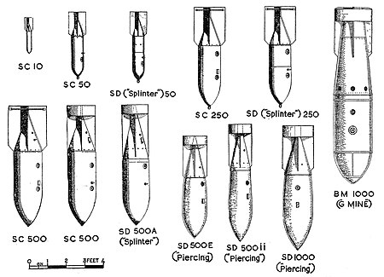
Steel extension rods (German name: Dinort) are sometimes fitted to the noses of SD 50 and SD 250 bombs.
Steel spikes to prevent ricochet are fitted only to bombs specially designed for them (German name Stabbomben, abbreviated to Stabo).
A retarder ring (Kopfring) is sometimes fitted to SC 50, SC 250 and SC 500 bombs.
Figure 1.GCerman H.E. Bombs: Smaller Types
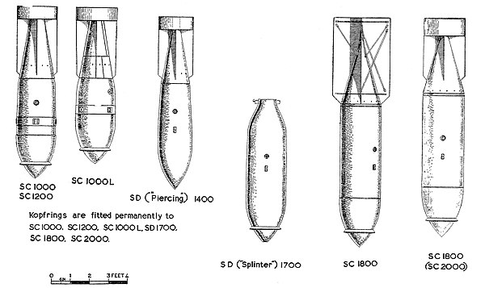
Figure 2.—German H.E. Bombs: Larger Types
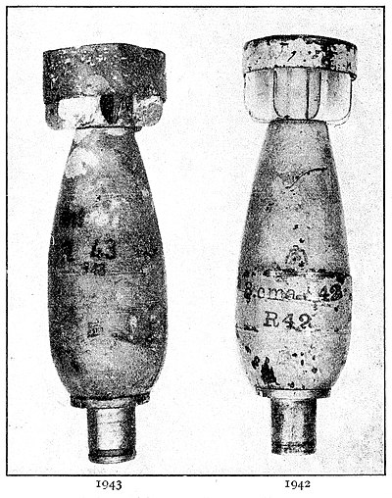
Figure 3.—German 1 kg. Anti. Personnel Bomb: SD 1 (½ full size)
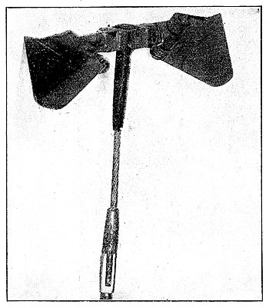
Figure 4.—Modified Arming Cable for SD 2 Bomb. (½ full size)
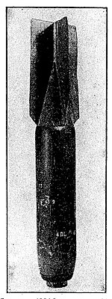
Figure 5.—German 10 kg. Anti-Personnel Bomb: SD 10A (½ full size)
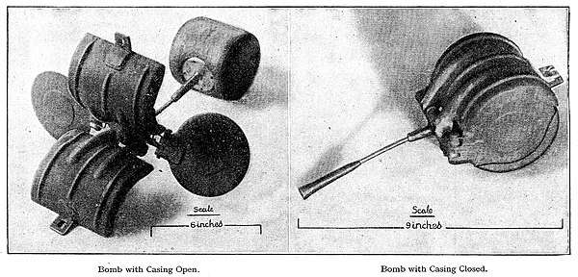
Figure 6.—German 2 kg. Anti-Personnel Bomb: SD 2
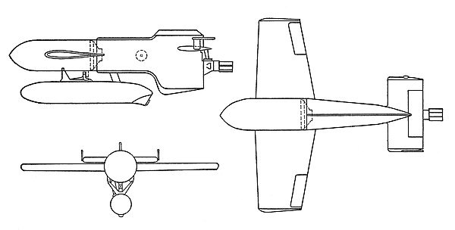
Figure 7.—German Radio-Controlled Jet-Propelled Glider Bomb: Hs. 293
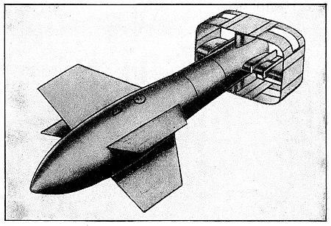
Figure 8.—German Radio-Controlled Armour Piercing Bomb: PC 1400 FX
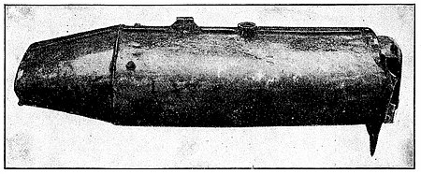
Figure 9A.—German Parachute Bomb: SB 1000/410
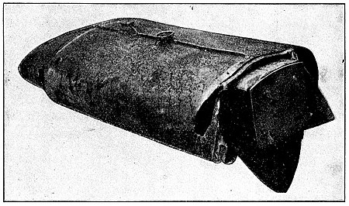
Figure 9B.—German Parachute Bomb: SB 1000/410
(b) Incendiary Bombs (I.B.)
(i) Small Magnesium Bombs
The principal German incendiary bomb so far used against this country has been the 1 kg. magnesium bomb with a thermite filling as illustrated in Figure 10. This bomb is the colour of aluminium, or may be spray-painted yellow-green, with markings both on the side and on the flat nose.
If when found unignited the holes near the nose are covered with insulating tape the detonator in the nose is probably still "live."
Do not tamper with any of these unignited bombs. Fatal accidents have occurred by so doing.
This bomb has remained the same in basic principles since the commencement of hostilities, but the following variations in pattern should be noted:—
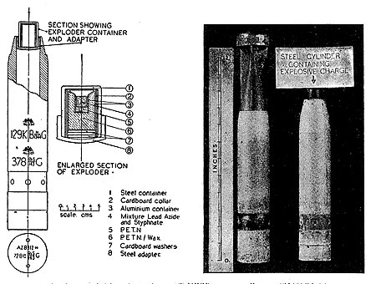
Figure 10.-German 1 kg. Incendiary bomb with explosive charge
Type with explosive charge in the tail (Exp. I.B.)
These have an explosive charge contained in a small metal cylinder about 1 in. in diameter and 1¼ in. long, screwed into the tapered or tail end (see Figure 10). This cylinder will be covered by the tail vanes if they are still in position when the bomb is found unignited. Typical markings, as found on both those with and those without the explosive charge, are seen in the illustration. The marking SODA II indicates a variation in the type of filling.
Type with steel nose (S.N.I.B.)
In this type the nose plug housing the striker, which is normally made of electron, has been replaced by a steel nose plug. This modification increases the weight of the bomb by 12 oz.
Instead of the usual marking AZ 8312, the plug is stamped AZ 1.3 A or AZ (1.3) A. Specimens of this type have been found painted yellow-green all over. The type may also be combined with an explosive charge in the tail end.
Type with explosive charge in the nose (N.Exp.I.B.)
This is a 1 kg. variant with a small explosive charge in the screw-in nose plug, and the charge is detonated by the heat of the burning electron casing between half a minute and five minutes after impact. The bomb may be identified by the very slight circular groove or recess formed in the flat nose by the screw-in cap 1⅝ in. diameter covering the explosive charge. The bomb is known to the Germans as the B 1 EZ.B or B 1.3 EZ-B, and was at first marked by a red painted B on the flat of the nose: a later marking is ZB or B stamped on the flat of the nose. The only specimens found so far in the U.K. were of the type with steel nose and were marked DKB 1938 on the body with a B stamped on the nose. (See Figure 14.)
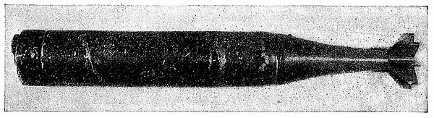
Figure 11A.—German 1 kg. Incendiary Bomb (French Type)
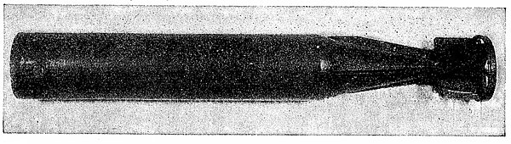
Figure 11B.—German 1 kg. Incendiary Bomb (French Type)
Type marked INC (French Type) This has the same general characteristics as the standard model, but is of a slightly different pattern. The general dimensions are as follows: Overall length 13.8 in.; diameter, 2 in.; length of tail about 5 in.; width of tail, 2 in.; weight, o 96 kg. (2.1 lb.).
The case is of magnesium alloy with a magnesium type filling and impact type nose fuze. The body is painted red up to 6¾ in. from the nose which is brown coloured; the tail is painted a glossy blue-green. Slight variations in these colours have been observed.
No explosive charge has so far been experienced in this type, the general appearance of which is shown by Figures 11A and 11B which also show the two patterns of tail vane construction observed in this type of bomb. In one case there are eight cast metal vanes, and in the other six sheet metal vanes enclosed in a strengthening hoop. The markings on the body of the bombs illustrated are in black and red as follows:—
   | INC
  EB | 83 | 36
  INC
  AEM | 1513-41
Incendiary bomb with explosive nose (I.B.E.N.) and (I.B.S.E.N.)
This again is in the form of an ordinary I kg. incendiary bomb to which has been fitted, in a steel extension to the nose, a charge considerably more powerful than that fitted in the tail of the Exp. I.B.
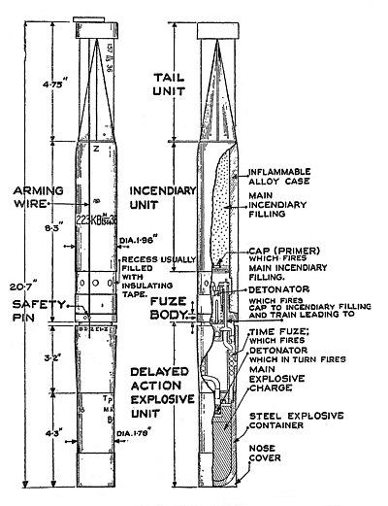
Figure 12A.—German Incendiary Bomb with Explosive Nose
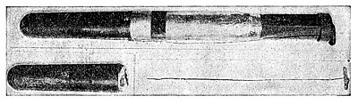
Figure 12B.—German Incendiary Bomb with Explosive Nose (I.B.E.N)
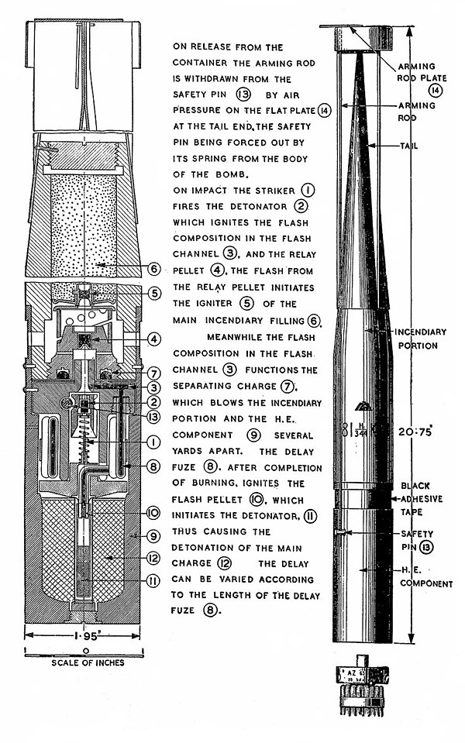
Figure 13.—German Incendiary Bomb with Separating Explosive Nose (I.B.S.E.N.)
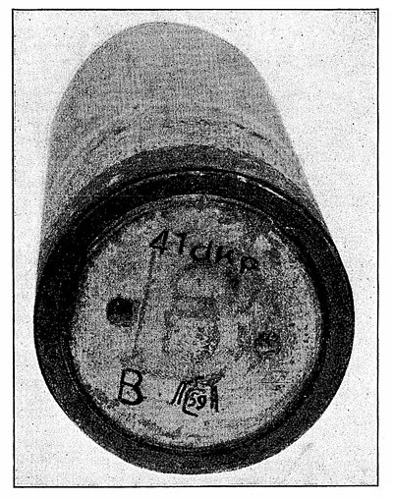
Figure 14.-German 1 KG. Incendiary Bomb with Explosive Charge in the Nose (N.Exp, I.B)
described above. The first type (I.B.E.N.—Figures 12A and 12B) has a 3½ oz. charge and a total weight of 2.2 kg. which will cause the bomb to penetrate further into buildings than the ordinary type. The overall length without tail is 1 ft. 5 in. A stiff wire 13 in. long with metal disc about 1½ in. diameter at the upper end is passed through the ring at the end of the tail vanes down the side of the bomb and through a hole in a safety pin, projecting from the fuze body. On release from the aircraft air pressure withdraws the wire, which falls separately and may be found on the ground some distance from the bomb. The safety pin is then ejected by an internal spring leaving the striker free. On impact the fuze functions igniting the incendiary body immediately and lighting a slow match fuze in the nose, extending the delay before the detonation of the explosive charge up to a maximum of seven minutes. The explosive extension may also break off on impact and detonate separately, some distance from the incendiary body (Figure 12B).
The second type (I.B.S.E.N.-Figure 13) is known to the Germans as the B 2 E.Z. The charge in the nose is reduced to 2 oz. and the total weight to 2 kg., but a small separating charge is fitted to fling the steel nose and incendiary body some yards apart. The normal I kg. portion is slightly shorter than the standard type, but the tail unit is longer, being 9¾ in., and has only three main fins. The cylinder, which contains the separating charge, the delay fuze, the H.E. filling and detonator, is 5⅜ in. long, flat nosed, and is a push fit on the turned-down portion of the 1 kg. bomb, to which it is secured by four small pins. The overall length is 1 ft. 8½ in. The wall thickness is slightly more than that of the I.B.E.N., but the arming wire and safety pin are of the same type. The tail is painted field grey, the incendiary portion green, and the explosive portion black. The letter Z is stamped on the incendiary portion just below the tail and a Z is painted in red on the flat nose. On impact the incendiary portion is ignited in the normal way, the separating charge, which consists of a small pellet about ⅛ in. thick and ¾ in. diameter, blows the incendiary and H.E. containers apart, igniting the delay fuze; the delay fuze subsequently actuates the detonator and the H.E. charge after a delay which may be varied to a maximum of at least 7½ minutes.
Markings of bombs with explosive charges
Incendiary bombs with the explosive charge in the tail, irrespective of whether the nose plug is electron or steel, are known to the Germans as type A, viz.: B 1 EZ–A and B 1.3 EZ–A respectively. These are distinguishable by a red-painted A on the nose and a stamped Z (= delayed action bomb) on the shoulder of the bomb. The A was later omitted but the Z retained.
Incendiary bombs with the explosive charge in the nose plug irrespective of whether the nose plug is electron or steel are known as type B; viz., B 1 EZ–B and B 1.3 EZ–B. These were at first marked by a red painted B on the flat of the nose; a later marking is ZB or B stamped on the nose. (See also the markings given on the I.B.E.N. and I.B.S.E.N. in Figures 12 and 13.)
(N.B.—Magnesium bombs, when burning on wet ground, may smell like acetylene, which sometimes gives rise to mistaken reports that they are of a type containing calcium carbide.)
(ii) Larger Types of Incendiary Bombs
Oil Bombs
There is an oil bomb weighing 110 kg. which has approximately the same external dimensions as, and to some extent resembles, a 250 kg. H.E. bomb, as will be seen from Figure 15. This bomb is known as "Flam C250 C." An earlier version known as "KC 250 GB" is shown in Figure 17, which illustrates the "method of filling"; the nose piece of this bomb is shown in Fig. 16.
A modified type of this bomb has no aperture, but instead the nose is covered by a cap, shaped like a saucepan and secured to the nose by a bolt fitted into the suspension lug socket.
A larger oil bomb weighing about 250 kg. of the same approximate dimensions as a 500 kg. H.E. bomb has also been dropped. (Note: The Germans call these oil bombs Flammenbomben, i.e. flame bombs, the latest types being known as Flam C 250 C and Flam C 500).
Phosphorus-oil bomb (Ph.I.B.)
This bomb contains a dark and extremely viscous liquid consisting of phosphorus, oil and a rubber solution in a casing similar to that of a 50 kg. H.E. bomb, which is split open on impact by the usual type of fuze, and may, scatter the sticky liquid contents some yards. The contents, which ignite spontaneously, have a total weight of about 25 lb.; of this 86.% is benzene, 10% rubber and 4% phosphorus. The case of the bomb is 2 ft. 6 in. long and 8 in. in diameter, with a wall about ⅛ in. thick (see Figure 18). It appears to be built in one piece
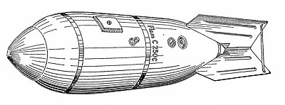
Figure 15.—German 110kg. Oil Bomb.
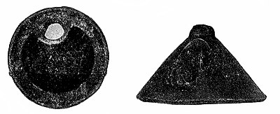
Figure 16.—Nose Piece of German 110kg. Oil Bomb.
with no weld marks. The suspension eye-bolt may be in the side or the nose of the bomb as in normal 50 kg. H.E. bombs.
The phosphorus-oil bomb can be distinguished from the 50 kg. H.E. bomb by the following features:—
(a) The rear of the bomb from shoulder to filling hole is painted red.
(b) The filling cap is painted red. The cap is screwed down on a clearly visible black rubber washer. (See Figure 19).
(c) A sheet metal collar may be welded to the case between the filling cap and the shoulder. The collar, which is often painted red, is drilled and tapped to take 8 screws.
(d) On one of the specimens a 1 in. red band was painted round the bomb an inch behind the suspension eye-bolt. The body of this bomb was painted dark grey-green or blue-grey.
This bomb is marked "Brand C 50 A." A later model marked "Brand C 50 B" is painted light fawn colour and has two red bands ¾ in. wide, one on the nose and the other between the tail and suspension lug (see Figure 18). In this type the case is of welded construction and the base filling cap is the female pattern with two studs projecting rearwards.
There is also a larger version of this bomb in a casing similar to a 250 kg. H.E. bomb. The filling is similar to that of the 50kg. type, but the rubber content has been increased to 13% and that of the phosphorus reduced to 0.4%.
The phosphorus content of these bombs may be carried in glass containers designed to break on impact and mix with the main filling. Bombs so filled have a representation of a glass container 40 × 80 mm. stencilled in red and "Brand C 50 A "; "Brand C 50 B"; or " Brand
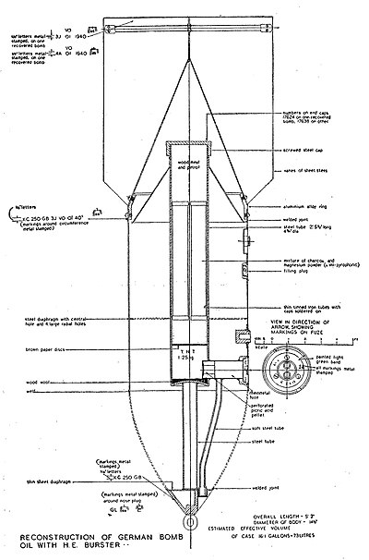
Figure 17.—German 110 kg. Oil Bomb: Longitudinal Section
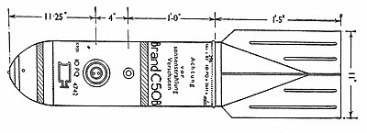
Figure 18.—German Phosphorus-Oil Bomb (Ph.I.B.)
C 250 A" stencilled in black on the side of the bomb casing remote from the fuze.
Phosphorus ignites spontaneously in contact with the air and care must be taken to avoid it. Do not touch the bomb, or any ground or equipment splashed with the filling. No smoking and no naked light should be allowed near these bombs as their contents are liable to give off vapour forming an explosive mixture with the air.
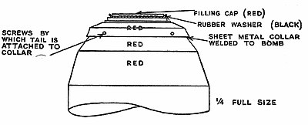
Figure 19.—Phosphoprus-Oil Bomb—Rear end of 50 kg.
Firepot Incendiary Bomb (Firepot I.B.)
The firepot bomb combines H.E. and incendiary elements in a casing of the same size and shape as a 50 kg. H.E. bomb (Figure 20A). On impact after the base-plug has been blown off six pre-ignited firepots
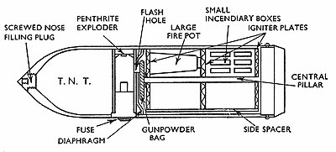
Figure 20A.—Firepot Incendiary Bomb
of the magnesium-electron type, each shaped like a large tumbler, 2¼ in. at the base, 3¾ in. in diameter at the top, and 5¾ in. long, together with 67 small incendiary units are ejected. These are about 2½ in. long and triangular in section, the side being about 1 in. and they have a magnesium type filling. The detonation of the 17 lb. charge of T.N.T. in the nose of the main bomb follows almost immediately. To distinguish these bombs from a 50 kg. H.E. when unexploded, it may be noted that they have a screwed filling plug in the nose, and have "SPRENGBRAND C 50" stencilled in black lettering, indicating their composite nature (Spreng = explosive; Brand = fire or incendiary). Details of the firepot assembly are shown in Figure 20B. These
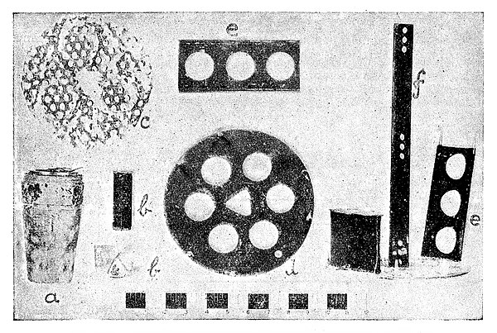
Figure 20B.—Components of Firepot Incendiary Bomb
illustrate the components which may be found near an exploded bomb of this type. The firepot is shown at a; the metal containers at b; an igniter plate at c; and the perforated bracket side spacer and central pillar at d, e and f respectively. This bomb is sometimes fitted with a flare-type fuze designed to make the bomb burst in the air and scatter its incendiary contents.
2. MINES DROPPED ON LAND
(a) Parachute Mines (P.M.)
Parachute mines dropped on land in this country so far have been of two types. Figures 21 and 22 show the smaller or D" type, and Figure 23 the larger or "C" type. Both types are cylindrical and 2 ft. 2 in. in diameter, the difference being only in the length, which in one is 5 ft. 8 in., and the other 8 ft. 8 in., without the tail bowl.
The nose of the mine is roughly hemispherical; the other end is open, but until the mine is released from the aircraft this open end is covered by a hemispherical bowl about 16 in. deep, with the parachute stowed inside. When the mine is dropped from the aircraft, this bowl is pulled off and opens the parachute, to which it is attached by four
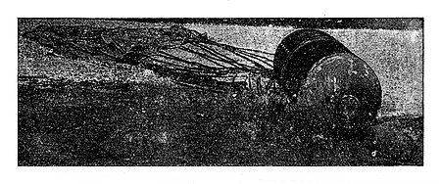
Figure 21.—Parachute Mine Type "D"
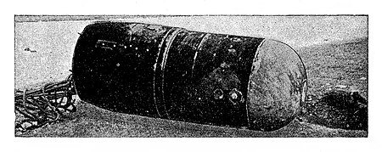
Figure 22.—Parachute Mine Type "D"
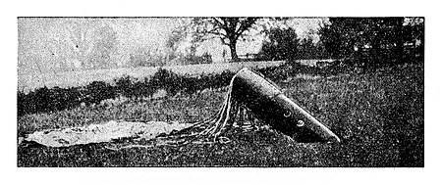
Figure 23.—Parachute Mine Type "C"
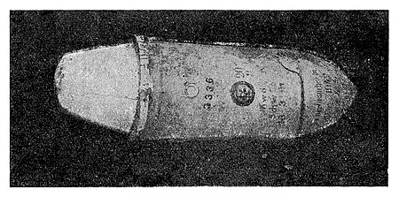
Figure 24.—Type "G" Mine
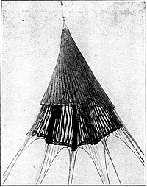 | 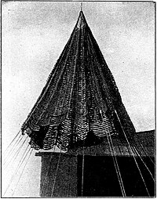
Figure 25.—Vertical Lattice | Figure 26.—Horizontal Lattice
Patachutes for German Mines
guy ropes. The bowl may still be attached when it reaches the ground, or may be found some distance away.
The parachute is usually of sea-green artificial silk. It is some 27 ft. in diameter, has thick silk cords, and allows the mine to fall at about forty miles per hour. Two other types of parachute are also used with mines. Both are of dark khaki-coloured artificial silk ribbon 2 in. wide. In one type the ribbons radiate slantwise from the apex to form a lattice work (see Figure 25) and in the other they are laid circumferentially and held together by the cords, which are carried right through to the apex of the parachute (see Figure 26). A white artificial silk drogue is used with the first type and is drawn off when the mine is released. It will usually be found surrounding the guy ropes attached to the tail-bowl of the mine.
There is usually little difficulty in distinguishing between a parachute mine and a bomb since the former has no tail vanes and its rear end is likely to be found open. There is, however, obviously more likelihood of confusion with the parachute bomb, and the distinguishing features to be borne in mind are the latter's oval shape and its characteristic parachute, which is of a different shape, size and colour from that used for mines (see Section I (a) (vi) and Figures 9A and 9B).
(b) Type "G " Mines
Another type of mine is known as the type "G" (see Figures 24, 27, 28 and 29). It has no parachute,^{[1]} but on to the tail unit cover are fitted tail fins and a ring of brown bakelised material painted light blue on the outside which easily break off on impact. General dimensions are as follows:—
Length overall, 6 ft. 4 in. (omitting the tail fins).
Diameter of body, 2 ft. 2 in.
Total weight about 2,160 lb.
This weapon is a mine of the magnetic or acoustic type and is usually painted light blue.
Any heavy vibration of the ground or any iron or steel object, e.g. a spade, taken into the immediate vicinity might cause detonation.
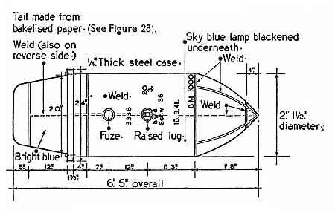
Figure 27.—Diagram of a Type "G" Mine
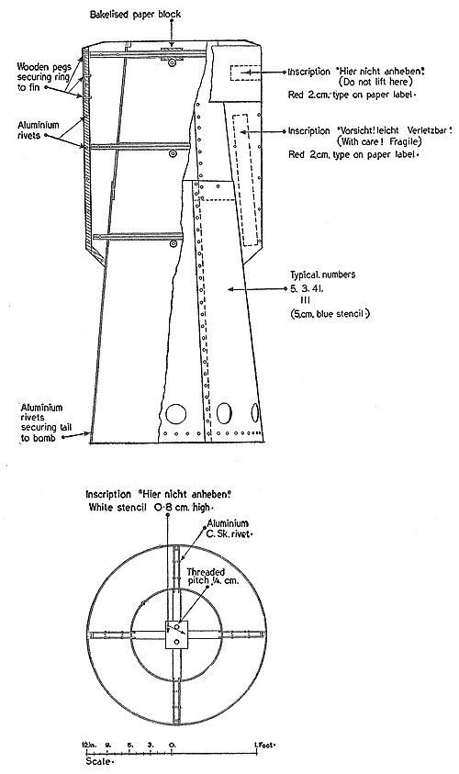
Figure 28.—Diagram of the Tail Fin Assembly of a Type "G" Mine
The unexploded "G" mine is likely to be buried and cannot be identified from its hole of entry, which will be the same as that of a large bomb. Fragments of bakelised material will, however, generally indicate its presence as, so far, fins of this material have not been observed on other German bombs, and the tail cover dome, which is of unusual shape, may be found broken off by impact.
The tail fin assembly carries the following markings in red letters ¾ in. high printed on paper labels:—
(a) On the ring round the end of the tail fins: "Hier nicht anheben" (Do not lift here). (b) On one or more fins: "Vorsicht—Leicht verletz-bar" (With care—fragile).
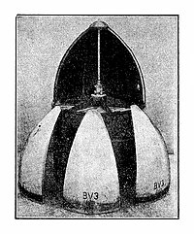
Figure 29.—Nose Extension for Type "G" Mine
The nose of one such mine was inscribed "Zu verbrauchen bis März 1942 Bk. 1.4.41. 1609."
(To be used before March, 1942. Manufactured 1.4.41.
A specimen has been recovered which shows that a new device may occasionally be fitted to the nose of this mine in order to prevent too rapid penetration on impact.
This device (not yet dropped in this country) consists of an extension in two parts.
The rear portion, made of brown bakelised material painted light blue in the same way as the tail fins, consists of a cylinder 2 ft. 1½ in. diameter, which is fitted over the nose of the mine.
In front of this is fitted a false nose shaped like the real nose of the mine. This false nose is about I ft. 8 in. deep and is made of six metal segments with a central rod and radial ribs or stays of metal. It serves merely to streamline the mine while it is being carried below the aircraft. On release from the aircraft a fuze immediately operates to blow off the false nose, leaving the cylinder attached to the mine.
The cylinder has the effect of a brake, delaying the fall of the mine through air or water. The mine itself remains externally unchanged. The metal segments, of which some. may bear the markings B.V.3., and other components of the false nose (see Figure 29) may be found intact at some distance from the mine.
Portions of the bakelised material of the cylinder may be found at the point of impact.
3. GERMAN PHOTOGRAPHIC FLASH-BOMBS
The Germans use for photographic reconnaissance at night a flash-bomb weighing 30 kg., which is sometimes mistaken for an incendiary weapon. This "bomb" has the outer casing of a 50 kg. H.E., but
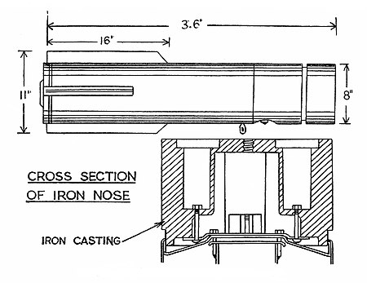
Figure 30.-Рhotographic Flash-Bomb
is fitted with a red painted fuze, similar to that used on parachute flares. The following inscription may be found stencilled upon it in black lettering: "Lieferungs Nr. DELEU—Dr. Feistel Angefertigt, (Date)." The casing is spray-painted aluminium or khaki and the marking BLC 50 in black letters appears near the tail. [Probably an abbreviation for "Blitz-licht (or Blitz-leucht)—cylindrisch," i.e. cylindrical flashlight type.]
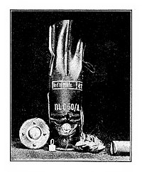
Fig. 31.—German Photographic Flash-Bomb
Another form of photographic flash-bomb (see Figure 30) has the same outward appearance as the casing of a parachute flare (Figure 56) being cylindrical with four fins at one end. It is 8 in. in diameter, 3 ft. 6 in. long and the fins project about 1 in. The outer casing is painted grey and is of thin sheet steel terminating in a heavy iron casting at the nose, which is flat and has in it four circular pockets or recesses about 2 in. in diameter and 3 in. deep. As will be seen from Figure 31, this bomb has BLC 50/A stencilled on the body.
The fuze is of a flare-type and great care should be taken with any such bombs found unignited, as they are liable to explode with considerable violence.
4. "CROWS-FEET
The Germans have devices for puncturing the tyres of aircraft and motor transport known from their shape as "Crows-feet." · They are segments of sheet metal with four barbed points so arranged that when resting on any three points the fourth is projecting upwards. They are of two sizes; in one, when the foot is on the ground, the base of the
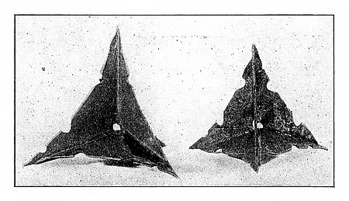
Figure 32.-"Crows-Feet"
triangle made has 3 in. sides and the height of the projecting point is 2½ in.; in the other, the corresponding measurements are 2½ in. and 2 in. The metal is painted green or green and khaki (Figure 32). These devices are sometimes carried in a container, type F (i) (see Figure 46).
5. AIRCRAFT DEMOLITION BOMBS'
German aircraft carry metal canisters filled with T.N.T. intended for the use of the crew in destroying the aircraft should it be forced to land in a hostile country. The canisters are painted German field-grey and are made in two sizes: One weighs 2 kg. and measures 7 in. by 4 in. by 3 in., and the other weighs 3 kg., and measures 9½ in. by 6½ in. by 3 in. In the event of aircraft crashing, these canisters may be thrown some distance from the wreckage, and should not be tampered with.
There is a small wire half-loop handle counter-sunk into the top of the canister. Three coloured labels are stuck over holes in the sides; one is generally fixed at the top near the handle, the second in one of the broad sides of the canister, and the third at the bottom. The weight is also painted in white on one side and the labels may bear some such inscription in bright orange lettering as:—
"Geballie Ladung. 3 kg. F.P. 02 Sulfiltri ESG. 1938. RDF 5. Lief. 1938."
6. GERMAN SMALL ARMS AMMUNITION
German small arms ammunition is mainly of three calibres, viz.:—
7.92 | mm. | (0.312 in.) | Mauser pattern.
13 | mm. | (0.5 in.) | Solothurn pattern.
20 | mm. | (0.8 in.) | Oerlikon or Mauser (151/20 mm.) pattern.
In addition, 15 mm. and 30 mm. calibres exist, but are less frequently found, However, the 30 mm. may be expected to be found in increasing numbers. Each calibre is divided into several types, e.g. armour-piercing, tracer, incendiary-with combinations of these in one projectile. In addition, there are rounds with a very sensitive
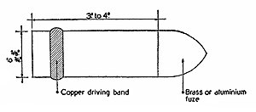
Figure 33.—German 20 mm. Cannon Shell
self-destroying nose or base fuze. A sketch of a 20 mm. cannon shell is given in Figure 33.
Ammunition must be handled with the greatest care and not tampered with in any way, whether it is complete with cartridge case or not. All types are potentially dangerous and some rounds are particularly so; even if damaged, or recovered after being fired, they are still liable to function with the slightest shock. The characteristics of these most dangerous types are shown in Appendix "B."
(N.B.-It is no longer practicable to include, as in the first edition of this Training Pamphlet, an exhaustive list of all the many varieties of the types of each calibre now used by the enemy.)
7. GERMAN AMMUNITION CONTAINERS
The standard German 7 92 mm. machine-gun magazine of the spectacle type is illustrated in Figure 34. It is about 10 in. long, 4 in. high; usually has a handle as shown in the illustration and carries about 75 rounds. The ammunition container on the right of the picture
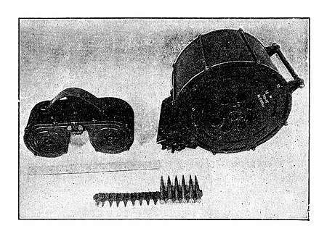
Figure 34.—German Ammunition Containers
shows the 20 mm. Oerlikon drum. This holds about 60 rounds and is of all-metal construction, about 6 in. thick and 11 in. wide, and when full it weighs just over 60 lb. In the foreground can be seen a short length of 7.92 mm. metal machine-gun belting holding a few rounds of ammunition.
All ammunition containers should be handled with the greatest care.
8. WHISTLE ATTACHMENT FOR SCREAMING BOMBS
Two types of whistle, sometimes attached to the vanes of German high explosive bombs, causing them to scream as they fall, are illustrated in Figure 35. These whistles are often found near the scene of a bomb explosion.
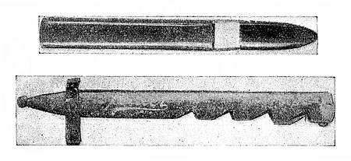
Figure 35.—Whistle Attachments for Screaming Bombs
One type is a black cardboard tube, shaped like an organ pipe. The other model is an adapted bayonet scabbard, with an attachment for fastening it to one of the vanes of the bomb. Both models are approximately 14 in. in length and 1½ in. in diameter, the vent being about 4 in. from the closed end, which is rounded. Owing to mechanical weakness, the former often breaks in two at the vent and the parts may be found separately.
In the second type, the body of the pipe is sometimes a hollow sheet-metal tube, spot-welded in two seams down the side, with a wooden nose secured to the tongue of the metal tube by two nails.
(Note: 1-kg. incendiary bombs have also been found fixed to the vanes of a 50-kg. H.E. bomb by clips.)
9. GERMAN CONTAINERS
The Germans are now using a large number of different containers to carry small incendiary and anti-personnel bombs, and flares. Most recent types are marked "AB" or "ABB" and are meant to open at approximately predetermined heights below the aircraft, according to fuze setting. The initials AB stand for "Abwurf" = a throwing out, "Behälter = a container, which taken together indicate the later types which are released intact from the aircraft; the additional B stands for "Brandbomben" = incendiary bomb, though other than incendiary bombs may now be carried in containers marked ABB. The BdC 10, BSK 36, Mark 500 Boden, Mark 250 BK and Mark 250 LK are. also released from the aircraft.
Where the numeral used corresponds with an H.E. bomb of the same weight, e.g. AB 250, AB or ABB 500, and AB 1000, the container occupies the same stowage space as the equivalent H.E. bomb, i.e. 250 kg., 500 kg. or 1000 kg. The containers are listed below in four tables divided according to the bomb stowage space occupied.
A. Occupying 50 kg. Bomb Stowage Space
German Marking |  | Colour | Dimensions |  |  | Contents |  | Report as Type
 |  | Colour | Length |  | Diameter in. | No. | Type | Report as Type
 |  | Colour | Ft. | in.
(i) | BdC 10 | Red | Hinged clamp |  |  | 5 | SC 10 | I
 |  |  | 10 in. diameter. or |  |  | 5 | SD 10A
(ii) | AB 23 SD2 | Dark Green | 3 | 7½ | 8 | 23 | SD 2 | J
(iii) | AB 24t SD2 | Not known | 3 | 9½ |  | 24 | SD 2 | K
(iv) | AB 36 | Dark Green or | 3 | 6 | 8 | 36 | I.B. | B or
 |  | Olive Green |  |  | or | 24 | I.B.S.E.N. | C
(v) | BSK 36 | Silver | 3 | 7 |  | 36 | I.B.
 |  |  |  |  | or | 16 | I.B.S.E.N | A
(vi) | AB 42 | Not Known | Not | Kno | wn | 42 | I.B | L
(vii) | AB 70 D1 | Field Grey | 3 | 7½ | 8 | 50 | SD1 | M(i)
(viii) | AB 70-3 | Fawn | 3 | 4 | 8 | 22 | SD 2 | M(ii)
(ix) | AB 70-5 | Khaki | 3 | 7½ | 8 | 23 | SD 2 | M(iii)

B. Occupying 250 kg. Bomb Stowage Space
German Marking |  | Colour | Dimensions |  |  | Contents |  | Report as Type
 |  | Colour | Length |  | Diameter in. | No. | Type | Report as Type
 |  | Colour | Ft. | in.
(i) | AB 250–2 | Khaki | 5 | 3.6 | 14,7 | 224 | SD 1 | N(i)
 |  |  |  |  | or | 17 | SD 10A
(ii) | AB 250–3 | Dark Green | 5 | 3.7 | 14.7 | 108 | SD 2 | N(ii)
(iii) | Mark 250-BK | Khaki | 4 | 1 | 14.7 |  | Single candle Flares and | N (iii)
 | 3 SD 2 |  |  |  |  | 3 | SD2
(iv) | Mark 250 LK | Khaki | 4 | 1 | 14 | 41 | small flares | N(iv)

C. Occupying 500 kg. Bomb Stowage Space}
German Marking |  | Colour | Dimensions |  |  | Contents |  | Report as Type
 |  | Colour | Length |  | Diameter in. | No. | Type | Report as Type
 |  | Colour | Ft. | in.
(i) | ABB 500 | Slate Grey | 5 | 9.6 | 18.4 | 140 | I.B.
 |  | Red band |  |  | or | 2200 | Crows-feet | F(i)
(ii) | ABB 500 M10 | Slate Grey  Red Band | 5 | 9.6 | 18.4 | 10 | Small Flares | F(ii)
(iii) | Mark 500 | Slate Grey  Red Band | 5 | 9.6 | 18.4 | 10 | Small Flares | F(iii)
(iv) | Mark 500 BODEN | Slate Grey | 5 | 9.6 | 18.4 | 9 | Small flares and | F(iv)
 | 6 SD 2 |  |  |  |  | 6 | SD 2
(v) | AB 500–1 | Khaki | 6 | 10 | 19 | 184 | I.B. | H
 |  |  |  |  | or | 116 | I.B.S.E.N.
 |  |  |  |  | or | 37 | SD 10A
 |  |  |  |  | or | 392 | SD 1
(vi) | BSB 320 | Black | 7 | 9 | 20 | 320 | I.B. | E (ii)

D. Occupying 1000 kg. Bomb Stowage Space
German Marking |  | Colour | Dimensions |  |  | Contents |  | Report of Type
 |  | Colour | Length |  | Diameter in. | No. | Type | Report of Type
 |  | Colour | Ft. | in.
(i) | AB 1000-2 | Khaki | 9 | 10 | 26.5 | 620 | I.B. | G
 |  |  |  |  | or | 372 | I.B.S.E.N.
 |  |  |  |  | or | 238 | I.B.
 |  |  |  |  | + | 248 | I.B.S.E.N.
(ii) | AB 1000–3 | Fawn | 10 | 1 | 26 | 110 | SD 10A | O
(iii) | BSB 700 | Light Blue | 10 | 3 | 26 | 700 | I.B. | E (i)
(iv) | BSB 1000 | Khaki | 8 | 8 | 24 | 620 | I.B. | P
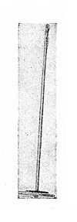
Figure 36.—Type "A": BSK 36
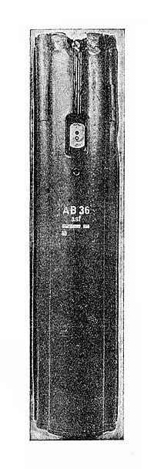
Figure 37.—Type "C": AB 36
GERMAN CONTAINERS
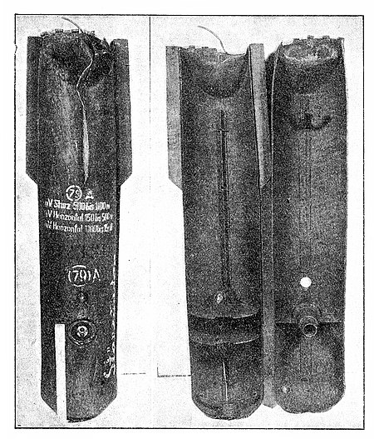
Figure 38.—Type "J": AB 23SD2
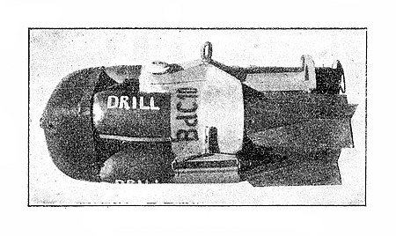
Figure 39.—Type "I" : BdC 10
GERMAN CONTAINERS
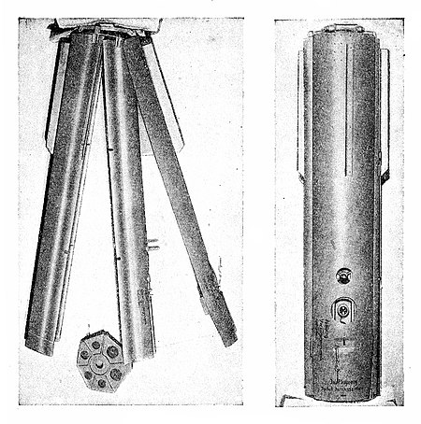
Fig. 40.—Type "B": AB 36
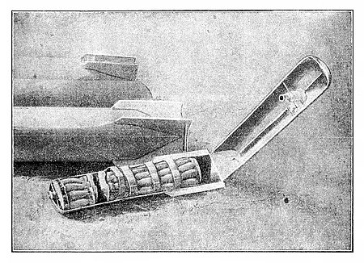
Fig. 41.—Type "M" (i): AB 70 D1
GERMAN CONTAINERS
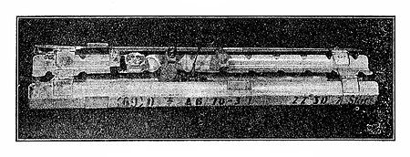
fig. 41A.—Type "M" (ii): AB 70–3
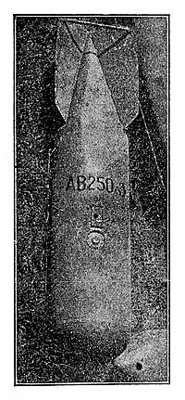
Figure 43.—Type "N" (ii) AB 250–3
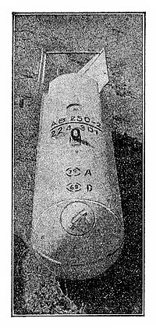
Figure 42.—Type "N" (i) :AB 250–2
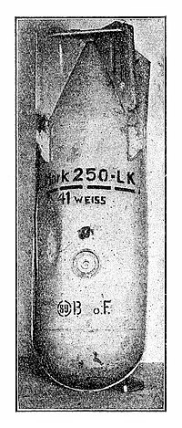
Figure 44.—Type "N" (iv): Mark 250–LX
GERMAN CONTAINERS
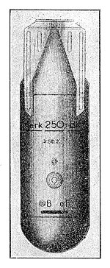
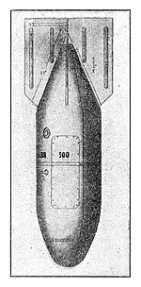
Figure 45.—-Type "N" (iii): MARK 250–BK
Figure 46.—Type "F" (i) : ABB 500
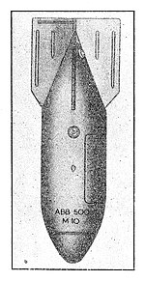
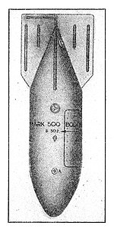
Fig. 47.—Type F (ii) : ABB 500 M 10
Fig. 48.—Type "F" (iv): Mark 500 BODEN: 6 SD 2
GERMAN CONTAINERS
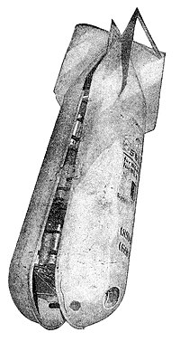
Figure 49.—Type "H": AB 500–1
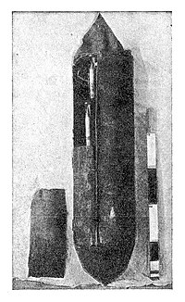
Figure. 50.—Type "E" (ii): BSB 320
GERMAN CONTAINERS
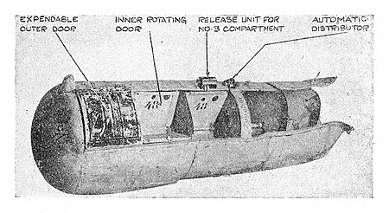
Figure 51.—Type "E" (i): BSB 7oo
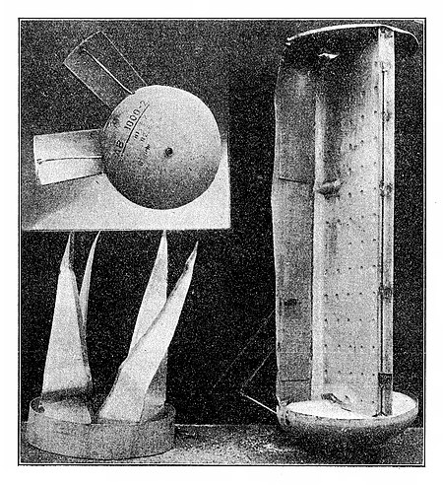
Figure 52.—Type "G": AB 1000–2
GERMAN CONTAINERS
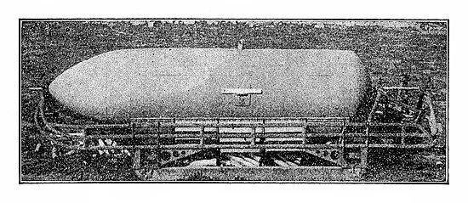
Figure 53.—Type "P": BSB. 1000 Container
10. MESSAGE TUBES
A tube used for urgent messages, about 15 in. in length, is shown in Figure 54. It is painted red, with the following German inscription in yellow lettering: Meldebüchse (Land) Fl.24575.
Then follow three German instructions, ending with the words in block letters:—
UNGEFÄHRLICH (not dangerous)
WICHTIGE MELDUNG! (important message)
SOFORT WEITERGEBEN (forward at once)
It is opened at one end by a bayonet catch, and is notched at the other end to operate a short-delay smoke fuze. These tubes are normally used in Army co-operation duties, but they have been found in this country, usually near crashed enemy aircraft.
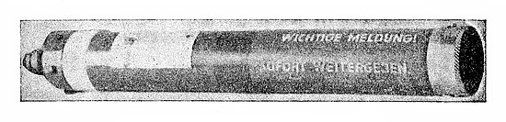
Figure 54. German Message Tube
II. AUXILIARY PETROL TANKS
An auxiliary plywood petrol tank, sometimes jettisoned over this country, is illustrated in Figure 55. It is built up from 12-ply wood, glued together. It is torpedo-shaped with a tail fin, and has a maximum diameter of 2 ft. 7 in. and an overall length of 11 ft. 6 in. It is held to the aircraft by a rod with an eyepiece, and is steadied by four stay rods, having ball-joint ends. A vent pipe and rubber suction pipe with a fine-mesh strainer made of brass are fitted to the upper side of the tank. The German word geprüft (i.e. tested), followed by a date, may be found stencilled on it as well as "Bei Verwendung von Stutzstreben diese Platten enifernen" (when using steadying struts remove these plates).
An auxiliary petrol tank of similar shape measuring 6 ft. 6 in. by 1 ft. 8 in.., but made of aluminium and without a tail fin is also used and is illustrated in Figure 55A.
For operational reasons any petrol tanks found should be reported immediately, care being taken to preserve any petrol they may stil contain.
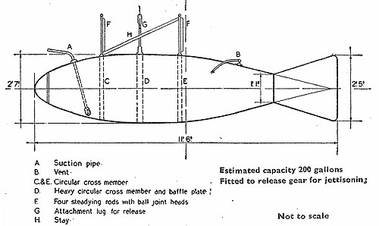
Figure 55.—Auxiliary Petrol Tank
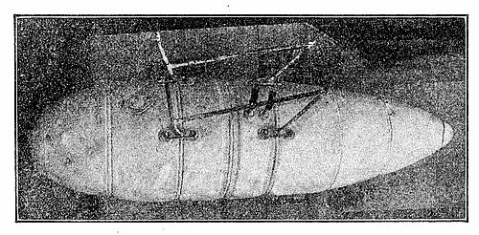
Figure 55A.—Metal Auxiliary Petrol Tank
12. WIRELESS APPARATUS
A form of portable wireless, for use by German airmen who may come down in the sea, is sometimes thrown out of aircraft which break up in the air or crash. This is packed in a sealed metal canister, painted yellow; it is 16 in. by 17 in. by 9 in., with handles on the side and German inscriptions on the top.
13. GERMAN RADIO TARGET BEACON
The Germans have developed a radio target beacon designed for dropping from aircraft and having the general appearance of an H.E. bomb probably of 50 kg., though it may be of 250 kg. It contains a small short-wave wireless transmitter designed to send out signals at intervals to guide aircraft to their target. Neither the exact size, colour nor markings of the device are yet known, but it has a tail unit of insulating material with a vertical-type aerial about 3 ft. to 4 ft. long protruding from it. If dropped from the appropriate height it is believed that it will be just buried in soft ground so that the aerial projects above the surface.
14. GERMAN VISUAL TARGET INDICATORS
One type of target indicator consists of a container of thin cardboard rolled to form an open-ended cylinder 1 in. diameter and 0.1 in, thick and either 8 in. or 3½ in. long. Both ends are strengthened by a metal capping and one end is closed by a cardboard disc. It is filled with a flare composition, grey in colour, designed to ignite on impact with the ground.
Various other target indicators may be developed and any small cardboard or metal tube of this sort should be reported immediately.
15. FLARES AND FLARE PARACHUTES
Parachute flares are of two main types, one with a single candle, and the other having four. The complete unit consists of a cylindrical aluminium or pressed paper casing, 3 ft. 3 in. long and 8 in. in diameter, and contains the parachute, detonator, and the candle or candles (see Figure 56). Where there is only a single candle, it is 24 in. in length and 7 in. in diameter. Where there are four candles, they measure about 24 in. by 3 in. diameter, and are mounted on a flat steel pressing, roughly the shape of a Maltese cross.
The following markings on the outside casing have been seen:—
DEPYFAG 2:40 Lief. 9.
The outside of the candles has the appearance of polished aluminium
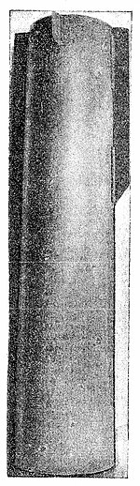
Figure 56.—Parachute Flare Casing
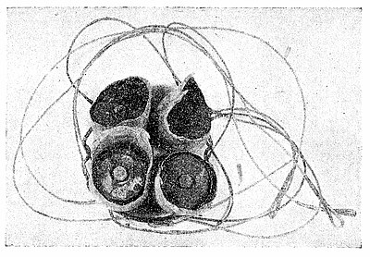
Figure 57.—Parachute Flare—Burnt Out
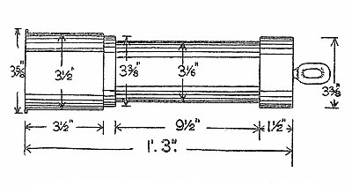
Figure 58.—Small Parachute Flare
and usually bears an inscription indicating the maker and date of manufacture, such as:
Ausfuhrung Nicolaus 8/1940 (i.e. Nicolaus Pattern August 1940).
Other makers are:
Eisfeld: Deleu Dr. Feistel: Berck Holtz: Deutsche Pyrotechnische Fabrik A/G: Sawie: Dr. Schmarr.
When found, some or all of the candles are likely to be burnt down to a short stump, and will be attached to the housing of the igniter unit, an aluminium pressing resembling a saucepan 5 in. deep (see Figure 57).
Other single candle flares are of the following types:-
(i) That illustrated in Figure 58 which is a small flare 1 ft. 3 in. long and a little over 3 in. diameter. Ten of this type are released from the containers type F (ii) or F (iii) (see Figure 47).
(ii) A flare with a casing similar in appearance to the one illustrated in Figure 56 but with the lower end dome-shaped. The rear end, where the parachute is housed, has four fins 1½ in. wide and is closed by an end-plate secured by six light screws. The container is 3 ft. 6 in. overall in length, about 7¾ in. diameter, and has "L.C. 50 F. Ausf." stencilled on a silver patch just forward of the fuze pocket.
(iii) A flare with a casing of about the same size as (ii) but without tail fins and with "MARK 50/F/A" or "MARK C 50FA" stencilled in yellow, green or red lengthwise on the body. It would appear that the colour of the stencilled marking indicates the burning colour of the flare composition.
(iv) Another small type enclosed in an alloy casing about 1 ft. 6 in.long and 3½ in. diameter, with a sheet steel cap at the upper end, and stamped in yellow or green lettering: "70 Eisfeld Dez" 1937 (see Figure 59).
(v) Another small type enclosed in an aluminium casing 13¼ in. long, 2.4 in. diameter with no markings. The nose is recessed 2 in. to hold a pull percussion igniter. This flare is attached to a parachute by a wire cable 36 in. long.
The container of the type illustrated in Figures 47 and 48, marked in red either "MARK 500 BODEN" or "MARK 500" or "ABB 500 M 10 " is used to carry ten of the small flares type (iv). Alternatively nine of these flares and 6 small anti-personnel bombs may be carried, in which case the outer containers are marked "MARK 500 BODEN in red followed by "6 SD 2" in white underneath.
The container illustrated in Figure 44, marked "Mark 250-LK; 41 Weiss" carries 41 flares of type (v).
The flare parachute is smaller than that used on the parachute mine, being about 10 ft. in diameter with thin cords; it is usually of silk or artificial silk, and has seven segments. With the heavier type of flare, however, the parachute may be as much as 14 ft. 3 in. in diameter, and may have twelve segments. That used with type (ii) above is 4 ft. diameter vented at the centre and is attached to the aluminium-cased candle by twelve shrouds, each 10 ft. long, arranged in two groups, each group being attached to a 4 ft. length of steel-wire rope which is connected to the end-plate of the candle. That used with type (iii) above is vented at the top; has a circumference of about 21 ft. 4 in. and is made in 8 sections. The shrouds are arranged in two groups of four, which are connected by two suspension cables to the two brackets bolted to the candle unit lid. That used with type (v) above is formed of 8 main panels; has a circumference of 12. ft. 10 in. and a vent at the top 3¾ in. diameter.
The parachutes may be white, red or camouflage colouring and bear the mark "Kurt Peterhansel." A flare parachute, however, has been reported marked "Nicolaus," and other markings may be found.
The German flame float has a casing consisting of two pieces of sheet-steel welded together, with overall dimensions similar to those of the parachute flare (3 ft. long by 8 in. diameter), filled with a composition which on contact with water produces gases that spontaneously ignite. The case is coloured yellow and marked "LUX N" or "LUX S."
Care should be taken not to pull any cords attached to unignited flares as this may cause them to explode.
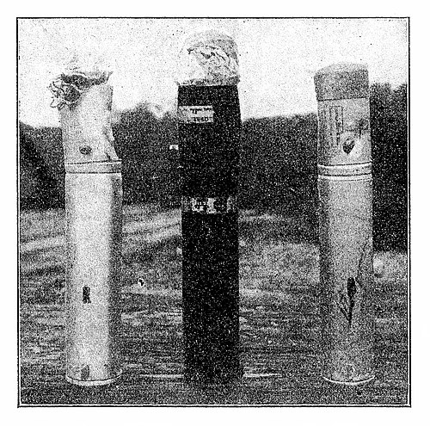
Figure 59.—German Single Candle Flares
16. DYE-BAGS
Small canvas bags are carried in German aircraft inside a rubberised bag, brown-yellow in colour, about 7½ in. long and about 9½ in. in diameter, which are marked in black letters on the outside with the word "Farbbeutel" (i.e. dye-bag). These bags contain a sodium compound of dye-stuff of the fluorescein type, which is orange-red in colour and is for use in the event of the aircraft falling into the sea. It is very soluble in water and imparts a yellow-red colour to the surrounding sea with intense fluorescence.
17. METEOROLOGICAL BALLOONS
British meteorological balloons comprise:—
(a) A small type about 2 ft. in diameter, many of which have a tail of thread about 25 ft. long with a sheet of coloured paper tied to the end; they should eventually burst and fall to the ground;
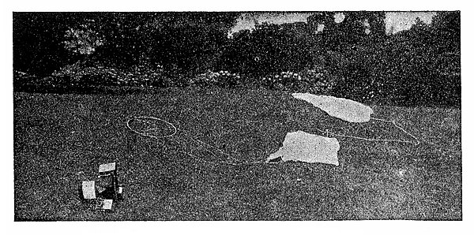
Figure 60.—Meteorological Balloon
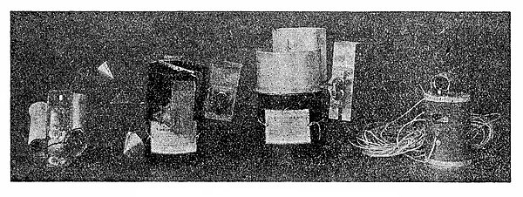
Figure 61.—Typical Meteorographs
These balloons sometimes carry a small Chinese lantern at the end of the tail.
(b) A larger type about 8 ft. in diameter, carrying a meteorograph which, when the balloon bursts, floats down to the ground on a parachute about 3 ft. diameter; this will usually be found with a label addressed to finder and giving instructions as to its disposal. Typical meteorographs carried by these balloons are illustrated in Figures 60 and 61, the former showing a British instrument with parachute as it would be found after falling. Of the instruments shown in Figure 61 the two in the centre are British while those on the outside are German. The outer casings, from left to right, are made of celluloid, bakelised cardboard, aluminium and bakelised cardboard respectively. In all these instruments the meteorological elements are surrounded by aluminium shields.
The American meteorograph, also used with this balloon, is enclosed in a container measuring 8½ in. × 8½ in. × 4¼ in. and composed of rigid white cardboard having a glazed appearance. Protruding from the sides are several short wires of various colours and fixed across the top is a ¾ in. white webbing strap by which the instrument is attached to the parachute.
This balloon may also carry a device used in connection with radio-detection consisting of a light wooden kite-like framework the top of which is a square of about 3 ft. side, from the points of which strips converge to a point 2 ft. below the centre of the square. Metallised paper is stretched across the framework and secured to it by glue.
German meteorological balloons are generally made of natural-coloured rubber with a non-fabric strengthener, or are made of latex. They have a peculiar smell which is quite distinct from that of their British counterpart. They can be definitely distinguished, however, by the fact that they are constructed in several segments, whereas British balloons are all in one piece or in two sections; again, German balloons have a number of rubber loops cemented on with strings attached to hold the instruments, whereas British balloons have the instruments tied to the neck or valve.
The German balloon measures about 4 ft. long when deflated and weighs from 1 to 2 lb. The Germans have also used balloons of French manufacture, similar in construction to the British type. The distinguishing features mentioned above may, therefore, not always be present.
All such balloons, both British and German, are liable to leak, in which case they may come to the ground still partially filled with hydrogen.
No naked light or lighted cigarette should be brought too near them otherwise the gas may ignite, or, in the case of larger balloons, cause an explosion.
Apart from the danger of fire, hydrogen is harmless.
18. LEAFLET-CARRYING BALLOONS
Two types of German leaflet-carrying balloons have been found so far, one khaki and the other silver, but apart from colour they appear identical. As will be seen from the illustration (Figure 62), they are in the form of a vertical cylinder with rounded ends, and measure when deflated about 16 ft. by 13 ft. They are made of rubberised fabric and have a long fin of some 4 to 5 ft. at the base.
The leaflet-carrying box is slung underneath, and consists of a small cardboard box in cube form with an 8½ in. side, in the centre compartment of which is a simple clockwork mechanism. Around this are four compartments (see Figure 63), containing bundles of leaflets which are held in position by wire bands until the moment of release.
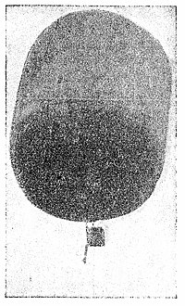
Figure 62.—German Leaflet-Carrying Balloon
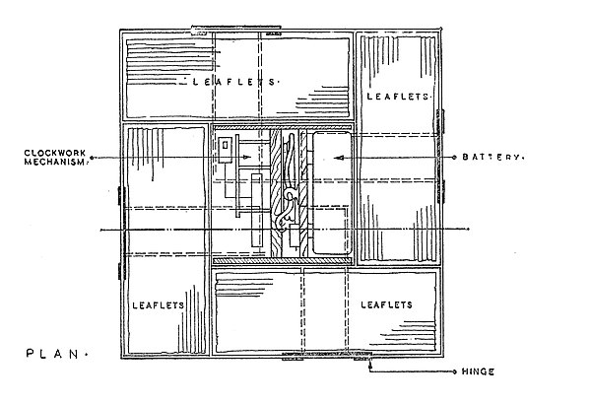
Figure 63.—Leaflet-Carrying Box: Cross-section
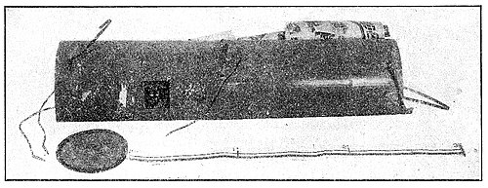
Figure 64.—German Leaflet Container DPA 1006
The clockwork mechanism drives two pulleys; round one is wound a thin wire and round the other a silk cord. The thin wire unwinds off the pulley under the impulse of the clockwork and lets fall the wire bands clear of the bottom of the box, thereby releasing the leaflets. In a small compartment adjoining the clockwork a dry cell is held between two spring clips. Leads from this cell are carried into a smali bag of flash-powder, and contacts on the clockwork side are arranged to give a delayed action.
When the box is found unopened on the ground, it is only necessary to reverse the battery end for end in the clips to prevent this powder being fired. Injuries have been caused in certain cases through the omission to take this precaution.
Another pattern of leaflet container, which is of metal and about 3 ft. long, is dropped from aircraft and is illustrated in Figure 64.
19. LEAFLET-CARRYING PARACHUTES
Prior to the use of balloons for this purpose, the Germans dropped leaflets by means of parachutes, the leaflets being carried in bundles and secured by a simple wire device which was broken open by a small explosive charge. It is possible this practice may be resumed.
20. MAN-CARRYING PARACHUTES
German man-carrying parachutes for emergency use are of two types:-
(a) A seat-type harness where the wearer sits on the parachute pack.
(b) A pack-type which is carried on the wearer's back.
The parachutes have white canopies, usually of artificial silk, and are opened by pulling a rip cord releasing a pilot parachute, which in turn opens the main one. The pilot parachute is in eight segments, alternate segments being opened by four wire or strip-metal springs. The length of seam is 16 in.; the top width of each segment is approximately 3 in., and the bottom width about 12½ in.
The main parachute is in twenty-four segments. The length of seam is 10 ft: 6 in. to 10 ft. 9 in.; the width of each segment at the top is 3 in., and at the bottom, 2 ft. 11 in. to 3 ft. 2 in.
In the seat-type the harness rigging lines are retained in six hanks by canvas loops, and in the pack type by five canvas loops.
The following markings have been found on German emergency parachutes:-
(a) On the underside of seat-type—
Sitzfallschirm (Seat-type parachute)
Baumuster | (Pattern) | 30IS24BSA
Werknummer | (Works No.) | 2000480
Gewicht | (Weight) | 9.5 kg.
Tag der Herstellung | (Date of Manufacture) | 1 Feb. 1939
Anforderungszeichen | (Reference No.) | F L 30201
Hersteller | (Maker) | AUTOFLUG,
Berlin
(b) On the belt clasp of pack-type-
AUSLOSEN
DREHEN DANN DRUCKEN. (To open, turn and then push.)
An artificial silk parachute of similar dimensions has been reported which has cords dyed sepia and the canopy camouflaged in an all-over pattern of emerald green, gold, and olive green.
21. “BLACK STRIPS "
A device consisting of strips of paper coated silver and then blacked over is used from the air to interfere with radio location. The strips are usually about ¾ in. wide and from 6 in. to 24 in. long, but a considerable diversity of length and appearance may be expected.
The Germans have used containers type "F(i)"—ABB 500—and type "J"—AB 23 SD 2—to release this device and when the latter is so used it is found without any of the internal partitions shown in Figure 38.
22. BRITISH AND AMERICAN BOMBS
Sufficient details are given in the figures and tables on pages 46 to 53 to enable unexploded British and American bombs to be identified.
23. BRITISH AND AMERICAN PRACTICE BOMBS
(a) British Practice Bombs
British practice bombs are of three types, differing in weight and material, but all are of the same shape. The dimensions are—length 16–18 in. maximum diameter 3 in., tail vanes 3 in. long and all have a small lug approximately 5 in. from the nose.
The individual types are:—
- 11½ lb. Practice Bomb. This is of all-metal construction and is normally painted white with two ½ in. green bands ½ in. apart on the tail unit. If these bands are black, and there is in addition a red band round the nose, the bomb is filled with flash composition instead of the normal smoke filling.
- 10 lb. Practice Bomb. This differs from the first type in weight only.
- 8½ lb. Practice Bomb. This is of plastic construction and is therefore likely to be very badly damaged when recovered. This bomb is smoke-filled only, and the marking is the same as on the 11½ lb. type.
The following bombs are also used for practice purposes:—250 lb. G.P., 500 lb. G.P. and 1000 lb. G.P. (either inert or H.E. filling). Normally they will be painted black and have a yellow band around the greatest diameter.
All the bombs contain an extremely powerful detonator-burster.
(b) Infantry Training Bombs
Two types of infantry training bombs may be met—the 6 lb. and the 60 lb. Both are filled with a powerful explosive and should be treated as H.E. bombs. The 6 lb. bomb is a cardboard cylinder 20 in. by 3¾ in.; the 60 lb. bomb, which may be fitted with a nose extension rod, is 42½ in. long (including the extension rod) and 8½ in. diameter, and also made in cardboard. Without the extension rod it is 34 in. long.
(c) American Practice Bombs
The most common type of American practice bomb is the 100 lb. It is painted sky-blue and is 47½ in. long overall and 8 in. diameter. It contains an explosive charge housed in a red canister held in the tail and is dangerous to handle.
There are also five other types, weighing 3 lb., 13 lb., 100 lb., 500 lb., and 1000 lb., which may be recognised by their colour, which is black, with the exception of the 3 lb. bomb, which is unpainted. These bombs have no fuzes and the nature of the filling is stencilled on the side of the body.
24. BRITISH INCENDIARY BOMBS
The 4 lb. British incendiary bomb exists in three types-non-explosive, explosive and high explosive, the latter having a lethal range of about 100 yards. These are all the magnesium type and are normally jettisoned "safe" in this country. in small bomb containers holding 90 bombs or in clusters which hold up to 158. The 30 lb. incendiary bomb contains a phosphorus filling, which may leak from damaged bombs and ignite spontaneously. Normally 30 lb. incendiary bombs. are jettisoned in a small bomb container holding 8 bombs or in clusters holding 14.
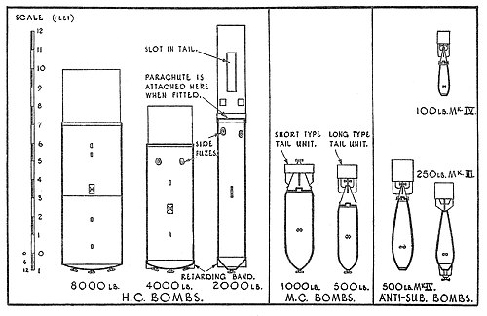
Figure 65.—British H.E. Bombs
Table No. 1.-BRITISH H.E. BOMBS
Type | Weight (lbs.) | Dimensions |  |  |  |  |  | Main Colour | Fuzes | Tail unit | Notes
Type | Weight (lbs.) | Overall length with tail |  | Bomb body
Type | Weight (lbs.) |  |  | Length |  | Diameter
Type | Weight (lbs.) | ft. | in. | ft. | in. | ft. | in.
Н.С. (High capacity) | 8,000 | 11 | 1½ | 8 | 1½ | 3 | 2 | Dark green | 3 nose fuzes | Hollow drum, closed by an end plate, and slotted in the case of 2,000 lb. H.C.  Tail may be replaced by a cotton or hessian parachute in the case of 2,000 lb. H.C. | —
Н.С. (High capacity) | 4000 | 9 | 1½ | 6 | 9½ | 2 | 6 | Dark green | 1 or 3 nose fuzes and/or  2 side fuzes |  | May be fitted with a sheet metal collar (retarding band) around the nose.
Н.С. (High capacity) | 2000 | 13 | 5½ | 8 | 4 | 1 | 6½ | Dark green | 1 or 2 nose fuzes and/or  2 side fuzes
Н.С. (High capacity) |  | (9 1 with parachute and housing)
M.C. (Medium capacity) | 1,000 | 6 | 0½ | 4 | 4½ | 1 | 5½ | Dark green | Nose and/or tail | Attached by 4 clips. Both sizes may be fitted either with long or short type of tail. | —
M.C. (Medium capacity) |  | (with short tail)
M.C. (Medium capacity) | 500 | 5 | 10½ | 3 | 8 | 1 | 1 | Dark Green | Nose and/or tail |  | —
M.C. (Medium capacity) |  | (with long tail)
Anti-Submarine | 500 | 6 | 0½ | 4 | 0 | 1 | 2½ | Dark green or ocassionally) Yellow | Mks I, II and III— nose fuze  Mk. IV—tail fuze | Mks I, II and III— tail attached by a central bolt  Mk. IV—tail attached by 4 spring clips | Mks I, II and III—The nose of the bomb is covered by an aluminum ballistic cap, shaped like a plant pot, through which fuze protrudes.
Anti-Submarine | 250 | 4 | 9½ | 2 | 10 |  | 11½
Anti-Submarine | 100 | 3 | 5 | 1 | 11 |  | 8
Note:— ¼ in. red band near nose = bomb has explosive filling. 1 in. green band at max. diameter = filled with T.N.T.
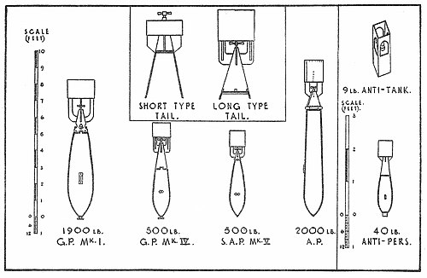
Figure 66.—British H.E. Вombs
Table No. 2.-British H.E. Bombs
Type | Weight (lbs.) | Dimensions |  |  |  |  |  | Main Colour | Fuzes | Tail unit | Notes
Type | Weight (lbs.) | Overall length with tail |  | Bomb body
Type | Weight (lbs.) |  |  | Length |  | Diameter
Type | Weight (lbs.) | ft. | in. | ft. | in. | ft. | in.
G.P. (General purpose) | 4,000 | 10 | 11 | 7 | 1 | 2 | 0½ | Dark green or (occasionally) yellow | Nose and/or tail 2 side fuzes | Long or short pattern tail may be used. Tail fixed by 4 wing nuts. | These are the only types of bomb normally fitted with long delay and anti-handling fuzes.
G.P. (General purpose) | 1,900 | 8 | 5 | 5 | 6 | 1 | 6¾ | " | Nose and/or tail. Fitted with a plug in nose when no nose fuze is used
G.P. (General purpose) | 1,000 | 7 | 2¾ | 4 | 6 | 1 | 4
G.P. (General purpose) | 500  (Mks. IV & 5) | 5 | 10½ | 3 | 1 | 1 | 1 | " |  | Long or Short Pattern tail may be used. Tail fixed by 4 clips
G.P. (General purpose) | 250  (Mks. IV & 5) | 4 | 8 | 2 | 4½ |  | 10¼
S.A.P (Semi-Armour Piercing) | 500 | 5 | 2 | 3 | 5 |  | 11½ | " | Tail fuze only | Long or short pattern tail may be used  Mark II—tail bolted on  Mk V.—Tail fixed by 4 clips.
S.A.P (Semi-Armour Piercing) | 250 | 4 | 1½ | 2 | 7 |  | 9½
A.P (Armour Piercing | 2,000 | 9 | 5 | 6 | 7 | 1 | 1½ | " | Tail fuze only | Attached by 6 screws or 4 wing nuts. Made of light alloy
Anti-Personnel | 40 | 2 | 3½ | 1 | 4½ |  | 5 | " | Nose fuze only (Cannot be released "safe") | Attached by bolt. | The 40lb. bomb may be fitted with parachute.
Anti-Personnel | 20 | 1 | 10 | 1 | 1 |  | 4
Anti-tank | 9 | 1 | 2 | — |  | 5″×5″  (square) |  | " | Tail fuze only | Built in one piece with body of the bomb. | Dropped in pairs, nesting into one another.
Note:— ¼ in. red band near nose = bomb has explosive filling. 1 in. green band at max. diameter = filled with T.N.T.
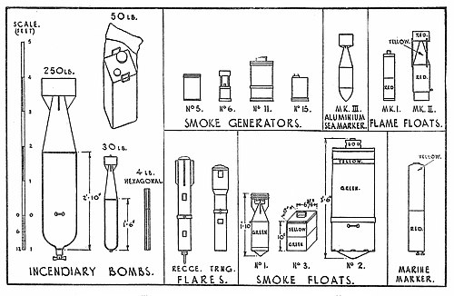
Figure 67.—British Incendiary Bombs and Miscellaneous Pyrotechnics
Table No. 3.—BRITISH INCENDIARY BOMBS AND MISCELLANEOUS PYROTECHNICS
Type | Dimensions |  |  | Main Colour(s) | Fuzes | Tail unit | Notes
Type | Overall length |  | Diameter
Type | ft. | in. | in.
Incendiary Bombs
250lbs | 5 | 0 | 12 | Dull Red | Nose | Attached by Bayonet joint | Filled with liquid fuel and phosphorus
30 lbs | 2 | 8¾ | 4¾ | Dull Red | Nose | Screwed to body | Filled with liquid fuel and phosphorus
50 lbs | 1 | 4½ | 9×9 (rect.) | Dull Red | NIL | Cloth drouge | Filled with liquid fuel and phosphorus
4 lbs | 1 | 9½ | 1¾ (hex.) | Black, nose dull red | Tail | Tinplate (hex.) | Magneisum body filled thermite.  May have explosive charge.
Flares—5.5″ Recce. | 4 | 0 | 5½ | Black | Nose | Parachute | The empty outer case falls sperately
4.5″ Recce. | 2 | 9 | 4½ | Black | Nose | Parachute | The empty outer case falls sperately
Training | 2 | 6 | 4 | Black | Pull igniter | Parachute | Outer case does not fall separately.
Photogrpahic flash-bomb | 2 | 9 | 4½ | Black | Nose | Parachute | Similar to 4.5in Recce. Flare but with word "FLASH" painted in white.
Smoke floats | Nos. 1 and 2— Fuzed in tail No. 3—Pull igniter
Smoke Generators | All are painted bright green. No. 5—Pull igniter No. 6—fuzed in tail. Nos. 11 and 15—fired electrically.
Marine Marker | No fuze—produces a flame when dropped in water.
Aluminium Sea Marker Mk. III | Fuzed in the nose. Filled with aluminum powder.
Flame Floats | No Fuzes—produce a flame when dropped in water by the action of water on the chemicals inside.
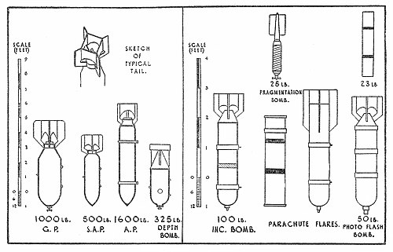
Figure 68.—American Bombs
Table No. 4.—AMERICAN H.E. BOMBS, etc.
Type | Weight (lbs.) | Dimensions |  |  |  |  |  |  |  | Main Colour | Fuzes | Notes
Type | Weight (lbs.) | Overall  length  with tail |  | Bomb body |  |  |  | Width of tail |  | Main Colour | Fuzes | Notes
Type | Weight (lbs.) |  |  | Length |  | Diameter
Type | Weight (lbs.) | ft. | in. | ft. | in. | ft. | in. | ft. | in. | Main Colour | Fuzes | Notes
G.P.  (General Purpose) | 100 | 3 | 0 | 2 | 6 |  | 8 |  | 11 | Dark green or yellow | Nose and tail
G.P.  (General Purpose) | 250 | 3 | 9½ | 3 | 0 |  | 11 | 1 | 3 | Dark green or yellow | Nose and tail
G.P.  (General Purpose) | 500 | 4 | 9 | 3 | 9 | 1 | 2 | 1 | 7 | Dark green or yellow | Nose and tail
G.P.  (General Purpose) | 1,000 | 5 | 7½ | 4 | 5 | 1 | 7 | 2 | 1½ | Dark green or yellow | Nose and tail
G.P.  (General Purpose) | 2,000 | 7 | 6½ | 5 | 11 | 1 | 11 | 2 | 7½ | Dark green or yellow | Nose and tail
G.P.  (General Purpose) | 4000 | 9 | 7 | 7 | 11 | 2 | 10 | 3 | 11½ | Dark green or yellow | Nose and tail
S.A.P  (Semi Armour Piercing) | 500 | 4 | 10 | 3 | 11 | 1 | 0 | 1 | 4 | " | Tail only
S.A.P  (Semi Armour Piercing) | 1,000 | 5 | 10 | 4 | 9½ | 1 | 3 | 1 | 8½ | " | Tail only
Depth Bomb | 325 | 4 | 4½ | 2 | 7 | 1 | 3 | 1 | 3 | " | Nose only
Depth Bomb | 650 | 5 | 10 | 3 | 5 | 1 | 6 | 1 | 6 | " | Nose only
Fragmentation  (Anti-Personnel) | 20 | 1 | 7½ |  | 11 |  | 3½ |  | 5 | " | Nose only | The 23 lb, Fragmentation bomb is fitted with a parachute.
Fragmentation  (Anti-Personnel) | 23 | 2 | 3 |  | 11½ |  | 3½ | parachute |  | " | Nose only | The 23 lb, Fragmentation bomb is fitted with a parachute.
Fragmentation  (Anti-Personnel) | 30 | 2 | 1½ |  | 13 |  | 4¼ |  | 6½ | " | Nose only | The 23 lb, Fragmentation bomb is fitted with a parachute.
Incendiary | 4 | 1 | 9¾ |  | 13½ |  | 1¾ |  | 1¾″ (hex) | Blue grey or unpainted with purple band | Tail only | Similar to British 4lb. incendiary. May have explosive charge.
Incendiary | 100 | 3 | 9½ | 2 | 10 |  | 8 |  | 11 | Grey with red disc 4 in. diameter on body | Nose only | Filled liquid fuel and phosphorus
Parachute Flares | — | 3 | 1 | — |  |  | 8 | — |  | Blue grey | Pull igniter
Parachute Flares | — | 3 | 11 | — |  |  | 8½ | — |  | Blue grey | Nose Fuze
Photographic  Flash-bomb | 23 | 2 | 1½ | — |  |  | 4½ | — |  | Blue grey with "PHOTOFLASH" stencilled on | Pull igniter
Photographic  Flash-bomb | 50 | 3 | 9 | 2 | 9 |  | 8 |  | 11 | Blue grey with "PHOTOFLASH" stencilled on | Nose Fuze
25. AMERICAN INCENDIARY BOMBS
The 4 lb. American incendiary bomb approximates to the British 4 lb. incendiary bomb in behaviour. The 100 lb. incendiary bomb contains a powerful burster charge. There is also a 500 lb. incendiary bomb identical with the American 500 lb G.P. bomb except that it is painted grey and has a purple band. It contains a powerful burster charge and has a phosphorus filling.
26. BRITISH PYROTECHNICS
(a) Flame Floats
Flame floats are of five types:—
(i) A fabric bag containing a metal cylinder 3 in. diameter and 8 in. long with the bag collapsed or 17 in. with the bag extended. It may be found packed in a metal cylinder painted red with a yellow label on the lid.
(ii) A metal body and container 24 in. long, 5·8 in. diameter and weighing about 12 lb. complete. The outer portion is painted red and the inner yellow on the conical end.
(iii) A yellow tin-plate cylinder 18·5 in. long, 2-9 in. diameter, fitted with four fins.
(iv) A metal cylinder 36¼ in. long, 6 in. diameter, painted blue-grey.
(v) A metal cylinder 30 in. or 26 in. long (according to type), 5·8 in. diameter, with the lower half painted red and top half yellow.
(b) Smoke Floats
The normal smoke float has a cylindrical body with drum tail, weighing 11 lb. It is 22 in. long and 6 in. diameter, and is painted green. The tail end is fitted with a pistol to fire the float. The smoke is poisonous in an enclosed space.
There is also a much larger type with a cylindrical body 14½ in. diameter and 45 in. long, which is painted green and weighs about 200 lb.
(c) Smoke Bombs
Smoke bombs are of four types:—
(i) The 4 lb. smoke bomb, usually dropped in the small bomb container holding 42 bombs, is a small metal cylinder 7·8 in. long and 3·7 in. diameter with a bakelite dome and is painted light green.
(ii) The 100 lb. smoke bomb is a sheet-metal can 18·3 in. by 10 in. by 9·8 in. painted green and containing a phosphorus filling.
(iii) The 120 lb. smoke bomb is a steel tube welded to a flattened nose-piece and is fitted with a tail. It is 31 in. long overall and 10 in. diameter and is fitted with a powerful ejection charge.
(iv) The 500 lb. smoke bomb is of sheet-steel construction painted green. It is 13·1 in. diameter, is fitted with a tail and contains a phosphorus filling.
(d) Smoke Generator
There is a smoke generator consisting of a small metal cylinder with a tail drum, 7 in. long and 2½ in. diameter, which weighs about 1 lb. and is painted light green. It may contain a pistol and cap.
(e) Parachute Flares
The training flare has a tinplate body painted black, 30 in. long, 4 in. diameter at the nose, and 5·5 in. at the tail end, which contains the parachute. The filled flare weighs 19 lb.
The 4·5 in. flare has a black-painted iron or tinplate body 33 in. long and 4·5 in. diameter. It may have a fuze at the nose end and should be handled with great care. Its weight is about 21 lb.
The 5·5 in. flare is similar in appearance to the 4·5 in. flare but weighs 41 lb. and is 48 in. long by 5·5 in. in diameter.
The 7 in. flare, which is normally dropped in clusters of four, is a black metal cylinder 63 in. long and 7 in. diameter and weighs 85 lb. There is also a similar flare weighing 58 lb.
(f) Photographic Flash-bomb
The photographic flash-bomb is similar in weight and dimensions to the 4·5 in. flare and contains a very dangerous explosive. An embossed plate on the body is marked "FLASH" in large letters. The closing dome and tail fins are painted red.
(g) Target Indicator Bomb
The target indicator bomb is a black painted bomb of steel construction fitted with a tail. It is 60 in. long and 12 in. diameter and contains a powerful burster charge and incendiary filling.
27. AMERICAN PYROTECHNICS
(a) Flame Floats
The most common type of flame float is the cylindrical wooden body fitted with a metal nose and tail fin assembly. It is 13 in. long overall, 3 in. diameter, and contains a flare composition.
(b) Smoke Bombs
The normal American smoke bomb is the 100 lb. bomb. It is identical in external appearance with the American 100 lb. incendiary bomb except that a yellow band surrounds the body and the filling contains phosphorus.
(c) Flares
The normal American flare has a blue-coloured bomb-shaped case 50 in. long, 8 in. diameter, and weighs approximately 53 lb. when filled. It has four fins attached to the body.
(d) Photographic Flash-bomb
The photographic flash-bomb is 55·2 in. long, 8 in. diameter, weighs 50 lb., and is similar in external appearance to the flare except for the tail, which consists of four vanes welded to a tail cone. Since the flash-bomb contains a dangerous explosive, it is important to note this difference between it and the flare above.
28. BRITISH TRENCH MORTAR BOMB
The type of British trench-mortar bomb shown in Figures 69 and 70, is sometimes mistaken for a German incendiary bomb. It has a cylindrical body 2 in. in diameter and 5½ in. long with a tail fuze unit 3½ in. long terminating in a milled screw cover about 3/4 in. in diameter. There are six vanes with three holes in the stem between each vane;
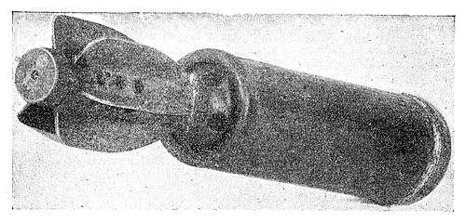
Figure 69.—British Trench Mortar Bomb
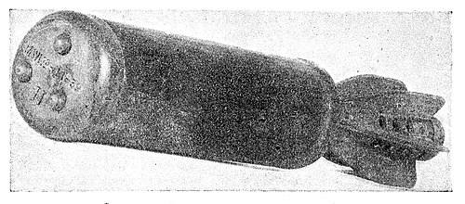
Figure 70.—British Trench Mortar Bomb
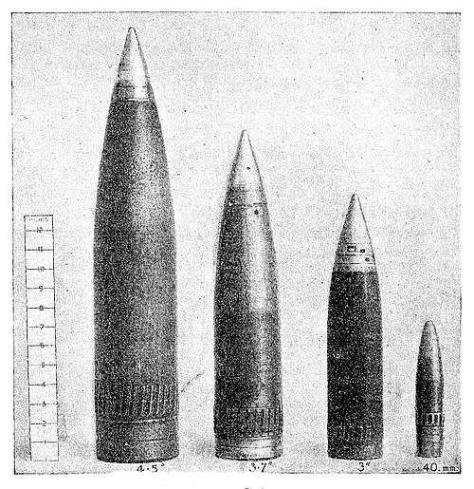
Figure 71.—Anti-Aircraft Shells
the blunt nose of the bomb has three rivet heads in the face and typical markings are shown in the accompanying Figures.
29. BRITISH ANTI-AIRCRAFT SHELLS
British anti-aircraft shells are of the following dimensions:-
(a) 5·25 in.
(b) 4·5 in. × 22¾ in.
(c) 3·7 in. × 17¼ in.
(d) 3.0 in. × 14 in.
(e) 40 mm. × 6·44 in.
The last four are shown in Figure 71 and they may further be recognised by the fact that they have a copper driving band in front of the base and may be distinguished from bombs by the absence of any vanes or attachments for vanes.
30. BRITISH U.P. SHELLS
Two types of U.P. shells are shown in Figures 72 and 73.
(a) That in Figure 72 consists of metal tubular casings, approximately 76 in. long, and with a small head either black or bronze, lacquered, 3 in. in diameter. At the other end are four vanes approximately 8¼ in. long.
(b) That in Figure 73 consists of a tube 36 in. long and 2¼ in. in diameter, fitted with four fins. The following may be found on the ground associated with this shell:—
(i) the long tube with four fins 8¼ in. long and 3 in. wide attached to a parachute; this is harmless.
(ii) A small yellow bomb similar to that described in Section 32 (f) (i), with two parachutes.
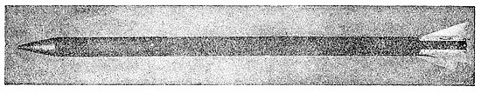
Figure 72.—British U.P. Shell: 3 in.
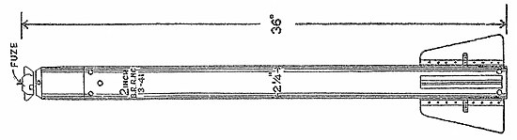
Figure 72.—British U.P. Shell: 2 in.
31. BRITISH SMALL ARMS AMMUNITION
Of the small arms ammunition used in British aircraft, the forms most likely to be found are fired cartridge cases, belt links, or spent bullets. The first two are harmless, being brass cases or small steel clips of various shapes and sizes, but all spent bullets should be considered as dangerous until identified, since they may contain incendiary composition or high explosive.
32. BRITISH BALLOON DEVICES
The following objects of British origin may be found. Each is associated with a balloon 8 ft. diameter. (See top of Figure 77.)
(a) Small Yellow Bombs (Balloon Device "A")
The Small Yellow Bomb is no longer in use in its original form, but a modified version is now being used as an attachment to barrage balloons. (See Figure 74 and sub-section (f) below.)
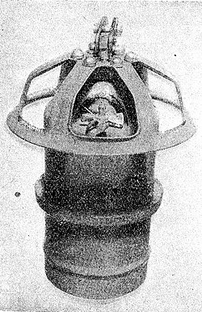
Figure 74.—British Small Yellow Вomb
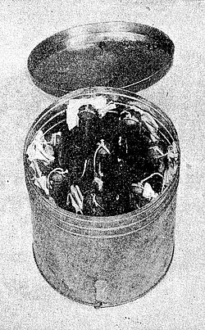
Figure 75.—Phosphorus Bottles in Container
(b) Canisters with Wire (Balloon Device "B")
Suspended close to the balloon may be found a small canister, of ordinary tin colour, 8 in. diameter and 9 in. long with lengths of string or wire which may amount to a total of 1,000 feet attached. The contents of these canisters (shown suspended at the bottom of Fig. 77) are harmless unless exposed to a naked flame.
(c) Phosphorus Bottles (Balloon Device "C")
This device is associated with the canister used in device (b). It consists of a cylindrical metal container 8¼ in. diameter and 9 in. long fitted with a lid and holding seven or eight short-necked half-pint bottles containing a mixture of phosphorus and benzine which ignites immediately if the glass is shattered. The bottles may be found separately or with a metal sleeve fitted over the neck of the bottle and a ball about 1 in. diameter attached to a short length of canvas. (See Figures 75 and 76.)
For precautions against phosphorus see Section 1 (b): Phosphorus-Oil Bomb, on page 17.
'(d) Incendiary Socks (Balloon Device "D")'
This device is also associated with the canister used in device (b)
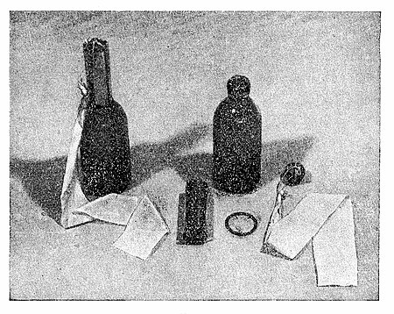
Figure 76.—Phosphorus Bottle and Breaker Assembly
and consists of a bundle of incendiary socks containing wood-wool and paraffin wax in a canvas cover. The whole bundle measures about 27 in. × 10 in. × 10 in. (see Figure 77).
(e) Cans of Incendiary Jelly (Balloon Device "E")
This device consists of a can 11 in. × 6 in. × 4 in., containing one gallon of incendiary jelly, and is slung beneath a canister of the type used in device (b). At one end of the can there is a releasing device mounted on a plate which slides on to the end of the can, and at the other end a fuze for igniting the jelly, which, on ignition, erupts over a radius of about 20 feet (see Figure 78).
(f) Attachments to Barrage Balloons
Any of the devices described below may be attached to barrage balloons and, when these break loose and are found on the ground, care should be taken not to touch either the flying cable or the devices attached to it. The police should be informed immediately.
(i) A small yellow bomb as illustrated in Figure 74 2 in. diameter and about 4 in. long. It has a sealed joint projecting round the centre and a small wind-vane at the top, over which fits a skeleton bowl- shaped cover. The bomb is painted yellow and may be found:—
(a) alone or
(b) with a small parachute about 1 ft. diameter attached or
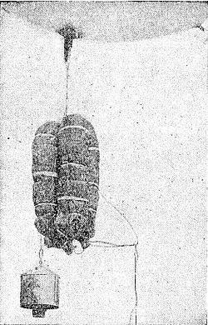
Figure 77.—Incendiary Sock Unit
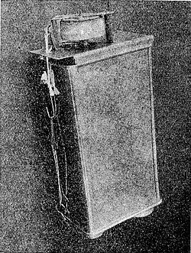
Figure 78.—Can of Incendiary Jelly
(c) attached by a jubilee clip round the body of the bomb to a shallow dark green cylindrical canister, in which case the overall dimensions of the bomb and canister are about 7 in. long by 3 in. diameter.
Any of the above may be attached to a length of balloon mooring wire, at the other end of which a larger parachute may be found. A small brass cylinder about 4 in. long will probably be found attached to the bomb. This should be handled carefully, as it contains a small cartridge, which may be fired by a sharp jerk.
(ii) A metal link 9 in. long fitted between the balloon and cable and connected by a short length of cable to a black parachute bag, which is secured to the balloon rigging (see Figure 79).
(iii) A metal link 10 in. long with a lug at each end through which the balloon cable passes and connected at one end to a black parachute bag, which is also attached to the cable by a 4 ft. length of wire (see Figure 80).
(iv) A device which is slung between twin cables in an open metal frame shaped somewhat like a bicycle saddle 20 in. long and which consists of a dark green box-shaped bomb about 6 in. square and 3 in. deep (see Fig. 81).
No naked light and no smoking should be allowed near grounded balloons. All four devices have lethal components, some of which may be operated by a jerk on the flying cable.
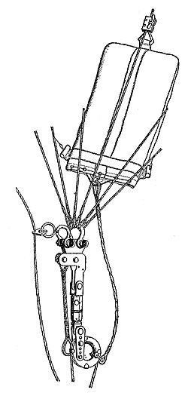 | 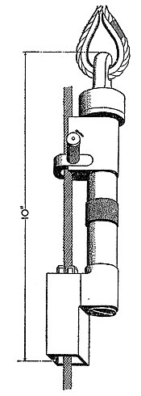
Figure 79.—9-in. Balloon Link | Figure 80.—10-in. Balloon Link
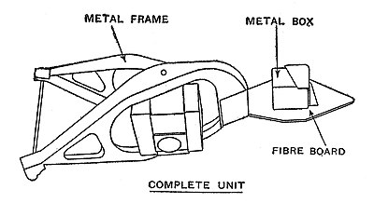
Figure 81.—Barrage Balloon Attachment
33. ROCKET USED BY ROYAL OBSERVER CORPS
In certain areas the Royal Observer Corps occasionally fire a rocket about 4 ft. long and 3¼ in. diameter, weighing about 10 lb. The head is painted aluminium, and the metal work and the four-unit tail fin, green. The fins are approximately 4 in. diameter.
When fired, the rocket ascends to a height of some 1,500 feet and bursts expelling a parachute flare, while the metal framework and fins fall to the ground. The parachute is usually white but may be coloured.
34. GERMAN FLYING BOMBS
The flying-bomb (see Figures 82 and 83) is a mid-wing monoplane with a single fin and rudder and having a jet-propulsion unit mounted above the rear portion of the fuselage. The principal dimensions are as follows:—
Length of fuselage—21 ft. 10 in.
Length of jet propulsion unit—11 ft. 3 in.
Overall length (including the overhang of, propulsion unit)—25 ft. 4 in. <!"--Maximum diameter 2' 8¼" -->
Maximum diameter of propulsion unit—1 ft. 10¾ in.
Wing span—17 ft. 6 in. with little or no taper in the wings, or in another version (as shown in the silhouette)—16 ft.
Apart from the extreme nose of the fuselage and the elevators and the rudder, which are of light metal, the structure is entirely of steel, the fuselage being in sections bolted together. The central section of the fuselage comprises a cylindrical steel fuel tank of 150 gallons capacity behind which is a compartment containing two wire-bound spheres 1 ft. 9¼ in. diameter, filled with compressed air. In front of the fuel tank is the explosive charge weighing about 850 kg. in a steel casing approximately 2 mm. thick and designed to explode by means of sensitive impact fuzes.
There is a possibility, under certain circumstances, that a flying bomb may make a belly landing more or less undamaged and that a delay may occur before the explosion. One case of a 10 minute delay has occurred.
The light metal sheeting and airframe may be coloured light blue, dark green or black. A number (usually six figures) is sometimes painted in white 1 in. to 2 in. high on the right-hand (starboard) side of the fuselage and repeated on wings, tail plane and elevators. The markings "NICHT ANFASSEN " (Do not grip) and "Geprüft" (tested), also appear.
The fin is marked:-
STUTZKEIL HIER EINSETZEN
Bei Transport u. bei abgen
Rumpfabdeckblech
VOR DEM START ENTFERNEN
(Insert supporting wedge here
During transit and when
fuselage cover plate is off
Remove before launching)
The propulsion unit operates at about 40 cycles per second and the noise heard when the bomb is in flight depends on the distance away and the speed at which it is travelling. If at all near it gives a deep booming note and when quite close the rattle of the jet propulsion unit can be heard. At night it shows at the rear end a flame varying in colour from white to red.
If the bomb is damaged in flight by our defences the flames issuing from the rear may be abnormally long or they may appear from other parts of the jet propulsion unit.
Normally when the bomb goes into a dive, the propulsion unit cuts out and the light fades, but cases have been reported where the bomb has glided some minutes before impact, with the propulsion unit cut out; it then falls with a slight whistle. In other cases again, the bomb has dived with the unit still running. In some instances the bomb has turned a complete circle at the end of its flight before diving, but usually it continues on almost a straight course, turning slightly to the left—or port—as it dives. The interval between the propulsion unit cutting out and impact with the ground has varied from 2 seconds to 2 minutes, but is usually between 5 and 15 seconds.
The bomb may also carry a clock-work device which can be set to alter course once only after launching through an angle up to 90 degrees. The duration of the flight and consequently the range is determined by the operation of an air log. After a pre-set period of flight, two electric detonators in the tail unit are fired which release a spring-loaded trip. This trip-lever locks the elevators in the diving position.
A small proportion of the flying bombs carry a wireless transmitter by means of which the enemy endeavours to assess the duration of the flight and point of impact of the bomb so fitted.
In some cases 23 small incendiary bombs of the type with an explosive charge in the tail (Exp. I.B.—see Figure 10) have been fitted inside the flying bomb and been scattered by its explosion on impact. They appear to be held inside the fuselage in one or more circular plates about 12 in. diameter with 23 perforations each of 2 in.
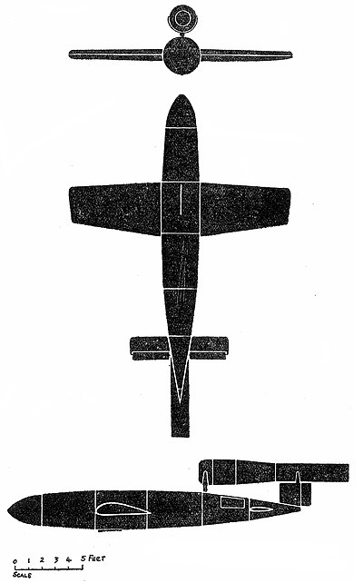
Fig. 82.—German Flying Bomb
Span 16ft Length 25 ft 4½in
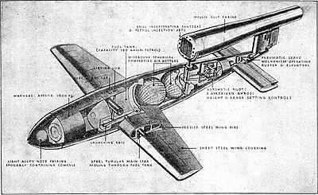
Fig 83.—German Flying Bomb—Internal Arrangement
APPENDIX A
General Survey of German H.E. Weapons
(Dimensions in inches)
German marking nominal weight kg. |  | Body |  | Tail |  | Total Length of bomb with tail | Material | Function
 |  | Overall length | Max. dia. | Overall length | Мах. dia. | Total Length of bomb with tail | Material | Function
S.D. | 1 | 4¼ + 1¼ (with fuze) | 2 | 1¼ | 2 | 6¾ |  | Damage by  fragments  to exposed  personnel (S.D.1  S.D.2 and  S.D.10).
 | 2 | 3 | 3⅛ | drogue type |  | 9¼
S.D. | 10 | 12¾ | 3⅜ | 8½ | 4⅜ | 21⅝
 | *50 | 23½ | 8 | 24½ | 11 | 42½ to 43
S.D† | 70 | 28½ to 30 | 8 | 16½ | 11 | 43 to 45 approx only |  | S.D. 50, S.D. 250,  S.D. 500A,  S.D.1700 blast  and heavy fra-  gment effect.
 | *250 | 33½ | 14½ | 25+14 | 20 | 63½
 | *500A | 53 | 17½ | 35½ | 17½ | 80
 | 1700 | 92 | 25½ | — | not | known | —
P.C | 500 E | 43½ | 15½ | 27 | 15½ | 68 |  | Penetration into  protected tar-  gets (battleships  and emplace-  ments, etc.) be-  fore detonation.
 | 500 L | 54 | 15½ | 30 | 15½ | 78
 | 1000 | 58 | 19¾ | 32 | 20¼ | 82
 | 1400 | 76½ | 22 | 43 | 22¼ | 111 | Steel
P.C.‡ | 1000. R.S | 47 | 15½ | 33 | 21 | 108
 |  | 72 with rocket container
S.C | § 50 | 28¼ to 30 | 8 | 16½ | 11 | 43 to 45
 | §250 | 46 to 47½ | 14½ | 25 | 20 | 64 to 66
 | §500 | 54 to 56 | 18½ | 29½ | 25 | 78 to 79
 | 1000 | 74½ | 26 | 46½ | 25½ | 112½ |  | High charge  /weight ratio for  heavy blast effect
 | 1200
 | 1000L | 67 | 25½ | — not known —
 | 1800 | 104½ | 26 | 55½ | 36 | 147
 | 2000 | 104½ | 26 | 45 | 25 | 136½
 | 2500 | not  known | abt 39 | not  known |  | about 197 | Aluminum alloy
B.M | 1000 | 78 | 25½ | 56½ | 25 | 114 | Steel
P.M type C | 1000 kg. | 104 | 26 | 15 | 23½ | 119
 |  |  |  | (bowl) |  | (with bowl)
P.M type D | 500 kg. | 67 | 26 | 15 | 23½ | 82 | Aluminium
 |  |  |  | (bowl) |  | (with bowl)
S.B. | 1000/410 | 72 | Section 31 by 16½ | — | — | — | Steel
* Steel extension rods, with a thread at one end for screwing into the nose of the bomb and with a metal pressure plate at the other end, may be fitted to these bombs. The rods are either 2 ft. or 1 ft. 3 in. long.
† May have a parachute instead of a tail.
‡ P.C. 500 R.S. and P.C. 1800 R.S. rocket bombs are known to exist, but details of dimensions, etc., are not available.
§ A spiked rod screwed into the nose may be fitted to these bombs; the spiked rods are 1 ft. 64 in. and 2 ft. 3 in. long. The intention of the rods is to achieve detonation above ground and of the spikes to prevent ricochet.
АPPENDIX B
The Most Dangerous Types of German Small Arms Ammunition
Item | Calibre | Pattern | Type^{[2]} | Distinctive Colour Markings on Projectile
1 | 13 m.m.  ·512 in. | Solthurn | Н/ЕТ | Yellow
2 | 13 m.m.  ·512 in. | Solthurn | HE/I/T | Yellow  Blue Band
3 | 15 m.m.  ·591 in. | Mauser | HE/T | Yellow  Black Band in Front of  Driving Band
4 | 15 m.m.  ·591 in. | Mauser | HE/T/(SD) | Yellow or Unpainted Yellow
5 | 15 m.m.  ·591 in. | Mauser | HE/I/T/(SD) | Yellow  ·25 in. Blue Band 1 in. From Nose
6 | 20 m.m.  ·791 in. | Oerlikon | HE or HE(SD fuze) | Yellow  Black Band
7 | 20 m.m.  ·791 in. | Oerlikon | HE/T(SD) | Yellow  Black band
8 | 20 m.m.  ·791 in. | Oerlikon | HE/T(SD) | Steel  White Band
9 | 20 m.m.  ·791 in. | Oerlikon | HE/T/SY) | Yellow
10 | 20 m.m.  ·791 in. | Oerlikon | HE/I/T(SD) | Yellow  Blue Band
11 | 20 m.m.  ·791 in. | Oerlikon | I/T | Blue  Red Band
12 | 20 m.m.  ·791 in. | Mauser  MG 151/20 | HE (SD fuze) | Yellow  Black Band
13 | 20 m.m.  ·791 in. | Mauser  MG 151/20 | HE/I/T(SD) | Yellow  Blue Band
14 | 20 m.m.  ·791 in. | Mauser  MG 151/20 |  | Black  ·7 in Yellow Band At  ·2 in from driving band.
15 | 20 m.m.  ·791 in. | Mauser  MG 151/20 | HE/I/SD | Yellow  Black Band
16 | 20 m.m.  ·791 in. | Mauser  MG 151/20 | I/T | Blue  Red Band
17 | 30 m.m.  1·186 in. | Solthurn  MG 151/20 | AP/HE/T | Black  White Band  Yellow Band
18 | 30 m.m.  1·186 in. | Solthurn  MG 151/20 | HE/T | Yellow  White Band  Black Band.
APPENDIX C
INDEX TO CODE LETTERS AND MARKINGS OF ENEMY MISSILES AND ABBREVIATIONS USED IN REPORTING
Serial No. | Lettering | Use* | Missile concerned | Report as | See Section | Explanation
1 | AB 23 | M | Container | Type J | 9
2 | AB 24 SD 2 | M | Container | Type K | 9
3 | AB 36 | M | Container | Type C | 9
4 | AB 70 D1 | M | Container | Type M(i) | 9
5 | AB 70–3 | M | Container | Type M(ii) | 9
6 | AB 70-5 | M | Container | Type M(iii) | 9
7 | AB 250–2 | M | Container | Type N(i) | 9
8 | AB 250–3 | M | Container | Type N(ii) | 9
9 | AB 500–1 | M | Container | Type H | 9
10 | ABB 500 | M | Container | Type F(i) | 9
11 | ABB 500 Mro | M | Container | Type F(ii) | 9
12 | AB 1000–2 | M | Container | Type G | 9
13 | AB 1000–3 | M | Container | Type O | 9
14 | BL.C 50 | M | Photographic Flash-bomb | Flash-bomb | 3
15 | BL.C 50A | M | Photographic Flash-bomb | Flash-bomb | 3
16 | BM 1000 | M | Mine-bomb | Type "G" Mine | 2 (b) | B = Bombe  M = Mine
17 | B1 E (or B1) | C | Standard 1kg. Magnesium electron incendiary bomb | I.B. | 1 (b) (i) | B = Brandbombe (Incendiary Bomb)  1 = 1 kg.  E = Elektron
18 | B1 E-Z | C | 17 with explosive charge | Exp. I.B. | 1 (b) (i) | Z = Zünder (fuze)
19 | B1.3E (or B1.3) | C | 17 with steel nose plug | S.N.I.B | 1 (b) (i)
20 | B1.3E-Z | C | 19 with explosive charge | Exp. I.B. | 1 (b) (i)
21 | B1 E-Z Ausf.B. | C | 19 with explosive charge in nose plug | N.Exp.I.B. | 1 (b) (i) | Ausf.B = Ausführung B (Pattern B)
22 | B2 E-Z (or B2) | C | 17 with separating explosive | I.B.S.E.N. | 1 (b) (i)
23 | B2.2 E-Z (or B2.2) | C | 17 with explosive nose | I.B.E.N | 1 (b) (i)
24 | Brand C 50A | M | Phosphorus-oil Bomb | Ph. I.B | 1 (b) (ii)
25 | Brand C 250A | M | Phosphorus-oil Bomb | Ph. I.B | 1 (b) (ii)
26 | BSB 320 | M | Container | Type E(ii) | 9
27 | BSB 700 | M | Container | Type E(i) | 9
28 | BSB 1000 | M | Container | Type P | 9
29 | BSK 36 | M | Container | Type A | 9
30 | Exp.I.B | A | Explosive Incendiary Bomb (see 18 and 20 above)
31 | Flam C 250 C | M | Oil Bomb | Oi Bomb | 1 (b) (ii)
32 | Flam C 500 | M | Oil Bomb | Oi Bomb | 1 (b) (ii)
33 | FX | C | Radio-controlled armour-piercing bomb | H.E. | (1 (a) (v) (b) | F = Fritz (German name for 1400 kg. bomb)
34 | H.E. | A | High Explosive Bomb (other than anti-personnel) | H.E. | 1 (a)
35 | Hs. 293 | C | Radio-controlled glider-bomb | Glider Bomb | 1 (a) (v) (a) | Hs. = Henſchel (German aircraft manufacturer)
36 | I.B. | A | See 17
37 | I.B.E.N. | A | See 23
38 | I.B.S.E.N | A | See 22
39 | INC. | A | French type incendiary bomb of about I kg. | I.B. | 1 (b) (i) | INC = Incendaire
40 | KC 250 | M | German chemical bomb | Gas Bomb | 1 (b) (ii) | K= Kampstoff  C=C Cylindrisch (i.e cylindrical "gas" bomb)
 |  |  | (used so far only as oil bomb) | (Oil Bomb when so Used) |  | K= Kampstoff  C=C Cylindrisch (i.e cylindrical "gas" bomb)
41 | MARK 250–BK | M | Container | Type N(iii) | 9
42 | MARK 250–LK | M | Container | Type N(ii) | 9
43 | MARK 500–BODEN | M | Container | Type F(iv) | 9
44 | N. Exp I.B | A | See 21
45 | P.C. | C | Armour-piercing bomb | H.E. | 1 (a) (ii) | P=panzer  C=Cylindrisch (i.e. cylindrical armour (percing) bomb)  R= Raketen  S=Satz (i.e rocket set or unit)
46 | P.C. (Weight) R.S. | C | 45 when rocket assisted | H.E. | 1 (a) (ii)
47 | Ph. I.B. | A | See 24 and 25
48 | S.B. 1000 | M | Parachute Bomb | Para. Bomb | 1 (a) (vi) | S=Spreng  B= possibly Behälter or Blech (i.e explosive container or canister)
49 | S.C. | C | High Explosive Bomb | H.E. | 1 (a) (i) | S=SPreng  C= Cylindrisch  D=Dickwändig (i.e explosive cylindrical or explosive thick-walled fragmentation bomb)
50 | S.D
51 | S.D.½ | A | Anti-personnel bomb, ½ kg. | S.D.½ | 1 (a) (iv)
52 | S.D.1 | A | Anti-personnel bomb, 1 kg. | S.D.1 | 1 (a) (iv)
53 | S.D.2 | A | Anti-personnel bomb, 2 kg. | S.D.2 | 1 (a) (iv)
54 | S.D.10 | A | Anti-personnel bomb, 10 or 12 kg. | S.D.10 | 1 (a) (iv)
55 | S.N.I.B | A | See 19
56 | Sprengbrand C 50 | M | Firepot Incendiary Bomb | Fireport I.B. | 1 (b) (ii)
A = Abbreviation. M = Marking. C = Code letter.
B5245. Wt.2117 9/44 U.B.L. G428.
S.O. Code No.34-295-2-44
- ↑ Recently this mine has also been used with a parachute about 4 ft. across instead of the tail unit.
- ↑ HE= High Explosive. T Tracer. I = Incendiary. SD = Self-destroying. AP = Armour-piercing.

