Bomb Disposal Tasks in the Far East Post War.
A brief background of the Far East through the War and Post War.
Through the war period Japan had invaded and taken control of Hong Kong, Malaya and Burma from the British, the Dutch had lost the Netherlands East Indies, the Americans removed from the Philippines and the French losing their colonies in South East Asia.
With the defeat of Japan there was to be a change in the political climate in the Far East. Where as post war the idea of self-government of these territories was a remote ideal, it emerged as a live issue, not just in the communities of the East but also in the capitals of colonial power.
In 1947 there was the Indian Independence Act, Burma became Independent in 1948. Also, in February 1948 the Federation of Malaya was created, this was being planed in Whitehall during the War. It meant that former Straits Settlements, Penang and Malacca, the Federated Malaya States and five unfederated states of the Malaya Peninsula came under a common administration. There were other agreements made in the area.
For Britain post war we maintained small garrisons in Hong Kong, Singapore and Malaya.
Clearance of Japanese Ordinance.
Post war no large-scale clearance operations were undertaken to clear Japanese munitions, by British Forces. These were left where they were, unless they impeded military operations/movements or were an issue of public safety
The only organised specific clearance information found is a joint RE and RAOC Clearance in Borneo 1948. The RASC involvement seems to have been around the use of Landing Craft Tank 1147 commanded by Captain C Buchan Talfar RASC. 3 Officers and 53 men left Singapore on the LCT to Sea dump ordnance found Japanese, American and British on airfields and dumps in Borneo. The RE contingent was commanded by Major E L Bourne GM. He formerly commanded a deep-sea bomb disposal team of divers and frogmen.
See article below about this task, there is no indication as to what unit the RE contingent were from.
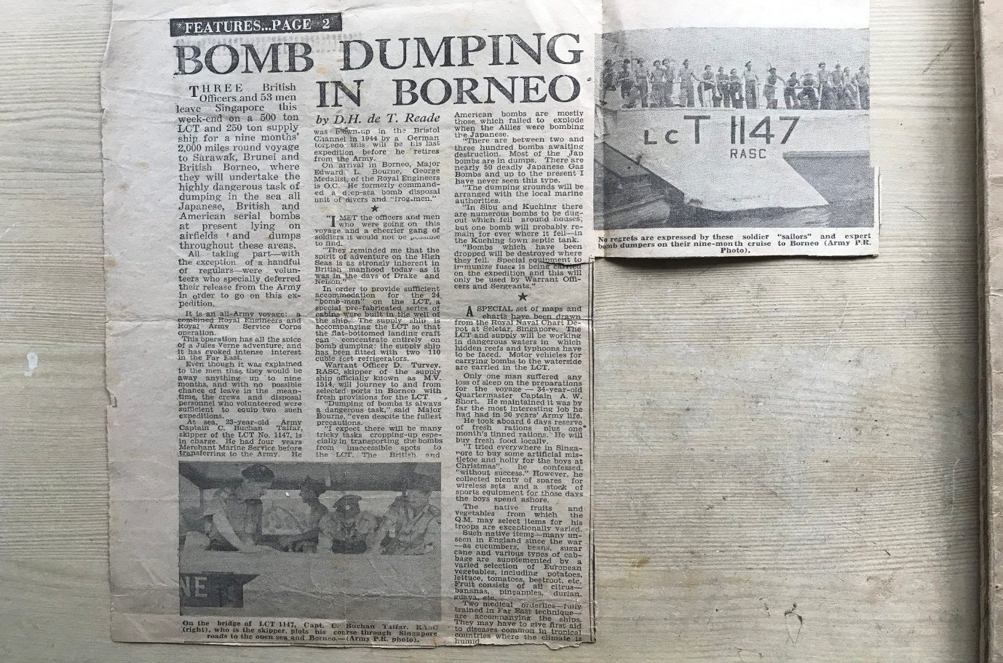
Clearance of Labuan reported 3 May 1948. Clearance of British North Borneo reported on 30 July 1948, Clearance of the 4 Division reported 30 August 1948. Clearance of Sarawak was reported on 8 September 1948.
Bournes Citation for his George Medal from 1943.
154267 Lieutenant Temporary Captain
Edward Louis Bourne George Medal
4 Bomb Disposal Company
Royal Engineers.

The Citation is taken from file WO373/68/207 held at the National Archives.
Placed in the London Gazette on the 21st December 1943. Supplement 36279. Page 5572.

During August 1943, the enemy dropped over two hundred and fifty anti-personnel bombs on districts in Norfolk, and Captain Bourne personally dealt with one hundred and forty-two of them. His disposal of 31, 2-kilogram anti-personal bombs at Wells-on-Sea, constituted a very heavy risk, and each of the remaining bombs which he dealt with also entailed a slight though none the less real risk. The cumulative danger in disposing of 142 bombs, was, however, high, and Captain Bourne’s action called for sustained courage. This officer has been employed on bomb disposal duties since October 1940, and disposed of three hundred and forty-six other bombs of various calibre, many of them under highly dangerous conditions.

Further information.
A note handwritten on the citation states: Not for publication in the Press.
His Sergeant Fred Fisher was awarded the British Empire Medal for this incident
Clearance as required was undertaken in Hong Kong and Singapore, however there was no Royal Engineer, Bomb Disposal Units on strength, until a Bomb Disposal Troop of Chinese Sappers was formed in 1950, with British Officers and SNCOs, in 1952 the Hong Kong Squadron RE was formed and absorbed the Bomb Disposal Troop into its organisation.
In general, what clearance was carried out seems to have been ad hoc and often carried out by Royal Engineer Field Units, not BD Units.
In 1956 150 bomb cases appeared on the Penang Scrap Market, the Islanders had become used to living with bombs on their doorstep.
In 1959 there was a re-organisation of Royal Engineers in Hong Kong. The BD Troop of Chinese Sappers were attached to 306 ESD. This continued to 1962 when 306 and the BD Troop were amalgamated into the Hong Kong Fortress Squadron.
No information or records have been located at this time as to tasks carried out by the BD Troop. However, the below 3 incidents could be attributed to the unit.
In 1960 Major HP Qualtrough who was at the time serving as a Staff Officer to the CRE RE Headquarters Land Forces, Hong Kong dealt with 3 UXBs. For this he was awarded the MBE his citation below
On 19th October 1959, 20th January 1960 and 30th March 1960 three unexploded bombs, of approximately 500 to 600 lbs weight, were found in Kowloon and successfully disposed of by a bomb disposal squad working under the direction of Major Qualtrough.

The first was found on a building site. As the impact nose fuze was distorted and could not be removed, the fuzed bomb was driven in a truck to the docks, embarked in a landing craft and carefully dumped at sea under Major Qualtrough’s personal control.

The second was picked up in Hong Kong Harbour by a dredger. When brought ashore it was found to have, in addition to the impact nose fuze, a tail fuze which had the appearance of a chemical delay type; Major Qualtrough therefore removed this fuze by remote means.

The third was found on a building site and Major Qualtrough personally supervised the removal of the nose and tail fuze. In this instance, also, the tail fuze could not be positively identified before removal.

The bombs were identified as being of American type, dropped in 1944 or 1945. They did not however conform exactly to the data to the data available in instructional manuals, and the presence of Chinese markings on one fuze indicated the possibility of unrecorded variations in design. The age of the bombs, therefore, and the lack of reliable information intensified the element of hazard always present in this type of operation.

Throughout the work Major Qualtrough took personal charge at all stages involving danger. By his confident handling of each incident, and by his disregard for his own safety, he set an example which gave immense encouragement to the less experienced British and Chinese members of the squad, as well as to the Hong Kong Police officers and constables cordoning the area. His concern was always that his men should as far as possible, add to their own knowledge by doing the work themselves, and they should get praise for it. His actions reflected great credit on himself and were in keeping with the best traditions of his Corps.

In Designed to Kill there is reference to clearance being carried out in 1950 on Penang, however no details. In 1963 the Administration of the Gilbert and Ellice Islands requested assistance in the clearance of Ordnance remaining from the War.

Betio.
A task was set to collect all ordnance that remained on the surface and was a hazard to the local population, also excavate 40 bunkers that had been back filled.
After extensive discussions Major H P Qualtrough and Sergeant H Cooke Bomb Disposal Unit (UK) arrived on Betio 29 November 1965. Work commenced on the 3 December, the working party included 15 local prisoners and some locally employed labourers. Rain was an issue during the work, however, by 19 January 39 bunkers had been cleared. After 20 tons of high explosives had been removed from the final bunker work stopped due to the stability of the ground. This was cleared in 1977.
Total of 10 tons of missiles recovered from the ground and 90 tons from the bunkers. Dumping at sea was completed by 30 March 1966, using a native canoe and a ships lifeboat.
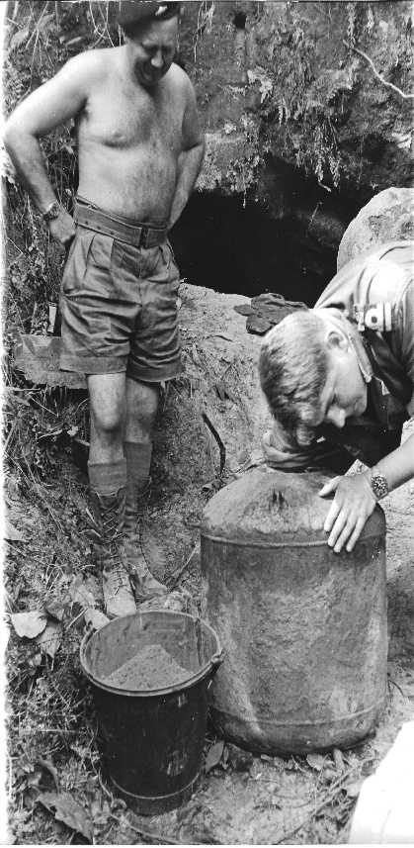
Sergeant H E Cooke GM with Naval Officer.
Major Qualthrough and Sergeant Cooke were awarded the George Medal for their efforts, citation below:
Major Qualtrough and Sergeant Cook undertook a reconnaissance of the notorious Japanese bomb and sea mines dumps on Penang Island after which they cleared about 100 tons of bombs and shells from Japanese bunkers on the Island of Betio in the Gilbert and Ellice Islands. Their drive and complete disregard of personal safety were the two factors which led to the completion of these two difficult tasks in the short time available. On Penang Island they located tunnels and covered trenches at nine major sites and excavated and removed for analysis samples of bombs and mines from each site. The dangers included the possibility of the formation of most dangerous unstable picrate crystals from picric fillings, the presence of corroded and unsafe fuzes and the likelihood of very dangerous copper azide formed from the lead azide in detonators. Well, knowing the risks involved they entered a tunnel which had partially collapsed and was in imminent danger of further roof falls and removed 60 kg Japanese bombs which in addition to damage by roof falls had been subject to years of corrosion. On Betio Island about forty Japanese bunkers were excavated and cleared. These bunkers had been sealed by dozing during a previous clearance shortly after the war, but remained a serious danger to the inhabitants of this highly populated Island. Their clearance and detector search and clearance of the whole including a coral causeway produced about one hundred tons of Japanese and American bombs and shells many of which were fuzed or in a state of critical decomposition. At all times during the hazardous tasks Major Qualtrough and Sergeant Cooke displayed the highest standards of courage and skill. Sergeant Cooke was in 1960 awarded the British Empire Medal for BD work in the United Kingdom.
Major Qualtrough Major Henry Qualtrough| The Qualtrough Family
Penang

March 1967 saw the next involvement from British Bomb Disposal Teams dispatched from the UK. Its task was to remove Japanese Ordnance from Penang. At this time Bomb Disposal had been reduced in strength and the first detachment commander Major A J Loch, was not of a BD background and came from Depot Regiment. A Sergeant and 12 BD trained JNCOs and Sappers were sent. They were placed under FARELF, who supplied administration, back up, plant and vehicles. Their full title was FARELF (Bombs Penang). A second Sergeant later joined the detachment and a small Naval Mine team attached when torpedoes and mines were located.

The ordnance was found on the surface and in tunnels, in many there was still human remains, which were to be re-interred. Manual Proline Augers were used to bore holes and then locators lowered to find the bunkers. Apart from the explosive hazard’s leaches, mosquitoes, scorpions, green pit vipers and venomous Golden Orb Spiders were encountered.

Disposal was by sea dumping, as no area with enough safety clearance could be found to use as a demolition ground. A RCT Landing Craft Tank 4073 under 10 Port Operating Squadron, with a Uniflote was used for the dumping operations.

Due to the temperature changes that the ordnance could be subjected to, where ever possible the munitions were sea dumped the same day as they were excavated as the explosives had deteriorated.

During March, April and May 1968 the team was replaced, Major M J V Hoskins taking command.

The locals had been digging up 60kg bombs for years for free explosives on 11 June there was an explosion near Bukit Gedong. On investigation it was found that locals had removed around 100 x 60kg bombs, 24 cases partially emptied of explosives were found, if any locals were killed or injured is unknown.

The task lasted for two years, an extremely but worthwhile BD detachment. In total 2,500 + ariel bombs from 60 to 500kg and 250 tons of other ordinance, including German anti-aircraft shells were located and disposed of.

The largest % of time was spent digging in collapsed tunnel deep underground.

Whilst in the Far East Major Hoskins was also called to Borneo and dealt with several UXBs.

Major Hoskins for his work on this task was awarded the George Medal, Staff Sergeant J C V Wood (later killed in Northern Ireland) and Sergeant G Duncan were awarded the British Empire Medal citations below.

464530 Captain Acting Major
Michael John Vernon Hoskins George Medal
Bomb Disposal Team (FARELF)
Royal Engineers.

The Citation is taken from file WO373/182/38 held at the National Archives.
Posted in the London Gazette on the 22nd May 1969. Supplement 44854. Page 5479.
On 3rd September 1968 the Government of Brunei requested the assistance of the British Army to deal with an unexploded bomb in a petrol distribution depot in Brunei Town. Major M.J.V Hoskins was despatched together with Staff Sergeant J.C.V Wood.

Having uncovered the bomb Major Hoskins identified it as an unexploded American 250 pond General Purpose Bomb, AN-M57 with a tail impact fuze M115. The fuze arming stem and vane had broken off. This fuze is described in the Bomb Disposal Manual as having a very sensitive striker plate, and he was now faced with a new problem for which he knew the correct immunisation equipment was not available. In the Far East.

Rather than delay the disposal of the bomb which was now exposed, and which he knew might well be in a very sensitive state close to the petrol tanks, Major Hoskins decided to remove the fuze by unscrewing it himself by hand. Taking full consideration for the safety of others he remained alone with the bomb, and with complete disregard for his own safety he applied penetrating oil and proceeded to unscrew the fuze. This took some fifteen minutes of careful calm work until the fuze was extracted.

Major Hoskins showed courage and coolness of a very high order, equal to the finest traditions of Bomb Disposal operations. This example is only one of a number of bomb disposal operations in which Major Hoskins has demonstrated his qualities. He has been, for the last nine months, in charge of the special team which has dug out and disposed of some four thousand bombs, mines, torpedo war heads and other assorted explosives from old Japanese dumps on Penang Island. The explosive has been old and often in a very dangerous state, and throughout this exacting task Major Hoskin’s leadership and judgement have been of a very fine order. He has constantly dealt personally with any situation of more than ordinary danger.

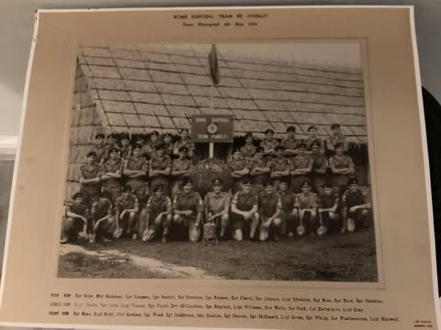

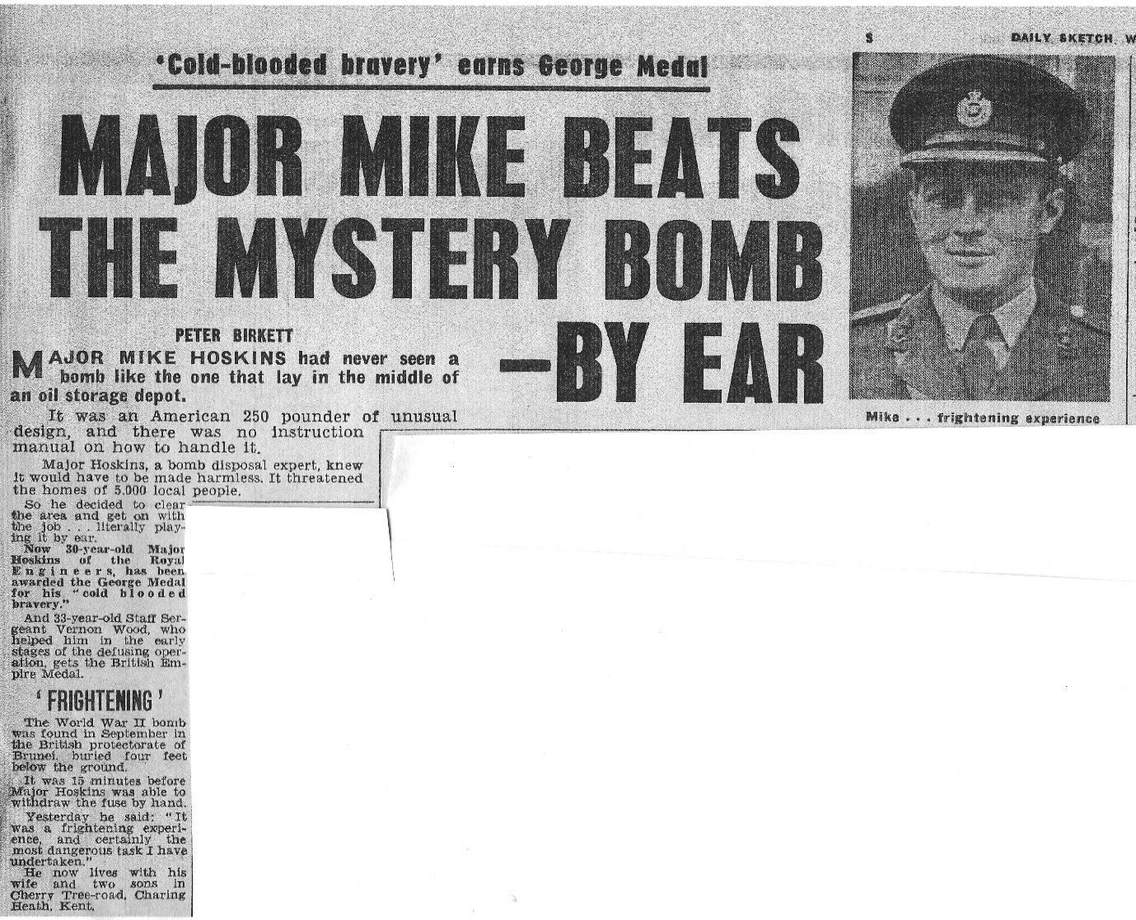

23478365 Staff Sergeant
G Duncan British Empire Medal
Bomb Disposal Team (FARELF)
Royal Engineers.

The Citation is taken from file WO373/182/39 held at the National Archives.
Posted in the London Gazette on the 22nd May 1969. Supplement 44854. Page 5480.

Staff Sergeant Duncan was a member of the original Bomb Disposal Team RE (FARELF) which started the clearance of the World War II Japanese bomb and storage sites on Penang Island in the Spring of 1967, and for the first three months he was the Senior NCO of the team. He served on this task for nineteen months, including crucial early stages of the work when drills were being established for dealing with hazardous largely unknown. During this time, he was personally responsible for the process of digging out and disposing of over a thousand bombs and other explosive devices. He displayed determination, energy and loyalty of the highest order, and his exceptional qualities were an inspiration to all who served with him. His courage and coolness in the face of obvious danger were an example to all and it is very largely due to his skill and technical proficiency that the task went so well from the start.

In January 1968 Staff Sergeant Duncan was badly injured when explosive from a sea mine ignited by accident. Whilst in hospital and whilst recuperating he maintained a close and cheerful interest in the progress of the work and as soon as possible he returned to duty. His ability, devotion to duty and uncomplaining endurance of tedious and dangerous work made him an outstanding example to all.

23548262 Staff Sergeant
J C V Wood British Empire Medal
Bomb Disposal Team (FARELF)
Royal Engineers

Staff Sergeant J C V Wood joined the Bomb Disposal Team RE (FARELF) in June 1967, and assumed the responsibilities of Senior NCO of the Team. Since there was only one Officer in the team he was effectively, second in command.

He has been closely involved with the digging out and disposal of over three thousand six hundred bomb, sea mines, torpedoes warheads and other explosive devices, left in collapsed tunnels on Penang Island by the Japanese at the end of World War II. All the explosive items were at least 25 years old and many in a critical condition.

He has at all times shown exceptional ability, a very strong sense of duty and unfailing cheerfulness. His skill, courage and determination in all aspects of this hazardous task and his standard of leadership and devotion to duty throughout this continuously testing period of seventeen months have been f the highest order, and the finest order, and of the finest tradition of Bomb Disposal operations.

He has been an outstanding example to the men working with him and a continual inspiration to the whole of the team.

Queens Commendations.

Sergeant Holliday, Lance Corporals T Floyd, E Meighan and P J Rees, Sappers J G Buck, B J Flynn J W Hawkins were awarded the Queens Commendation for their work.

The Citation is taken from file WO373/182/41 held at the National Archives.
Posted in the London Gazette on the 3rd June 1969.

In August 1968, a tunnel being excavated by the Bomb Disposal Team RE (FARELF) on Penang Island was found to contain about two hundred pounds of picric explosive. This was over 25 years old and in a very badly deteriorated condition. Picric is a hazardous explosive which Western countries ceased to use many years ago because of the dangers inherent in its use even in new conditions. In a deteriorated state it forms picrate’s which are even more sensitive. It is toxic and it attacks the skin.

Under normal circumstances it would have been preferable to demolish the explosive in situ. Unfortunately, the rotting boxes which had contained the picric were stacked on top of a row of torpedo warheads, alongside a row of sea mines. Demolition of the picric would have detonated all this explosive, estimated to total some five tons, which would have destroyed a nearby village.

Sergeant Holliday volunteered to lead a small team to remove the picric by hand. The team consisted of Lance Corporal’s Floyd, Meighan, Rees, Sapper’s Buck Flynn and Hawkins. To complete this hazardous task, they had to work slowly and carefully within the confines of the tunnel encumbered by rubber aprons and gloves. After extracting the explosives from the tunnel, they had to pack it in steel boxes prior to it being sea dumped. They completed the task efficiently and safely.

All concerned were fully aware of the obvious dangers and showed considerable courage and devotion to duty. Their cool acceptance of risk and their highly professional teamwork achieved completion of a very unpleasant task without incident.

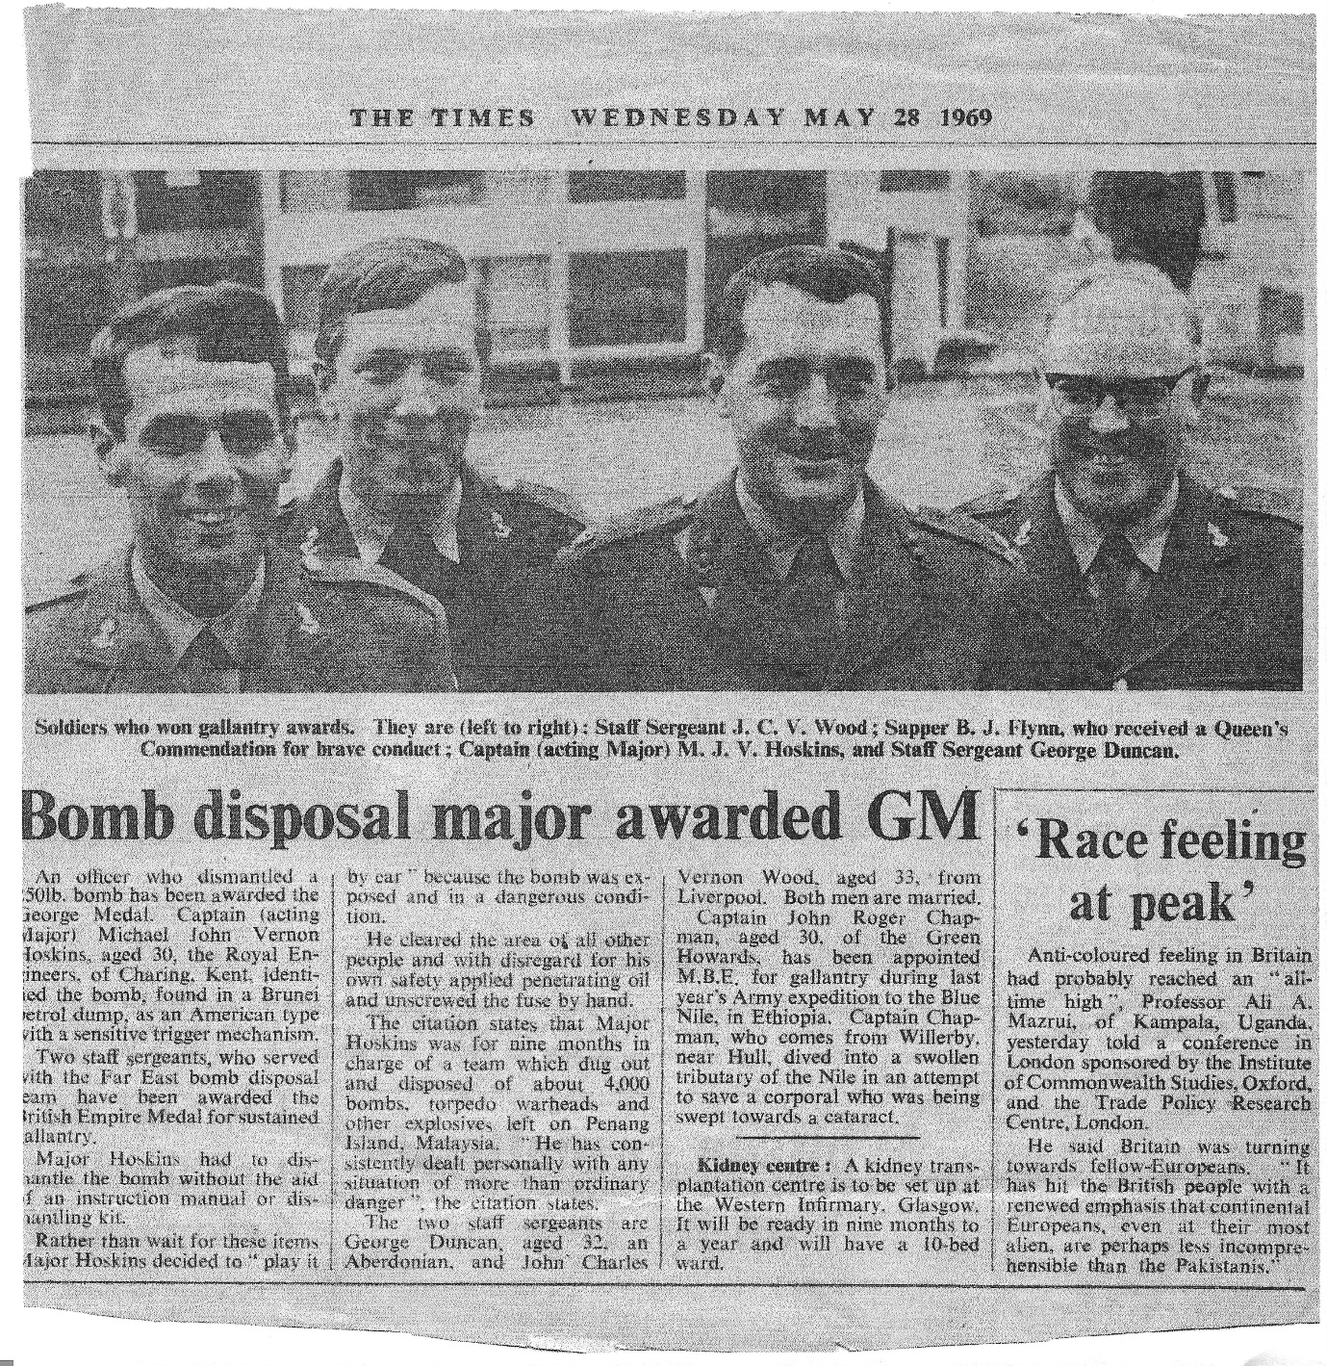

Request for General Service Medal Bombs Penang.

A request to the Ministry of Defence for the General Service Medal with a Clasp Bombs Penang, was turned down.

Apart from the hazardous conditions that these teams worked in with deteriorating ordnance, causing skin damage that meant for at least one of the team was medical discharged, from the Army. A SNCO received burns, received medical attention and after a period returned to work, he was not evacuated to the UK. Requests for recognition, this has been the continuing case through the years, when cases have been made for a award to be given in recognition of the Bomb Disposal, Explosive Ordnance Disposal work carried out throughout the years in peace time both by our military and civilian staff.

In 1977 a Joint Services team of 11 Royal Navy, one Army and one RAF member, all EOD trained took part in clearance of the Gilbert and Ellis Islands. The RE member was Sergeant J M Devine. 5 boat loads of munitions were sea dumped. The abandoned bunker which was left by Major Qualtrough was cleared

Hong Kong

In 1983 a team from 49 Field Squadron (EOD) 33 Engineer Regiment (EOD) were sent to Hong Kong to clear a Japanese Bunker. Photos below from John Swanborough. In total 5 Landing Craft Tank loads were sea dumped.

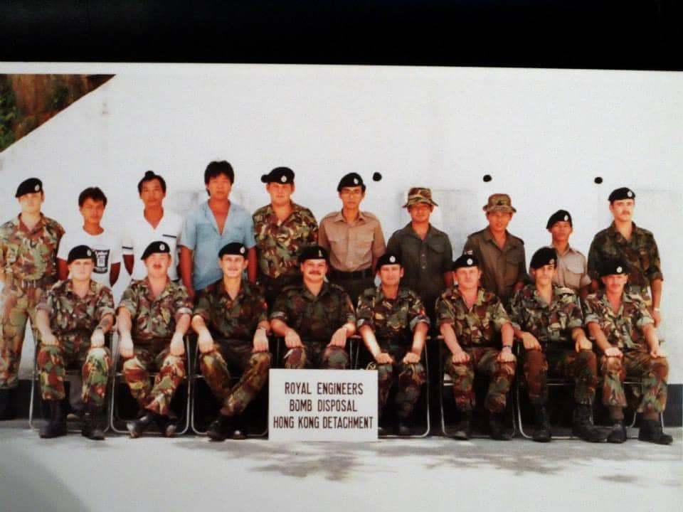

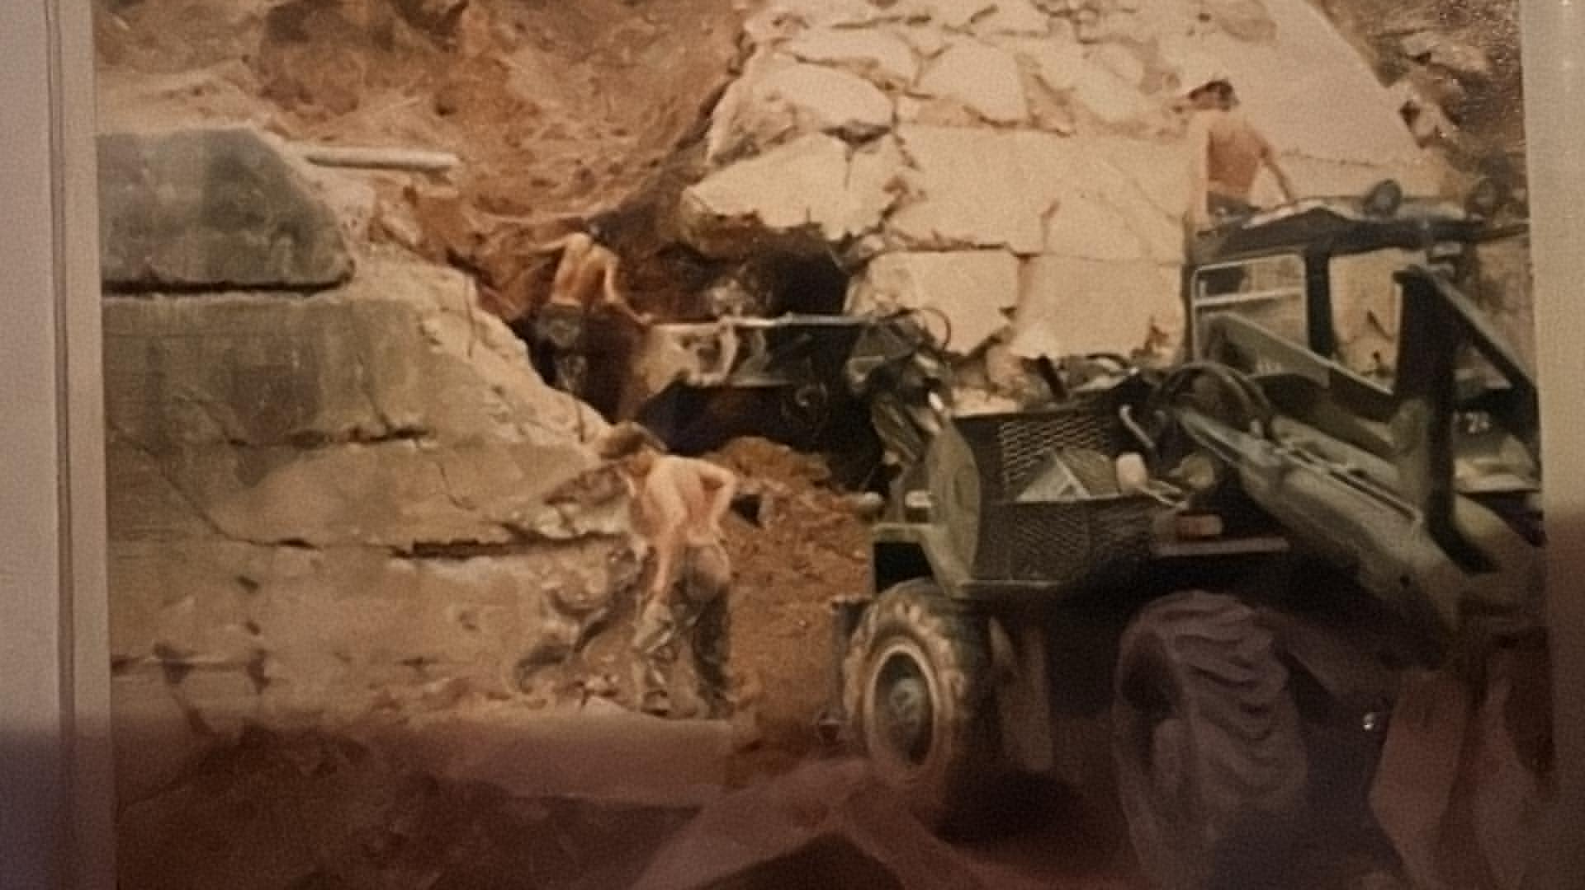

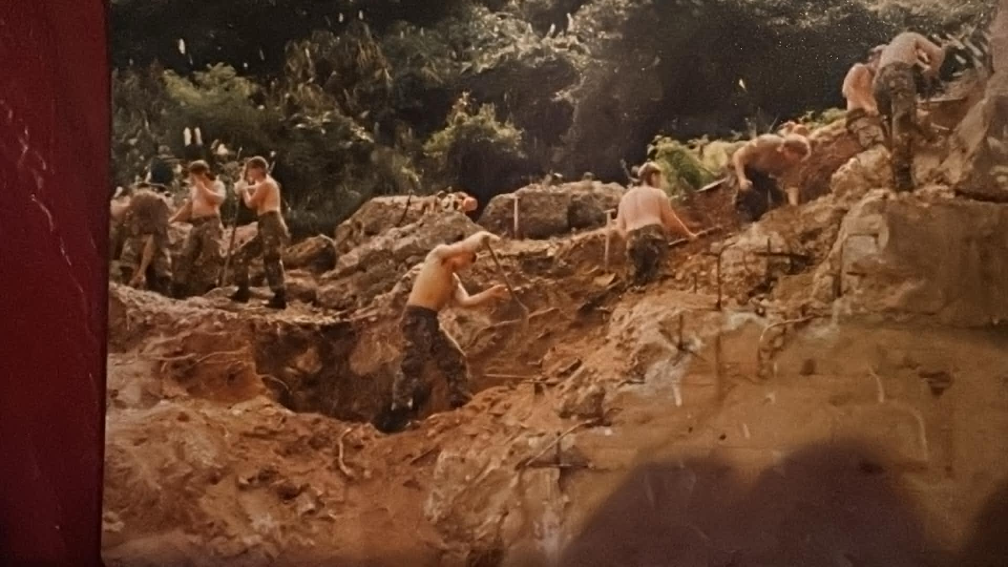

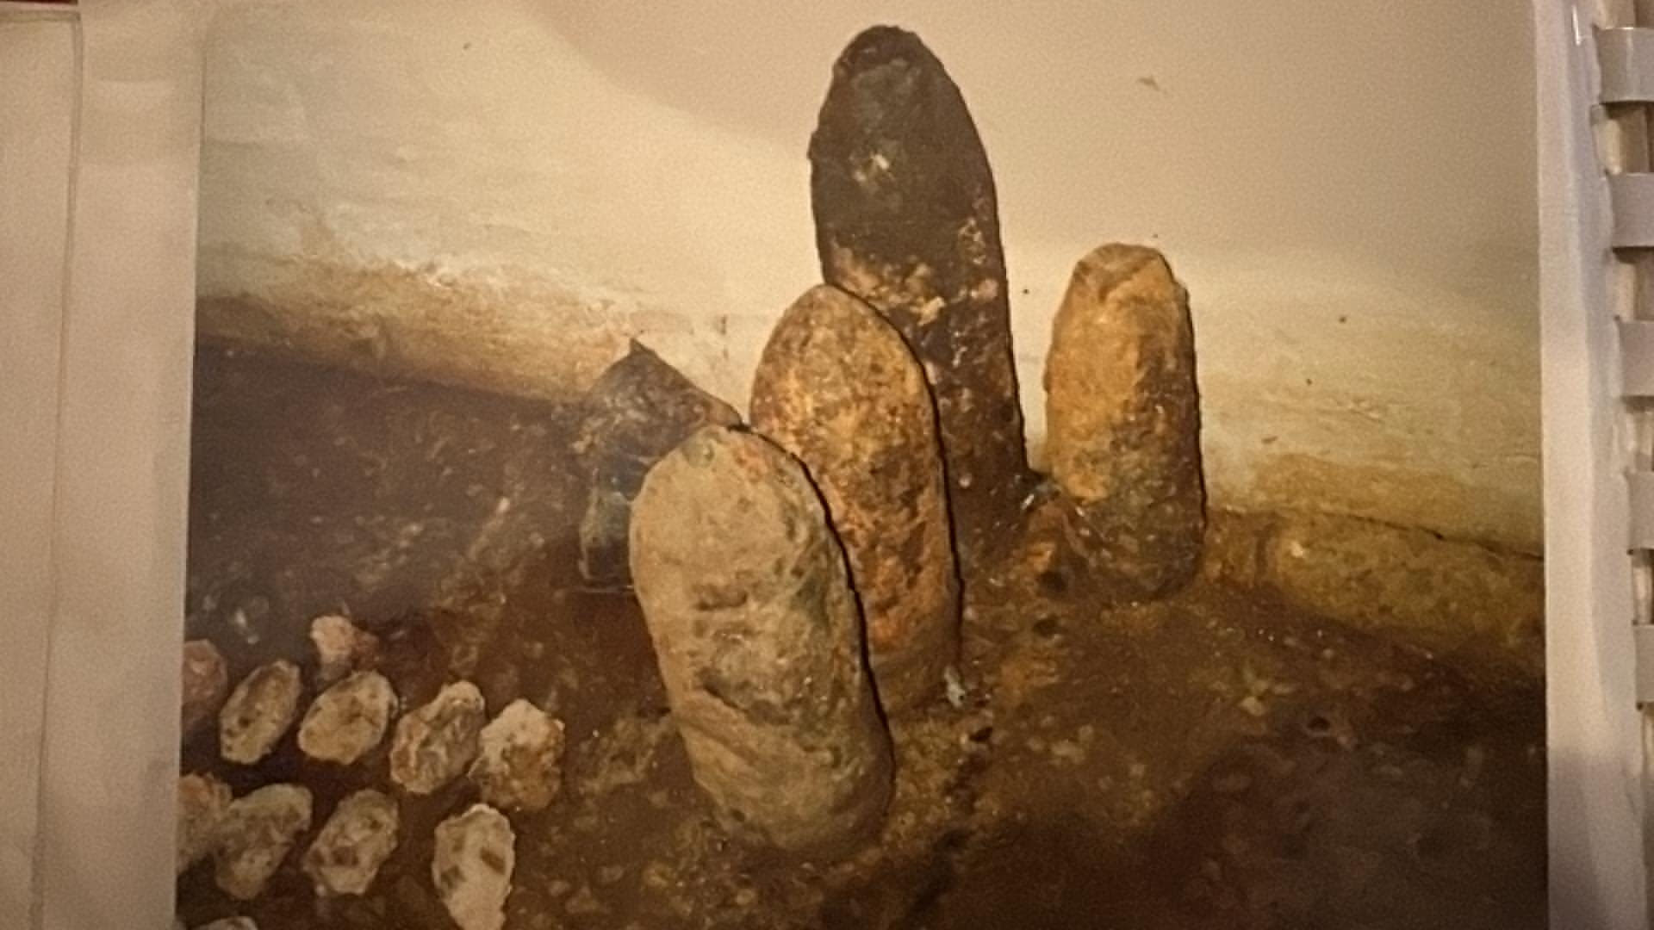
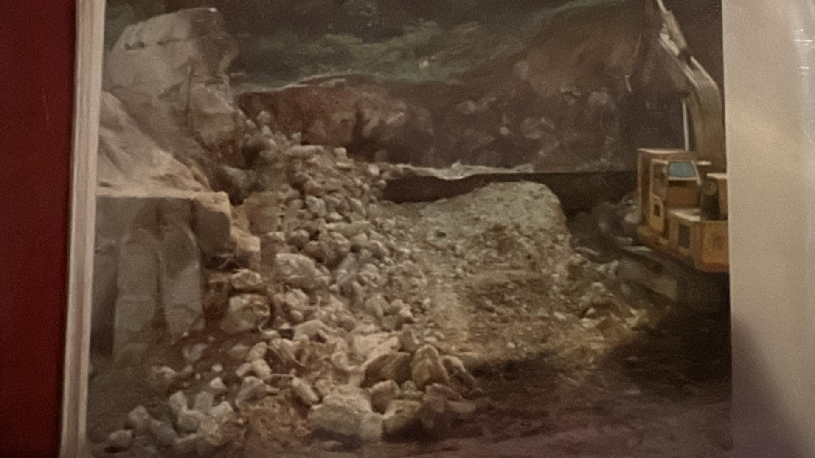

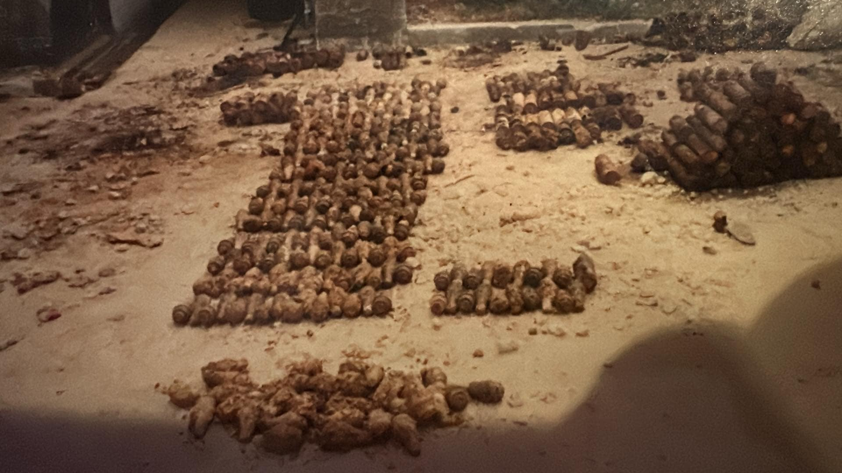
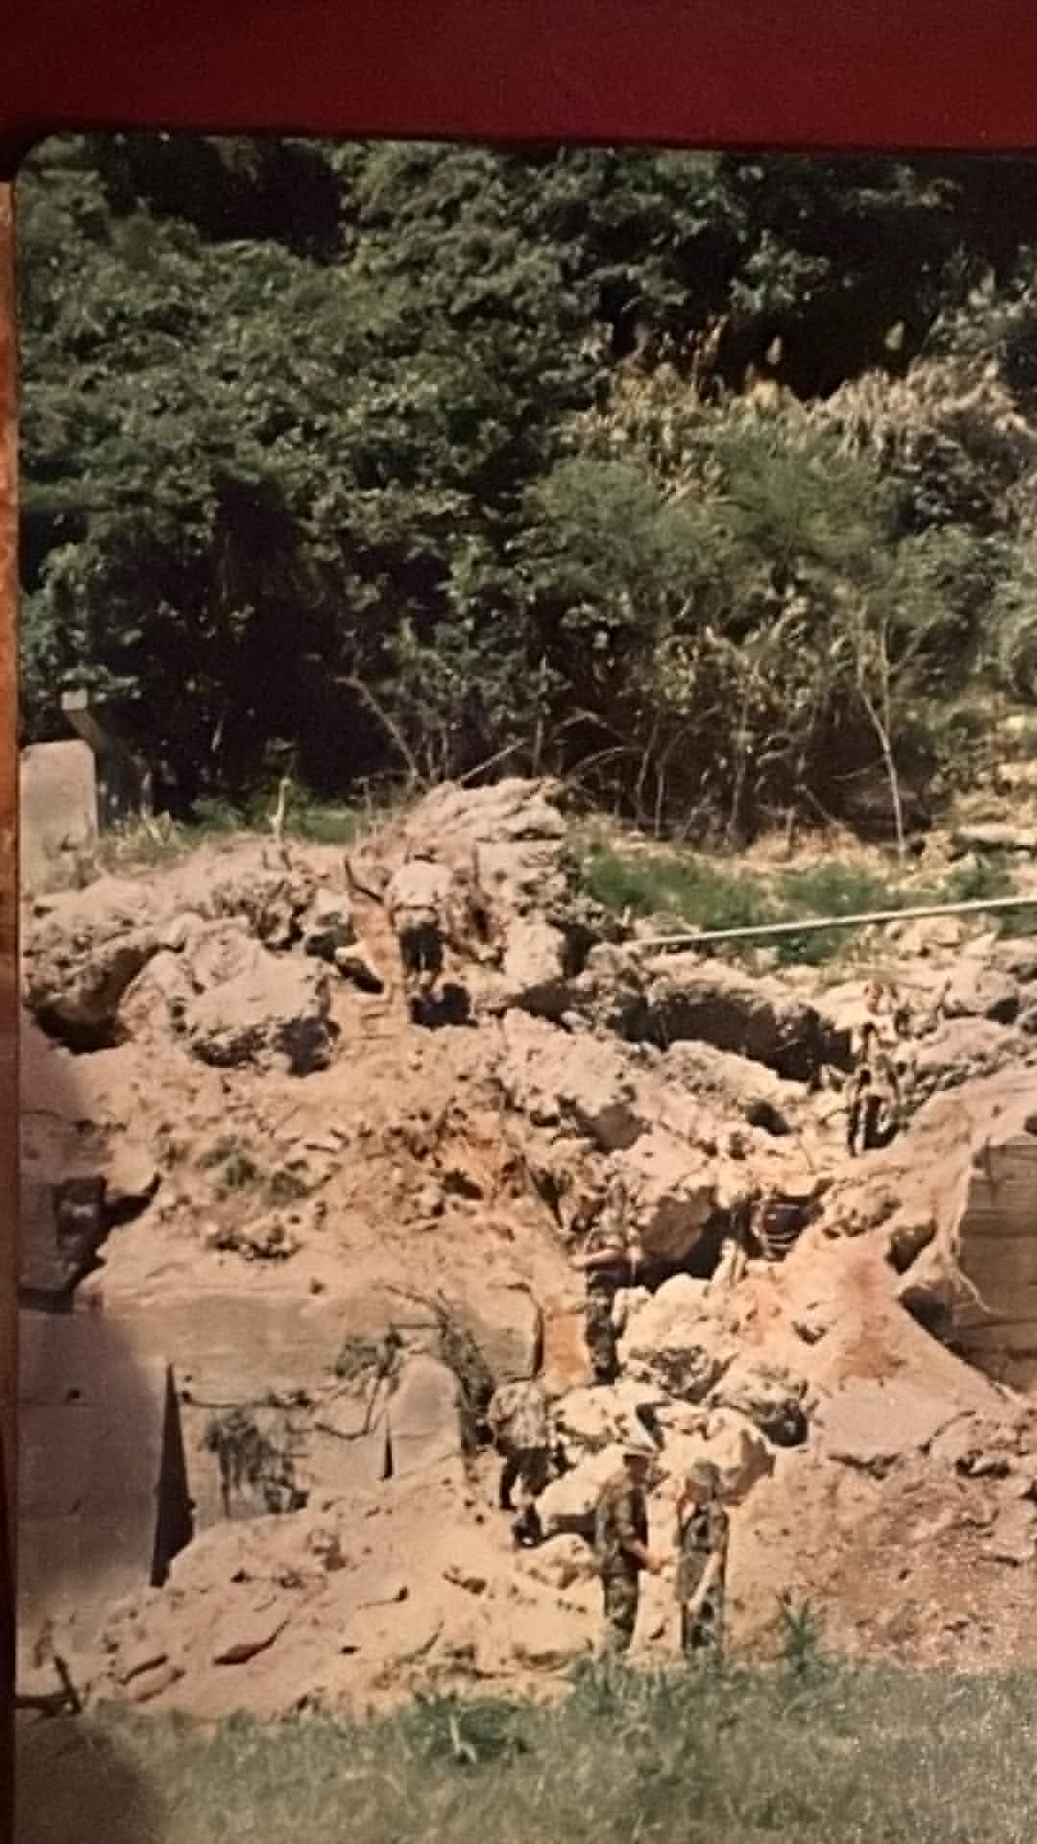

At this present time, we have no other information of these subjects of our history.
As ever please feel free to share your photos and stories in relation to your service with BD/EOD/Search so we can continue to expand on our history.
An incident today, is a story, tomorrow it is history, the day after details become blurred and forgotten. You can all in some even if a in a small way contribute.
Any questions, items to share please contact me historybdeod@gmail.com

Sources of Information.
REA BD Branch Archives.
History of the Corps of Royal Engineers Volume X and XI, 1960 to 1980.
Designed to Kill. Major Arthur Hogben QGM.
The Leftovers of War, Roger Farrow.
Information from John Green and Eric Meighan who were there.
John Swanborough.

