9 Bomb Disposal Company
Royal Engineers
Was formed 1 July 1940, Headquarters at Birmingham, the Company was Independent of the 4 Bomb Disposal Groups and came under Western Command. This was the first Company to be formed.
The Company covered Warwickshire, Worcestershire, Herefordshire, Staffordshire and Shropshire alongside 10 Bomb Disposal Company.
The nucleus of personal initially came from 726 General Construction Company.
Their first billets were at the Drill Hall, Court Oak Road, Harborne.
September 1940 to December 1941 they were based at Birmingham.
January to December 1942 they were based at Birmingham and Wolverhampton
January to December 1943 they were based at Birmingham, Harborne, Coventry, Sedbury and Neston
January to December 1944 based they were based at Birmingham, Wythal and Cardiff
January to September 1945 they were based at Birmingham, Manchester and in Wales
Sections under Command
67 Bomb Disposal Section
68 Bomb Disposal Section
69 Bomb Disposal Section
70 Bomb Disposal Section
71 Bomb Disposal Section
72 Bomb Disposal Section
73 Bomb Disposal Section
74 Bomb Disposal Section
106 Bomb Disposal Section
108 Bomb Disposal Section
Personnel
September to December 1941
Captain AJ Biggs Officer Commanding later Major
Captain T Sharman 2 i/c later Major GM
Lieutenant Bocock Admin Officer
January to December 1942
Major AJ Biggs Officer Commanding
93424 Captain Meynell 2 i/c latter Major
January to December 1943
Major AJ Bliss GM and Major Meynell Office Commanding
January to December 1944
Major TO Miles Officer Commanding
Captain Drake from August
January to September 1945
Major TO Miles and A Cleghorn Officer Commanding
163226 Major S F Knight MBE
Major R H Lee GM
119053 Major C C Stewart GM
Others Who served with the Company
Captain
56967 Captain A J Biggs GM
271193 Captain E Bunting
Captain FB Dean
Captain Drake
155767 Captain J H Grant
Captain R M W Norris
135406 Captain D S F Rayner GM
Captain R J J Simons
C9-820 aptain R M Taylor
255917 Captain C Walker
Lieutenant
Second Lieutenant DH Anderson GM MBE
397056 Second Lieutenant RGB Baker
Lieutenant C R Bocock
135004 Second Lieutenant AF Campbell GC
377425 Lieutenant WF Denny
377871 Lieutenant J C Harper
Lieutenant WEK Kenway
Lieutenant Leach
Lieutenant R D Lee
165370 Lieutenant H E Lewis-Winn
165372 Lieutenant M F H Lloyd
372449 Lieutenant J Maywood
Lieutenant Maxwell
Lieutenant McClune
Lieutenant Meynell
Lieutenant Norris
Lieutenant Raynor
Lieutenant Revitt
154300 Lieutenant G A W Smith
291827 Lieutenant W A Tavener MBE
Lieutenant RM Taylor
118349 Lieutenant E J Tergoning
Lieutenant Vickers
171645 Lieutenant W T Worts
Unsure of Rank with the Unit
48133 Lieutenant Colonel A Cleghorn OBE
Warrant Officers
1866721 SQMS JE Freeman
2205172 Warrant Officer II W H Kearns
1867508 Warrant Officer II G K Longbottom
Senior Non-Commissioned Officers
Staff Sergeant
1929576 Staff Sergeant J P Wood
Sergeant
2058790 Sergeant IH Andrews
895083 Sergeant H Bown
1873172 Sergeant A Edwards
14941103 Sergeant JW Edwards
2128046 Sergeant J Fisher BEM
4445289 Sergeant M Gibson GC
Sergeant J Gordon
4746951 Sergeant J C Oxtoby
Sergeant H Smith
Sergeant D T Stockwell
1913135 Sergeant H Watson
Lance Sergeant
2036910 Lance Sergeant H Elliot
2021663 Lance Sergeant J H Hinton GM
2111066 Lance Sergeant G A Jackson
1903138 Lance Sergeant J Jackson
2074517 Lance Sergeant A Sanders GM
Junior Non-Commissioned Officers
Corporal
19042106 Corporal SH Allmark
14449879 Corporal H Anderson
Corporal WA Ashwood
14452526 Corporal JE Coleman
2073122 Corporal A Haines
19057115 Corporal J W Hewitt
19064912 Corporal S Holmes
1880443 Corporal W Hone GM
2018336 Corporal P J O’Neil
Corporal I M Sillinge
14453507 Corporal C H Simcock
14141166 Corporal K A Spencer
1894337 Corporal J S Willis
Lance Corporal
2009926 Lance Corporal FW Coyle BEM
4451619 Lance Corporal W Dawson
14705375 Lance Corporal J Gray
22018745 Lance Corporal C R Jones
16136670 Lance Corporal G E Keatinge
1991261 Lance Corporal F Lowe
1920394 Lance Corporal E C Oxford
14050396 Lance Corporal J E Pye
1883145 Lance Corporal E W Suttle GM
Sappers
1904351 Sapper T J Adams
6017444 Sapper LS Baker
6711953 Sapper JE Brown
2196474 Sapper JE Brown Kings Commendation
2090614 Sapper HW Carman BEM
22047727 Sapper DW Cartman
1447692 Sapper K Cole
4614821 Sapper N Cryer
2004138 Sapper WW Davies
14962676 Sapper GE Feilding
2067106 Sapper JA Fisher
2000787 Sapper L Fitchett
2004028 Sapper H Fox
1890139 Sapper W Gibson
2000532 Sapper G Gilchrist
14245642 Sapper R G Griffiths
14310285 Sapper J C Hughes
14089567 Sapper D Jennings
19007854 Sapper T F Johnson
1942461 Sapper F Joyce
2187897 Sapper R R Ketteringham
1930981 Sapper H J Kinsey
1891040 served as A Knight (Rabinowitz)
22070424 Sapper G Moss
22038519 Sapper D Parry
22069045 Sapper R Phillipson
2073635 Sapper R W Skelton
Sapper F Ward
2387170 Sapper G E W Wells
21069556 Sapper D M Wilson
1904830 Sapper W B Wisely
4124550Sapper F Wright
Driver
Driver JW Edwards
2073309 Driver WH Fergusson
2158996 Driver H Garlick
14421770 Driver Holden
2019927 Driver T Howard
2011942 Driver G J Jones
Driver A Searle
Rank Unknown
14390368 DA Allam
S Barge
S Burge
1917357 JAC Chapman
14451710 J Cook
EJ Couchman
2078044 JW Edward
1879989 A C Hadfield
L R Hasler
D Hempshall
7041143 D Kane
13037681 P Melville
J Nelson
D Smith
D M Smith
H S Stevens
P J Tobin
F W S Wastall
K Yesford
Awards
George Cross
135004 2nd Lieutenant AF Campbell
4445289 Sergeant M Gibson
George Medal
100212 Second Lieutenant D H Anderson
56967 Captain H Biggs
2021663 Lance Sergeant J H Hinton
1880443 Corporal W Hone
2217011 Sergeant E Laing
Second Lieutenant R H Lee
93424 Lieutenant L Meynell
135406 Lieutenant D S F Rayner
2071457 Lance Sergeant A Sanders
71764 Captain T H Sharman
119053 Captain C C Stewart
1883145 Lance Corporal E W Suttle
Member of the British Empire
152403 Captain J E Drake
291827 Lieutenant W A Tavener
British Empire Medal
2090614 Sapper H W Carman
2036910 Sergeant H Elliott
2128046 Sergeant J Fisher BEM
2014169 Driver A E Green
1920394 Lance Corporal EC Oxford
Kings Commendations
2196474 Sapper J E Brown
1942454 Sapper J Todd
2 others name’s unconfirmed
Roll of Honour

1922152 | Driver | M T | ANDREWS | 19-Sep | 1940 | Age 26
2072958 | Sapper | O E | BRAYSHER | 29-Oct | 1940 | Age 20
2196474 | Sapper | J E | BROWN | 29-Oct | 1940 | Age 25
6711953 | Sapper | J E | BROWN | 18-Oct | 1940 | Age 42
135004 | 2nd Lieutenant | A F | CAMPBELL GC | 12-Dec | 1940 | Age 24
2009926 | Lance Corporal | F W | COYLE | 13-Apr | 1941 | Age 21
4614821 | Sapper | N | CRYER | 25-Aug | 1940 | Age 37
1942461 | Sapper | F | JOYCE | 8-9 April | 1941 | Age 46
2004138 | Sapper | W W | DAVIES | 25-Aug | 1940 | Age 20
4451619 | Lance Corporal | W | DAWSON | 17-Nov | 1940 | Age 23
2073309 | Driver | W H | FERGUSON | 25-Aug | 1940
2004028 | Sapper | H | FOX | 13-April | 1941 | Age 21
1890139 | Sapper | W | GIBSON | 18-Oct | 1940 | Age 22
4445289 | Sergeant | M | GIBSON GC | 18-Oct | 1940 | Age 34
2000532 | Sapper | R | GILCHREST | 18-Oct | 1940 | Age 23
2073122 | Corporal | A | HAINES | 25-Aug | 1940 | Age 21
1892057 | Driver | C | HOLDEN | 6-Nov | 1940 | Age 21
2019927 | Driver | T | HOWARD | 12-Dec | 1940
2011942 | Driver | G J | JONES | 13 April | 1941 | Age 26
1942461 | Sapper | F | JOYCE | 17-Nov | 1940 | Age 32
1930981 | Sapper | H J | KINSEY | 8-9-Apr | 1941 | Age 46
1895184 | Lance Corporal | J M | KIRKBY | 25-Aug | 1940 | Age 21
165372 | Lieutenant | H E | LEWIS-WINN | 13-Apr | 1941 | Age 35
165372 | Lieutenant | M F H | LLOYD | 18-Oct | 1940 | Age 25
1991261 | Lance Corporal | F | LOWE | 14-Sept | 1944
1942443 | Sapper | J | PLUMB | 18-Oct | 1940 | Age 20
1891040 | Sapper | A | RABINOWITZ (Served as Knight) | 13-Apr | 1941 | Age 26
2073635 | Sapper | R W | SKELTON | 12-Dec | 1940 | Age 35
154300 | Lieutenant | G A W | SMITH | 18-Oct | 1940 | Age 32
T/216142 | Driver | E F G | TAYLOR | 12-Dec | 1940 | Age 44
2073628 | Sapper | W H | THORNE | 25-Aug | 1940 | Age 27
1913135 | Sergeant | J | WATSON | 11-Apr | 1941 | Age 19
1894337 | Corporal | J S | WILLIS | 17-Nov | 1940 | Age 26
1904830 | Sapper | W B | WISELY | 25-Aug | 1940 | Age 24
4124550 | Sapper | F | WRIGHT | 17-Nov | 1940 | Age 26

Memorial for those who died 18 October 1940, Whitley Common, Coventry. Arranged by the Whitley Local History Group. REA BD Branch sent representation
Historic Detail

Heroes of the Birmingham Air Raids.
9 Bomb Disposal Company, Royal Engineers.
Some idea of the work done by this unit may be gained from the fact that more than 37 Officers and men lost their lives as a result of enemy action or while removing bombs, (further research has shown casualties were 34 in this Company, through the War) , 5 Officers and 10 other ranks gained awards, four other ranks being Commended. (further research show that 9 Officers, 10 other ranks received awards, only two Commendations confirmed in total not just through 1940 and 1941).
It is estimated that the Company dealt with more than 1,600 large calibre bombs. The largest number of outstanding incidents at any one time waiting to be dealt with being 305 on the 24 November 1940. Their work was carried out under especially difficult conditions, apart from frequent bombings, accommodation being a very knotty problem to solve. When the Drill Hall in Court Oak Road, Harborne was requisitioned only a small portion could be allotted to the Company and Officers and men had to take their meals together. Yet despite frequent casualties, periods of continuous raids and other troubles, the members of the Company always maintained a cheerfully attitude.
As far as Birmingham was concerned, there was no unit available to undertake the hazardous work of bomb disposal prior to July 1940, when the formation of the Company was commenced with a nucleus of officers and men mostly taken from Royal Engineers General Construction Companies. The first arrivals were Lieutenants Raynor and Leach and 47 other ranks from 726 GC Coy RE and they were joined three weeks later, following a air raid on the city lasting five hours by a further Officer. Lieutenant Campbell and another 45 other ranks. As time went on, more personnel arrived but, it was not until 1 September 1940 that Captain A J Biggs of Neath, arrived from 244 Field Company, where he had been 2 i/c and immediately got down to the task of forming the Company proper, with the assistance of Lieutenant C R Bocock as Administration Officer. The total personnel at this time were 7 Officers and 160 other ranks, few enough to deal with an area including the counties of Warwickshire, Worcestershire, Herefordshire, Staffordshire and Shropshire.
Captain Biggs who arranged certain big bangs including the explosion coming from the bottom of a hole 50 feet deep in a quarry near Oldbury. Some delayed action bombs had been unearthed by Lieutenant Raynor and his men in a residential suburb, and removed, at first, to a convenient sandpit. Even in the sandpit the bursting of the bombs might damage property, so it was decided they must be taken to the Oldbury quarry, where they would do no harm. Lieutenant W E K Kenway accompanied by his batman took three of the bombs, a 550lb and two 110lb bombs in a lorry, which he drove himself, along a circuitous route, so as to minimise the risk of damage to houses if the whole load blew up.
There, remained one other 110 lb bomb which was in a somewhat uncertain condition. With the bomb Captain Biggs himself set out on the journey to Oldbury. He thought that if it rode in a lorry the bomb might be detonated by the rattling and vibration, so he had it placed in the back seat of his own private car. He took it by a selected route to the quarry; dumped it in the fifty-foot hole and two or three hours later heard it detonate itself and the others already deposited there.
The Company sustained their first casualties on 31 August, 1940 when three bombs exploded during removal, killing seven other ranks and injuring five, (not supported by CWGC Records), one of whom died in hospital, 14 November, (records show no deaths in the Company on the 31/8/1941 but 5 on the 25/8/1940). 1940 brought the very concentrated enemy raid on Coventry. Roads were blocked, large fires started, communications dislocated, light and gas put out of action and the raid did not cease until 0616 am on the 15th. This was, if not the worst, one of the worst raids on any city in England. So bad was the raid that detachments were drawn from Manchester and Cardiff Companies to help in the disposal work. During this period too, it must be borne in mind that raids were still taking place in Birmingham. As early as2 September, 1940 a raid left a legacy of 109 incidents to be dealt with, yet by the 20 only 14 unexploded bombs were outstanding. From 13 to 15 October, raids were made daily on Coventry and Birmingham with others daily during November.
It was during November that Major General D B C Taylor, On Inspector of Fortifications and Director of Bomb Disposal, visited the Company and expressed great satisfaction with the methods and progress of the work which had been done, and personally congratulated Maor as he had become A J Biggs. By the end of 12 months of particularly heavy bombing the Company had dealt with 2.174 incidents and there only being 23 unexploded bombs, all in the Category D outstanding.
The good work was recognised when the following awards to members of the Company were notified in the London Gazette; George Cross Lieutenant A F N Campbell and Sergeant M C Gibson; George Medal; Major A J Biggs, Lieutenant L C Meynell, D S F Rayner, R H Lee and Lance Sergeant J H Hinton; Member of the British Empire Lieutenant D H Anderson; British Empire Medal Sergeant K Ashton, E C Oxford, Sapper H W Carman; Kings Commendations Sappers T Todd and J E Brown.
At the same time a special badge was granted to Bomb Disposal Unit’s to be worn on the left sleeve.
By the 29 February 1941 the Company had dealt with 2,290 incidents. Then there came a welcome lull broken on the on the 8 April 1941 by a concentrated raid on Coventry. The following day, a concentrated raid was made on Birmingham. Both cities had yet another raid on the 10. By the 13 April there was quite a lot of work on hand and 6 Auxiliary Bomb Disposal Squads, Home Guard from Austin Motors Ltd, commenced Bomb Disposal work under the supervision of the Company Commander. Four firms in Birmingham sent members of their Auxiliary Bomb Disposal Squads for practice training. Enemy activity continued at intervals during the next few months and the work of the Company had more gratifying recognition in the following awards which were announced at the end of September.
George Medal Captain T H Sharman, Sergeant E Laing, A Sanders, Corporal W Hone, Lance Corporal E W Suttle; British Empire Medal Lance Sergeant H Elliott, Corporal AE Green; Kings Commendation to two others not named.
In order to commemorate the Officers and Men of the Unit who lost their lives whilst employed on Bomb Disposal Duties in 1940 and 1941, two large oak candlesticks, (see photos at the end of this piece, the candles are still in use today) were purchased by the Company and installed in St Faith’s Church, (later the Parish Church of St Faiths and Saint Laurence), Harborne where the Company had held a parade service weekly during the last 3 years. Many Officers who had served with the unit during the “Blitz” returned for the Dedication Ceremony, chief of them being Major A J Gibbs GM, who had commanded the Company in 1940 -1941. The Reverend W Sissons conducted the service and a short but impressive dedication ceremony was carried out by the Major. The Rev Alex Birkmire, Senior Chaplain to the Forces, Birmingham Area. At the end of the service, which was held on the 7 November 1943 officers and men filed slowly past in Remembrance of their lost Comrades.
We want your bombs is their heroic motto.
The following article appeared in “The Birmingham Gazette18 September 1940”
We want your bombs, that death defying motto, chalked by hand of some unknown hero on the sides of a military lorry see yesterday in a Midlands town, typifies the spirit of the men of Bomb Disposal Sections of the Royal Engineers who have just won the world-wide admiration by their removal of a large bomb which threated St Pauls Cathedral with destruction.
Because it was one of the world’s great cathedrals which was endangered their heroism has, of course attracted single attention, but deeds of equal devotion and bravery performed in less spectacular circumstances by other officers and men of the sections must not be overlooked.
Early in the raiding season the Midland Region had three of these sections under the command of Lieutenant D S F Rayner formerly a Territorial, whose home is in Birmingham.
It was a party of his men in charge of Sergeant Bodsworth, of Thorpe Street, Drill Hall, Birmingham, who investigated a small hole in a field near Redditch. The hole was believed to contain a delayed action bomb and as it had been there for three days it could be expected to blow up at any moment.
The Sappers nevertheless, dug down in search of the bombs, found it at last about 20 feet below the ground and heard its clock fuze still ticking.
It was a 500ld bomb so anyone may guess what would have happened to Sgt Bodsworth and his party if, the bomb had done its worst at that moment, or if they had accidentally touched it.
They removed the fuze and carted the bomb away for examination by other interested experts.
Subsequently a large number of unexploded bombs were reported from various districts, of the Midlands Region. Some of them were creatures of the imagination, but others were far from being harmless. All of them had to be investigated and Captain A J Biggs, from Neath came with reinforcements for the disposal parties.
Captain Biggs “arranged” the innocuousness of certain big bangs that were heard on evening by most people in the Birmingham area. The explosions came from the bottom of a hole 50 foot deep in a quarry near Oldbury.
Some delayed action bombs had been unearthed by Lieutenant Rayner and his men in a residential area and removed at first, to a convenient sandpit, lest their explosion wrecked houses near the spot where they had fallen.
The RE’s then thought that even in the sandpit the bursting of the bombs might damage property, so it was decided that they must be taken away to the Oldbury quarry, where they could do no harm at all.
Lieut Kenway, accompanied by his batman, took three of the 500lb bombs and two 110lb bombs in a lorry, which he drove himself along a circuitous route, so as to minimise the risk of damage to houses if the whole load blew up.
Tere remained one other 110lb bomb which owing to a mischance during its previous treatment, was in a uncertain condition.
With this bomb Capt Biggs himself set out on the seven-mile journey to Oldbury. He rather thought that if it rode in a lorry the bomb might be detonated by the rattling and vibration to which lorries are prone, so he had it placed in the back seat of his of his own private car. He took it by a selected route to the quarry, dumped it in the fifty-foot hole. And two or three hours later= heard it detonate itself and the others already deposited there.
The Disposal Company had done its work without grievous loss. A party of Sappers had dug down to a bomb and were looking it over, when they heard a fizzing sound. Thet retreated for a few minutes, but a water wors employee told them that the fizzing had come from a punctured water main.
They accordingly returned to the crater they had dug and two of the men went down to tackle the bomb once again, while the others watched them from above. At this very moment the bomb exploded.
Seven men were killed on the spot another was fatally injured these were Corporal R Haines, Sappers N Cryer, W W Davies, W E Fergusson, A Knight, W E Thorne, Lance Corporal W Dawson, Sappers J C Cottrell and W Hardy, Driver E Ablett were injured. (Incorrect information, M T Andrews, R Haines, N Cryer, W W Davies, W E Thorne, W B Wisely all died on the 25/8/1941, Andrews died on the A Rabinowitz ( served as Knight) died on the 13/4/41, WE Fergusson 27/8/1940.
This document is from the Royal Engineers Association, Bomb Disposal Branch Archives. Actual source or date unknown.

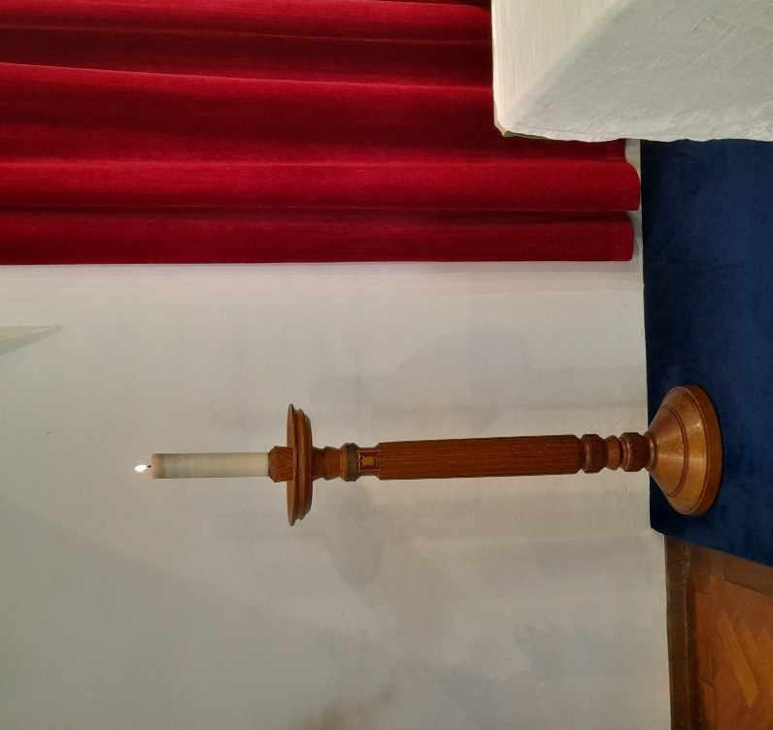

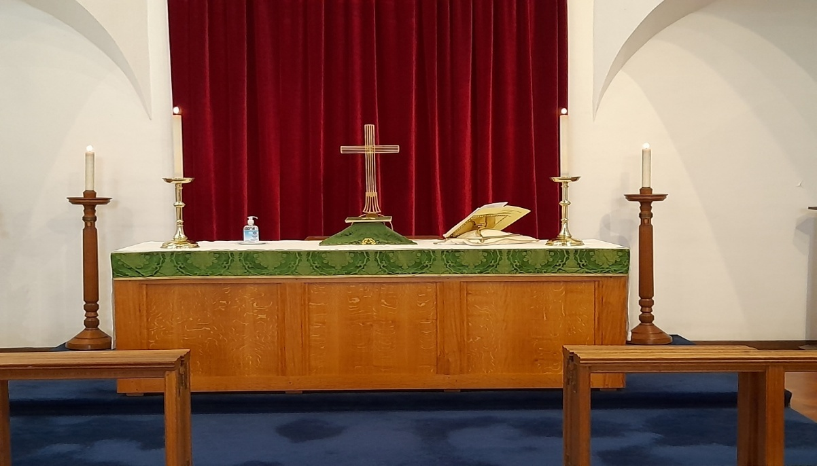
Candlestick Photos Credit Reverend David Parker
Incidents
On the 14 December 1940 at Chapel Street Coventry, members of 9 Bomb Disposal Company were tasked with a 250 kg bomb. After nearly 4 days it was uncovered. It was fitted with standard fuzes, these were so badly damaged they could not be removed. The electric charge was thought to have been dissipated due to the time period from when it had been dropped. However, a discharge tool was applied. On the 18 October 1940 the bomb now believed to be inert was removed from site by a lorry to Whitley Common, as it was being unloaded it detonated killing all.
Photos
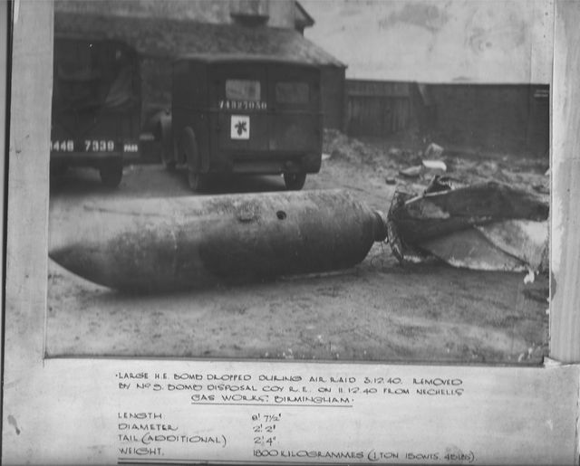
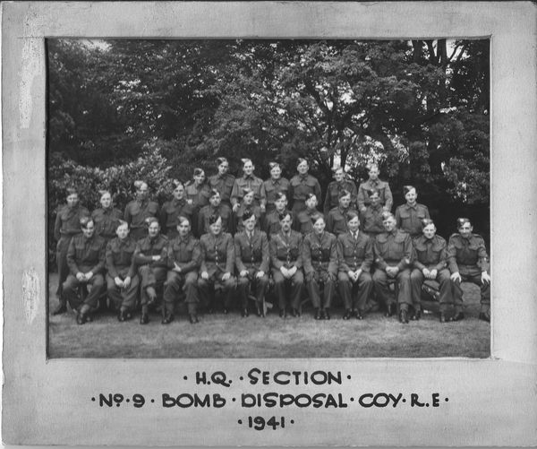
From Peter Markham Collection
Whitely Common Memorial, Coventry
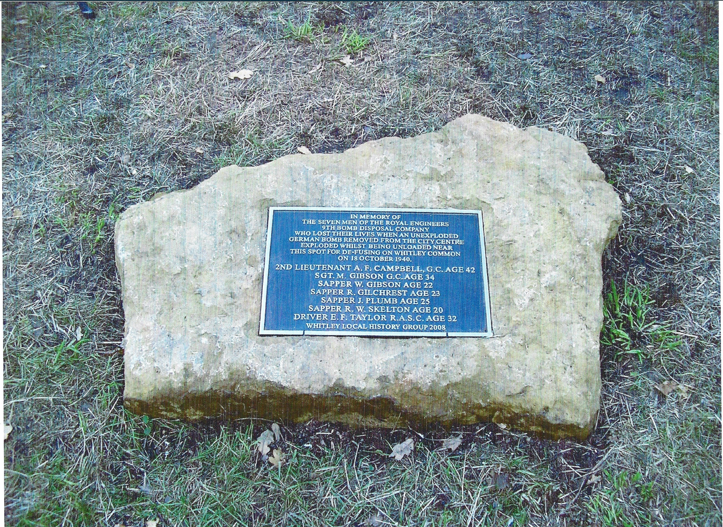
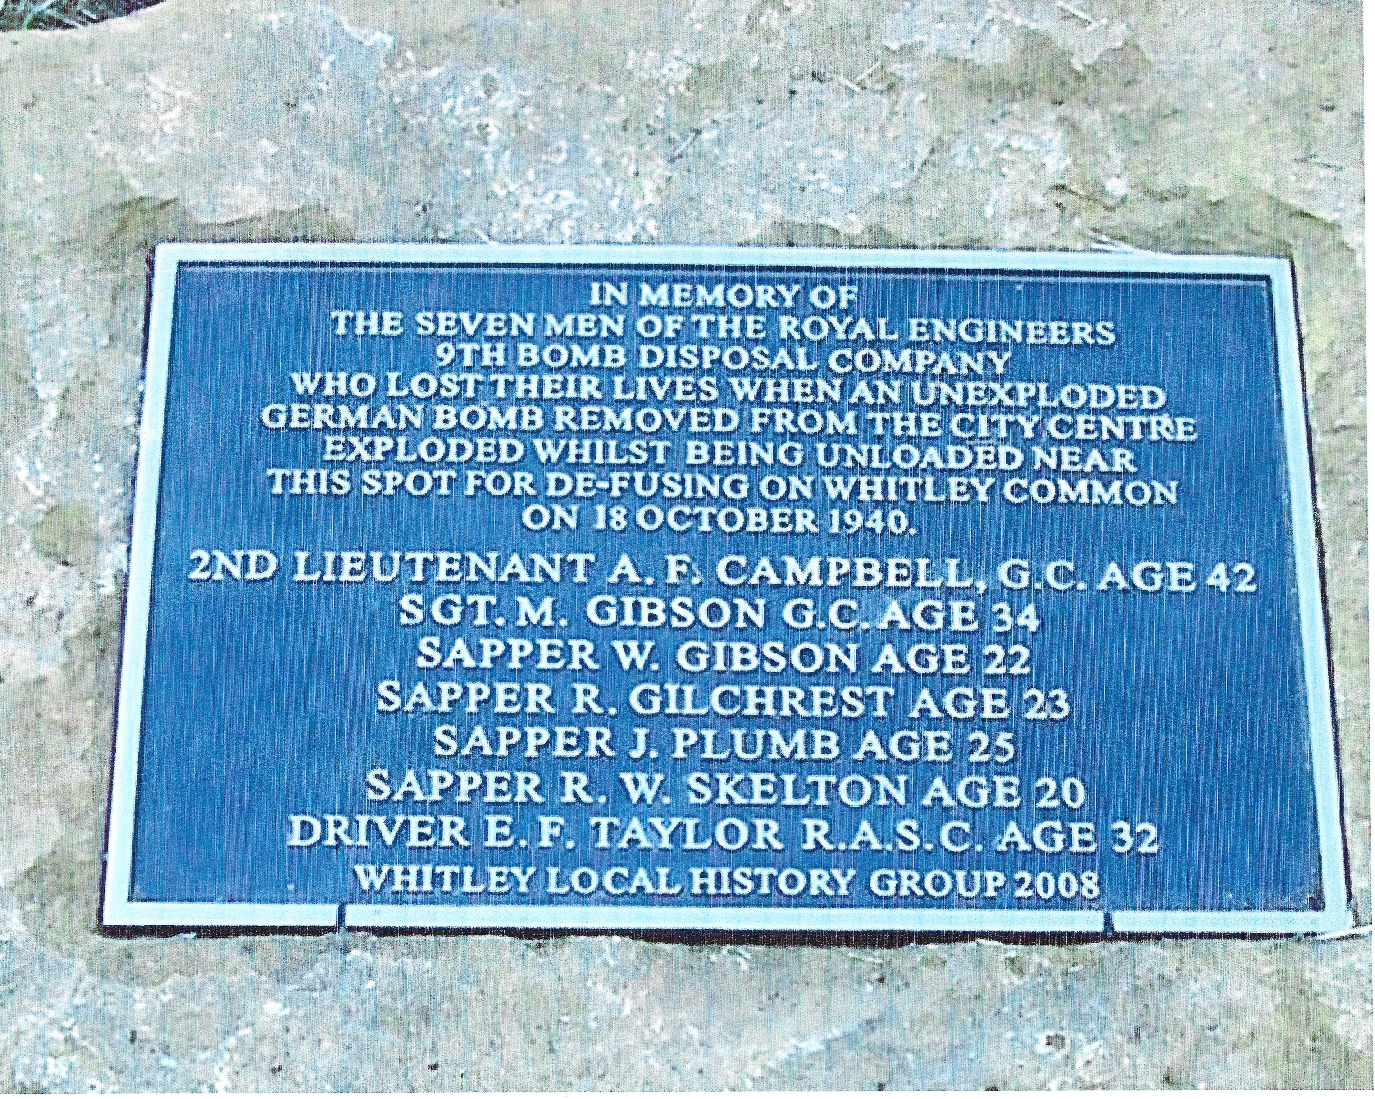
Photo Credit Peter Markham
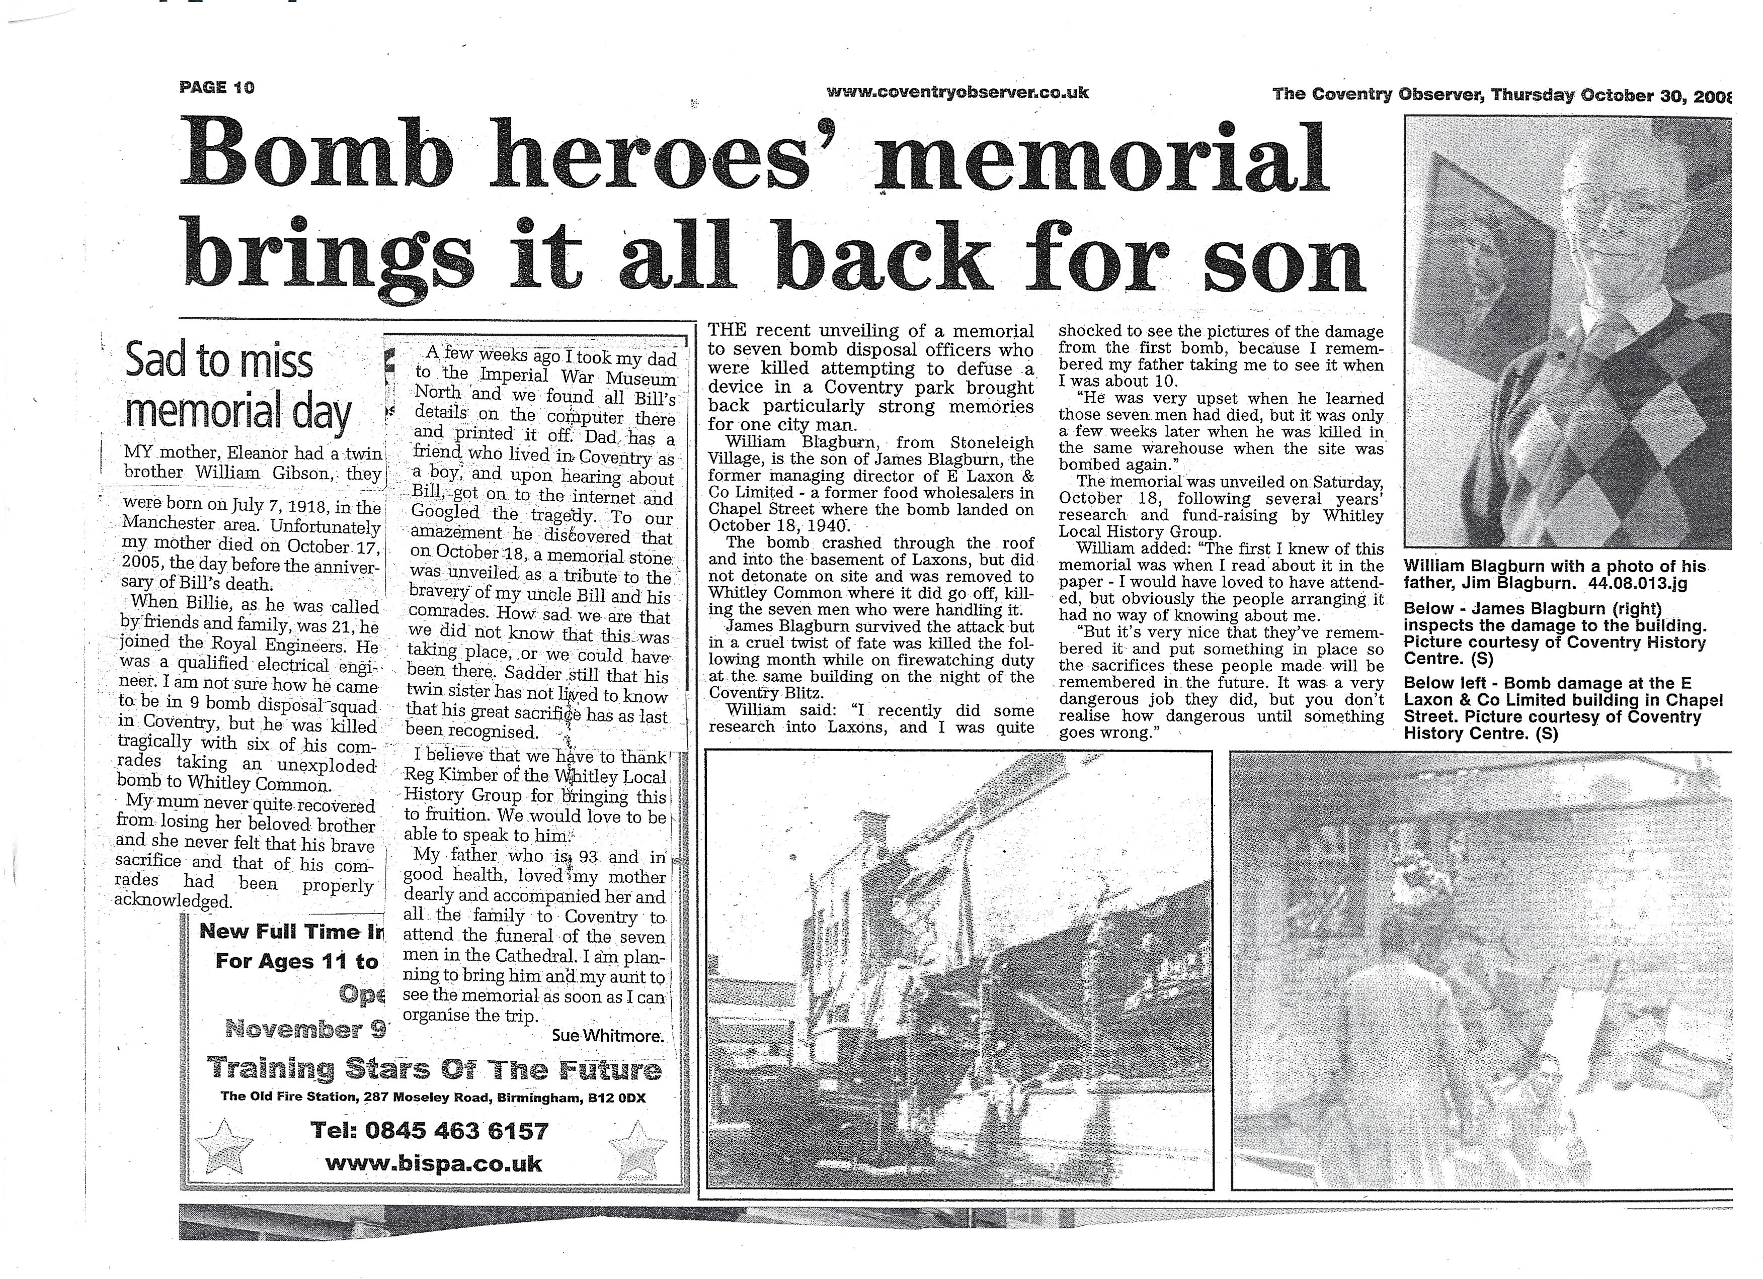
Paper Clipping from Reg Kimber

References Nation Archive Files
9 Bomb Disposal Company, War Diaries
WO166/4001 | 01 September 1940 to 31 December 1941 | Independent Western Command
WO166/8415 | 1942 | Independent Western Command
WO166/12357 | 1943 | Independent Western Command
WO166/15468 | 1944 | Independent Western Command
WO166/16938 | 01 January 1945 to 30 September 1945 | Independent Western Command

