1 Malaya Bomb Disposal Company.
The Forgotten Company in Bomb Disposal History.
Whilst researching the Royal Engineers Bomb Disposal Roll of Honour (www.reabd.org.uk) casualties were found that related to the 1 Malaya Bomb Disposal Company.
Who was this unit, when did they form, what happened to them? Research through all the books relating to Royal Engineers Bomb Disposal through World War 2 only showed a mention in Bomb Disposal and British Casualties of WW 2, Chris Ranstead. However this was in the casualty list, but nothing relating to the unit.
Possibly no detailed information uncovered as the Unit was very short lived, no evidence can be found of any major Bomb Disposal work being undertaken and they were part of the Singapore Garrison and taken captive when Singapore fell to the Japanese.
There were casualties one during the fighting for Singapore, the remainder during captivity many whilst working on the infamous railway.
Although they may have not been involved in Bomb Disposal activities to a large degree. They were a Royal Engineers Bomb Disposal Company and should be a part of the History of these Units.
The following is laid out in the format of.
- Brief details of when the unit was formed and where those in it came from.
- Nominal Role. Including Camps sent to.
- Nominal Roll of those posted from 1 Malaya Company prior to 15 February 1942.
- Roll of Honour, including photographs of graves and memorials.
- Information as to Cemetery’s.
- Appendixes.
- Notes.
Details in sections 2, 3, 6 taken from documents held in the National Archives at Kew. These are
WO 361/1421 1 Malaya Bomb Disposal Company, Book 4 SS/330/ILEP/4831
62/C No 1 Malaya Bomb Disposal Company RE
Singapore Fortress.
A naval base started to be built at Singapore in 1923, partly in response to Japan's increasing naval power. The base, completed in 1941 and defended by artillery, searchlights, and the newly built nearby Tengah Airfield, caused Singapore to be named in the press as the "Gibraltar of the East."
The Singapore naval base was built and supplied to sustain a siege long enough to enable Britain's European-based fleet to reach the area. By 1940, however, it was clear that the British fleet and armed forces were fully committed in Europe and the Middle East and could not be spared to deal with a potential threat in Asia. Most were convinced of Singapore's impregnability. This was based on the assumption that any assault would come from the south by sea.
On December 8, 1941, the Japanese troops sailed. By the evening of December 8, Japanese troops had established a foothold on the peninsula and Japanese airplanes had begun bombing Singapore. The main Japanese force moved quickly and began sweeping down the single north-south road. The Japanese occupied Johore Baharu on January 31, and the last of the British troops crossed to Singapore, blowing a fifty-meter gap in the causeway behind them. On the night of February 8, the Japanese landed under cover of darkness on the northwest coast of Singapore. On February 13, Percival cabled Wavell for permission to surrender, hoping to avoid the destruction and carnage that would result from a house-to-house defence of the city. Churchill agreed and on February 14 gave permission to surrender. On the evening of February 15, at the Japanese headquarters at the Ford factory in Bukit Timah, Yamashita accepted Percival's unconditional surrender.
countrystudies.us/singapore/8.htm
1 Malaya Bomb Disposal Company were amongst the units taken into captivity
Malaya Command.

Malaya Command was formed in the 1920’s to coordinate defence of Malaya made up of small garrisons.
In 1939 the Command reinforced its strength. The Command was mostly augmented by units from India.
On the 18 November 1940 Command was placed under British Far East Command and on the 7 January 1942 West Pacific Command.
The Command was disbanded on 15 February 1942 in conclusion of the Battle of Singapore.
In November 1940 following Royal Engineer Units under Command.
- Royal Engineers Brigade
Brig Ivan Simson
- 30th Fortress Company, Royal Engineers
- 34th Fortress Company, Royal Engineers
- 35th Fortress Company, Royal Engineers
- 41st Fortress Company, Royal Engineers
At this time no 1 Malaya Bomb Disposal Company.
The Volunteer Forces of the Federated and Unfederated States of Malaya and the Straits Settlements 1940 to 1942.
These comprised multi-racial battalions organised on a military basis. The Volunteers were required to continue with their civilian duties.

Within this Organisation
SSVF Bomb Disposal Section Royal Engineer (Volunteers) (28 personal)

1 Malaya Bomb Disposal Company.
Formed in June 1941, this has been taken from details in papers at the National Archives Kev, who Chris Ransted located for us. Although no concise date found for the units formation, records show when people were posted onto its strength. The majority were in June 1941.

Units posted from too I Malaya BD Company.
30 (Fortress) Company RE
34 (Fortress) Company RE
41 (Fortress) Company RE
5 Search Light Regiment RA
Singapore Straits Volunteer Force
https://en.wikipedia.org/wiki/Malaya_Command

Taken into captivity 15 February 1942.
Nominal Role.
For details of where registered see Appendix G.
41093 Local Acting Unpaid Captain J H Walsh  Daughter Florence Walsh  Higher Waterside  Darwen  Lancs  Registered OVS  Left Changi POW Camp with Japan Party 16 August 1942 for overseas | 13837? Lieutenant F E Kemlo  Wife  C/O Imperial Paymaster  Canberra  Australia  37 Saunders Street  Gillingham  Kent  16 January 1940  Registered OVS  Left Changi POW Camp with Japan Party 16 August 1942 for overseas  Reported in SA News Letter No 4 of 1 November 1943  That this officer died in Taiwan. Information obtained  by BRE letter received from Taiwan and marked dead.  Confirmed died 10 September 1942 see Roll of Honour
22045 Lieutenant E G W Davis  Father F H Davis  132 Divinity Road  Oxford  Commissioned 10 December 1941  Joined Unit 10 December 1941  Registered OVS  Left Changi POW Camp with Japan Party 16 August 1942 for overseas | 2nd Lieutenant Lambert Rees  Aunt Mrs C Phillides  172 President Street  Sunnyside  Pretoria  South Africa  Commissioned 21 Jan 1941  Joined Unit 24 June 1941  Registered OVS  Left Changi POW Camp with Japan Party 16 August 1942 for overseas  Emergency Commission.  Questions raised in relation to paperwork confirming his Commission was it raised or received in London or if his Commission appeared in the London Gazette.
1869278 Corporal J A Adams  Trade Electrician A 3  Church of England  Father L Adams  11 Gladstone Place  Newton Abbott  Tiverton  Devon  Posted from 30 (Fortress) Company 19 June 1941  Registered OVL (W)  Left Changi POW Camp with Overland Party W 26 October 1942 | 1832650 Sapper R Authers  Trade Pioneer E 2  Church of England  Father A Author  25 Council Gardens  Tiverton  Devon  Posted from 34 (Fortress) Company 12 June 1941  Registered OVS underneath OVL (W) crossed out  Left Changi POW Camp with Japan Party 16 August 1942 for Overseas  Returned to River Valley Road July 1944 and departed for Japan on 4 September 1944
1870571 Acting/Unpaid Corporal J Alderice  Trade Clerk C 3  Church of England  Wife  2 Gordon Crescent  Black Rock  Victoria  Australia  Family evacuated s/s Narkunda 16 January 1942 See note A.  Posted from 30 (Fortress) Company 19 June 1941  Registered as OVL (11) crossed out then CHA  Upcountry Party 13 May 1943 Force F  Returned to Sime Road POW Camp May 1944 | 4013306 Sapper H Allsop  Trade Pioneer E 3  Church of England  Father 14 Woodland Mount  Boothtown  Halifax  Yorks  Posted from 5 Search Light Regiment RA 14 October 1941  Registered as OVL (W)  Left Changi POW Camp with Overland Party W 26 October 1942
1874614 Sapper A Bleakley  Trade Plumber and Pipe Fitter B 2  Church of England  Father C A Bleakley  66 Silver??? Avenue  Liscard  Wallesay  Chester  Posted from 30 (Fortress) Company 12 June 1941  Registered as Changi | 1872438 Sapper W A Booth  Trade Pioneer E 2  Church of England  Father A H Booth  100 Stoneleigh Road  Hameworth  Birmingham 20  Posted from 34 (Fortress) Company 12 June 1941  Registered as OVS underneath is OVL (W) crossed out.  Left Changi POW Camp with Japan Party 16 August 1942 for overseas  Returned to River Valley Road July 1944 and departed for Japan on 4 September 1944.
1836001 Sapper H Brandwood  Trade Pioneer E 2  Wesleyan  Sister F Brandwood  24 Waterloo Street  Bolton  Lancs  Posted from 30 (Fortress) Company 12 June 1941  Registered as OVL (W)  Left Changi POW Camp with Overland Party W 26 October 1942  Reported died up Country  Not in the CWGC Listings | 1865414 Sergeant A D Brookes  Trade Carpenter and Joiner B 2  Church of England  Wife M Brookes  23 Park Street  Bridgetown  Staffs  Posted from 30 (Fortress) Company 12 June 1941  Registered Changi
1874815 Sapper W F Brown  Trade Pioneer E 2  Church of England  Father F Brown  1 Inestead Road  Norwich  Norfolk  Posted from 30 (Fortress) Company 12 June 1941  Registered OVL (8)  Left Changi POW Camp for up country in train number 8 on 22 March 1943  Died see Roll of Honour | 1863434 Corporal Burt  Trade Carpenter and Joiner B 3  Church of England  Father G Burt  63 George Street  ????port  Posted from 34 (Fortress) Company 8 June 1941  Registered OVL (W) crossed out  Left Changi POW Camp with Overland Party W 26 October 1942  Died of dysentery 19 February 1943  Kanbuiee? Thialand  Grave 60 (behind paper mills) see Roll of Honour
1874621 Acting Lance Corporal Thomas Carter  Trade Pioneer E 2  Church of England  Father 2 Council House  Walpole St Andrews  Wisbech  Cambs  Posted from 30 (Fortress) Company 12 June 1941  Registered OVL (11) crossed out.  Left Singapore POW Camp for upcountry 27 October 1942  Left Changi POW Camp for upcountry in train no 11 on 28 April 1943  Force F  Died of Diarrhoea on 2 August 1943? Brankali, Thailand  See Roll of Honour | 1871097 Sapper W G Carter  Trade Pioneer E 2  Church of England  Father J A Carter  Faversham Road  Lewisham  London  Posted from 30 (Fortress) Company 12 June 1941  Registered OVL (8)  Left Changi POW Camp for up country in train no 8 on 22 March 1942, Force D

1873449 Sapper R Collins  Trade Pioneer E 2  Church of England  Mother G W Batt  Butchers Farm  Eginton, nr Ashford  Kent  Posted from 30 (Fortress) Company 12 June 1941  Missing not record as died on the  Commonwealth War Graves Commission site  15 February 1942 last seen with Lt Truby (SRE (V) and Sapper Cunnington at 1400 in unit vehicle proceeding to Docks. Vehicle later found abandoned at dockside. | 1440248 Sapper E H Cooling  Trade Pioneer E 3  Methodist  Mother A Cooling  35 Col??? Street  Derby  Posted from 30 (Fortress) Company 12 June 1941  Registered OVL (9) crossed out  Left Changi POW Camp in train no 9 up country Party 23 March 1943  Died on 15 June 1943  See Roll of Honour
1872795 Sapper Cousins J  Plumber and Pipe Fitter B 3  Church of England  Father A Cousins  43 Pagoda Ave  Richmond  Surrey  Posted from 30 (Fortress) Company 12 June 1941  Registered OVS underneath it has OVL (8) crossed out  Left Changi POW Camp with Japan Party 16 August 1942 for overseas  Returned River Valley Camp Departed for Japan 4 September 1944 | 1871812 Sapper V F Cunnington  Trade Clerk C 3  Church of England  Father G F Cunnington  9 North Way  Uxbridge  Middlesex  Posted from 30 (Fortress) Company 12 June 1941  Missing not recorded as died on the  Commonwealth War Graves Commission site  15 February 1942 last seen with Lt Truby (SRE (V) and Sapper Collins proceeding to Docks. Vehicle later found abandoned at dockside.
1873311 W/Cpl P J Curran  Trade Carpenter and Joiner B 2  Roman Catholic  Father J P Curran  ????  Branston Road  Clacton on Sea  Essex  Posted from 30 (Fortress) Company 12 June 1941  Registered OVL (11) crossed out.  To I J A Workshops for duty 13 November 1942  Left Changi POW Camp for up country in train no 11 on 13 May 1943 Force H  Died of Dysentery of 28 August 1943 at Wangai, Tarso, Thailand  See Roll of Honour | 1870616 Corporal H Daunt  Trade Blacksmith B 3  Church of England  Wife 13 Theobald Square  Rochester  Kent  Posted from 30 (Fortress) Company 19 June 1941  Missing on 15 February 1942  Registered OVL missing crossed out  Seen in Sumartra by Major J L Nicholson RE  Re-captured at Padang 15 March 1942  British 3 Group W/P Burma
1870896 Corporal J F Doherty  Trade Carpenter and Joiner B 2  Roman Catholic  Father F G Doherty  1 Bull Point Barracks  St Budeause,  Plymouth  Posted from 30 (Fortress) Company 19 June 1941  Registered OVL (W).  Left Changi POW Camp with Overland Party W 26 October 1942 | 2613368 Corporal J G Dorse  Trade Electrician A 3  Church of England  Father G Dorse  14 Meadow Road  Clevedon  Somerset  Posted from 30 (Fortress) Company 19 June 1941  Registered S (OVS).  Overseas Party ex Singapore Working Camps 27 October 1942
1871248 Sapper R J Dunn  Trade Engineer: Hand i/c E 2  Church of England  Mother B N Dunn  29 a B???k Close  Cardiff  Posted from 34 (Fortress) Company 12 June 1941  Registered 0VL (H) crossed out.  Left Changi POW Camp for up country in train no 11 on 13 May 1943 Force H  WP1 Indicates Banking Account as of 31 March 1945 no further detail | 1986097 Sapper J Eadie  Trade Pioneer E 2  Roman Catholic  Father J Eadie  40 Larchfield Avenue  Glasgow  W4  Posted from 34 (Fortress) Company 12 June 1941  Registered OVL (9)  Left Changi POW Camp for up country, in train no 9 on 23 March 1943  Died see Roll of Honour
1859936 Sergeant C E Eason  Trade Bricklayer B 2  Roman Catholic  Friend Mrs A Parrett  Amblete Cottage  Chithurst  Petersfield  Hants  Posted from 34 (Fortress) Company 12 June 1941  Registered OVL (W)  Ex Singapore Working Camps  Left Changi POW Camp with Overland Party W 26 October 1942 | 1873185 Sapper F R Edney  Trade Pioneer E 2  Methodist  Mother L Edney  49 The Terrace  Len???  Cornwall  Posted from 34 (Fortress) Company 12 July 1941  Registered S (OVS)  Left Changi POW Camp with Japan Party 19 August 1942 for overseas  Also got date 27 October 1942 but no details
59423 Acting Unpaid Lance Corporal A Evans  Trade Pioneer E 2  Presbyterian  Father J Evans  23 Drummond Crescent  Friarton  Perth  Scotland  Posted from 30 (Fortress) Company 12 June 1941  Registered OVL (W)  Left Changi POW Camp with Overland Party W 26 October 1942 | 2043033 Sapper W E Faulkner  Trade Pioneer E 2  Church of England  Father W H Faulkner  11 Rosebury Avenue  Thornton Heath  Surrey  Posted from 30 (Fortress) Company 12 June 1941  Missing 15 February 1942. Last seen about 1400 hrs.  Believed to have left in a private car with a Sapper of Singapore Royal Engineers (Volunteers)  Bomb Disposal Section  Not registered as died on CWGC lists
1873445 Sapper A Fidler  Trade C and W Repairer B 3  Church of England  Father J Fidler  Erchfont  Nr Devices  Wilts  Posted from 30 (Fortress) Company 6 August 1941  Registered OVL (W)  Left Changi POW Camp with Overland Party W 26 October 1942 | 865710 Sergeant A E Gibson  Trade Blacksmith B 2  Wesleyan  Father E Gibson  Mill Cottage  St Marys Place  Sevenoaks  Kent  Posted from 41 (Fortress) Company 1 July 1941  Registered OVL (11) crossed out underneath CHA  Returned to SI???e Road POW Camp 29 January 1943 with F Force  Left Changi POW Camp for up country in train no 11 on 28 April 1943  Re-joined Changi POW Camp May 1944
1874647 Sapper W Grapes  Trade Pioneer E 3  Church of England  Father W J Grapes  4 Council Houses  West Drove  Walpole St Peter  Wisbech  Cambridgeshire  Posted from 5 S/L Regiment RA 14 October 1941  Registered OVS underneath crossed out OVL (W)  Left Changi POW Camp with Japan Party 16 August 1942  Left Changi POW Camp with Overland Party W 26 October 1942  Returned to River Valley Road July 1944 Departed for Japan 0n 4 September 1944  Died see Roll of Honour | 1871213 Lance Corporal Sapper N Grayson  Trade Pioneer E 2  Church of England  Father A Grayson  16 Raglan Street  Newland Avenue  Hull  Posted from 34 (Fortress) Company 19 June 1941  Registered OVL (11)  Acting Unpaid Lance Corporal N Grayson  Wounded 11 February 1942 during shelling Saint Andres School, Singapore Road. Compound Fracture right arm and eye injuries. Discharged from Hospital 9 May 1942.  Court Martialled on the 15 March 1943.  Section 40 Army Act  See appendix B  Left Changi POW Camp for up country in train no 11 on 28 April 1943  Died of Diarrhoea and Beri Beri on 11 October 1943 at Tanbaya, Malaya  See Roll of Honour
1867621 Acting Lance Sergeant A J Green MBE  Trade Bricklayer B 3  Church of England  Grandmother M Bloomfield  The Plough Inn  Sutton  Suffolk  Posted from 30 (Fortress) Company 12 June 1941  Registered OVL (W)  Left Changi POW Camp with Overland Party W 26 October 1942  Reported Died up country. Note from Lance Sergeant McLaren (41)  3 June 1944  Died see Roll of Honour | 1874829 Sapper E Gymer  Pioneer E 2  Church of England  Mother J Gymer  25 Stanley Road  Summerfield  Doncaster  Yorks  Posted from 30 (Fortress) Company 12 June 1941  Registered OVL (W)  Left Changi POW Camp with Overland Party W 26 October 1942  Reported died up country.  Confirmed see Roll of Honour
1872640 Sapper W E Haynes  Trade Pioneer E 2  Roman Catholic  Mother A Haynes  3 Geraldine Street  Dublin  Eire  Posted from 30 (Fortress) Company 19 June 1941  Registered OVL (W)  Left Changi POW Camp with Overland Party W 26 October 1942 | 1877212 Sapper S J Haime  Trade Pioneer E 3  Church of England  Mother L Palmer  Sturton Caundle  Blanford  Dorset  Posted from 30 (Fortress) Coy 12 June 1941  Registered OVL (8)  Left POW Camp Changi for up country in train no 8 0n 22 March 1943  Reported Died up Country  Confirmed see Roll of Honour
1872854 Sapper A Haywood  Trade Pioneer E 2  Church of England  Mother C E Hopkinson  129 West Gate  Southwell  Notts  Posted from 30 (Fortress) Coy 12 June 1941  Registered OVL (8)  Left POW Camp Changi for up country in train no 8 0n 22 March 1943 | 1872722 Sapper Ernest Hellyn  Trade Pioneer E 2  Church of England  Father R G Hellyn  19 Patrick Terrace  South Hetton  Durham  Posted from 30 (Fortress) Coy 12 June 1941  Registered OVS underneath crossed out OVL (W).  Left Changi POW Camp with Japan Party 19 August 1942  Left Changi POW Camp with Overland Party W 26 October 1942  Arrived River Valley Road. June 1944  And departed for Japan 4 September 1944  Died see Roll of Honour
1871306 Acting Unpaid Lance Corporal F Hoffer  Trade Miner B 3  Church of England  Father G S Hoffer  1 High Church Street  New Basford  Notts  Posted from 34 (Fortress) Coy 19 May 194119 June 1941  Registered OVL (W)  Left Changi POW Camp with Overland Party W 26 October 1942 | 1877451 Sapper R V Hutley  Trade Pioneer E 3  Church of England  Father C Huntley  36 Chambers Road  Stratford  London  Posted from 34 (Fortress) Company 12 June 1941  Registered OVL (W)  Left Changi POW Camp with Overland Party W 26 October 1942
1871739 Sapper A E M Jones  Trade Pioneer E 3  Church of England  Mother ?? Audne  40 Denton Place Crescent  Kenton Middlesex  Posted from 30 (Fortress) Company 12 June 1941  Registered OVL (W)  Left Changi POW Camp with Overland Party W 26 October 1942  Died see Roll of Honour  Returned to S???r Road POW Camp December 1943. Changi POW Camp May 44 | 1869786 Acting Lance Sergeant J W Keenan  Trade Painter and Decorator C 3  Roman Catholic  Father J Keenan  200 Balmoral Road  Gillingham  Kent  Posted from 30 (Fortress) Company 19 June 1941  Registered OVL (W)  Left Changi POW Camp with Overland Party W 26 October 1942
1873972 Sapper R M Kimber  Trade Pioneer E 3  Church of England  Father R Kimber  4 Cawthorne Terrace  Preston  North Shields  Posted from 30 (Fortress) Company 12 June 1941  Registered s (OVS)  Left Singapore POW Camp for up country 27 October 1942 POW Camp  Left Changi POW Camp for Overseas on 28 March 1943 | 2063032 Sapper B G King  Trade Pioneer E 3  Church of England  Father B H King  116 Wadington Road  Kentish Town  NW5  Posted from 34 (Fortress) Company 19 June 1941  Registered S (OVS)  Left Singapore POW Camp for up country 27 October 1942 POW Camp  Left Changi POW Camp for Overseas on 28 March 1943
6515346 Sergeant A J Knight  Trade Fitter A 3  Church of England  Wife  237 Marmion Street  Cottesloe  Perth  Western Australia  Family evacuated on SS Narkunda 15 January 1942 see note A.  Posted from 34 (Fortress) Company 19 June 1941  Registered OVL (11) crossed out underneath is CHA  Left Singapore POW Camp for up country  In train no 11 on 28 April 1943  Returned to Changi December 1943 with F Force  Left Changi W/P (Concreters) on 3 August 1945  Re-joined No 1 Camp 21 August 1945 | 1892268 Acting Lance Corporal J M Law  Trade Fitter A 3  Presbyterian  Father A Law  2 Parkerston Terrace  Dunlop  Ayeshire  Posted from 41 (Fortress) Company 12 June 1941  Registered OVL (11)  Left Changi POW Camp for up country in train 11 on 28 April 1943  Died of Malaria and Beri Beri on 29 September 1943 at Jambaya, Burma  See Roll of Honour
1869248 Corporal Rueben Edgar Lillycrop  Trade Carpenter and Joiner C 2  Church of England  Mother A Lansthorne  11 Reg??? Court  Walton on Thames  Posted from 30 (Fortress) Company 19 June 1941  Registered OVL (W) crossed out underneath OVS  Registered as OVL (W or H) which is recorded as Left Changi POW Camp with Overland Party W 26 October 1942 but crossed out  As registered as OVS Left Changi POW Camp with Japan Party 16 August 1942 for overseas  Returned River Valley Road June 1944 and departed for Japan on 4 September 1944  Died see Roll of Honour | 1914318 Acting Lance Corporal H Lovett  Trade Concreter B 2  Church of England  Wife G Lovett  55 London Road  Apsley  Hemel Hemstead  Herts  Posted from 41 (Fortress) 12 June 1941  Registered S (OVS)  Left Changi POW Camp with Japan Party 16 August 1942 for overseas
1865715 Acting Sergeant J B G Maber  Trade Jsmith and Wsmith 2 2  Church of England  Mother W N Hopper  10 High Street  Hoo  Rochester  Kent  Posted from 34 (Fortress) Company 12 June 1941  Registered CHA underneath crossed out is OVL (H)  Left Changi POW Camp with Overland Party W 26 October 1942  Returned to S Road POW Camp December 1943.  Re-joined Changi POW Camp May 1944 | 2034523 Sapper J MacMullen  Trade Fitter A 3  Baptist  Mother Mrs MacMullen  19 Rivers Street  Bath  Posted from 30 (Fortress) Company 12 June 1941  Registered OVL (W)  Left Changi POW Camp with Overland Party W 26 October 1942  Reported died up country See Roll of Honour
1877067 Sapper W J Marshall  Trade Pioneer E 3  Church of England  Father F Marshall  7 Beverly Grove  Skegness  Posted from 30 (Fortress) Company  Registered OVL (8)  Left Changi POW Camp with Overland Party W 26 October 1942  Died see Roll of Honour | 1877430 Sapper L Manning  Trade Pioneer E 2  Roman Catholic  Father L Manning  30 Lodge Road  Lenkhull  Stoke on Trent  Posted from 30 (Fortress) Company 12 June 1941  Registered OVL (W) crossed out then OVS  Left Changi POW Camp with Overland Party W 26 October 1942 crossed out  Left Changi POW Camp with Japan Party 16 August 1942 for overseas  Returned to River Valley Road. June 1944. Departed for Japan September 1944  L Manning survived the war and in later years joined the REA BD Branch.  He passed away in 2017
1871419 Acting Lance Corporal J McCabe  Trade Draughtsman A 3  Presbyterian  Mother J Meur  153 Milburn Street  ???  Glasgow  Posted from 30 (Fortress) Company 26 June 1941  Registered OVL (W)  Left Changi POW Camp with Overland Party W 26 October 1942 crossed out  Died see Roll of Honour | 2027396 Acting Lance Sergeant E A McDade  Trade Pioneer E 2  Church of England  Father B McDade  59 Saint Peters Road  Luton  Bedfordshire  Posted from 30 (Fortress) Company 19 June 1941  Registered OVL (W)  Left Changi POW Camp with Overland Party W 26 October 1942  River Road Valley Camp November 1944 from up country  Died see roll of honour
1876341 Sapper J McEwan  Trade Pioneer E 3  Father C McEwan  13 Fordyce Street  Patrick  Glasgow  W 1  Posted from 30 (Fortress) Company 12 June 1941  Registered S (OVS)  Left Changi POW Camp with Japan Party 16 August 1942 for overseas | 3240820 Corporal J McFarlane  Trade Plumber and Pipe Fitter B 3  Roman Catholic  Father A McFarlane  198 Cumberland Street  Glasgow  Posted from30 (Fortress) Company 12 June 1941  Registered OVL (W)  Left Changi POW Camp with Overland Party W 26 October 1942
3710671 Sapper D V Mc Guinness  Trade Pioneer E 3  Roman Catholic  Father J W McGuiness  11 Saint Johns Street  Thornton  Nr Blackpool  Registered OVL (W)  Posted from 30 (Fortress) Company 19 June 1941  Left Changi POW Camp with Overland Party W 26 October 1942  Died see Roll of Honour | 1877456 Sapper R A Metcalfe  Trade Pioneer E 2  Church of England  Father A Metcalfe  2 Monart Road  Bladsley  Manchester  Posted from 34 (Fortress) Company 07 June 1941  Registered OVL (W)  Left Changi POW Camp with Overland Party W 26 October 1942  Died see Roll of Honour  Transferred to Field Park Section RE 10 February 1942
1874946 Sapper J W L Morrison  Trade Pioneer E 2  C.I  Father T J Morrison  Sunnyside  Meville  Nr Donagal  Eire  Posted from 34 (Fortress) Company 12 June 1941  Registered OVL (W)  Left Changi POW Camp with Overland Party W 26 October 1942  Died see roll of honour | 1871735 Sapper C J Mullen  Trade Pioneer E 2  Roman Catholic  Mother M Mullen  2 Cottage Road  Sligo  Eire  Posted from 34 (Fortress) Company 19 June 1941  Registered 0VL (W)  Left Changi POW Camp with Overland Party W 26 October 1942  Reported as died not on Commonwealths War Graves Commission site.  Believed to have been mixed up with MacMulllen
1880700 Sapper J Noon  Trade Bricklayer B 3  Roman Catholic  Mother N M Noon  109 Cornwall Drive  Bury  Lancs  Posted from 30 (Fortress) Company 6 August 1941  Registered OVS (2)  Left Changi POW Camp for Overseas on 28 March 1943 | 1873388 Acting Lance Corporal S Parsons  Trade Engineer Hand i/c E 2  Church of England  Posted from 34 (Fortress) Company 12 June 1941  Left Changi POW Camp with Overland Party W 26 October 1942  Registered CHA underneath OVL (H) crossed out  Returned to S???Road POW Camp December 1943.  Re-joined Changi POW Camp May 1944  Injured whilst working in saw mill, saw blade broke, partial amputation little finger and termination of thumb. See Appendix C.
1870135 Corporal J H Perkiss  Carpenter and Joiner B 2  Church of England  Mother N Perkis  23 Hamilton Terrace  Lalamlash  Isle of Arran  Posted from 34 (Fortress) Company 19 June 1941  Registered as OVL (H) but no information as to what this is.  (OVL indicates one of the parties sent up country but not which one)  Returned to Changi December 1943 with F Force | 1874091 Sapper C A Pilbeam  Trade Pioneer E 3  Roman Catholic  Father A J Pilbeam  114 Athlston Road  Clive Val  Hastings  Sussex  Posted from 30 (Fortress) Company 19 June 1942  Registered (OVL) 8  Left Changi POW Camp for up country in train no 8 on 22 March 1943  Reported died up country see Roll of Honour
1874307 Sapper A C E Potter  Trade Pioneer E 2  Church of England  Father S Potter  152 Sunnyside Gardens  Upminster  Essex  Posted from 34 (Fortress) Company 12 June 194Registered OVL (H)  Left Changi POW Camp for up country in train no 8 on 22 March 1943  Died of AMOEBIC DYSENTRY on 21 September 1943 at H Hospital Thailand  Died see Roll of Honour | 2034918 Acting Lance Corporal G N Ranson  Trade Pioneer E 2  Church of England  Mother H Panker  257 Lomsdown Road  Ipswich  Suffolk  Posted from 34 (Fortress) Company 12 June 1941  Killed on active service by enemy action, during shelling as St Andres School, Serangoon Road, Singapore. Buried Bididoui Cemetery
1875168 Sapper J Rehbein  Trade Pioneer E 2  Church of England  Mother F E Little  Brownsend Road  Broxted  Dunmow  Essex  Posted from 34 (Fortress) Company 12 June 1941  Registered OVL (W) crossed out  Left Changi POW Camp with Overland Party W 26 October 1942  Died of Cholera at Tongshang South, Thailand 12 June 1943  Buried at Cholera Cemetery died see Roll of Honour | 873593 Acting Lance Corporal A L Reilly  Trade SLOD 3  Church of England  Father T H Reilly  Coolehannagh  Trevor Hill  Newry  Co Down  Wife interned in Singapore  Married 7 February 1942 to Rodney Florence Home-Wemyss at Saint Andrews Cathedral, Singapore  Posted from 30 (Fortress) Company 26 June 1941  Registered CHA underneath crossed out CHA 2  Changi POW Camp  Proceeded to No 2 POW Camp, Changi, 30 June 1945  Re-joined No 1 Camp 19 August 1945
872583 Sapper E G Rice  Trade Pioneer E 2  Church of England  Father P Rice  2 Sydney Cottages  Rock???  Exeter  Devon  Posted from 30 (Fortress) Company 19 June 1941  Left Changi POW Camp with Overland Party W 26 October 1942 | 2033567 Sapper H Richards  Pioneer E 2  Church of England  Father J Richards  Depot (The Buffs)  Canterbury  Kent  Posted from 34 (Fortress) Company 12 June 1941  Registered OVL (W)  Left Changi POW Camp with Japan Party 16 August 1942 for Overseas  Left Changi POW Camp with Overland Party W 26 October 1942  Returned to River Valley Road, June 1944 and Departed for Japan 4 September 1944
2035104 Sapper H E Richards  Pioneer E 2  Church of England  Mother J Richards  5 Therold Road  Luton  Kent  Posted from 34 (Fortress) Company June 1941  Registered OVS underneath crossed out OVL (W)  Left Changi POW Camp with Overland Party W 26 October 1942 | 1871314 Acting Lance Corporal D N Richardson  Trade Electrician A 3  Church of England  Father H Richardson  10 Mill Lane  Kings Worthy  Winchester  Hants  Posted from 30 (Fortress) Company  Registered OVL (W)  Left Changi POW Camp with Overland Party W 26 October 1942
2202049 WO (11) CSM L M Spreadbury  Trade Electrician A 2  Church of England  Wife  Wyndhead Cottages  Lander  Berwickshire  Family evacuated M V Marnix. See note B.  Van Street, Aldergonde 31 December 1942  Posted from 30 (Fortress) Company 10 August 1941  Registered OVL (W)  Left Changi POW Camp with Overland Party W 26 October 1942 | 1974751 Sapper G W Tharme  Trade Pioneer E 3  Church of England  Father W Tharme  69 West Howe Road  Kinson  Bournemouth  Posted from 34 (Fortress) Company 19 June 1941  Registered OVL (W)  Left Changi POW Camp with Overland Party W 26 October 1942  Reported Died of Dysentery at Base Hospital, Kanburra, Thailand November 1942
1872912 Sapper W Theakston  Trade Pioneer E 3  Roman Catholic  Wife 5 Rowlands Place  Mulgrave Road  Cork  Eire  Posted from 30 (Fortress) Company 12 June 1941  Registered OVL (W)  Left Changi POW Camp with Overland Party W 26 October 1942 | 1877229 Sapper H G Thirkettle  Trade Plumber and Pipe Fitter B 3  Church of England  Father S Thirkettle  34 Park Road  Hythe  Kent  Posted from 34 (Fortress) Company 12 June 1941  Left Changi POW Camp with Overland Party W 26 October 1942
1859769 CQMS A C Thompson  Trade Instrument Mechanic A 3  Roman Catholic  Wife  17 Mountjoy Place  Newport  South Mons  Posted from 30 (Fortress) Company 6 August 1941  Registered as OVL (H) OVL indicated overland party H which one but no detail  Changi POW Camp  Returned` to S??? Road POW Camp December 1943.  Registered OVL (W)  Re-joined Changi POW Camp May 1944 | 1877435 Sapper A K Thornton  Trade PNR E 2  Church of England  Father W Thornton  52 Woodview Avenue  Three LaneEnds  Castleford  York  Posted from 34 (Fortress) Company 19 June 1941  Registered CHA underneath crossed out OVL (H)  Left Changi POW Camp for overseas on 28 March 1943  Died see Roll of Honour
1846901 Acting unpaid Lance Corporal J Weeden  Trade PNR E 2  Church of England  Father B Weeden  4 Vale View  Bagbourangh  Nr Taunton  Somerset  Posted from 34 (Fortress) 12 June 1941  Registered OVL (W)  Left Changi POW Camp with Overland Party W 26 October 1942  Died see Roll of Honour | 874603 Sapper C E Wileman.  Trade PNR E 3  Church of England.  Father  J M Wileman  50 Chestnut Avenue  Midway,  Derbyshire.  Posted from 34 (Field) Company 12 June 1941.  Registered S (OVS)  Japan Party 16 August 1942.
1870077 Acting Lance Sergeant W C B Wood.  Trade Carpenter and Joiner B3.  Church of England  Father  E B Wood,  59 Highgate Road,  Copnor,  Portsmouth.  Posted from 30 (Field) Company 12 June 1941  Registered as OVL (W) Upcountry Party 26 October 1942.  Reported died up country from Sapper McLauren3 June 1944  Confirmed died See Roll of Honour | 1871009 Sapper L W Wright  Trade Plumber and Pipefitter B 3.  Church of England  Father  E Wright.  39 Burtonstone Lane  York.  Posted 30 (Field Company 12 June 1941  Registered as OVL (W) Upcountry Party 26 October 1942.
. Singapore Straits Volunteer Force
C/E15 NG Kim Lee
Son of Tay Buck Sim of Singapore
Died 10 June 1945
See Roll of Honour
Posted from 1 Malaya Bomb Disposal Company, Prior to Singapore Surrendering.
1869404 Sergeant E G W Davis  Trade Mason B 3  Church of England  Posted from 1 Malaya Bomb Disposal Company to Officer Cadet Training Unit Malaya 8 September 1941 | 1866783 Corporal S Grafton  Church of England  Posted from 30 (Fortress) Company 19 June 41  Embarked for Malaya posted 23 September 1941
1867714 Acting Lance Sergeant R Morris  Trade Fitter A 2  Presbyterian  Posted to 35 (Fortress) Company | 1872518 Corporal R Mills  Trade Instrument Mech A2  Church of England  Posted from HQFRE 13 January 1942  Posted to Field Park Section RE 10 February 1942

Roll of Honour.

113832 Lieutenant Frederick Ernest Kemlo  Died 10 September 1942  Memorial Sai Wan War Cemetery  Memorial Reference VII.F.17  No photo of his grave at this time | 1874815 Sapper W F Brown  Died 14 August 1943  Buried at Chungkia War Cemetery  Grave 1 J 6  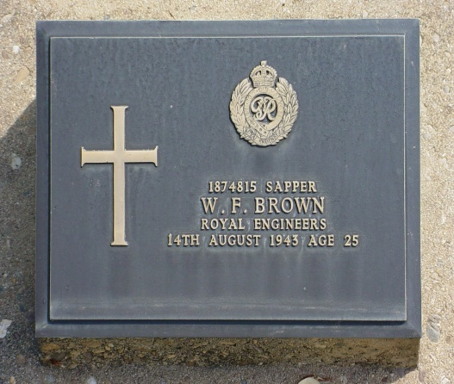
1863434 Corporal Joseph Hercules Burt  Died of dysentery on 19 February 1943.  Buried at Kanchanaburi War Cemetery Grave 2F 54  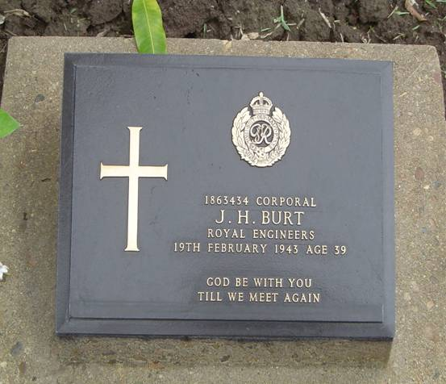 | 1874621 Acting Lance Corporal T Carter  Died on 02 August 1943.  Commemorated on the Singapore War Memorial  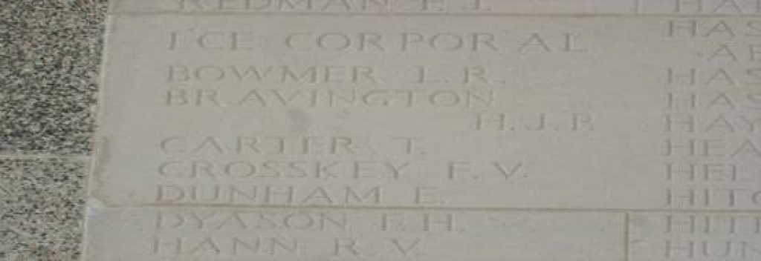
1440248 Sapper Ernest Hercules Cooling  Died on 15 June 1943  Buried at Kanchanaburi War Cemetery  Grave 8F 59  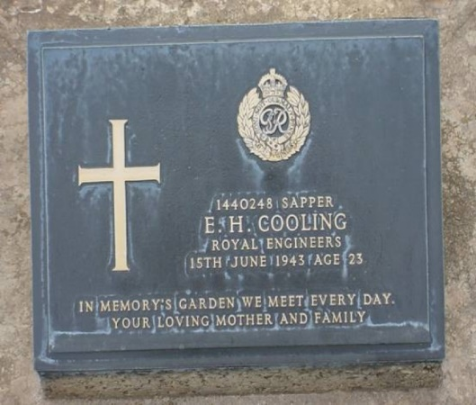 | 1873311 W/Cpl P J Curran  Died of Dysentery on 28 August 1943 at Wangai, Tarso, Thailand Buried at Chunkai War Cemetery  Grave 9 J 5  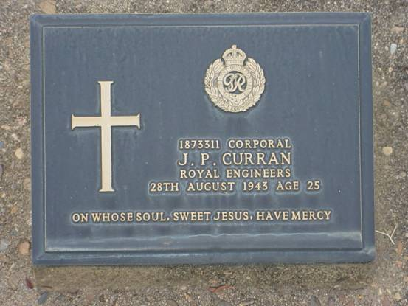
1986097 Sapper Thomas Eadie  Died on 15 July 1943  Commemorated at the Singapore Memorial  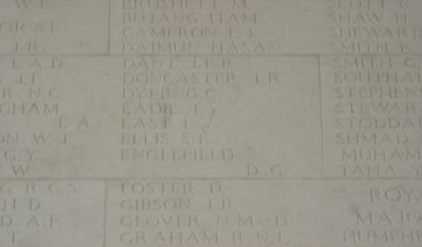  At Kinsaiyok Camp, Thailand on the 23 June 1943, with Gunner G escaped after a couple of days due to the difficulties they faced they gave themselves up.  They were returned to Kinsaiyko Camp and held there till the 15 July 1943, when they were taken out and executed near the 175kms marker. | 1874647 Sapper W Grapes  Died on 12 September 1944 Age 29  Commemorated on the Singapore Memorial  Column 40  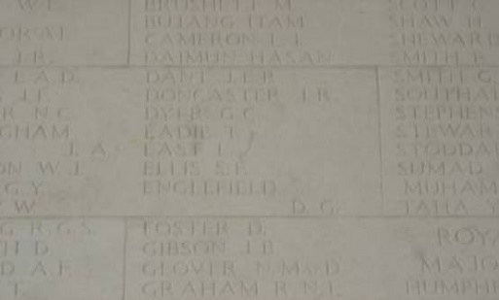
1871213 Sapper Noel Grayson  Died of Diarrhoea and Beri Beri on 11 October 1943 at Tanbaya, Malaya Buried at Thanbyuzayat War Cemetery Grave B6 P2  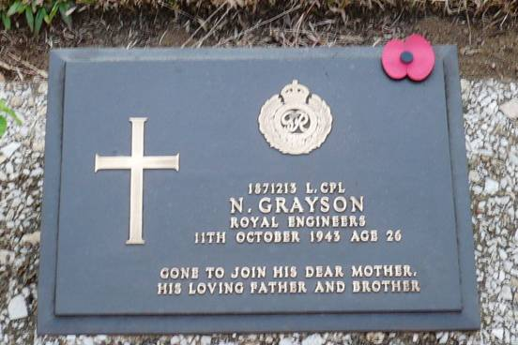 | 1867621 Acting Lance Sergeant A J Green MBE  Died 0n 13 October 1943  Buried at Kanchanaburi War Cemetery  Grave 2 K 6  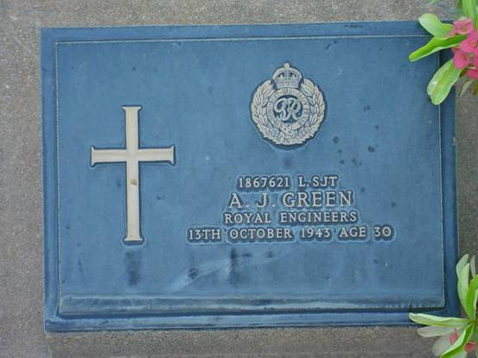
1874829 Sapper Eric Gymer  Buried at Kanchanaburi War Cemetery  Grave 8 K 54  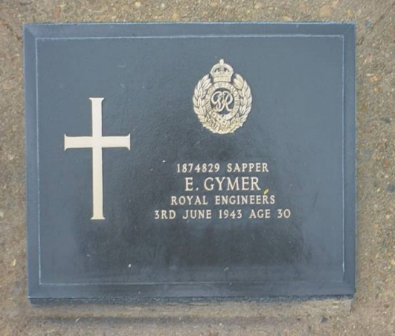 | 1877212 Sapper Stanley James J Haime  Died on 13 December 1943  Buried at Chungkai War Cemetery  Grave 3 M 8  No photo at this time
1872722 Sapper Ernest Hellyn  Died on 12 September 1944  Commemorated on Singapore Memorial  Column 40  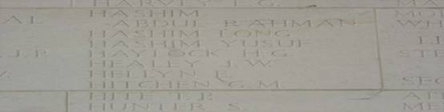 | 1871739 Sapper Albert Eric Mathew Jones  Died on 15 July 1943  Buried at Kanchanburi War Cemetery  Grave 8 L 65
1892268 Acting Lance Corporal J M Law  Died of Malaria and Beri Beri on 29 September 1943 at Jambaya, Burma  Buried at Thanbyuzayal War Cemetery  Grave B 6 M 5  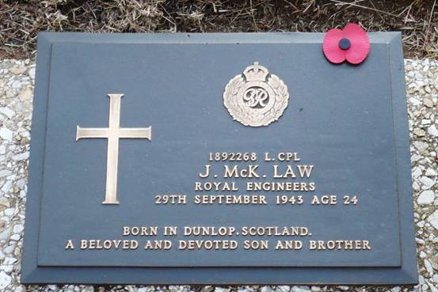 | 1869248 Corporal Rueben Edgar Lillycrop  Died on 12 September 1944 Age 31  Commemorated on Singapore Memorial  Column 39  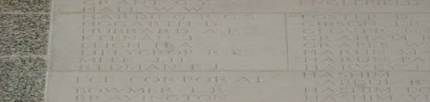
2034523 Sapper J MacMullen  Died on 21 May 1943  Buried at Kanchanaburi War Cemetery  Grave G 8 J 70  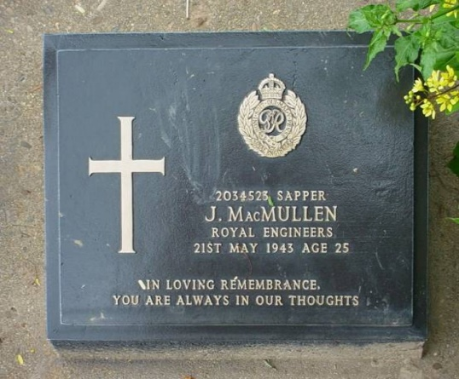 | 1877067 Sapper W J Marshall  Died on the 28 August 1943  Buried at Chungkia War Cemetery  Grave 4 G 2  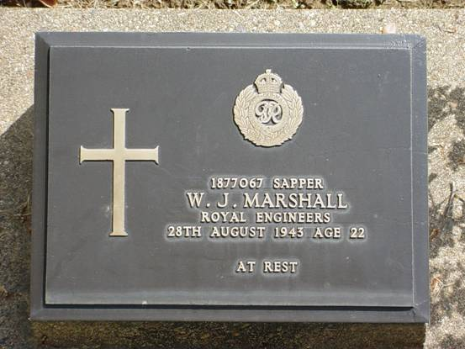
1871419 Acting Lance Corporal J McCabe  Died 19 July 1943  Buried at Kanchanaburi War Cemetery  Grave 4 A 30  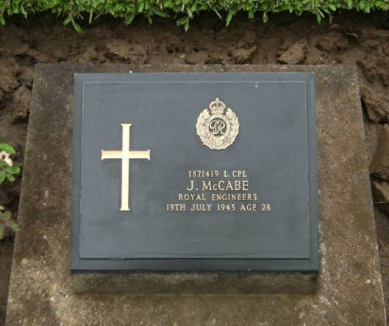 | 2027396 Acting Lance Sergeant E A McDade  Died 21 January 1944  Buried at Chungkia War Cemetery  Grave 2 E 4  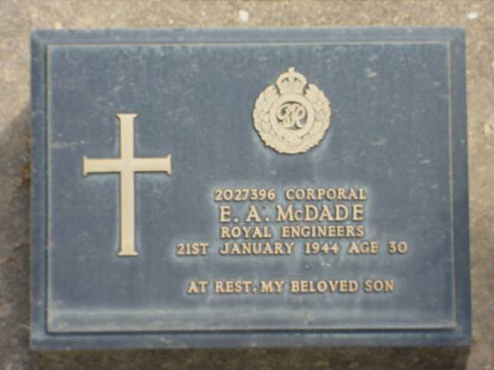
3710671 Sapper D V Mc Guinness  Died on 08 August 1943  Buried at Kanchanaburi War Cemetery  Grave 4 A 63  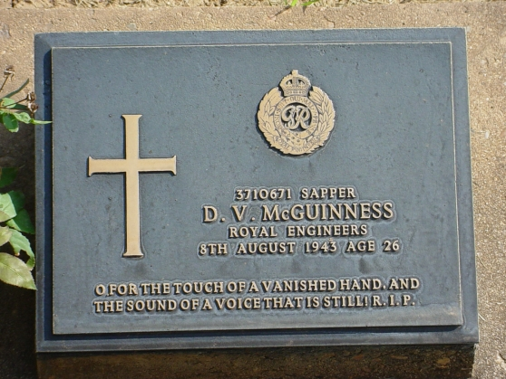 | 1877456 Sapper Reginald Arthur A Metcalfe  Died on 09 August 1943  Buried at Kanchanaburi War Cemetery  Grave 4 A 72  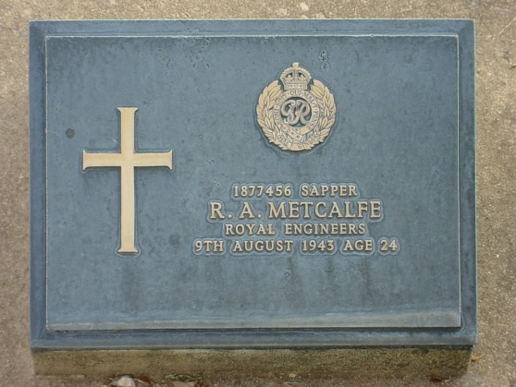
1874946 Sapper J W L Morrison  Died on 17 June 1943  Buried at Chungkia War Cemetery  Grave 1 M 7  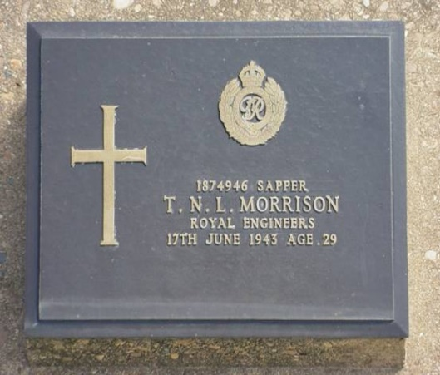 | 1874091 Sapper C A Pilbeam  Died 14 July 1943 Age 26  Buried at Kanchanaburi War Cemetery  Grave 4 A 24  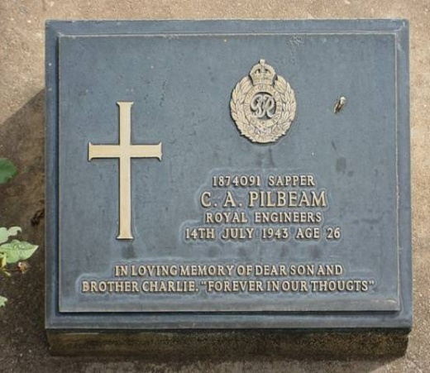
1874307 Sapper A C E Potter  Died on 21 September 1943  Died of Amoebic Dysentery at H Hospital Thailand  Buried at Kanchanaburi War Cemetery  Grave 2 E 25  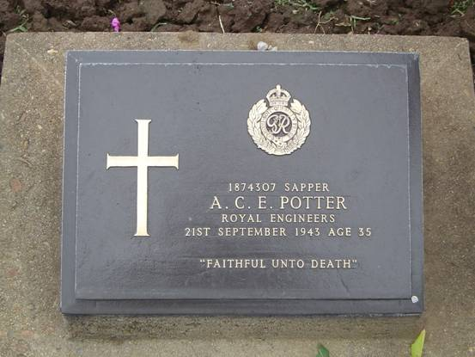 | 2031849 Acting Lance Corporal George Victor Ranson  Killed on active service by enemy action on 10 to 15 February 1942, during shelling at Saint Andrews School, Singapore. Buried Bididari Cemetery initially.  Buried at Kranji War Cemetery  Grave 18 C 19-20  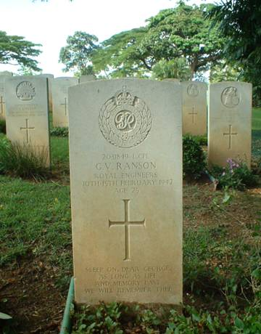
1875168 Sapper J Rehbein  Died on 12 June 1943  Died of Cholera at Tongshang South Thailand. Buried initially at Cholera Cemetery  Buried at Kanchanaburi War Cemetery  Grave 6 A 76  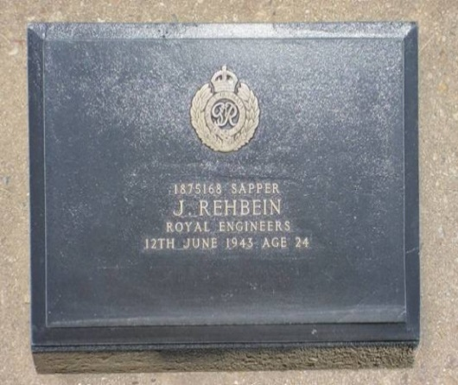 | 1874751 Sapper George Henry William Tharme  Died on 19 November 1942 of Dysentary at Base Hospital, Kanburi Thailand  Buried at Kanchanaburi War Cemetery  Grave 4 E 69  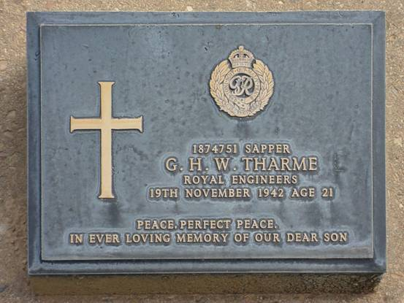
1877435 Sapper Albert Kenneth Thornton  Died on 20 January 1945  Commemorated Singapore Memorial  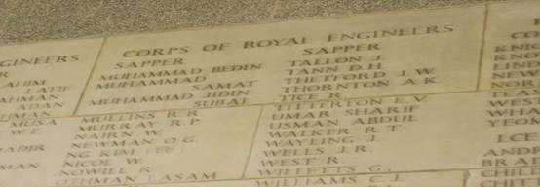 | 1846901 Acting unpaid Lance Corporal J Weeden  Died on 03 August 1943  Buried at Kanchanaburi War Cemetery  Grave 4 A 57  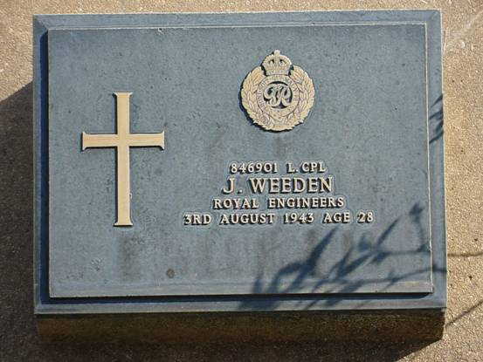
187007 Lance Sergeant William Claude Benchley Wood  Died on 15 December 1943 Age 30  Buried at Chungkia War Cemetery  Grave 3 M 15  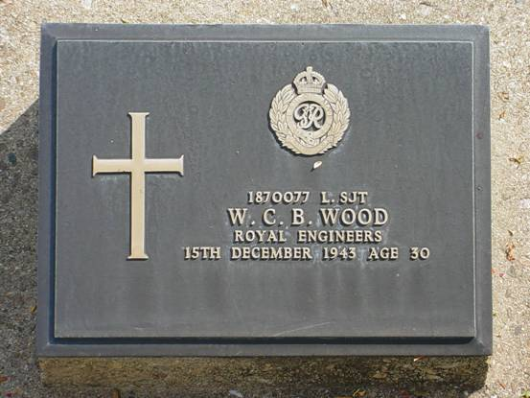 | 1871009 Sapper Laurence Walter  Died on 05 October 1943  Buried at Kanchanaburi War Cemetery  Grave 4 C 16  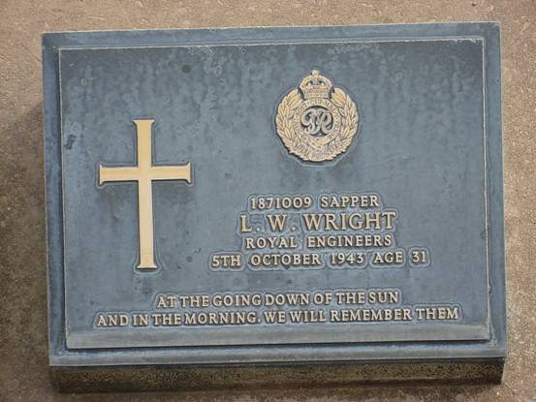

C/E 15 Sapper N G Kim Lee
Died on 10 June 1945
Son of Tay Buck Sim of Singapore
Commemorated on Singapore War Memorial
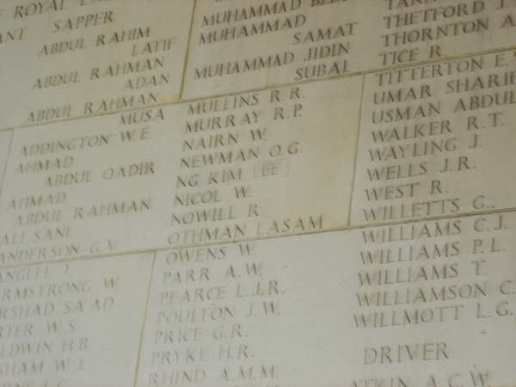

Cemetery Information.
All details taken from Commonwealth War Graves Commission web site
https://www.cwgc.org
Chungkai War Cemetery.
Is located just outside the town of Kanchanaburi, which is 129 kilometres north-west of Bangkok, at the point where the river Kwai divides into two separate rivers.

History Information

The notorious Burma-Siam railway, built by Commonwealth, Dutch and American prisoners of war, was a Japanese project driven by the need for improved communications to support the large Japanese army in Burma. During its construction, approximately 13,000 prisoners of war died and were buried along the railway. An estimated 80,000 to 100,000 civilians also died in the course of the project, chiefly forced labour brought from Malaya and the Dutch East Indies or conscripted in Siam (Thailand) and Burma (Myanmar). Two labour forces, one based in Siam and the other in Burma, worked from opposite ends of the line towards the centre. The Japanese aimed at completing the railway in 14 months and work began in October 1942. The line, 424 kilometres long, was completed by December 1943. The graves of those who died during the construction and maintenance of the Burma-Siam railway (except for the Americans, whose remains were repatriated) were transferred from camp burial grounds and isolated sites along the railway into three cemeteries at Chungkai and Kanchanaburi in Thailand and Thanbyuzayat in Myanmar. Chungkai was one of the base camps on the railway and contained a hospital and church built by Allied prisoners of war. The war cemetery is the original burial ground started by the prisoners themselves, and the burials are mostly of men who died at the hospital.
Kanchanaburi War Cemetery.
The town of Kanchanaburi is 129 kilometres North-West of Bangkok.

History Information

The notorious Burma-Siam railway, built by Commonwealth, Dutch and American prisoners of war, was a Japanese project driven by the need for improved communications to support the large Japanese army in Burma. During its construction, approximately 13,000 prisoners of war died and were buried along the railway. An estimated 80,000 to 100,000 civilians also died in the course of the project, chiefly forced labour brought from Malaya and the Dutch East Indies, or conscripted in Siam (Thailand) and Burma (Myanmar). Two labour forces, one based in Siam and the other in Burma worked from opposite ends of the line towards the centre. The Japanese aimed at completing the railway in 14 months and work began in October 1942. The line, 424 kilometres long, was completed by December 1943. The graves of those who died during the construction and maintenance of the Burma-Siam railway (except for the Americans, whose remains were repatriated) were transferred from camp burial grounds and isolated sites along the railway into three cemeteries at Chungkai and Kanchanaburi in Thailand and Thanbyuzayat in Myanmar. KANCHANABURI WAR CEMETERY is only a short distance from the site of the former 'Kanburi', the prisoner of war base camp through which most of the prisoners passed on their way to other camps. It was created by the Army Graves Service who transferred to it all graves along the southern section of railway, from Bangkok to Nieke. Some 300 men who died (most from a Cholera epidemic in May/June 1943) at Nieke camp were cremated and their ashes now lie in two graves in the cemetery. The names of these men are inscribed on panels in the shelter pavilion. There are now 5,085 Commonwealth casualties of the Second World War buried or commemorated in this cemetery. There are also 1,896 Dutch war graves and 1 non-war grave. Within the entrance building to the cemetery will be found the KANCHANABURI MEMORIAL, recording the names of 11 men of the army of undivided India buried in Muslim cemeteries in Thailand, where their graves could not be maintained. The cemetery was designed by Colin St Clair Oakes.

Kranji War Cemetery, Singapore War Memorial.

Singapore Memorial stands in Kranji War Cemetery. It bears the names of more than 24,000 casualties of the land and air forces of the Commonwealth who died during the campaigns in Malaya and Indonesia or in subsequent captivity and have no known grave. The memorial also commemorates airmen who died during operations over the whole of southern and eastern Asia and the surrounding seas and oceans. After the surrender of Singapore, the Kranji area was used as a prisoner of war camp by the Japanese and this cemetery was begun by the Commonwealth prisoners at the camp. In 1946, it was decided that Kranji would be designated as Singapore's main war cemetery.

The small Prisoner of War cemetery was expanded after the war when graves were brought from across Singapore, including from Buona Vista and Changi which was the site of the main prisoner of war camp in Singapore.
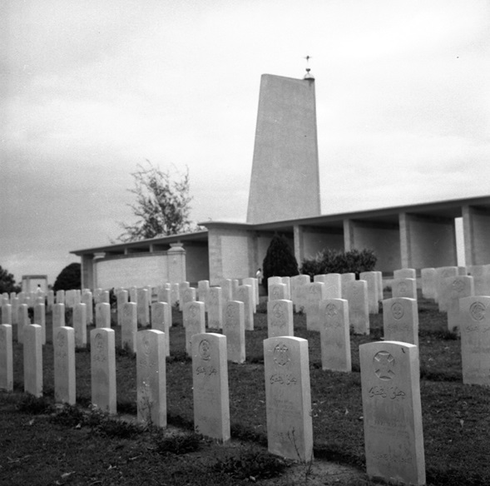
Before 1939 the Kranji area was a military camp and at the time of the Japanese invasion of Malaya, was the site of a large ammunition magazine. On 8 February 1942, the Japanese crossed the Johore Straits in strength, landing at the mouth of the Kranji River within two miles of the place where the war cemetery now stands. On the evening of 9 February, they launched an attack between the river and the causeway. During the next few days fierce fighting ensued, in many cases hand to hand, until their greatly superior numbers and air strength necessitated a withdrawal. After the fall of the island, the Japanese established a prisoner of war camp at Kranji and eventually a hospital was organised nearby at Woodlands, which was staffed by British and Australian personnel, the British predominating.Following the reoccupation of Singapore, the small cemetery started by the prisoners at Kranji was developed into a permanent war cemetery by the Army Graves Service when it became evident that a larger cemetery at Changi could not remain undisturbed. A large camp hospital had been set up there by the Australian Infantry Force, and the burials at Changi were mostly from this hospital. The site on which the cemetery laid was required for the expansion of Changi Airport.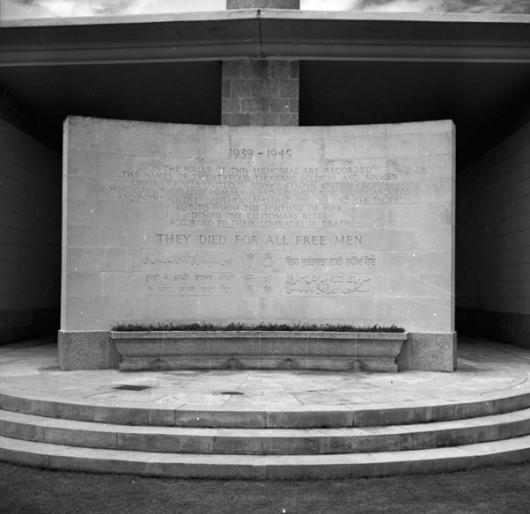
In 1946, the graves were moved from Changi to Kranji, as were those from the Buona Vista prisoner of war camp. Many other graves from all parts of the island were transferred to Kranji together with all Second World War graves from Saigon Military Cemetery in French Indo-China (now Vietnam), another site where permanent maintenance could not be assured. The Commission later brought in graves of both world wars from Bidadari Christian Cemetery, Singapore, where again permanent maintenance was not possible. There are now more than 4,460 Commonwealth casualties of the Second World War buried or commemorated at Kranji War Cemetery. More than 850 of the burials are unidentified. The Chinese Memorial in Plot 44 marks a collective grave for 69 Chinese servicemen, all members of the Commonwealth forces, who were killed by the Japanese during the occupation in February 1942. First World War burials and commemorations number 64, including special memorials to three casualties known to have been buried in civil cemeteries in Saigon and Singapore, but whose graves could not be located.
The Singapore Memorial, bears the names of more than 24,000 casualties of the Commonwealth land and air forces who have no known grave. Many of these have no known date of death and are accorded within our records the date or period from when they were known to be missing or captured. The land forces commemorated by the memorial died during the campaigns in Malaya and Indonesia or in subsequent captivity, many of them during the construction of the Burma-Thailand railway, or at sea while being transported into imprisonment elsewhere. The airmen who are commemorated died during operations over the whole of southern and eastern Asia and the surrounding seas and oceans.
The memorial was unveiled by Sir Robert Black, Governor of Singapore on 2 March 1957.
Sai Wan War Cemetery.

History Information

The island of Hong Kong fell to the Japanese on Christmas Day 1941 following a brief but intense period of fighting. Most of those buried in this cemetery were killed at this time, or died later as internees or prisoners of war during the Japanese occupation. The remains of those who died as prisoners in Formosa (now Taiwan) were brought to Hong Kong for burial at Sai Wan in 1946. There are now 1,505 Commonwealth casualties of the Second World War buried or commemorated at Sai Wan War Cemetery. 444 of the burials are unidentified. At the entrance to the cemetery stands the SAI WAN MEMORIAL bearing the names of more than 2,000 Commonwealth servicemen who died in the Battle of Hong Kong or subsequently in captivity and who have no known grave. Additional panels to the memorial form the SAI WAN CREMATION MEMORIAL, bearing the names of 144 Second World War casualties whose remains were cremated in accordance with their faith, and the SAI WAN (CHINA) MEMORIAL, commemorating 72 casualties of both wars whose graves in mainland China could not be maintained. Both the cemetery and memorial were designed by Colin St Clair Oakes.
Thabyuzayat War Cemetery.
The village of Thanbyuzayat is 65 kilometres south of the port of Moulmein, and the war cemetery lies at the foot of the hills which separate the Union of Myanmar from Thailand.

History Information
The notorious Burma-Siam railway, built by Commonwealth, Dutch and American prisoners of war, was a Japanese project driven by the need for improved communications to support the large Japanese army in Burma. During its construction, approximately 13,000 prisoners of war died and were buried along the railway. An estimated 80,000 to 100,000 civilians also died in the course of the project, chiefly forced labour brought from Malaya and the Dutch East Indies, or conscripted in Siam (Thailand) and Burma (Myanmar). Two labour forces, one based in Siam and the other in Burma worked from opposite ends of the line towards the centre. The Japanese aimed at completing the railway in 14 months and work began in October 1942. The line, 424 kilometres long, was completed by December 1943. The graves of those who died during the construction and maintenance of the Burma-Siam railway (except for the Americans, whose remains were repatriated) were transferred from camp burial grounds and isolated sites along the railway into three cemeteries at Chungkai and Kanchanaburi in Thailand and Thanbyuzayat in Myanmar. Thanbyuzayat became a prisoner of war administration headquarters and base camp in September 1942 and in January 1943 a base hospital was organised for the sick. The camp was close to a railway marshalling yard and workshops, and heavy casualties were sustained among the prisoners during Allied bombing raids in March and June 1943. The camp was then evacuated and the prisoners, including the sick, were marched to camps further along the line where camp hospitals were set up. For some time, however, Thanbyuzayat continued to be used as a reception centre for the groups of prisoners arriving at frequent intervals to reinforce the parties working on the line up to the Burma-Siam border. Thanbyuzayat War Cemetery was created by the Army Graves Service who transferred to it all graves along the northern section of the railway, between Moulmein and Nieke.

Appendixes.
  - Letter relating to 2/Lieutenant L Rees and his Commission.
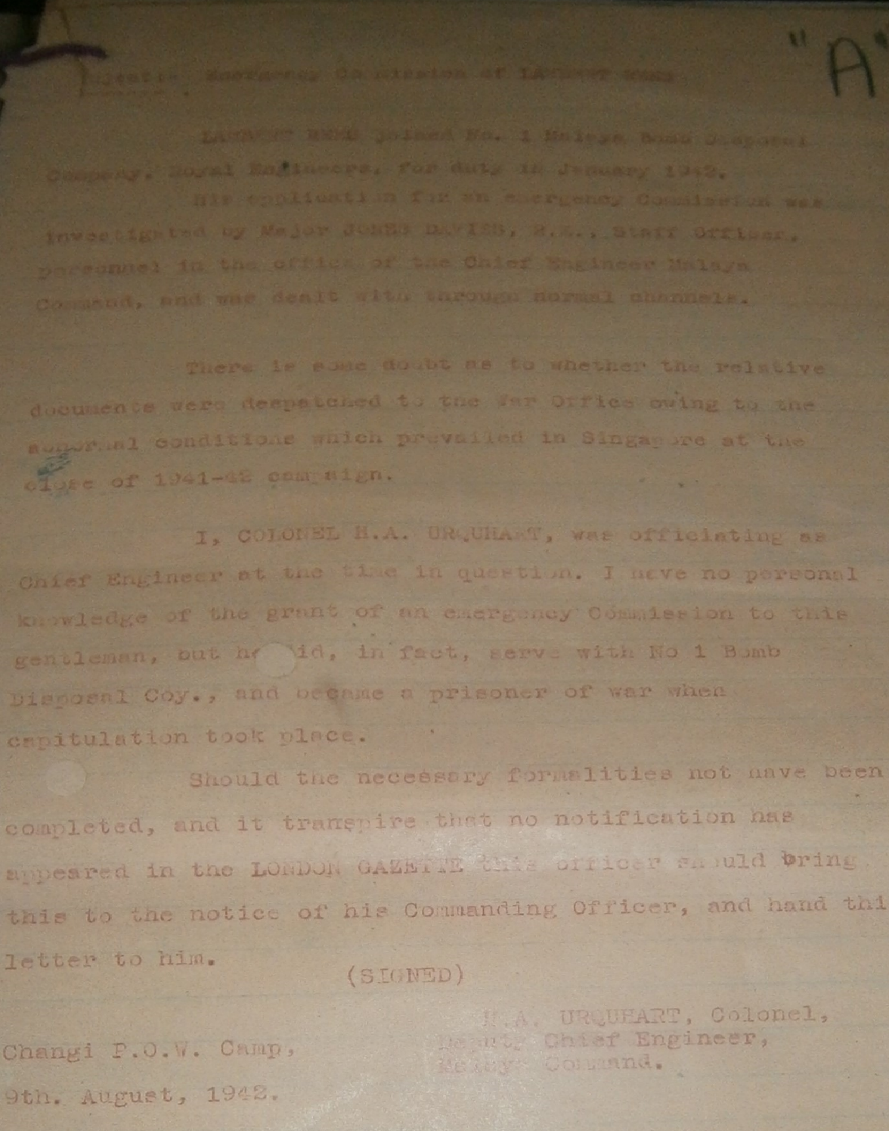

  - Court Martial of 1871213 Lance Corporal N Grayson.
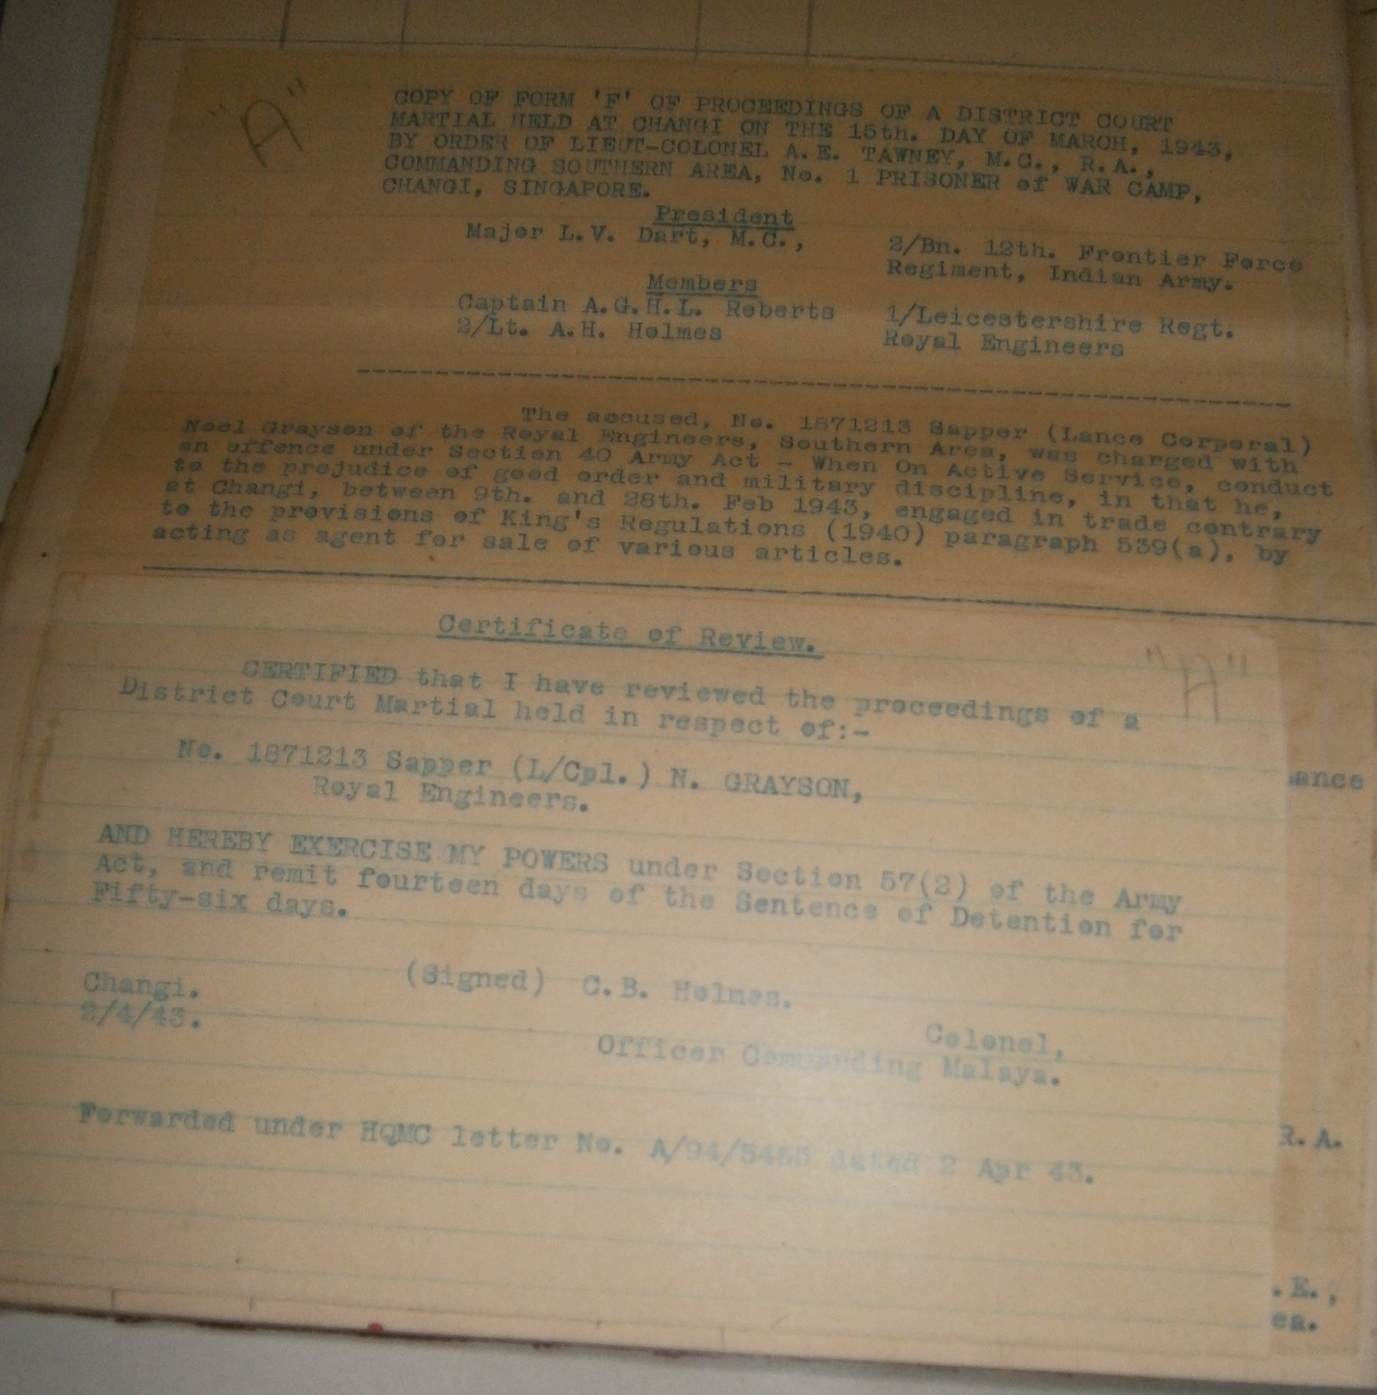

C. Sergeant A Knight promoted Acting WO 2 (CSM).

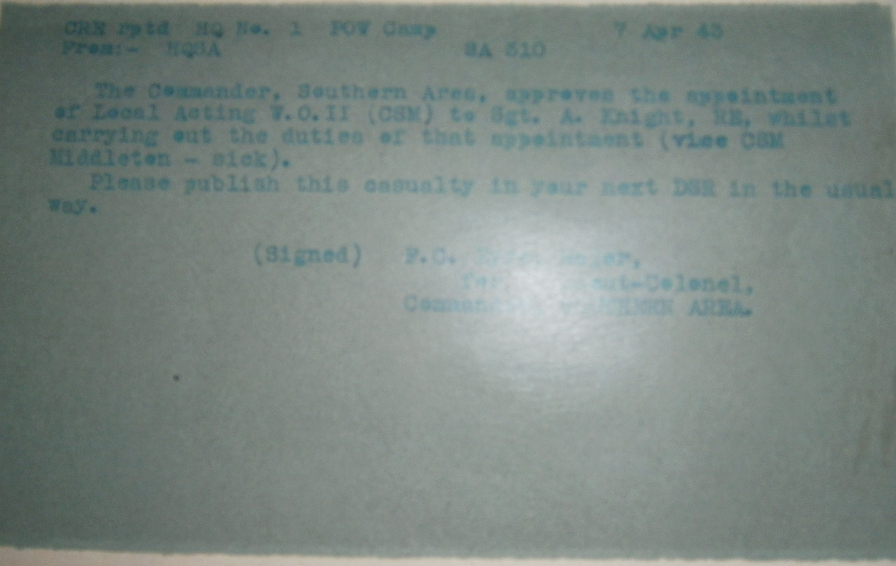

D. 1914318 Lance H Corporal Lovett Charge sheet.
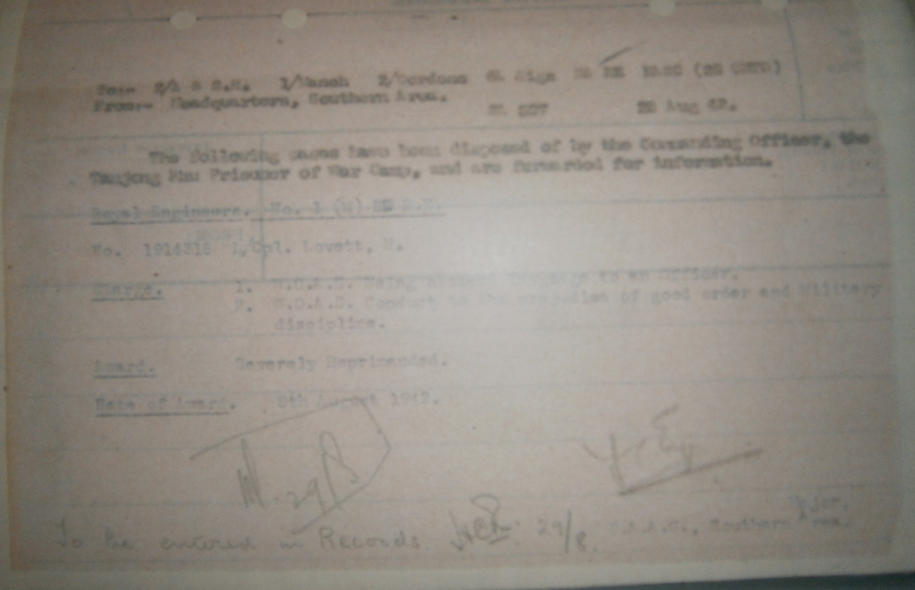
E. Two Documents relating to injury’s sustained by 1873368 Lance Corporal S Parsons
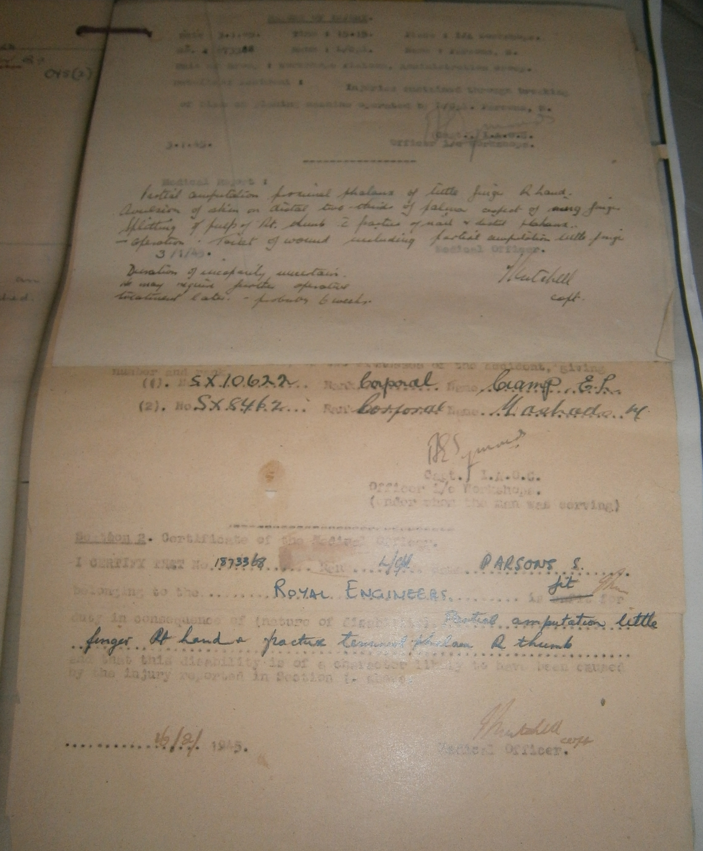
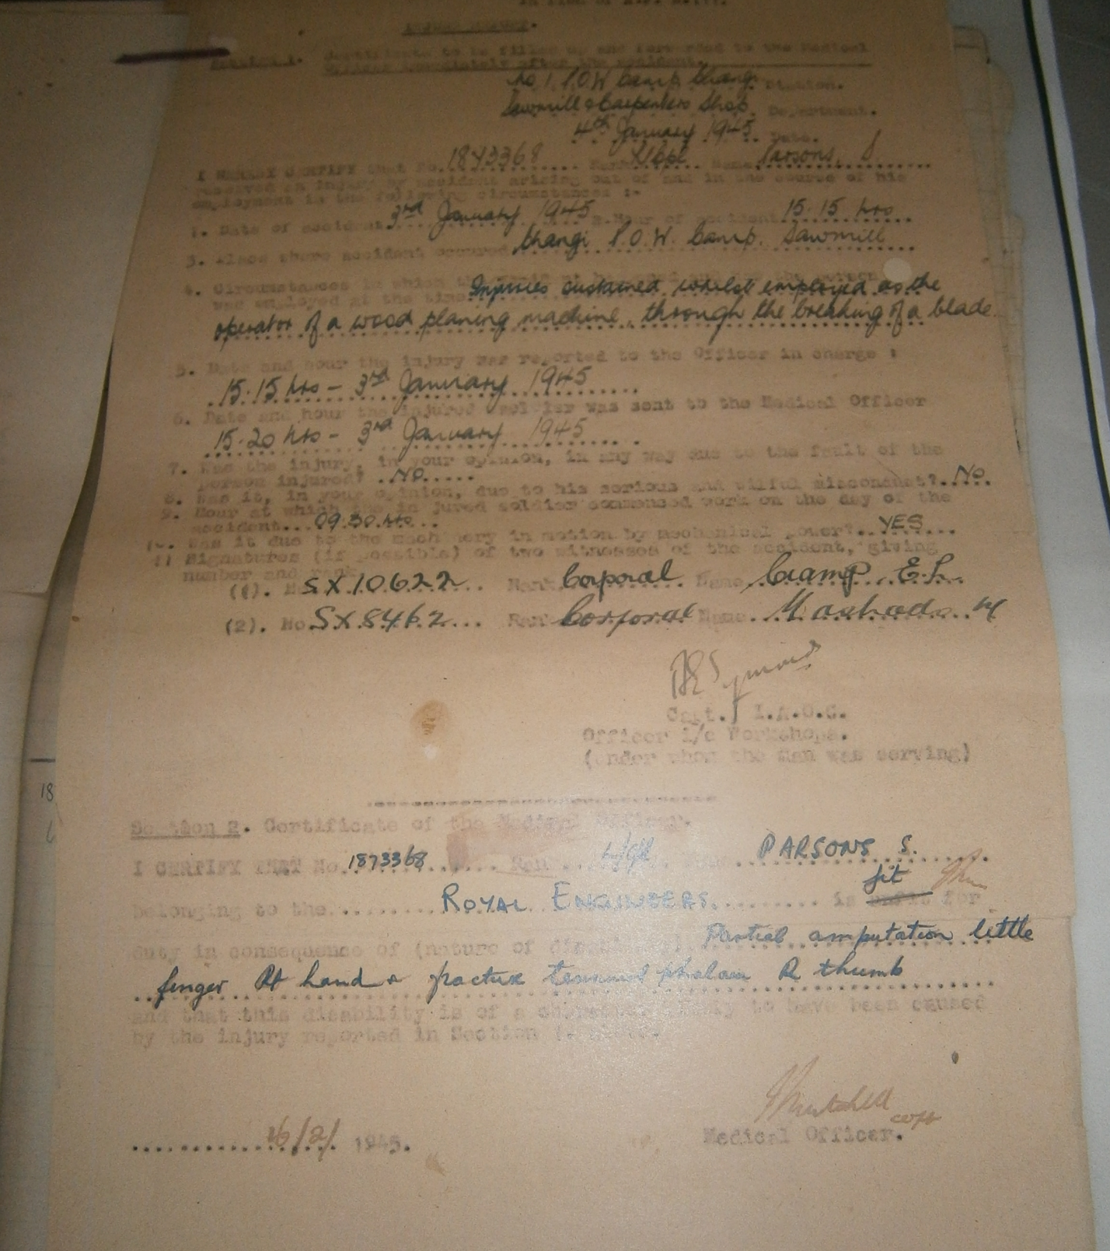
F. Document relating to Cash Imprest and Company Funds.
From Lieutenant Kemlo to Chief Royal Engineer
Cash disposed of as follows.
12 February 1942
85 handed to Captain Webb at the Supreme Court. 65 being from Company funds.
15 February 1942
Handed over approximately 350 to Captain Walsh in the presence of Lieutenant Colonel W Randle at Fort Ca???????. Captain Walsh said he would talk to Colonel Peate RE and he would ask him what to do with the money.
19 February when Lieutenant Kemlo returned to Singapore to change he asked Captain Walsh what and happened to money Captain Walsh said it had been burnt and he would pay back money from Company funds out of his own pocket.
Dated 27 April 1942

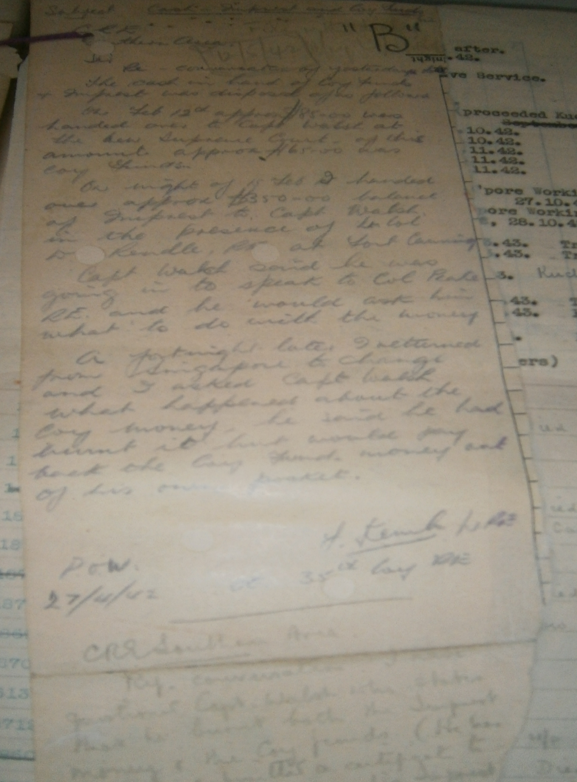

G. Key to where people sent
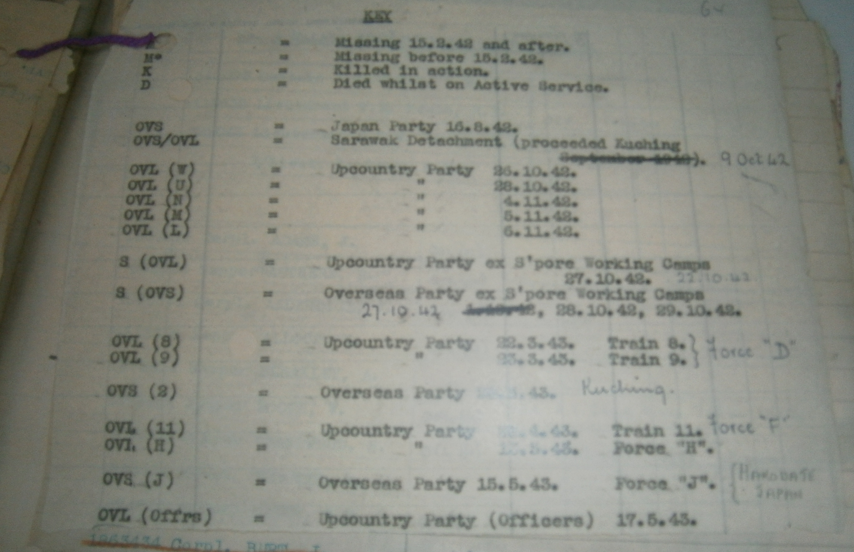

Notes.
S/S Narkunda.
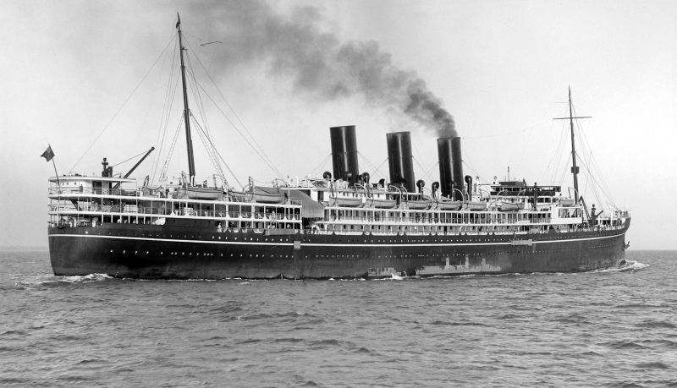
SS Narkunda had a lengthy construction time, having been ordered in 1913. Narkunda was built by Harland & Wolff in Belfast. She did not enter service during the war, and was passed to P&O at its end. She entered service on 30th March 1920, five days after her sister Naldera.
They were the first three-funnelled P&O liners and the first with cruiser sterns. Narkunda ran on the mail service to Australia, and later to the Far East, carrying 673 passengers (426 of which were first class). Narkunda was converted to oil firing in 1927 (unlike her sister) which extended her career.
She continued in passenger service until 1940, making trips to Shanghai and Cape Town after war had been declared. She also evacuated personal from Singapore including families from 1 Malaya Bomb Disposal Company. Used as a troopship thereafter, Narkunda was bombed and sunk in 1942 during the African landings, the third of three P&O ships to be lost there.
http://www.shipspotting.com/gallery/photo.php?lid=1549127

MV Marnix.
MV Marnix van Sint Aldegonde was a Netherland Line luxury passenger ship and cargo liner built in 1930 for service between Amsterdam and Jakarta. She operated out of Surabaya from 21 February 1940, and was requisitioned as a troopship at Singapore in May 1941 to transport Australian troops from Melbourne to Asia and Africa, and to bring 1,000 Italian Prisoners of War from Egypt to Mumbia. She also evacuated personal from Singapore including families from 1 Malaya Bomb Disposal Company. She left the Indian Ocean in 1942, and subsequently carried Allied troops for Operation Torch, Operation Husky, and Operation Avalanche. Her Ships Master H W Hettma was awarded the Distinguished Service Cross in January 1943 after his ship destroyed two attacking bombers of North Africa on 9 November 1943.
She sailed with convoy KMF 25 on 27 October 1943. She came under attack by Kampfgeshwader 26 Dornier 217 torpedo bombers after entering the Mediterranean: and was hit by a torpedo which flooded the engine room on the evening of 6 November 1943. All personnel were safely rescued by other ships and was taken in tow. The Grace Liner Santa Elena had been similarly disabled by another torpedo in the same attack: and was also taken in tow. The two ships collided in tow, and both sank from progressive flooding the following evening.
https://en.wikipedia.org/wiki/MV_Marnix_van_Sint_Aldegonde

